Supporting Information for

Comparison of hepatic metabolism of triazolam in wild type and Cyp3a-knockout mice for understanding CYP3A-mediated metabolism in CYP3A-humanized mice in vivo

Genki Minegishi,¹ Yasuhiro Kazuki,^{2,3} Yuki Yamasaki,¹ Fuka Okuya,¹ Hidetaka Akita,¹ Mitsuo Oshimura,² Kaoru Kobayashi¹

¹Laboratory of DDS design and Drug Disposition, Graduate School of Pharmaceutical Sciences, Chiba University, Chiba 260-8675, Japan

²Chromosome Engineering Research Center, Tottori University, Tottori, Japan
³Department of Biomedical Science, Institute of Regenerative Medicine and Biofunction, Graduate School of Medical Science, Tottori University, Tottori, Japan

Contents
Figure S1. Effects of ketoconazole and an antibody against CYP2C on TRZ α- and 4-hydroxylation activities in liver microsomes of WT and Cyp3a-KO mice treated with PCN.
Figure S2. Effect of PCN treatment on plasma concentrations of TRZ, α-OH TRZ, 4-OH TRZ in CYP3A-humanized mice.
Table S1. Oligonucleotide primers used in real-time PCR
Table S2. Incubation conditions in microsomal reactions
Table S3. Pharmacokinetic parameters of TRZ and its metabolites in CYP3A-humanized mice in vivo

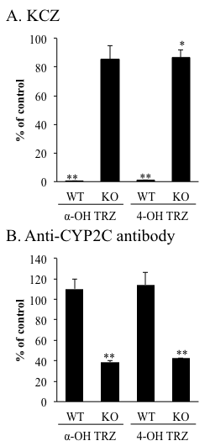
Figure. S1. Effects of ketoconazole and an antibody against CYP2C on TRZ α- and 4-hydroxylation activities in liver microsomes of WT and Cyp3a-KO mice treated with PCN. TRZ (4 μM) was incubated with pooled liver microsomes (each four mice) in the presence or absence of 1 µM ketoconazole (a) or an antibody against CYP2C (b). TRZ α- and 4-hydroxylation activities in the liver microsomes of mice treated with PCN were analyzed by LC-MS/MS. Data are shown as mean with S.D. of triplicate incubations. *p < 0.05 and **p < 0.01 versus control values in the absence of ketoconazole or anti-CYP2C antibody. Statistical analysis was performed by Welch’s t test.
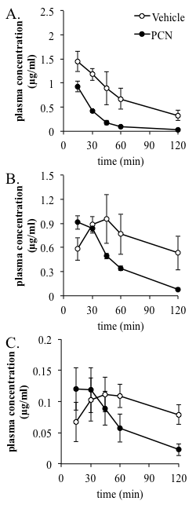

Figure S2. Effect of PCN treatment on plasma concentrations of TRZ, α-OH TRZ, 4-OH TRZ in CYP3A-humanized mice. Plasma concentration versus time curves of TRZ (a), α-OH TRZ (b) and 4-OH TRZ (b) after intravenous TRZ administration (2 mg/kg) in CYP3A-humanized mice. Mice were pretreated with vehicle (corn oil) or PCN (100 mg/kg, i. p) for three days. Data are shown as mean with S.D. of four to five mice.

Table S1 Oligonucleotide primers used in real-time PCR
Name | Direction | Sequence (5’ to 3’) | References
Cyp2c29 | Forward | CCAGAGATTCATCGACCTCCT | 27
 | Reverse | TAGTTCCCTTGGGGATGAGGTAT
Cyp2c39 | Forward | TTGTGTGAATAAAAAGGGTTTCCA | 27
 | Reverse | TTGAGAAATTGGTTAAGGATTGGCT
Cyp2c55 | Forward | AGGAAGCTCTGGATGACCTTGG | 28
 | Reverse | TTGAGAAGCGCCGAAGCTCCTT
Cyp2c70 | Forward | TGGCTTTCTCAGCAGGAAGAA | 27
 | Reverse | AACTGGCTTGGTGTCGATGT
Gapdh | Forward | AAGCCCATCACCATCTTCCAGG | 29
 | Reverse | GGTTCACACCCATCACAAACAT

Table S2 Incubation conditions in microsomal reactions
Liver microsome | Concentration  (mg protein/mL) | Incubation time (min)
WT, Vehicle | 0.2 | 60
WT, PCN | 0.05 | 30
KO, Vehicle | 0.025 | 30
KO, PCN | 0.01 | 30

Table S3 Pharmacokinetic parameters of TRZ and its metabolites in CYP3A-humanized mice in vivo
 | CYP3A-humanized
 | Vehicle | PCN
Triazolam
AUC₀₋₁₂₀  (µg/mL*min) | 101 ± 21 | 35 ± 3**
AUC_{0-∞}  (µg/mL*min) | 125 ± 30 | 36 ± 3**
total clearance  (mL/min/g) | 17 ± 5 | 56 ± 5**
half-life  (min) | 48.9 ± 10.6 | 22.8 ± 2.1**
α-OH triazolam
AUC₀₋₁₂₀  (µg/mL*min) | 81 ± 21 | 49 ± 2**
4-OH triazolam
AUC₀₋₁₂₀  (µg/mL*min) | 10.7 ± 2.2 | 7.7 ± 2.5
**p < 0.01 versus CYP3A-humanized mice treated with the vehicle.

