Code Sheet
Latino Organization Websites – Visual Analysis of Culture-Specific and Multi-cultural Images
Coder ID _______________ Date Screen-Captured ________________
Sample ID# _____________ URL _______________________________
For references to visuals, use the flagged images in the following sources or collected in the visual dictionary created for the study based on Kim, etc.:
- Bailey, G. A. (2004). The art of colonial Latin America. New York: Phaidon. and Scott, J. F. (2008). Latin American art: Ancient to modern. Gainesville, FL: University Press of Florida.
- For architecture (possibly Mexican) visit https://www.mna.inah.gob.mx/ for references.

CATEGORY 1 (Non-photo content) Cultural Orientation of Logos, Names, and Slogans (RQs #1 & 2) & Content (RQs 1 & 5)
LOGO
YES NO Indigenous symbol with name
YES NO Colonial (Spanish) symbol with name
YES NO US symbol (flag, monument) with name
YES NO Symbol w/no cultural reference (stylized people, building, etc.)
YES NO Can’t identify symbol with name
YES NO Name of organization in Spanish or Portuguese only
YES NO Name of organization in English only
YES NO Name of organization bilingual
Organization Slogan
YES NO Slogan is Latino/a or Hispanic-oriented
YES NO Slogan is multi-cultural oriented
YES NO Slogan is assimilation-oriented
Languages Represented on Homepage Graphics/Text (not masthead)
_____ Total Number of Languages
_____ English
_____ Spanish
_____ Portuguese
_____ Other(s) ___________________________________________________________________

Non-photo Images
_____Total number of acculturation images
_____Total number of resistance/immigrant advocacy images
_____Total number of images depicting TRADITIONAL CULTURAL SYMBOLS (ex. a sundial)
_____Total number of images depicting EMERGENT CULTURAL SYMBOLS (ex. Latino Power Graffiti art)
Languages Represented on Homepage Graphics/Text (not masthead)
_____ Total Number of Languages
_____ English
_____ Spanish
_____ Portuguese
_____ Other(s) ___________________________________________________________________

CATEGORY 2 - Photos only - Cultural Orientation of Photography (RQs #2, 3, 4)
_____Total number of photographs
_____ Total number of photos without people (buildings, plants, art, guitar, animals, books, etc.)
_____Total number of photos with at least one person
Acculturation/Integration Themes of photos (each photo can only go in one category)
_____ Number of photos whose main message is WORK/WORKING
_____ Number of photos whose main message is EDUCATION
_____ Number of photos whose main message is CITIZENSHIP (voting, civic engagement, etc.)
_____ Number of photos whose main message is LEADERSHIP (business leadership, political leadership)
_____ Number of photos whose main message is FAMILY (healthy families, happy families, etc.)

Latino Threats/Pluralism Themes of photos
_____ Number of photos whose main message deals with CULTURAL IDENTITY, PRIDE, EMPOWERMENT

Latino Threat Themes of photos
_____ Number of photos whose main message is PROTEST, MARCHES, or STRIKES
_____ Number of photos dealing with ILLEGAL/CRIMINAL THEMES

CODER NOTES:
Table 3
Intercoder reliability for all variables
Variable Type | Variable | Percent Agreement | Krippendorff's Alpha
Logos | Pre-Colombian | 100 | 1.000
 | Colonial | 100 | 1.000
 | US Symbol | 93.75 | 0.000
 | No Symbol | 93.75 | 0.866
 | Unclear Symbol | 100 | 1.000
Slogans | Slogan (Y/N) | 100 | 1.000
 | Slogan - Multi-cultural | 100 | 1.000
 | Slogan - Acculturation | 100 | 1.000
 | Slogan – Pluralism | 93.75 | 0.850
Graphics (webpage body) | Non-photo image - Acculturation | 100 | 1.000
 | Non-photo image –Pluralism | 100 | 1.000
 | Non-photo image – Traditional | 100 | 1.000
 | Non-photo image - New/emerging | 100 | 1.000
 | Other | 100 | 1.000
Language | Lang - Total | 100 | 1.000
 | Lang - English | 100 | 1.000
 | Lang - Spanish | 100 | 1.000
 | Lang - Portuguese | 100 | 1.000
 | Lang - Other | 100 | 1.000
Photos | Photos - Total | 93.75 | 0.930
 | Photos - No Humans | 93.75 | 0.812
 | Photos -Humans | 87.5 | 0.856
 | Photos - Acculturation - Work | 100 | 1.000
 | Photos - Acculturation - Education | 93.75 | 0.913
 | Photos - Acculturation - Citizenship | 93.75 | 0.000
 | Photos - Acculturation - Leadership | 100 | 1.000
 | Photos - Acculturation - Family | 93.75 | 0.886
 | Photos - Pluralism - Empowerment | 100 | 1.000
 | Photos – Pluralism - Resistance – Protest  Photos – Pluralism – Resistance - Illegal | 100  100 | 1.000  1.000

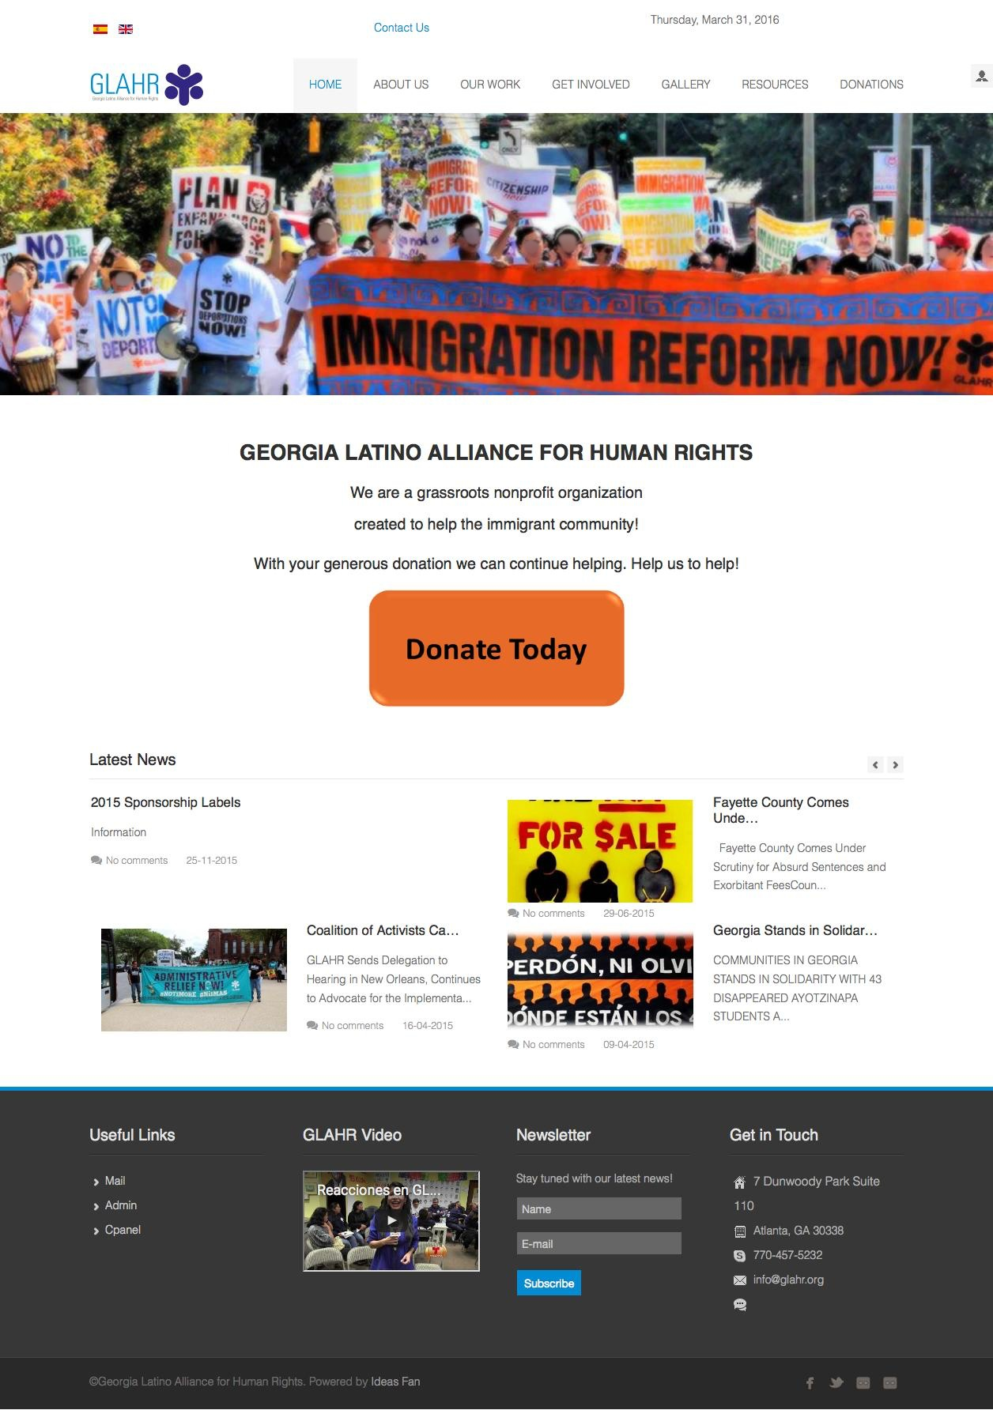
Pluralism-Resistance-Protest category, Georgia Latino Alliance for Human Rights
Acculturation-Education category-Instituto del Progreso Latino
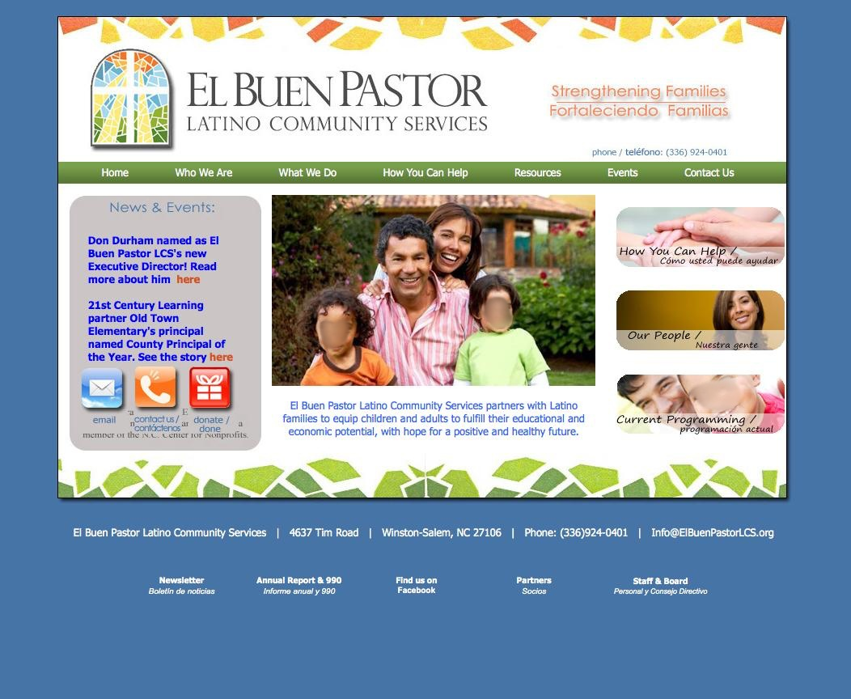
Acculturation-Family category-El Buen Pastor Latino Community Services
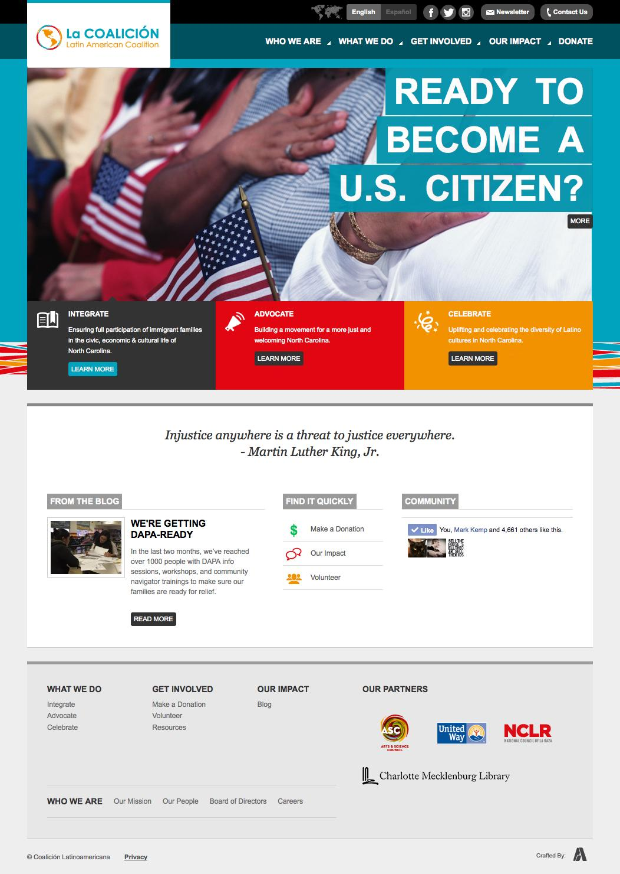

Acculturation-Citizenship category-Latin American Coalition
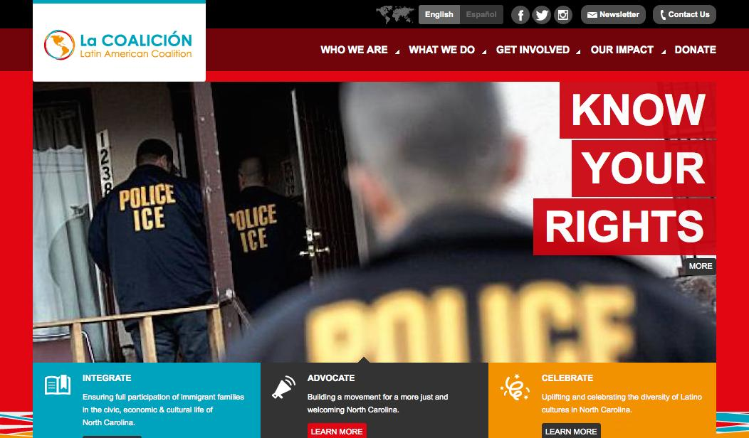

Pluralism-Resistance-Illegal category-Latin American Coalition
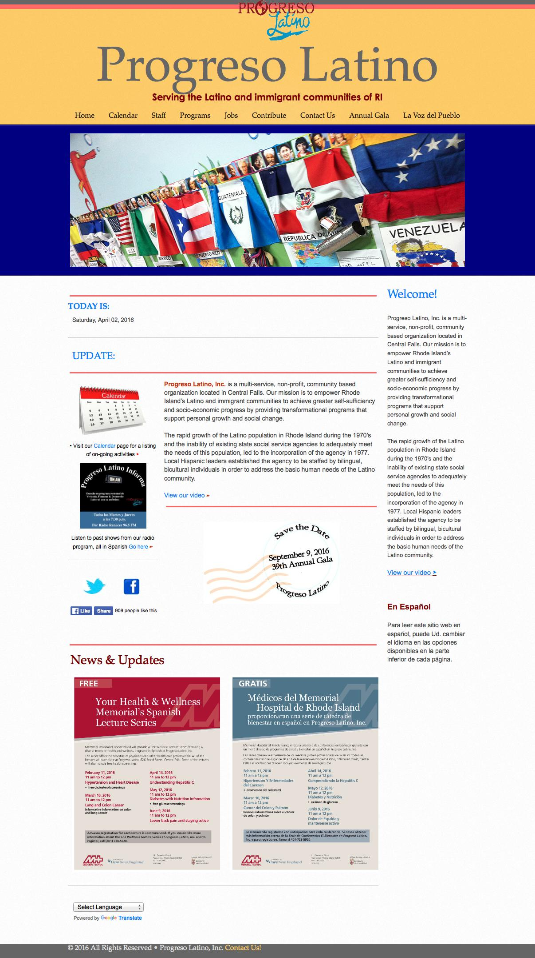
Pluralism-Empowerment category-Progresso Latino

