Who Refers Most? Institutional Incentives and Judicial Participation in the Preliminary Ruling System
Arthur Dyevre, Monika Glavina, Angelina Atanasova

ONLINE APPENDIX
- Workload
Figure 1A plots the average number of cases (civil cases) per judge by tier of courts for the three waves of CEPEJ reporting (2010, 2012, 2014).
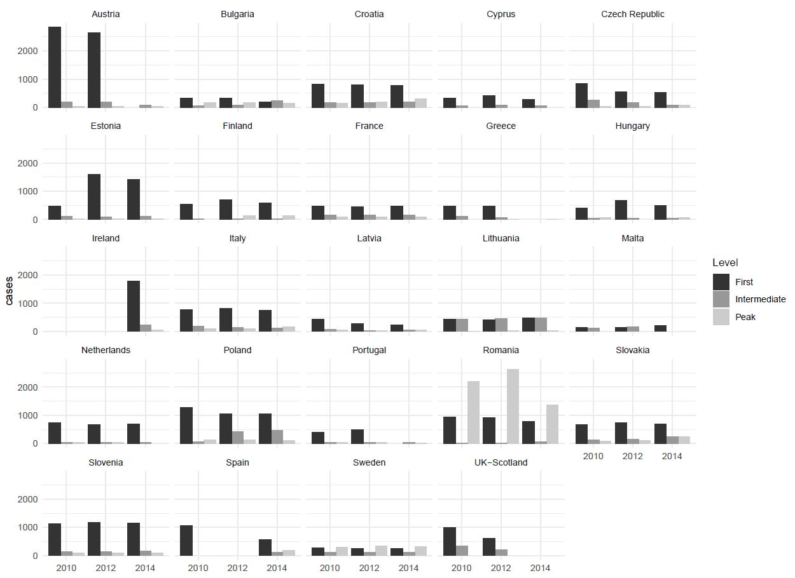
Figure 1A. Workload per court level, civil cases, 2010, 2012 and 2014

- Referral activity by court level

Figure 1B plots the number of referrals by court type for all 28 EU member states.
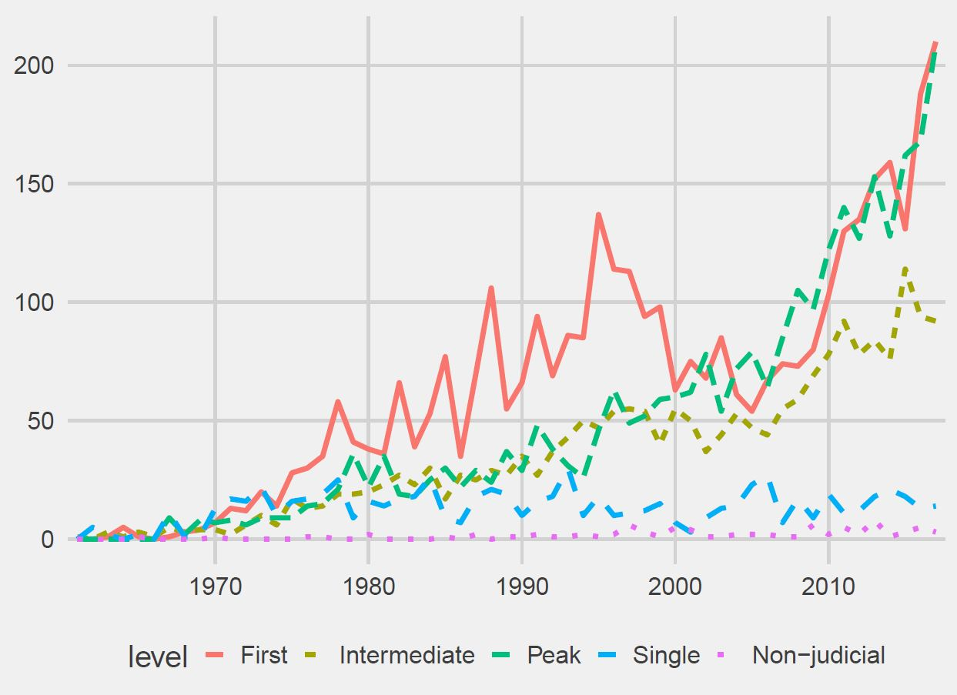
Figure 1B. Referral activity by court level, 1961-2017
Table 1B lists the most referring courts.
Court name | No. of referrals | Proportion of country’s referrals
Bundesfinanzhof (Germany)* | 299 | 14.2%
Hoge Raad der Nederlanden (Netherlands)* | 266 | 29.1%
Cour de Cassation (France)* | 229 | 31.5%
Bundesgerichtshof (Germany)* | 210 | 10%
High Court of Justice of England & Wales | 202 | 30.3%
Finanzgericht Hamburg (Germany) | 159 | 7.6%
College van Beroep voor het Bedrijfsleven (Netherlands)* | 135 | 14.8%
Oberster Gerichtshof (Austria)* | 128 | 28%
Consiglio di Stato (Italy)* | 125 | 13.7%
Bundesverwaltungsgericht (Germany)* | 112 | 5.3%
Verwaltungsgerichtshof (Austria)* | 106 | 23.2%
Raad van State (Netherlands)* | 100 | 11%
Tribunal Supremo (Spain)* | 94 | 51.6%

Table 1B. Most referring courts, 1961-2014. ‘*’ denotes peak courts.

- Referral Rates by Subject Matter Jurisdiction
Because subject matter authority varies considerably in how it is delineated across countries, the data was coded using a coding protocol with 17 categories designed to capture as many nuances as possible. The subject matter definitions and corresponding codes are displayed in Table 1C. These codes were then merged to obtain the more general categories used in the analysis below.
Subject matter | Code
Civil/criminal | 1
Administrative | 2
Courts dealing with constitutional matters | 3
Finance/tax | 4
Social | 6
Labour | 7
Social/Labour | 8
Commerce | 9
Arbitration tribunal/court | 10
Intellectual property (patents, trademarks, copyrights, personal data) | 11
Specialised agencies and non-judicial bodies. | 12
Civil/criminal/administrative | 13
Civil/criminal/fiscal | 14
Family law | 15
Civil/criminal/constitutional | 16
Administrative/labour/social (only for Hungary) | 17
Table 1C. Coding scheme, subject matter jurisdiction.
We first consider a five-category classification: (1) civil, (2) administrative, (3) constitutional, (4) non-judicial and (5) other. For this purpose we merge code 1, 6, 7, 8, 9, 13, 14 and 15 to obtain the category “civil”; code 2, 4, and 17 to obtain the category “administrative” and code 3 and 16 to obtain the category “constitutional”. Meanwhile, “other” corresponds to code 10 and 11 and “non-judicial” to code 12. Applying this classification, Article 267 use appears to differ according to the courts’ subject matter jurisdiction. On the face of things, it looks as if Figure 1B is suggesting that civil courts make more frequent referrals than administrative ones. But this, presumably, is simply an artefact of civil courts processing a larger caseload. More significant probably is the differential between civil and administrative, on the one hand and the three remaining categories (constitutional, other and non-judicial), on the other.
Figure 1C plots referrals from constitutional tribunals.
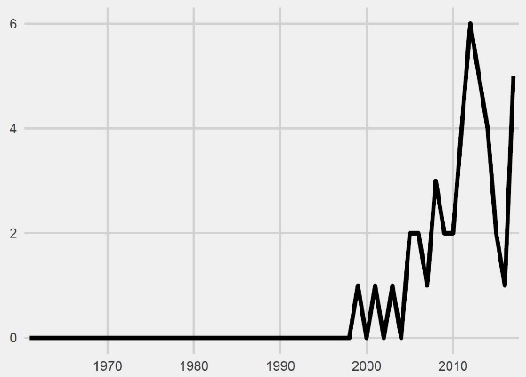
Figure 1C. Referral activity, constitutional courts, 1961-2017
Figure 2C plots the number of referrals by subject matter jurisdiction.
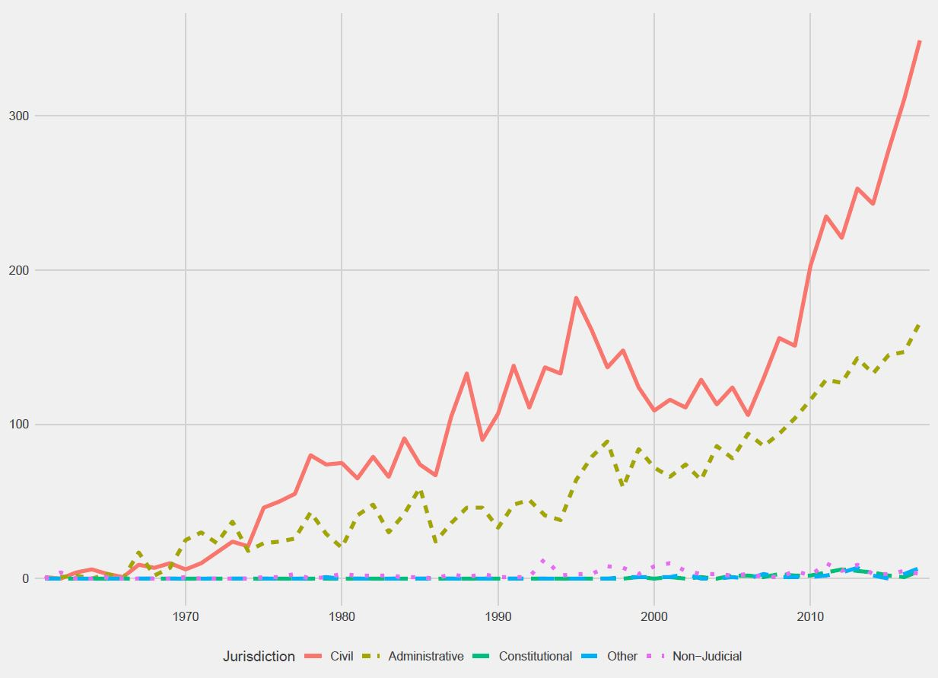
Figure 2C. Referral rates by subject matter jurisdiction, 1961-2017
How does the picture look like across member states? From the data visualisation in Figure 3C we see that civil courts come out on top of the referral league tables in nearly every member state. Noteworthy are the dynamics observed in founding member states like France and Italy, where administrative courts initially lagged behind in referral activity but have been catching up on civil ones. The evolution characterising the referral behaviour of French administrative judges is, plausibly, a consequence of the jurisprudential U-turn taken by the Conseil d’État in the late 1980s, when it put an end to its protracted tug-of-war with the Court of Justice and finally embraced European integration (Alter 2001, 145). In other member states with high referral rates, such as Austria and the Netherlands, civil and administrative courts have been virtually tied since these countries became part of the EU.
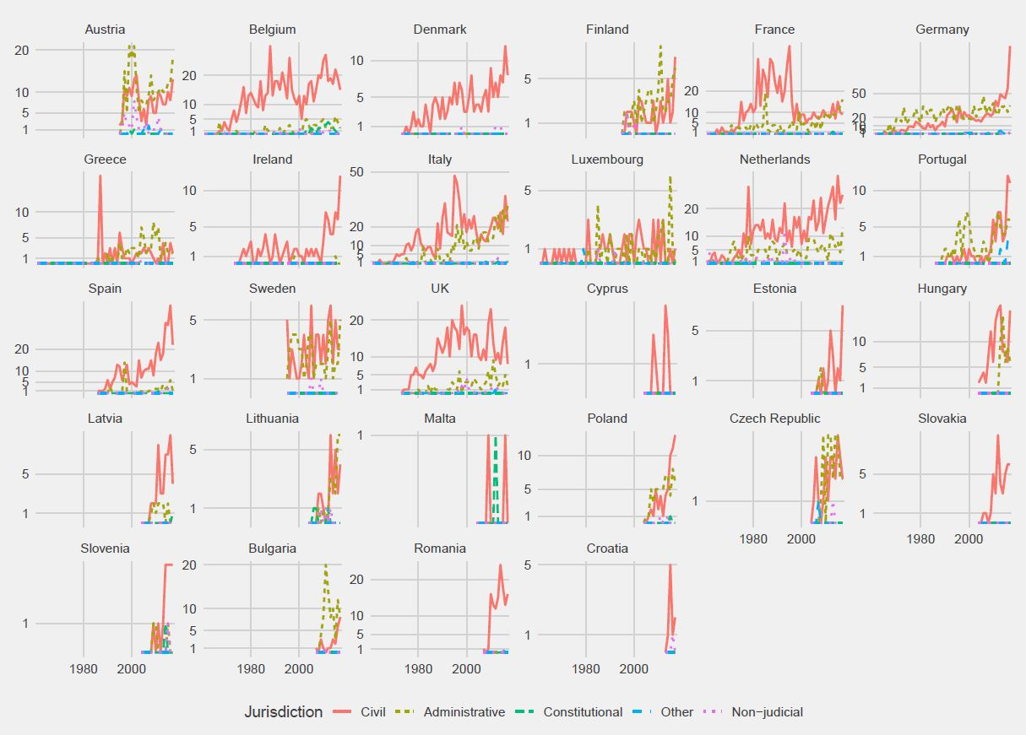
At first sight, German administrative courts, with referral rates consistently higher than civil courts, look exceptionally active. Yet this is largely an artefact of our operationalisation of the category “administrative” courts. Unlike judiciaries in Belgium, the Netherlands, France, Italy, or Sweden—which are essentially structured around two judicial hierarchies, administrative and civil—the German court system comprises of five hierarchies—civil, administrative, labour, social and tax—each overseen by its own supreme court. Of these five hierarchies, the one formed by tax courts accounts for a very substantive chunk of the references submitted by German courts. So including tax courts in the administrative category meant it would automatically inflate referral rates for this category.
Figure 3C. Referral rates by subject matter jurisdiction and member state, 1961-2017

An alternative classification we also consider distinguishes “generalist” and “specialised” courts. We take the category “generalist” to encompass code 1, 2, 3, 13, 14, 15, 16 and 17 and “specialist” all the other codes except 10 and 12—the latter forming the category “other”. This classification clearly puts the generalist judges ahead (Figure 4C). What is more, the gap between the two groups has grown considerably over time. Only in Germany do specialised courts come out on top, at least until around 2010 (see Figure 5C). But that is because tax courts, this time, are included in this group.

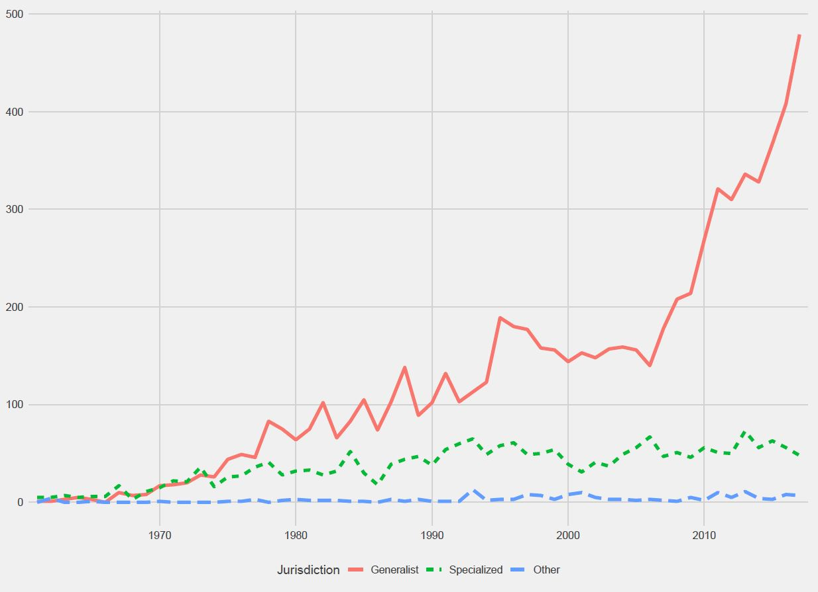
Figure 4C. References, by generalist vs specialised courts, 1961-2017
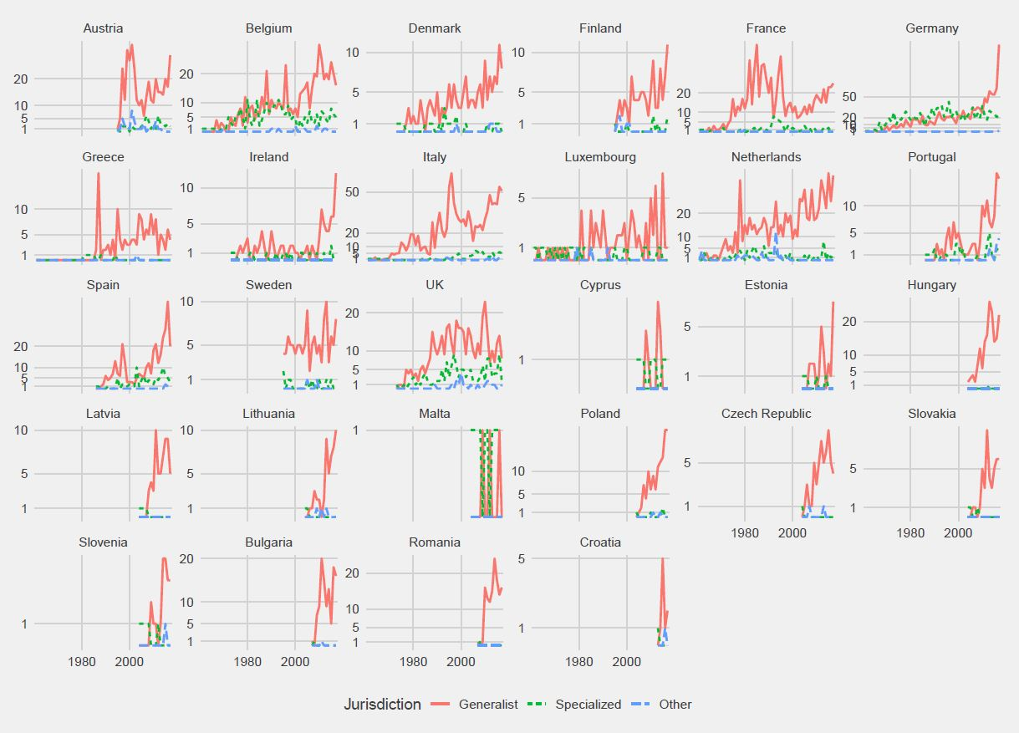
Figure 5C. Specialised vs generalist courts by member state, 1961-2017
While there are, admittedly, many ways to look at the data and to classify judicial bodies, these patterns do not offer conclusive evidence for the claim that jurisdictional specialisation, or focus on commercial litigation correlates with higher referral propensity (Broberg and Fenger 2014a; De la Mare 1999) or that administrative courts are shunning Article 267 (Stone Sweet and Brunell 1998). Civil courts, it is true, tend to submit more than administrative ones. But the difference is not such that we can really say that it generally supports the view that administrative courts are reluctant to pass on questions to the Luxembourg Court or that administrative litigation is less conducive to this form of inter-judicial dialogue. These claims may well have been overdetermined by the situation that prevailed in some big member states prior to the 1990s (e.g. low referral rates for French and Italian administrative courts). In any case, they do not appear to generalise to a more comprehensive picture of referral dynamics.

Corresponding author: KU Leuven, Leuven, Belgium; E-mail: arthur.dyevre@kuleuven.be; Phone: +32 16325387
KU Leuven. E-mail: monika.glavina@kuleuven.be
KU Leuven. E-mail: angelina.atanasova@kuleuven.be
Includes references from High Court of Justice’s Queen's Bench Division, Chancery Division and Family Division.
French civil courts, for example, handle four times more cases than their administrative counterparts.

