Supplementary material for
SYNTHESIS OF SOME NOVEL 5-(8-SUBSTITUTED-11H-INDOLO[3,2-c]ISOQUINOLIN-5-YLTHIO)-1ʹ,3ʹ,4ʹ-OXADIAZOL-2-AMINES BEARING THIAZOLIDINONES ANDAZETIDINONES AS POTENTIAL ANTIMICROBIAL, ANTIOXIDANT, ANTITUBERCULOSIS AND ANTICANCER AGENTS.
Vaijinath a. verma*ª and Anand R. Saundane^{b}
ªDepartment of Chemistry, S. S. Margol College of Arts, Science and Commerce, Shahabad-585 228, Kalaburagi, Karnataka, India.
^{b}Department of Post-Graduate Studies and Research in Chemistry, Gulbarga University, Kalaburagi -585 106, Karnataka, India
Email: drvermachem@gmail.com
*For Correspondence

Contents:
- Antimicrobial……………….. 02
- Antioxidant and data…………02-05
- Anti-mycobacterial…………...05
- Anticancer…………………….05
- IR, ¹H, ¹³C-NMR and MS Spectra figures S1-S25…….06-29

Biological evaluation.
- Antimicrobial activity

The antimicrobial screening the synthesized compounds was tested against four bacteria and four fungal species using culture medium in a sterilized borosilicate test tubes and different bacterial strains incubated at 106 bacilli/mL concentration by the broth dilution method³¹⁻³³ (concentrations 50, 25, 12.5, 6.25, 3.12 and 1.5 µg/mL), respectively. The optical density is measured at a wavelength of 655 nm of each sample and compared with streptomycin and fluconazole as standard drugs for antibacterial and antifungal activities, respectively. The precise of MIC values were obtained from the lowest concentration of the test compound. The bacterial and fungal growth were completely inhibited at this concentration.
- Antioxidant activity.
1,1-Diphenyl-2-picryl-hydrazil (DPPH) radical scavenging activity (RSA)
The RSA of the test compounds in methanolic solution at concentrations 25, 50, 75 and 100 µg/mL containing freshly prepared DPPH solution (0.004 % w/v) was carried out and compared with those of standards by using reported method ³⁴. All the test analyses were performed on three replicates were averaged. The results in percentage are expressed as the ratio of absorption decrease in the presence of test compounds and absorption of DPPH solution in the absence of test compounds at 517 nm on ELICO SL171 mini spect spectrometer. The percentage scavenging activity of the DPPH free radical was determined using the following equation:
DPPH radical scavenging (%) = [(Ac-As/Ac)] X 100
Where,
Ac is the absorbance of the control reaction and As is the absorbance of the sample or standards.
- Ferric ion (Fe3+) reducing antioxidant power (FRAP).
Ferric ion (Fe3+) Reducing Antioxidant Power (FRAP): The reducing power of the synthesized compounds was determined according to the literature method³⁵ using BHA, TBHQ and AA as standards. Different concentrations of samples (25, 50, 75 and 100 µg/mL) in DMSO (1 mL) were mixed with phosphate buffer (2.5 mL, 0.2 M, pH=6.6) and potassium ferricyanide(2.5 mL,1 %). The mixture was incubated at 50 ºC for 20 min, after which 2.5 mL of trichloroacetic acid (2.5 mL, 10 %) was added to the mixture and centrifuged for 10 min at 1000 rpm. The upper layer solution (2.5 mL) was mixed with distilled water (2.5 mL) and ferric chloride (0.5 mL, 0.1%). Then the absorbance at 700 nm was measured in spectrophotometer. Higher absorbance of the reaction mixture indicated greater reducing power.
Data of 1,1-Diphenyl-2-picryl-hydrazil (DPPH) radical scavenging activity (RSA)
Compounds | 25 | 50 | 75 | 100
5a | 31.49 | 56.91 | 61.88 | 66.85
5b | 16.35 | 26.17 | 31.49 | 42.9
5c | 20.89 | 37.33 | 44.29 | 55.29
5d | 33.27 | 48.18 | 50.42 | 51.25
5e | 44.57 | 55.43 | 61.88 | 65.55
5f | 11.88 | 33.98 | 38.12 | 45.3
5g | 48.9 | 51.66 | 55.99 | 61.55
5h | 27.86 | 34.26 | 44.29 | 54.6
5i | 20.89 | 37.33 | 39.2 | 52.09
6a | 60.5 | 66.85 | 74.37 | 78.83
6b | 32.29 | 44.75 | 56.65 | 61.56
6c | 30.92 | 38.44 | 46.52 | 58.57
6d | 28.06 | 31.67 | 40.56 | 57.58
6e | 16.39 | 28.89 | 39.44 | 59.72
6f | 31.94 | 28.89 | 45 | 60.56
6g | 11.39 | 44.72 | 48.61 | 54.72
6h | 38.61 | 39.47 | 56.39 | 67.32
6g | 19.72 | 54.44 | 68.89 | 66.55
7a | 18.1 | 62.61 | 68.41 | 77.27
7b | 44.28 | 55.71 | 51.55 | 66.85
7c | 14.48 | 17.55 | 20.89 | 33.98
7d | 32.31 | 40.94 | 50.41 | 59.61
7e | 40.38 | 50.41 | 62.21 | 62.67
7f | 50.69 | 55.71 | 62.85 | 69.99
7g | 33.98 | 40.38 | 55.71 | 61.55
7h | 40.11 | 55.71 | 66.3 | 62.14
7i | 45.15 | 55.18 | 65.21 | 67.04
8a | 47.35 | 52.11 | 63.53 | 72.04
8b | 46.51 | 55.98 | 59.88 | 61.55
8c | 33.42 | 40.11 | 47.08 | 50.69
8d | 46.51 | 44.29 | 55.71 | 61.55
8e | 11.97 | 40.11 | 58.5 | 62.67
8f | 15.87 | 39.83 | 56.54 | 58.5
8g | 46.51 | 51.56 | 62.7 | 70.7
8h | 28.69 | 42.06 | 43.17 | 48.74
8i | 39.83 | 40.38 | 44.57 | 50.41
BHA | 87.47 | 85.52 | 92.2 | 91.64
TBHQ | 90.25 | 92.76 | 91.64 | 90.25
AA | 88.86 | 88.02 | 94.71 | 93.59

Data of Ferric ion (Fe3+) reducing antioxidant power (FRAP)
Compounds | 25 | 50 | 75 | 100
5a | 0.205 | 0.268 | 0.318 | 0.424
5b | 0.228 | 0.345 | 0.405 | 0.543
5c | 0.315 | 0.363 | 0.429 | 0.458
5d | 0.238 | 0.375 | 0.459 | 0.425
5e | 0.326 | 0.489 | 0.563 | 0.545
5f | 0.302 | 0.458 | 0.486 | 0.629
5g | 0.211 | 0.228 | 0.368 | 0.415
5h | 0.308 | 0.438 | 0.542 | 0.592
5i | 0.233 | 0.348 | 0.492 | 0.618
6a | 0.224 | 0.31 | 0.393 | 0.427
6b | 0.297 | 0.243 | 0.3 | 0.318
6c | 0.118 | 0.197 | 0.219 | 0.254
6d | 0.318 | 0.343 | 0.492 | 0.328
6e | 0.538 | 0.662 | 0.783 | 0.998
6f | 0.498 | 0.513 | 0.648 | 0.683
6g | 0.338 | 0.353 | 0.392 | 0.428
6h | 0.342 | 0.492 | 0.558 | 0.698
6i | 0.295 | 0.368 | 0.423 | 0.585
7a | 0.224 | 0.31 | 0.393 | 0.427
7b | 0.297 | 0.243 | 0.3 | 0.318
7c | 0.118 | 0.197 | 0.219 | 0.254
7d | 0.318 | 0.343 | 0.492 | 0.328
7e | 0.538 | 0.662 | 0.725 | 0.893
7f | 0.398 | 0.513 | 0.648 | 0.762
7g | 0.338 | 0.353 | 0.392 | 0.428
7h | 0.342 | 0.492 | 0.558 | 0.698
7i | 0.295 | 0.368 | 0.423 | 0.58
8a | 0.224 | 0.264 | 0.296 | 0.345
8b | 0.312 | 0.328 | 0.434 | 0.458
8c | 0.218 | 0.264 | 0.393 | 0.436
8d | 0.155 | 0.173 | 0.208 | 0.235
8e | 0.448 | 0.491 | 0.662 | 0.798
8f | 0.346 | 0.455 | 0.542 | 0.711
8g | 0.209 | 0.161 | 0.218 | 0.245
8h | 0.318 | 0.368 | 0.517 | 0.656
8i | 0.266 | 0.322 | 0.322 | 0.526
BHA | 0.919 | 1.115 | 1.134 | 1.34
TBHQ | 0.885 | 1.115 | 1.341 | 1.343
AA | 0.7 | 0.838 | 0.991 | 1.158

- Anti-tuberculosis activity
Anti-tuberculosis activity of synthesized compounds was tested against M. tuberculosis (ATCC 27294) H37R_{V} using alamar blue reagent. Serial diluted solutions (100, 50, 25, 12.5, 6.25, 3.12, 1.5 and 0.8 µg/mL) of the test compounds in dimethyl formamide (DMF), Rifampicin (1.0 μg/mL) as a positive control and DMF as negative control were used to determine the activity according to the literature (MABA) method ³⁶.
Anticancer activity
The anticancer activity of synthesized compounds was tested against three different human cancer cell lines including MCF-7 (breast carcinoma), A-549(lung carcinoma) and HeLa (Cervical carcinoma) cancer cell lines. The synthesized compounds were diluted in Dimethyl Sulfoxide (DMSO) at various concentrations (10, 5, 2.5 and 1.25 μg ML⁻¹) and assessed using 3-(4, 5-dimethyl-2-yl-2, 5-diphenyl tetrazolium bromide (MTT assay)³⁷. Anticancer activity was determined for cells treated various concentrations of the tested compounds, the untreated cells (negative control) and Doxorubicin (positive control). A statistical significance was tested between sample and negative control using independent t-test by SPSS 12 program. The concentration of test compounds required to kill 50% of cell population (IC₅₀) were determined by non-linear regression analysis. Cytotoxic activity was expressed as the mean IC₅₀ of three independent experiments.
5. IR, 1H, 13C-NMR and MS Spectra of all c(2-6 and 8) series synthesized compounds

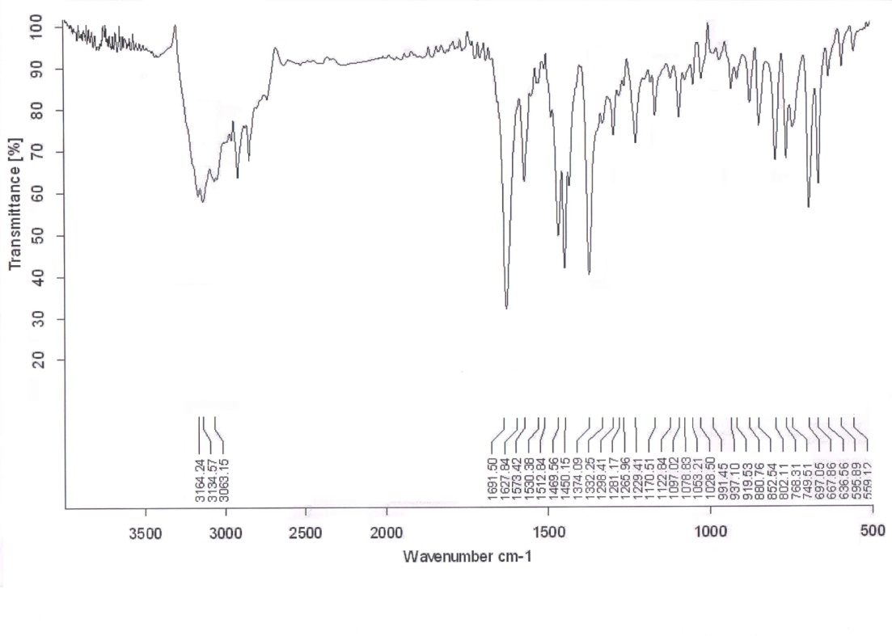

Figure S1: IR spectrum for ethyl (11H-indolo[3,2-c]isoquinolin-5-ylthio)formate (2c)

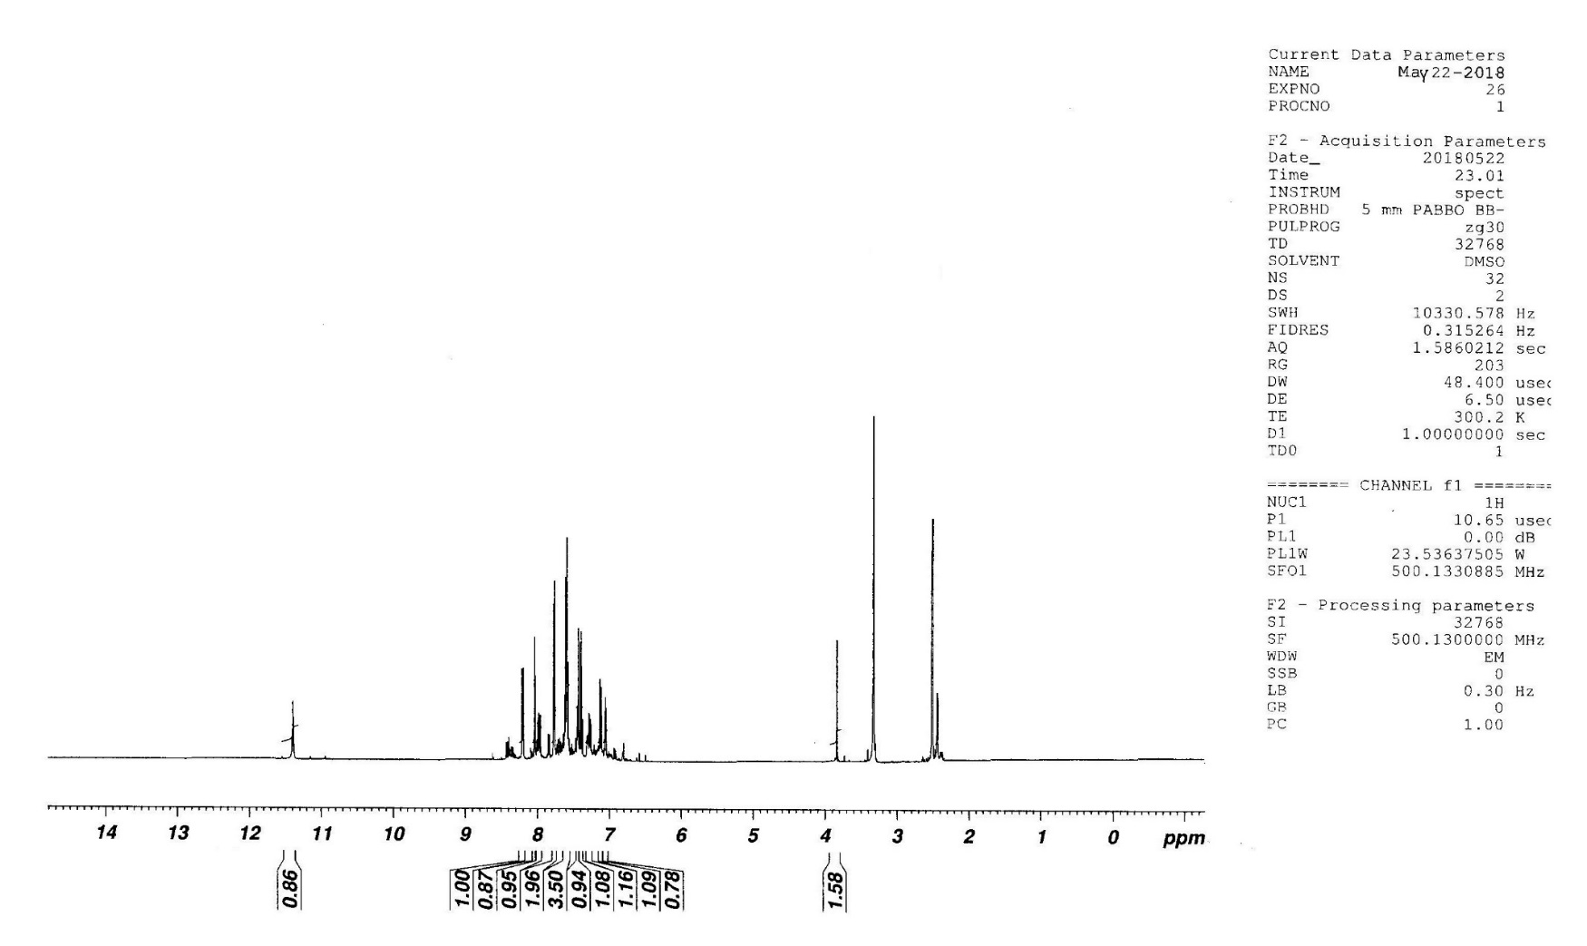

Figure S2: ¹H NMR for ethyl (11H-indolo[3,2-c]isoquinolin-5-ylthio)formate (2c)

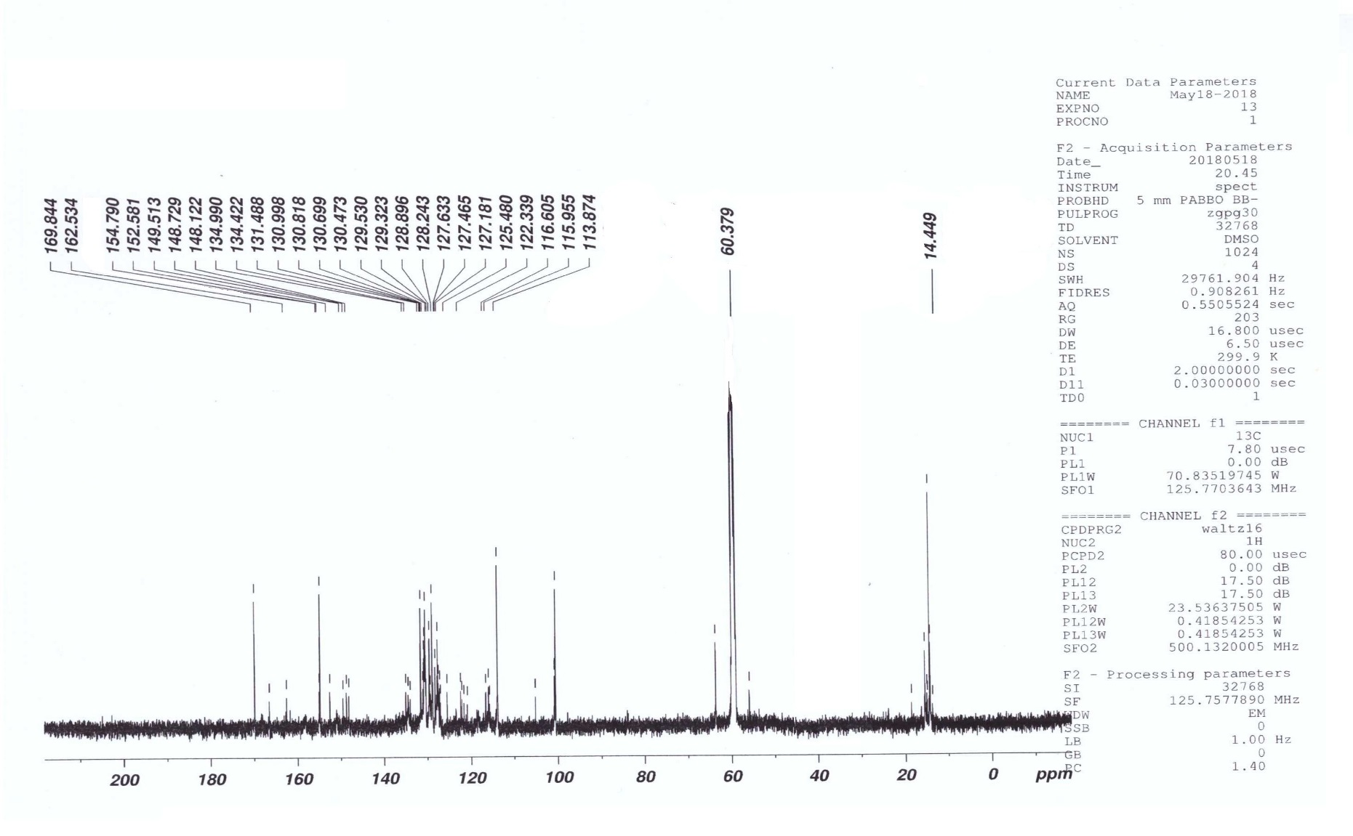

Figure S3: ¹³C NMR for ethyl (11H-indolo[3,2-c]isoquinolin-5-ylthio)formate (2c)

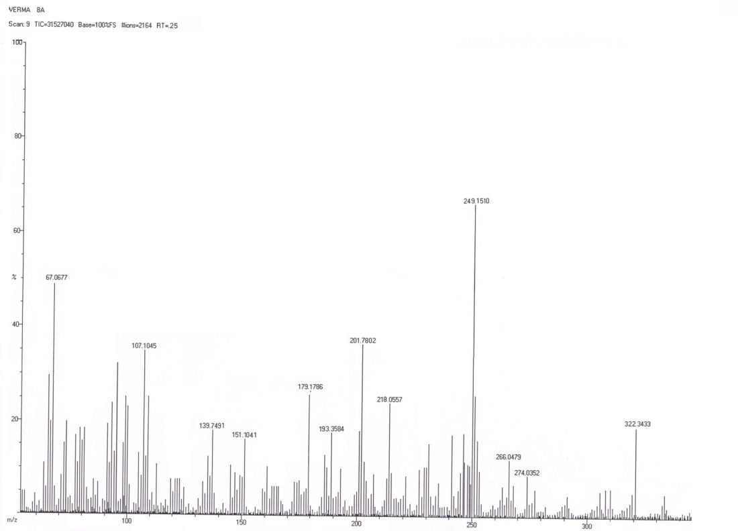

Figure S4: Mass spectrum for ethyl (11H-indolo[3,2-c]isoquinolin-5-ylthio)formate (2c)
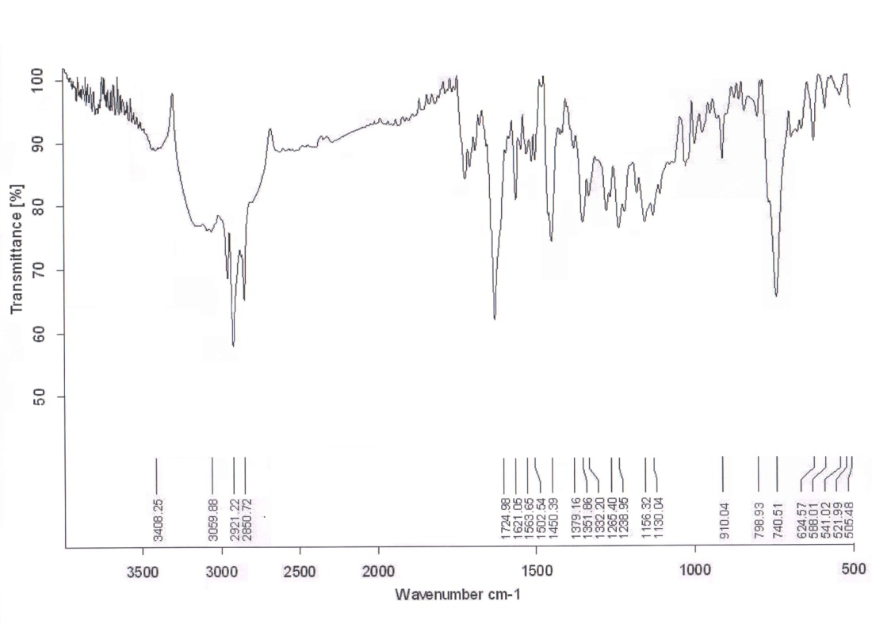

Figure S5: IR spectrum for ethyl (11H-indolo[3,2-c]isoquinolin-5ylthio)carbohydrazide (3c)

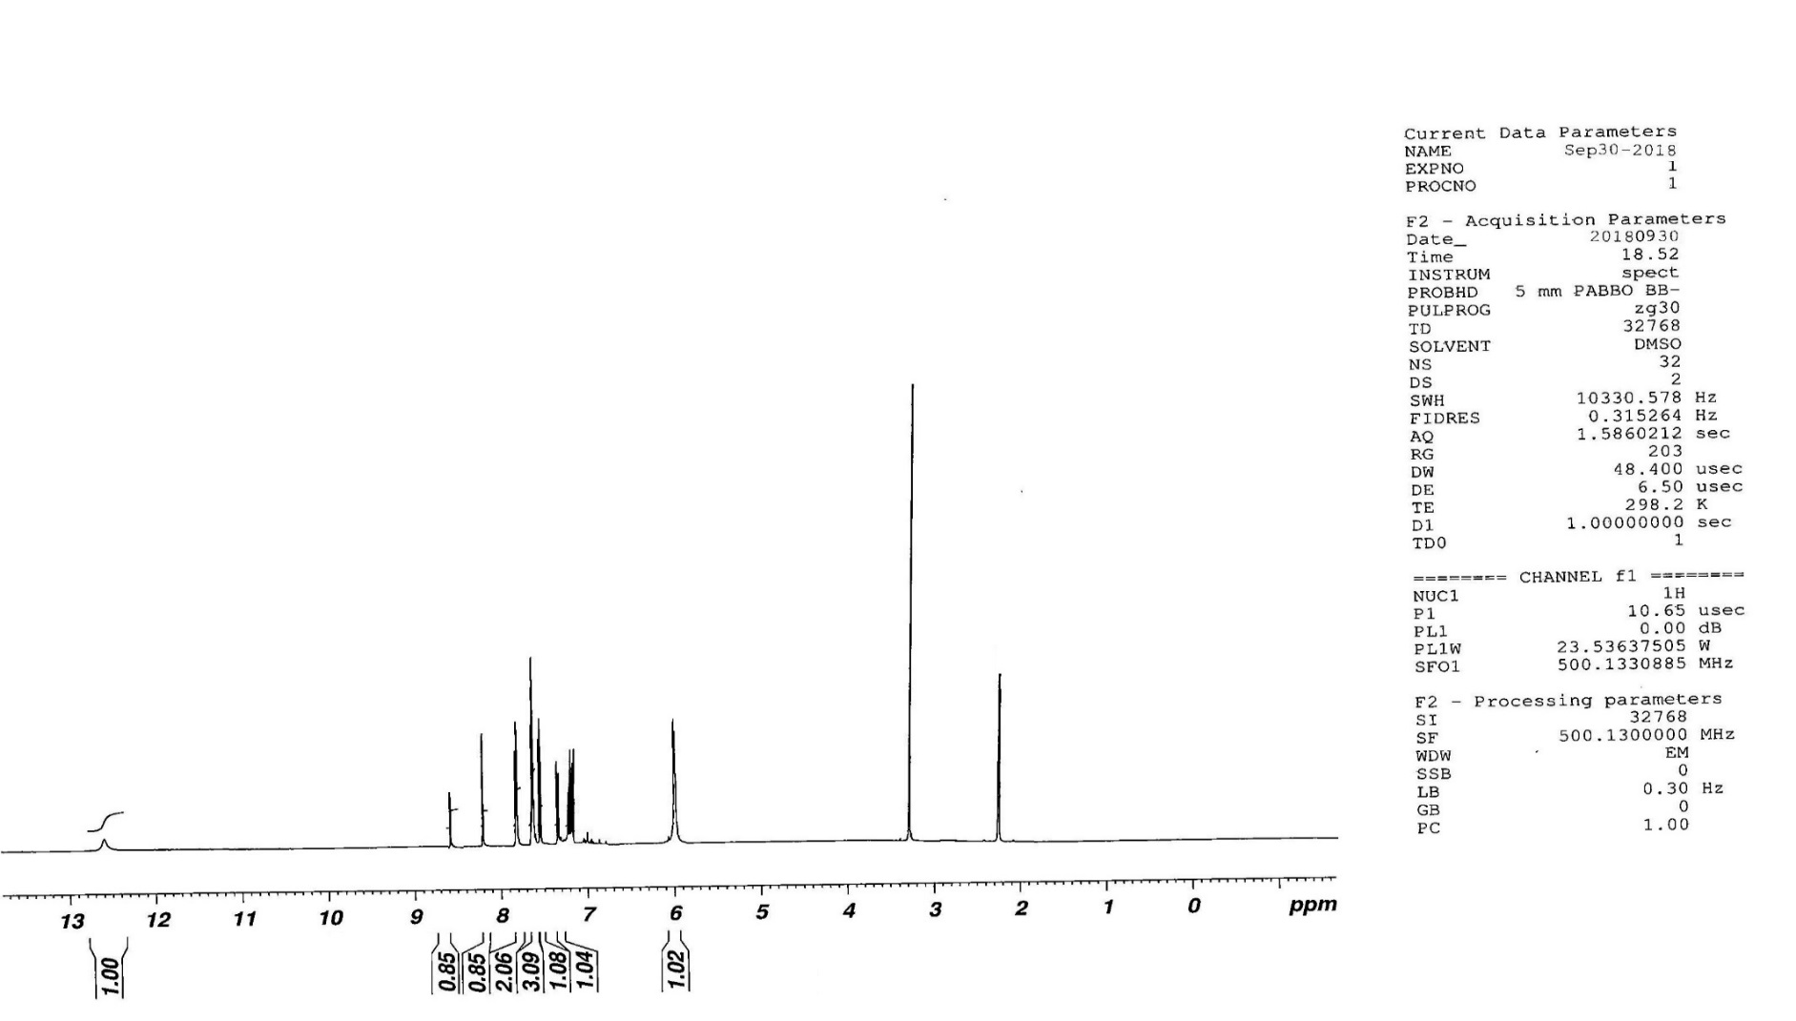

Figure S6: ¹H NMR for ethyl (11H-indolo[3,2-c]isoquinolin-5ylthio)carbohydrazide (3c)

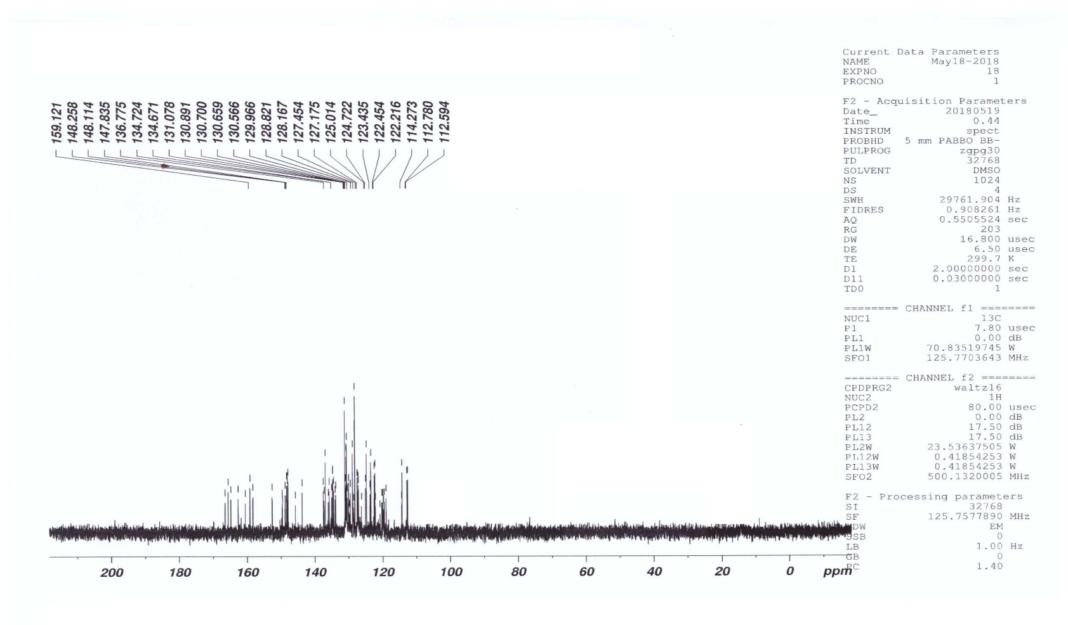

Figure S7: ¹³C NMR for ethyl (11H-indolo[3,2-c]isoquinolin-5ylthio)carbohydrazide (3c)

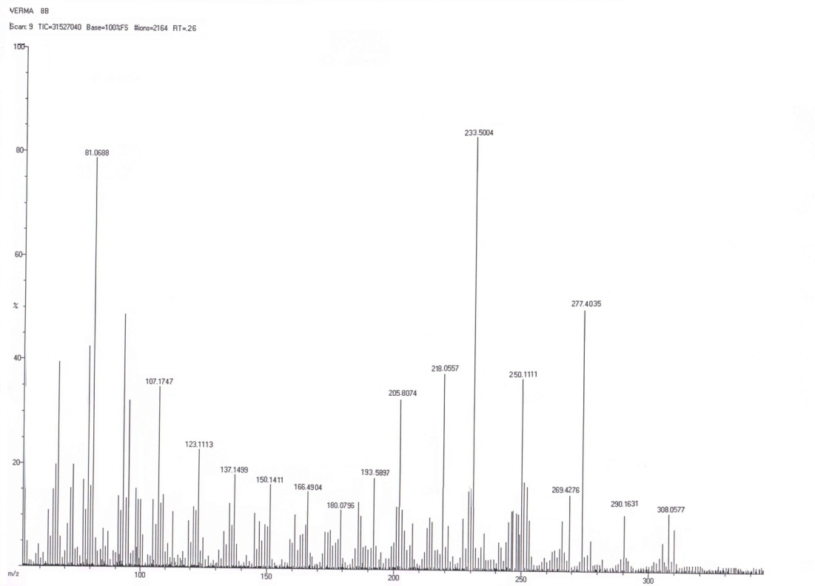

Figure S8: Mass spectrum for ethyl (11H-indolo[3,2-c]isoquinolin-5ylthio)carbohydrazide (3c)

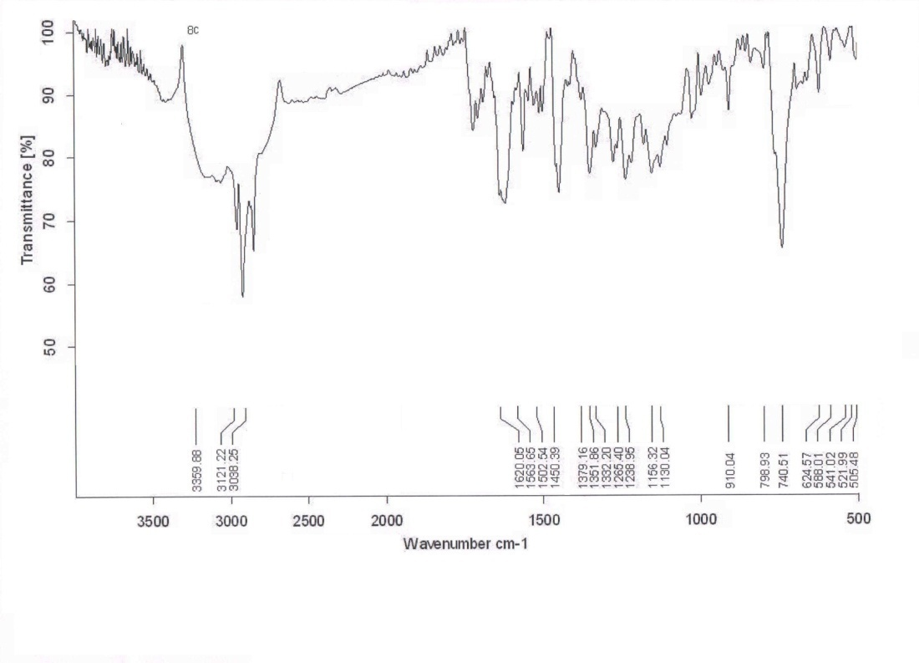

Figure S9: IR spectrum for 5-(8-Substituted 11H-indolo[3,2-c]isoquinolin-5-ylthio)-1,3,4-oxadiazol-2-amine (4c) .

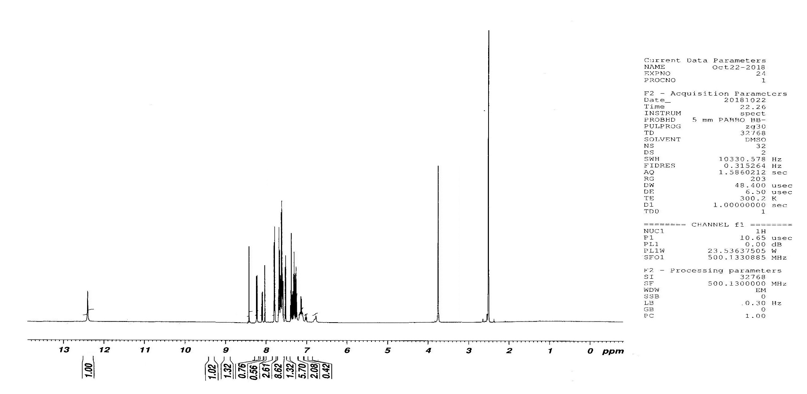

Figure S10: ¹H NMR spectrum for 5-(8-Substituted 11H-indolo[3,2-c]isoquinolin-5-ylthio)-1,3,4-oxadiazol-2-amine (4c)

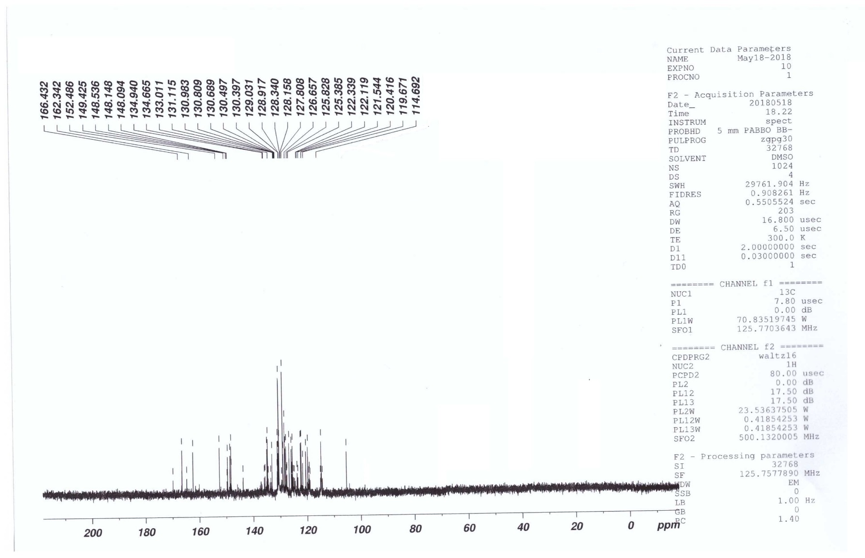

Figure S11: ¹³C NMR spectrum for 5-(8-Substituted 11H-indolo[3,2-c]isoquinolin-5-ylthio)-1,3,4-oxadiazol-2-amine (4c)

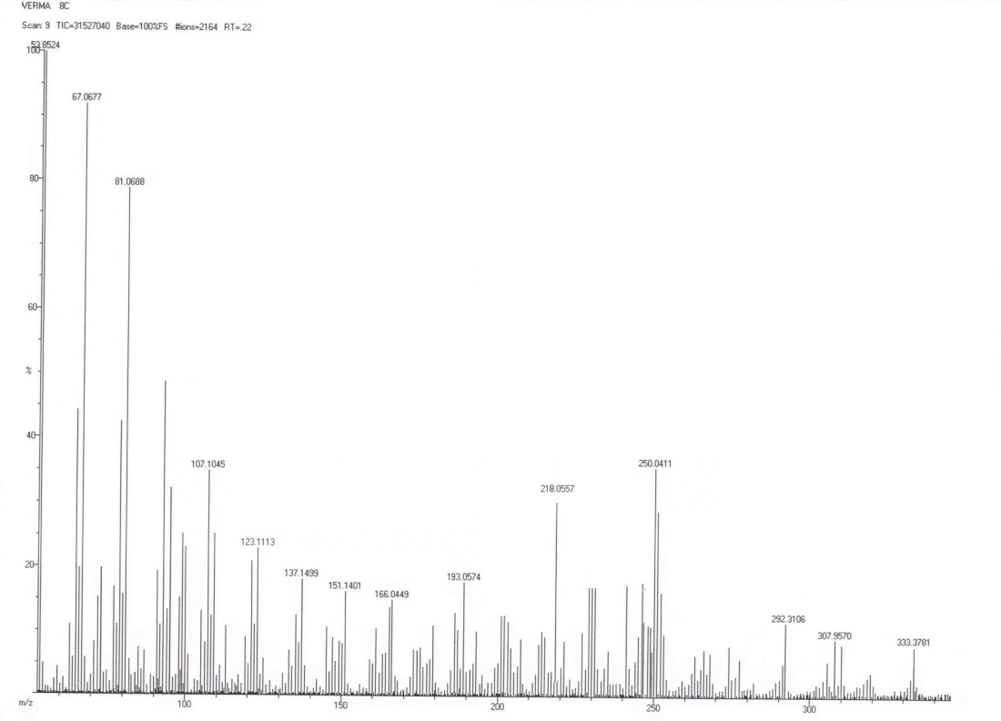
Figure S12: Mass spectrum 5-(8-Substituted 11H-indolo[3,2-c]isoquinolin-5-ylthio)-1,3,4-oxadiazol-2-amine (4c)

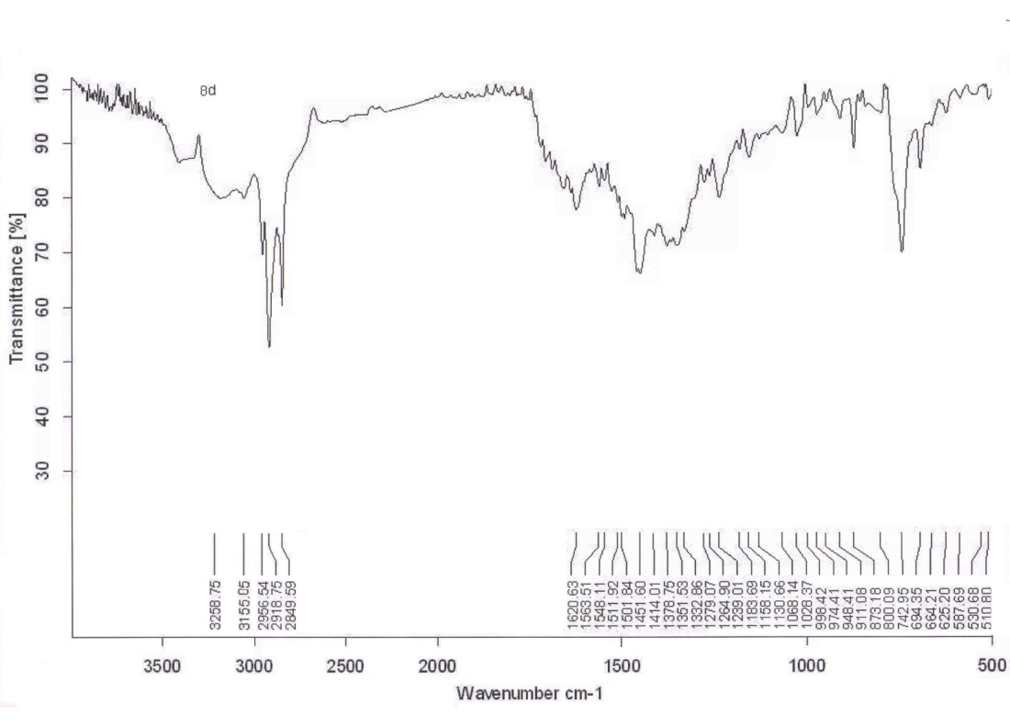

Figure S13: IR spectrum for 5-(11H-indolo[3,2-c]isoquinolin-5-ylthio)-N-{(5-chloro-2-phenyl-1H-indol-3-yl)methylene}-1,3,4-oxadiazol-2-amine (5c).
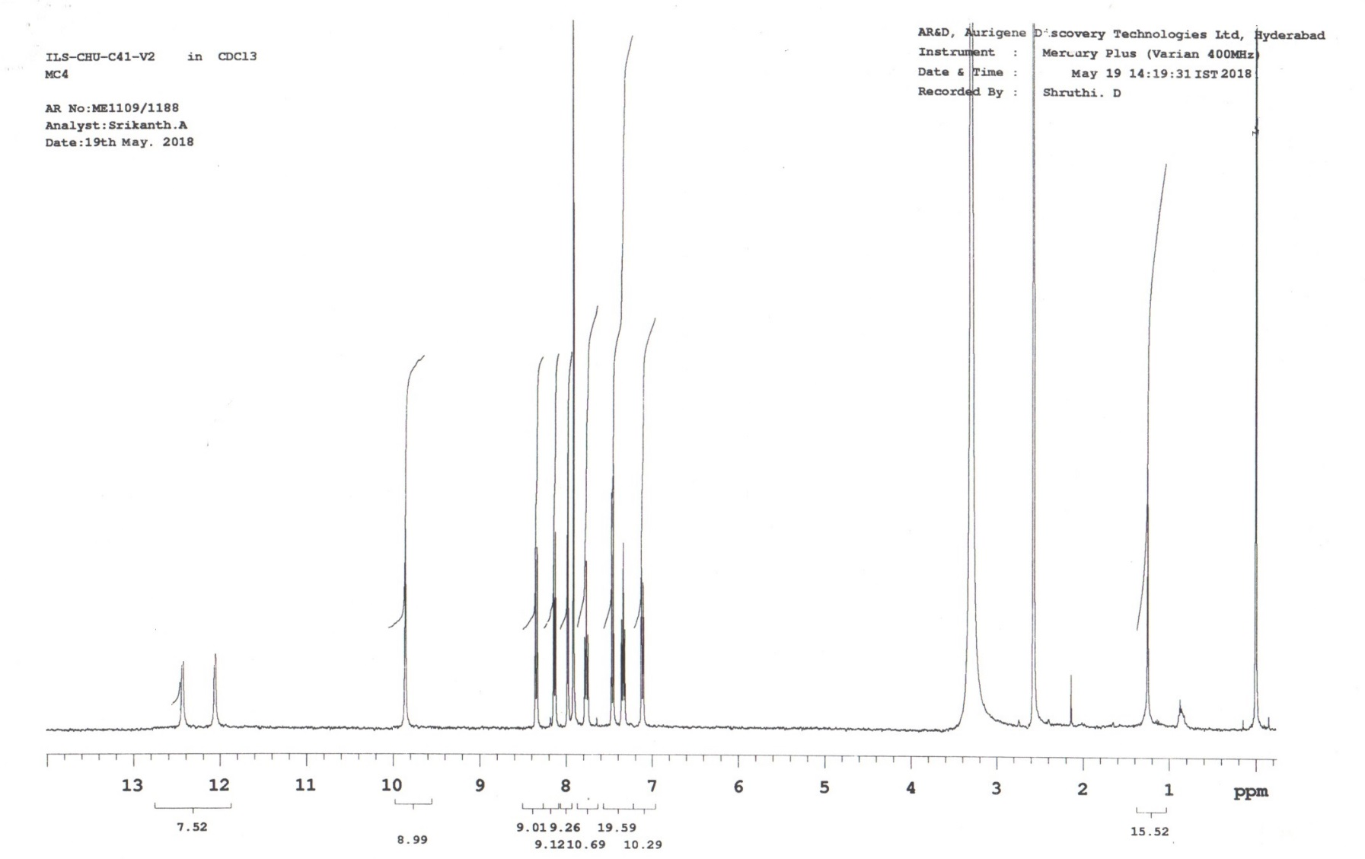

Figure S14: ¹H NMR spectrum for 5-(11H-indolo[3,2-c]isoquinolin-5-ylthio)-N-{(5-chloro-2-phenyl-1H-indol-3-yl)methylene}-1,3,4-oxadiazol-2-amine (5c).
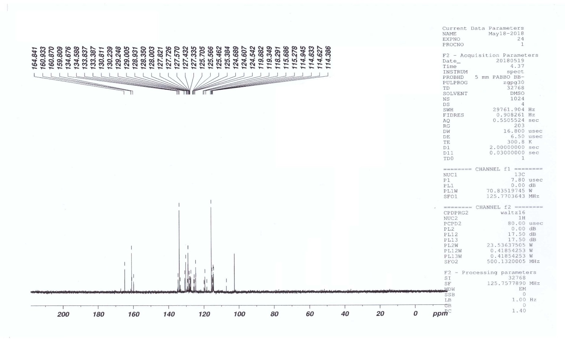

Figure S15: ¹³C NMR spectrum for 5-(11H-indolo[3,2-c]isoquinolin-5-ylthio)-N-{(5-chloro-2-phenyl-1H-indol-3-yl)methylene}-1,3,4-oxadiazol-2-amine (5c).

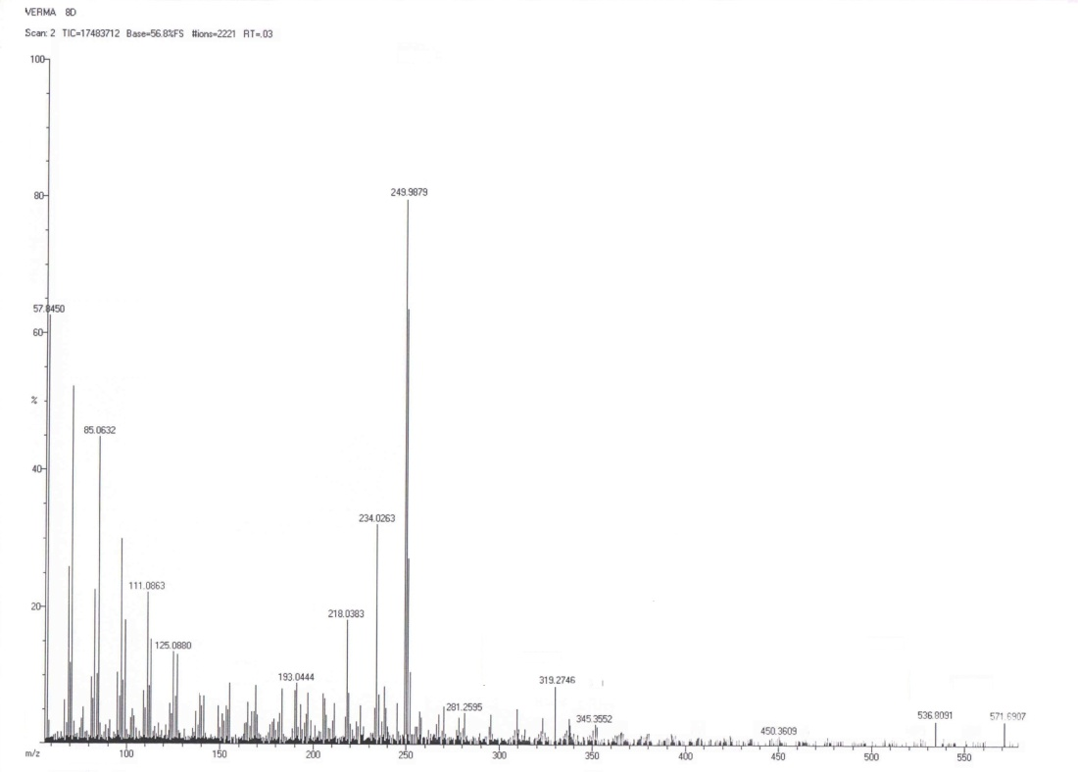

Figure S16: Mass spectrum for for 5-(11H-indolo[3,2-c]isoquinolin-5-ylthio)-N-{(5-chloro-2-phenyl-1H-indol-3-yl)methylene}-1,3,4-oxadiazol-2-amine (5c).

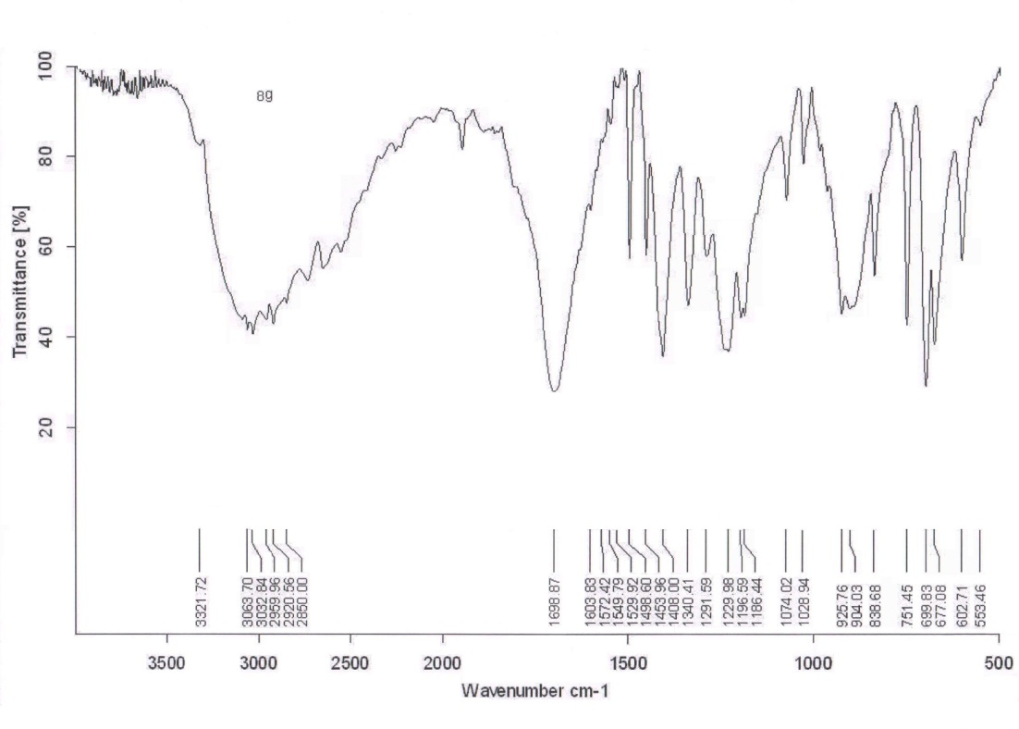

Figure S17: IR spectrum for 3-{5-(11H-indolo[3,2-c]isoquinolin-5-ylthio)-1,3,4-oxadiazol-2-yl}-2-(5-chloro2-phenyl-1H-indol-3-yl)thiazolidin-4-one (6c)
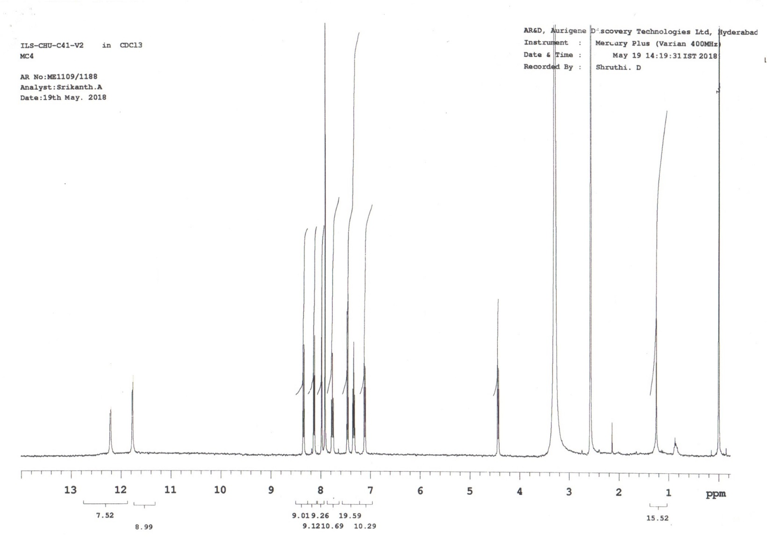

Figure S18: ¹H NMR spectrum for 3-{5-(11H-indolo[3,2-c]isoquinolin-5-ylthio)-1,3,4-oxadiazol-2-yl}-2-(5-chloro2-phenyl-1H-indol-3-yl)thiazolidin-4-one (6c)
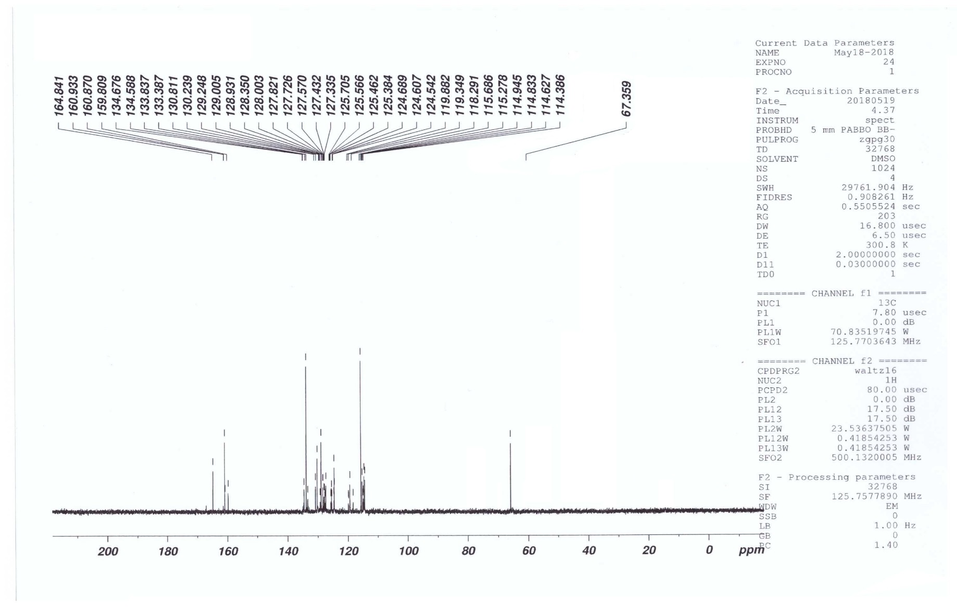
Figure S19: ¹³C NMR spectrum for 3-{5-(11H-indolo[3,2-c]isoquinolin-5-ylthio)-1,3,4-oxadiazol-2-yl}-2-(5-chloro2-phenyl-1H-indol-3-yl)thiazolidin-4-one (6c)
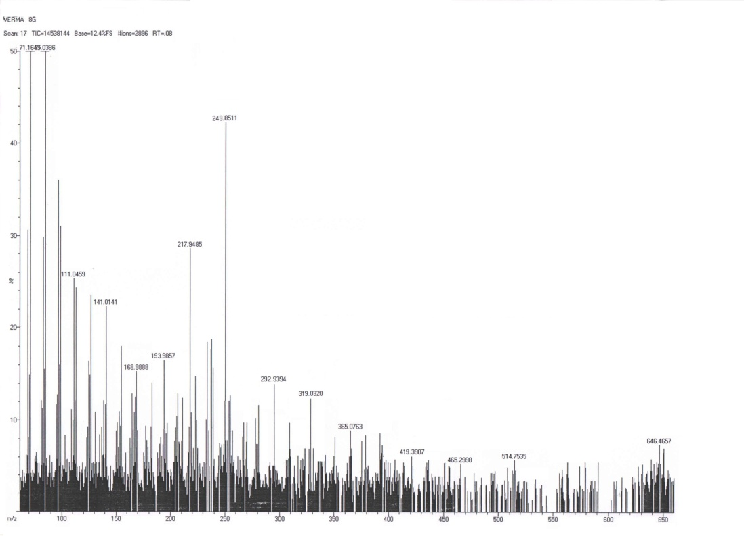

Figure S20: Mass spectrum for 3-{5-(11H-indolo[3,2-c]isoquinolin-5-ylthio)-1,3,4-oxadiazol-2-yl}-2-(5-chloro2-phenyl-1H-indol-3-yl)thiazolidin-4-one (6c)

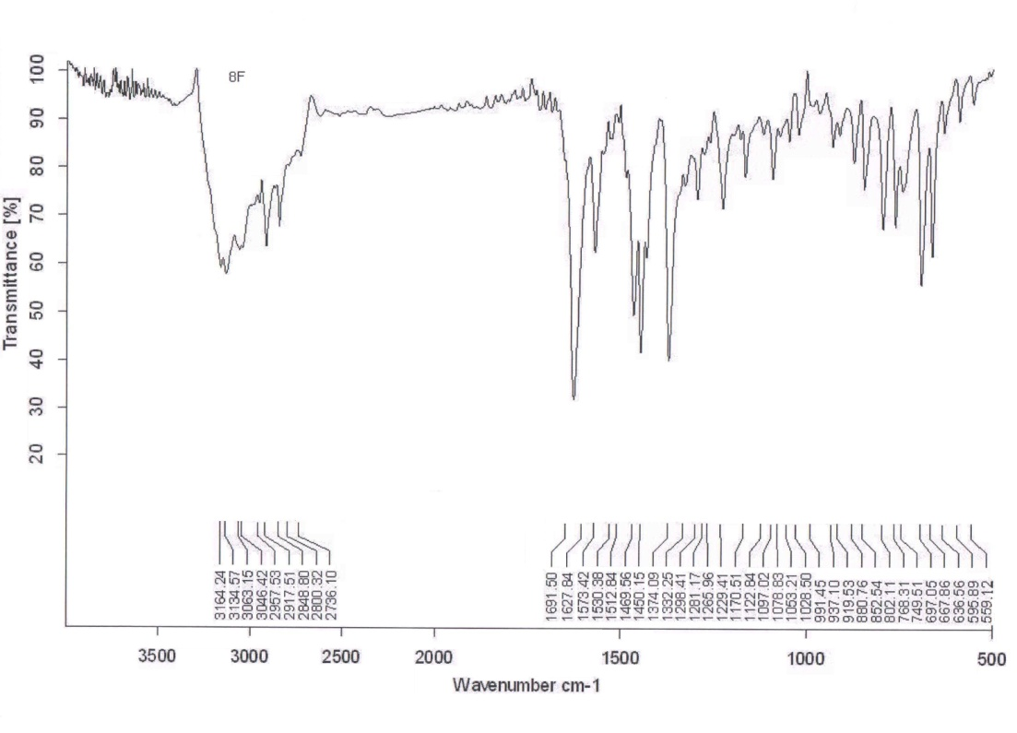

Figure S21: IR spectrum for 1-{5-(11H-indolo[3,2-c]isoquinolin-5-ylthio)-1,3,4-oxadiazol-2-yl}-4-(5-chloro-2-phenyl-1H-indol-3-yl)-3-phenylazetidin-2-one (8c)

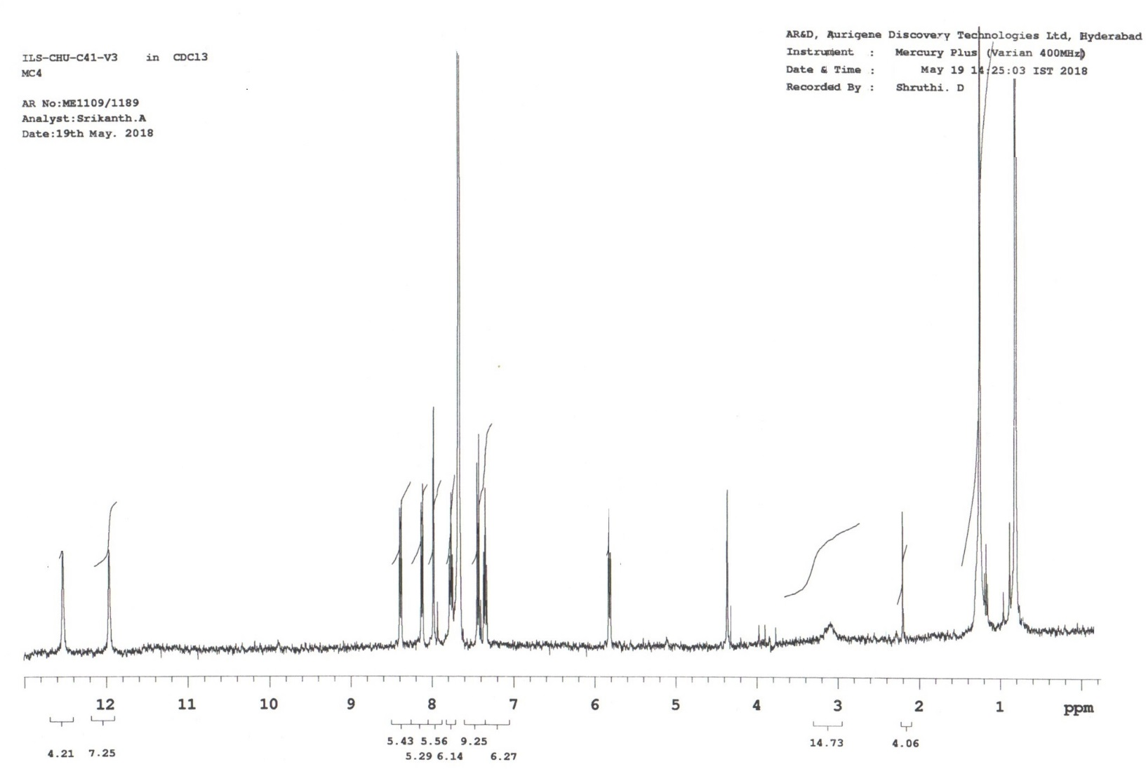

Figure S22: ¹H NMR spectrum for 1-{5-(11H-indolo[3,2-c]isoquinolin-5-ylthio)-1,3,4-oxadiazol-2-yl}-4-(5-chloro-2-phenyl-1H-indol-3-yl)-3-phenylazetidin-2-one (8c)
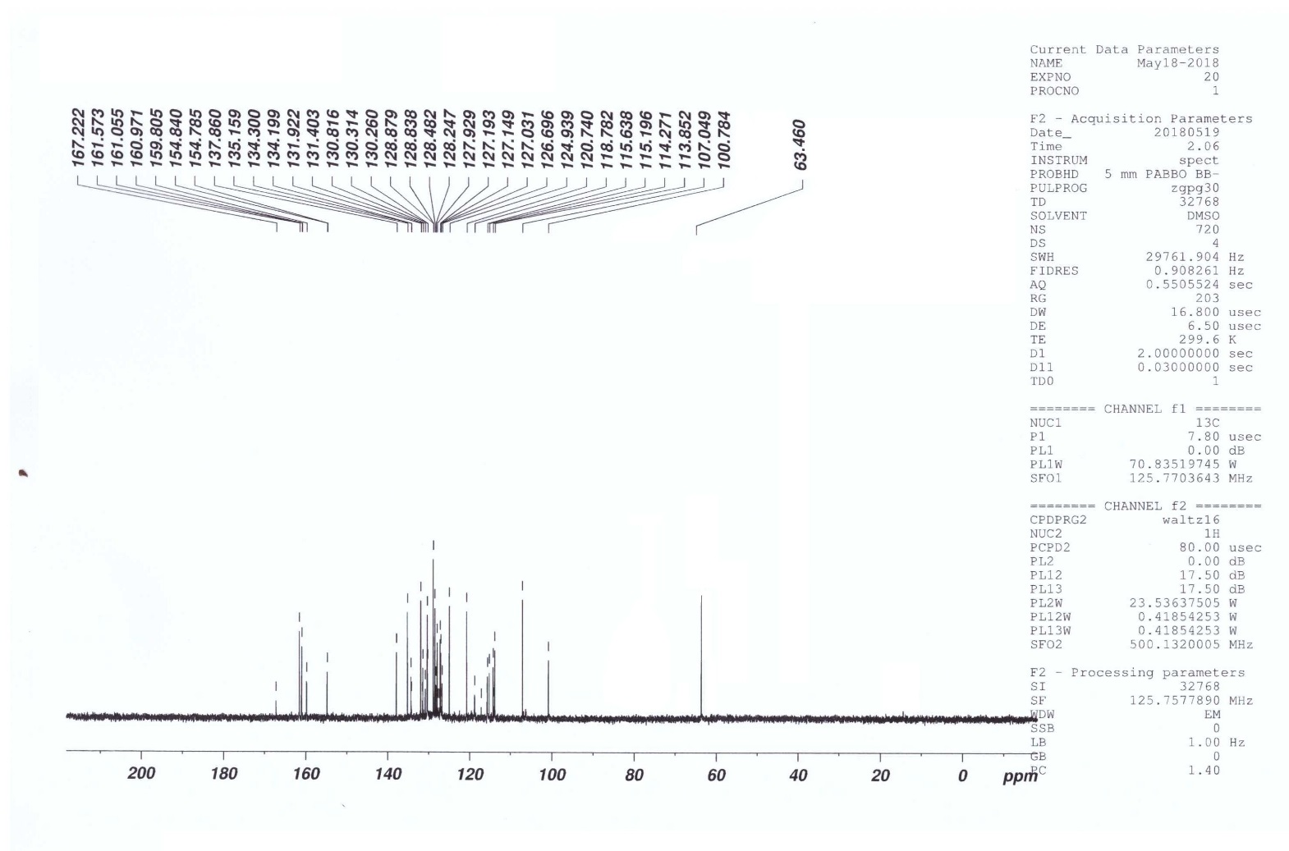

Figure S23: ¹³C NMR spectrum for 1-{5-(11H-indolo[3,2-c]isoquinolin-5-ylthio)-1,3,4-oxadiazol-2-yl}-4-(5-chloro-2-phenyl-1H-indol-3-yl)-3-phenylazetidin-2-one (8c)

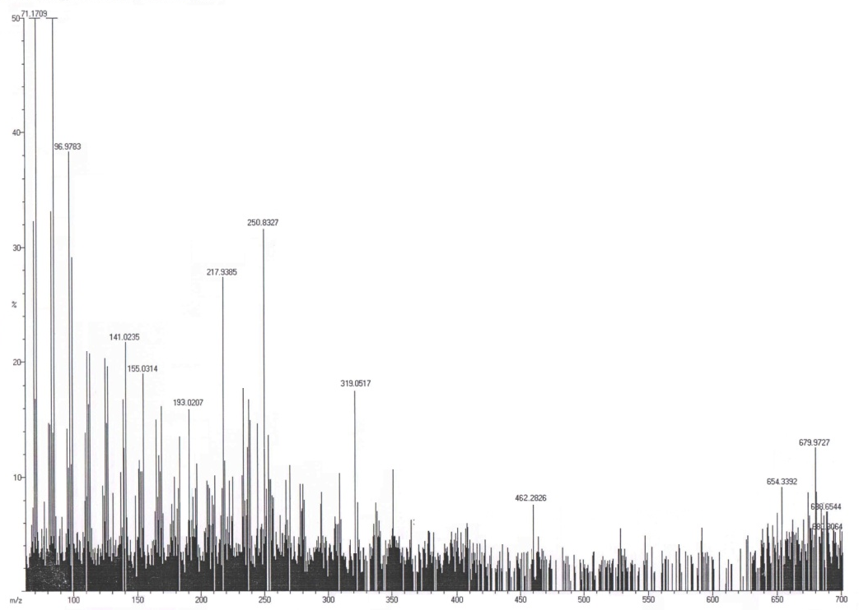

Figure S24: Mass spectrum 1-{5-(11H-indolo[3,2-c]isoquinolin-5-ylthio)-1,3,4-oxadiazol-2-yl}-4-(5-chloro-2-phenyl-1H-indol-3-yl)-3-phenylazetidin-2-one (8c)

