Supplementary data

Cell culture and adhesion force measurements
Human pulmonary artery endothelial cells (HPAECs, Lonza) were cultured on four different micropost substrates (Han 2012) manufactured via replica molding of polydimethylsiloxane (PDMS, Sylgard 184, Dow Corning). The microposts were approximated as short beams. The deflection of a post (δ) was used to determine the local traction force (F) of a cell according to Bernoulli’s equation $F=kδ=\left({3πEd^{4}}/{64h^{3}}\right)δ$ where k is the spring constant of a post, d is its diameter, h is its height, and E is the elastic modulus of PDMS. All four types of substrates were made of the same PDMS with a Young’s modulus of 2.5 MPa measured according to ASTM standard D412. Diameters (ranging between 2.14 μm and 2.42 µm) and heights (ranging between 7 μm and 9 µm) resulted in four different bending stiffness (11.0 nN/µm, 15.5 nN/µm, 31.0 nN/µm and 47.8 nN/µm). We categorized these stiffness values into the following designations: Very Soft (11.0 nN/µm ±2.3), Soft (15.5 nN/µm ±3.6), Hard (31.0 nN/µm ±6.2) and Very hard (47.8 nN/µm ±10) (Han 2012). The PDMS microposts presented here have a diameter/height ratio between 0.24 and 0.35, which is above the maximum threshold of d/L = 0.1 to consider them as short beams. Even though the Bernoulli equation is thus considered inapplicable due to the presence of shear and traction stresses, previous studies have shown that a linear relationship between micropost deflection and applied force remains a good approximation (Tan2003, Han2012, Fu2010, Lemmon2005, Li2007). Microposts were evenly spaced in a rectangular grid-like fashion, 9 µm from center to center. The edge-to-edge spacing between microposts was therefore ~7 µm. The 7 µm spacing is assumed to be wide enough to prevent ~2 µm long contractile units from being able to perceive micropost bending stiffness (Meacci 2016). Before seeding, in order to confine the spread area of the cells, the tips of micropost substrates were microcontact-printed with fibronectin (50 μg/ml, BD Biosciences) via a stamp-off method (Han 2012; Sniadecki et al. 2013 Methods in Cell Biology) into square shaped pattern areas (441, 900, 1521, or 2304 μm²). Cell seeding density was low enough (<30,000 per mL) so that single cells could separately attach to individual pattern areas. For each of the 4 adhesion conditions, 8-15 cells were imaged and analyzed for traction forces and cytoskeletal tension quantification. The cells were permeabilized using 0.5% Triton for 2 min after being allowed to spread for 14 hours on the micropost arrays. Cells were then stained with Hoechst 33342 (Invitrogen), phalloidin (Invitrogen), IgG anti-vinculin (hVin1, Sigma Aldrich), and anti-IgG antibodies (Invitrogen) with manufacturer-recommended concentration. Images of the cells and microposts were obtained via fluorescence microscopy (Nikon TiE, 60× oil objective, 1.4 NA). We only selected isolated cells. These cells were therefore not able to form cadherin mediated cell-cell junctions with neighboring cells, instead they formed focal adhesions which allowed them to pull on their surrounding environment. Micropost deflection and bending stiffness were used to measure the pulling force exerted by the cell on each post (Lemmon 2005). Micropost deflection was measured by comparing the horizontal position of the center of the top of each micropost to the horizontal position of the base (bottom). The focal plane of the microscope image was manually adjusted to respectively observe the tops and bottoms of the microposts. The difference in position allowed us to calculate the corresponding deflection vector, therefore indicating both the magnitude and directionality of the pulling force exerted on each post. For each observed cell, the traction force was calculated by adding the magnitudes of all adhesion forces. The spreading area of a cell on the micropost array was measured from an outline of its actin image.

Internal pressure
The “default cross linear tension” we find is about 1 nN/µm, however we consider this projected cross linear tension value to be to super impose contribution of the ventral and dorsal actin cortex. We would like to know how this “default” tension could compare to intracellular hydrostatic fluid pressure values expressed in the literature. Since we believe that this default tension is still present in a non-adherent round cell (Fig. 1) we will conduct our analysis as if the cell was spherical.
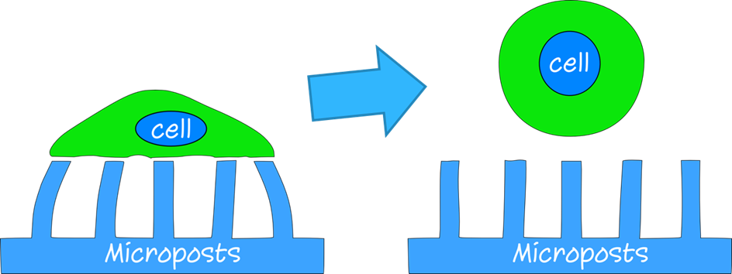Figure 1: actin tension ensures the mechanical integrity of the cell even if it is non adherent

To calculate the intracellular cytoplasmic pressure inside a round cell, we use the following reasoning. We can consider that if we take a cross section of the cell going straight through its center (Fig. 2), we can assume that the peripheral force generated by the thin actin cortex (${\vec{F}}_{cortical}$) is counter balanced by the fluid pressure (P), and therefore equal and opposite to the fluid pressure force (${\vec{F}}_{pressure}$) exerted on the half-sphere (Eq. 1).
$${\vec{F}}_{pressure}+{\vec{F}}_{cortical}=\vec{0} (1)$$
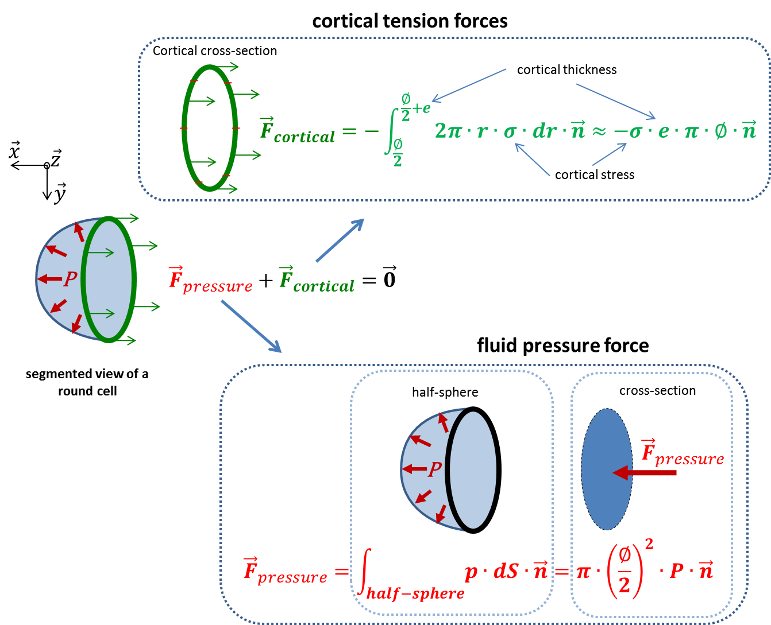
Figure 2: Illustration of cross-sectional forces generated by the actin cortex and the intracytoplasmic fluid pressure of a round cell.
In other words, since the actin cortex is ‘thin’, we can consider that its internal stress ($σ$) is constant. Furthermore, the internal stress multiplied by the thickness (e) of the actin cortex is equal to half the default cross linear-tension ($T_{cl-def}$), since this cross-linear tension value accounts for the dorsal and ventral layer of the actin cortex (Eq. 2):
$$σ∙e=\frac{T_{cl-def}}{2} (2)$$
So, the peripheral force generated by the thin actin cortex should be equal to (Eq. 3):
$${\vec{F}}_{cortical}≈-σ∙e∙π∙∅∙\vec{n} = -\frac{T_{cl-def}∙π∙∅}{2}∙\vec{n} (3)$$
$$with ∅=diameter of the round cell$$
And, the fluid pressure force is equal to (Eq. 4):
$${\vec{F}}_{pressure}=π∙{\left(\frac{∅}{2}\right)}^{2}∙P∙\vec{n} (4)$$
$with \vec{n} : unitery vector$
To conclude, this leads to Eq. 5:
$${\vec{F}}_{pressure}+{\vec{F}}_{cortical}=\vec{0} → P= \left|\frac{{2∙T}_{cl-def} }{ ∅}\right| (5)$$
Using this Eq. 5 and based on our calculations, for $T_{cl-def}$ equal to ~1 nN/µm and a diameter ($∅$) of 15 µm, we obtain a theoretical hydrostatic pressure ($P$) of 133 Pa. The expressed pressure value equates to relative pressure, ambient pressure must be added to obtain absolute pressure. This value is in accordance with internal hydrostatic pressure values found in the literature, which range between 40 to 400 Pa (Fischer 2014). We can therefore conclude that it would not only be qualitatively coherent, but also quantitatively coherent to assume that the “default” tension found by the image-based model corresponds to cortical actin contraction.

