Appendix A: Individual transmissibility responses of 21 participants in two positions (forward lean, backward lean) at 24 anatomical locations.
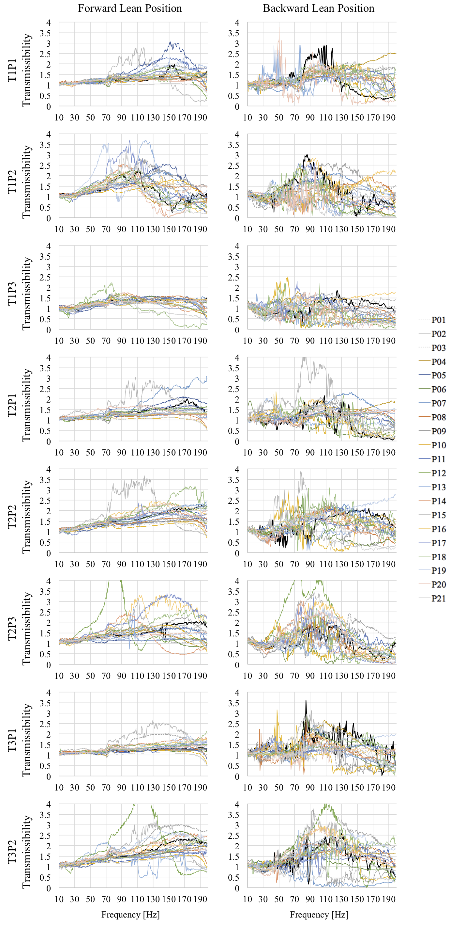
Appendix A: Individual transmissibility responses of 21 participants in two positions (forward lean, backward lean) at 24 anatomical locations.
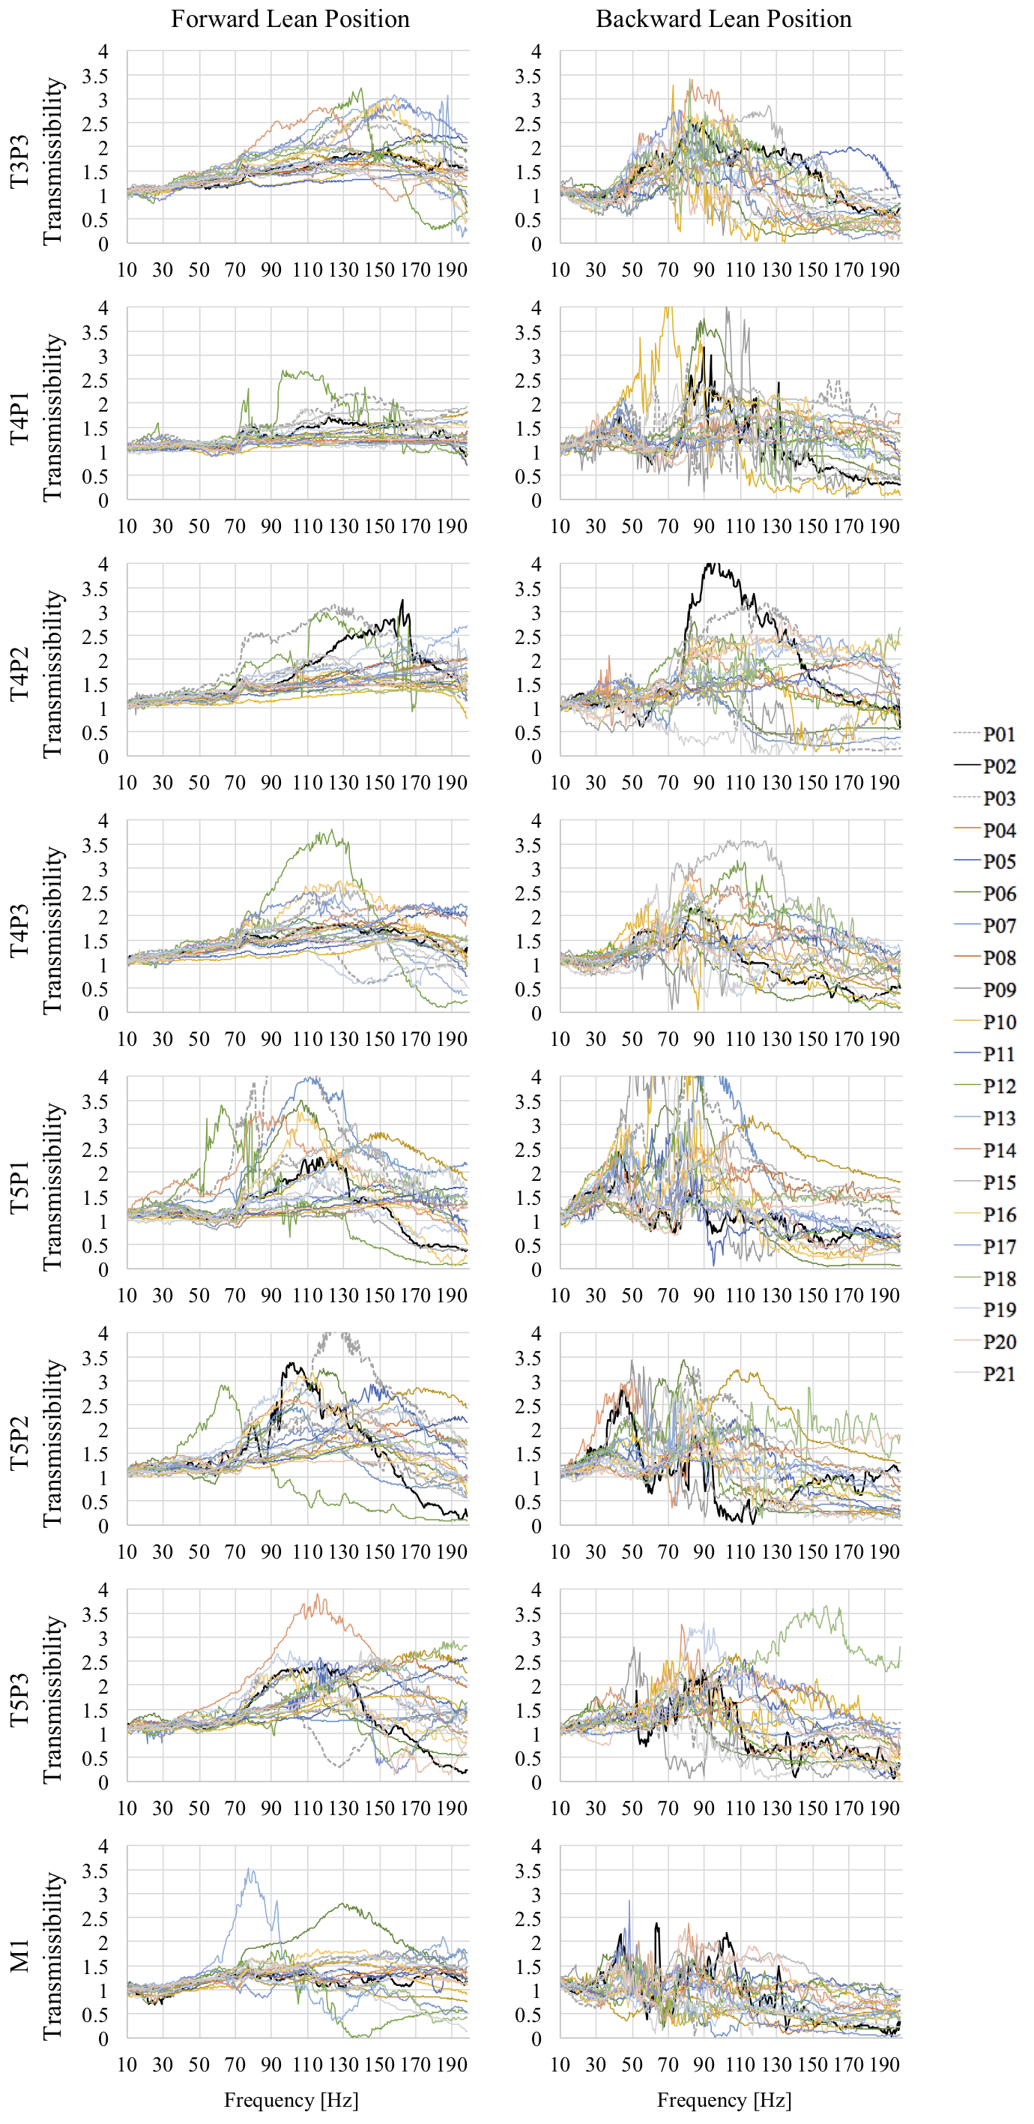
Appendix A: Individual transmissibility responses of 21 participants in two positions (forward lean, backward lean) at 24 anatomical locations.
