Supporting Information

Appendix A. TWINSPAN classification of the relevés.

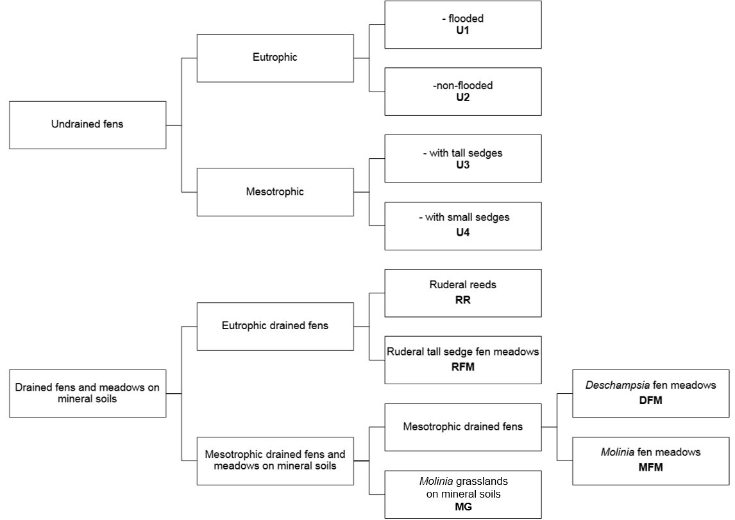

Figure A1. Scheme of the TWINSPAN classification of the relevés.

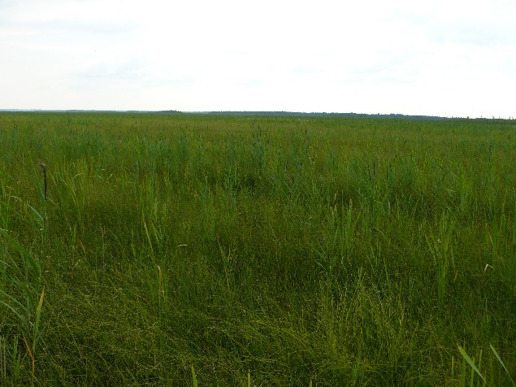  U1 | 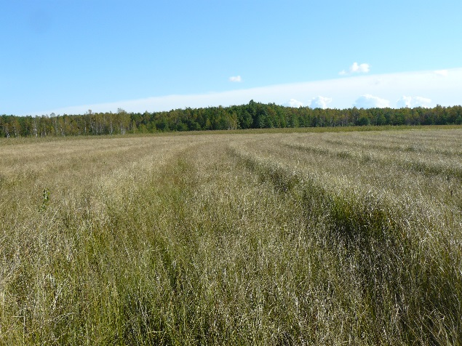  U2 | 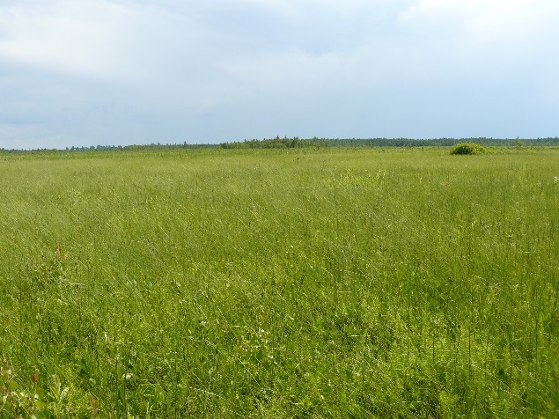  U3
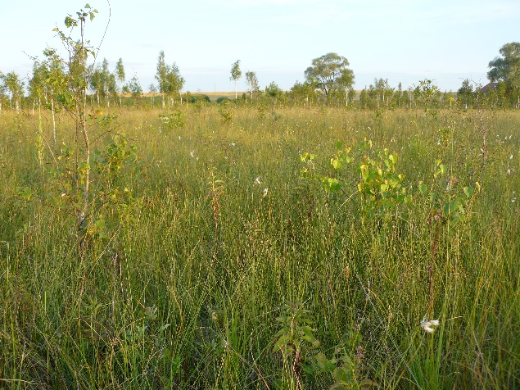  U4  RR | 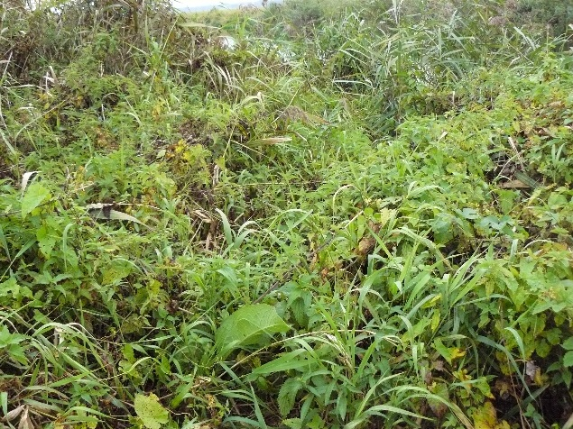  MG  MFM | 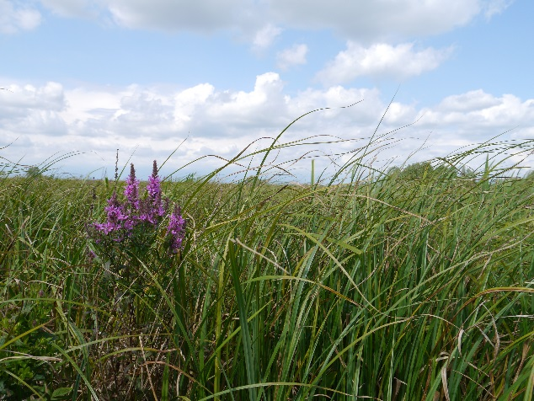  RFM
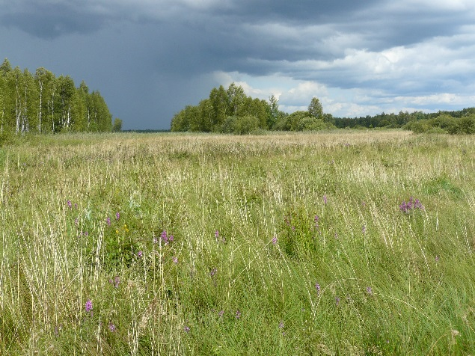  DFM | 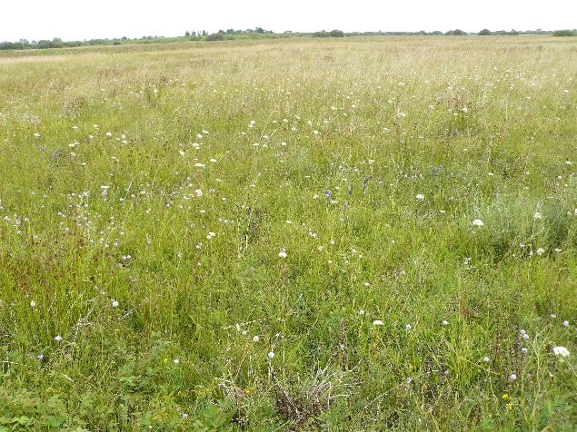 | 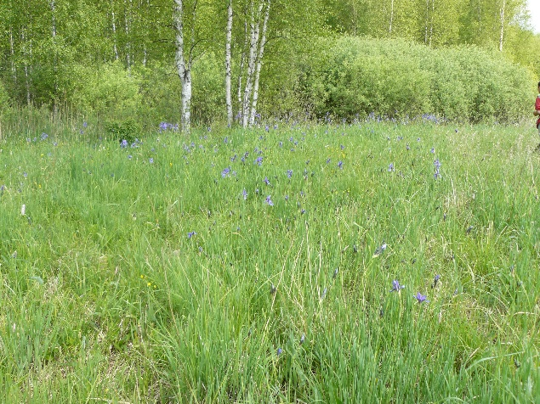

Figure A2. Photographs of the studied communities (by Łukasz Kozub).

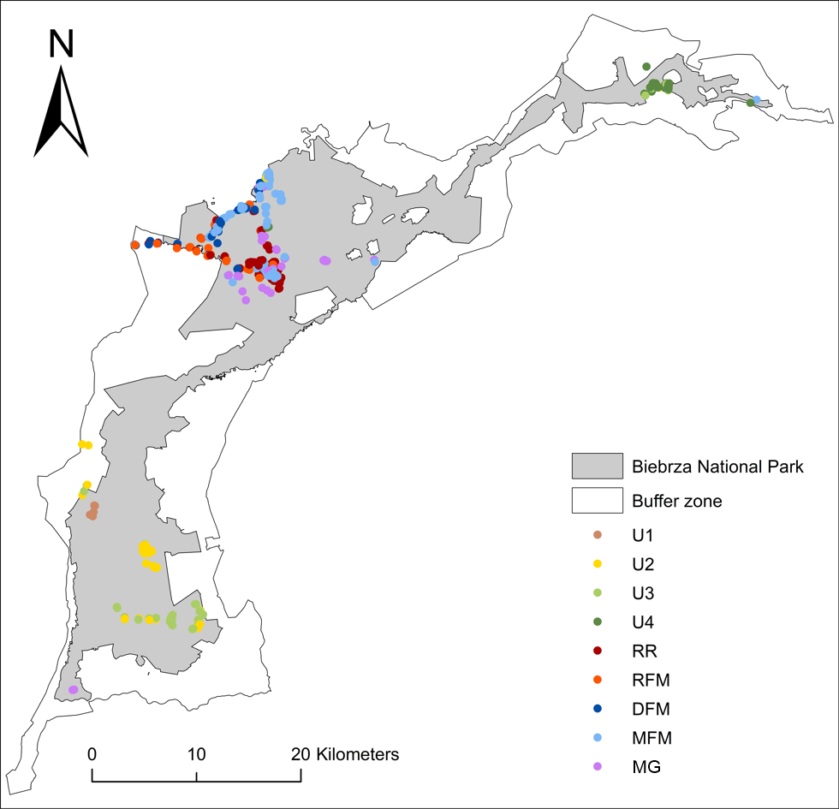

Figure A3. Map of the distribution of relevés classified into respective communities.

Appendix B. Assignment of nutrient deficiency classes to communities.

The approximate values of dry weight of the above-ground standing crop for the communities obtained from TWINSPAN (Table B1) were derived from the literature and our own measurements. The measurements were performed in July 2012 in the Middle Biebrza Basin, where the living part of standing biomass was harvested from 0.16 m² plots. Plant material was dried for 48 h at 70°C and weighed. We assumed the multiplicative rather than the additive meaning of biomass weight and transformed the data logarithmically. The subsequent classification of nutrient deficiency classes was based on relative similarities among communities (Fig. B1).

Table B1. Biomass dryweight in studied communities.

 | Community | Source | Biomass [g/m²] |  | Class
 |  |  |  | Log₁₀
U1 | Undrained eutrophic flooded fens | Wassen et al., 2003 | 1167  n=2 | 3.067 | 1
U2 | Undrained eutrophic non-flooded fens | Wassen et al., 2003 | 699  n=4 | 2.844 | 2
U3 | Undrained mesotrophic fens with tall sedges | Kotowski and Van Diggelen, 2004; Stelmaszczyk et al., 2015 | 280  n=17 | 2.411 | 3
U4 | Undrained mesotrophic fens with small sedges | Olde Venterink et al., 2009 | 150  n=6 | 2.176 | 4
RR | Ruderal reeds | Wassen et al., 2003 | 1428  n=1 | 3.155 | 1
RFM | Ruderal tall sedge fen meadows | Own data | 557  n=5  SD=66.2 | 2.746 | 2
DFM | Deschampsia fen meadows | Own data | 209  n=48  SD=114.7 | 2.32 | 3
MFM | Molinia fen meadows | Own data | 220  n=15  SD=96.5 | 2.342 | 3
MG | Molinia grasslands on mineral soils | Own data | 253  n=8  SD=85.7 | 2.403 | 3

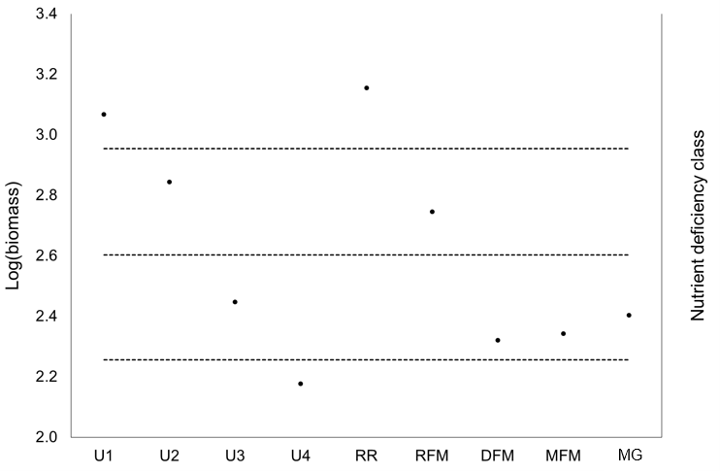

Figure B1. Log of biomass dryweight as the basis for the nutrient deficiency class assignment for communities (for abbreviations see Table 1 in main text).

REFERENCES
Kotowski, W., and van Diggelen, R. (2004). Light as an environmental filter in fen vegetation. J. Veg. Sci. 15, 583–594.
Olde Venterink, H., Kardel, I., Kotowski, W., Peeters, W., and Wassen, M.J. (2009). Long-term effects of drainage and hay-removal on nutrient dynamics and limitation in the Biebrza mires, Poland. Biogeochemistry 93, 235–252.
Stelmaszczyk, M., Okruszko, T., and Meire, P. (2015). Nutrients availability and hydrological conditions of selected wetland ecosystems in the Biebrza river valley. Ann. Wars. Univ. Life Sci. Land Reclam. 47.
Wassen, M.J., Peeters, W.H., and Venterink, H.O. (2003). Patterns in vegetation, hydrology, and nutrient availability in an undisturbed river floodplain in Poland. Plant Ecol. 165, 27–43.

Appendix C. Scaling of functional trait values prior to functional indices computations.
The scaling of continuous functional traits was proceeded within a reference fen mires species pool, containing about 1300 species from a database of more than 5000 plots collected on natural, degraded, restored, managed and unmanaged fens, from central and north-western Europe, compiled by our research team. The minimum and maximum values, fixing 0 and 1 after scaling, were assigned as the extreme values occurring in this “absolute” fen species pool, consulted with The LEDA Traitbase (Kleyer et al., 2008). They were as follows (Table C1):

Table C1. Scaling of functional trait values.
 | Trait | Min | Max
CH | canopy height [m] | 0.001 | 4
SLA | specific leaf area [mm²/mg] | 3 | 115
LDMC | leaf dry matter content [g/g] | 0.04 | 0.52
F | Ellenberg's water value | 1 | 12

REFERENCES
Kleyer, M., Bekker, R.M., Knevel, I.C., Bakker, J.P., Thompson, K., Sonnenschein, M., Poschlod, P., Van Groenendael, J.M., Klimeš, L., and Klimešová, J. (2008). The LEDA Traitbase: a database of life‐history traits of the Northwest European flora. J. Ecol. 96, 1266–1274.

Appendix D. Pairwise comparisons among communities according to all single-trait indices.
a)
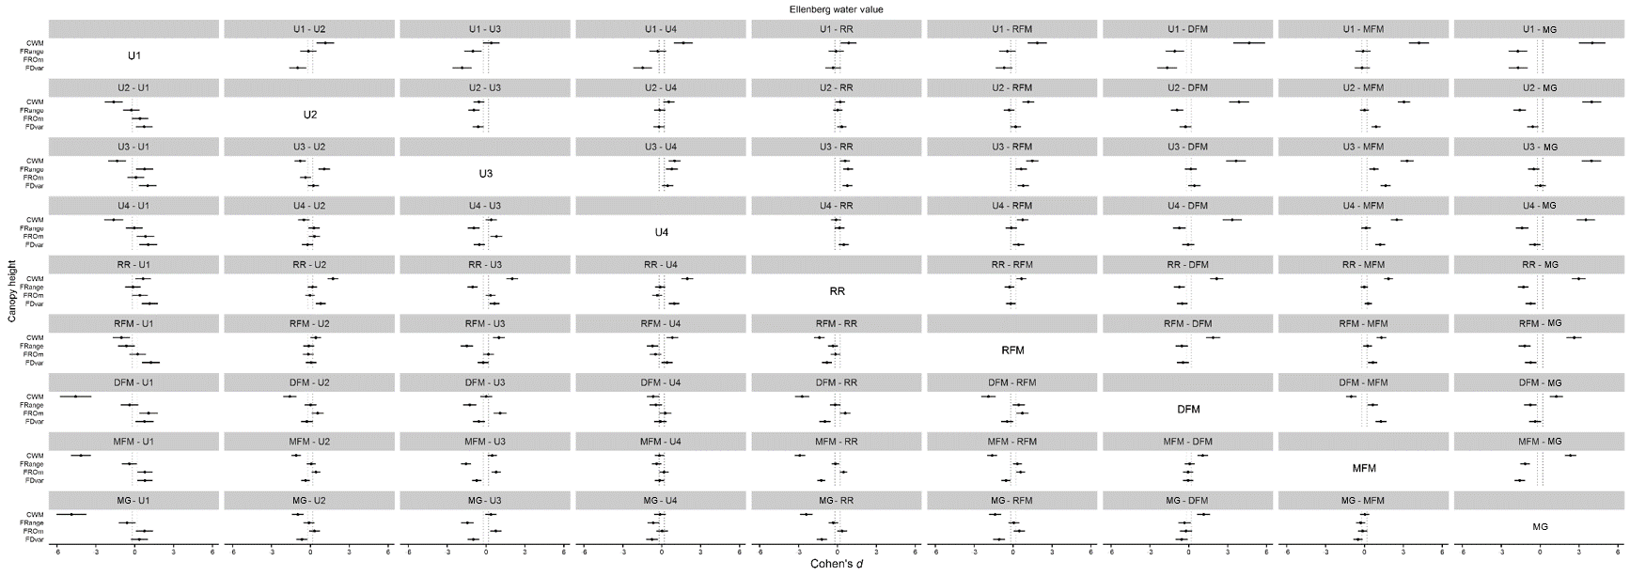

b)
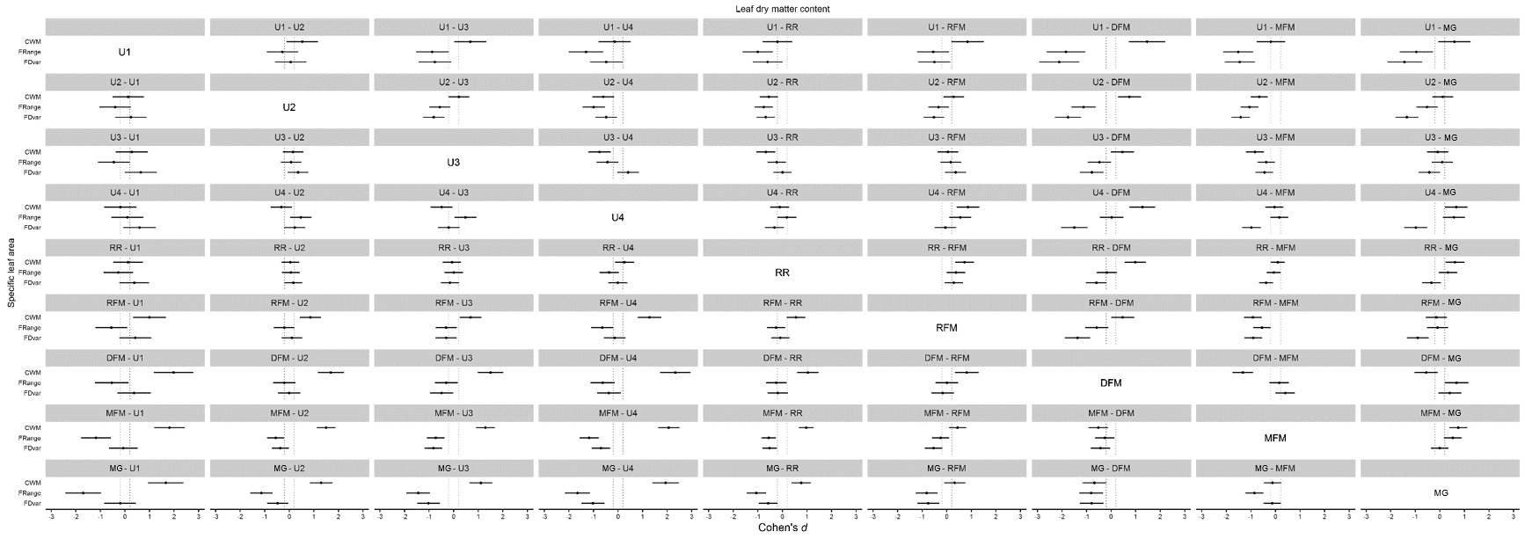

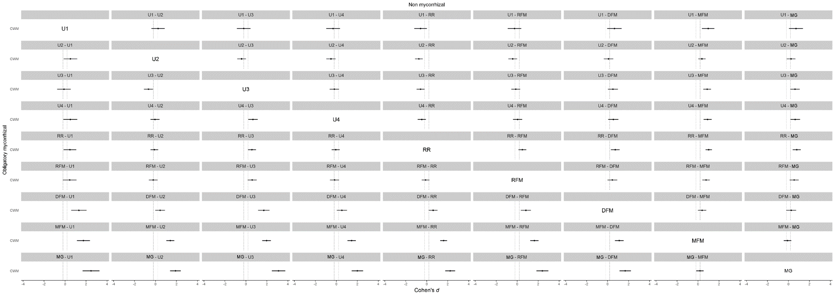
c)
Figure D1. Standardized differences for pairwise comparisons between communities according to all analyzed indices and traits: a) Ellenberg water value above the diagonal, Canopy height below the diagonal; b) Leaf dry matter content above the diagonal, Specific leaf area below the diagonal; c) Non-mycorrhizal species above the diagonal, Obligatory-mycorrhizal species below the diagonal; for communities abbreviations see Table 1 in the main text. Dashed lines indicate the interval of negligible difference (|d|<0.2, see Cohen, J. 1992. A power primer. Psychol. Bull. 112, 155–159.).

Appendix E. Multi-trait indices computed on the basis of an alternative set of functional traits.
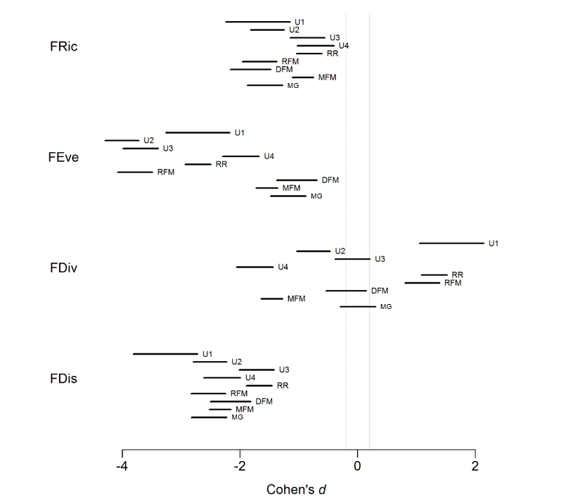
Figure E1. 95% confidence intervals for standardized differences between multi-trait indices for observed and simulated relevés. Traits used for computations: canopy height (log), specific leaf area (log), leaf dry matter content, Ellenberg's water value (for sources see the main text), seed mass (log, source: TRY, for references see Data sources section), clonal spread (source: Klimešová and De Bello, 2009), start of flowering (sources: Rutkowski L., 2011, Moraczewski et al., 2000). For indices abbreviations see Table 3 in the main text, for communities abbreviations see Table 1 in the main text. Dashed lines indicate the interval of negligible difference (|d|<0.2, Cohen, 1992).

REFERENCES
Cohen, J. (1992). A power primer. Psychol. Bull. 112, 155–159.
Klimešová, J., and De Bello, F. (2009). CLO‐PLA: the database of clonal and bud bank traits of Central European flora §. J. Veg. Sci. 20, 511–516.
Moraczewski, I.R., Sudnik-Wójcikowska, B., Dubielecka, B., Rutkowski, R., Nowak, K.A., Borkowski, W., and Galera, H. (2000). Flora ojczysta - gatunki pospolite, chronione, ciekawe... CD-ROM: Atlas roślin, słownik botaniczny i multimedialne klucze do oznaczania. (Polish multimedia key for vascular plants). Wyd. Stigma, Warszawa, PL. (in Polish).
Rutkowski, L. (2011). Klucz do oznaczania roslin naczyniowych Polski nizowej. (Guidebook for the identification of vascular plants of Polish lowlands). Wydawn. Naukowe PWN, Warszawa, PL. (in Polish).

