Supplementary-Tables

Table S-1 Properties of macroporous resins used in the study
Resin | Framework | Polarity | Particle diameter  (mm) | Surface area (m²/g) | Average pore diameter  (nm) | Pore rate  (%) | Pore volume (mL/g)
HPD100 | Polythene | - | 0.3-1.20 | 650-700 | 85-90
H103 |  | - | 0.3-1.25 | 1000-1100 | 85-95 | 55-59 | 1.08-1.12
001×1.1 |  | strong | 0.3-1.25
D101 |  | weak | 0.25-0.84 | 500-550 | 90-100
NKA-9 |  | strong | 0.3-1.25 | 250-290 | 155-165 | 46-50
D151 |  | weak | 0.3-1.25

Tale S-2 Elution properties of different macroporous resins
Type of Resin | Adsorption content（mg/g） | Desorption content（mg/g） | Elution (%)
D101 | 7.55 | 6.82 | 90.38
HPD100 | 8.56 | 8.29 | 96.78
NKA-9 | 8.40 | 8.24 | 98.14

Table S-3 Eluting of different macroporous resins
The types of resins | Elution content（mg/g resin）
 | 10% | 30% | 50% | 70% | 90%
D101 | 1.8±0.02 | 4.3±0.14 | 1.3±0.08 | 0.3±0.01 | 0.2±0.01
HPD100 | 1.5±0.02 | 3.4±0.14 | 2.1±0.08 | 0.6±0.01 | 0.1±0.01
NKA-9 | 1.3±0.02 | 4.1±0.14 | 2.4±0.08 | 0.8±0.01 | 0.0±0.01

Supplementary-Figures
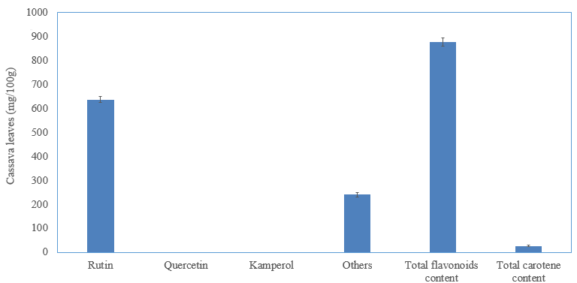
Figure S-1 total flavonoids, carotene, rutin, and the others contents of CL (mg·100g ⁻¹ dry weight)
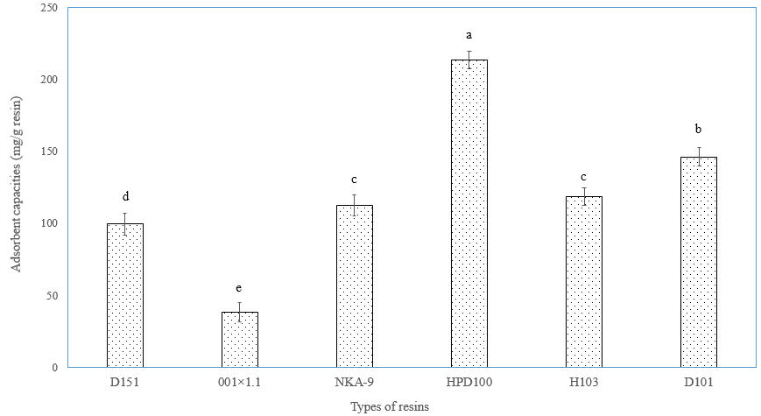
FigureS-2 Flavonoid compounds adsorption capacities of macroporous resins used in the study
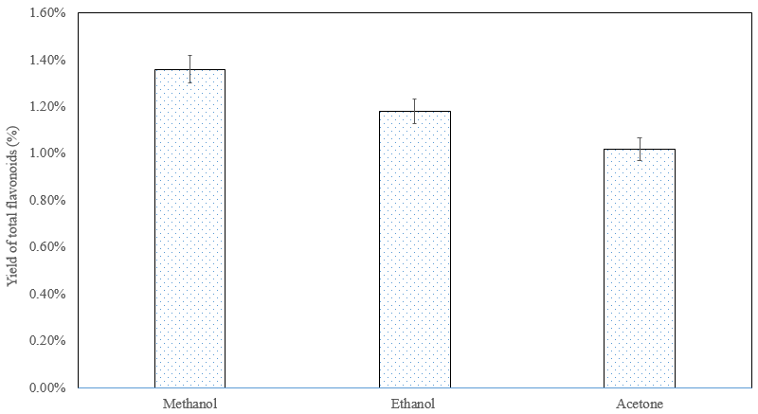
Figure S-3 Effect of different solvents on the extracting flavonoids from cassava leaves

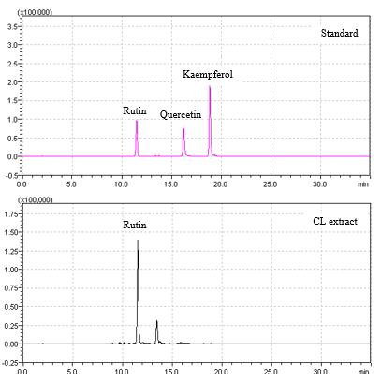
Figure S-4 HPLC chromatogram of cassava leaves ethanol extracts and flavonoids standards

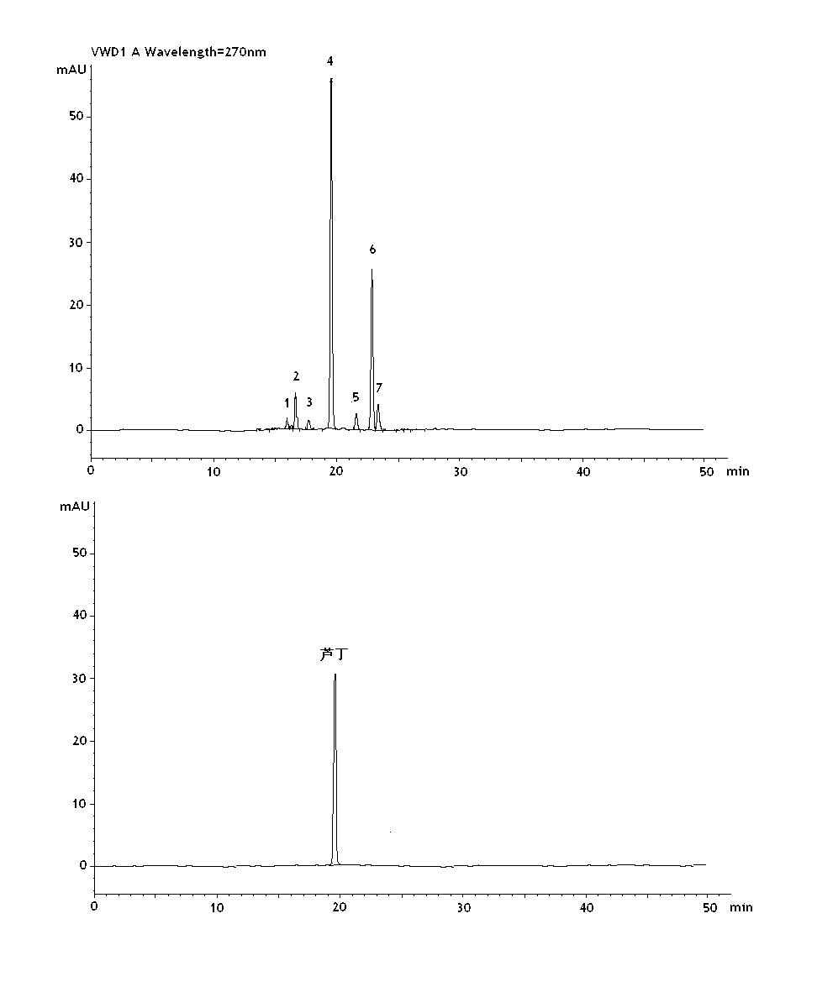
Figure S-5 HPLC/FTICR-MS chromatogram of cassava leaves flavonoids and rutin

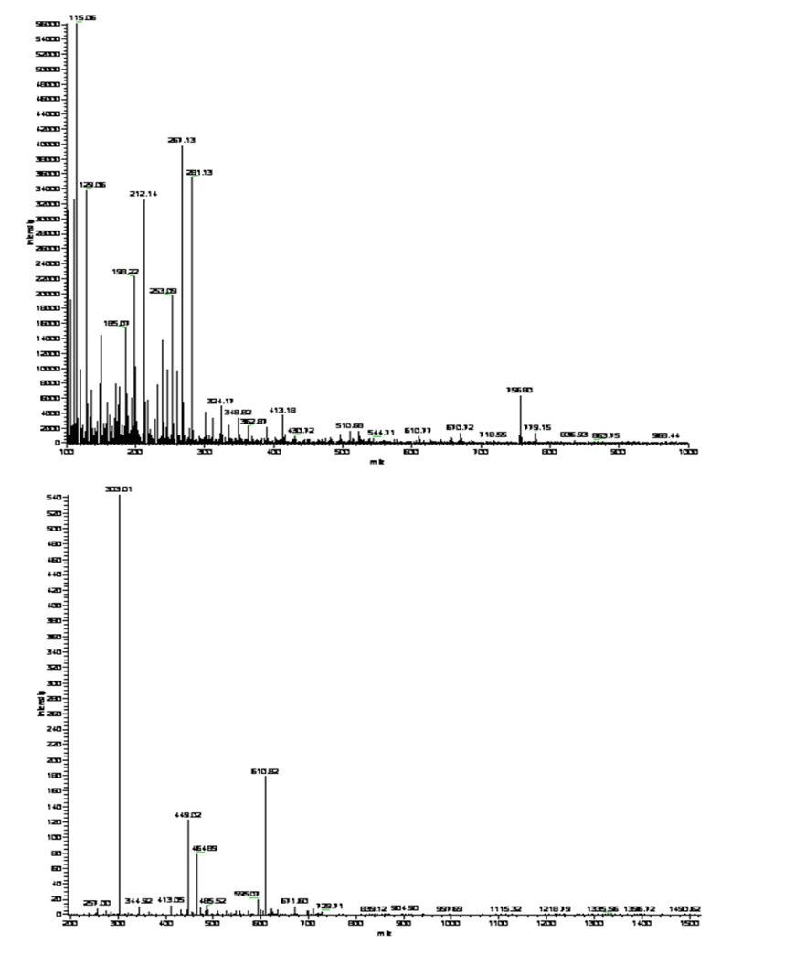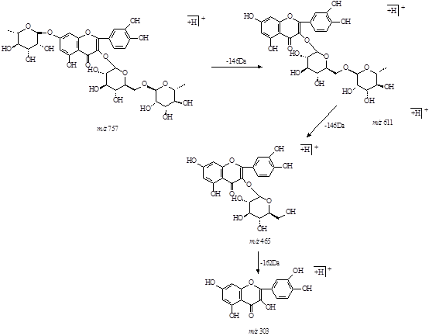

Figure S-6 ESI-MS/MS² chromatograms of compound 1(cloven) Figure S-6 Fragmentation scheme of compound 1(cloven)

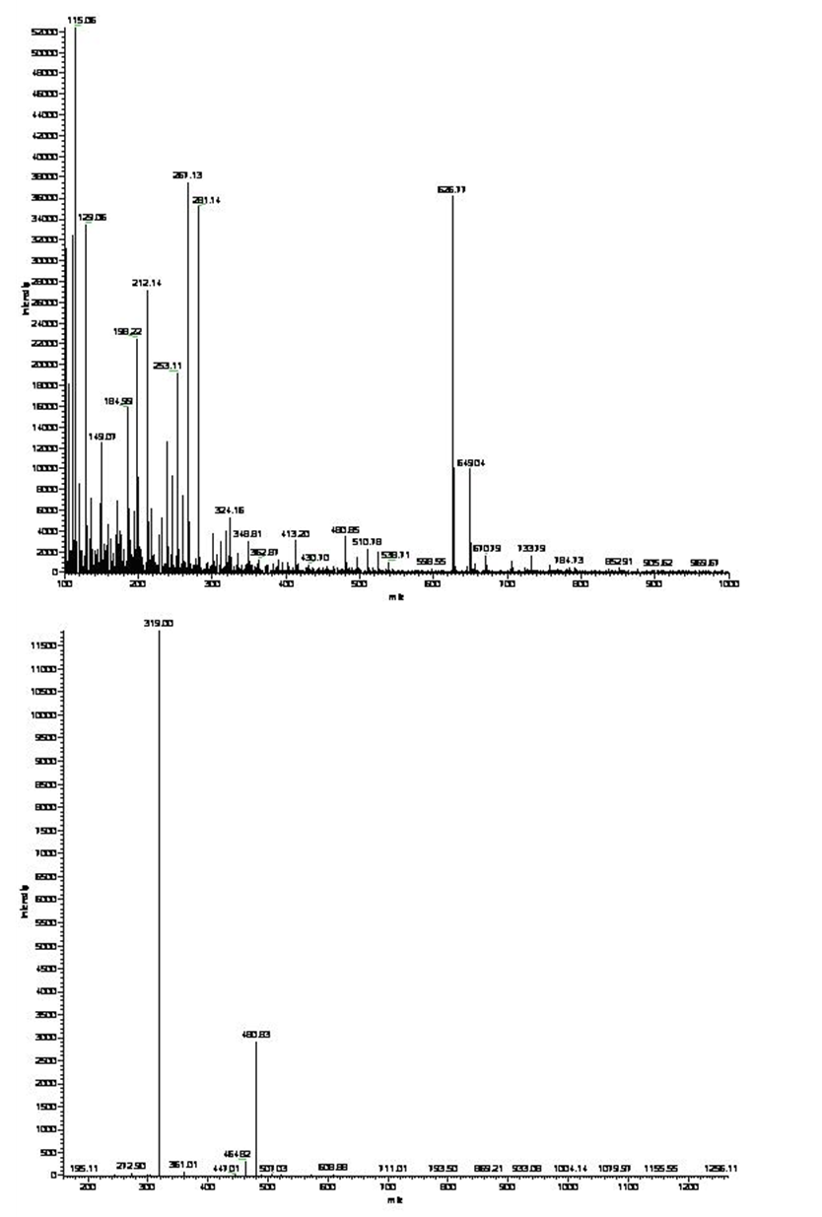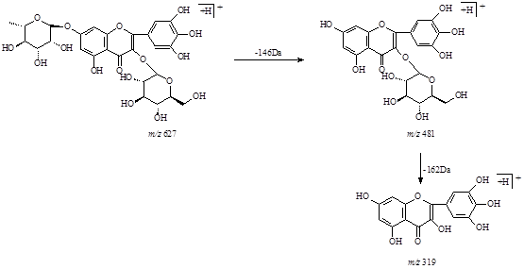

Figure S-7 ESI-MS/MS² chromatograms of compound 2 (myricetin-3-O-rutinoside) Figure S-7 Fragmentation scheme of compound 2

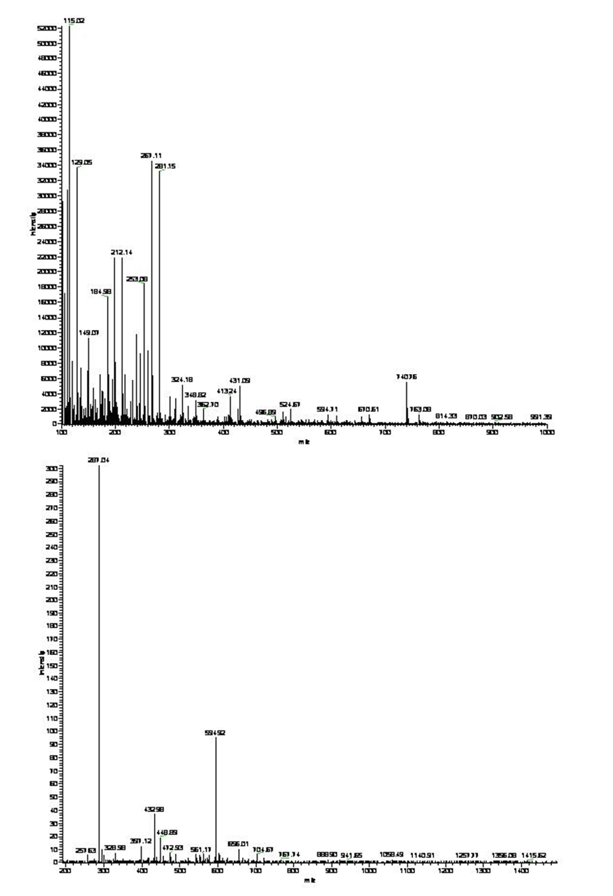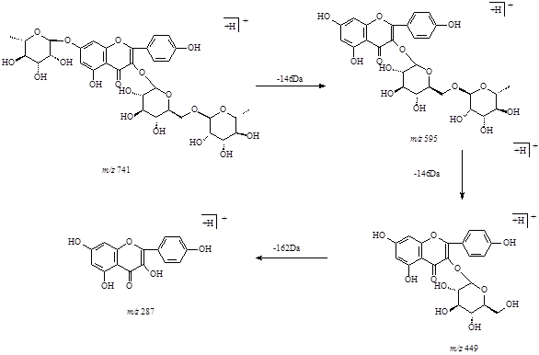
Figure S-8 ESI-MS/MS² chromatograms of compound 3 (robinin) Figure S-8 Fragmentation scheme of compound 3 (robinin)
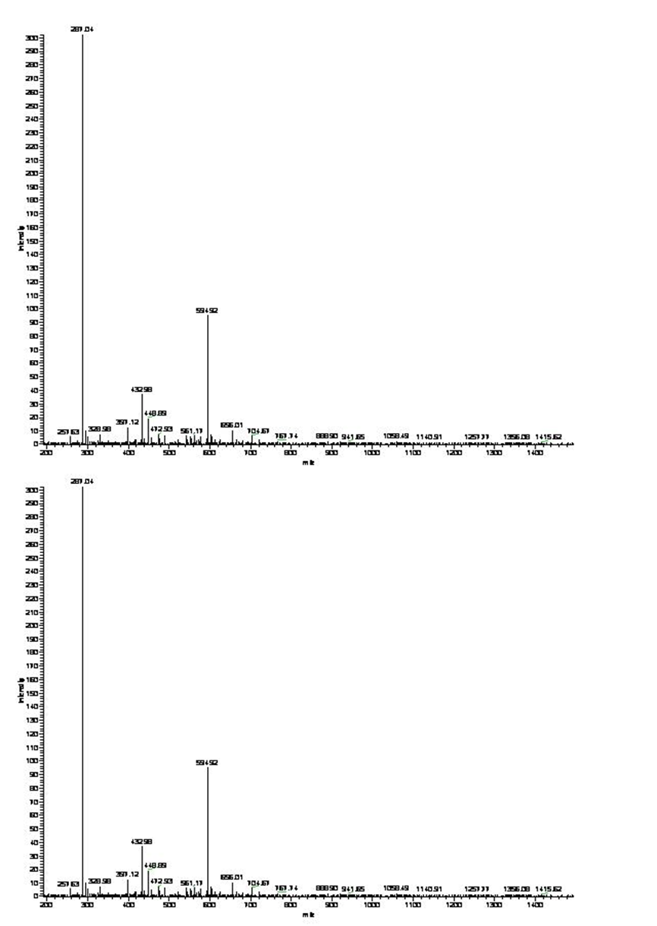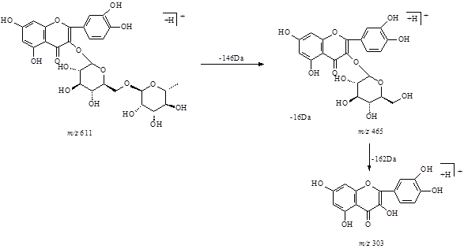
Figure S-9 ESI-MS/MS² chromatograms of compound 4 (rutin) Figure S-9 Fragmentation scheme of compound 4 (rutin)
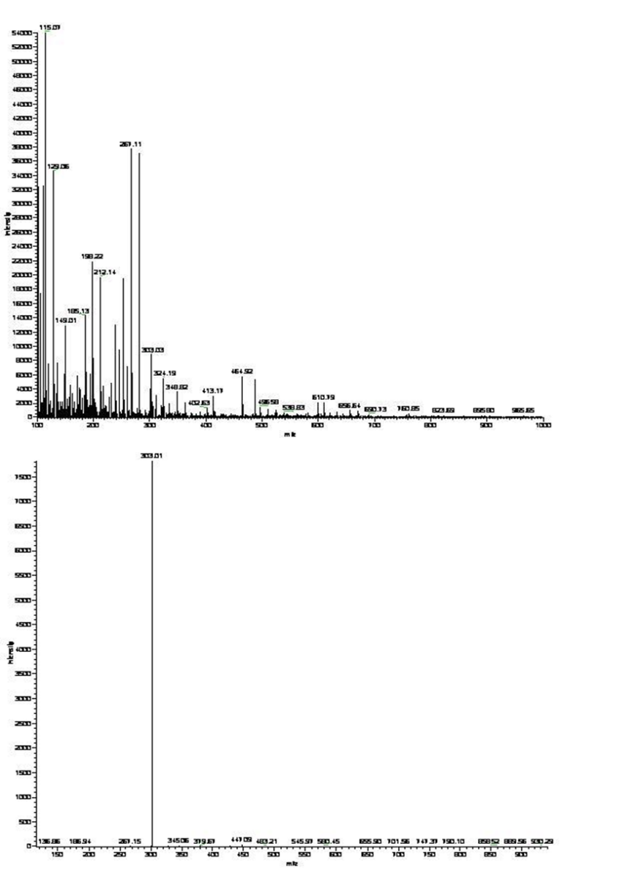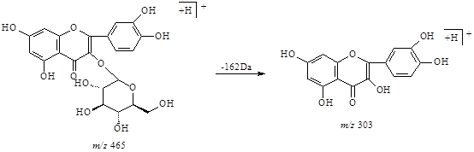
Figure S-10 ESI-MS/MS² chromatograms of compound 5 (hyperoside) Figure S-10 Fragmentation scheme of compound 5 (hyperoside)
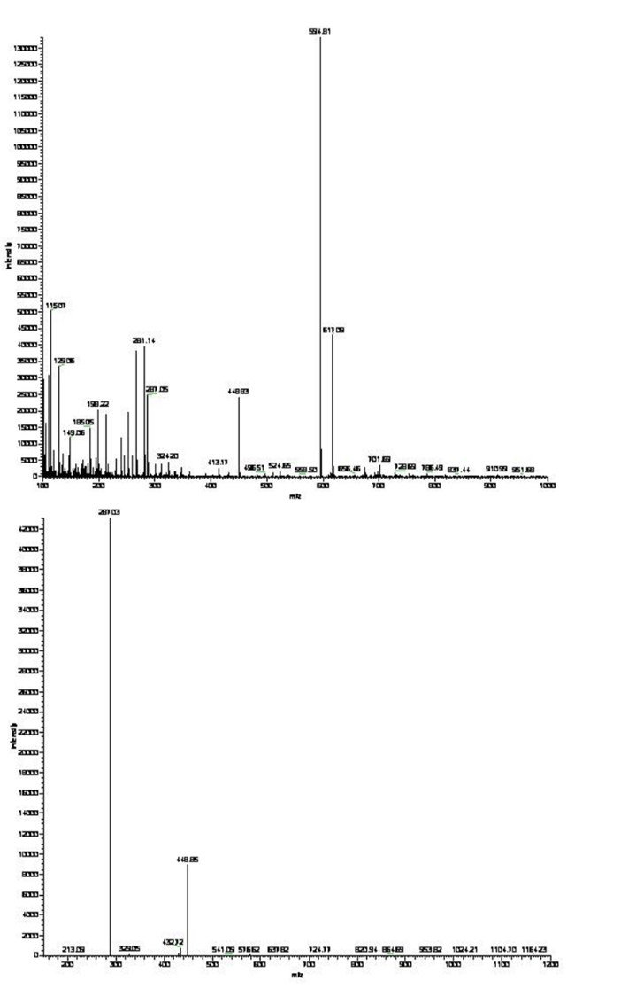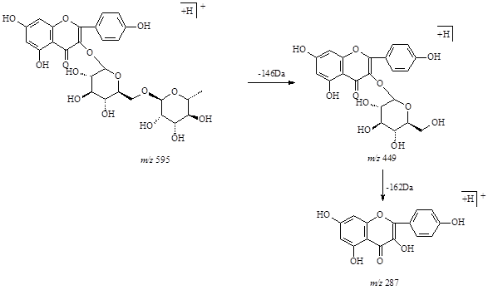
Figure S-11 ESI-MS/MS² chromatograms of compound 6 (nicotiflorin) Figure S-11 Fragmentation scheme of compound 6 (nicotiflorin)

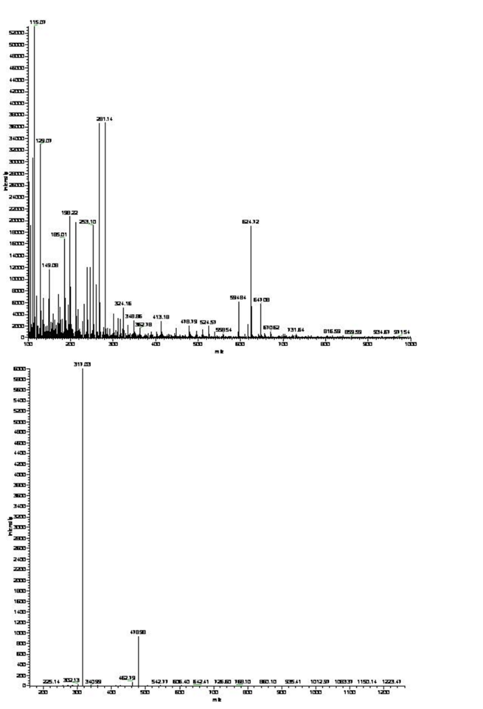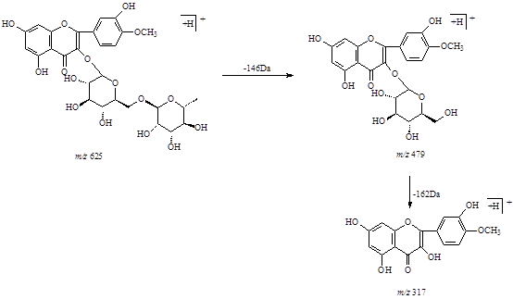
Figure S-12 ESI-MS/MS² chromatograms of compound 7 (narcissin) Figure S-12 Fragmentation scheme of compound 7 (narcissin)

