**Supplementary materials**

**Cost-effective and eco-friendly synthesis oftitanium dioxide (TiO2) nanoparticles using fruit’s peel agro-waste extracts: Characterization, In vitro Antibacterial, Antioxidant activities**

NoushinAjmala*, Keerti Saraswata, Md. Afroz Bakhtb*,Yassine Riadi,c Mohammed Jawed Ahsand , Md. Noushade

*aDepartment of Basic Sciences and Humanities, Pratap University, Jaipur, Rajasthan 303104, India.*

*bDepartment of Chemistry, College Science and Humanities, Prince Sattam Bin Abdulaziz University, P.O. Box- 173, Al-Kharj 11942, Saudi Arabia.*

*cDepartment of Pharmaceutical Chemistry, College of Pharmacy, Prince Sattam Bin Abdulaziz University, PO Box 173, Alkharj 11942, Kingdom of Saudi Arabia.*

*dDepartment of Pharmaceutical Chemistry, Maharishi Arvind College of Pharmacy, Jaipur, Rajasthan 302 039, India*

*eBottom Up Technologies Corporation [BT Corp], Bangaluru, India.*

*Correspondingauthor .: Email: [noush.biochem04@gmail.com](mailto:noush.biochem04@gmail.com) (N.Ajmal)

[m_afroz007@yahoo.com](mailto:m_afroz007@yahoo.com) ( M.A.Bakht)

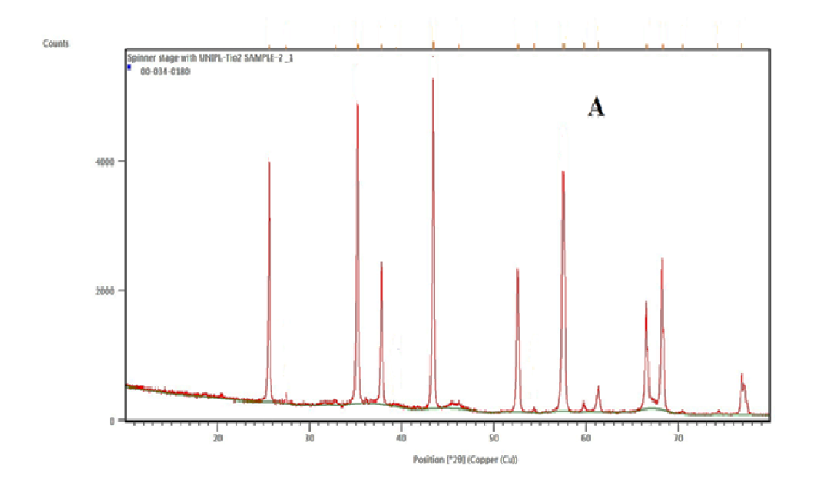

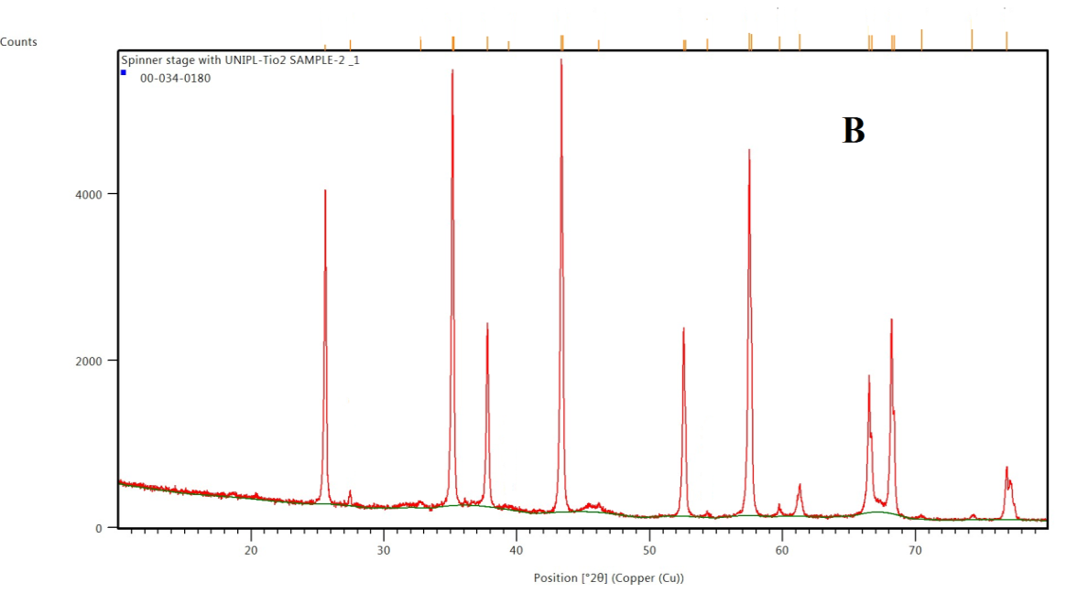

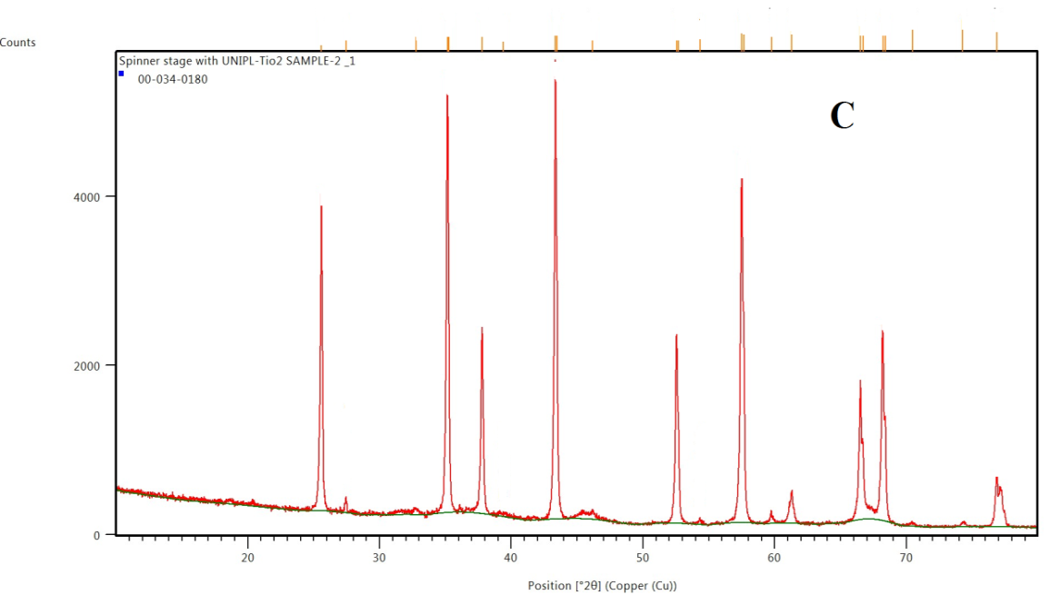

**Figure 1S.** XRD pattern of biosynthesized TiO2 NPs from (A) Plum, (B) Kiwi and (C) Peach peels extract

C:\Users\ok\Pictures\FT-IR TiO2 A.tif

C:\Users\ok\Pictures\FT-IRTiO2.B.tif

C:\Users\ok\Pictures\FT-IRTiO2.tif C.tif

**Figure 2S.** FT IR pattern of biosynthesized TiO2 NPs from (A) Plum, (B) Kiwi and (C) Peach peels extract

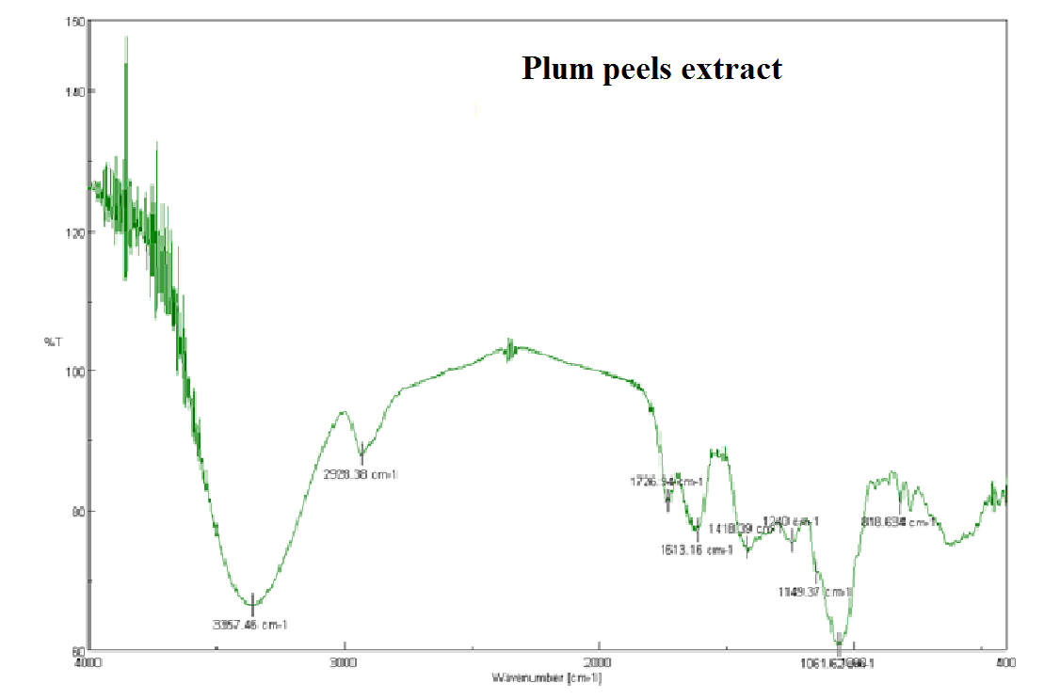

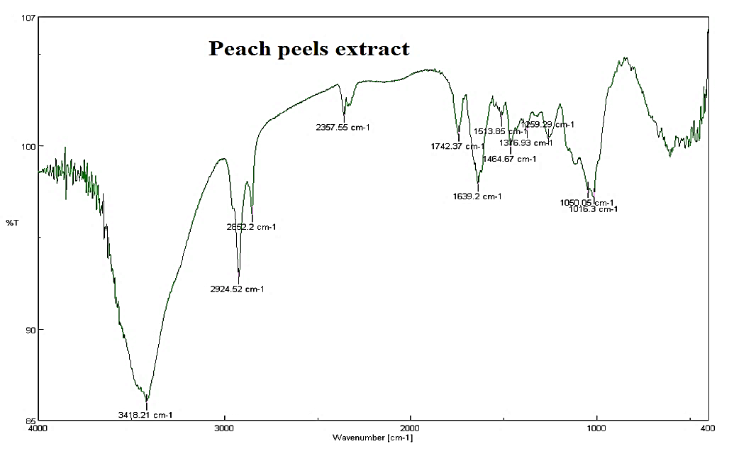

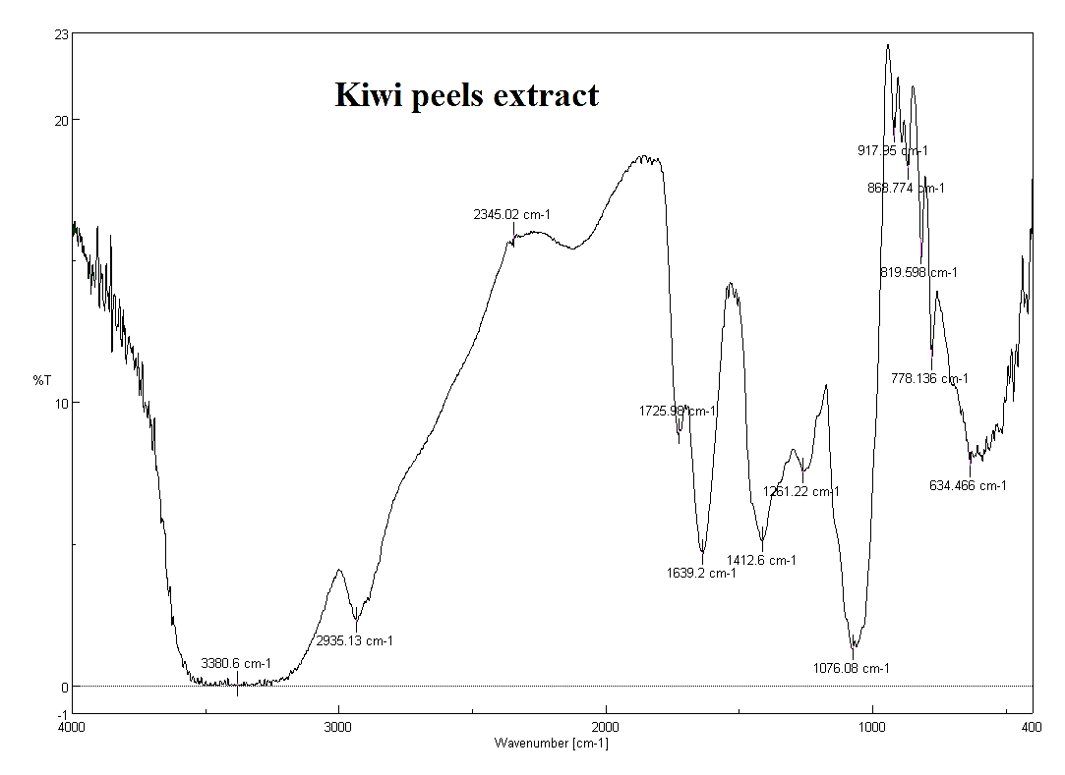

**Figure 3S.** FT-IR values of fruits peel extract