Supplemental Material for the article

Structural basis of Type IV CRISPR RNA biogenesis by a Cas6 endoribonuclease

H. N. Taylorª, E. E. Warnerª, M. J. Armbrustª, V. M. Crowleyª, K. J. Olsenª, and R. N. Jacksonª*
ªDepartment of Chemistry and Biochemistry, Utah State University, Logan, UT, USA
*To whom correspondence should be addressed. Phone: 1-435-797-1621. E-mail: ryan.jackson@usu.edu

Supplemental Figure S1

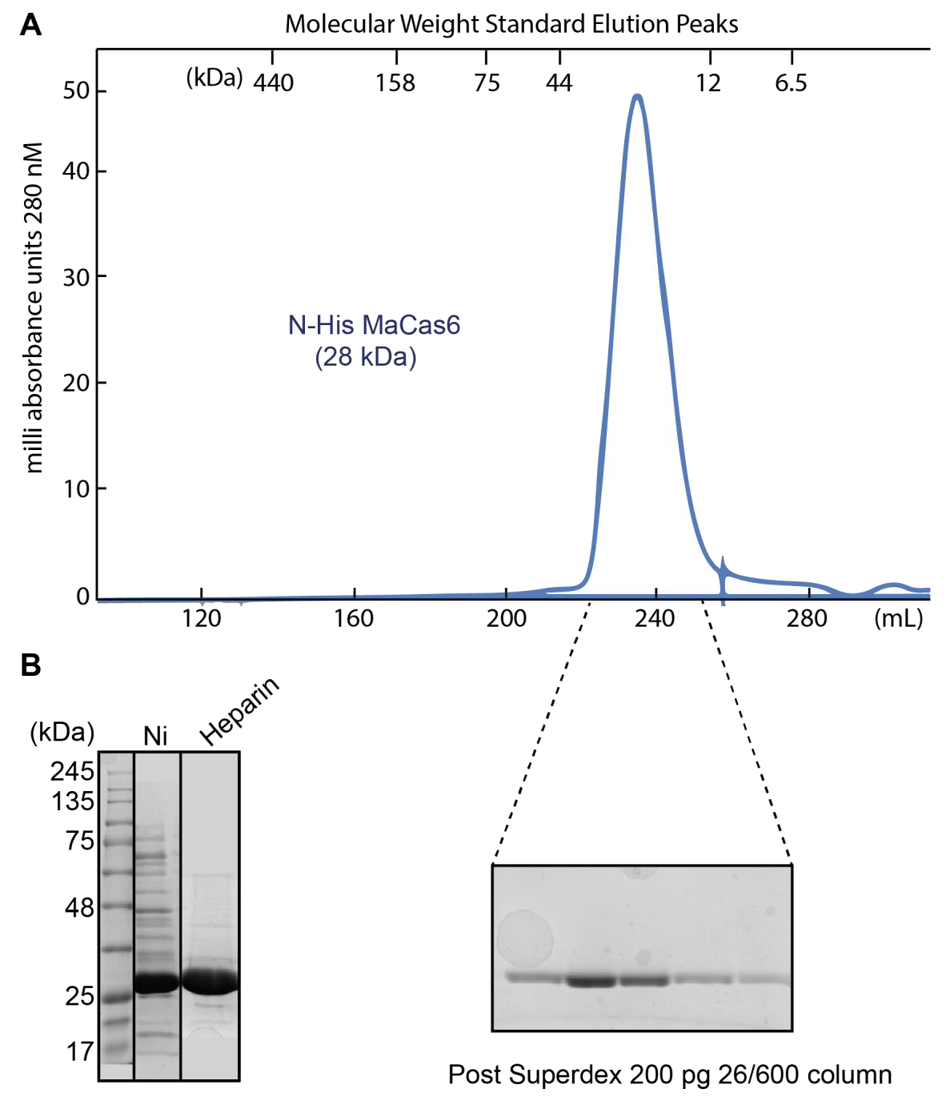

Supplemental Figure S1. Ma Cas6-IV purifies as a monomer. (A) Size exclusion chromatogram of purified Ma Cas6-IV. Molecular weight standard elution peaks are indicated on top. His-tagged Ma Cas6–IV elution peak suggests a 28 kDa monomer is purified. (B) SDS-PAGE representatives after each of the steps of purification (Ni affinity, Heparin ion exchange, and Size Exclusion over a Superdex 200 pg column).

Supplemental Figure S2

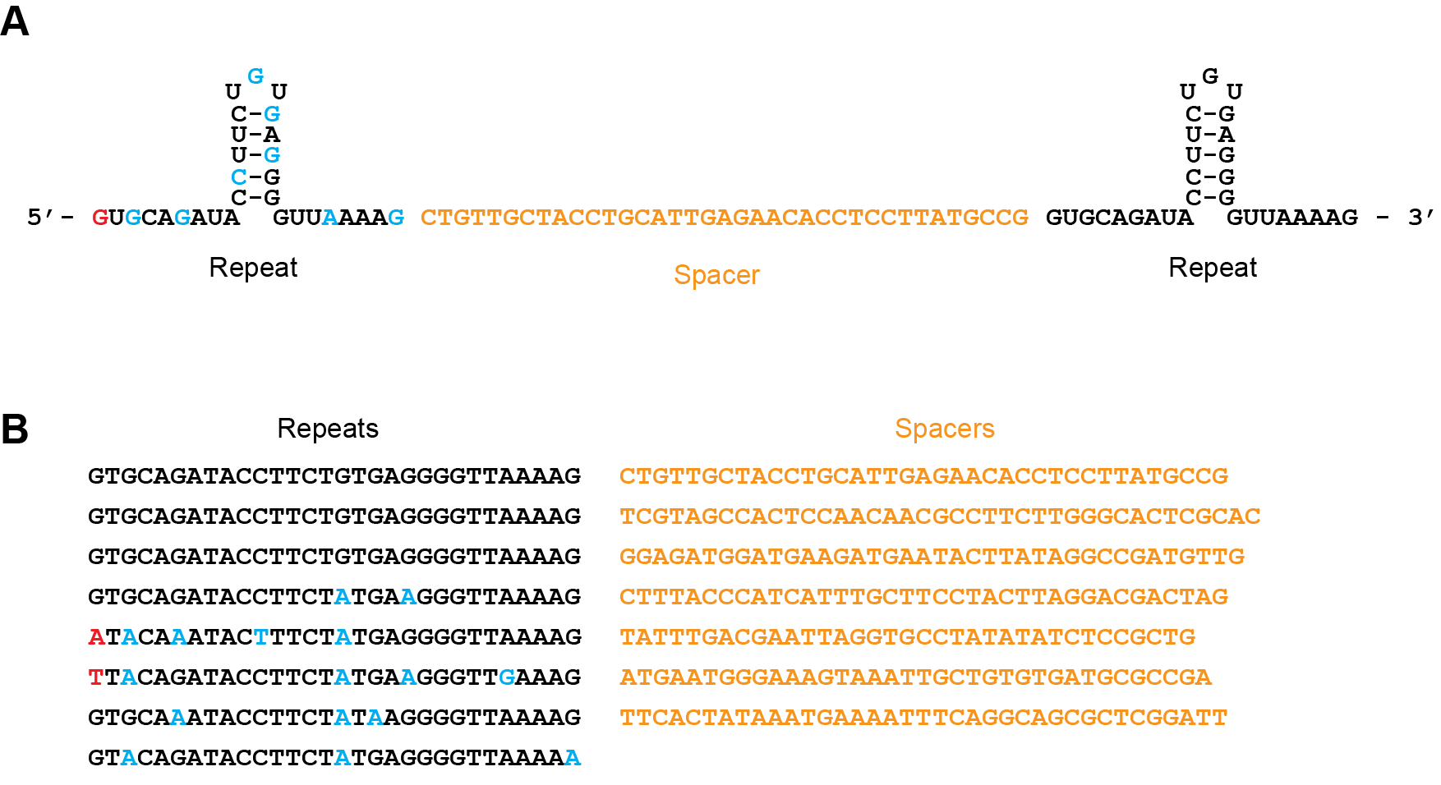

Supplemental Figure S2. CRISPR RNA repeat sequence degeneracy and spacer sequences. (A) Shown is the repeat spacer repeat sequence that was repeated three times in tandem to make the in vitro transcribed pre-crRNA. Nucleotides highlighted in blue indicate a purine-purine or pyrimidine-pyrimidine shift in sequence. Bases colored red indicate broader mutations. (B) The repeat and spacer sequences observed in the Mahella australiensis genome. Repeat nucleotides that differ from the first three repeats are colored as in (A).

Supplemental Figure S3

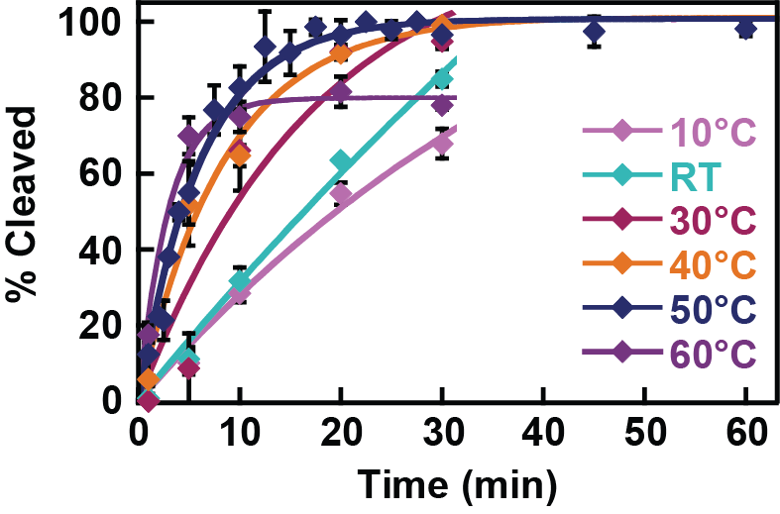

Supplemental Figure S3. Cleavage of Repeat IV by WT Ma Cas6-IV at various temperatures. Cleavage of radiolabelled Type IV Repeat was monitored at different temperatures. Shown are data collected in triplicate and fit as in Figure 1. Cleavage occurred at all temperatures, with optimal cleavage observed at 50°C.

Supplemental Figure S4
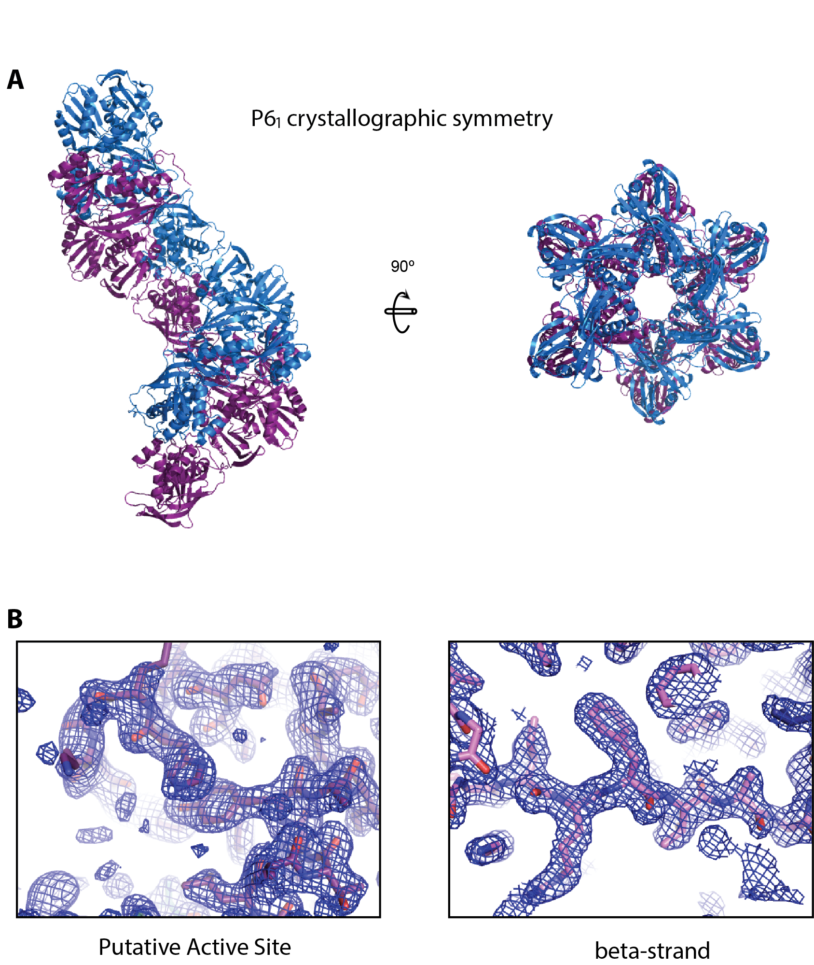

Supplemental Figure S4. Crystallographic symmetry and electron density of Ma Cas6. (A) Side and top views of the P6₁ symmetry of Cas6 dimers in the crystal. (B) Examples of electron density observed at the putative active site and within the C-terminal RRM (RNA Recognition Motif).

Supplemental Figure S5

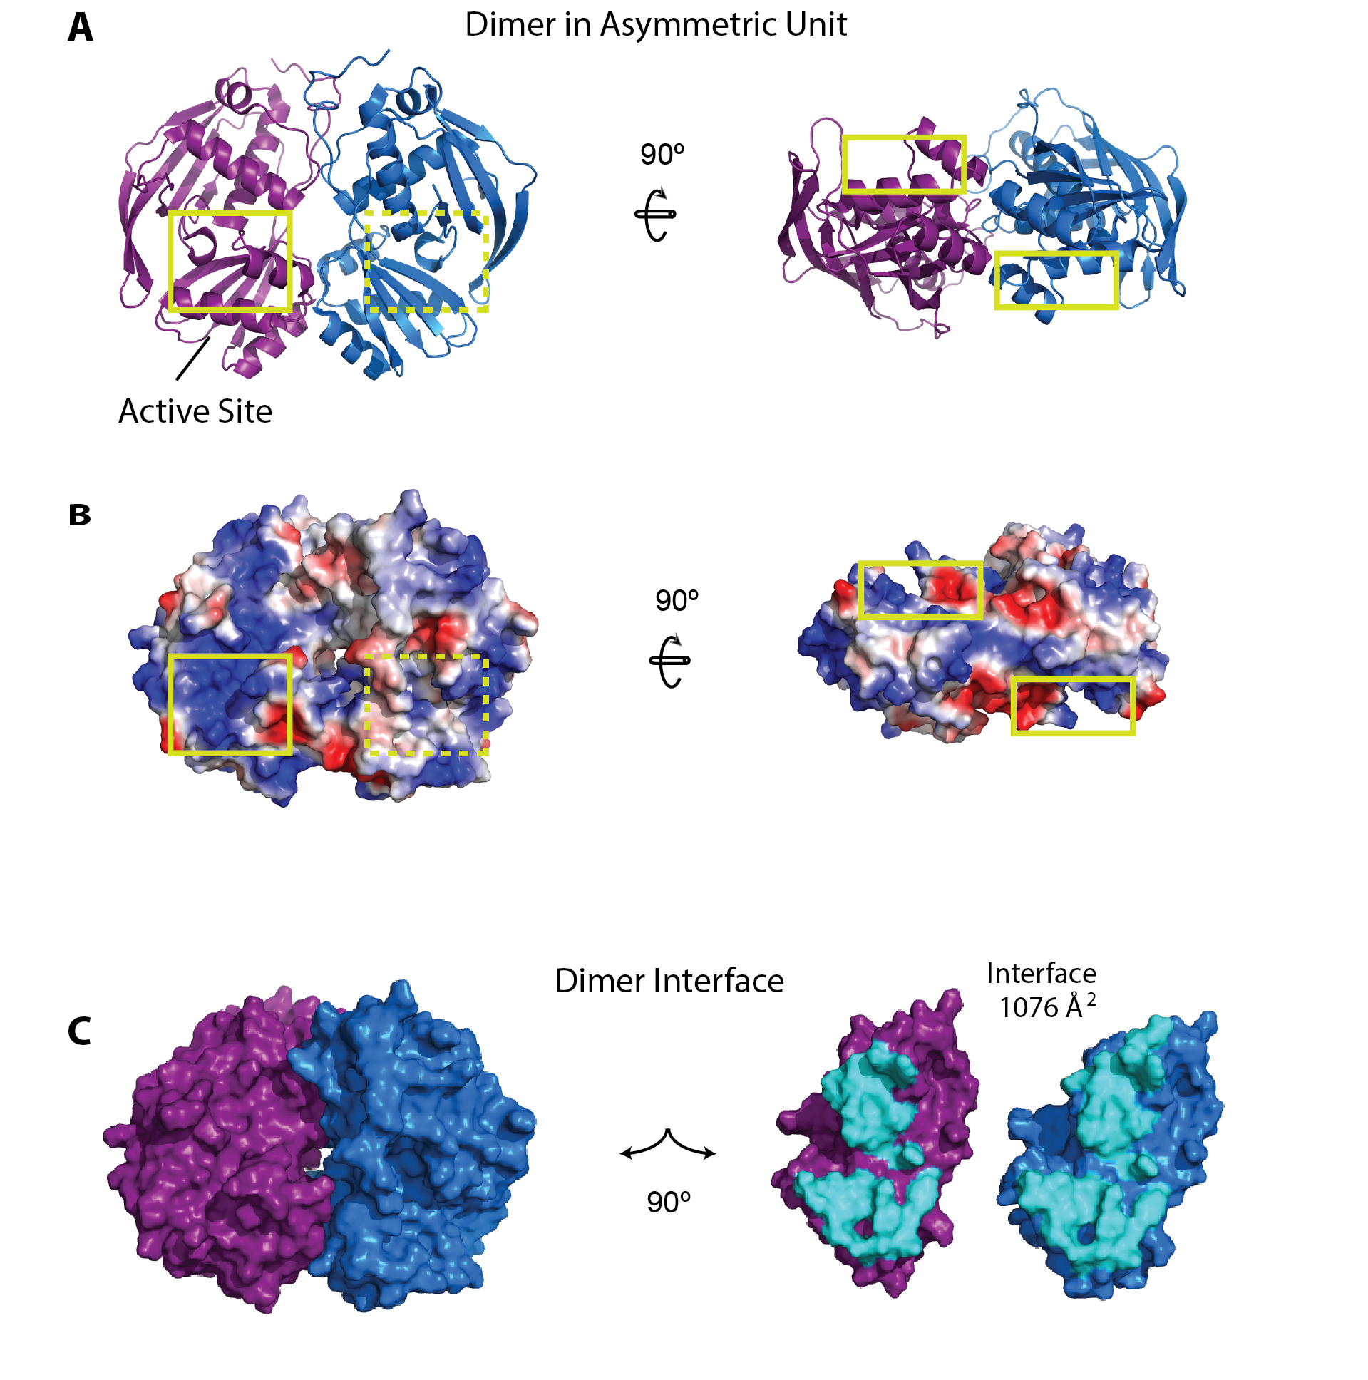
Supplemental Figure S5. Structural analysis of the crystallographic dimer. (A) Ribbon views of the side and bottom of the crystallographic dimer. A yellow square line indicates the location of the active site on proximal side, and a dashed square line indicates the active site on the opposite side (B) Surface charge is shown on side and bottom views of dimer. Active sites are indicated as in A. (C) The dimers are shown as a surface. The interface is shown as cyan where the monomers of the dimer have been rotated 90 degrees. The calculated surface area of the interface is 1076 Å².
Supplemental Figure S6

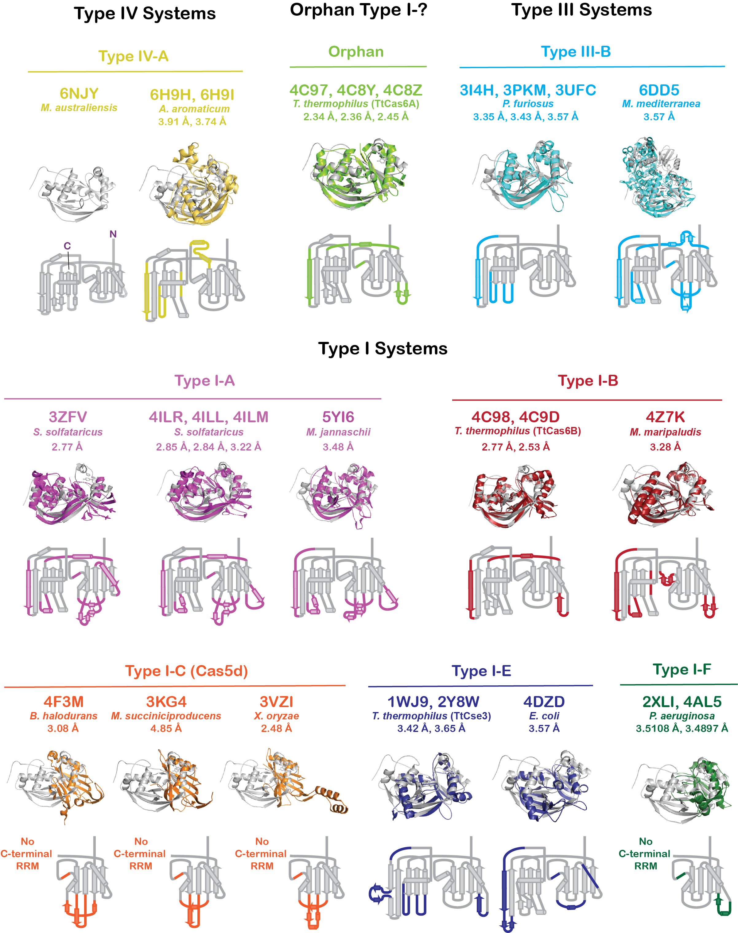
Supplemental Figure S6. Alignment of Ma Cas6-IV with Cas6 orthologs. Ma Cas6-IV was aligned with Cas6 and Cas5d models available in the PDB using the SSM (Secondary Structure Matching) tool in Coot. The structure of Ma Cas6-IV is shown in the top left corner. PDB codes, RMSDs, and organism names of aligned structures are indicated. A topology map of each structure is shown. It is indicated in color where the topology of the aligned structure is different from Ma Cas6-IV.

Supplemental Figure S7

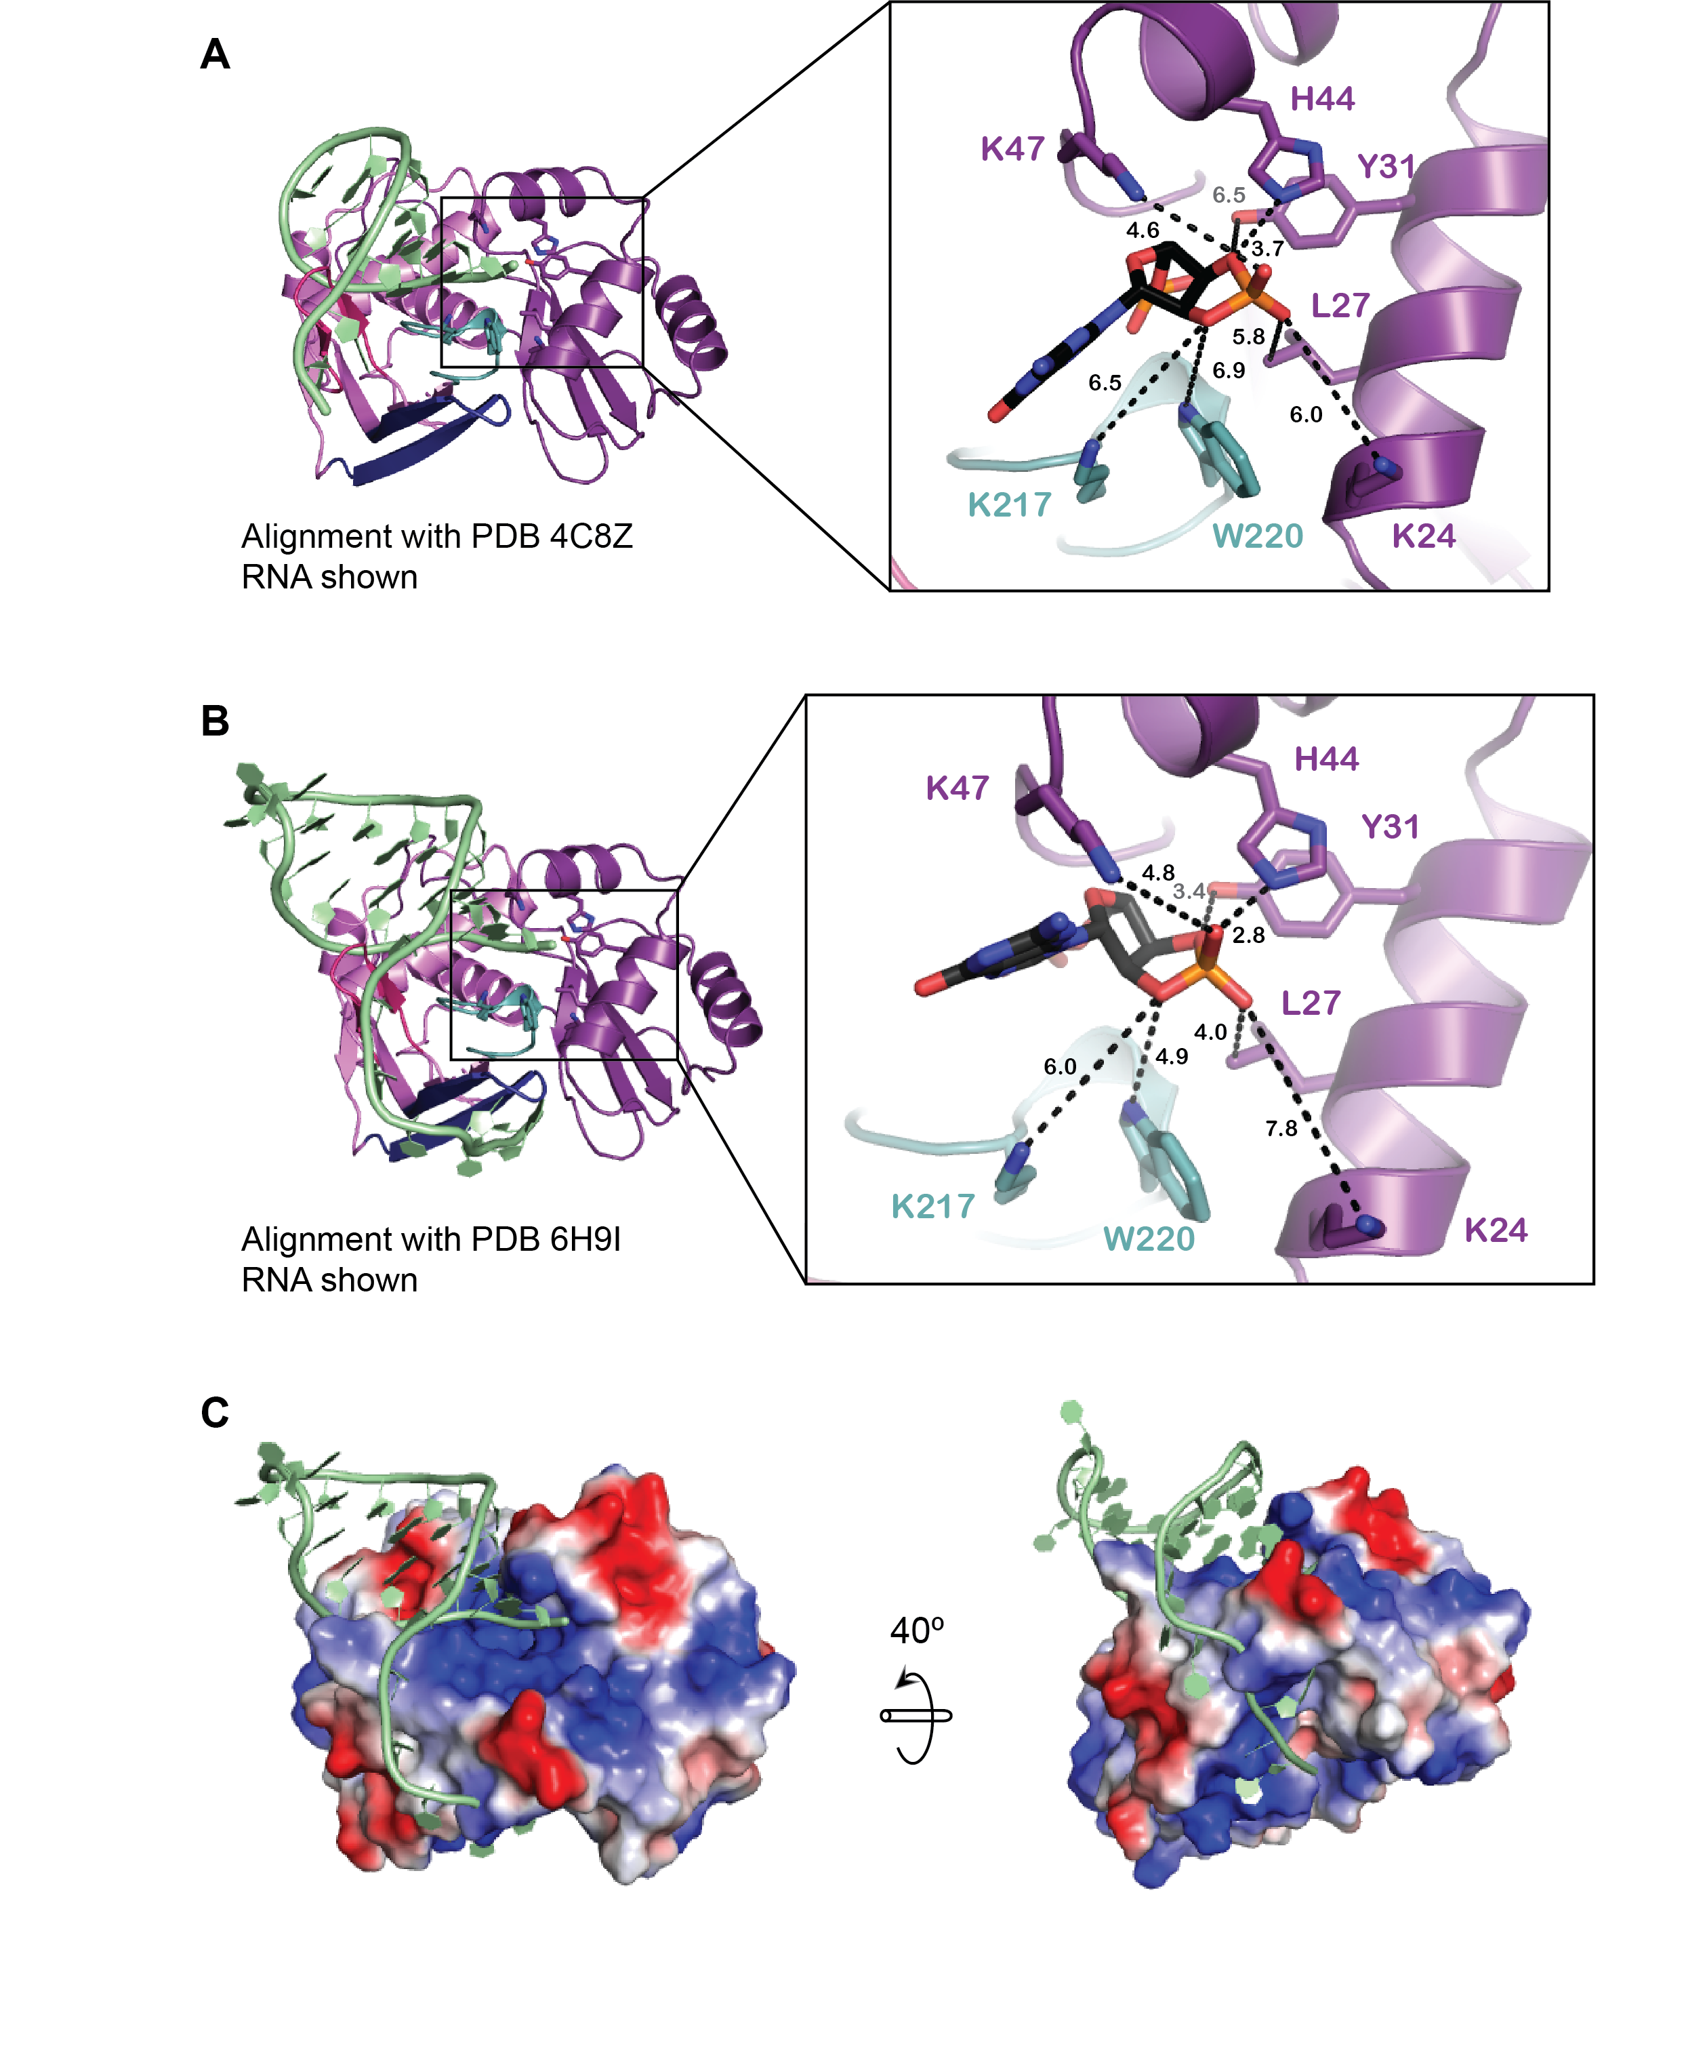

Supplemental Figure S7. Overlays of Ma Cas6 with Cas6 homologs bound to RNA. (A) Overlay of the RNA of PDB 4C8Z. Inset shows residues in putative active sites and distances to 2’-3’ cyclic phosphate. (B) Second overlay with RNA from Type IV Cas-homolog Csf5. Putative active site is shown in the inset. (C) Overlay of Csf5 on Ma Cas6 rendered as an electrostatic surface.
Supplemental Figure S8

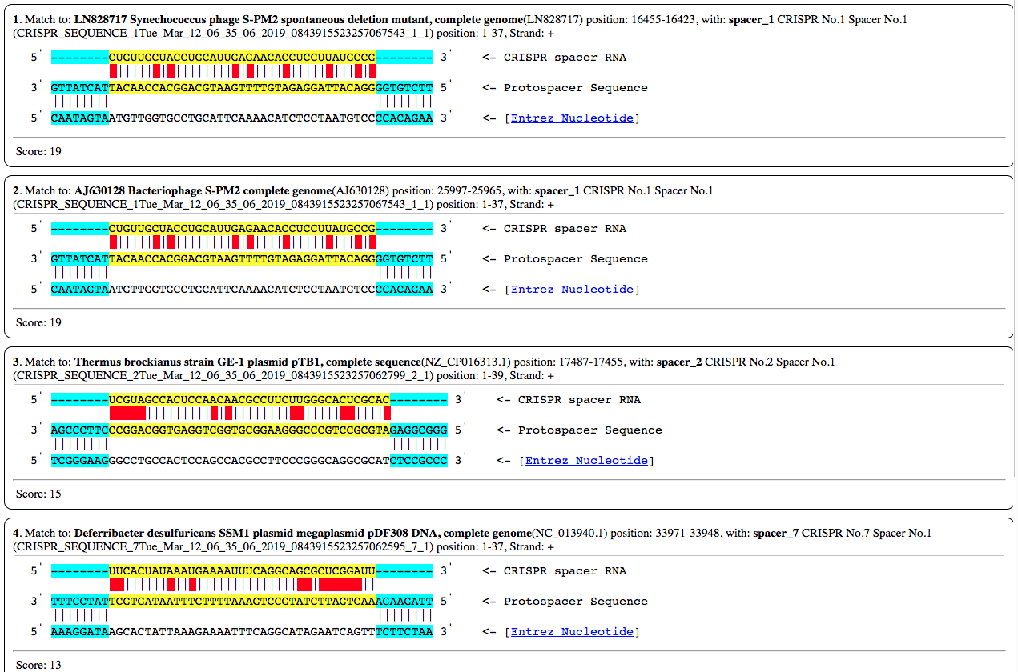

Supplemental Figure S8. CRISPRTarget results with Mahella australiensis spacer sequences as search criteria. Matches 1 and 2 are of the same phage. Mismatches are highlighted in red.

Table 1. Structural alignment data of Cas6 homologs from subtypes of CRISPR-Cas systems.

Subtype | Organism | Other Names | PDB IDª | RMSD (Å) | Aligned/Moving Residues | % Identity | References
I-A | Sulfolobus solfataricus | Sso2004 | 4ILR | 2.8495 | 187/279 | 15.508 | Shao, Y. and Li, H. (2013)
 |  |  | 4ILL | 2.8417 | 185/278 | 15.1351
 |  |  | 4ILM | 3.2212 | 188/279 | 12.766
 |  | Sso1437 | 3ZFV | 2.7694 | 165/259 | 16.9697 | Reeks, J. et al. (2013)
 | Methanocaldococcus jannaschii | Cas6 | 5YI6 | 3.4796 | 175/241 | 10.8571 | Lee, M.C. et al. (2018)
I-B | Thermus thermophilus | TTHB231 | 4C98 | 2.7742 | 172/242 | 17.4419 | Niewoehner, O. et al. (2014)
 |  |  | 4C9D | 2.5348 | 189/262 | 16.9312
 | Methanococcus maripaludis | Mm Cas6b | 4Z7K | 3.2812 | 167/218 | 16.1677 | Shao, Y. et al. (2016)
I-C | Bacillus halodurans | Cas5d | 4F3M | 3.0815 | 67/213 | 8.9552 | Nam, K.H. et al. (2012); Koo, Y. et al. (2013)
 | Mannheimia succiniciproducens |  | 3KG4 | 4.8526 | 43/184 | 13.9535
 | Streptococcus pyogenes |  | 3VZH | 5.005 | 52/194 | 11.5385
 | Xanthomonas oryzae |  | 3VZI | 2.4844 | 74/214 | 9.4595
I-E | Thermus thermophilus | TTHB192, Cse3 | 1WJ9 | 3.4209 | 134/188 | 10.4478 | Sashital, D.G. et al. (2011); Gesner, E.M. et al. (2011); Ebihara, A. et al. (2006)
 |  |  | 2Y8W | 3.6472 | 150/215 | 11.3333
 |  |  | 3QRP | 3.609 | 151/214 | 10.596
 | Escherichia coli | CasE | 4DZD | 3.5718 | 147/193 | 9.5238
I-F | Pseudomonas aeruginosa | Csy4 | 2XLI | 3.5108 | 85/167 | 3.5294 | Haurwitz, R.E. et al. (2010); Haurwitz, R.E. et al. (2012)
 |  |  | 4AL5 | 3.4897 | 89/189 | 2.2472
III-B | Pyrococcus furiosus | PfCas6 | 3I4H | 3.3531 | 180/232 | 13.3333 | Carte, J. et al. (2008); Wang, R. et al. (2011)
 |  |  | 3PKM | 3.4297 | 175/229 | 12
 |  |  | 3UFC | 3.5745 | 181/243 | 9.3923 | Park, H.M. et al. (2012)
 | Marinomonas mediterranea | Cas6 | 6DD5 | 3.3147 | 188/652 | 14.3617 | Mohr, G. et al. (2018)
IV-A | Aromatoleum aromaticum | Csf5 | 6H9H | 3.9062 | 108/250 | 8.3333 | Özcan, Ahsen, et al. (2019)
 |  |  | 6H9I | 3.7411 | 156/250 | 8.3333
Orphan | Thermus thermophilus | TTHB78 | 4C97 | 2.338 | 173/233 | 16.763 | Niewoehner, O. et al. (2014)
 |  |  | 4C8Y | 2.3557 | 180/238 | 16.6667
 |  |  | 4C8Z | 2.4531 | 184/238 | 16.8478

ªPDB ID key: apo (plain text), substrate bound (italics), product bound (bold).

