Supplementary Information

Pyridine-based complexes of copper(II) chloride and bromide: ligand conformation effects on crystal structure. Synthesis, structure and magnetic behavior of Cu(2-Cl-3-X’py)₂X₂ [X, X’ = Cl, Br]

ROBERT J. DUBOIS, CHRISTOPHER P. LANDEE, MELANIE RADEMEYER and MARK M. TURNBULL*

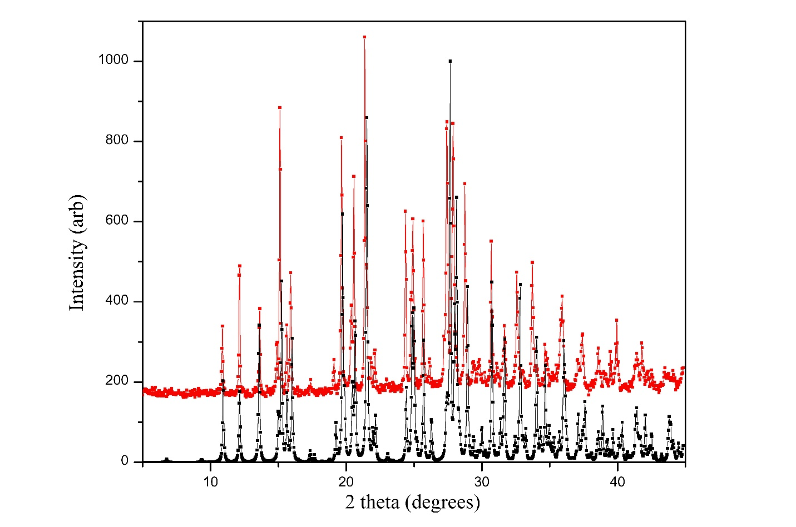
Figure S1. Comparison of experimental (red, upper) and theoretical (black, lower) powder patterns for 1.

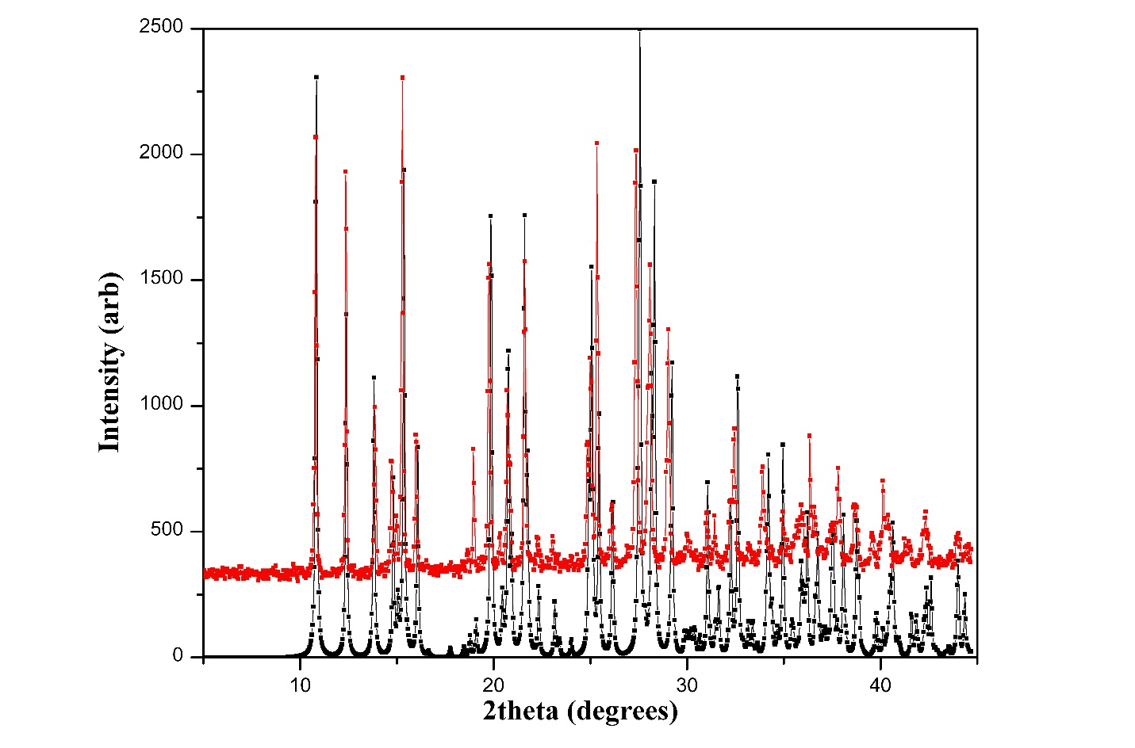
Figure S2. Comparison of experimental (red, upper) and theoretical (black, lower) powder patterns for 3.
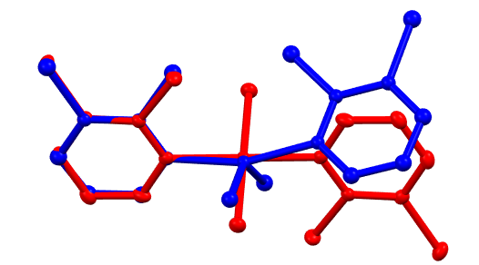
Figure S3. Superposition of the two crystallographically independent molecules of 1. The figure was generated using Mercury Version 4.0.0 (C.F. Macrae, P.R. Edgington, P. McCabe, E. Pidcock, G. P. Shields, R. Taylor, M. Towler, J. van de Streek. J. Appl. Cryst., 39, 453 (2006)).

