Supplemental material

Supplementary Table S1. Ingredient composition and nutrient levels of the basal diet
Ingredient | Content (%) | Nutrient level (calculated value)
Corn | 55.92 | Metabolizable energy (kcal/kg) | 3073
Soybean oil | 4.55 | Crude protein (%) | 16.50
Soybean meal | 29.77 | Crude fibre (%) | 3.15
Salt | 0.30 | Phosphorus (%) | 0.52
_{D,L}-Methionine | 0.20 | Calcium (%) | 0.96
Limestone | 6.0 | Lysine (%) | 1.05
Dicalcium phosphate | 1.86 | Methionine (%) | 0.52
Calcium carbonate | 1.10 | Methionine + cysteine (%) | 0.76
Premix¹ | 0.30
Total | 100.00
¹Premix provided per kg of diet: Cu, 10 mg; Fe, 50 mg; Mn, 60 mg; Zn, 65 mg; Se, 0.40 mg; vitamin A, 9000 IU; vitamin D₃, 3100 IU; vitamin E, 25 IU; vitamin B₁, 2.5 mg; vitamin B₂, 5 mg; vitamin B₁₂, 0.02 mg; biotin, 0.1 mg; folacin, 1 mg; pantothenic acid, 12 mg; nicotinic acid, 38 mg; and pyridoxine, 3.5 mg

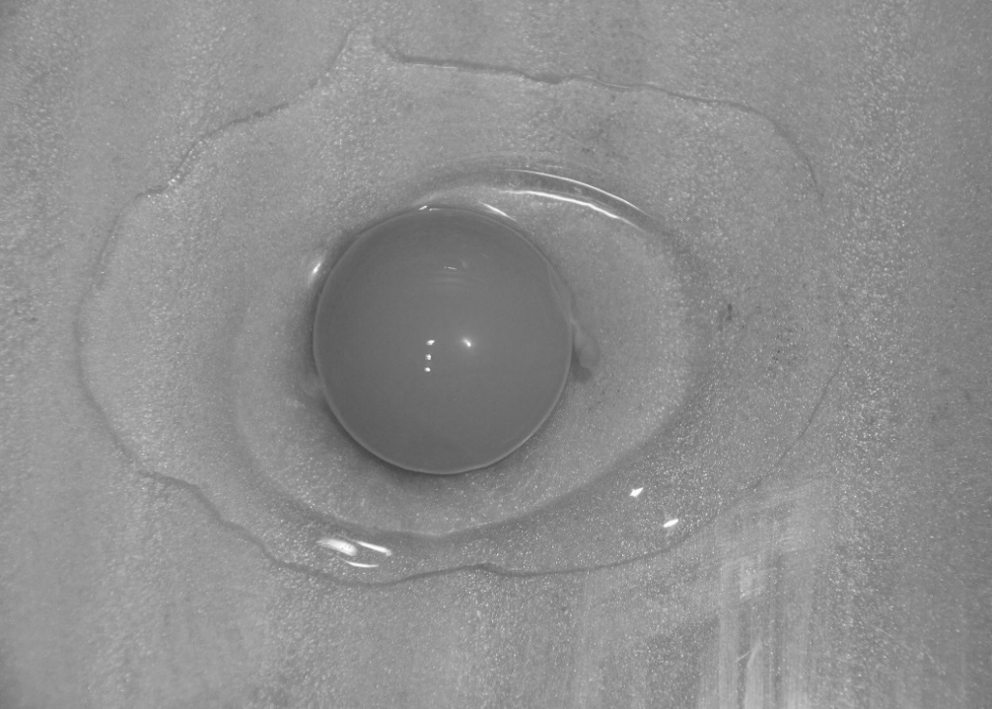
Yolk
Thick albumen
Thin albumen
Supplementary Figure S1. Internal egg material spread on a flat surface. Note the difference in density between the thick and thin albumen

