Glycosylated tris-bipyridine ferrous complexes as molecular mimics of densely packed glycoclusters on cell surfaces: spatial carbohydrate packing of the glycoclusters changes on additions of salts

Naoto Chigira ª, Nao Maeda ^{b}, Kanako Tachikawa ^{b}, Maki Sekiguchi ^{b}, Yoshitsugu Amano ª, Mayu Inokuchi ^{b}, Qintong Li ^{b}, and Teruaki Hasegawa ^{b, c,} ∗

ªGraduate School of Life Sciences, Toyo University, 1-1-1 Izumino, Itakura-machi, Ora-gun, Gumma 374-0193, Japan
^{b}Faculty of Life Sciences, Toyo University, 1-1-1 Izumino, Itakura-machi, Ora-gun, Gumma 374-0193, Japan
^{c}Bio-Nano Electronics Research Centre, Toyo University, 2100 Kujirai, Kawagoe, Saitama 350-8585, Japan

*Correspondence should be addressed to T.H. (t-hasegawa@toyo.jp)

Structures of Le^{X}, G_{M}3, Gg3, and LacCer (Chart S1), a colored version of Fig. 2 (Fig. S1), a colored version of Fig. 5 (Fig. S2), and ¹H/¹³C NMR spectra of the newly synthesized compounds.

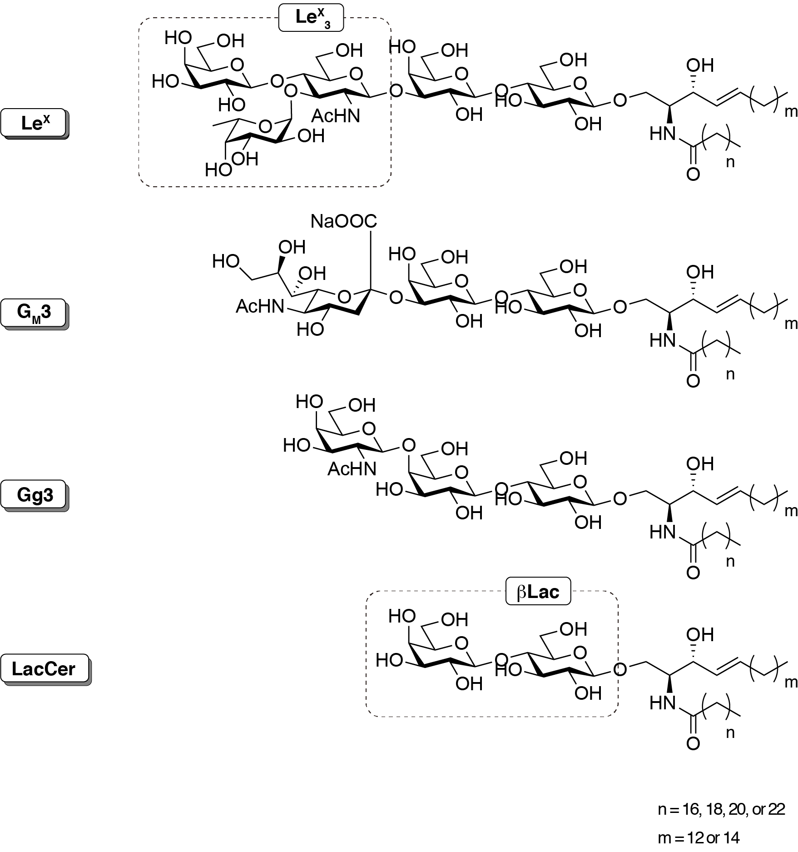

Chart S1. Structures of Le^{X}, G_{M}3, Gg3, and LacCer.

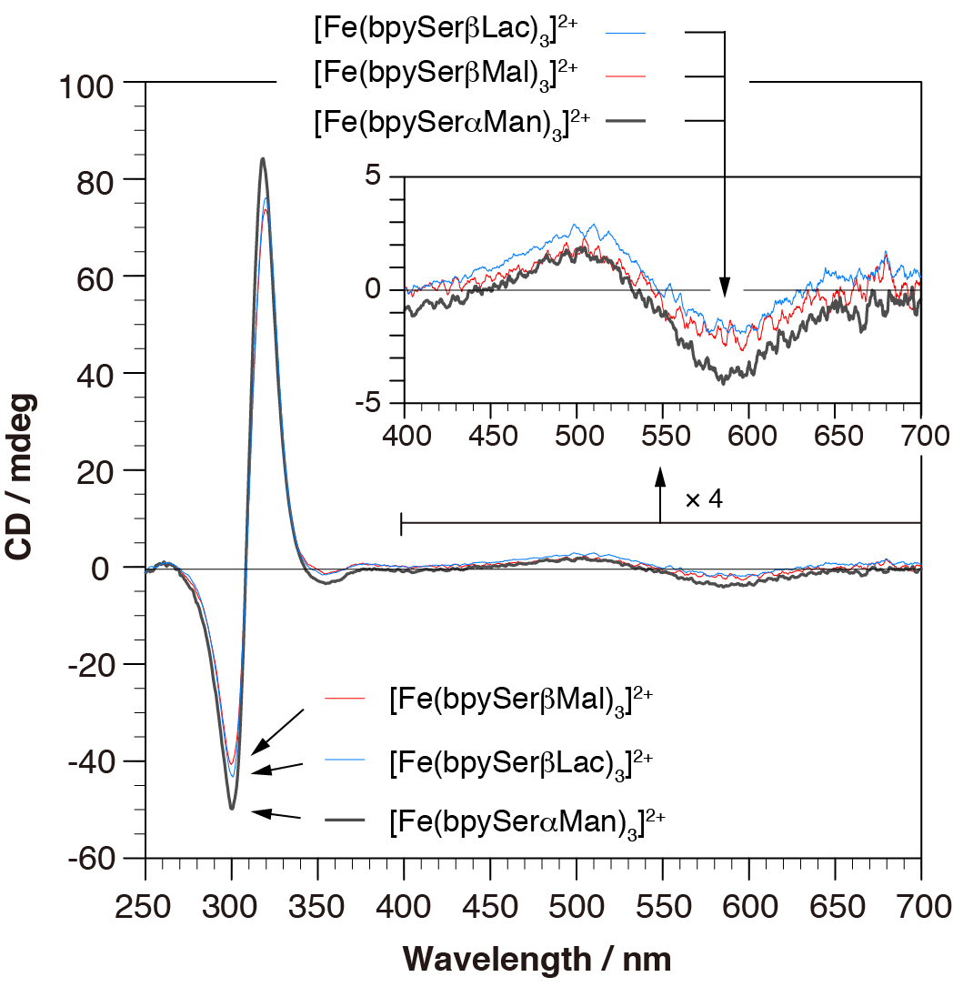

Fig. S1. Colored version of Fig. 2.

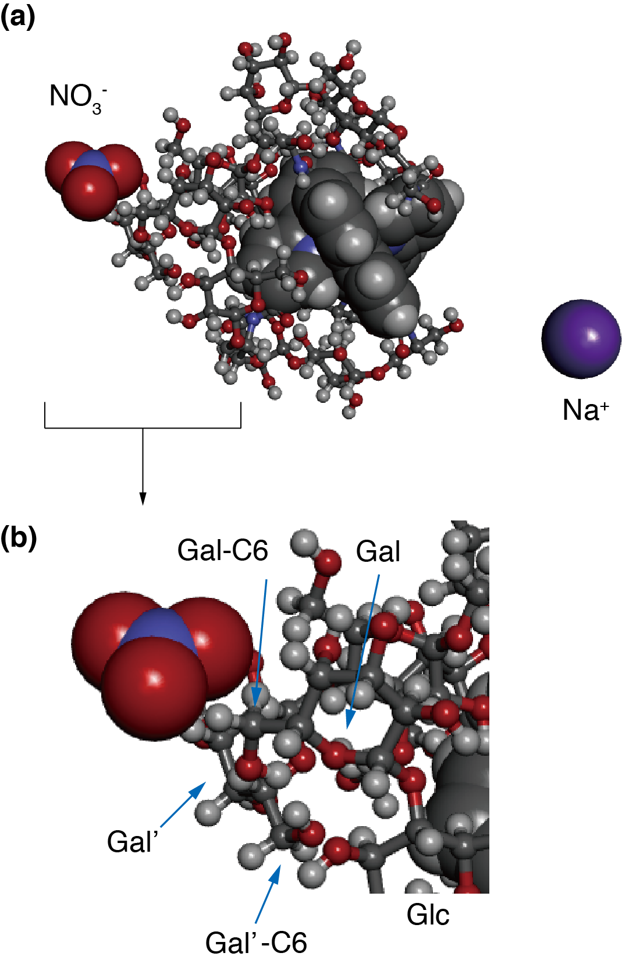
Fig. S2. Colored version of Fig. 5.

¹H/¹³C NMR spectra of bpySerMeLacAc

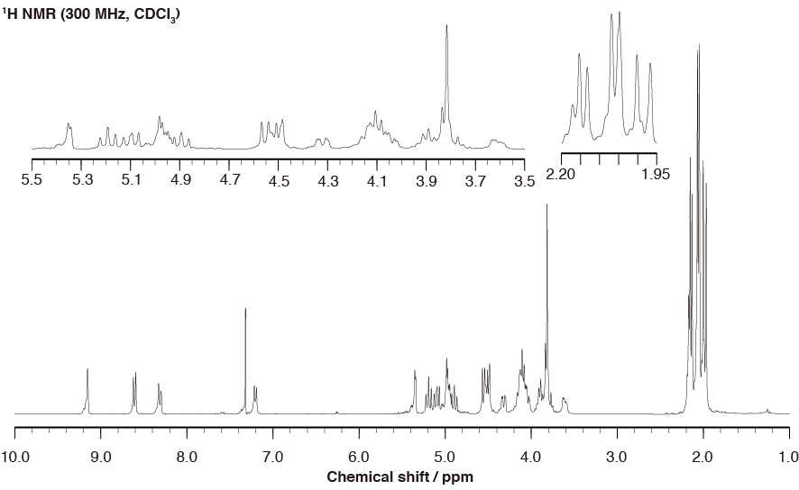

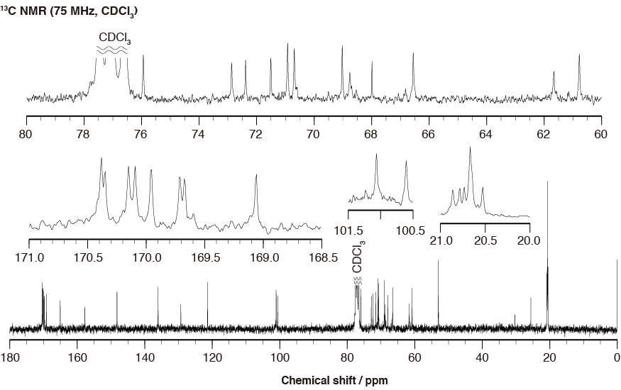

¹H/¹³C NMR spectra of bpySerMeMalAc

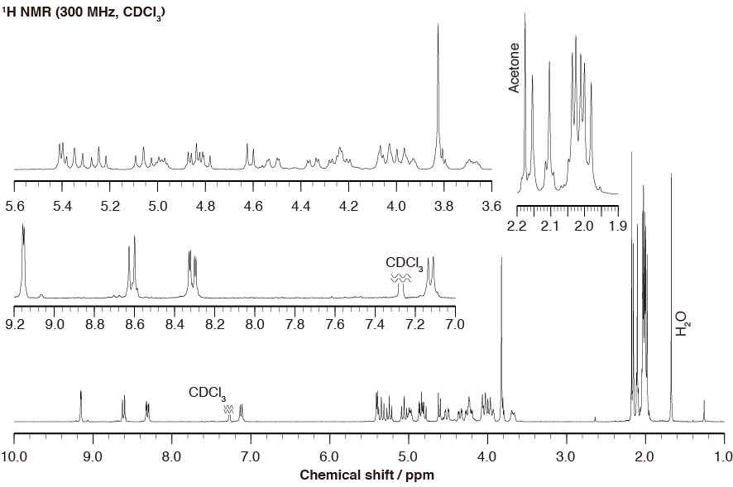

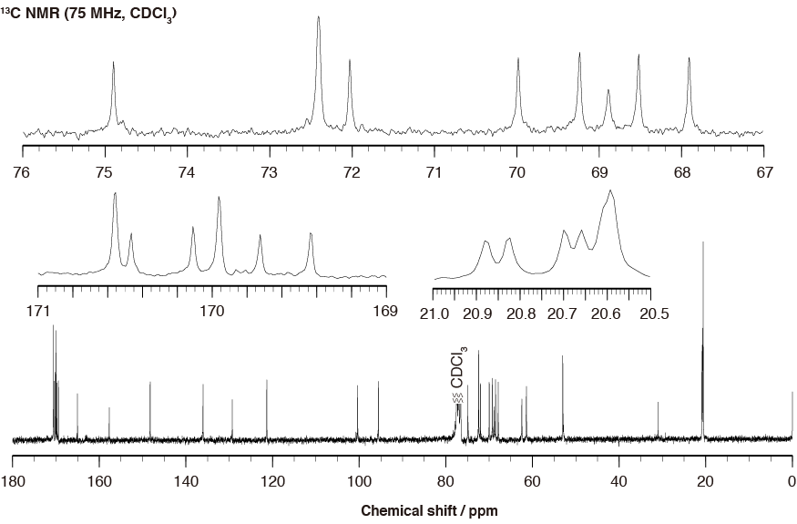
¹H/¹³C NMR spectra of bpySerMeManAc

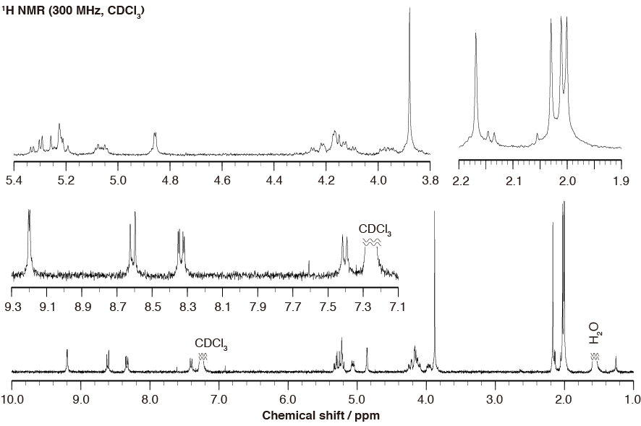

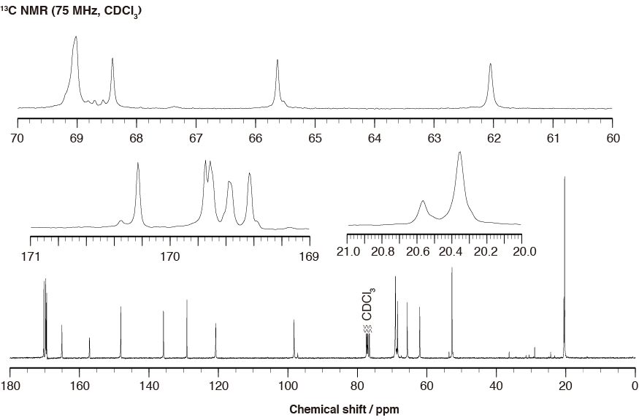
¹H/¹³C NMR spectra of bpySerLac

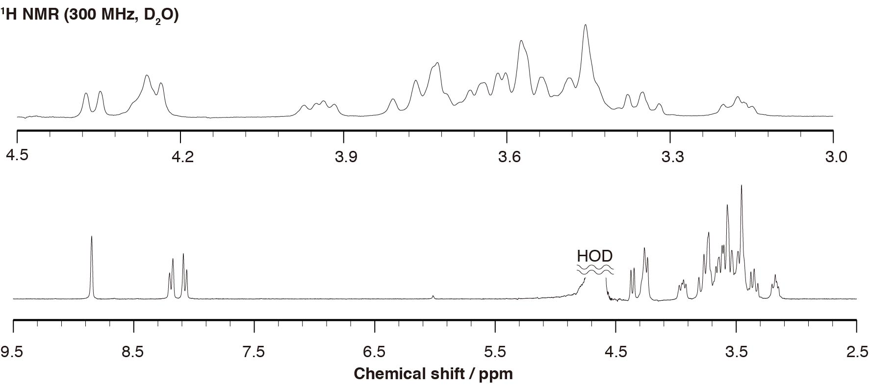

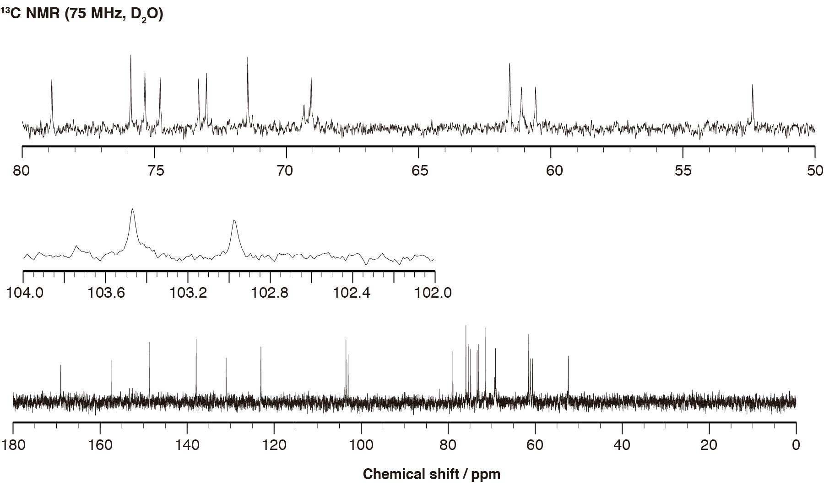

¹H/¹³C NMR spectra of bpySerMal

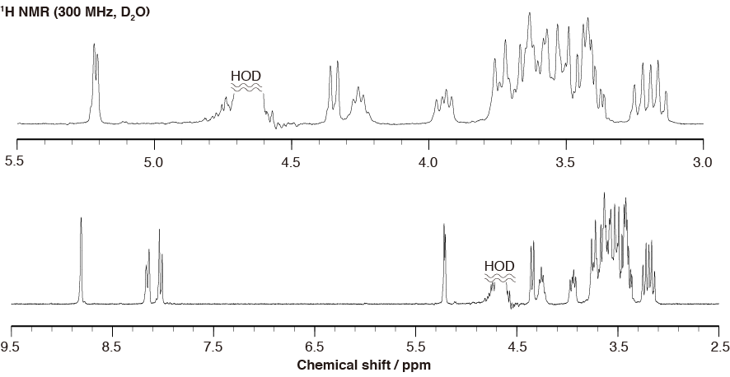

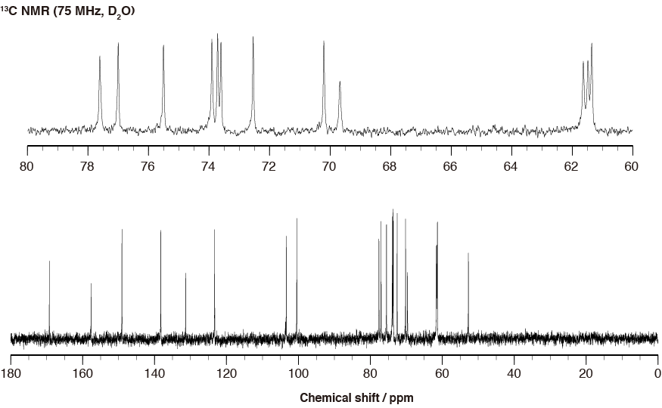

¹H/¹³C NMR spectra of bpySerMan

