Supplementary information
Figure S1. Methodological approach
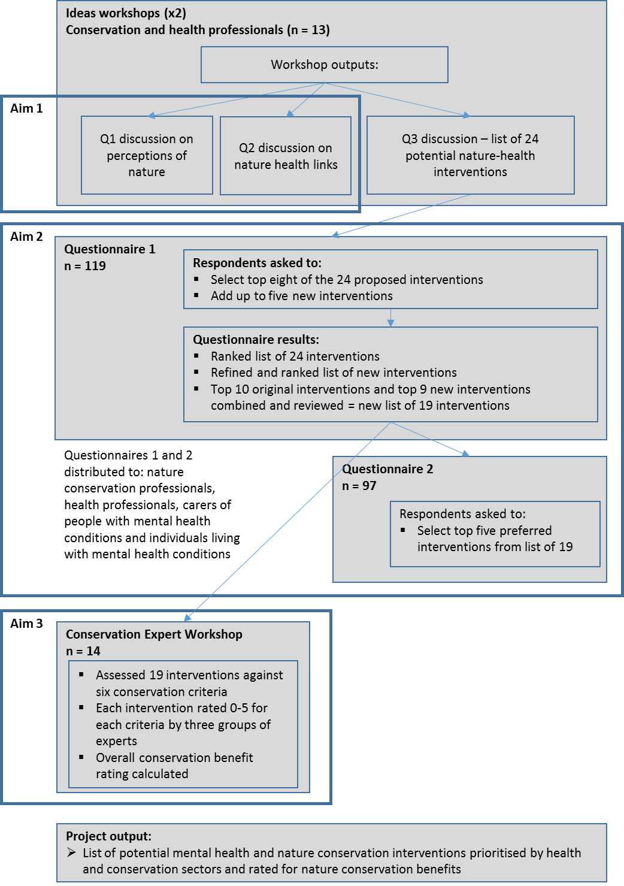
Figure S2. Age and gender distribution of the 94 respondents providing demographic information. The 95 respondents supplying demographic data voted for five (n = 1), six (n = 1), seven (n = 5) or eight interventions. In total, 64 females and 30 males responded (one respondent opted to not answer the gender question) and the majority of people were in the 35-54 age bracket.
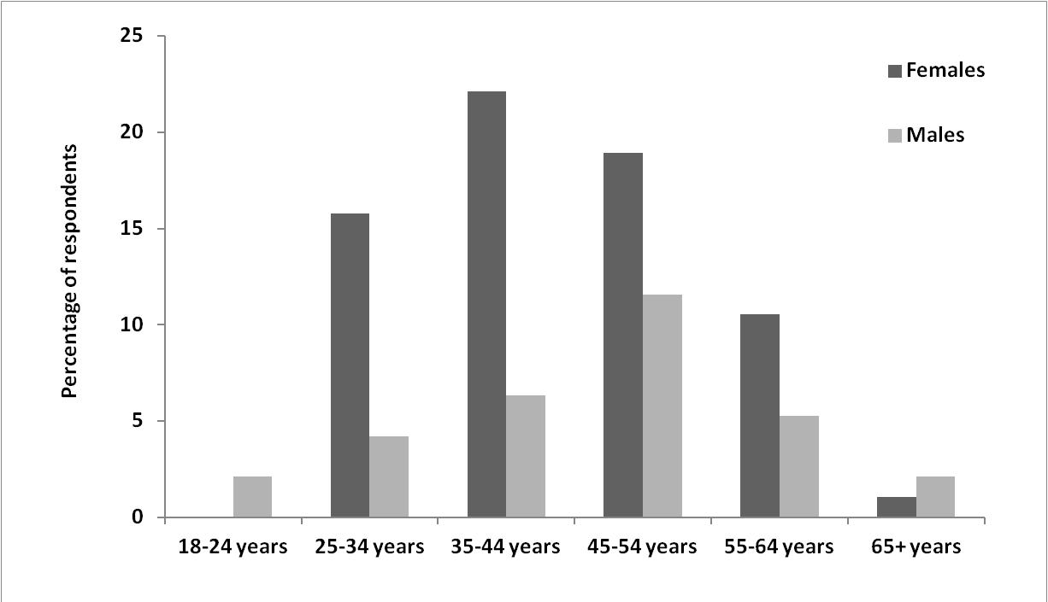

Table S1: The 24 nature interventions initially identified through the two Ideas Workshops, in ranked order as voted for by the first online survey.
Intervention | Category | Group Rank |  |  | Overall
 |  | Health | Conservation | Combined | Votes | Rank
Incorporate nature-based activities into Wellness and Recovery Action Plans. | Activity | 2 | 1 | 2 | 56 | 1a
Create allotments and garden therapy program to encourage personal development. | Activity | 1 | 4 | 12 | 56 | 1b
Create supported volunteer opportunities for NHS users and carers, e.g., conservation work on RSPB reserves. | Activity | 10 | 3 | 8 | 51 | 3a
Create more healing gardens or nature spaces in and around our buildings. | Physical Nature | 9 | 4 | 2 | 51 | 3b
Develop program for outdoor therapy sessions. | Activity | 2 | 8 | 2 | 49 | 5
Strengthen links between DPT and existing nature programs. | Activity | 5 | 21 | 2 | 46 | 6a
Develop occupational/vocational therapy sessions based on nature, e.g., making bird, bat, and bug boxes. | Activity | 7 | 10 | 12 | 46 | 6b
Create wild / unmanaged areas for wildlife that are accessible by nature paths. | Physical Nature | 17 | 2 | 17 | 45 | 8
Make it easier to use the outdoors in daily work, e.g., meetings, work-breaks, and therapies. | Access | 2 | 11 | 1 | 44 | 9
Create scheme for green prescriptions from GPs | Activity | 13 | 4 | 8 | 43 | 10
Make the outdoors more usable for work, e.g., benches, tables, outdoor meeting rooms, and rain shelters. | Access | 10 | 11 | 12 | 39 | 11
Research the question: what kinds of nature experiences improve mental health the most? How might this vary amongst different people? | Research | 20 | 7 | 2 | 38 | 12
Better recognition of the value of nature for staff and service users. | Mind-set | 15 | 11 | 17 | 37 | 13a
Utilise natural light and ventilation indoors, have opening windows. | Access | 7 | 15 | 2 | 37 | 13b
Improve quality of green spaces by increasing the range of plants, flowers, trees, ponds, etc. | Physical Nature | 15 | 11 | 17 | 34 | 15a
Have lots of bird, bat, and bug boxes on DPT sites. | Physical Nature | 19 | 15 | 8 | 34 | 15b
Create wild / unmanaged areas for wildlife. | Physical Nature | 13 | 15 | 8 | 34 | 15c
Have more photos, art, and murals depicting nature and scenic views in work spaces and clinic rooms. | Access | 5 | 20 | 12 | 34 | 15d
Contribute to the evidence base for nature based-health interventions. Determining what needs to be measured and how intervention outcomes can be assessed, e.g., quality of life indices, self-esteem, self-worth. | Research | 10 | 19 | 12 | 32 | 19
Create opportunities to explore nature, e.g., pond-dipping, rock pooling, bug hunting. | Activity | 18 | 9 | 22 | 30 | 20
Develop outdoor educational resources and sensory experiences, e.g., adult-aged show and tell sessions and nature tables. | Activity | 21 | 15 | 17 | 26 | 21
Have more indoor potted plants. | Physical Nature | 22 | 22 | 17 | 15 | 22
Research the question: how wild does nature need to be? i.e., how important is biological diversity to mental health? | Research | 23 | 22 | 22 | 7 | 23
Have window boxes wherever possible. | Physical Nature | 23 | 24 | 22 | 5 | 24

Table S2. The list of 19 ‘top’ nature interventions in ranked order, as voted for in the second online survey.
Intervention | Theme | Group Rank |  |  | Overall
 |  | Health | Conservation | Combined | Votes | Rank
Create more healing gardens and nature spaces in and around our buildings, and improve the quality of existing green space by increasing the range of plants, flowers, trees, ponds, wildlife, and sensory experiences. | Physical Nature | 1 | 1 | 2 | 36 | 1
Create supported volunteer opportunities for NHS service users and carers, e.g., appropriate conservation work on the DPT estates, RSPB reserves, other conservation charities, etc. | Activity | 6 | 3 | 5 | 29 | 2a
Develop programs for outdoor/environmental therapy sessions, both on the DPT estates and externally, e.g. mindfulness walking/sitting, day trips to National Parks | Activity | 1 | 5 | 6 | 29 | 2b
Create or link to nature-based physical activity programs, e.g. Nature walks, bicycle rides, social walking groups | Activity | 1 | 5 | 11 | 29 | 2c
Incorporate nature-based activities into Wellness and Recovery Action Plans. | Activity | 13 | 2 | 2 | 27 | 5
Create scheme for green prescriptions from GPs. | Activity | 13 | 4 | 1 | 25 | 6
Create allotments, horticultural therapy, plant care, and farming programs to encourage personal development. | Activity | 4 | 8 | 6 | 24 | 7
Increase awareness of any nature-based programs within the DPT, and strengthen links with external nature-based activity or therapy programs. | Activity | 9 | 8 | 6 | 20 | 8
Develop indoor/outdoor spaces so gardens and outdoor spaces still feel accessible in bad weather, e.g., open folding doors and verandas that bring the outside in for colder days, or for those who don't feel like venturing outside completely. | Access | 4 | 16 | 11 | 19 | 9a
Challenge the values of the DPT, ie, stop focusing on illness and medication and place more value on our need to be connected to our natural world and the benefits derived from access to nature. | Mind-set | 6 | 8 | 11 | 19 | 9b
Make it easier to use the outdoors in daily work, e.g., meetings, work-breaks, and therapies, and provide more benches, tables, and rain shelters. | Access | 11 | 7 | 6 | 18 | 11a
Create wild /unmanaged areas for wildlife that are accessible by nature paths. | Physical Nature | 9 | 8 | 11 | 18 | 11b
Develop or link to animal therapy and animal care programs, e.g. donkey sanctuary, pet therapy, wildlife rescue/rehabilitation groups. | Activity | 8 | 18 | 2 | 18 | 11c
Promote art in nature with painting, photography, seasonal nature-based crafts, etc. Artistic creations can be brought inside to improve the presence of nature indoors. | Activity | 11 | 15 | 6 | 16 | 14
Research how patients currently use nature in their recovery and support them to improve their home environments and gardens. | Research | 15 | 8 | 11 | 13 | 15
Develop occupational/vocational therapy sessions based on nature, e.g., making bird, bat, and bug boxes. | Activity | 17 | 8 | 17 | 12 | 16
Have educational nature activities, e.g., walks led by naturalists explaining: natural history, how we integrate with other species, and what's important for ecosystem health on both small scales and in big picture. | Activity | 15 | 8 | 17 | 11 | 17
Provide nature based educational courses and resources, e.g., plant and animal identification courses, wildlife photography, natural history, nature books, etc. | Learning | 17 | 18 | 17 | 8 | 18
Create wildlife spotting and monitoring programs on the DPT estates using educational notice boards and live twitter feeds. | Activity | 19 | 16 | 11 | 7 | 19

