Supporting Information

Coixlachryside B: A new benzoxazinoid glycoside from the roots of Coix lachryma-jobi var. ma-yuen (Gramineae)

Yun-Hyeok Choi^{a,b}, Chun Whan Choiª, Seong Hyun Hongª, Se Kyu Park^{c}, Joa Sub Oh^{d},
Dongho Lee^{b,}, and Seong Su Hong^{a,}*

ªBio-Center, Gyeonggido Business & Science Accelerator (GBSA), Suwon 16229, Republic of Korea.
^{b}Department of Biosystems and Biotechnology, College of Life Sciences and Biotechnology, Korea University, Seoul 02841, Republic of Korea.
^{c}Hansolbio Co., Ltd, Seongnam 13215, Republic of Korea.
^{d}College of Pharmacy, Dankook University, Cheonan 31116, Republic of Korea.

List of Supporting Information Page
Characterization of Compounds 2, 3 and 5-11………………..…………………………….. S3
Figure S1. ¹H NMR spectrum (700 MHz, DMSO-d₆) of coixlachryside B (1) ……………. S6
Figure S2. ¹³C NMR spectrum (175 MHz, DMSO-d₆) of coixlachryside B (1) …………… S7
Figure S3. DEPT135 spectrum of coixlachryside B (1) ………………………..………….. S8
Figure S4. ¹H-¹H COSY spectrum of coixlachryside B (1) ……….………………………. S9
Figure S5. HSQC spectrum of coixlachryside B (1) …………………….………………. S10
Figure S6. HMBC spectrum of coixlachryside B (1) ……………….……………..………. S11
Figure S7. HRESIMS spectrum of coixlachryside B (1) …………………………………. S12
Figure S8. CD spectrum of coixlachryside B (1) …………………………………………. S13
Figure S9. ¹H NMR spectrum (700 MHz, methanol-d₄) of 8S-tarennone (2) …………. S14
Figure S10. ¹³C NMR spectrum (175 MHz, methanol-d₄) of 8S-tarennone (2) ………. S15
Figure S11. DEPT135 spectrum of 8S-tarennone (2) ………………………..………….. S16
Figure S12. ¹H-¹H COSY spectrum of 8S-tarennone (2) ……….………………………. S17
Figure S13. HSQC spectrum of 8S-tarennone (2) …………………….………………. S18
Figure S14. HMBC spectrum of 8S-tarennone (2) ……………….……………..………. S19
Figure S15. HRESIMS spectrum of 8S-tarennone (2) …………………………………. S20

Characterization of Compounds 2, 3 and 5-11

(2R)-2-Hydroxy-7-methoxy-1,4(2H)-benzoxazin-3-one glucoside (HMBOA-Glc, 2)
White amorphous powder; [α]_{D}²⁵ +53.9º (c = 1.0, MeOH); CD (MeOH) λ_{max} (Δε) 218 (+12.4) nm; ¹H-NMR (700 MHz, DMSO-d₆) δ 10.8 (1H, s, NH), 6.83 (1H, d, J = 9.1 Hz, H-5), 6.75 (1H, d, J = 2.8 Hz, H-8), 6.59 (1H, dd, J = 8.4, 2.8 Hz, H-6), 5.65 (1H, s, H-2), 4.55 (1H, d, J = 8.4 Hz, H-1'), 3.71 (1H, dd, J = 11.9, 2.1 Hz, H_{a}-6'), 3.70 (3H, s, OCH₃), 3.43 (1H, dd, J = 11.9, 6.3 Hz, H_{b}-6'), 3.18 (1H, m, H-5'), 3.14 (1H, t, J = 9.1 Hz, H-3'), 3.01 (1H, t, J = 9.1 Hz, H-4'), 2.91 (1H, t, J = 9.1 Hz, H-2'); ¹³C-NMR (175 MHz, DMSO-d₆) δ 159.2 (C-3), 155.0 (C-7), 140.5 (C-9), 119.1 (C-10), 115.2 (C-5), 108.1 (C-6), 103.2 (C-8), 102.1 (C-1'), 94.3 (C-2'), 76.9 (C-3'), 76.1 (C-5'), 72.6 (C-2'), 69.1 (C-4'), 60.5 (C-6'), 54.7 (OCH₃); ESI-MS m/z 380 [M +Na]⁺, 356 [M – H]–.

(2R)-2-Hydroxy-4,7-dimethoxy-1,4(2H)-benzoxazin-3-one glucoside (HDMBOA-Glc, 3)
White amorphous powder; [α]_{D}²⁵ +15.5º (c = 0.5, MeOH); CD (MeOH) λ_{max} (Δε) 216 (+18.1) nm; ¹H-NMR (700 MHz, CD₃OD) δ 7.18 (1H, d, J = 8.4 Hz, H-5), 6.78 (1H, d, J = 2.1 Hz, H-8), 6.72 (1H, dd, J = 8.4, 2.1 Hz, H-6), 5.88 (1H, s, H-2), 4.67 (1H, d, J = 8.4 Hz, H-1'), 3.94 (3H, s, N-OCH₃), 3.87 (1H, dd, J = 11.9, 2.1 Hz, H_{a}-6'), 3.78 (3H, s, 7-OCH₃), 3.68 (1H, dd, J = 11.9, 4.9 Hz, _{b}-6'), 3.32 (2H, m, H-3', 5'), 3.29 (1H, t, J = 9.1 Hz, H-4'), 3.17 (1H, t, J = 9.1 Hz, H-2'); ¹³C-NMR (175 MHz, CD₃OD) δ 159.0 (C-3), 156.8 (C-7), 143.5 (C-9), 120.6 (C-10), 114.5 (C-5), 110.1 (C-6), 105.3 (C-8), 104.1 (C-1'), 98.4 (C-2), 78.5 (C-5'), 77.9 (C-3'), 74.7 (C-2'), 71.0 (C-4'), 63.4 (N-OCH₃), 62.6 (C-6'), 56.2 (7-OCH₃); ESI-MS m/z 410 [M + Na]⁺.

8R-Evofolin B (5)
White amorphous powder; [α]_{D}²⁵ ‒5.6º (c = 0.2, MeOH); CD (MeOH) λ_{max} (Δε) 237 (‒2.22), 261 (+1.13), 305 (‒1.30) nm; ¹H-NMR (700 MHz, CD₃OD) δ 7.61 (1H, dd, J = 8.4, 2.4 Hz, H-6'), 7.56 (1H, d, J = 2.1 Hz, H-2'), 6.89 (1H, d, J = 2.1 Hz, H-2''), 6.80 (1H, d, J = 8.4 Hz, H-5'), 6.75 (1H, dd, J = 8.4, 2.1 Hz, H-6''), 6.72 (1H, d, J = 8.4 Hz, H-5''), 4.74 (1H, dd, J = 9.1, 5.6 Hz, H-2), 4.24 (1H, dd, J = 11.2, 9.1 Hz, H_{a}-3), 3.86 (3H, s, 3-OCH₃), 3.82 (3H, s, 3'-OCH₃), 3.70 (1H, dd, J = 11.5, 5.6 Hz, H_{b}-3); ¹³C-NMR (175 MHz, CD₃OD) δ 199.6 (C-1), 153.1 (C-4'), 149.3 (C-3''), 148.9 (C-3'), 147.0 (C-4''), 130.4 (C-1'), 129.9 (C-1''), 125.2 (C-6'), 122.2 (C-6''), 116.6 (C-5''), 115.7 (C-5'), 112.7 (C-2''), 112.6 (C-2'), 65.5 (C-3), 56.4 (OCH₃), 56.3 (OCH₃), 56.3 (C-2); ESI-MS m/z 319 [M + H]⁺, 341 [M + Na]⁺, 317 [M – H]–; HRESIMS (positive) m/z 319.11843 [M + H]⁺ (calcd for C₁₇H₁₈O₆, 319.11762).

3,4,5-Trimethoxyphenylmethanol (6)
Yellow powder; ¹H-NMR (700 MHz, CD₃OD) δ 6.67 (2H, s, H-2, 6), 4.54 (2H, s, H-7), 3.83 (6H, s, 3, 5-OCH₃), 3.75 (3H, s, 4-OCH₃); ¹³C-NMR (175 MHz, CD₃OD) δ 154.5 (C-3, 5), 138.1 (C-4), 139.0 (C-1), 105.0 (C-2, 6), 65.3 (C-7), 61.1 (4-OCH₃), 56.5 (3, 5-OCH₃); ESI-MS m/z 199 [M + H]⁺, 221 [M + Na]⁺.

α-Hydroxypropiosyringone (7)
White amorphous powder; ¹H-NMR (700 MHz, CD₃OD) δ 7.32 (2H, s, H-2, 6), 5.19 (1H, q, J = 6.3 Hz, H-8), 3.90 (6H, s, 3, 5-OCH₃), 1.41 (3H, d, J = 6.3 Hz, H-9); ¹³C-NMR (175 MHz, CD₃OD) δ 201.9 (C-7), 149.1 (C-3, 5), 142.9 (C-4), 126.2 (C-1), 107.7 (C-2, 6), 70.0 (C-8), 56.9 (3, 5-OCH₃), 22.1 (C-9); ESI-MS m/z 227 [M + H]⁺, 249 [M + Na]⁺, 225 [M – H]–.

β-Hydroxypropiovanillone (8)
Colorless amorphous powder; ¹H-NMR (700 MHz, CD₃OD) δ 7.57 (1H, dd, J = 8.4, 2.1 Hz, H-6), 7.54 (1H, d, J = 2.1 Hz, H-2), 6.86 (1H, d, J = 8.4 Hz, H-5), 3.94 (2H, t, J = 6.3 Hz, H-9), 3.90 (3H, s, 3-OCH₃), 3.16 (2H, t, J = 6.3 Hz, H-8); ¹³C-NMR (175 MHz, CD₃OD) δ 199.7 (C-7), 153.3 (C-4), 149.1 (C-3), 130.6 (C-1), 124.7 (C-6), 115.8 (C-5), 111.8 (C-2), 58.9 (C-9), 56.4 (3-OCH₃), 41.6 (C-8); ESI-MS m/z 197 [M + H]⁺, 219 [M + Na]⁺, 195 [M - H]⁻.

β-Hydroxypropiosyringone (9)
Colorless amorphous powder; ¹H-NMR (700 MHz, CD₃OD) δ 7.31 (2H, s, H-2, 6), 3.95 (1H, t, J = 6.3 Hz, H-9), 3.90 (6H, s, 3, 5-OCH₃), 3.18 (1H, t, J = 6.3 Hz, H-8); ¹³C-NMR (175 MHz, CD₃OD) δ 199.6 (C-7), 149.0 (C-3, 5), 142.5 (C-4), 129.2 (C-1), 107.2 (C-2, 6), 58.9 (C-9), 56.8 (3, 5-OCH₃), 41.7 (C-8); ESI-MS m/z 227 [M + H]⁺, 249 [M + Na]⁺, 225 [M - H]⁻.

1-O-Feruloylglycerol (10)
White amorphous powder; ¹H-NMR (700 MHz, CD₃OD) δ 7.65 (1H, d, J = 16.1 Hz, H-7), 7.19 (1H, d, J = 2.1 Hz, H-2), 7.08 (1H, dd, J = 8.4, 2.1 Hz, H-6), 6.81 (1H, d, J = 8.4 Hz, H-5), 6.39 (1H, d, J = 16.1 Hz, H-8), 4.26 (1H, dd, J = 11.2, 4.2 Hz, H_{a}-1'), 4.17 (1H, dd, J = 11.2, 6.3 Hz, H_{b}-1'), 3.87 (1H, m, H-2'), 3.61 (2H, m, H-3'); ¹³C-NMR (175 MHz, CD₃OD) δ 169.2 (C-9), 150.6 (C-4), 149.4 (C-3), 147.0 (C-7), 127.7 (C-1), 124.1 (C-6), 116.5 (C-5), 115.3 (C-8), 111.7 (C-2), 71.3 (C-2'), 66.6 (C-1'), 64.1 (C-3'), 56.3 (3-OCH₃); ESI-MS m/z 269 [M + H]⁺, 291 [M + Na]⁺, 267 [M – H]–.

10Z,13Z-nonadecadienoic acid (11)
White amorphous powder; ¹H-NMR (700 MHz, CDCl₃) δ 5.36-5.29 (4H, m, H-10, 11, 13, 14), 2.74 (2H, t, J = 7.0 Hz, H-12), 2.32 (2H, t, J = 7.0 Hz, H-2), 2.02 (4H, dd, J = 14.0, 7.0 Hz, H-9, 15), 1.61 (2H, m, H-3), 1.35-1.23 (16H, m, H-4, 5, 6, 7, 8, 16, 17, 18), 0.86 (3H, t, J = 7.7 Hz, H-19); ¹³C-NMR (175 MHz, CDCl₃) δ 179.9 (C-1), 130.2 (C-10), 130.0 (C-14), 128.1 (C-11), 127.9 (C-13), 34.1 (C-2), 31.5 (C-17), 29.6 (C-8), 29.4 (C-6, 7), 29.2 (C-16), 29.1 (C-5), 29.0 (C-4), 27.2 (C-15), 27.1 (C-9), 25.6 (C-12), 24.7 (C-3), 22.6 (C-18), 14.1 (C-19); ESI-MS m/z 295 [M + H]⁺, 317 [M + Na]⁺, 293 [M – H]–.

Figure S1.

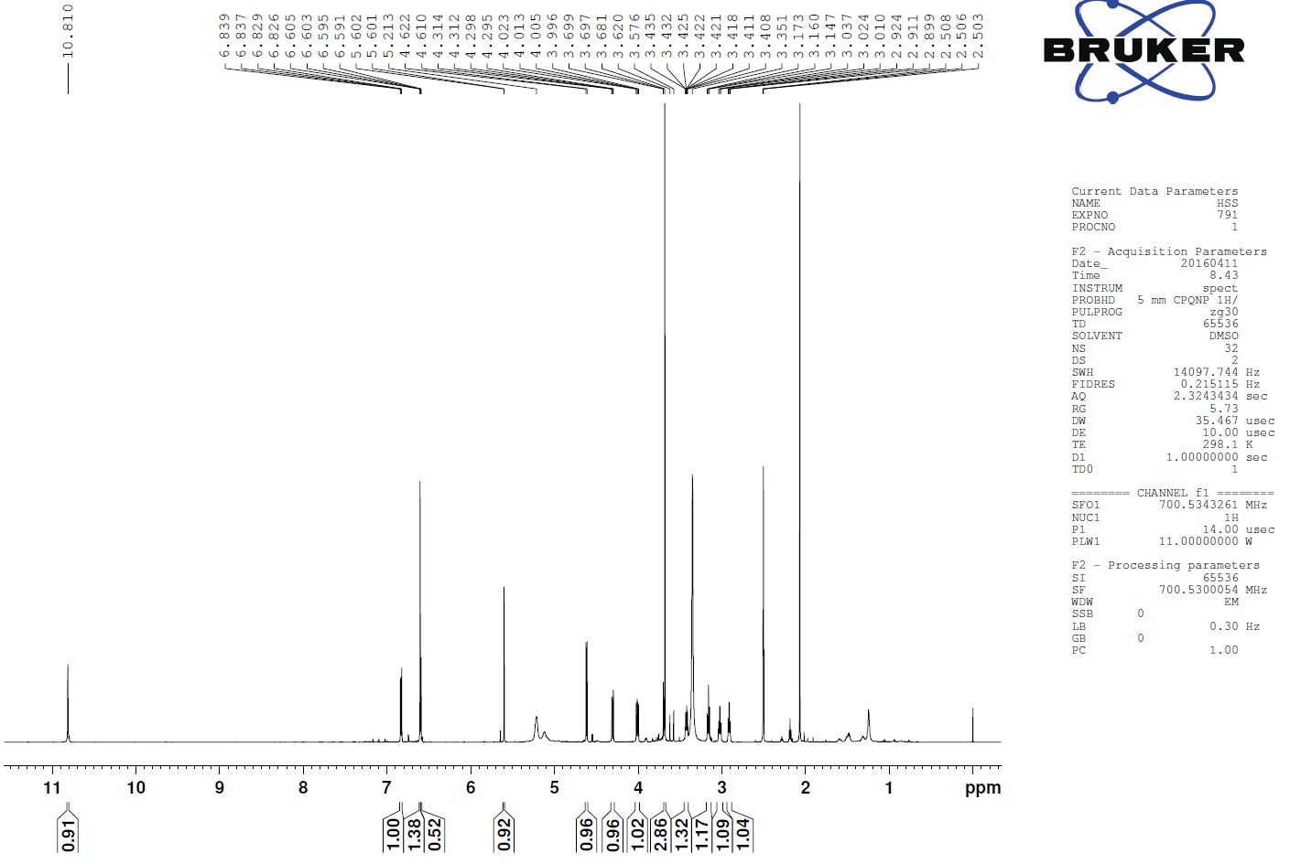
Figure S2.
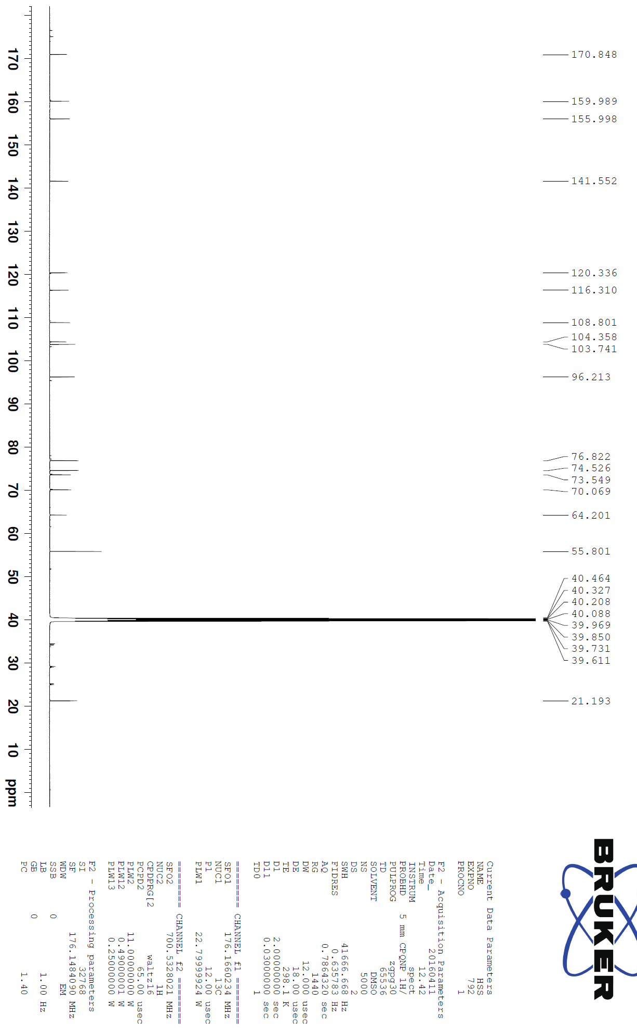
Figure S3.
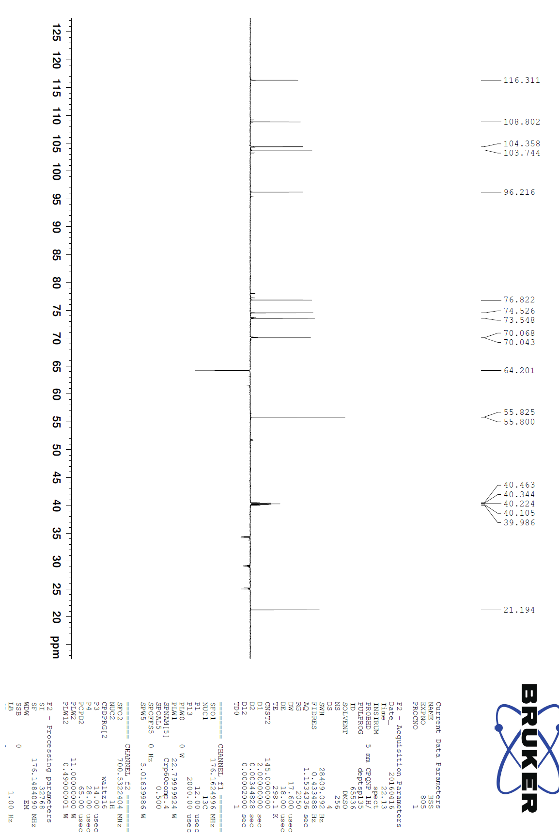
Figure S4.

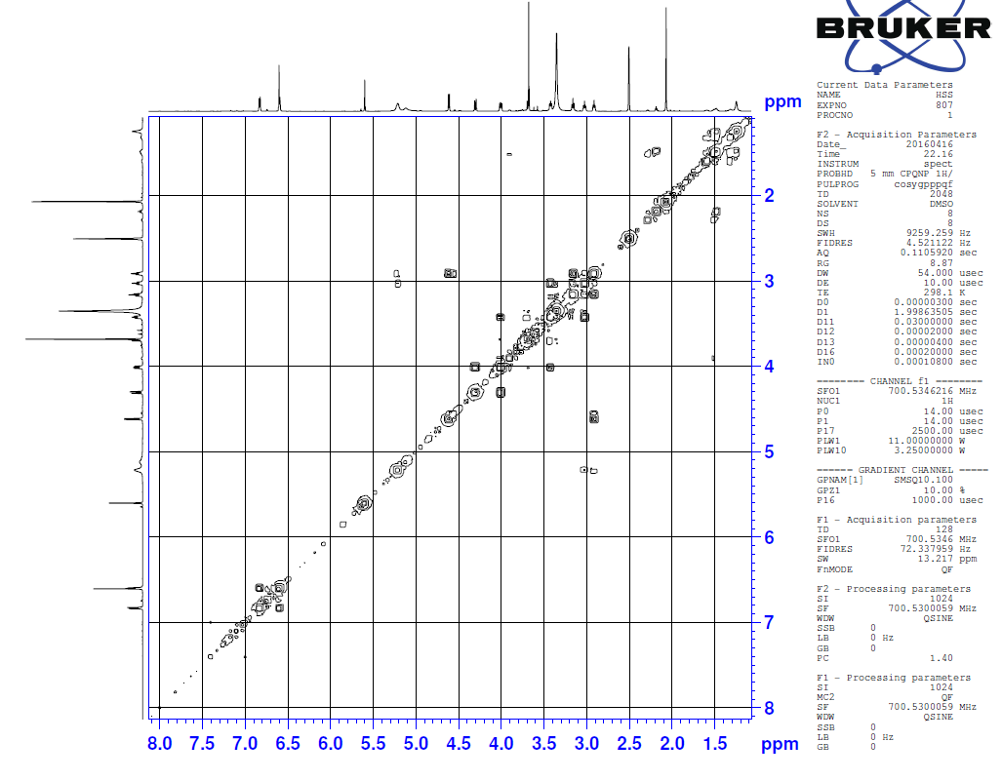

Figure S5.

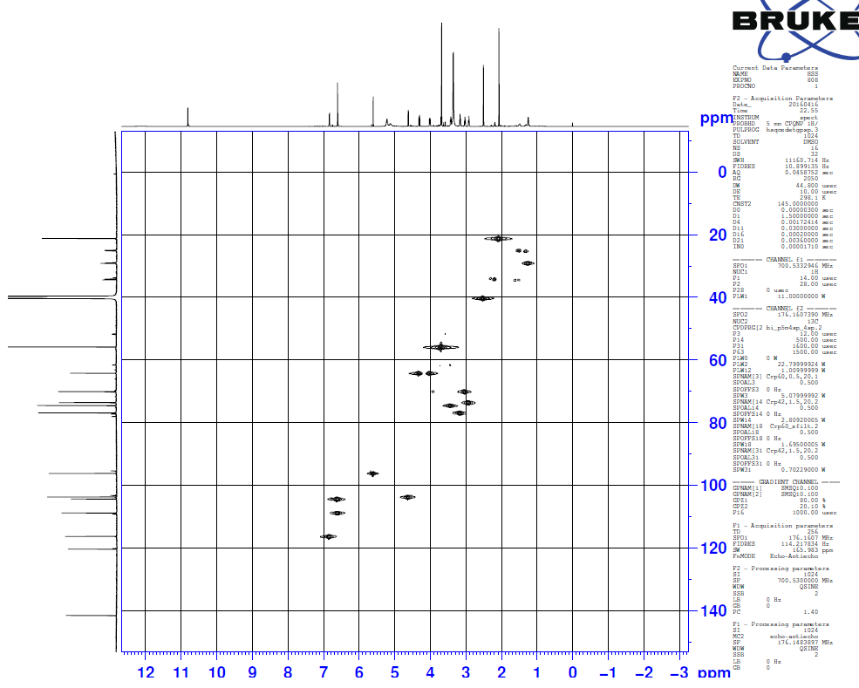

Figure S6.

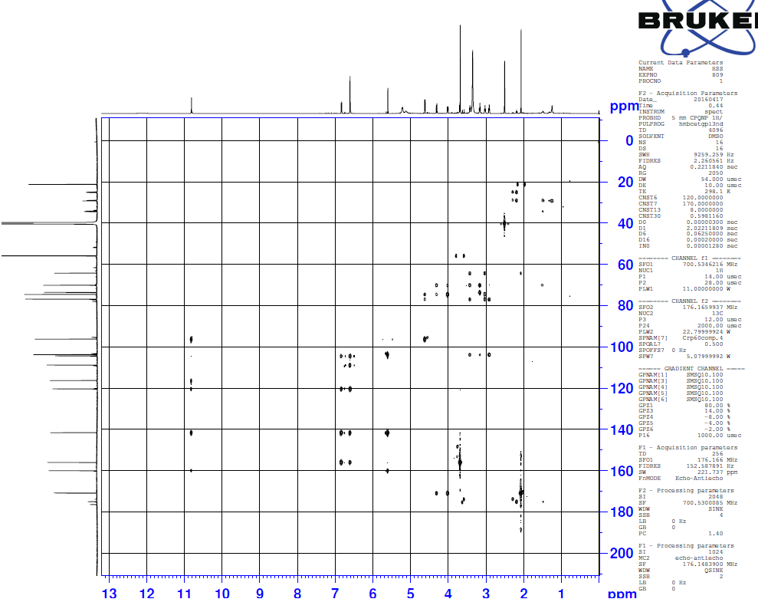

Figure S7.
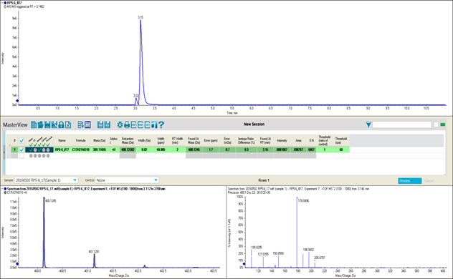
Figure S8.
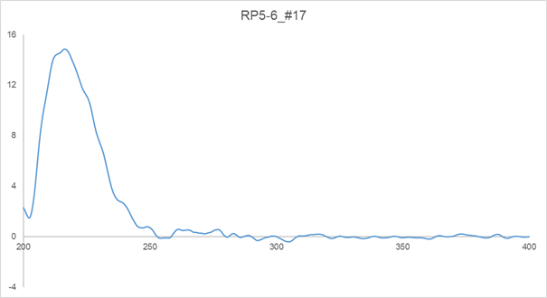

Figure S9.
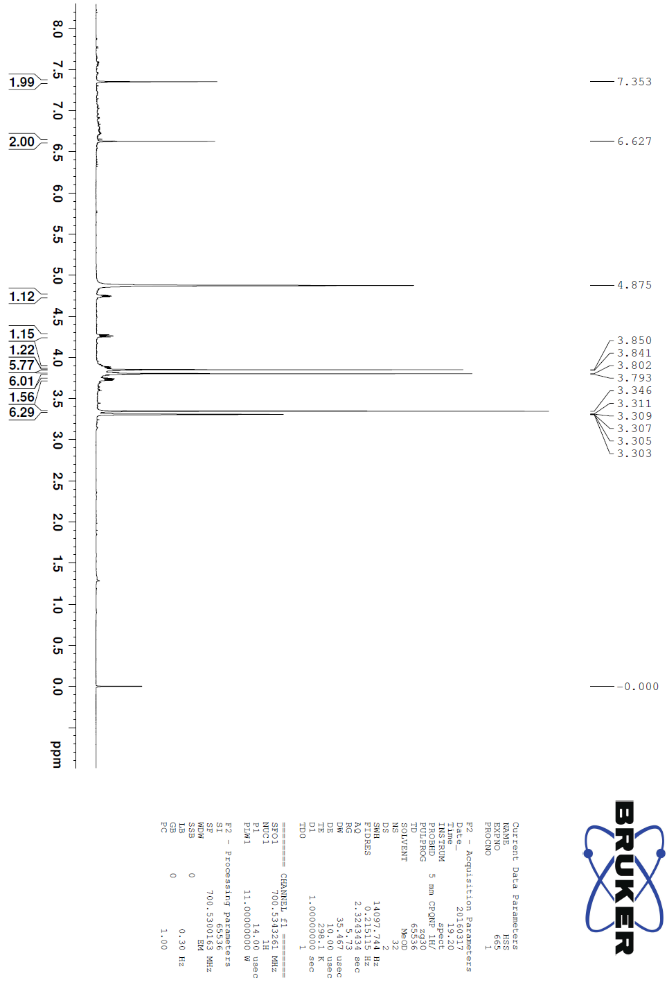
Figure S10.
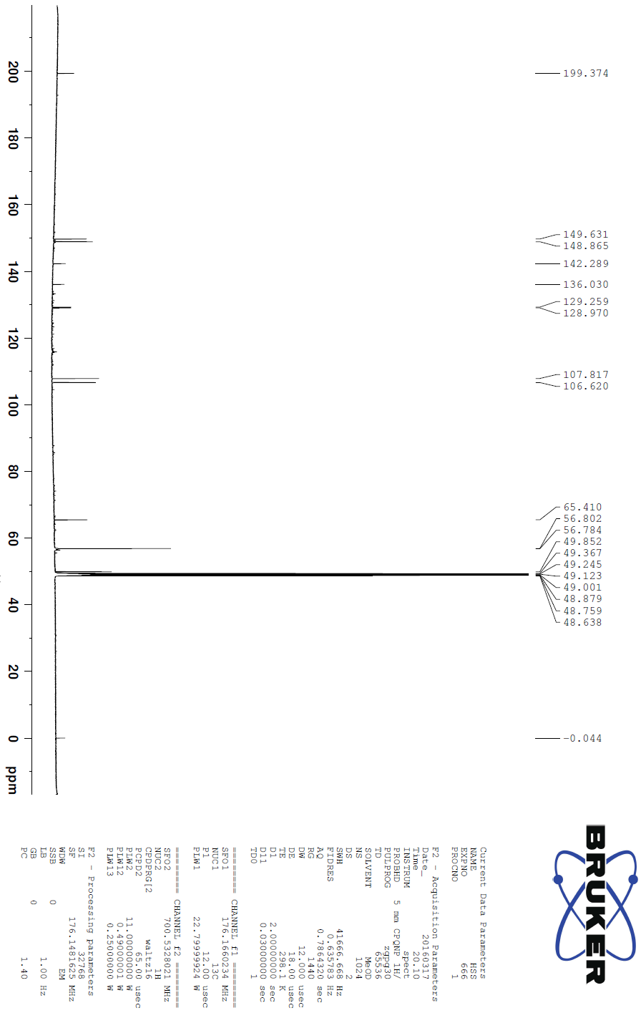
Figure S11.
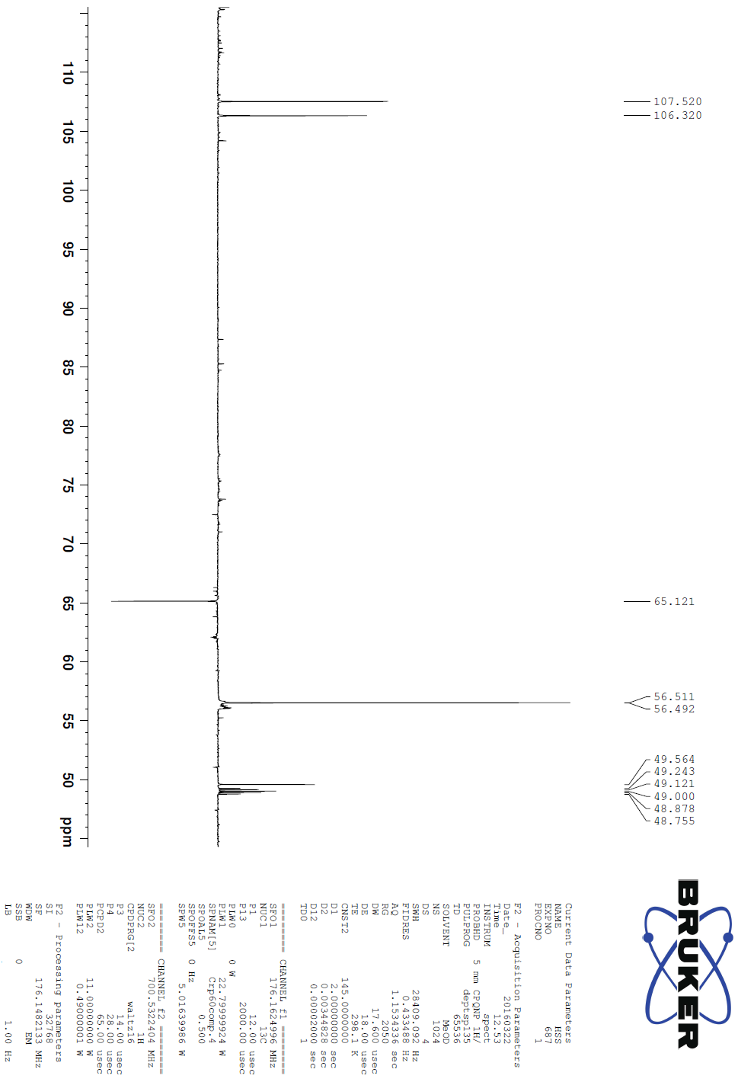
Figure S12.

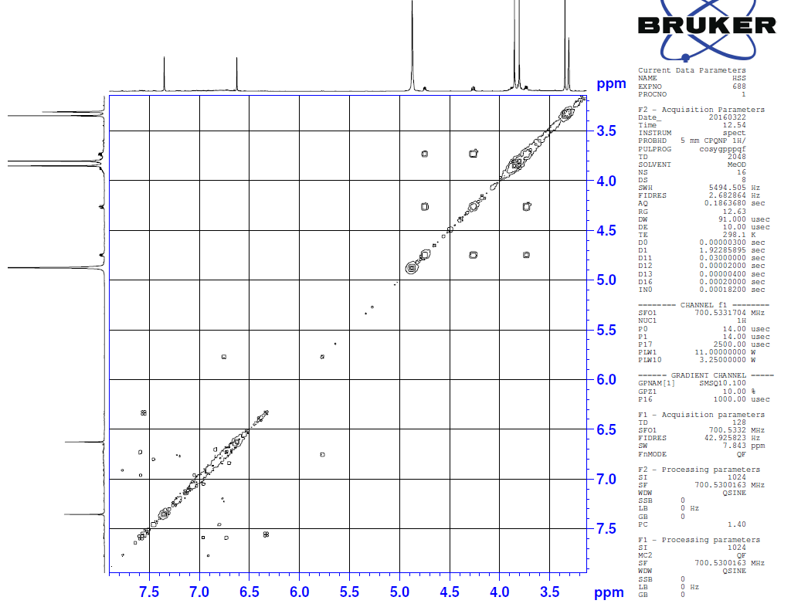

Figure S13.

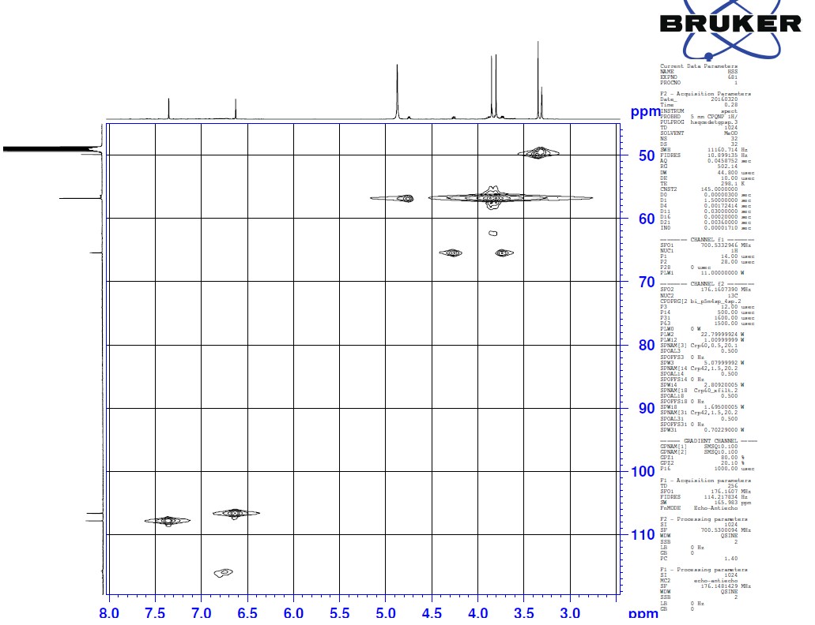

Figure S14.

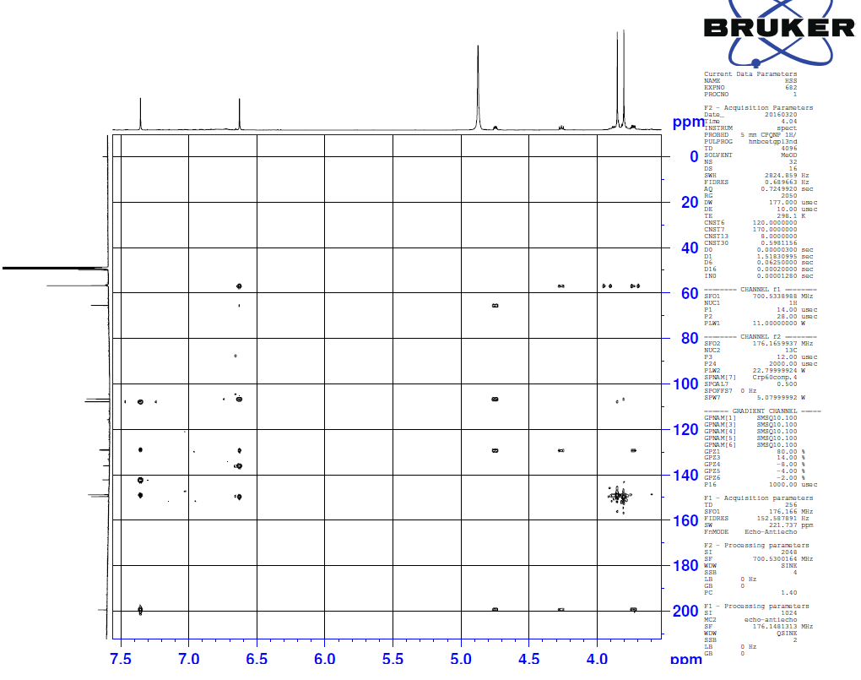

Figure S15.
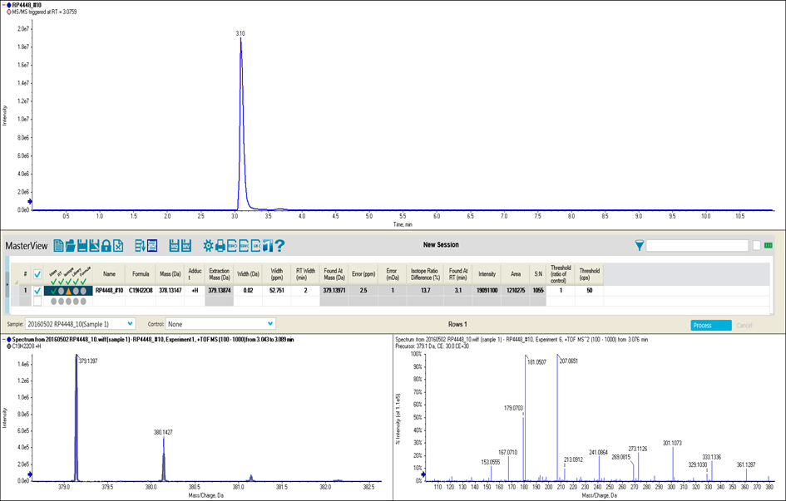

Corresponding authors. E-mail addresses: dongholee@korea.ac.kr (D. Lee), bestgene@hotmail.com (S.S. Hong).

