Systematic review and meta-analysis of adverse cardiovascular events associated with proton pump inhibitors used alone or in combination with antiplatelet agents

SUPPLEMENTAL MATERIAL

Supplemental Material I - Search strategies 2
Embase (with Scottish Intercollegiate Guidelines Network filters) 2
Medline (with Scottish Intercollegiate Guidelines Network filters) 4
Cochrane Central Register for Controlled Trials (with Scottish Intercollegiate Guidelines Network filters) 6
Supplemental Material II - Screening forms 8
Supplemental Material III - Data extraction form 10
Supplemental Material IV - Characteristics of included studies 20
Supplemental Material V - Reasons for exclusion of studies from meta-analysis 75
Supplemental Material VI - Group B Subgroup and sensitivity analyses 77
Supplemental Material VII – Quality of observational studies included in the meta-analysis 84
Supplemental Material IX – Funnel plots 92

Supplemental Material I - Search strategies

Embase (with Scottish Intercollegiate Guidelines Network filters)
 | Search terms | Results
1 | Proton pump inhibitor$.tw. | 15682
2 | Ppi$.tw. | 22015
3 | *proton pump inhibitor/ | 6465
4 | Esomeprazole.tw. | 2064
5 | Pantoprazole.tw. | 2307
6 | Lansoprazole.tw. | 2985
7 | Omeprazole.tw. | 10010
8 | Rabeprazole.tw. | 1583
9 | *Esomeprazole/ | 1254
10 | *Pantoprazole/ | 1483
11 | *Lansoprazole/ | 2238
12 | *omeprazole/ | 8388
13 | *Rabeprazole/ | 1115
14 | or/1-13 | 45500
15 | myocardial infarction$.tw. | 195179
16 | heart infarction$.tw. | 977
17 | heart attack$.tw. | 5719
18 | heart infarction/ | 217265
19 | cerebrovascular accident$.tw. | 7478
20 | stroke$.tw. | 251045
21 | cerebrovascular accident/ | 111017
22 | mortality.tw. | 705132
23 | mortality/ | 594725
24 | death$.tw. | 776905
25 | death/ | 182715
26 | cardiovascular mortality/ | 16475
27 | or/15-26 | 1921157
28 | 14 and 27 | 3260
29 | limit 28 to (human and English language) | 2519
30 | Clinical trial/ | 852915
31 | Randomized controlled trial/ | 388215
32 | Randomization/ | 68660
33 | Single blind procedure/ | 21256
34 | Double blind procedure/ | 124707
35 | Crossover procedure/ | 45093
36 | Placebo/ | 266122
37 | Randomi?ed controlled trial$.tw. | 126586
38 | Rct.tw. | 18750
39 | Random allocation.tw. | 1466
40 | Allocated randomly.tw. | 2073
41 | Randomly allocated.tw. | 23605
42 | (allocated adj2 random).tw. | 741
43 | Single blind$.tw. | 16593
44 | Double blind$.tw. | 156454
45 | ((treble or triple) adj blind$).tw. | 502
46 | Placebo$.tw. | 223606
47 | Prospective study/ | 313531
48 | or/30-47 | 1520035
49 | Case study/ | 34656
50 | Case report.tw. | 294365
51 | Abstract report/ or letter/ | 944138
52 | or/49-51 | 1266554
53 | 48 not 52 | 1479906
54 | Clinical study/ | 71067
55 | case control study/ | 99837
56 | Family study/ | 10950
57 | Longitudinal study/ | 82996
58 | Retrospective study/ | 435645
59 | Prospective study/ | 313531
60 | Randomized controlled trials/ | 86770
61 | 59 not 60 | 311111
62 | Cohort analysis/ | 222382
63 | (Cohort adj (study or studies)).mp. | 151743
64 | (Case control adj (study or studies)).tw. | 89202
65 | (follow up adj (study or studies)).tw. | 48109
66 | (observational adj (study or studies)).tw. | 83399
67 | (epidemiologic$ adj (study or studies)).tw. | 81050
68 | (cross sectional adj (study or studies)).tw. | 110429
69 | or/54-58,61-68 | 1428334
70 | exp Meta Analysis/ | 101478
71 | ((meta adj analy$) or metaanalys$).tw. | 109987
72 | (systematic adj (review$1 or overview$1)).tw. | 90438
73 | or/70-72 | 197971
74 | cancerlit.ab. | 674
75 | cochrane.ab. | 48937
76 | embase.ab. | 48668
77 | (psychlit or psyclit).ab. | 963
78 | (psychinfo or psycinfo).ab. | 11510
79 | (cinahl or cinhal).ab. | 14940
80 | science citation index.ab. | 2518
81 | bids.ab. | 482
82 | or/74-81 | 77679
83 | reference lists.ab. | 11930
84 | bibliograph$.ab. | 15793
85 | hand-search$.ab. | 5446
86 | manual search$.ab. | 3307
87 | relevant journals.ab. | 960
88 | or/83-87 | 33648
89 | data extraction.ab. | 14316
90 | selection criteria.ab. | 23030
91 | 89 or 90 | 35974
92 | review.pt. | 2096963
93 | 91 and 92 | 17606
94 | letter.pt. | 909295
95 | editorial.pt. | 492388
96 | animal/ | 1695032
97 | human/ | 16366505
98 | 96 not (96 and 97) | 1271960
99 | or/94-95,98 | 2658216
100 | 73 or 82 or 88 or 93 | 237029
101 | 100 not 99 | 229519
102 | 48 or 69 or 101 | 2680283
103 | 29 and 102 | 1105

Medline (with Scottish Intercollegiate Guidelines Network filters)
Searched Ovid MEDLINE(R) In-Process & Other Non-Indexed Citations and Ovid MEDLINE(R)
 | Search terms | Results
1 | proton pump inhibitor$.tw. | 10107
2 | ppi$.tw. | 15427
3 | esomeprazole.tw. | 1122
4 | pantoprazole.tw. | 1346
5 | lansoprazole.tw. | 2083
6 | omeprazole.tw. | 7292
7 | rabeprazole.tw. | 969
8 | Proton Pump Inhibitors/ | 8279
9 | esomeprazole/ | 781
10 | pantoprazole/ | 0
11 | lansoprazole/ | 1973
12 | omeprazole/ | 8346
13 | rabeprazole/ | 869
14 | or/1-13 | 32654
15 | myocardial infarction$.tw. | 145835
16 | heart infarction$.tw. | 218
17 | heart attack$.tw. | 4376
18 | myocardial infarction/ | 149423
19 | cerebrovascular accident$.tw. | 5550
20 | stroke$.tw. | 173130
21 | stroke/ | 69428
22 | mortality.tw. | 530062
23 | mortality/ | 36648
24 | death$.tw. | 606795
25 | death/ | 12620
26 | cardiovascular mortality/ | 0
27 | or/15-26 | 1318764
28 | 14 and 27 | 1601
29 | limit 28 to (english language and humans) | 1188
30 | limit 29 to yr="1980 -Current" | 1182
31 | Epidemiologic studies/ | 6448
32 | exp case control studies/ | 762625
33 | exp cohort studies/ | 1512988
34 | Case control.tw. | 90849
35 | (cohort adj (study or studies)).tw. | 110344
36 | Cohort analy$.tw. | 4554
37 | (Follow up adj (study or studies)).tw. | 40507
38 | (observational adj (study or studies)).tw. | 57146
39 | Longitudinal.tw. | 164309
40 | Retrospective.tw. | 327471
41 | Cross sectional.tw. | 207413
42 | Cross-sectional studies/ | 207789
43 | or/31-42 | 2157945
44 | Meta-Analysis as Topic/ | 15046
45 | meta analy$.tw. | 84578
46 | metaanaly$.tw. | 1540
47 | Meta-Analysis/ | 62186
48 | (systematic adj (review$1 or overview$1)).tw. | 73746
49 | exp Review Literature as Topic/ | 8485
50 | or/44-49 | 158682
51 | cochrane.ab. | 40289
52 | embase.ab. | 40550
53 | (psychlit or psyclit).ab. | 898
54 | (psychinfo or psycinfo).ab. | 10418
55 | (cinahl or cinhal).ab. | 13468
56 | science citation index.ab. | 2338
57 | bids.ab. | 384
58 | cancerlit.ab. | 612
59 | or/51-58 | 64423
60 | reference list$.ab. | 11860
61 | bibliograph$.ab. | 13096
62 | hand-search$.ab. | 4680
63 | relevant journals.ab. | 853
64 | manual search$.ab. | 2896
65 | or/60-64 | 29917
66 | selection criteria.ab. | 22865
67 | data extraction.ab. | 11912
68 | 66 or 67 | 32947
69 | Review/ | 2078265
70 | 68 and 69 | 21919
71 | Comment/ | 673946
72 | Letter/ | 956717
73 | Editorial/ | 400060
74 | animal/ | 5648637
75 | human/ | 14553252
76 | 74 not (74 and 75) | 4053214
77 | or/71-73,76 | 5514207
78 | 50 or 59 or 65 or 70 | 190931
79 | 78 not 77 | 179513
80 | Randomized Controlled Trials as Topic/ | 104215
81 | randomized controlled trial/ | 416556
82 | Random Allocation/ | 86926
83 | Double Blind Method/ | 136065
84 | Single Blind Method/ | 21606
85 | clinical trial/ | 508511
86 | clinical trial, phase i.pt. | 16133
87 | clinical trial, phase ii.pt. | 25900
88 | clinical trial, phase iii.pt. | 10999
89 | clinical trial, phase iv.pt. | 1103
90 | controlled clinical trial.pt. | 92193
91 | randomized controlled trial.pt. | 416556
92 | multicenter study.pt. | 199128
93 | clinical trial.pt. | 508511
94 | exp Clinical Trials as topic/ | 303963
95 | or/80-94 | 1131907
96 | (clinical adj trial$).tw. | 250905
97 | ((singl$ or doubl$ or treb$ or tripl$) adj (blind$3 or mask$3)).tw. | 141670
98 | PLACEBOS/ | 34122
99 | placebo$.tw. | 175469
100 | randomly allocated.tw. | 19887
101 | (allocated adj2 random$).tw. | 22672
102 | or/96-101 | 474957
103 | 95 or 102 | 1305549
104 | case report.tw. | 229815
105 | letter/ | 956717
106 | historical article/ | 332255
107 | or/104-106 | 1505772
108 | 103 not 107 | 1270783
109 | 43 or 79 or 108 | 3209343
110 | 30 and 109 | 635

Cochrane Central Register for Controlled Trials (with Scottish Intercollegiate Guidelines Network filters)
 | Keywords | Results
1 | proton pump inhibitor$.tw. | 1548
2 | ppi$.tw. | 1106
3 | Proton Pump Inhibitors/ | 816
4 | esomeprazole.tw. | 531
5 | esomeprazole/ | 289
6 | pantoprazole.tw. | 561
7 | pantoprazole/ | 0
8 | lansoprazole.tw. | 893
9 | lansoprazole/ | 543
10 | omeprazole.tw. | 2473
11 | omeprazole/ | 1956
12 | rabeprazole.tw. | 459
13 | rabeprazole/ | 257
14 | or/1-13 | 5283
15 | myocardial infarction$.tw. | 14964
16 | heart attack$.tw. | 326
17 | heart infarction$.tw. | 18
18 | Myocardial Infarction/ | 7742
19 | cerebrovascular accident$.tw. | 309
20 | stroke$.tw. | 22617
21 | Stroke/ | 3643
22 | mortality.tw. | 25644
23 | Mortality/ | 283
24 | death$.tw. | 24668
25 | Death/ | 59
26 | or/15-25 | 69642
27 | 14 and 26 | 183
28 | limit 27 to English language | 166

Supplemental Material II - Screening forms

Screening forms specific to this project were designed using DistillerSR (Evidence Partners) and are presented below.

Stage 1 –Title and abstract screening
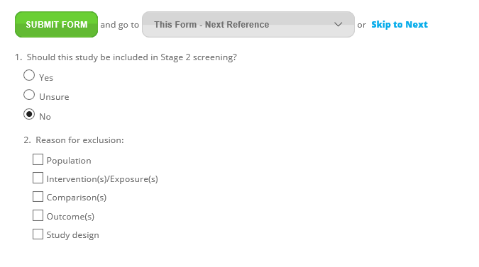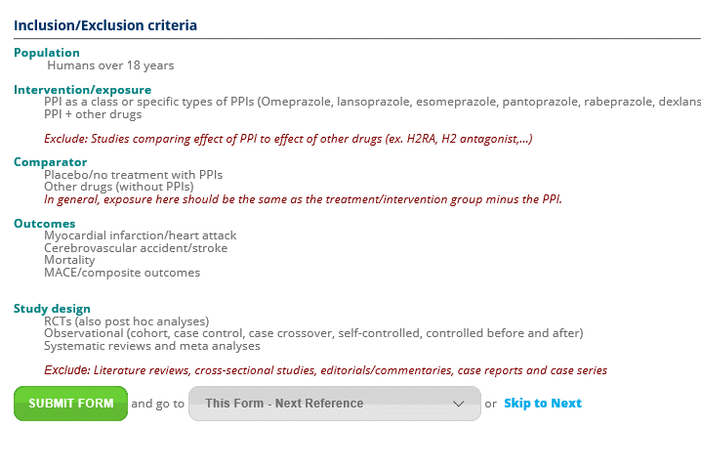
Stage 2 – Full-text screening
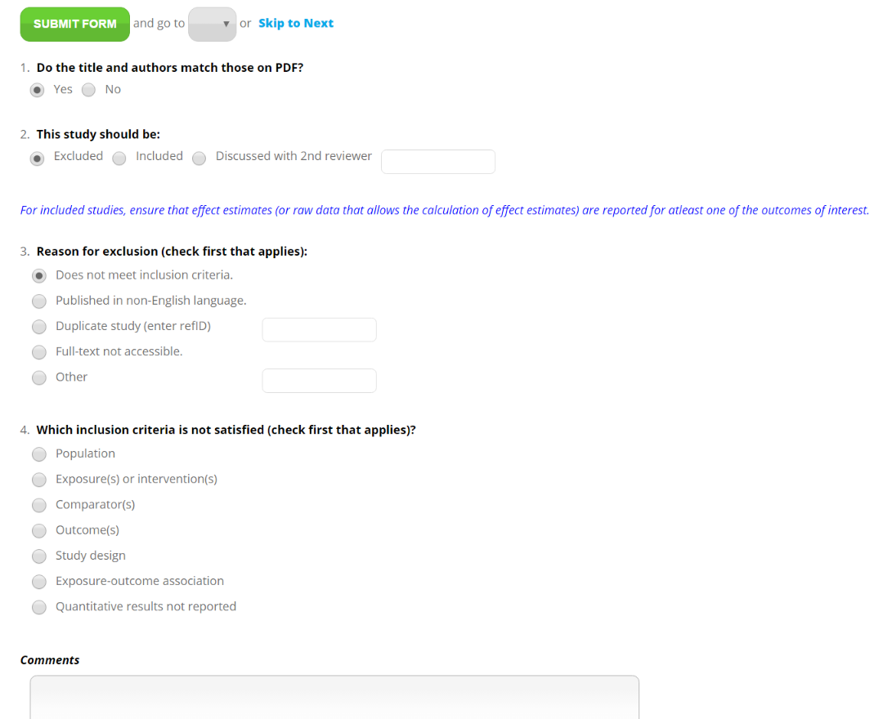

Supplemental Material III - Data extraction form

The following data extraction forms were designed using DistillerSR (Evidence Partners) for this project.

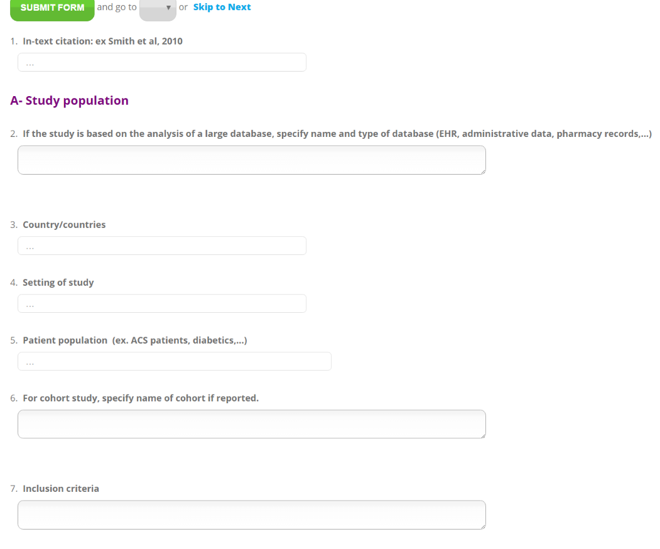
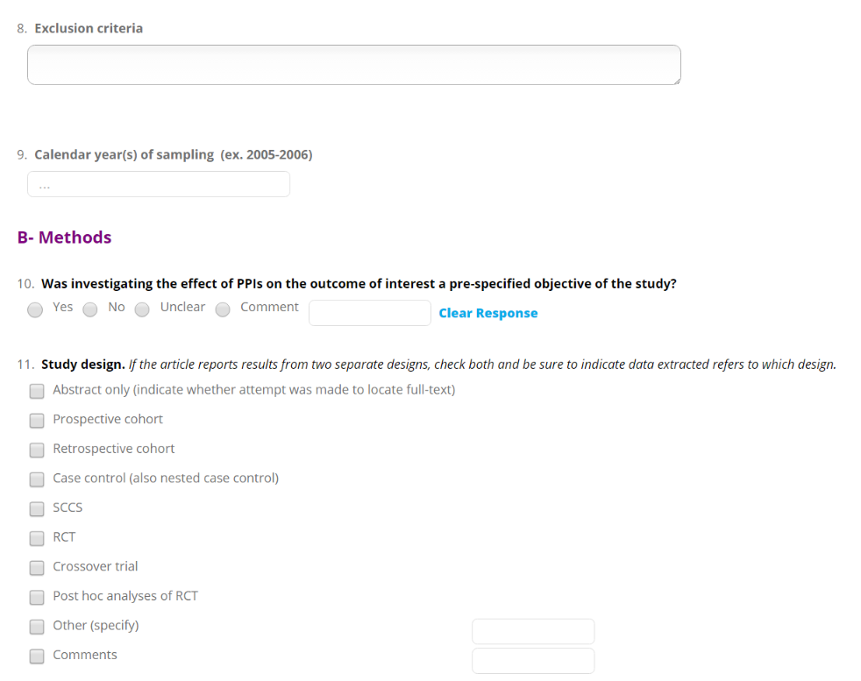
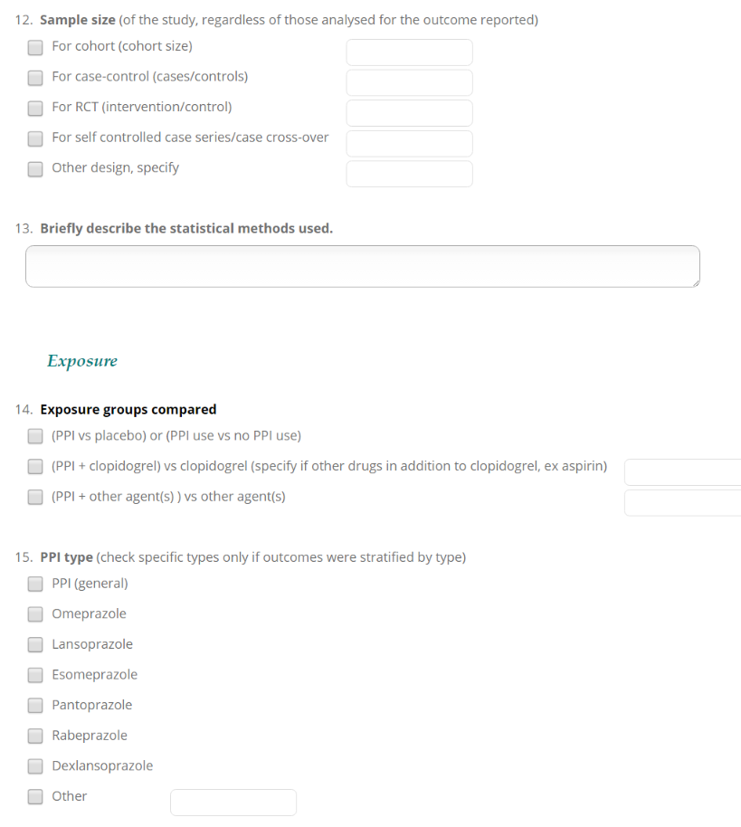
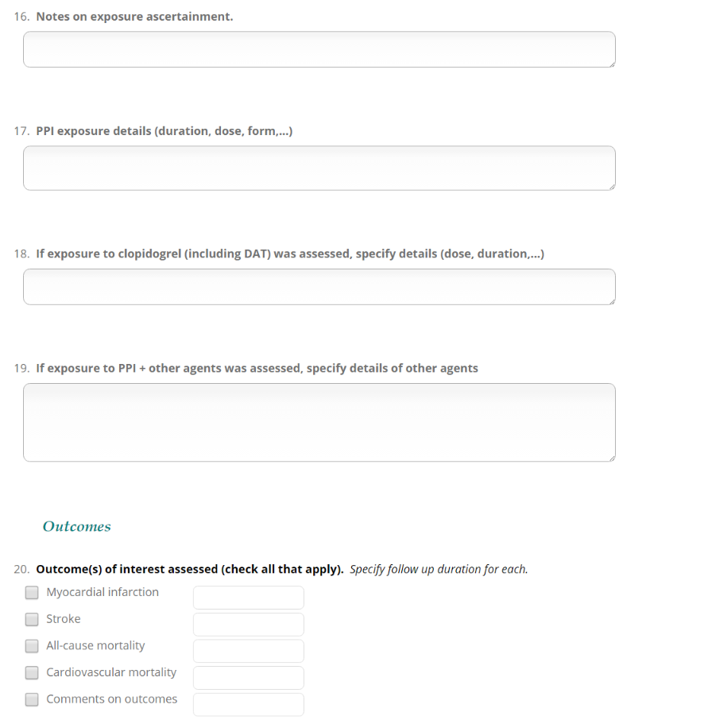
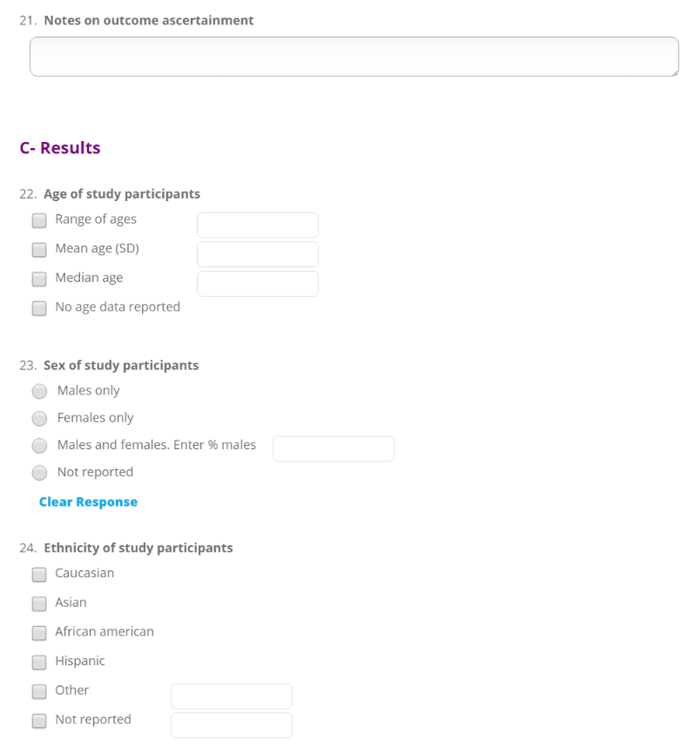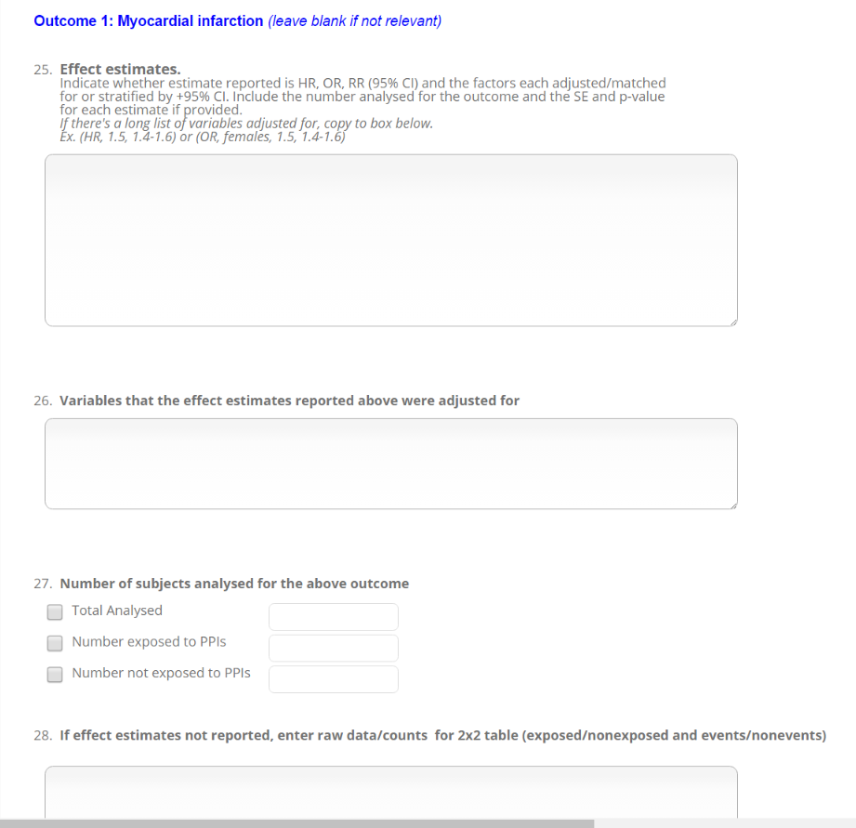
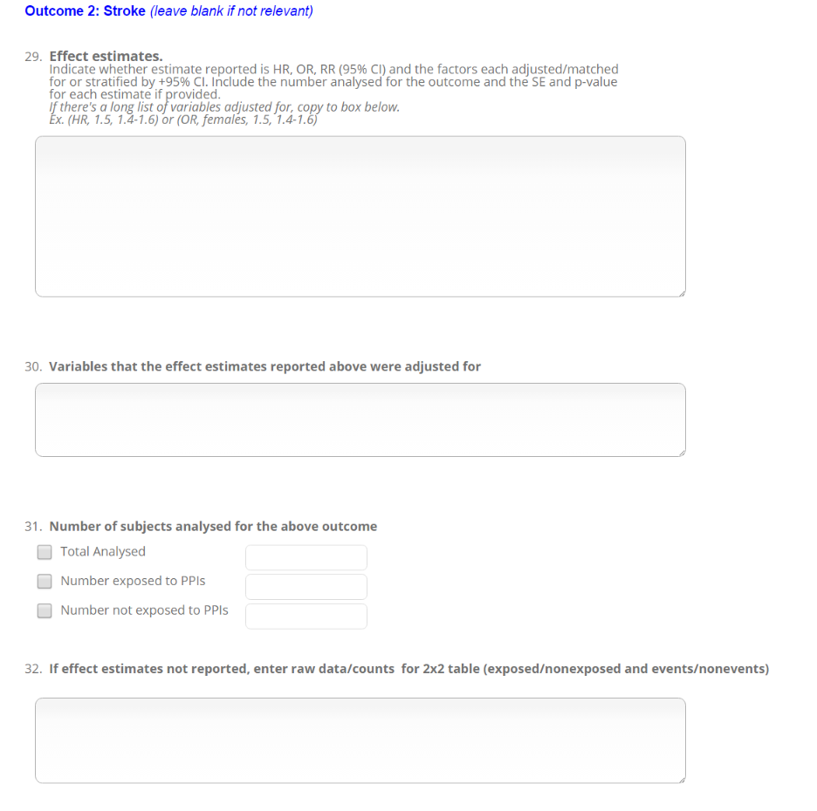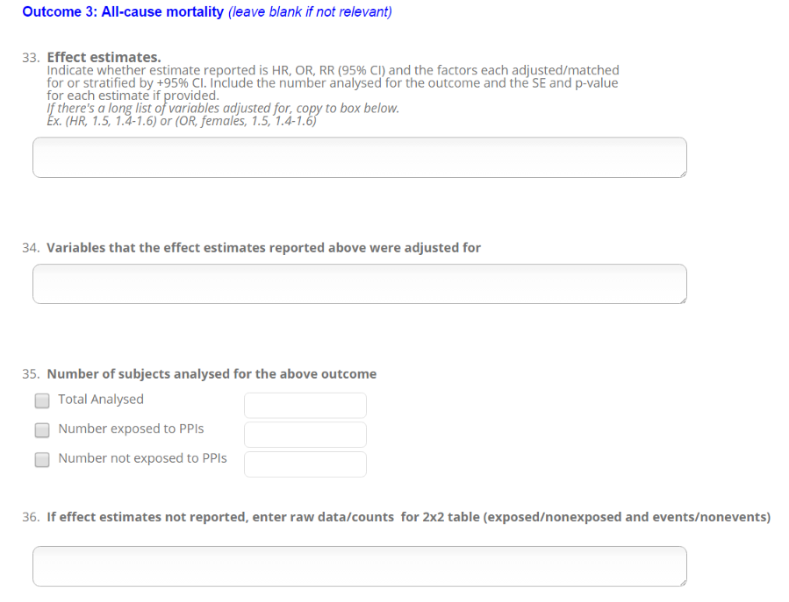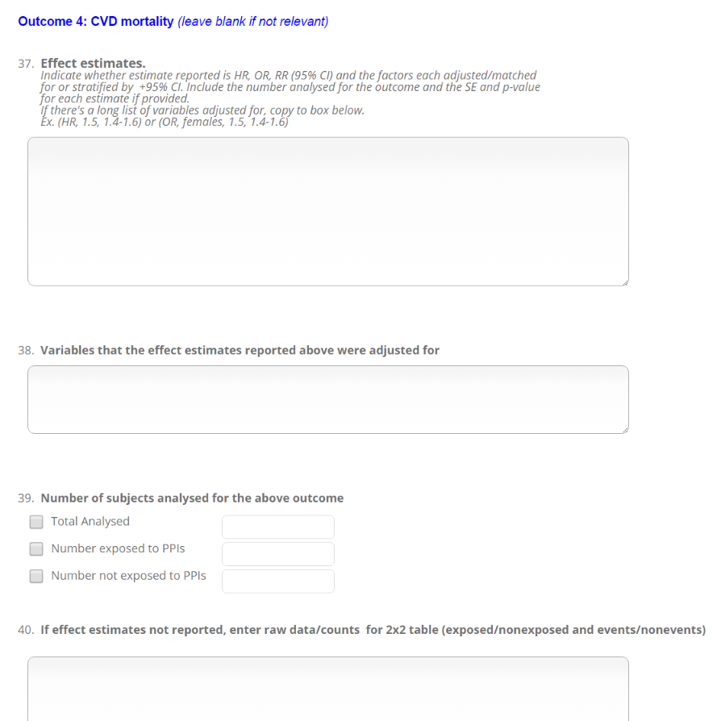
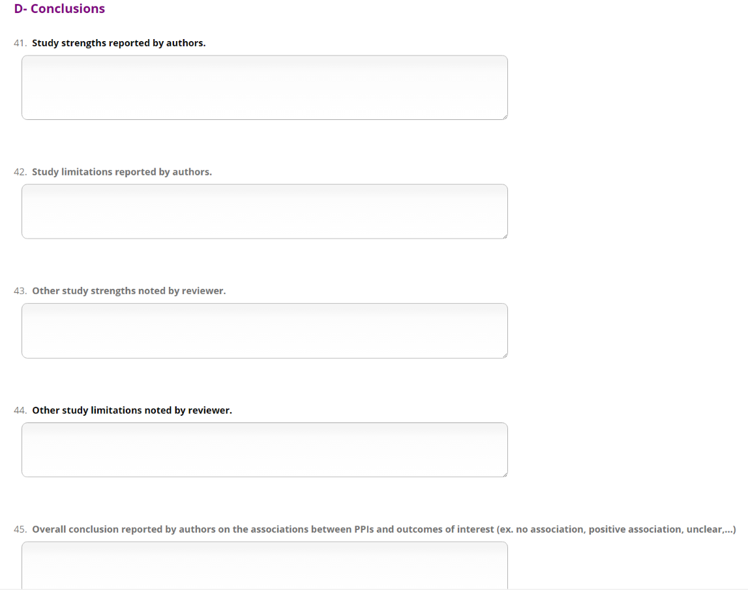

Supplemental Material IV - Characteristics of included studies

Detailed information extracted from the included studies regarding study characteristics is presented in this section.

Table S1. Characteristics of study design and patient population of studies that assessed the effect of PPI use vs no PPI use (Group A).

Table S2. Characteristics of the exposure, outcomes and source of funding of studies that assessed the effect of PPI use vs no PPI use (Group A).

Table S3. Characteristics of study design and patient population of studies that assessed the effect of concomitant PPI and clopidogrel treatment vs clopidogrel alone (Group B).

Table S4 Characteristics of the exposure, outcomes and source of funding of studies that assessed the effect of concomitant PPI and clopidogrel treatment vs clopidogrel alone (Group B).

Table S5. Characteristics of study design and patient population of studies that assessed the effect of concomitant treatment of PPIs and other drugs vs other drugs alone (Group C).

Table S6. Characteristics of the exposure, outcomes and source of funding of studies that assessed the effect of concomitant treatment of PPIs and other drugs vs other drugs alone (Group C).

Table S1. Characteristics of study design and patient population of studies that assessed the effect of PPI use vs no PPI use (Group A).
Citation  (Location) | Study design  (Setting) | Database/cohort name or NCT identifier | Patient population | Selection criteria | Study sample size | Mean age (years) (sd) | % Males | Ethnicity
Observational studies
(Antunes et al. 2016)  (Portugal)  Abstract | Retrospective cohort  (1 tertiary center) |  | Cirrhotic | Inclusion:  - hospitalization with cirrhosis  - patients with ascites and microbiological cultures at admission | Cohort size: 571;  PPI: 180 | NR | NR | NR
(Arana et al. 2015a)  (UK) | Nested case-control  (database analysis, population based) | Clinical Practice Research Datalink-Global initiative for Chronic Obstructive Lung Disease (CPRD-GOLD | UGI disorders | Inclusion:  - registered in database  - has linkable data to HES (hospital episode statistics) and ONS (office of national statistics)  - at least 1 continuous year of enrollment in CPRD GOLD after first exposure to either study drugs between 2005-2011  Exclusion:  - residing in institutions on or before cohort entry  - cancer diagnosis before cohort entry date | 15,811  (Cases: 3,239; Controls: 12,572 | 55 (median) | 43% | Not reported
(Bang el al 2018)  (Denmark)  Abstract | Retrospective cohort  (Database analysis) | Danish Prescription Database | With alcoholic cirrhosis | Inclusion:  - with alcoholic cirrhosis  -history of opioid claims (for PS matching)  Exclusion:  -cancer, chronic viral hepatitis, non-alcoholic fatty liver disease, follow-up time <30 days. | Cohort size: 19,687;  PS matched cohort: 2,592 | 56 (10) | 65% | NR
(Bell el al 2017)  (USA)  Abstract | Retrospective cohort  (Database analysis) | Rochester Epidemiology Project's medical records system | General population | Inclusion:  - resident of Olmsted County, MS  Exclusion:  - <18 years old  -history of CVD  - missing data for variables needed in the analysis  - PPI use in prior year | Cohort size: 58,175 | NR | NR | NR
(Bettinger et al 2018)  (Germany) | Retrospective cohort  (Database analysis) |  | Pyogenic liver abscess | Inclusion:  - with pyogenic liver abscess and information on diagnosis, treatment and clinical course | Cohort size: 181;  PPI: 100;  No PPI: 81; | PPI: 62.3 (13.4);  No PPI: 63.2 (14.4); | PPI: 67%:  no PPI: 68%; | NR
(Caffrey et al 2016)  (USA)  Abstract | Retrospective cohort  (Veteran Affairs hospitals) |  | With S. aureus bacteremia | Inclusion:  - admitted to Veterans Affairs hospitals  -positive S. aureus blood culture and receiving antibiotics within 2 days of culture collection | Cohort size: 12,211  PPI: 809;  no PPI: 12,402 | NR | NR | NR
(de Francisco et al 2018)  (Spain) | Retrospective cohort;  (Database analysis - 40 Clinics) | EuCliD database | Hemodialysis patients | Inclusion:  - 3 sessions per week hemodialysis  Exclusion:  - < 18 years old  -prescription for diuretics | Cohort: 2242;  PPI: 1,776; No PPI: 466;  PS matched: 410 pairs; | PPI: 68.0 (range: 57-76);  no PPI: 68.5 (range: 56-76); | PPI: 62%;  no PPI: 66%; | NR
(Charlot et al. 2010)  (Denmark) | Retrospective cohort  (database, hospitals) | Danish National Patient Registry | MI | Inclusion:  - >30 years  - hospitalized with MI between 2000-2006  Exclusion:  - prior MI  - partially missing data | Cohort size : 56,406  PS matched: (PPI: 15,443; No PPI: 15,433) | No treatment: 70 (13)  PPI only: 73 (12)  CP only: 64 (13)  Concomitant: 66 (13)  PS matched: 73 (13) | No treatment: 61%  PPI only: 53%  Clopidogrel only: 71%  Concomitant: 62%  PS matched: 54% | (largely Caucasian population)
(Chen et al. 2014)  (Taiwan) | Retrospective cohort  (database study) | National Health Insurance Research database | ESRD | Inclusion:  - ESRD on dialysis with first catastrophic illness certificate and had hemodialysis, peritoneal dialysis, or hemofiltration  - >18 years admitted to hospital for first time ischemic stroke between 1998-2006  - received standard dose of aspirin or clopidogrel once daily  - had 3 years of medical data  Exclusion:  - prior stroke (other than index stroke)  - missing data  -receiving antiplatelets other than clopidogrel | 1,936 | 65 (11) | 50% | Not reported
(Chitose et al. 2012)  (Japan) | Prospective cohort  (registry, hospitals -16 centers) | Kumamoto Intervention Conference Study (KICS) | PCI | Inclusion:  - consecutive patients undergoing PCI at one of 16 centers in Japan between June 2008 - March 2009  - written consent  Exclusion:  - in-hospital death  - not on thienopyridines at time of discharge  - re-intervention after first registration  - planned staged interventional procedure | 1,270  (PPI: 331; No PPI: 939) | PPI: 72(12)  no PPI: 69(12) | PPI: 68%  no PPI: 71% | Not reported
(Daskalopoulou et al. 2008)  (UK) | Retrospective cohort  (database, general practice) | UK General Practice Research Database (GPRD) | MI | Inclusion:  ->20 years  -survived at least 90 days following a first MI between Jan 2002 and Dec 2004  - minimum of 3 years of records in GPRD | 9,939  (PPI: 3,070; No PPI: 6,869) | 68 (13) | 60% | Not reported
(Dultz et al. 2015)  (Germany) | Prospective cohort  (hospital) |  | Cirrhosis | Inclusion:  - attending clinic with cirrhosis between 2009-2011  - cirrhosis confirmed by liver histopathological exam or pathognomonic results in MRI or CT  Exclusion:  - cancer history other than hepatocellular carcinoma in prior 5 years  - prior solid organ transplant at age less than 18 years | 272  (PPI: 213; No PPI: 59) | PPI: 57  no PPI: 57 (median) | 67% | Not reported
(Freedberg et al. 2013)  (USA) | Retrospective cohort  (database analysis) |  | CDI | Inclusion:  - incident CDI between Dec 1, 2009 and June 30, 2012 and no prior positive test within 90 days  Exclusion:  - did not meet study endpoints  - no proven clinical follow-up in medical system after the 90-day study period | 894  (PPI: 551;  No PPIs: 343) | PPI: 64 (18)  no PPI: 65 (20) | 48% | Caucasian, African American, Hispanic, Other
(Gardezi et al 2018)  Abstract | Hospitals |  | Non-variceal bleeding | Inclusion:  - received upper GI endoscopy for nonvariceal bleeding | 763 | NR | NR | NR
(Haider et al. 2012)  (USA) | Retrospective cohort  (records of hospital patients - 1 center) |  | CDI | Inclusion:  ->18 years  - positive for C. difficile between Jan 2001 - Oct 2009  Exclusion:  - pregnant women  - prior history of CDI | 627  (PPI: 172; No PPI: 358, others) | 69 (median) | 47% | 98% Caucasian
(Im et al. 2014) (Korea) | Retrospective cohort  (University hospitals - 7 centers) |  | Percutaneous endoscopic gastrostomy (PEG) | Inclusion:  - consecutive patients that underwent PEG between June 2006 -Jan 2012  Exclusion:  - <18 years  - personal history of gastrectomy  - insufficient data on patient  - simple PEG changes during the study period after an initial PEG placement | 1,021  (PPI: 203; No PPI: 472) | Mean (SD) : PP: 68 (15)  no PPI: 66 (14) | 67% | Not reported
(Johansson et al. 2003)  (UK) | Nested case-control  (database, general practice) | UK General Practice Research Database (GPRD) | GERD | Inclusion:  GERD cohort  - 18-79 years  - registered in database and 2+ years of enrolment with the GP before 1996  - first recorded diagnosis of GERD during 1996  Cases  - MI and from GERD cohort  Controls  - free of GERD  - randomly sample from the source population  - matched by age and sex to case  Exclusion:  - GERD diagnosis or cancer diagnosis before 1996  - pregnant women  -past history and long term use of acid suppressing drugs without specific treatment indication | (Cases: 7,084; Controls: 10,000) | 18-79 (range) | Not reported | Not reported
(Juurlink et al. 2013)  (Canada) | Self-controlled case series  (database) | Ontario Drug Benefit Claims Databases, Canadian Institute for  Health Information’s Discharge Abstract Database (CIHI-DAD), Registered  Persons Database, Ontario Health Insurance Plan Database | MI | Inclusion:  - Ontario residents  - 66+ years  - hospitalizations occurring within 12 weeks of initiation of PPI treatment  Exclusion:  - hospitalizations for MI and hospital length of stay <3 days | 5,550 | 77 (median) | 51% | Not reported
(Keyvani et al. 2006)  (Canada) | Retrospective cohort  (tertiary care - 2 centers) |  | Acute non-variceal UGIB | Inclusion:  - primary diagnosis with acute non-variceal UGIB between April 1999-March 2004  Exclusion:  - evidence of only chronic GI bleeding (iron deficiency, stools positive for occult blood);  - GI bleeding related to portal hypertension  - transferred from another health care institution more than 6 hours after initial presentation  - did not undergo endoscopy within 24 hours of initial presentation | 385  (PPI: 132; No PPI: 253) | PPI: 65  no PPI: 66 | PPI: 37%  no PPI: 40% | Not reported
(Kwon et al. 2013)  (Korea) | Retrospective cohort  (Medical centers -2 centers) |  | Cirrhosis and ascites | Inclusion:  - cirrhotic patients with ascites  - underwent diagnostic paracentesis after hospitalisation from January 2003 to December 2010  - liver cirrhosis confirmed biopsy or by clinical evidence of cirrhosis  Exclusion:  - GI bleeding within 14 days prior to admission  - organ transplantation  - antibiotic use within 2 weeks prior to admission  - no access to medication list on admission  - tuberculous peritonitis  - carcinomatosis  - HIV | 1,140  (PPI: 82; No PPI: 451; Others) | PPI: 62 (10)  no PPI: 63 (9) | 75% | Not reported
(Kwon et al 2016)  Abstract | Prospective cohort  (Single center) |  | Cirrhotic with variceal bleeding | Inclusion:  - with gastroesophageal variceal bleeding and cirrhosis | Cohort size: 348  PPI: 175;  No PPI: 173 | NR | NR | NR
(Lei et al 2017)  (Taiwan) | Retrospective cohort  (Database analysis) | National Health Insurance (NHI) | GERD | Inclusion:  - newly diagnosed with GERD  Exclusion:  - diagnosis with CAD, peripheral artery disease, or AMI before enrollment. | Cohort size: 54,422; | 51.6 (17) | 46.50% | NR
(Lee et al. 2015)  (Taiwan) | Retrospective cohort  (database analysis) | National Health Insurance Program (Taiwan) | COPD | Inclusion:  - COPD diagnosis between 2001-2005  -randomly sampled from database  - 30+ years | 17,498  (PPI: 109; No PPI: 16,863; Others) | >30 | 59% | Not reported
(Maggio et al. 2013)  (Italy) | Prospective cohort  (acute care medical wards - 11 centers) | Pharmaco-surveillance in the Elderly Care | Elderly (≥65) | Inclusion:  - ≥65 years  -admitted to participating wards  Exclusion:  - in-hospital death  - enrolled in long term care units  - declined participation | 491  (PPI: 174; no PPI 317) | PPI: 80 (6)  no PPI 80 (6) | PPI: 47%  no PPI: 45% | Not reported
(Mandorfer et al. 2014)  (Austria) | Retrospective cohort  (medical records, hospitals -1 center) |  | Cirrhosis and ascites | Inclusion:  -with cirrhosis and underwent first paracentesis at the medical university between 2006-2011  Exclusion:  - with other causes of ascites (such as severe cardiovascular disease, renal insufficiency, extra-hepatic malignancies and non-cirrhotic portal hypertension) | 607  (PPI: 520; No PPI: 87) | PPI: 57 (12)  no PPI: 60 (12) | 70% | Not reported
(Myles et al. 2009)  (UK) | Retrospective cohort  (database, general practice) | The Health Improvement network (THIN) | Pneumonia | Inclusion:  - ≥40 years  -pneumonia diagnosis between July 2001-July 2002  Exclusion:  - date of death recorded before pneumonia diagnosis date (errors) | 3,681  (PPI: 1,060; No PPI: 2,621) | >40 | Not reported | Not reported
(Nardelli et al 2018)  (Italy) | Prospective cohort |  | Cirrhotic | Inclusion:  - cirrhotic patients without overt hepatic encephalopathy  - cirrhosis confirmed by clinical, biochemical and radiological signs.  Exclusion:  - overt HE based on West-Haven criteria  - alcohol/psychoactive drugs  -neurological disease  - lack of compliance with psychometric evaluations due to language barriers or reduced vision  -dementia  - advance hepatocellular carcinoma  - TIPS and/or large porto- systemic shunts and patients with a history of persistent or recurrent HE defined by two or more than two episodes within the last six months, even if without overt HE on first observation were also excluded. | Cohort size: 310;  PPI: 125;  no PPI: 185; | 62.2 (11.8);  PPI: 63.3 (11.6);  no PPI: 61.5 (11.9); | 71.3%;  PPI: 67.2%;  no PPI: 74.0%; | NR
(Nguyen et al 2018)  (USA) | Prospective cohort | Nurse's Health Study and Health Professionals Follow-up Study | No history of stroke | Inclusion:  - female nurses between 30-55 years at enrollment, since year 2000 (Nurse's Health Study);  - male health care professionals between 40-75 years at enrollment, since 2004 (Health Professionals Follow-up Study)  Exclusion:  - history of stroke or cancer  -missing data on exposure of interest | Cohort size: 97,503;  PPI: 9,122;  no PPI: 88,381; | 69 (8);  Nurses’ Health Study: 65.7 (7.1);  Health Professionals Follow-up Study: 69.9 (8.6); | 29.70% | NR
(Oudit et al. 2011)  (Canada) | Retrospective cohort  (database analysis) | Ambulatory Care Database, Alberta Inpatient Discharge Abstract Database, Alberta Health Care Insurance Registry, Blue Cross Medication Database | Heart failure | Inclusion:  - >65 years  - diagnosed with heart failure as most responsible diagnosis between 1 Apr 1, 1999 – Dec 31, 2005 | 22,107  (PPI: 6,431; No PPI: 15,676 | PPI: 80  no PPI: 81 (median) | 55% | Not reported
(Sehested et al 2018)  (Denmark) | Retrospective cohort  (Database analysis) | Six nationwide administrative registers | UGIB | Inclusion:  - elective upper endoscopy  Exclusion:  - <30 or >100 years of age  - patients with prior coronary heart disease, stroke, atherosclerosis of extremities, users of adenosine diphosphate receptor antagonists or dipyridamole. | Cohort size: 214, 998 | PPI nonusers: 53 (median);  Short-term PPI users: 55 (median);  long-term PPI users: 59 (median); | 43.30% | NR
(Shah et al. 2015)  (USA) | Prospective cohort  (medical centers) | GenePAD cohort (the Genetic Determinants of Peripheral Arterial Disease) | Shortness of breath or abnormal stress test and underwent coronary angiogram | Inclusion:  - underwent non-emergent coronary angiogram for angina, shortness of breath or an abnormal stress test at one of the medical enters  Exclusion:  - History of radiation treatment, organ transplant or viral diseases | 1,503 | 66 (11) | 65% | Caucasian, Asian, African American, Hispanic, Other
(Shih et al. 2014)  (Taiwan) | Retrospective cohort  (database analysis) | Longitudinal Health Insurance Database (Taiwan) | On PPIs | Inclusion:  - PPI prescription during ambulatory visits between 2000 and 2009  - 18-80 years  - no history of MI, acquired immunodeficiency syndrome, HIV infection, or cancer before PPI prescription  - no prior PPI prescription within 120 days  Exclusion:  - prescription of PPI within 60 days after an episode of severe UGI bleeding that needed hospitalization, blood transfusion, or inotropic agent | 252,734  (PPI: 126,367; No PPI: 126,367) | PPI: 49 (15)  no PPI: 49 (15) | 51% | Not reported
(Simon et al. 2011)  (France) | Retrospective cohort  (Hospitals and private clinics with ICU - 223 centers) | French Registry of Acute ST-Elevation and Non–ST-Elevation Myocardial Infarction (FAST-MI) Registry | MI | Inclusion:  - >18 years  - admitted to ICU with definite MI  Exclusion:  - diagnosed with iatrogenic MI (invalidated for an alternative diagnosis)  - unstable angina with no elevation of cardiac necrosis | 2,744  (PPI: 1611; No PPI: 1,133) | PS matched cohorts:  PPI: 65 (12)  no PPI: 66 (13) | 27%- 42% between groups | Not reported
(Taha et al. 2013)  (NR)  [abstract] | Prospective cohort/ (Hospitals) |  | UGIB | Inclusion:  - undergoing endoscopy for UGIB | Cohort size : 404 (202 PPI, others no PPI) | NR | NR | Not reported
(Teramura-Gronblad et al. 2012) -Cohort 2  (Finland) | Retrospective cohort  (Long term care hospitals) |  | Chronic patients requiring 24-hr care | Inclusion:  - agree to participate in study  Exclusion:  - incomplete medical data | 1004  (PPI: 231; No PPI: 773) | PPI: 81 (11)  no PPI: 82 (11) | PPI: 29%  no PPI: 24% | Not reported
(Teramura-Gronblad et al. 2012) –Cohort 1  (Finland) | Retrospective cohort  (assisted living facilities - 69 centers) |  | In assisted-living facilities | Inclusion:  - residents in assisted living facilities in Helsinki and Espoo in 2007  Exclusion:  - decline to participate  - incomplete medication data  - residents of temporary respite care | 1,389 (Cohort 1)  (PPI: 367; No PPI: 1,022) | PPI: 84 (8)  no PPI: 82 (8) | PPI: 24%  no PPI: 20% | Not reported
(Teramura-Gronblad et al. 2012) –Cohort 3  (Finland) | Retrospective cohort  (hospital and nursing home) |  | Geriatric, frail patients | Inclusion:  - in geriatric wards and nursing homes in Helsinki  - agree to participate in study  Exclusion:  - <70 years | 425  (PPI: 91; No PPI: 334) | PPI: 86 (7)  no PPI: 86 (7) | PPI: 21%  no PPI: 18% | Not reported
(Turkiewicz et al. 2015)  (Sweden) | Self-controlled case series  (hospital records) | Swedish Population Register and Skåne Healthcare Register | MI | Inclusion:  - included in database  - AMI event between Oct 14, 2005 and Dec 31, 2006  - age 40 to 90 at AMI event | 3,490 | 73 (12) | 61% | Not reported
(Valkhoff et al. 2011)  (Netherlands) | Nested case-control  (database analysis) | PHARMO Record Linkage System (Netherlands) | MI | Inclusion:  Cohort: patients admitted for MI between Jan 1999- Dec 2008  -required to have had one prescription filled at least 1 year preceding the date of cohort entry  Cases  - recurrent MI 30 days of baseline MI  Controls  - randomly selected from cohort, matched on gender, age, risk of recurrent MI, and calendar time; | (Cases: 616; Controls 126,817) | 65 (13) | 67% | Not reported
(van der Hoorn et al. 2015)  (Australia) | Prospective cohort  (database analysis) | Australian Longitudinal Study data linked to Pharmaceutical Benefits Scheme | Elderly women | Inclusion:  - Australian citizens and permanent residents  - women born 1921-1926  - included in Medicare database  Exclusion:  - completed a short version of the survey  - did not consent to data linkage  - died before 2003  - received PPI and/or osteoporosis medication in 2002  - missing confounder data | 4,432  (PPI: 2,328; No PPI: 2,104) | PPI: 78 (1); no PPI: 78 (2) | 0 | Not reported
(Wang 2017)  (Taiwan) | Retrospective cohort  (Database analysis) | Longitudinal Health Insurance Database | General population | Inclusion:  - ≥ 20 years  - no prior diagnosis of atrial fibrillation, AIDS, HIV infection, cerebrovascular disease, or cancer before the prescription of PPI  - no use of any PPI within 30 days before the current prescription  - no hospitalizations in prior 30 days | Cohort size: 396,296;  PPI: 198,148;  No PPI: 198,148; | 51.7 (15.4) | 53.60% | NR
(Win et al. 2010)  (USA)  [abstract] | Retrospective cohort  (chart review, hospital) |  | UGIB | Inclusion:  - endoscopic evaluation of UGIB between Jan 2005-Dec 2008  Exclusion:  - no significant finding on upper endoscopy | 658  (PPI: 110; No PPI: 548) | 59 (15) | 60% | African American (95%); others;
Intervention studies
(Daneshmend et al. 1992)  (England) | RCT  (hospitals -2 centers) |  | UGIB | Inclusion:  - UGIB  - history of hematemesis or melena within 24 hours preceding admission  Exclusion:  - <18 years  - pregnant  - severe illness making active treatment inappropriate (terminal disease, advanced malignancy) or inability to start treatment within 12 hours of admission  - severe bleeding that needs surgery, trivial bleeding, bleeding for other reasons  - potential to drug interactions with concomitant medications (such as warfarin) | 1,147  (PPI (omeprazole): 578; No PPI: 569) | PPI: 59 (19)  no PPI: 60 (19) | PPI: 62%  no PPI: 65% | Not reported
(Gao et al. 2009)  (China) | RCT  (hospitals – 2 centers) |  | MI | Inclusion:  - hospitalized for MI from Jan 2003 - Dec 2007  - underwent "canalization"  Exclusion:  - did not undergo "canalization"  - had presented UGIB in 6 months before hospitalization | 237  (PPI (omeprazole): 114; No PPI: 123) | PPI: 58 (9)  no PPI: 58 (9) | 53% | Not reported
(Hasselgren et al. 1997)  (Sweden and Norway) | RCT  (hospitals - 29 centers) |  | UGIB | Inclusion:  - >60 years  - admitted with melena or hematemesis, endoscoped within 12 hours of admission  - UGIB  Exclusion:  - UGI malignancy  - deficient hemostasis  - renal, hepatic or cardiac failure  - significant abnormalities in laboratory screening  - anticoagulation therapy within 5 days of admission | 322  (PPI (omeprazole): 159; No PPI: 163) | PPI: 75 (8)  no PPI: 74 (7) | PPI: 56%  no PPI: 60% | Not reported
(Hawkey et al. 2001)  (UK) | RCT  (hospitals - 2 centers) |  | UGIB | Inclusion:  - admitted for suspected UGIB  Exclusion:  - absence of UGIB upon endoscopy  -severe bleeding requiring surgical interventions  - other conditions: pregnancy, lactation, active thromboembolism or intravascular coagulopathy, high creatinine levels | PPI (lansoprazole): 102  No PPI (placebo): 103  Other groups: 209 | PPI: 59  no PPI: 56 | PPI: 80%  no PPI: 77% | Not reported
(Hung et al. 2007)  (China) | RCT  (hospital) |  | UGIB | Inclusion:  -with UGIB that had upper endoscopy  -with successful haemostasis  Exclusion:  with previous gastrectomy or vagotomy, those that had taken warfarin , H2RAs or PPI in the previous 48 hours | 168  (PPI: 114; No PPI: 54) | PPI infusion: 64  PPI bolus: 58  no PPI: 63 | PPI infusion: 59%  PPI bolus: 72%  no PPI: 74% | Asian
(Javid et al. 2001)  (India) | RCT  (hospital) |  | UGIB | Inclusion:  - UGIB  - underwent GI endoscopy within 12 hours of admission and showed peptic ulcers or stigmata of recent hemorrhage  Exclusion:  - terminal cancer  - perfuse hemorrhage accompanied by persistent shock  - continued bleeding within 34 hours of endoscopic treatment and needed emergency surgery  - could not provide consent | 166  (PPI (omeprazole): 82; No PPI: 84) | PPI: 55 (10)  no PPI: 56 (8) | PPI: 63%  no PPI: 61% | Not reported
(Kantorova et al. 2004)  (Czech Republic) | RCT  (hospital) |  | high UGIB risk | Inclusion:  - >18 years  - admitted to ICU for major abdominal or thoracic surgery between Feb 2000 - June 2002  - need mechanical ventilation for at least 48 hours or had coagulopathy, and nasogastric tube in place  Exclusion:  - <48 hours expected length of stay  - history of esophago-gastric surgery  - GI bleeding at time of admission or in previous year  - pneumonia  - treatment with PPIs, H2RAs, antacids or sucralfate in prior 72 hours  - peptic ulcer disease in prior year  - use of anticoagulants, high dose oral corticosteroids or thrombolytic agents during previous week  - renal insufficiency needing hemodialysis  - thrombocytopenia <30,000/ml  - life expectancy < 3 months  - cannot give informed consent | 323  (PPI (omeprazole); No PPI: 75; others) | PPI: 44 (15)  no PPI: 46 (19) | PPI: 67%  no PPI: 67% | Not reported
(Kaviani et al. 2003)  (Iran) | RCT  (hospitals - 2 centers) |  | UGIB | Inclusion:  - >15 years  - UGIB  - successful endoscopic treatment of actively bleeding ulcers or ulcers with non-bleeding visible vessels between April 1999 and May 2000  Exclusion:  - low risk bleeders  - unknown source of bleeding  - on anti-secretory drugs (PPIs or H2RAs)  - highly probable gastric malignancies  - unsuccessful endoscopic treatment | 160  (PPI-omeprazole: 80; No PPI: 80) | PPI: 53 (18)  no PPI: 52 (19) | PPI: 80%  no PPI: 80% | Not reported
(Khuroo et al. 1997)  (India) | RCT  (hospital) |  | UGIB | Inclusion:  - UGIB  - endoscopy between Jan 1992 - Aug 1994  Exclusion:  - terminal illness preventing endoscopy  - profuse hemorrhage with persistent shock | 220  (PPI: 110; No PPI 110) | PPI: 58 (8)  no PPI: 56 (8) | PPI: 62%  no PPI: 60% | Not reported
(Krag et al 2018)  [Multicenter - 2 European countries] | RCT  (33 Intensive care units) | NCT02467621 | ICU patients at risk for GI bleeding | Inclusion  - 18 or over  admitted to ICU for acute conditions  -had at least one risk factor for GI bleeding;  Exclusion:  -ongoing daily treatment with acid suppressants  - consent could not be obtained  - gastrointestinal bleeding during index hospital admission  - withdrawn from active therapy or were brain dead  - underwent organ transplantation during index hospital admission  - peptic ulcer confirmed by endoscopy or other method during index hospital admission  - contraindication to pantoprazole 17 Were pregnant  - pregnancy | 3,298;  PPI (pantoprazole 40 mg): 1,645;  Placebo: 1,653; | Pantoprazole: 67 (IQR 56-75);  Placebo: 67 (IQR 55-75); | Pantoprazole: 63%;  Placebo: 65%. | NR
(Kuipers et al. 2011)  (16 countries) | RCT  (emergency departments (91 centers)) | NCT00251979 | UGIB | Inclusion:  - 18+ years  - successful hemostatic treatment of a bleeding peptic ulcer by endoscopy  - single peptic ulcer (≥55 mm in diameter) and current or recent bleeding | 767  (PPI: 376; No PPI:391) | PPI: 62  no PPI: 60 | PPI: 68%  no PPI: 69% | (88% Caucasian)
(Lau et al. 2000)  (Hong Kong) | RCT  (hospital) |  | UGIB | Inclusion:  -admitted for UGIB  -underwent successful endoscopy of active ulcers (or ulcers with nonbleeding vessels)  Exclusion:  -unsuccessful endoscopy | (PPI: 120; no PPI: 120) | PPI: 64 (17)  no PPI: 37 (16) | PPI: 67%  no PPI: 67% | Not reported
(Lau et al. 2007)  (Hong Kong) | RCT  (hospital) |  | UGIB | Inclusion:  - presenting with UGIB to hospital  Exclusion:  - continued shock despite resuscitation  - <18 years  - cannot provide consent  - pregnant  - allergy to PPI  - on aspirin for CV protection | (PPI: 319; no PPI: 319) | PPI: 62 (18)  no PPI: 62 (18) | PPI: 66%  no PPI: 63% | Not reported
(Leung et al 2018)  [China] | RCT  (hospital) | NCT01873079 | Undergoing ERCP sphincterotomy | Inclusion:  - 18 or older  -scheduled for elective ERCP and EST  Exclusion:  - prior EST, history of gastrectomy, acid-reduction surgery, sphincterotomy, sphincteroplasty or liver transplantation  - receiving PPIs or H2RAs within the previous week  - on warfarin, novel anticoagulants or other new antiplatelet agents; (- pregnant or lactating  - did not consent | 125;  PPI (esomeprazole): 60;  No PPI: 65; | Esomeprazole: 70 (14);  No PPI: 72 (16); | Esomeprazole: 57;  no PPI: 43% | NR
(Liu et al. 2013)  (China) | RCT  (hospital) | ChiCTR-TRC-12001871, (Chinese clinical trial registry) | Intracerebral hemorrhage | Inclusion:  - hospitalized at neurosurgical ICU between April 2006-Dec 2008  - 18+ years  - intracerebral hemorrhage requiring surgery  - nasogastric tube in place  - baseline intragastric pH <4 on 2 consecutive measurements  - informed consent  Exclusion:  - arteriovenous malformation or aneurysmal hemorrhage,  - history of peptic ulcers  - patients likely to swallow blood (for example, those with severe facial trauma)  - underwent antiplatelet and anticoagulation therapy  - renal insufficiency requiring hemodialysis  - thrombocytopenia less than 30,000/ml  - died within 72 hours after the ictus | 165  (PPI -omeprazole: 58; No PPI: 53; others) | >18 years (range) | PPI: 53%  no PPI: 66% | Not reported
(Nikcevic et al. 2011)  (NR)  [abstract] | RCT  (Hospital) |  | ACS | Inclusion:  - admitted to hospital with ACS between Jan 2008 - Dec 2008 | 300  (PPI -Pantoprazole: 150; No PPI: 150) | Not reported | Not reported | Not reported
(Schaffalitzky de Muckadell et al. 1997)  (Denmark, Holland and France) | RCT  (hospital - 34 centers) |  | UGIB | Inclusion:  ->18 years  - UGIB with peptic ulcer  - endoscoped within 12 hours after admission  - history of circulatory failure and bleeding  Exclusion:  - oesophageal varices, Mallory Weiss lesion, deficient hemostasis  - anticoagulant therapy, need for NSAIDS during study  - upper GI malignancy  - expected life expectancy <6 months  - phenytoin treatment  - pregnancy, lactation or childbearing potential with no use of contraception  -omeprazole treatment less than 5 days before enrollment | 274  (PPI-omeprazole: 134; No PPI:140) | PPI: 66 (15)  no PPI: 67 (16) | PPI: 58%  no PPI: 58% | Not reported
(Selvanderan et al 2016)  [Australia] | RCT  (1 ICU unit) | Australian New Zealand Clinical Trials Registry: ACTRN12613000807752 | Mechanically ventilated/critically ill | Inclusion:  - admitted to Royal Adelaide Hospital ICU  - anticipated to be mechanically ventilated for more than 24 hours and receive enteral nutrition within 48 hours of admission;  Exclusion:  - use of acid-suppressive therapy prior to admission  - admission with gastrointestinal bleeding  - history of proven peptic ulcer disease  - administration of greater than 100 mg daily of prednisolone (or equivalent of other corticosteroid)  - surgery on the upper gastrointestinal tract or cardiac surgery during the current hospital admission  - pregnancy  -Jehovah’s witnesses  - patients who could not receive their first dose of study medication within 36 hours of initiation of mechanical ventilation  - admission for the sole purpose of providing palliative care  -patients readmitted to the ICU. | 216;  PPI (pantoprazole): 107;  no PPI: 109; | Pantoprazole: 52 (18);  Placebo: 52 (17); | Pantoprazole: 72%;  Placebo: 68%; | NR
(Sung et al. 2009)  (16 countries) | RCT  (emergency departments (91 centers)) | NCT00251979 | UGIB | Inclusion:  - ≥18 years  - UGIB in prior 24 hours to hospitalization  - 1 bleeding gastric or duodenal ulcer that was at least 5 mm in diameter  Exclusion:  - bleeding from multiple ulcers or concomitant UGI sources,  - another major disease  - life expectancy <6 months  - needed treatment with NSAID, aspirin or CP during first 7 days of the study  - received more than 40 mg of PPI intravenously in 24 hours before enrollment  -needed a drug known to interact with PPI | 767  (PPI-esomeprazole: 376; No PPI: 391) | PPI: 62  no PPI: 60 | PPI: 67%  no PPI: 69% | Caucasian, Asian, African American, Other  (>87% Caucasian)
(Wei et al. 2007)  (Taiwan) | RCT  (hospital) |  | UGIB | Inclusion:  ->16 years  - UGIB and admitted to hospital between Sept 2002 and March 2004  - successful endoscopy treatment for actively bleeding of ulcers or ulcers with nonbleeding visible vessels  Exclusion:  - unsuccessful endoscopy | 70  (PPI: 35; No PPI: 35) | PPI: 57 (13)  no PPI: 64 (11) | PPI: 69%  no PPI: 60% | Not reported
(Zargar et al. 2006)  (India) | RCT  (hospital) |  | UGIB | Inclusion:  -history of hematemesis and/or melena  -underwent endoscopy within 12 hours of bleeding or after resuscitation  Exclusion:  - <18 years  - cannot give informed consent  - pregnant or lactating women  - on anticoagulants  - more than one possible source of bleeding  - severe coagulopathy  - previous acid reducing surgeries  - terminally ill | (PPI-pantoprazole: 102; no PPI: 101) | PPI: 55 (9)  no PPI: 52 (9) | PPI: 62%  no PPI: 69% | Not reported

Table S2. Characteristics of the exposure, outcomes and source of funding of studies that assessed the effect of PPI use vs no PPI use (Group A).
Citation | PPI type assessed | Exposure ascertainment | Outcome(s) of interest  (follow-up period) | Outcome ascertainment | Calendar year(s) of sampling | Source of funding
Observational Studies
(Arana et al. 2015b) | PPIs (general) | From EMRs (prescription dates, quantity and duration). | CVD mortality¹ (up to 7 years) | EMRs and linkage with ONS death certificate. | 2005-2011 | Industry
(Antunes et al. 2016)  Abstract | PPIs (general) | NR | ACM (1 and 3 month) | NR | 2010-2014 | NR
(Bang el al 2018)  Abstract | PPIs (general) | NR | ACM | NR | 1994-2014 | NR
(Bell el al 2017)  Abstract | PPIs (general) | Electronic health records and outpatient prescriptions | Stroke (12 years) | Diagnosis codes | 2004-2016 | NR
(Kwon et al 2016)  Abstract | Omeprazole | NR | ACM (NR) | MR | 2007-2013 | NR
(Sehested et al 2018) | PPIs (general) | Prescription records | Stroke (up to 16 years);  MI (up to 16 years);  Median follow-up: 5.8 years | Database/registry (ICD codes) | 1997-2012 | Public/non profit
(Caffrey et al 2016)  Abstract | PPIs (general) | NR | ACM (14-day, 30-day and inpatient) | NR | 2002-2013 | NR
(Bettinger et al 2018) | PPIs (general) | EMRs | In hospital mortality | In hospital | 2005-2017 | None.
(de Francisco et al 2018) | PPIs (general) | Database (at baseline) | ACM (up to 33 months);  Cardiovascular mortality (up to 33 months); | NR | 2013 | Private (Fresenius Medical Care)
(Nardelli et al 2018) | PPIs (general) | Hospital and physician records; follow up visits. | ACM | NR | 2014-2016 | NO financial support.
(Nguyen et al 2018) | PPIs (general) | Biennial questionnaires. | Stroke (12 years) | Medical records. | 2000-2012 | Public/non profit
(Wang et al 2017) | PPIs (general) | Prescription records/ database | First time stroke (4 months) | Database | 2002-2012 | Public/non profit
(Lei et al 2017) | PPI (general) | Outpatient pharmacy prescription records database | MI (12 years, median: 3.3 years) | Database | 2000-2011 | Non-profit
(Charlot et al. 2010) | PPIs (general) | National prescription registry (PPI prescriptions obtained up till 1 year after discharge) | MI (1 year)  Stroke (1 year)  ACM (1 year)  CVD mort (1 year) | Danish National Patient Registry | 2000-2006 | Public/non profit
(Chen et al. 2014) | PPIs (general) | Health insurance database | Stroke (11 years)  ACM (11 years) | Patient records | 1998-2006 | Public/non profit
(Chitose et al. 2012) | PPIs (general) | Registry. Compliance with drugs was confirmed. | MI (18 months)  Stroke (18 months)  CVD mort (18 months) | Hospital records; clinical and radiological evidence (stroke) | 2008-2009 | Public/non profit
(Daskalopoulou et al. 2008) | PPIs (general) | Prescription records | ACM (1 year) | NR | 2002-2004 | Public/non profit
(Dultz et al. 2015) | PPIs (general) | PPI exposure assessed at hospital admission. | ACM (median 266 days; range 1-1,382 days) | Not clear | 2009 -2011 | Public/non profit
(Freedberg et al. 2013) | PPIs (general)  (98% of patients on esomeprazole) | Discharge summaries were manually reviewed to extract information regarding discharge PPIs | ACM (3 months) | EMRs cross is cross-indexed with the National Social Security Death Index. | 2009 - 2012 | Public/non profit
(Haider et al. 2012) | PPIs (general) | No info where data was from (assuming hospital records) | ACM (in-hospital, 6 months) | NR | 2001-2009 | No statement
(Im et al. 2014) | PPIs (general) | Hospital records | ACM (median: 136 days; range 1-2693 days) | Not clear | 2006- 2012 | No statement
(Johansson et al. 2003) | PPIs (general) | Electronic health records. | MI | Electronic records; MI events confirmed with GP questionnaire. | 1996-2000 | Industry
(Juurlink et al. 2013) | PPIs (general) | Medical records. | MI (12 weeks) | Database records | 1996-2008 | Public/non profit
(Keyvani et al. 2006) | PPIs (general) (majority of patients received omeprazole and pantroprazole) | Medical chart abstraction. | ACM (in hospital) | Medical records | 1999-2004 | Industry and public/non profit
(Kwon et al. 2013) | PPIs (general) | Use of electronic medical records from hospital. | ACM (up to 1 month) | EMRs | 2003 - 2010 | None
(Lee et al. 2015) | PPIs (general) | Prescriptions records. | ACM (up to 10 years) | Patient records | 2001-2005 | Public/non profit
(Maggio et al. 2013) | PPI (general) | Questionnaires during hospitalization and follow up visits (every 3 months for 1 year). | ACM (1 year) | Contact with relatives; death certificates and registers; | 2007 | Public/non profit
(Mandorfer et al. 2014) | PPIs (general) | Medical records. | ACM (up to 5 years) (defined as transplant-free survival: time to liver transplantation, death or end of follow-up.) | Not clear. | 2006-2011 | None
(Myles et al. 2009) | PPIs (general) | Prescription records; | ACM (1 month, median follow up of 2.8 years) | Not reported | 2001-2002 | Public/non profit
(Oudit et al. 2011) | PPIs (general)  Omeprazole  Pantoprazole | Medication databases in the year prior to index HF diagnosis. | ACM (1 year) | Database | 1999-2005 | Public/non profit
(Shah et al. 2015) | PPIs (general) | Assessed at enrollment | CVDM (8 years) | Medical and contact of patients/relatives. Deaths confirmed in Social Security Death Index | 2004-2008 | Public and private
(Shih et al. 2014) | PPIs (general) | Prescription records (drugs, dispensing date, quantity, dose collected). | MI (120 days)  ACM (120 days) | Insurance records | 2000-2009 | Public/non profit
(Simon et al. 2011) | PPIs (general)  Omeprazole  Lansoprazole  Omeprazole  Pantoprazole | EMRs | MI (1 year)  Stroke (1 year)  ACM (1 year) | EMRs | 2005 | Industry and Public/non profit
(Taha et al. 2013) | Omeprazole | NR | ACM (1 month) | NR | NR | No statement
(Teramura-Gronblad et al. 2012) (Cohort 2) | PPIs (general) | Medical charts | ACM (1 year) | National registers | Sept 2003 | Public/non profit
(Teramura-Gronblad et al. 2012) (Cohort 1) | PPIs (general) | Medical charts | ACM (1 year) | Central national registers | 2007 | Public/non profit
(Teramura-Gronblad et al. 2012) (Cohort 3) | PPIs (general) | Medical charts | ACM (1 year) | National registers | NR | Public/non profit
(Turkiewicz et al. 2015) | PPIs (general) | Prescription records and pharmacy dispensing records for PPI exposure; | MI | Hospital records, discharge diagnosis | 2005-2006 | Public/non profit
(Valkhoff et al. 2011) | PPIs (general) | Electronic health records, outpatient drug dispensing files of pharmacies. | recurrent MI (up to 9 years; median: 3.6 years) | Hospital records | 1999-2008 | Public/non profit
(van der Hoorn et al. 2015) | PPIs (general) | Pharmaceutical Benefits Scheme  (PBS) administrative database | ACM (mean 6.6 years) | National death index | 1996 | Public/non profit
(Win et al. 2010) | PPIs (general) | Chart review | ACM (not clear) | Not clear if in-hospital mortality. No details on ascertainment. | 2005-2008
Intervention studies
(Daneshmend et al. 1992) | Omeprazole | Randomized PPI exposure | ACM (40 days) | NR | 1986-1989 | Industry
(Krag et al 2018) | Pantoprazole (40 mg once daily) | Medication received intravenously at hospital until discharge or death | ACM (3 months) | Patient files, contact with patients or family, regional and national registries. | 2016-2017 | Public/non profit
(Leung et al 2018) | Esomeprazole (40 mg twice daily for 10 days) | Medication received in hospital | ACM (1 month) | Follow up visits and national mortality records. | 2013-2016 | Public/non profit
(Selvanderan et al 2016) | Pantoprazole IV (40 mg once daily) | Randomized. Medication dispensed in hospital ICU | ACM (3 months) | Not reported | 2014-2015 | Public/non profit
(Gao et al. 2009) | Omeprazole | Randomized PPI exposure | ACM (2 weeks) | NR | 2003-2007 | No statement
(Hasselgren et al. 1997) | Omeprazole | Randomized PPI exposure | MI (3 weeks)  Stroke (3 weeks)  ACM (3 weeks) | NR | NR | Industry
(Hawkey et al. 2001) | Lansoprazole | Randomized PPI exposure (4 groups) | ACM (unclear) | Personal visits by research staff | Not reported | Industry
(Hung et al. 2007) | Pantoprazole | Randomized PPI exposure (3 groups) | ACM (1 month) | Monitoring of patients | 2002-2005 | Public/non profit
(Javid et al. 2001) | Omeprazole | Randomized PPI exposure | ACM (not clear) | Not clear | 1996-1999 | No statement
(Kantorova et al. 2004) | Omeprazole | Randomized PPI exposure | ACM (in hospital) | NR | 2000-2002 | Public/non profit
(Kaviani et al. 2003) | Omeprazole | Randomized PPI exposure | ACM (3 weeks) | NR | 1999-2000 | Public/non profit
(Khuroo et al. 1997) | Omeprazole | Randomized PPI exposure | ACM (1 month)¹ | NR | 1992-1994 | Public/non profit
(Kuipers et al. 2011) | Esomeprazole | Randomized PPI exposure | ACM (up to 1 month) | At each center | 2005-2007 | Industry
(Lau et al. 2000) | Omeprazole | Randomized PPI exposure | ACM (1 month) | Monitoring of patients | 1998-1999 | Public/non profit
(Lau et al. 2007) | Omeprazole | Randomized PPI exposure | MI (unclear)  ACM (1 month) | Hospital records; Patient contact; Clinic follow up; | 2004-2005 | Public/non profit
(Liu et al. 2013) | Omeprazole | Randomized PPI exposure | ACM (1 month) | NR | 2006 - 2008 | Public/non profit
(Nikcevic et al. 2011) | Pantoprazole | Randomized PPI exposure; not blinded. | ACM (not reported) | Not blinded | 2008 | No statement
(Schaffalitzky de Muckadell et al. 1997) | Omeprazole | Randomized PPI exposure | ACM (3 days, 21 days, 35 days) | Survey; Deaths reviewed by external group. | NR | No statement
(Sung et al. 2009) | Esomeprazole | Randomized PPI exposure | MI (1 month)  ACM (1 month) | Blinded committee (for mortality) | 2005-2007 | Industry
(Wei et al. 2007) | Esomeprazole | Randomized PPI exposure | ACM | NR | 2002-2004 | No statement
(Zargar et al. 2006) | Pantoprazole | Randomized PPI exposure | ACM (unclear - maximum of 6 weeks) | Follow up visits; | 2001-2003 | No statement
¹Cardiac death, defined as an unexpected natural death from circulatory arrest, usually due to a life-threatening ventricular arrhythmia, and that was consistent with an underlying cardiac cause

Table S3. Characteristics of study design and patient population of studies that assessed the effect of concomitant PPI and clopidogrel treatment vs clopidogrel alone (Group B).
Citation  (Location) | Study design  (Setting) | Database/cohort name or NCT identifier | Patient population | Selection criteria | Study sample size | Mean age (years) (sd) | % Males | Ethnicity
Observational Studies
(Aihara et al. 2012)  (Japan) | Retrospective cohort  (hospital registries (12 centers) | Ibaraki Cardiac Assessment Study (ICAS) registry | PCI with stent | Inclusion:  -informed consent  -underwent PCI +stenting between Feb 2006-Aug 2009  -treated with CP following stenting  Exclusion:  -not prescribed CP after discharge  -patients confirmed to have discontinued or newly started PPIs after discharge  -non Ibaraki residents  -patients that could not be linked to hospital discharge billing (to avoid loss to follow up) | 1,887  (PPI: 1,068; No PPI: 819) | PPI: 69 (11)  no PPI: 68 (10) | no PPI: 76  PPI: 74% | Asian
(Banerjee et al. 2011)  (USA) | Retrospective cohort  (database analysis, hospitalized patients) | Veterans Affairs Pharmacy Benefits Management database, National Patient Care Database | PCI | Inclusion:  - in Veterans affairs pharmacy benefits management database and national patient care database  - PCI with stent implantation between Jan 2003-Dec 2008  - discharged on clopidogrel  - complete demographic and drug refill data | 4,545  (PPI: 867; No PPI: 3,678) | PPI 65: (10)  no PPI: 64 (10) | 98 (veterans) | Caucasian, African American, Hispanic, Other
(Bhurke et al. 2012)  (USA) | Retrospective cohort  (database analysis,, population based) | IMS LifeLink Health Plan | ACS | Inclusion:  - ACS patients  - 18+  - ER visit or hospitalization  - new clopidogrel users (within 90 days after diagnosis) and no clopidogrel use 180 days prior to ACS diagnosis  Exclusion:  - ACS diagnosis during 180 days prior to index date (first clopidogrel prescription) | 10,101  (PPI: 2,958; No PPI: 7,143) | PPI: 61 (12)  no PPI: 61 (12)  (PS matched cohorts) | 70 | Not reported
(Burkard et al. 2012)  (Netherlands) | Post-hoc analyses of RCT  (hospitals) | BASKET trial (post-hoc) | PCI | Inclusion:  - undergoing PCI  Exclusion:  - no discharge medication | 801  (PPI: 109; No PPI: 692) | PPI: 66(11)  no PPI: 63 (11) | PPI: 69  no PPI: 80 | Not reported
(Charlot et al. 2010)  (Denmark) | Retrospective cohort  (database analysis,, hospitals) | Danish National Patient Registry | MI | Inclusion:  - >30 years  - hospitalized with AMI between 2000-2006  Exclusion:  - prior MI  - partially missing data | Cohort size : 56406  PS matched: (PPI: 15,443; No PPI: 15,433) | no treatment: 70(13)  PPI only: 73(12)  CP only: 64 (13)  Concomitant: 66(13)  PS matched: 73 (13) | no treatment: 61  PPI only: 53  Clopidogrel only: 71  Concomitant: 62  PS matched: 54 | (largely Caucasian population)
(Ching et al. 2012)  (US) | Retrospective cohort  (hospital) |  | PCI | Inclusion:  - PCI at Hartford Hospital Cardiac Catheterization Lab between Jan 2004-Nov 2008  - discharged on clopidogrel and aspirin | 3,287  (PPI: 1,128; No PPI: 2,159) | PPI: 66 (13)  no PPI: 62(13) | PPI: 60  no PPI: 71 | Not reported
(Chitose et al. 2012)  (Japan) | Prospective cohort  (hospital registries (16 centers)) | Kumamoto Intervention Conference Study (KICS) | PCI | Inclusion:  - consecutive patients undergoing PCI at one of 16 centers in Japan between June 2008 - March 2009  - written consent  Exclusion:  - in-hospital death  - not on thienopyridines at time of discharge  - re-intervention after first registration  - planned staged interventional procedure | 1,270  (PPI: 331; No PPI: 939) | PPI: 72(12)  no PPI: 69(12) | PPI: 68  no PPI: 71 | Not reported
(Depta et al. 2015)  (USA ) | Prospective cohort  (medical centers (24 centers)) | TRIUMPH cohort (Translational Research Investigating Underlying disparities in acute Myocardial  infarction Patients' Health status) | ACS | Inclusion:  - AMI (elevated troponin level and documented clinical ischemia  - Caucasian or African American  - discharged on clopidogrel after AMI | 2,062  (PPI: 372; No PPI: 1,690) | PPI: 60 (12)  no PPI: 58 (12) | 70 | Caucasian, African American
(Douglas et al. 2012)  (UK) | Retrospective cohort  (database analysis) | UK General Practice Research Database (GPRD), Myocardial Ischemia National Audit Project (MINAP), Office for National Statistics | On clopidogrel and aspirin | Inclusion:  - active within GPRD from Jan 2003 onwards with at least 12 months between first registration and first recorded CP prescription  - concurrently prescribed aspirin | 24,471  (PPI: 9,111; No PPI: 15,360) | PPI: 71  no PPI: 68 | PPI: 58  no PPI: 65 | Not reported
(Evanchan et al. 2010)  (US) | Retrospective cohort  (electronic and paper records) |  | MI and stent | Inclusion:  - admitted with AMI and underwent PCI with stent between Jan 2003-Jan 2008  - discharged on clopidogrel | 5,794  (PPI: 1369; No PPI: 4,425) | PPI: 64  no PPI: 63 | Not reported | Not reported
(Gaglia et al. 2010)  (USA) | Retrospective cohort  (database analysis, hospital (1 center)) |  | PCI with DES | Inclusion:  - underwent PCI with DES  - randomly selected from database | 820  (PPI: 318; No PPI: 502) | PPI: 64 (12)  no PPI: 64 (12) | PPI: 62  no PPI: 64 | Caucasian (70%), Asian, African American, Hispanic
(Galante et al. 2012)  (Brazil) | Retrospective cohort  (database analysis, hospital) |  | PCI | Inclusion:  - treated with clopidogrel between Jan 2007- Nov 2009 at the Heart Institute in Sao Paulo | 2,823  (PPI (omeprazole): 1,273; No PPI: 1,295; Others) | 63 (12) | 64 | Not reported
(Gargiulo et al 2016)  (Italy) | Post-hoc analysis of RCT  (3 hospitals) | PRODIGY trial NCT00611286. | PCI | Inclusion:  - PCI patients receiving DES at 3 Italian sites randomized to either 6 or 24 months of DAPT (clopidogrel + aspirin). | 1,970;  PPI: 738; | No PPI: 59-77 (range);  PPI: 62-78 (range) ; | No PPI: 79.2%;  PPI: 72.5%; | NR
(Gaspar et al. 2010)  (Portugal) | Retrospective cohort  (database analysis, hospital (1 center)) |  | ACS | Inclusion:  -admitted with ACS  -discharge on aspirin and CP for at least 6 months  Exclusion:  - incomplete prescription data to allow exposure assessment | 802  (PPI: 274; no PPI: 528) | PPI: 64(13)  no PPI: 61 (13) | PPI: 74  no PPI: 77 | Not reported
(Goodman et al. 2012)  (43 countries) | Post-hoc analyses of RCT  (hospitals, 3 centers) | PLATO trial (post-hoc) | ACS | Inclusion:  - hospitalized for ACS and had ST segment elevation or new left bundle branch block and were to undergo PCI  - or had at least 2 of the following: ST-segment deviation; positive biomarker indicating myocardial necrosis; age 60 years; prior myocardial infarction (MI) or coronary artery bypass grafting; coronary artery disease (with 50% stenosis in 2 vessels); prior ischemic stroke, transient ischemic attack, carotid stenosis (50%), or cerebral revascularization; diabetes mellitus; peripheral arterial disease; or chronic renal dysfunction (creatinine clearance 60 mL/min per 1.73 m2)  Exclusion:  - increased risk of bleeding (ex, active bleeding, major surgery 30 days),  - clinically important anemia or thrombocytopenia  - need for ongoing oral anticoagulation therapy  - moderate/severe liver disease. | 18,601  (PPI: 6,539; No PPI: 12,060) | PPI: 63  no PPI: 62 | PPI: 72  no PPI: 71 | Caucasian, Asian, African American, Other  (>90% Caucasian)
(Gupta et al. 2010)  (USA) | Retrospective cohort  (hospital records (1 center)) |  | PCI | Inclusion:  - underwent PCI between Jan 2003-Aug 2004  - discharged on clopidogrel  Exclusion:  -not discharged on CP | 315  (PPI: 72; No PPI: 342) | PPI: 62(1)  no PPI: 62 (1) | Not reported | Not reported
(Harjai et al. 2011)  (USA) | Retrospective cohort  (registry, hospitals) | Guthrie PCI registry | CAD with OCI | Inclusion:  -underwent PCI  -stable or unstable CAD  -discharged alive without MI, TVR or stroke  Exclusion:  -enrolled in an RCT on AP treatment  -incomplete/lack of discharge data on PPI use  - did not complete 6 month follow-up | 2651  (PPI: 751; no PPI: 1902) | PPI: 64(12)  no PPI: 66 (11) | PPI: 72  no PPI: 62 | 99% Caucasian
(Ho et al. 2009)  (USA) | Retrospective cohort  (records of patients/charts, hospitals (127 VHA centers)) | Veterans Health Administration | ACS | Inclusion:  - discharged with MI or unstable angina between Oct 2003 - Jan 2006  - prescribed clopidogrel at discharge | 8205  (PPI: 5,244; No PPI: 2,961) | PPI: 68 (11)  no PPI: 66 (12) | 99 (veterans) | Not reported
(Hokimoto and Ogawa 2010)  (Japan)  [abstract] | Prospective cohort  (Hospital) |  |  | Inclusion:  - on aspirin 100 mg/day and clopidogrel 75 mg/day and treated with either rabeprazole or no PPI | 170  (PPI (rabeprazole): 37; no PPI: 133) | NR | Not reported | Not reported
(Huang et al. 2010)  (Taiwan) | Retrospective cohort  (database analysis) | National Health Insurance database (Taiwan) | PCI | Inclusion:  - underwent PCI after Jan 1, 2002  - on clopidogrel | 3,278  (PPI: 572; No PPI: 2,706) | PPI: 69(11)  no PPI: 65 (12) | 72 | Asian
(Hudzik et al. 2010)  (Poland) | Prospective cohort  (Hospitals) |  | Stent | Inclusion:  - with prior stent implantation, and underwent coronary angiography between Jan 2006 - July 2008  Exclusion:  - co-existing autoimmune disorders, acute infectious diseases, chronic inflammatory diseases, renal failure  - known malignant diseases, decompensated diabetes mellitus, hepatitis  - severe trauma or burns during the 12 months prior to coronary angiography  - ischemic or hemorrhagic stroke during the 12 months prior to coronary angiography  - glucocorticoids and/or androgen therapy  - psychiatric disorders  - lack of patient consent to participate | 38  (PPI (omeprazole): 18; No PPI: 20) | PPI: 63(9)  no PPI: 61 (12) | PPI: 83  no PPI: 65 | Not reported
(Juurlink et al. 2009)  (Canada) | Nested case-control  (database analysis, hospitals) | Ontario Public Drug Program, Canadian Institute for Health Information Discharge  Abstract Database, Ontario Health Insurance Plan database, Registered Persons Database | MI | Inclusion:  Cohort  - ≥66 years  -discharged for MI between Apr 2002 - Dec 2007  - universal access to health care and drug coverage  - filled clopidogrel prescription within 3 days of discharge  Cases  - readmitted for MI within 90 days of discharge (readmission is index date)  Controls  - 3 controls per case  - no MI before index date of case  - matched by age (+/- 3 years), in-hospital PCI, date of hospital discharge, date of hospital discharge (+/- 5 days), predicted probability of short term mortality  Exclusion:  -received clopidogrel, ticlopidine or dipyridamole in the year before admission  - in long term care facilities  - received PPI within 90 days before or after the index date to eradicate H pylori | (Cases: 734; Controls: 2057) | 77 (median) | Cases: 52  Controls: 55 | Not reported
(Juurlink et al. 2011)  (Canada) | Nested case-control  (database analysis, hospitals) | Canadian Institute for Health Information Discharge Abstract Database , Ontario Public Drug Program Benefit Program, Ontario Health Insurance Plan, Registered Persons Database | Stroke | Inclusion:  Cohort  - ≥66 years in Ontario  - discharged after stroke between April 2002-Sept 2008  - filled prescription for clopidogrel within 30 days of discharge after stroke  Cases  -experienced outcome of interest within 180 days of discharge after stroke  Controls  - sampled randomly with replacement from cohort  - event free but at risk on the index date  - matched on age (+/- 1 year), gender, and outcome  Exclusion:  Received clopidogrel in year prior to hospitalization or ticlopidine or dipyridamole in the 90 days before hospitalization  -patients in long term care facilities  -those who received PPI products to eradicate Helicobacter pylori in the year preceding the index date or 90 days thereafter  -patients who underwent carotid endarterectomy within 90 days after hospitalization  -patients readmitted for stroke between cohort entry and first CP prescription | (Cases: 118; Controls: 472) | 77 (median) | Cases: 42  Controls: 42 | Not reported
(Kim et al. 2014)  (Korea)  [abstract] | Case crossover  (database analysis, hospitals) | Korean Health Insurance Review and Assessment Service database | MI | Inclusion:  - MI and received clopidogrel and aspirin between Jan 2008- Dec 2010 (after MI hospitalization)  - 20-99 years | 43822 | 30-99 (range) | NR | Not reported
(Kreutz et al. 2010)  (US) | Retrospective cohort  (database analysis) | Medco Health Solutions | PCI with stent | Inclusion:  - ≥18 years  - PCI with coronary stent between Oct 2005-Sept 2006  - continuous eligibility data 6 months prior to index PCI and 12 months after | 16,690  (PPI: 6,828; No PPI 9,682) | PPI: 68 (10)  no PPI: 65 (11) | PPI: 62  no PPI: 74 | Not reported
(Mahabaleshwarkar et al. 2013)  (USA) | Nested case-control  (database) | Medicare | Elderly clopidogrel users | Inclusion:  Cohort of clopidogrel users:  - 65 years of age as of January 1, 2006  - continuous Medicare part A coverage and at least 1 month of Part B coverage from January 1, 2006 to December 31, 2008 or until death  - initiated clopidogrel therapy and did not have any gap of 30 days or more between clopidogrel fills between July 1, 2006 and December 31, 2008,  - no clopidogrel claims in the 6 months prior to start of study  Cases  - had an index event: (AMI, stroke, receiving CABG surgery, or PCI) or death, between date of first prescription claim for clopidogrel and Dec 2008;  Controls  - did not experience an index event  - matched by age (+/- 5 years) and time to cohort entry (+/-7 days); | (Cases: 9,908; Controls: 9,908) | All patients: 77 (7)  Cases: 79 (8)  Controls: 79 (8) | 38 | Caucasian, African American, Other  (85% Caucasian)
(Munoz-Torrero et al. 2011)  (Spain) | Retrospective cohort  (hospital registries (14 centers)) | Factores de Riesgo y ENfermedad Arterial (FRENA), Registry for CAD, CVD and PAD. | CAD, cerebrovascular or PAD | Inclusion:  - outpatients with symptomatic artery disease with at least one episode of CAD, CVD or PAD.  - receiving clopidogrel at baseline  -oral consent to be in registry | 1,222  (PPI: 519; No PPI: 703) | PPI: 68 (11)  no PPI: 64 (12) | PPI: 75  no PPI: 77 | Not reported
(O’Donoghue et al. 2009)  (30 countries) | Post-hoc analyses of RCT  (hospitals) | TRITON-Timi 38 trial (post-hoc) | ACS with PCI | Inclusion:  - ACS patients undergoing planned PCI  - randomized to either prasugrel or clopidogrel  Exclusion:  - high risk of bleeding  - history of anemia, thrombocytopenia, pathological intracranial findings  - use of thienopyridine within 5 days before randomization | (PPI: 4,529; No PPI: 9,079) | PPI: 62  no PPI: 61 | CP users:  PPI: 70  no PPI: 75  Prasugrel users:  PPI: 73  no PPI 76; | Not reported
(Ortolani et al. 2012)  (Italy) | Retrospective cohort  (database analyses) |  | ACS | Inclusion:  - primary discharge of ACS diagnosis from private and public hospitals between Jan 2008 - Aug 2008  - filled prescription for clopidogrel within 30 days after discharge  Exclusion:  - hospitalization more than 180 days  - residence outside Emilia-Romagna region  - prior diagnosis that increases hemorrhagic risk | 3,896  (PPI: 3,519; No PPI: 377) | PPI: 69(12); no PPI: 63 (12) | PPI: 69  no PPI: 77 | Not reported
(Rassen et al. 2009)  (USA and Canada) | Retrospective cohort  (database analysis, hospitals) | PHARMNET (British Columbia), Pharmaceutical Assistance Contract for the Elderly (Pennsylvania), Pharmaceutical Assistance to the Aged and Disabled (New Jersey) | ACS or PCI | Inclusion:  - ≥65 years  -underwent PCI or hospitalized for ACS (AMI or unstable angina) in British Columbia, Pennsylvania or New Jersey between Jan 2001-Dec 2005,  - hospitalization was between 3-180 days  - initiated clopidogrel within 7 days of index date  - no clopidogrel use in 180 days before index,  - at least 1 medical service and filled at least 1 prescription in each of the two 6 months periods preceding the index event. | BC: 10,391  (PPI: 1,353; No PPI: 9,038)  PA 4,176  (PPI: 1,352; No PPI: 2,824)  NJ 3,998  (PPI: 1,291; No PPI: 2,707) | BC cohort  PPI: 76 (7)  no PPI: 74 (6)  PA cohort  PPI: 79 (7)  no PPI: 78 (7)  NJ cohort  PPI: 78 (7)  no PPI: 78 (7) | BC cohort  PPI: 54  no PPI: 64  PA cohort  PPI: 22  no PPI: 27  NJ cohort  PPI: 31  no PPI: 36 | Caucasian, Other  (US cohort: Caucasians and others; BC cohort: not reported)
(Ray et al. 2010)  (US) | Retrospective cohort  (Database analysis, hospitals ( multiple centers)) | Tennessee Medicaid program | ACS | Inclusion:  - hospitalized for AMI, coronary artery revascularization, or unstable angina  - prescribed clopidogrel between Jan 1999-Dec 2005  - enrolled in Medicaid  - ≥30 years  - on clopidogrel for at least 1 day during study period  - 1 year or more Medicaid enrolment prior to index hospitalization  - available data to classify patients  - evidence of regular medical care during the 1 year preceding index hospitalization, defined as at least 1 prescription or outpatient visit  Exclusion:  - diagnosed cocaine use, alcohol abuse, cancer, HIV, renal, hepatic or respiratory failure, organ transplant, liver cirrhosis, esophageal varices, bariatric or other surgery resulting in gastrojejunal anastomosis  - nursing home residents | 20,596  (PPI: 7,593; No PPI: 13,003) | PPI: 61 (11)  no PPI: 60 (11) | PPI: 46  no PPI: 53 | Caucasian, Other  (78% Caucasian)
(Rossini et al. 2011)  (Italy) | Retrospective cohort  (Registry (2 centers)) |  | PCI with DES | Inclusion:  - PCI with DES implantation at one of two institutes in Northern Italy  - discharge on DAT (aspirin and clopidogrel)  Exclusion:  - incomplete data | 1328  (PPI: 1,158; No PPI: 170) | PPI: 64 (11)  no PPI: 63 (11) | PPI: 76  no PPI: 81 | Not reported
(Sarafoff et al. 2010)  (Germany) | Retrospective cohort  (hospital) |  | DES | Inclusion:  - DES implantation between July 2002-Dec 2006  - received clopidogrel and Aspirin prior to DES as well as for follow-up period | 3,338  (PPI: 698; No PPI: 2,640) | PPI: 69 (11)  no PPI: 66 (11) | PPI: 70  no PPI: 77 | Not reported
(Simon et al. 2011)  (France) | Retrospective cohort  (hospitals and private clinics with ICU (223 centers)) | French Registry of Acute ST-Elevation and Non–ST-Elevation Myocardial Infarction (FAST-MI) Registry | MI | Inclusion:  - 18+ years  - admitted to ICU with definite MI  Exclusion:  - diagnosed with iatrogenic MI (invalidated for an alternative diagnosis)  - unstable angina with no elevation of cardiac necrosis | 2,744  (PPI: 1611; No PPI: 1,133) | PS matched cohorts:  PPI: 65 (12)  no PPI: 66 (13) | 27 - 42% between groups | Not reported
(Stockl et al. 2010)  (US) | Retrospective cohort  (database analysis) | (Insurance claims database (pharmacy and medical claims), hospital data , from Western US) | MI or stent | Inclusion:  - 18-84 years  - filled prescription for clopidogrel between Jan 2004-Dec 2006  - inpatient hospitalization with primary code for acute MI or coronary stent placement within 30 days before identification  - continuous enrollment in the health plan during the 180 days before the index date  Exclusion:  - clopidogrel prescription filled in the 180 days before index date  - diagnosis of renal disease, renal failure, liver failure, abnormal secretion of gastrin, GERD, helicobacter pylori, or gastric ulcers | 7,049  (PPI: 1,041; No PPI: 6,008)  PS matched: 1,033 in each group. | PPI: 69 (11)  no PPI: 69 (11) (matched cohorts) | 56 | Not reported
(Sweeny et al. 2009) (USA)  [abstract] | Retrospective cohort  (database analysis, hospitals) | New York State Interventional database | PCI with DES | - underwent PCI with DES between Apr 2003-June 2007 | 8,311  (PPI: 1,385; no PPI: 6,926) | Not reported | Not reported | Not reported
(Tentzeris et al. 2010)  (Austria) | Retrospective cohort  (registry, hospital) |  | PCI with stent | Inclusion:  For registry inclusion  - consecutive patients, successful PCI with stent implantation between Jan 2003 - Dec 2006  -on DAPT (aspirin and clopidogrel) | 1,210  (PPI: 691; No PPI: 519) | PPI: 64 (12)  no PPI: 64 (12) | PPI: 65  no PPI: 73 | Not reported
(Ulhaq et al. 2011)  (UK) | Retrospective cohort  -letter to the editor  (hospital -1 center) |  | MI | Inclusion:  ACS on DAPT | 184  (PPI: 96; no PPI:88) | 67 | 66 | Caucasian, Asian
(Valkhoff et al. 2011)  (Netherlands) | Nested case-control  (database analysis) | PHARMO Record Linkage System (Netherlands) | MI | Inclusion:  Cohort: patients admitted for AMI between Jan 1999- Dec 2008 (primary diagnosis)  -required to have had one prescription filled at least 1 year preceding the date of cohort entry  Cases  - recurrent MI (primary diagnosis) with 30 day period between discharge from baseline MI and recurrent MI  Controls  - randomly selected from cohort, matched on gender, age and risk of recurrent MI, and calendar time; | (Cases: 616; Controls 126,817) | 65 (13) | 67 | Not reported
(van Boxel et al. 2010)  (Netherlands) | Retrospective cohort  (database analysis) | Two Dutch health insurance databases | New clopidogrel users | Inclusion:  - insured, ≥18 years  - registered for at least 1 year in database  - at least 1 prescription for clopidogrel between Jan 2006-Dec 2007  Exclusion:  - use of clopidogrel in the 180 days before the index clopidogrel prescription date | 18,139  (PPI: 5,734; No PPI: 12,405) | PPI: 69 (12)  no PPI: 66 (12) | PPI: 59  no PPI: 67 | Not reported
(Wang et al. 2014)  (Sweden) | Retrospective cohort  (Population based database) | Swedish Patient Register and Swedish Prescribed Drug Register (SPDR) | CVD and high risk for UGIB | Inclusion:  - high risk for UGIB  - first hospitalization for CVD (AMI, stroke, angina) between 2006-2008  Exclusion:  - prescription of aspirin  - prior MI, stroke or angina within 1 year before entry other than index hospitalization  - emigrated before January 1, 2006  - cardiovascular rehospitalisation or had died less than 7 days after study entry | 2,285 (cohort) | 67% of sample >75 years | 56 | Caucasian
(Weisz et al. 2015)  (US and Germany) | Prospective cohort  (registries, hospitals -10-15 US and European centers) | ADAPT-DES multicenter registry | CAD with DES | Inclusion:  - all comers with CAD  - treated with aspirin and clopidogrel  - underwent placement of one or more DES  Exclusion:  - major complication during the procedure or before platelet function testing - planned bypass surgery after stenting  - significant anemia preventing accurate measurement of platelet reactivity  - unable to take DAPT were excluded | 8,582  (PPI: 2,697; No PPI 5,885) | PPI: 64 (11)  no PPI: 63 (11) | PPI: 70  no PPI: 76 | Caucasian, Other  (90% Caucasian)
(Wu et al. 2010)  (Taiwan) | Retrospective cohort  (database analysis, hospitals) | National Health Insurance Research Database (Taiwan) | ACS | Inclusion:  - primary diagnosis of ACS between July 2002- June 2005  - Clopidogrel treatment  Exclusion:  - ACS events within first month after discharge  - <20 years | 6,552  (PPI: 514; No PPI: 5,551; others) | PPI: 72 (1)  no PPI: 66 (0) | PPI: 61  no PPI: 71 | Not reported
(Yan et al 2016)  (Multiple countries) | Retrospective cohort  (Registry analysis) | BleeMACS registry NCT02466854 | ACS, PCI | Inclusion:  - 18 years of age or older  - discharged alive with a diagnosis of ACS and treated with PCI  - users of ticagrelor or clopidogrel | Cohort size: 9,429;  PPIs: 5,165;  No PPI: 4265; | PPI: 66.2;  No PPI: 61.3; | PPI: 75%;  No PPI: 79%; | NR
(Yi et al 2018) | Stroke patients receiving clopidogrel | http://www.chictr.org ChiCTR-OCH-14004724 | Stroke patients receiving clopidogrel | Inclusion:  - first time stroke within 7 days of enrollment  - visiting one of two participating centers  - written consent  - 40+ years  - no history of clopidogrel treatment for at least 14 days before admission  Exclusion:  - allergy to clopidogrel  - cerebral embolism and other determined etiology or undetermined etiology IS  - taking other nonsteroidal anti-inflammatory drugs except aspirin, or anticoagulants with warfarin or heparin within 2 weeks;  - very low or very high platelet count  - any major surgical procedure or severe trauma within 1 week prior to enrollment  - fever, hypoxia, or any relevant hemodynamic compromise on admission;  - myelodysplastic syndrome or other blood diseases  - a history of carotid endoartectomy or carotid stent therapy or carotid endoartectomy or carotid stent therapy during the follow-up period. | 523;  PPI: 161;  no PPI: 362; | Patients that experienced MI, stroke or death: 71.0 (13.2);  Patients that did not experience an event: 67.2 (12.4); | Patients that experienced MI, stroke or death: 63.8%;  Patients that did not experience an event: 64.4%; | NR
(Zairis et al. 2010)  (Greece) | Retrospective cohort  (hospital -1 center) |  | ACS with stent | Inclusion:  - successful coronary stent in Tzanio hospital due to stable angina or ACS between April 2003- Jan 2005  - treated with acetylsalicylic acid and clopidogrel for at least 12 hrs before stent | 588  (PPI (Omeprazole): 340; No PPI:: 248) | PPI: 62 (11)  no PPI: 62 (11) | 82 | Not reported
(Zou et al. 2014)  (China) | Retrospective cohort  (hospital) |  | PCI with DES | Inclusion:  - complete medication data for 1 month before PCI and stent and for 12 month follow-up thereafter  - PPI users had to have at least 3 PPI prescriptions or took PPI more than 6 days throughout the follow up period  Exclusion:  - no discharge medication data were excluded from the analysis  - interrupted clopidogrel medication or were not on clopidogrel | 7906 (enrolled)  (PPI: 6,188; No PPI: 1,465) | PPI: 66 (10)  no PPI: 66 (11) | 73 | Asian
Intervention studies
(Bhatt et al. 2010)  (15 countries) | RCT  (hospitals) |  | ACS | Inclusion:  - ≥21 years  - anticipated use of clopidogrel and aspirin for the next 12 months (including ACS patients or undergoing stent placement)  Exclusion:  - discharge from hospital was not anticipated within 48 hours of admission  - need for short-term or long-term use of PPIs, H2RAs, sucralfate, misoprostol  - pre-existing erosive esophagitis, esophageal, gastric variceal disease or previous non-endoscopic gastric surgery  - receipt of clopidogrel or another thienopyridine for more than 21 days before randomization  - receipt of oral anticoagulation therapy that could not be safely discontinued for the duration of the study  - recent fibrinolytic therapy | 3,873  (PPI: 1,876; No PPI: 1,885) | PPI: 69  no PPI: 69 | PPI: 67  no PPI: 70 | Caucasian, Other  (94% Caucasian)
(Hsu et al. 2011)  (Taiwan) | RCT  Comments : open label  (hospital ) |  | Atherosclerosis and history of peptic ulcers | Inclusion:  -history or peptic ulcer  -underwent endoscopy for dyspeptic symptoms or routine screening  -on CP to prevent ischemic events for at least 2 weeks  Exclusion:  - peptic surgery other than oversewing of a perforation  - allergies to study drugs  - need for long term NSAID, corticosteroids, aspirin or anticoagulants  - pregnancy  - active cancer  - acute serious medical illness or terminal illness.  - GERD  - received PPI or antibiotic therapy within 2 weeks before endoscopy | (PPI: 83; no PPI: 82) | PPI: 71 (12)  no PPI: 73 (11) | PPI: 78  no PPI:72 | Not reported
(Wu et al. 2011)  (China) | RCT  (hospitals (3 cardiology centers)) |  | ACS and high risk for UGIB | Inclusion:  -diagnosis of ACS, consecutively admitted to 3 cardiology hospitals between May 2008-April 2010  -confirmed ACS diagnosis AND 1 or more of these risk factor for GI bleeding: 75+ years, history of peptic ulcer disease, history of GI bleeding, cardiogenic shock and chronic renal dysfunction;  Exclusion:  -patients with contraindications to antithrombotic or antiplatelet therapy,  - patients who were already on PPI or other acid-suppressive medications before hospital admission  -patients with known active peptic ulcer disease or GI bleeding within 3 months  -patients who were expected to die within 24 hours of admission | 665  (PPI: 333; No PPI: 332) | 76% were over 75+ | PPI:74  no PPI: 73 | Not reported

Table S4 Characteristics of the exposure, outcomes and source of funding of studies that assessed the effect of concomitant PPI and clopidogrel treatment vs clopidogrel alone (Group B).
Citation | PPI type assessed | Patients taking aspirin | Exposure ascertainment | Outcome(s) of interest  (follow-up period) | Outcome ascertainment | Calendar year(s) of sampling | Source of funding
Observational Studies
(Aihara et al. 2012) | PPIs (general) | Yes | Follow up at 30 days, 6 months and 1 year after PCI. | MI (1 year)  Stroke (1 year)  ACM (1 year) | Medical records | 2006-2009 | No statement
(Banerjee et al. 2011) | PPIs (general) | No | Dispensing records using the prescription release dates and days of supply. | ACM (1 year, 6 years) | National Patient Care database | 2003-2008 | Public/non profit
(Bhurke et al. 2012) | PPIs (general) | No | Medical records (fill dates and supply) | MI (mean 268 days) | Medical records (ICD codes) | 2001-2008 | Public/non profit
(Burkard et al. 2012) | PPIs (general) | Yes | PPI from discharge records. Antiplatelet randomised. | MI (3 years)  ACM (3 years) | Hospital records, lab confirmation (MI);  Death (not clear); | 2003-2004 | Public/non profit
(Charlot et al. 2010) | PPIs (general) | No | National prescription registry (PPI prescriptions obtained up till 1 year after discharge) | MI (1 year)  Stroke (1 year)  ACM (1 year)  CVD mort (1 year) | Danish National Patient Registry | 2000-2006 | Public/non profit
(Ching et al. 2012) | PPIs (general) | Yes | Patient charts. | ACM (9 months) | Chart reveiw or direct contact with patients/relatives | 2004-2008 | Public/non profit
(Chitose et al. 2012) | PPIs (general) | No | Registry. Compliance with drugs was confirmed. | MI (18 months)  Stroke, CVD mort (18 months) | Hospital records; clinical and radiological evidence (for stroke) | 2008-2009 | Public/non profit
(Depta et al. 2015) | PPIs (general) | No | Chart abstraction at admission | ACM (1 year)  Stroke (1 year) | Social Security Administration Death Master File | 2005-2008 | Public/non profit
(Douglas et al. 2012) | PPIs (general)  strong PPIs grouped together (omeprazole, esomeprazole, lansoprazole) | Yes | EMRs. | MI (median 303 days)  ACM (median 303 days)  CVD mort (median 303 days) | Office for National Statistics Mortality records (mortality);  Myocardial Ischemia National Audit Project records (MI); | 2003-2009 | Public/non profit
(Evanchan et al. 2010) | PPIs (general) | No | Discharge records. | MI (1 year) | Chart review | 2003-2008 | None
(Gaglia et al. 2010) | PPI (general)  Omeprazole  Lansoprazole  Esomeprazole  Pantoprazole  Rabeprazole | Yes | Hospital charts | MI (in-hospital, 1 year)  ACM (1 month, 1 year) | Phone or in person interview. Events adjudicated by independent committee; | 2003-2007 | No statement
(Galante et al. 2012) | Omeprazole | Some patients | Hospital records | ACM (not reported) | Not clear | 2007-2009 | No statement
(Gargiulo et al 2016) | PPIs (general) | Yes | Interview (baseline and follow-up) | ACM (2 years);  MI (2 years);  Cardiovascular mortality (2 years); | Hospital records and adjudication by committee | NR | None.
(Gaspar et al. 2010) | PPI (general)  (excluding those on pantoprazole | Yes | Clinical records | ACM (6 months) | By phone interviews and hospital record review. | 2004-2008 | No statement
(Goodman et al. 2012) | PPIs (general) | No | Self-reported and assessment during follow up at 20, 60, 90 and 180 days. | MI (1 year)  ACM (1 year)  CVD mort (1 year) | Ascertained by an independent clinical events committee (blinded) | 2006-2009 | None for this analysis; Industry funding for PLATO trial
(Gupta et al. 2010) | PPIs (general) (78% of patients on rabeprazole) | No | Discharge records. | ACM (4 years) | EMRs | 2003-2004 | No statement
(Harjai et al. 2011) | PPI (general)  Omeprazole  Esomeprazole | Yes | Patients records; Self-reported compliance to PPI at 6 months | MI (6 months)  ACM (6 months) | Patients records (MI);  Social Security Death Index (ACM) | 2001-2007 | None
(Ho et al. 2009) | PPIs (general) | No | Pharmacy refill data | ACM (1,080 days) | Vital status file (mortality) | 2003-2006 | Public/non profit
(Hokimoto and Ogawa 2010) | Rabeprazole | Yes |  | MI (1 year)  Stroke (1 year)  CVD mort (1 year) | Not reported | Not reported | No statement
(Huang et al. 2010) | PPIs (general) | No | Claims database records | ACM (up to 6 years (from Kaplan Meir curve) | Database | 2002-2007 | Public/non profit
(Hudzik et al. 2010) | Omeprazole | Yes | Not reported. | Stroke (1 year)  ACM (1 year)  Death (1 year) | Follow up | 2006-2008 | No statement
(Juurlink et al. 2009) | PPIs (general) | No | Prescription records | MI (3 months)  ACM (3 months) | Hospital admissions database | 2002-2009 | Public/non profit
(Juurlink et al. 2011) | PPIs (general) | No | Drug program database | Stroke (readmission) (up to 6 months)  ACM (up to 6 months) | Database | 2002-2008 | Public/non profit
(Kim et al. 2014)  [abstract] | PPIs (general) | Yes | Database | recurrent MI (not reported) | Database | 2008 - 2010 | No statement
(Kreutz et al. 2010) | PPIs (general) | No | Prescription claims database. | MI (1 year)  CVD (1 year) | Claims records | 2005-2006 | Industry and Public/non profit
(Mahabaleshwarkar et al. 2013) | PPIs (general) | No | Medicare drug event file | MI  Stroke  ACM | Inpatient claims (MI and stroke);  Medicare Beneficiary Summary file (ACM). | 2006 - 2008 | Public/non profit
(Munoz-Torrero et al. 2011) | PPIs (general) | No | Collected info within 3 months of study entry. | MI (at least 1 year)  Stroke (at least 1 year)  ACM (at least 1 year) | Case report forms | 2003-2009 | Industry
(O’Donoghue et al. 2009) | PPIs (general) | No | PPI exposure determined at study entry and at follow up | MI (400 days)  ACM (400 days)  CVD mort (400 days) | Independent committee (blinded) | 2004-2007 | None for this analysis; trial funded by industry
(Ortolani et al. 2012) | PPIs (general) | No | Pharmacy refill data (dispensing date and the number of  days supplied for each dispensed medication) | ACM (1 year) | Municipal registries and hospital discharge records. | 2008 | Public/non profit
(Rassen et al. 2009) | PPIs (general) | No | Insurance claims records | MI (6 months)  ACM (6 months) | Insurance claims records (MI); Vital statistics and government agencies (mortality) | 2001-2005 | Public/non profit
(Ray et al. 2010) | PPIs (general) | Yes | Medicaid files of medications dispensed at the pharmacy; | Stroke (6 years)  CVD mort (6 years) | Hospital admissions data; Death certificates (CVD mortality); | 1999-2005 | Public/non profit
(Rossini et al. 2011) | PPIs (general) | Yes | Telephone contact or outpatient clinical visits at 1, 6, and 12 months after the index procedure. | ACM (1 year) | In-hospital death | NR | No statement
(Sarafoff et al. 2010) | PPIs (general) (77% of patients were on pantroprazole) | Yes | Hospital charts and discharge data | MI (30 days)  ACM (30 days) | Phone/in person interview. | 2002-2006 | No statement
(Simon et al. 2011) | PPIs (general)  Omeprazole  Lansoprazole  Omeprazole  Pantoprazole | No | EMR | MI (1 year)  Stroke (1 year)  ACM (1 year) | EMRs | 2005 | Industry and Public/non profit
(Stockl et al. 2010) | PPIs (general)  Pantoprazole | No | Prescription records | MI (1 year) | Database claims | 2004-2006 | No statement
(Sweeny et al. 2009)  [abstract] | PPIs (general) | No | Database | ACM (mean 2 years) | Social Security Index | 2003-2007 | No statement
(Tentzeris et al. 2010) | PPIs (general) | Yes | Discharge summaries. | ACM (mean 7.8 months)  CVD mort (mean 7.8 months) | Follow up; Statistics Austria (mortality) | 2003-2006 | Public/non profit
(Ulhaq et al. 2011) | PPI (general) | Yes | NR | MI (1 year) | Not reported | Not reported (1 year)
(Valkhoff et al. 2011) | PPIs (general) | No | Electronic health records, outpatient drug dispensing files of pharmacies. | recurrent MI (up to 9 years; median: 3.6 years) | Hospital records | 1999-2008 | Public/non profit
(van Boxel et al. 2010) | PPIs (general) | No | Prescriptions records from insurance database | MI (750 days)  Stroke (750 days)  ACM (750 days) | Database | 2004-2007 | Industry
(Wang et al. 2014) | PPIs (general) | No | Swedish Prescribed  Drug Register | ACM (3 months) | Swedish Cause of Death Register | 2006-2008 | Public/non profit
(Weisz et al. 2015) | PPIs (general) | Yes | Case report forms and hospital discharge data. | MI (2 years)  ACM (2 years) | Follow up | 2008-2010 | No statement
(Wu et al. 2010) | PPIs (general) | No | Prescription records | ACM (3 months) | Database | 2002-2005 | Public/non profit
(Yan et al 2016) | PPIs (general) | Some patients | Discharge records | ACM (1 year);  MI (1 year); | Telephone or in person interviews; medical records | 2003-2014 | NR
(Yi et al 2018) | PPIs (general) | Not clear | BR | MI, recurrent stroke, Cardiovascular mortality | Medical chart review, interviews, and adjudication by independent committee | 2014-2015 | Public/non profit
(Zairis et al. 2010) | Omeprazole | Yes | Follow up data collected prospectively, at 1, 6, 9 and 12 months after discharge. | MI (1 year)  CVD mort¹ (1 year) | Discharge reports, physician contact, death certifications. | 2003-2005 | No statement
(Zou et al. 2014) | PPIs (general)  (90.% of patients on omeprazole) | Yes | Hospital discharge records, outpatient clinical visits, questionnaires or telephone interviews | MI (1 year)  CVD mort (1 year) | Hospital records, outpatient clinical visits, written questionnaires, and telephone interviews | 2005-2010 | Public/non profit
Intervention studies
(Bhatt et al. 2010) | Omeprazole | Yes | Randomized PPI exposure (stratified permuted blocks) | MI (6 months)  Stroke (6 months)  ACM (6 months)  CVD mort (6 months) | Independent cardiologists (blinded) | 2008 | Industry
(Hsu et al. 2011) | Esomeprazole | No | PPI exposure randomized. | MI (6 months)  Stroke (6 months)  CVD mort (6 months) | Independent committee | 2008-2010 | Public/non profit
(Wu et al. 2011) | Pantoprazole | Yes | PPI randomized. | ACM (1 month) | Medical records and telephone contact with relatives. | 2008-2010 | No statement
¹(Cardiac death defined as sudden unexplained death, death due to fatal myocardial infarction, or death after rehospitalisation because of heart failure or possible acute myocardial ischemia

Table S5. Characteristics of study design and patient population of studies that assessed the effect of concomitant treatment of PPIs and other drugs vs other drugs alone (Group C).
Citation  (Location) | Study design  (Setting) | Database/cohort name or NCT identifier | Patient population | Selection Criteria | Study sample size | Mean age (years) (sd) | % Males | Ethnicity
Observational studies
(Charlot et al. 2011)  (Denmark) | Retrospective cohort  (database analysis, hospitals) | Danish national patient registry, National prescription registry, Danish civil registry | MI | Inclusion:  -consecutive patients >30 years  -admitted with first MI (1ry or 2nd diagnosis) between 1997-2006  -filled prescription for aspirin within 30 days of discharge  Exclusion:  - treated with clopidogrel  - partially missing data  - emigrating patients censored at time of emigration | 19,925  (PPI: 4,306; No PPI: 15,619) | PPI: 73 (12)  no PPI: 70 (13) | PPI: 54  no PPI: 61 | Not reported
(Goodman et al. 2012)  (43 countries) | Post-hoc analyses of RCT  (hospitals (3 centers)) | PLATO trial (post-hoc analysis) | ACS | Inclusion:  - hospitalized for ACS and had ST segment elevation or new left bundle branch block and were to undergo PCI  - or had at least 2 of the following: ST-segment deviation; positive biomarker indicating myocardial necrosis; age 60 years; prior MI or coronary artery bypass grafting; coronary artery disease; prior ischemic stroke, transient ischemic attack, carotid stenosis, or cerebral revascularization; diabetes mellitus; peripheral arterial disease; or chronic renal dysfunction  Exclusion:  - increased risk of bleeding  - clinically important anemia or thrombocytopenia  - need for ongoing oral anticoagulation therapy  - moderate/severe liver disease. | 18,601  (PPI: 6,539; No PPI: 12,060) | PPI: 63  no PPI: 62 | PPI: 72  no PPI: 71 | Caucasian, Asian, African American, Other  (>90% Caucasian)
(Kimura et al. 2011)  (Japan) | Retrospective cohort  (database analysis, hospitals -26 centers) | CREDO-Kyoto (Coronary REvascularization Demonstrating Outcome Study in Kyoto) PCI/CABG registry Cohort-2 | PCI | Inclusion:  - PCI or CABG as first coronary revascularization between Jan 2005- Dec 2007  -discharged on thienopyridines  Exclusion:  -refused participation in study upon follow-up  -in-hospital deaths | 12,446  (PPI: 3223; No PPI: 9223) | PPI: 69 (11)  no PPI: 68 (11) | PPI: 69  no PPI: 73 | Not reported
(O’Donoghue et al. 2009)  (30 countries) | Post-hoc analyses of RCT  (hospitals) | TRITON-Timi 38 trial (post-hoc) | ACS with PCI | Inclusion:  - ACS patients undergoing planned PCI  - randomized to either prasugrel or clopidogrel  Exclusion:  - high risk of bleeding  - history of anemia, thrombocytopenia, pathological intracranial findings  - use of thienopyridine within 5 days before randomization | (PPI: 4,529; No PPI: 9,079) | PPI: 62  no PPI: 61 | CP users:  PPI: 70  no PPI: 75  Prasugrel users:  PPI: 73  no PPI 76; | Not reported
Yan et al 2016  (Multiple countries) | Retrospective cohort  (Registry analysis) | BleeMACS registry NCT02466854 | ACS, PCI | Inclusion criteria:  - 18 years of age or older  - discharged alive with a diagnosis of ACS and treated with PCI  - users of ticagrelor or clopidogrel | Cohort size: 9,429;  PPIs: 5,165;  No PPI: 4265; | PPI: 66.2;  No PPI: 61.3; | PPI: 75%;  No PPI: 79%; | NR
Intervention studies
(Angiolillo et al. 2014)  and (Goldstein et al, 2010)¹ | RCT  (59 centers (Angiolillo); 70 centers (Goldstein)) | NCT00527787 | On NSAIDs | Inclusion:  - helicobacter pylori negative patients  - clinical diagnosed osteoarthritis, rheumatoid arthritis, ankylosing spondylitis or any other condition expected to required daily NSAID therapy for at least 6 months  - 18-49 years with documented history of uncomplicated gastric or duodenal ulcer within past 5 years or 50+ years  Exclusion:  - peptic ulcer (3+mm diameter with depth) determined by endoscopy at baseline were excluded from these studies,  - history of hypersensitivity or allergy to any PPI or NSAID and/or any uncontrolled acute or chronic medical illness  - prior GI disorders or surgery  -history of alcohol or drug abuse | Study 1: 438  (PPI: 218; No PPI: 220);  Study 2: 423  (PPI: 212; No PPI:211) | Study 301: 61  Study 302: 60 | over 63% | Caucasian, Asian, Other  (>84% Caucasian)
(F.K.L. et al. 2007)  (China) | RCT  (hospital -1 center) | NCT00365313 | UGIB | Inclusion:  - at Prince of Wales Hospital in Hong Kong  - UGIB and taking NSAIDs for arthritis  - endoscoped to confirm ulcer bleeding  - 8 weeks course of PPI to heal ulcer and ulcers were healed  - negative for H pylori  - NSAIDS indicated for duration of the trial;  Exclusion:  - unhealed ulcers  - use of low dose aspirin, anticoagulants, or corticosteroids before index bleeding  - previous gastric or duodenal surgery other than a patch repair  - allergy to celecoxib  - erosive esophagitis, gastric outlet obstruction, terminal illness, cancer or renal failure | 273  (PPI: 137; No PPI: 136) | PPI: 70 (12)  no PPI: 72(11) | PPI: 47  no PPI: 49 | Not reported
(Lai et al. 2002)  (Hong Kong) | RCT  (hospital -1 center) |  | Peptic ulcers and on low dose aspirin | Inclusion:  - peptic ulcer at least 5 mm in diameter  - on low dose aspirin for at least 1 month before complications  - had disease such as stroke or heart disease, that required long term aspirin treatment  -18-80 years  -positive for H pylori infection  Exclusion:  - esophagitis revealed by endoscopy  - history of gastric or duodenal surgery other than oversewing of a perforation  - allergy to study drugs  - concomitant treatment with NSAIDS, corticosteroids, anticoagulants  - active cancer  - H Pylori infection that could not be eradicated after two attempts | 123  (PPI (lansoprazole): 62; No PPI: 61) | PPI: 72 (8)  no PPI: 69 (8) | PPI: 75  no PPI: 69 | Not reported
(Scheiman et al 2011)  [Multinational -20 countries] | RCT  (multicenter) | OBERON NCT00441727 | Cardiovascular disease at high risk for ulcers | Inclusion:  - prescribed low dose aspirin daily  - helicobacter pylori negative  - 18 or older with documented history of uncomplicated peptic ulcer; 60 or older with specific risk factors  Exclusion:  - Cardiovascular exclusion criteria: unstable hypertension; recent ACS, PCI, CABG, clinically relevant valvular disease, serious cardiac failure and stroke.  - Gastrointestinal exclusion criteria: Los Angeles grade C or D erosive (reflux) oesophagitis at baseline; patient-reported severe oesophagitis within 1 year; peptic ulcer at baseline; history of peptic ulcer complications (eg, clinically significant bleeding and/or perforation) and previous gastric or duodenal surgery (patients who had undergone laparoscopic fundoplication were eligible).  - Other exclusion criteria | 2,426;  PPI (esomeprazole 40 mg): 817;  PPI (esomeprazole 20 mg): 804;  Placebo: 805; | Esomeprazole 40 mg: 67.7 (range: 21-87);  Esomeprazole 20 mg: 67.7 (range: 24-89);  Placebo: 67.4 (range: 24-94); | Esomeprazole 40 mg: 53.5%;  Esomeprazole 20 mg: 53.4%;  Placebo: 50.1% | > 80% white
(Sofia et al. 2000)  (Portugal) | RCT  (hospital -1 center) |  | UGIB | Inclusion:  - UGIB, endoscoped within 24 hours of admission  - Peptic ulcer with active bleeding, a non-bleeding visible vessel or an adherent fresh clot | 208  (PPI (omeprazole): 40; No PPI: 44) | PPI: 59 (17)  no PPI: 65 (15) | PPI: 66  no PPI: 57 | Not reported
(Sugano et al. 2014)  (Japan, Korea and Taiwan) | RCT  (hospitals) | LAVENDER study (Low-dose Aspirin-related ulcer recurrence preVENtion unDER esomeprazole); NCT01069939 | CVD and peptic ulcers | Inclusion:  - 20+ years  - medical history of peptic ulcer  - ulcer scarring or clear evidence of open ulcer according confirmed by endoscopy  -thrombotic condition (MI, cerebrovascular disease, etc., taking ASA for)  - non-lactating and negative pregnancy test (for women)  Exclusion:  - active ulcer at enrolment (confirmed by endoscopy)  - history of GI surgery  - current or past evidence of GI disorder or gastric outlet obstruction  - malignancy  - severe disease  - uncontrolled diabetes  - unstable hypertension  - pancreatitis  - severe pulmonary disease  - scarring related to other conditions or endoscopic therapy, such as endoscopic mucosal resection or endoscopic submucosal dissection | 430  (PPI (esomeprazole):215; No PPI: 215) | PPI: 66 (10)  no PPI: 68 (9) | 80 | Asian
(Whellan et al. 2014)  (USA) | RCT  (hospitals (78 centers)) | NCT00960869 and NCT00961350 | CVD or CVA disease/ high risk for gastric ulcers | Inclusion:  - established CV or cerebrovascular disease  - taking ASA from 6 months or more  - at risk for ASA associated gastric ulcerations (either 55+ years, or 18-45 years with documented history peptic ulcer in the 5 years before study entry  Exclusion:  -ulcer 3mm or more3 with depth at screening/baseline endoscopy  -positive H pylori at screening  -history of serious UGI event/disorder  -surgery leading to impaired drug absorption  -recent coronary revascularization | 1,049  (PPI: 524; No PPI: 525) | PPI 66; No PPI: 66 | PPI: 72  no PPI:71 | Caucasian, Asian, African American, Other  (90% Caucasian)
(Yeomans et al 2008)  [10 countries] | RCT  (78 centers) | NCT00251966;  AstraZeneca study code: D9617C00011 | 60 or over and receiving low dose aspirin | Inclusion:  - 60 or over  -clinical diagnosis that requires low dose treatment with aspiring expected to continue for 26-weeks  - negative for infection with H. pylori  -no evidence of duodenal ulcer at baseline  Exclusion:  - erosive esophagitis (Grade B-D) at baseline  - Barrett's esophagus  -dysplastic changes in esophagus  -other gastroduodenal pathology  - unstable angina, MI, stroke, TIA in prior 3 months  - upper GI symptoms requiring treatment  - receiving specific medications  - received a PPI, prostaglandin analogue, or H2RA during in the prior 14 days | 991;  Esomeprazole 493;  Placebo: 498; | Esomeprazole: 69.5 (6.6);  Placebo: 69.1 (6.5); | Esomeprazole; 56.8%;  Placebo: 57.4%; | NR
¹ These two publications referred to the same study. Data was extracted from both papers.

Table S6. Characteristics of the exposure, outcomes and source of funding of studies that assessed the effect of concomitant treatment of PPIs and other drugs vs other drugs alone (Group C).
Citation | PPI type assessed | Exposure groups compared | Exposure ascertainment | Outcome(s) of interest  (follow-up period) | Outcome ascertainment | Calendar year(s) of sampling | Source of funding
Observational Studies
(Charlot et al. 2011) | PPIs (general) | (PPI+aspirin) vs (aspirin) | Prescription claims database (date dispensed, type, quantity, dose, days of supply); | MI (1 year)  Stroke (1 year)  ACM (1 year)  CVD mort (1 year) | National patient registry | 1997-2006 | Public/non profit
(Goodman et al. 2012) | PPIs (general) | (PPI+ ticagrelor) vs (ticagrelor) | Self-reported and assessment during follow up at 20, 60, 90 and 180 days. | MI (1 year)  ACM (1 year)  CVD mort (1 year) | Ascertained by an independent clinical events committee (blinded) | 2006-2009 | Other: No funding for the analyses; AstraZeneca funded PLATO trial.
(Kimura et al. 2011) | PPIs (general) | (PPI +ticlopidine) vs (ticlopidine) (90% of patients)  (PPI+CP) vs (CP) (10% of patients)  (all patients on aspirin) | Hospital charts or databases and from follow up forms. | MI (3 years)  Stroke (3 years)  ACM (3 years)  CVD mort (3 years) | Hospital charts, referring physician or patient/relative contact; All outcomes were adjudicated by committee; | 2005-2007
(O’Donoghue et al. 2009) | PPIs (general) | (PPI+prasugrel) vs (prasugrel) | PPI exposure determined at study entry and at follow up | MI (400 days)  ACM (400 days)  CVD mort (400 days) | Independent committee (blinded) | 2004-2007 | None for this analysis; original trial funded by industry
(Yan et al 2016) | PPIs (general) | (PPI+ticagrelor) vs (ticagrelor) | Discharge records | ACM (1 year);  MI (1 year); | Telephone or in person interviews; medical records | 2003-2014 | NR
Intervention studies
(Angiolillo et al. 2014)  and (Goldstein et al, 2010) | Esomeprazole | (PPI+naproxen) vs (naproxen) | Randomized to receive either EC naproxen + esomeprazole or EC naproxen; | MI (6 months)  ACM (6 months) | NR | 2007-2008 | Industry
(F.K.L. et al. 2007) | Esomeprazole | (PPI+celecoxib) vs (celecoxib) | Randomized PPI exposure. (compliance assessed by pill counts) | Stroke: 13 months  ACM : 13 months | Independent committee (blinded) | 2002-2004 | Public/non profit
(Lai et al. 2002) | Lansoprazole | (PPI+aspirin) vs (aspirin) | Randomized PPI exposure | ACM (median 1 year) | Follow up visits | 1999-2001 | Public/non profit
(Scheiman et al 2011) | Esomeprazole (40 mg and 20 mg once daily) | (PPI+ aspirin) vs (aspirin) | Adherence to esomeprazole was assessed during follow up visits;  Adherence to aspirin was not assessed; | ACM (26 weeks) | Follow up visits | 2007-2008 | Industry
(Sofia et al. 2000) | Omeprazole | (PPI+ethanol) vs (ethanol) | Randomized PPI exposure | ACM (not clear) | NR | 1994-1997 | No statement
(Sugano et al. 2014) | Esomeprazole | (PPI+aspirin+gefarnate) vs (aspirin+gefarnate) | Randomized. | MI (72 weeks)  ACM (72 weeks) | Not clear | 2010-2012 | Industry
(Whellan et al. 2014) | Omeprazole | (PPI+ aspirin) vs (aspirin) | Randomized. | MI (1,3, 6 months)  Stroke (1,3, 6 months)  CVD mort (1,3, 6 months) | Independent blinded committees; | 2009-2012 | Industry
(Yeomans et al 2008) | Esomeprazole (20 mg once daily) | (PPI+ aspirin) vs (aspirin) | Follow up visits and inspection of medication containers | ACM (26 weeks);  MI (26 weeks); | Not reported | 2004-2005 | Industry

Supplemental Material V - Reasons for exclusion of studies from meta-analysis
The studies listed in the following table were included in the systematic review but excluded from the meta-analysis. Reasons for exclusion are presented by study and outcome.
Table S7. Reasons for exclusion of studies from the meta-analyses.
Study | Outcome | Reason
Group A – observational studies
(Antunes et al. 2016) | All-cause mortality | Abstract only; full text not found.
(Bang el al, 2018 | All-cause mortality | Abstract only; full text not found.
(Bell et al, 2017) | Stroke | Abstract only; full text not found.
(Bettinger et al, 2018) | In hospital mortality | Patient population (pyogenic liver disease patients) cannot be combined with other study populations for this outcome.
(Caffrey et al, 2016) | All-cause mortality | Abstract only; full text not found.
(Kwon et al. 2016) | All-cause mortality | Abstract only; full text not found.
(de Francisco el al. 2018) | Cardiovascular mortality | Patient population (hemodialysis patients) cannot be combined with other study populations for this outcome.
(Taha et al. 2013) | All-cause mortality | Abstract only; full text not found.
(Lee et al. 2015) | All-cause mortality | Patient population (COPD patients) cannot be combined with other study populations.
(Maggio et al. 2013) | All-cause mortality | Patient population (elderly) cannot be combined with other study populations.
(Chen et al. 2014) | All-cause mortality | Patient population (ESRD patients) cannot be combined with other study populations.
(Im et al. 2014) | All-cause mortality | Patient population (PEG patients) cannot be combined with other study populations.
(Myles et al. 2009) | All-cause mortality | Patient population (pneumonia patients) cannot be combined with other study populations.
(Shih et al. 2014) | All-cause mortality | Patient population (PPI users) cannot be combined with other study populations.
(Sehested et al, 2018) | Stroke | Patient population (UGIB) cannot be combined with other study populations.
(Charlot et al. 2010) | Cardiovascular mortality | Patient population (MI patients) cannot be combined with other study populations.
(Arana et al. 2015) | Cardiovascular mortality | Patient population (patients on PPIs, domperidone or metoclopramide) cannot be combined with other study populations.
(Shah et al. 2015) | Cardiovascular mortality | Patient population (patients with shortness of breath or abnormal stress test) cannot be combined with other study populations.
(Chen et al. 2014) | Myocardial infarction | Patient population (ESRD patients) cannot be combined with other study populations.
Group A – RCTs
(Liu et al. 2013) | Myocardial infarction | Patient population (Intracerebral hemorrhage patients) cannot be combined with other study populations.
(Leung et al 2018) | All-cause mortality | Patient population (patients undergoing ERCP sphincterotomy) cannot be combined with other study populations.
(Nikcevic et al. 2011) | Myocardial infarction | Abstract only; full text not found.
(Gao et al. 2009) | Myocardial infarction | Patient population (MI patients) cannot be combined with other study populations.
(Wei et al. 2007) | Myocardial infarction | No deaths in either group
(Hasselgren et al. 1997) | Stroke | The only Group A RCT for this outcome.
Group B –observational studies
(Sweeny et al. 2009) | All-cause mortality | Abstract only; full text not found.
(Kim et al. 2014) | All-cause mortality | Abstract only; full text not found.
Groub B – RCTs
(Bhatt et al. 2010) | All-cause mortality | Patient population (ACS patients) cannot be combined with other study populations.
(Wu et al. 2011) | All-cause mortality | Patient population (ACS and high risk for UGIB) cannot be combined with other study populations.
(Bhatt et al. 2010) | Cardiovascular mortality | Patient population (ACS patients) cannot be combined with other study populations.
(Hsu et al. 2011) | Cardiovascular mortality | Patient population (atherosclerosis patients with peptic ulcer history) cannot be combined with other study populations.
(Bhatt et al. 2010) | Stroke | Patient population (ACS patients) cannot be combined with other study populations.
(Hsu et al. 2011) | Stroke | Patient population (atherosclerosis patients with peptic ulcer history) cannot be combined with other study populations.
Group C – observational studies
(Charlot et al. 2011) | All-cause mortality, myocardial infarction and cardiovascular mortality | Different interventions across studies.
(O’Donoghue et al. 2009) | All-cause mortality, myocardial infarction and cardiovascular mortality | Different interventions across studies.
(Charlot et al. 2011) | Stroke | The only observational study in Group C for this outcome.
Group C – RCTs
(Angiolillo et al. 2014)  and (Goldstein et al, 2010) | All-cause mortality and myocardial infarction | Different interventions across studies.
(Chan et al. 2007) | All-cause mortality and stroke | Different interventions across studies.
(Sofia et al. 2000) | All-cause mortality | Different interventions across studies.
(Sugano et al. 2014) | All-cause mortality | Different interventions across studies.
(Angiolillo et al. 2014)  and (Goldstein et al, 2010) | All-cause mortality | Different interventions across studies.
(Sofia et al. 2000) | All-cause mortality | Different interventions across studies.
(Whellan et al. 2014) | Cardiovascular mortality and stroke | The only RCT in Group C for this outcome
(Angiolillo et al. 2014)  and (Goldstein et al, 2010) | Myocardial infarction | Different interventions across studies.
(Sugano et al. 2014) | Myocardial infarction | Different interventions across studies.

Supplemental Material VI - Group B Subgroup and sensitivity analyses

Table S8. Subgroup analysis by PPI assessed among Group B studies that evaluated the effect of concomitant clopidogrel/PPI treatment on myocardial infarction. The number of studies pooled for each outcome is represented by “n”.
PPI type |  |  | Risk Ratio for MI (95% CI) |  | Number of studies pooled
Omeprazole |  |  |  | 0.97 (0.76-1.22) | n=3
Esomeprazole |  |  |  | 1.18 (0.83-1.68) | n=2
Pantoprazole |  |  |  | 1.18 (0.72-1.95) | n=3
Overall |  |  |  | 1.03 (0.88-1.20)

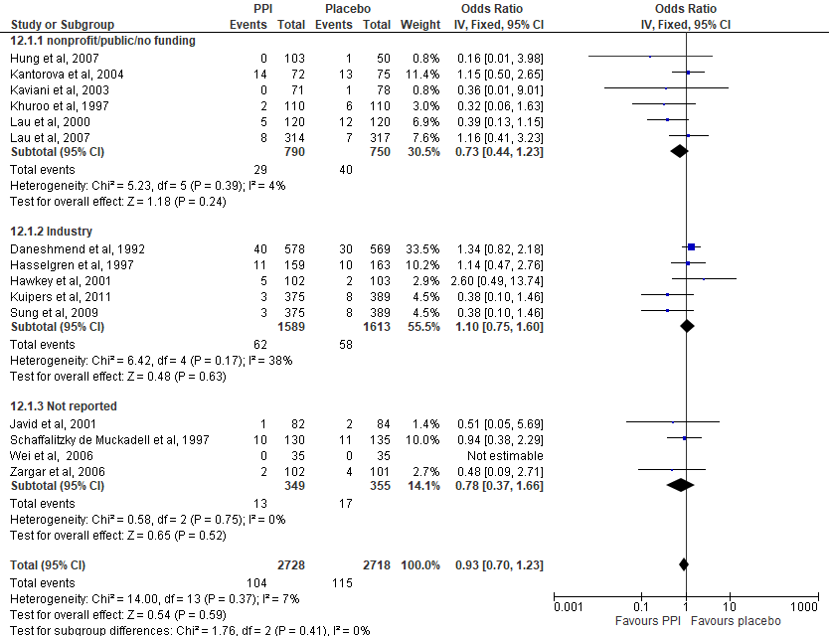
Figure S1. Sensitivity analyses by source of funding for Group A RCTs that assessed the association between PPI use vs nonuse with ACM among UGIB patients.
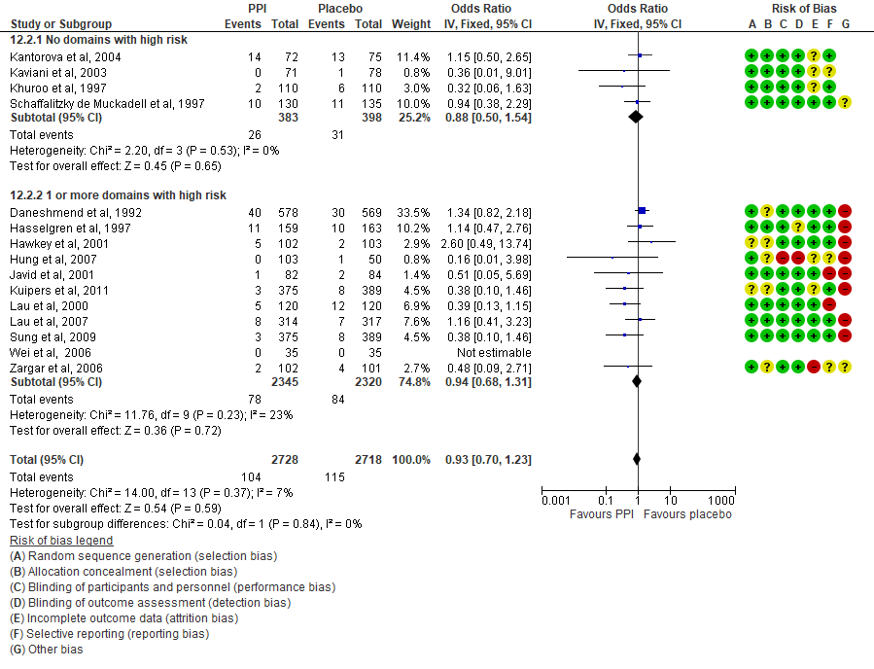
Figure S2. Sensitivity analyses by risk of bias in Group A RCTs that assessed the association between PPI use vs nonuse with ACM among UGIB patients.

Table S9. Sensitivity analyses assessing the effect of study funding source on the pooled effect estimates among Group B observational studies. n represents the number of studies pooled for each outcome.
 |  |  |  |  | Risk Ratio (95% CI)
Variable |  |  |  | All-cause mortality |  |  | Myocardial infarction |  | Cardiovascular mortality |  | Stroke
Funding source
 | Public/non-profit |  |  | 1.21 (1.02-1.43) |  | (n=16) | 1.20 (1.03-1.39) | (n=13) | 1.17 (0.93-1.48) | (n=8) | 1.34 (1.18-1.53) | (n=4)
 | Industry |  |  | 1.44 (0.86-2.43) |  | (n=2) | 1.59 (1.28-1.97) | (n=4) | 1.10 (0.51-2.37) | (n=1) | 0.98 (0.69-1.38) | (n=2)
 | Not reported |  |  | 1.18 (1.02-1.37) |  | (n=7) | 1.06 (0.83-1.36) | (n=6) | 1.00 (0.50-2.00) | (n=1) | 1.21 (0.48-3.05) | (n=1)
 | Overall |  |  | 1.23 (1.08-1.41) |  |  | 1.22 (1.07-1.38) |  | 1.16 (0.94-1.43) |  | 1.29 (1.15-1.46)

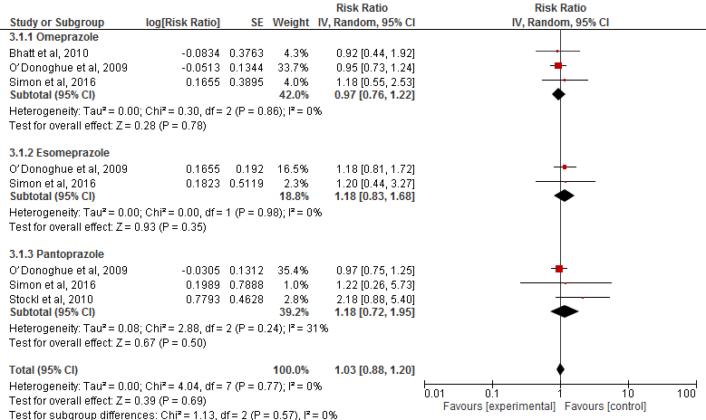

Figure S3. Sensitivity analyses by type of PPI for Group B observational studies that assessed the association between PPI use vs nonuse and MI among clopidogrel users.

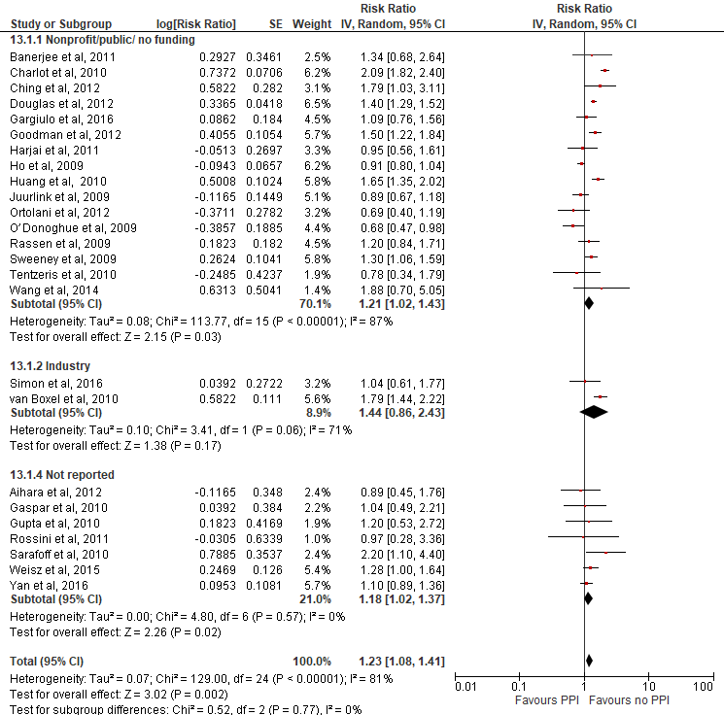

Figure S4. Sensitivity analyses by type source of funding for Group B observational studies that assessed the association between PPI use vs nonuse and ACM among clopidogrel users.

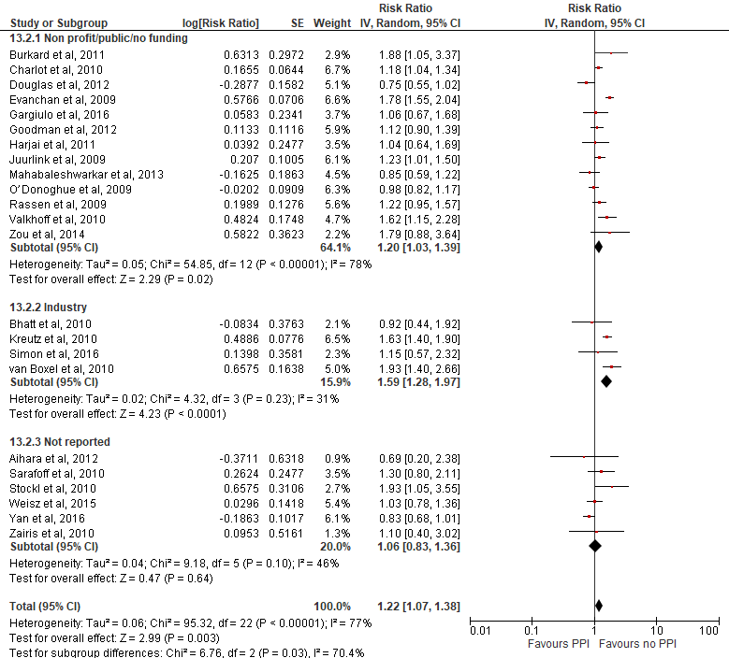

Figure S5. Sensitivity analyses by source of study funding for Group B observational studies that assessed the association between PPI use vs nonuse and MI among clopidogrel users.

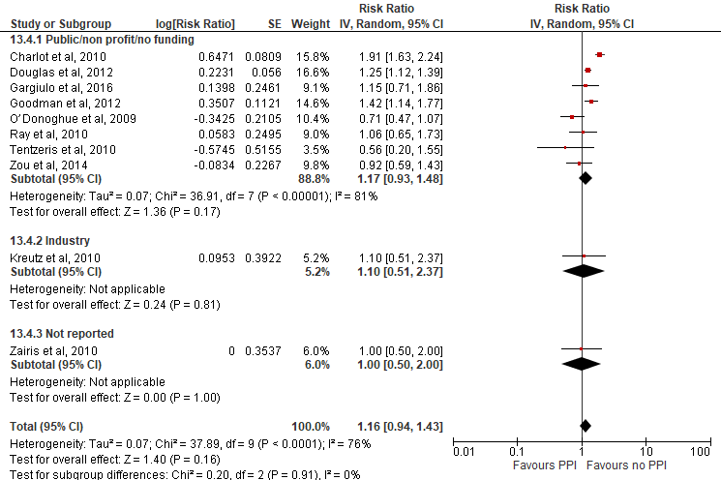

Figure S6. Sensitivity analyses by source of study funding for Group B observational studies that assessed the association between PPI use vs nonuse and cardiovascular mortality among clopidogrel users.

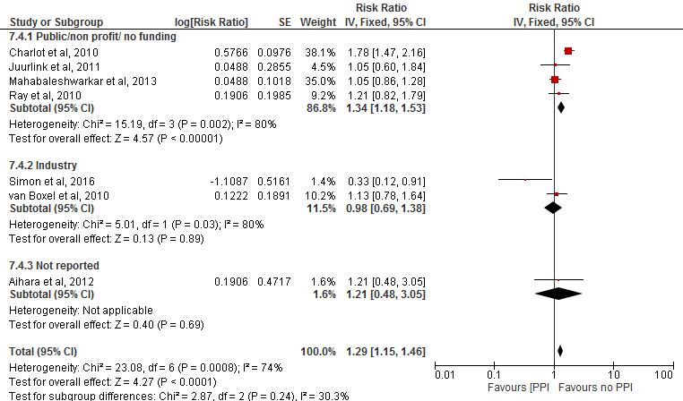
Figure S7. Sensitivity analyses by source of study funding for Group B observational studies that assessed the association between PPI use vs nonuse and stroke among clopidogrel users.

Supplemental Material VII – Quality of observational studies included in the meta-analysis
Table S10. Newcastle-Ottawa scores for observational studies.
Study | Study design | Cohort selections | Outcomes | Comparability | Selection of cases /controls | Exposure
Aihara et al, 2012 | Cohort | **** | *** | **
Banerjee et al, 2011 | Cohort | *** | *** | **
Bettinger et al, 2018 | Cohort | *** | *** | *
Charlot et al, 2010 | Cohort | **** | *** | **
Charlot et al, 2010 | Cohort | **** | *** | **
Ching et al, 2012 | Cohort | *** | *** | **
Daskalopoulou et al, 2008 | Cohort | **** | ** | **
de Francisco et al, 2018 | Cohort | **** | ** | *
Douglas et al, 2012 | Cohort | **** | *** | **
Dultz et al, 2014 | Cohort | **** | ** | **
Evanchan et al, 2009 | Cohort | *** | ** | **
Gargiulo et al, 2016 | Cohort | **** | ** | **
Gaspar et al, 2010 | Cohort | **** | *** | **
Goodman et al, 2012 | Cohort | **** | *** | **
Gupta et al, 2010 | Cohort | *** | ** | **
Harjai et al, 2011 | Cohort | **** | *** | **
Ho et al, 2009 | Cohort | **** | ** | ***
Huang et al, 2010 | Cohort | **** | ** | **
Kreutz et al, 2010 | Cohort | **** | *** | **
Kwon et al, 2013 | Cohort | **** | ***
Lei et al, 2017 | Cohort | **** | ** | **
Mandorfer et al, 2014 | Cohort | **** | ** | **
Nardelli et al, 2018 | Cohort | **** | * | *
Nguyen et al, 2018 | Cohort | **** | ** | ***
O’Donoghue et al, 2009 | Cohort | *** | ** | **
Ortolani et al, 2012 | Cohort | **** | *** | **
Oudit et al, 2011 | Cohort | **** | *** | **
Rassen et al, 2009 | Cohort | **** | *** | **
Ray et al, 2010 | Cohort | **** | *** | **
Rossini et al, 2011 | Cohort | **** | ***
Sarafoff et al, 2010 | Cohort | **** | ** | **
Sehested et al, 2018 | Cohort | **** | *** | **
Shih et al, 2014 | Cohort | **** | ** | **
Simon et al, 2016 | Cohort | **** | *** | **
Simon et al, 2016 | Cohort | **** | *** | **
Tentzeris et al, 2010 | Cohort | **** | *** | **
Teramura-Grönblad et al, 2012 | Cohort | **** | *** | **
van Boxel et al, 2010 | Cohort | **** | *** | **
Wang et al, 2014 | Cohort | **** | ** | **
Wang et al, 2017 | Cohort | **** | ** | *
Weisz et al, 2015 | Cohort | **** | *** | **
Yan et al, 2016 | Cohort | **** | * | **
Zairis et al, 2010 | Cohort | **** | ***
Zou et al, 2014 | Cohort | **** | *** | **
Johansson et al, 2003 | Case control |  |  | ** | **** | **
Juurlink et al, 2009 | Case control |  |  | ** | **** | **
Juurlink et al, 2011 | Case control |  |  | ** | *** | **
Juurlink et al, 2013 | Case control |  |  | ** | **** | **
Mahabaleshwarkar et al, 2013 | Case control |  |  | ** | *** | **
Turkiewicz et al, 2015 | Case control |  |  | * | **** | ***
Valkhoff et al, 2010 | Case control |  |  | ** | *** | **

Supplemental Materials VIII: Findings from observational studies that reported counts/rates of events.

Table S11. Findings from observational studies that reported counts/rates of events among PPI users and non-users (with no concomitant treatment) (Group A). These findings were not included in the meta-analysis.
Citation | Patient population | Outcome (follow up) | Percentage of events or unadjusted effect estimates (95% CI) and number of patients (N) in each exposure group | Overall author conclusion on the PPI-outcome of interest association¹
All-cause mortality
(Freedberg et al. 2013) | CDI | ACM (90 days) | Within 90 days: PPI: 32% (N=551); no PPI: 25% (N=343); p-value: 0.03. | Higher mortality CDI patients exposed to PPIs.
(Gardezi et al. 2018) | Non-variceal bleeding | ACM (NR) | PPI: 9%; No PPI: 14%; p-value: 0.91; | No association between pre-endoscopy use of PPIs and mortality.
(Haider et al. 2012) | CDI | ACM (in-hospital, 6 months) | Within 6 months of index CDI  PPI: 36% (N=172); no PPI: 31% (N=358); p-value: 0.25;  In hospital mortality  PPI: 9% (N=172); no PPI: 1% (N=358); p-value: <0.0001 | Difference in mortality between groups not statistically significant within 6 months of index CDI, but statistically significant for in-hospital mortality.
(Keyvani et al. 2006) | Acute non-variceal UGIB | ACM (in hospital) | PPI: 1.5% (N=132): no PPI: 3% (N=189); p-value: 0.04; (PPI exposure pre-endoscopy) | No difference in mortality between groups.
(van der Hoorn et al. 2015) | Elderly women | ACM (mean 6.6 years) | PPI: 20% (N=2,328); No PPI: 23% (N=2,104); p-value: 0.015; | Difference in mortality is statistically significant between treatment groups.
(Win et al. 2010) | UGIB | ACM (not clear) | PPI prior to admission: 3.63% (N=110); no PPI prior to admission: 9.12% (N=548); p-value 0.06; (PPI exposure assessed in the 4 weeks prior to admission) | Difference in mortality is not statistically significantly among treatment groups.
Cardiovascular mortality
(Chitose et al. 2012) | PCI | CVD mort (18 months) | All patients: PPI: 2% (N=331); no PPI: 1% (N=939); p-value: 0.43;  ACS patients: PPI: 1% (N=171); no PPI: 2% (N=450); p-value: 0.44; | No increased risk of adverse events with PPI after PCI/stent implantation.
Myocardial infarction
(Chitose et al. 2012) | PCI | MI (18 months) | All patients: PPI: 1% (N=331) ; no PPI: 0.5% (N = 939); p-value 0.24;  ACS patients: PPI: 1.1% (N=171); no PPI: 0.2% (N=450); p-value: 0.17; | No increased risk of adverse events with PPI after PCI/stent implantation.
Stroke
(Chitose et al. 2012) | PCI | Stroke (18 months) | All patients: PPI: 1% (N=331); no PPI: 1.7% (N=939); p-value: 0.5;  ACS patients: 1.2% (N=171); no PPI: 0.4% (N=450); p-value: 0.28; | No increased risk of adverse events with PPI after PCI/stent implantation.
¹ When the authors’ conclusions regarding the association in question was missing, the reviewers arrived at a conclusion based on whether there was a statistically significant difference in the proportion of events between the treatment groups; these conclusions are bolded in this column.

Table S12. Findings from observational studies that reported counts/rates of events or unadjusted RRs among concomitant PPI/clopidogrel users and patients on clopidogrel alone (Group B). These findings were not included in the meta-analysis.
Citation | Patient population | Outcome (follow up) | Counts/rates of events or unadjusted effect estimates and number of patients (N) in each exposure group | Overall author conclusion on the PPI-outcome of interest association¹
All-cause mortality
(Burkard et al. 2012) | PCI | ACM (36 months) | Clopidogrel and aspirin users  PPI: 9.2% (N=109); no PPI: 7.4% (N=692); p-value: 0.51 | No difference in deaths among groups. (not authors, authors not relevant to ACM).
(Depta et al. 2015) | ACS | ACM (1 year) | Clopidogrel users  Caucasians: PPI: 2.9% (N= 307); no PPI: 3.8% (N=1,325); p-value=0.48;  African Americans: PPI: 6.2% (N=65); no PPI: 7.4% (N=365); p-value=0.64; | No association between PPI use and all-cause mortality in either Caucasian or African American race or within each CYP2C19 genotype group.
(Galante et al. 2012) | PCI | ACM (not reported) | Unadjusted RR 1.0 (0.98-1.0); PPI: N=1273; no PPI: N=1295 | No statistical difference in MACE risk in concomitant clopidogrel and PPI treatment vs clopidogrel only treatment.
(Gaglia et al. 2010) | PCI with DES | ACM (30 days, 1 year) | Clopidogrel and aspirin users  30 days: PPI: 1% (N=318); no PPI: 0.2% (N=502); p-value 0.08;  1 year: PPI 5% (N=318); no PPI: 2% (N=502); p-value 0.02; | Association between PPI/clopidogrel use and MACE and all-cause mortality at 1 year in PCI patients with DES.
(Hudzik et al. 2010) | Stent | ACM (1 year) | Clopidogrel users  PPI: 0 (N=83); no PPI: 0 (N=65); | No difference in deaths among groups.
(Munoz-Torrero et al. 2011) | CAD, cerebrovascular or PAD | ACM (at least 1 year) | Clopidogrel users  All patients: Unadjusted RR, 2.2 (1.3–3.7); p value 0.003; PPI: N=519, no PPI: N=703;  CVD patients: Unadjusted RR, 1.6 (0.7–4.0), p-value 0.298; PPI: N=142 , no PPI: N=187;  PAD patients: Unadjusted RR, 1.9 (0.8–4.9), p-value 0.142; PPI: N=130, no PPI:N=168;  CAD patients: Unadjusted RR, 3.2 (1.2–8.8); p-value 0.014; PPI: N=247, no PPI: N=348; | Concomitant use of PPIs and clopidogrel is associated with increased mortality risk in CAD patients but not CVD or PAD patients
(Wu et al. 2010) | ACS | ACM (3 months) | Clopidogrel users  PPI: 11.4% (95% CI: 8-16%) (N=311); no PPI: 1.7% (95% CI: 1.4-2.1%) (N=5,551); | Concomitant PPI/clopidogrel treatment after hospital discharge for ACS increases risk of adverse MACE.
Cardiovascular mortality
(Chitose et al. 2012) | PCI | CVD mort (18 months) | Clopidogrel users  PPI: 2% (N=187); no PPI: 1% (N=443); p-value: 0.28; | No increased risk of adverse events with PPI after PCI/stent implantation.
(Hokimoto and Ogawa 2010) | On aspirin and clopidogrel | CVD mort (1 year) | Clopidogrel and aspirin users  PPI: no deaths (N=37); no PPI: 2% (N=133); p-value: 0.38; | No significant difference in clinical outcomes between rabeprazole treated and non-rabeprazole group.
(Yi et al. 2018) | Stroke patients | MI (1 year) | Clopidogrel users  PPI: 3/155 (1.9%); no PPI: 3/347 (0.9%); p-value: 0.32; | No association between PPI use and MACE among patients with a first time stroke.
Myocardial infarction
(Bhurke et al. 2012) | ACS | MI (mean 268 days) | Clopidogrel users  PPI: 6.4% (N=2,674); no PPI: 6.1% (N=2,674); p-value: 0.65; | Concomitant treatment associated with increased MI risk.
(Chitose et al. 2012) | PCI | MI (18 months) | Clopidogrel users  PPI: 0.5% (N=187); no PPI: 0.7% (N=443); p-value 0.97; | No increased risk of adverse events with PPI after PCI/stent implantation.
(Gaglia et al. 2010) | PCI with DES | MI (in-hospital, 1 year) | Clopidogrel and aspirin users  In hospital mortality: PPI: 0.3% (N=318); no PPI: 0.2% (N=502), p-value: 1;  30-day: PPI: 0% (N=318); no PPI: 0.2% (N=502); p-value: 1. | No difference in MI among groups.
(Hokimoto and Ogawa 2010) | On aspirin and clopidogrel | MI (1 year) | Clopidogrel and aspirin users  PPI: 0 (N=37); no PPI: 0 (N=133); | No significant difference in clinical outcomes between rabeprazole treated and non-rabeprazole group.
(Hudzik et al. 2010) | Stent | MI (1 year) | Clopidogrel and aspirin users  PPI: 33.4% (N=18); no PPI: 5.0% (N=20) ; p-value = 0.03; | Possible association between concomitant CP/omeprazole treatment and MI after stent implantation.
(Munoz-Torrero et al. 2011) | CAD, cerebrovascular or PAD | MI (at least 1 year) | Clopidogrel users  All patients: Unadjusted RR, 2.5 (1.3–4.8); N PPI 519, no PPI 703;  CAD patients: Unadjusted RR, 3.4 (1.5–8.2); N, PPI 247, no PPI 348;  PAD patients: Unadjusted RR, 0.9 (0.3–2.8), N PPI 130, no PPI 168; | Concomitant use of PPIs and clopidogrel is associated with an increased incidence MI and stroke in patients with established arterial disease.
(Ulhaq et al. 2011) | MI | MI (1 year) | Clopidogrel and aspirin users:  PPI: 10.4% (N=96); no PPI: 2.3% (N=88); p-value: 0.025; | Possible association between PPI/clopidogrel treatments.
(Yi et al. 2018) | Stroke patients | MI (1 year) | Clopidogrel users  PPI: 3/155 (1.9%); no PPI: 37/347 (1.2%); p-value 0.48; | No association between PPI use and MACE among patients with a first time stroke.
Stroke
(Chitose et al. 2012) | PCI | Stroke (18 months) | Clopidogrel users  PPI: 1% (N=187); no PPI: 2% (N=443); p-value: 0.6; | No increased risk of adverse events with PPI after PCI/stent implantation.
(Depta et al. 2015) | ACS | Stroke (1 year) | Clopidogrel users  Unadjusted rates: PPI: 0% (N=372); no PPI: 0.1% (N=1690); p-value: 1; | PPI use was associated increased cardiac rehospitalisation and risk varied by genotype.
(Hokimoto and Ogawa 2010) | On aspirin and clopidogrel | Stroke (1 year) | Clopidogrel and aspirin users  PPI (rabep): 3% (N=37); no PPI: 1% (N=133); p-value: 0.37; | No significant difference in clinical outcomes between rabeprazole treated and non-rabeprazole group.
(Hudzik et al. 2010) | Stent | Stroke (1 year) | Clopidogrel and aspirin users  PPI: 11.1% (N=18); no PPI: 5.0% (N=20); p-value: 0.4; | No association between concomitant clopidogrel/omeprazole treatment and stroke after stent implantation.
(Munoz-Torrero et al. 2011) | CAD, cerebrovascular or PAD | Stroke (at least 1 year) | Clopidogrel users  All patients: Unadjusted RR, 1.9 (1.03–3.7), PPI: N= 519, no PPI: N= 703  PAD patients: Unadjusted RR 10 (1.6–225), PPI: N=130, no PPI: N=168;  CVD patients: Unadjusted RR 1.5 (0.7–3.3) , N PPI: N=142, no PPI: N=187;  CAD patients: Unadjusted RR 1.3 (0.1–12), PPI: N=247, no PPI: N= 348; | Concomitant use of PPIs and clopidogrel is associated with an increased incidence of MI and stroke in patients with established arterial disease.
(Yi et al. 2018) | Stroke patients | MI (1 year) | Clopidogrel users  PPI: 25/155 (12.3%); no PPI: 44/347 (10.7%); p-value 0.63; | No association between PPI use and MACE among patients with a first time stroke.
¹ When the authors’ conclusions regarding the association in question was missing, the reviewers arrived at a conclusion based on whether there was a statistically significant difference in the proportion of events between the treatment groups; these conclusions are bolded in this column.

Table S13. Findings from an observational study that reported counts/rates of events among PPI/ticlopidine users and users of ticlopidine alone (Group C). These findings were not included in the meta-analysis.
Citation/Outcome | Patient population | Outcome (follow up) | Counts/rates of events or unadjusted effect estimates and number of patients (N) in each exposure group | Overall author conclusion on the PPI-outcome of interest association
(Kimura et al. 2011)
All-cause mortality | PCI | 3 years | Ticlopidine and aspirin users  PPI: 11.9%; no PPI: 6.4%;  p-value: <0.0001 | Possible association between PPI and MACE in the Japanese practice (antiplatelet therapy is ticlopidine and aspirin).
Cardiovascular mortality | PCI | 3 years | Ticlopidine and aspirin users  PPI: 5% (N=3,223); no PPI: 3% (N=9,223);  p-value <0.0001; (cardiac death)
Myocardial infarction | PCI | 3 years | Ticlopidine and aspirin users  PPI: 4.4% (N=3,223); no PPI: 3% (N=9,223);  p-value: 0.0004;
Stroke | PCI | 3 years | Ticlopidine and aspirin users  PPI: 4.5% (N=3,223); no PPI: 4.3% (N=9,223);  p-value: 0.52

Supplemental Material IX – Funnel plots

The following funnel plots correspond to meta-analyses that included ten or more studies are presented below. These plots were visually evaluated for publication bias.

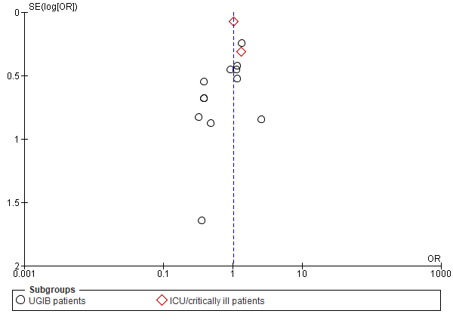
Figure S8. Funnel plot for the meta-analysis of ACM among Group A RCTs.

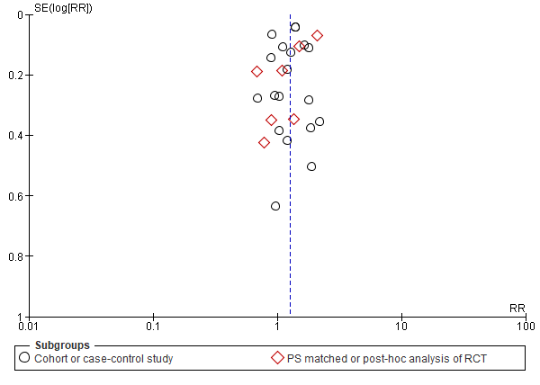
Figure S9. Funnel plot for the meta-analysis of ACM outcome among Group B observational studies.

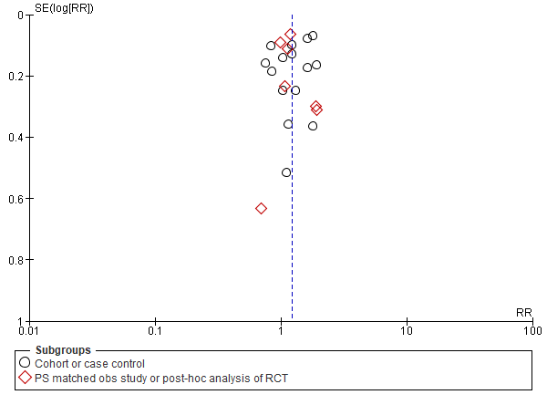
Figure S10. Funnel plot for the meta-analysis of MI outcome among Group B observational studies.

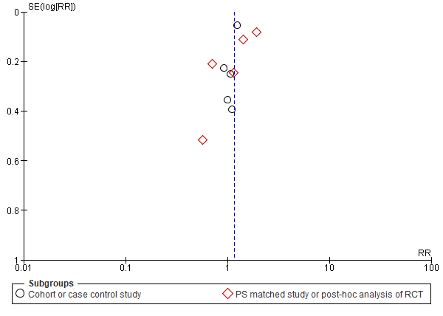
Figure S11. Funnel plot for the meta-analysis of cardiovascular mortality among Group B observational studies.

