Beautiful pictures of Antarctica
---- taken by the 29th CHINARE (2012.10—2013.04)
Antarctic inland Kunlun Station expedition members
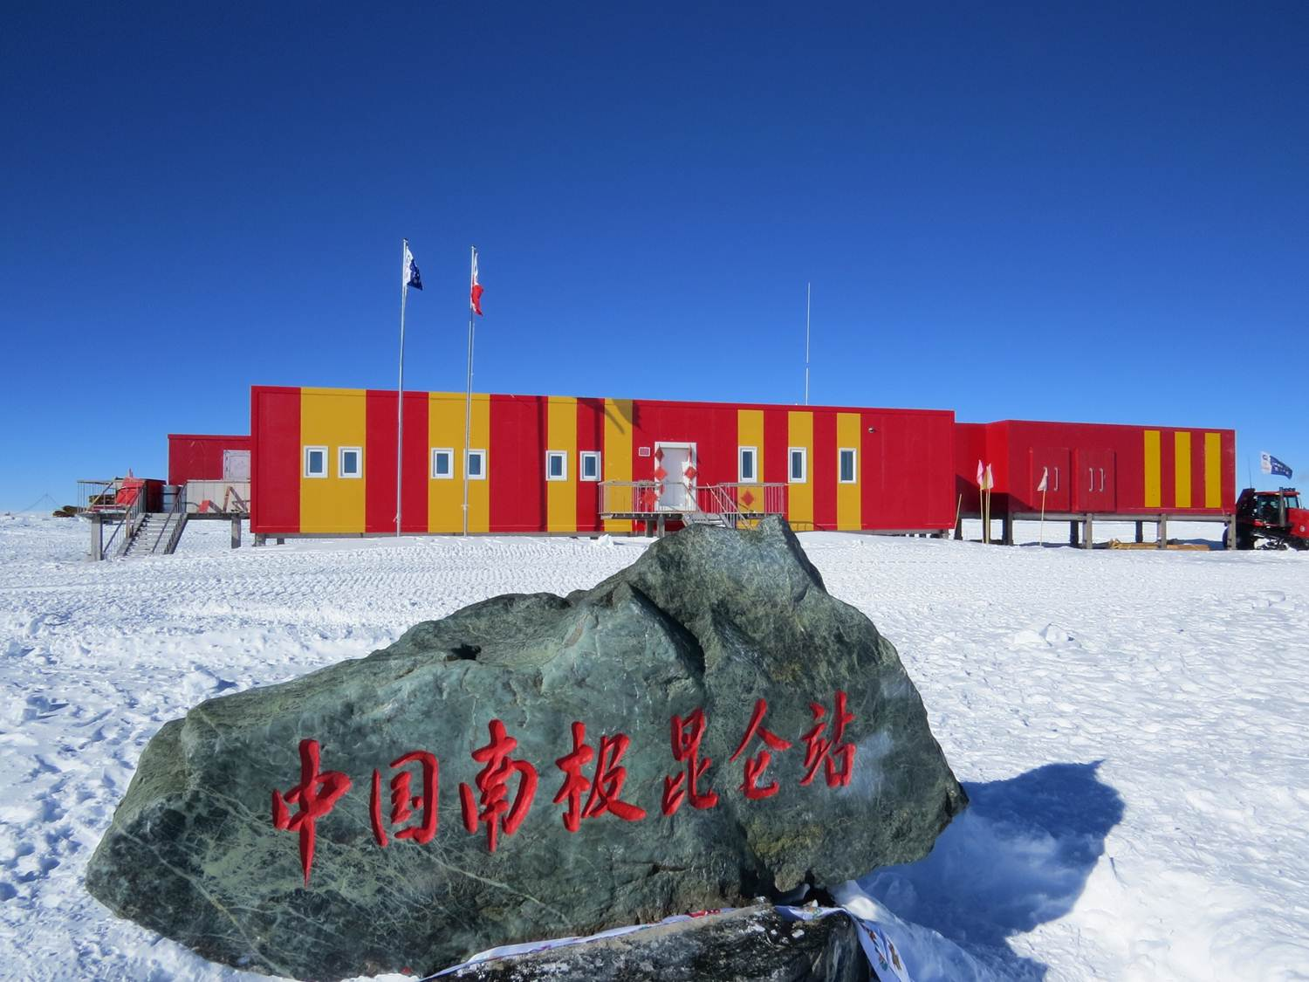
Fig.1 Antarctic inland Kunlun Station
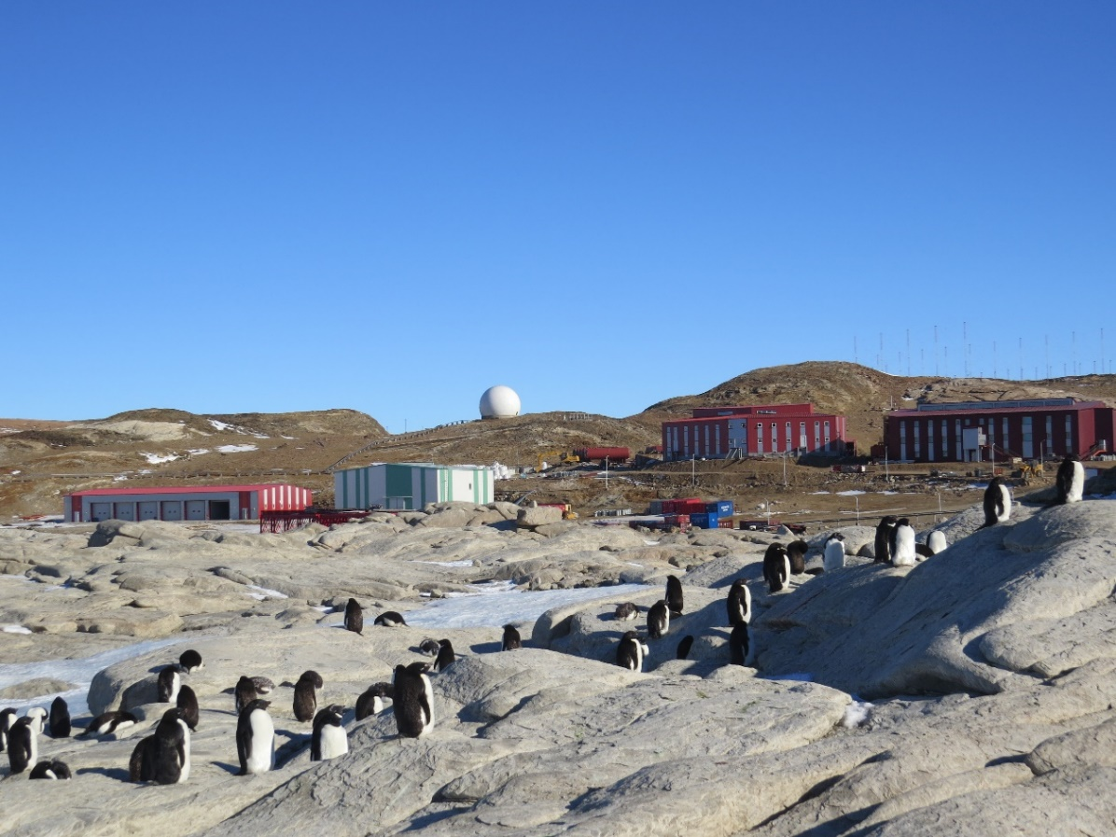
Fig.2 Antarctic penguins near Zhongshan Station

Fig.3 Xuelong research vessel on the sea

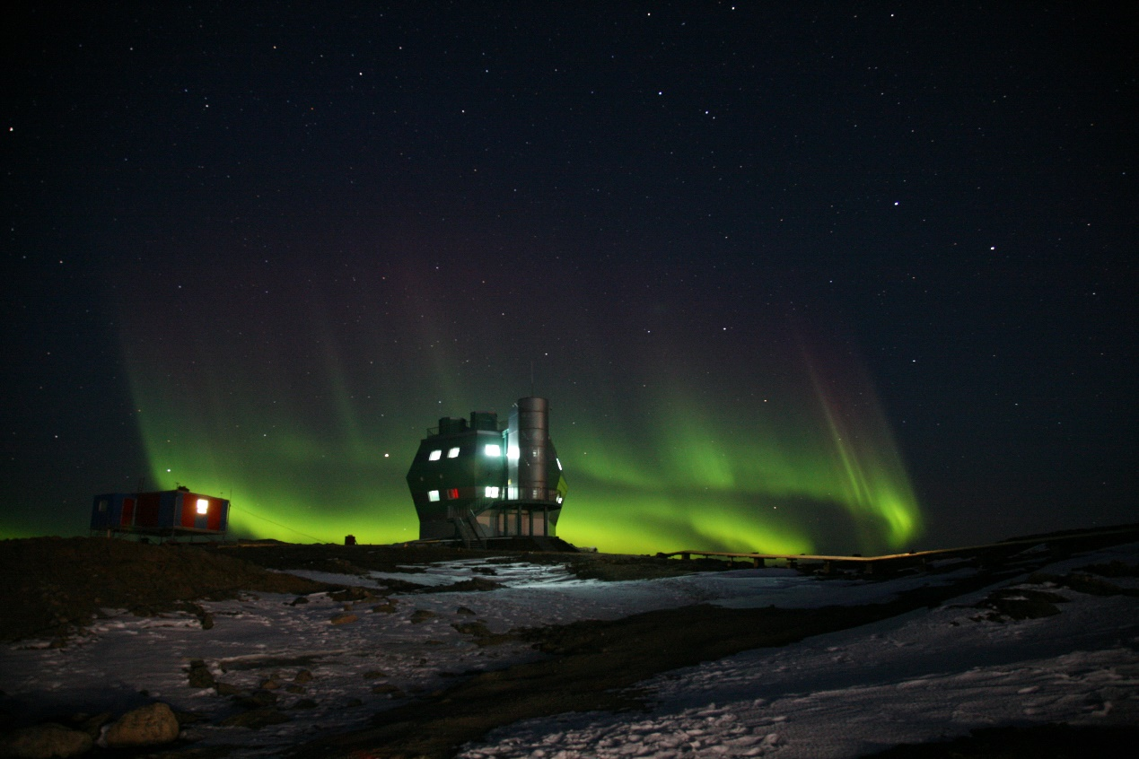
Fig.4 Antarctic aurora at Zhongshan Station
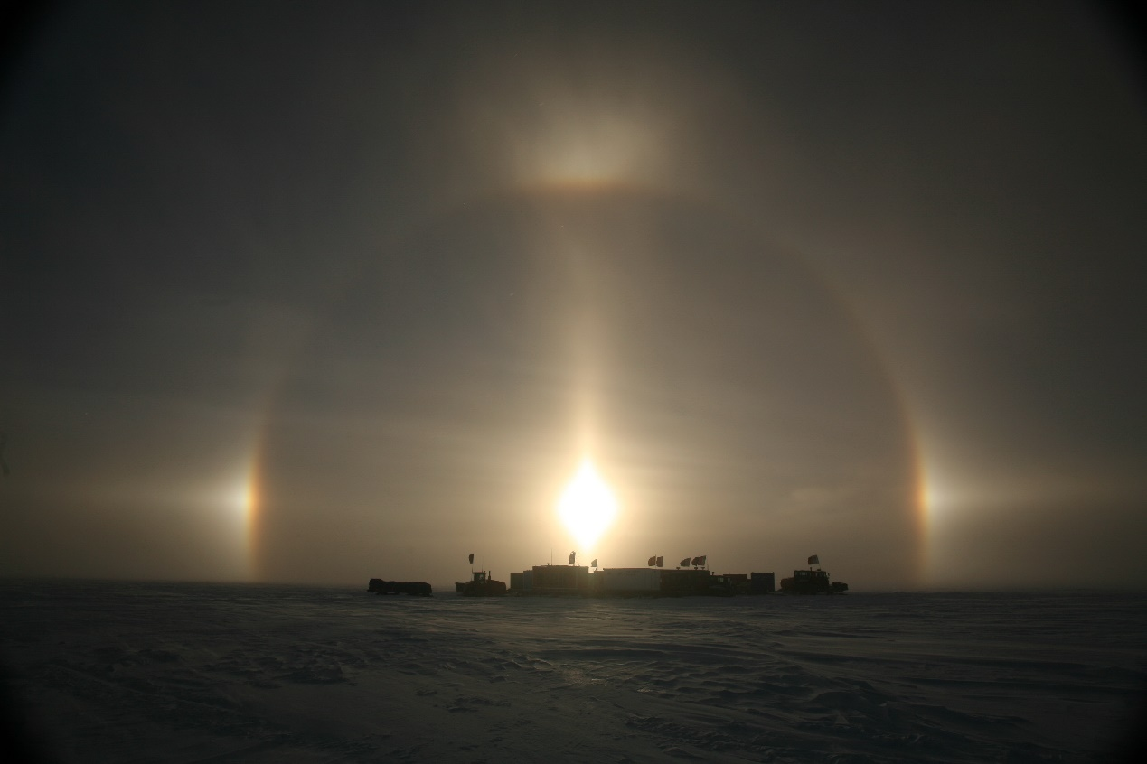
Fig.5 Antarctic inland solar halo

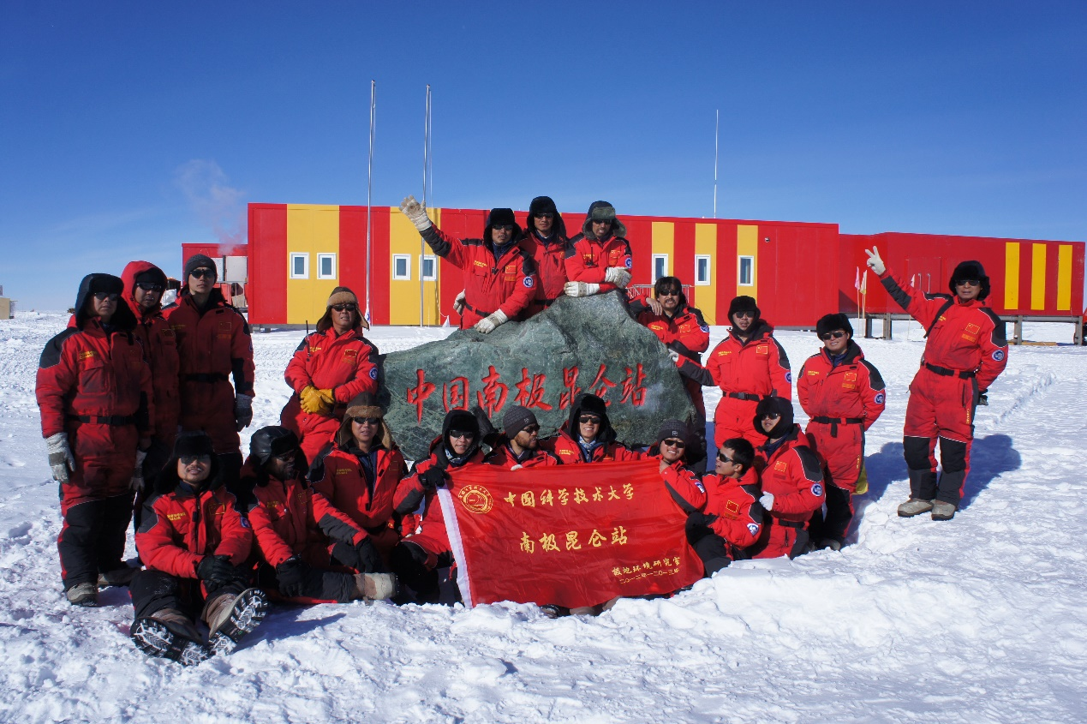
Fig.6 The flag of University of Science and Technology of China at Antarctic Kunlun Station

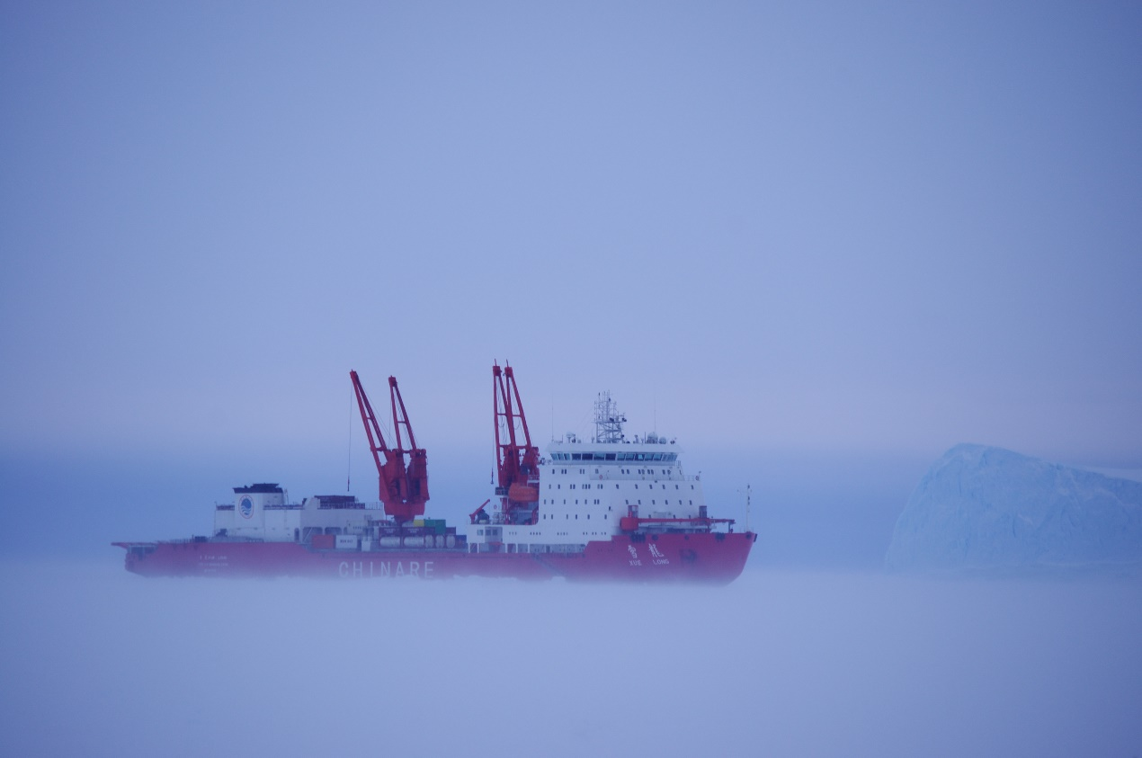
Fig.7 Xuelong research vessel on the ice

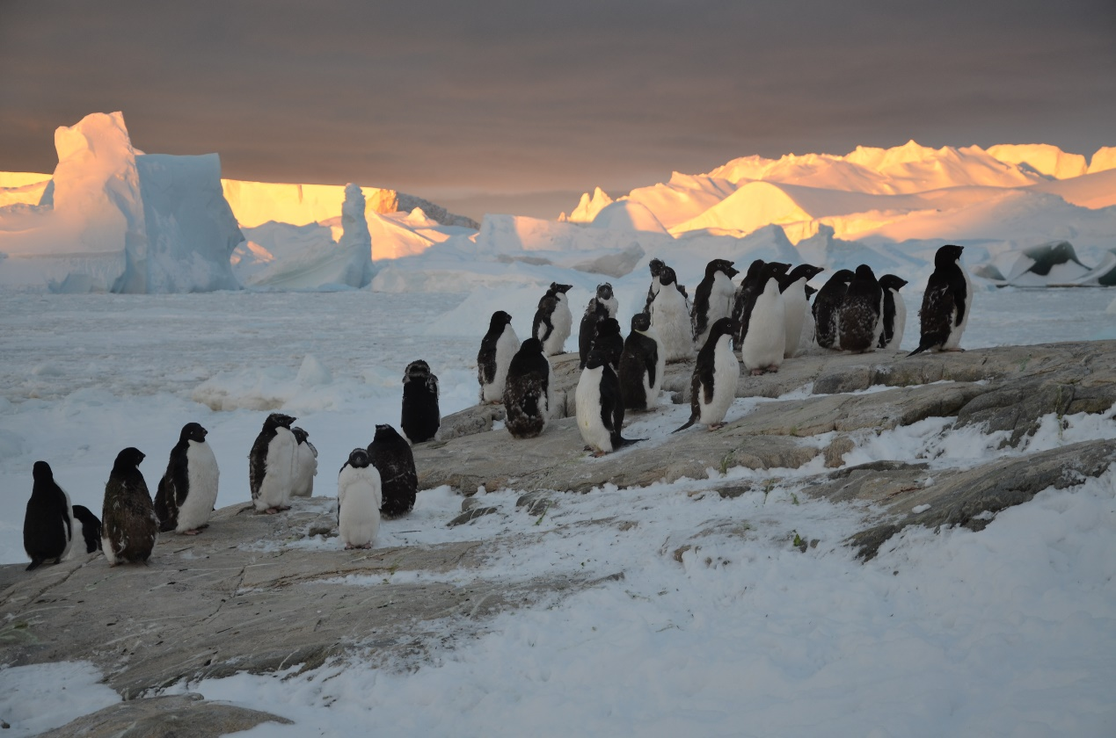
Fig.8 Antarctic penguins through the iceberg

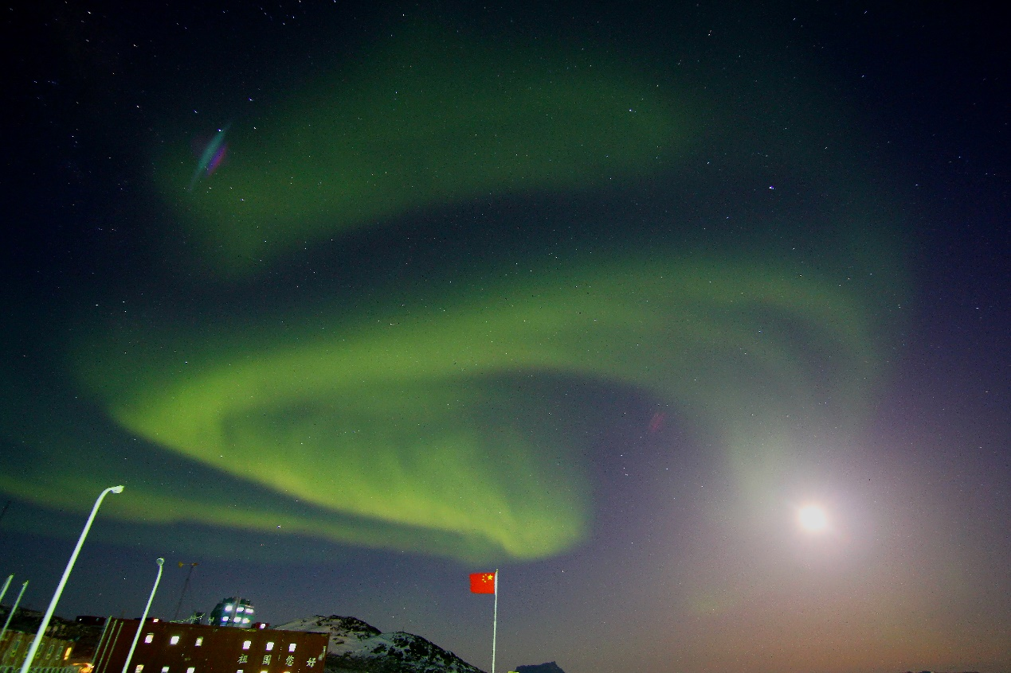
Fig.9 Antarctic aurora at Zhongshan Station

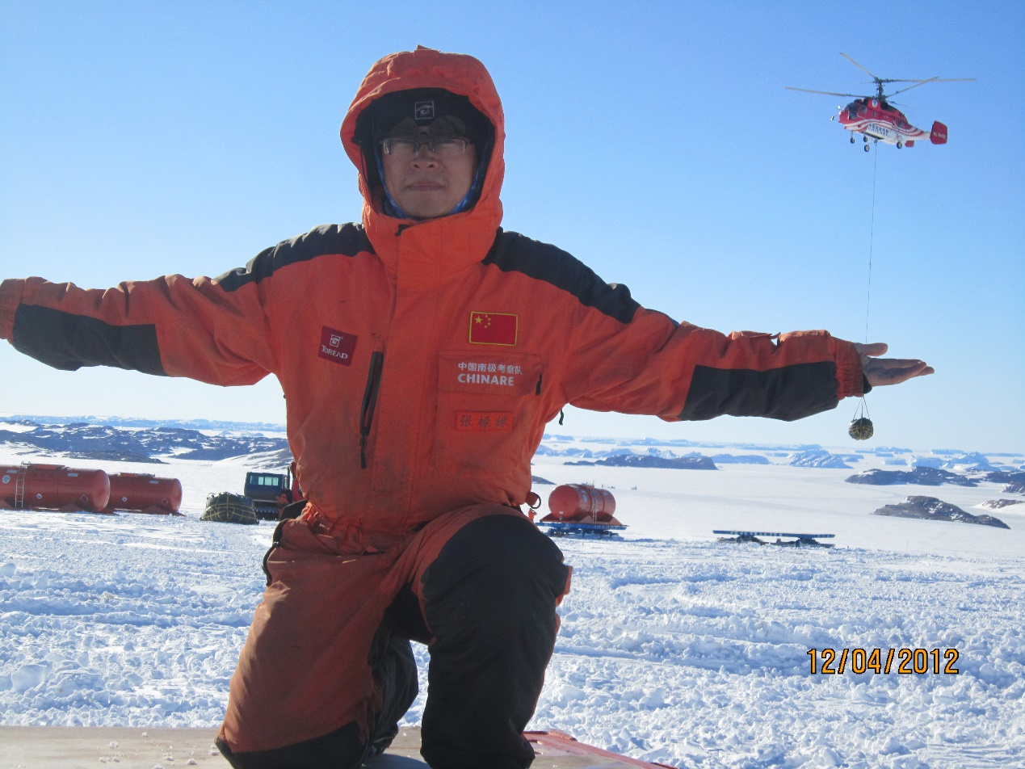
Fig.10 The author (Zhang Lulu) at Antarctic inland set off base (near Zhongshan Station)
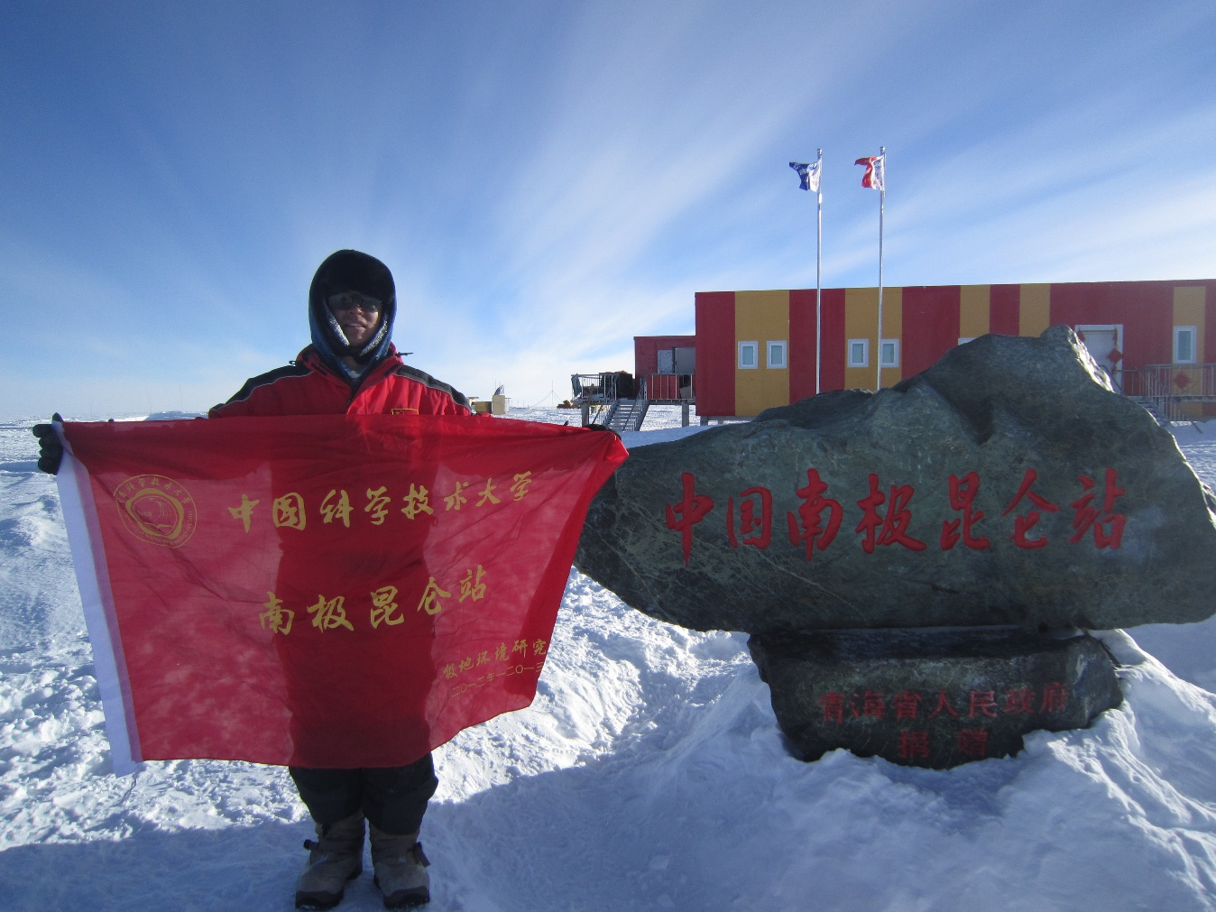
Fig.11 The author (Zhang Lulu) at Antarctic inland Kunlun Station

Fig.12 The 29th CHINARE at Dome A near Antarctic inland Kunlun Station

