**Table S1: Accession numbers of QS genes within *Vibrio* genomes (i.e. Table 2).** Genes have been retrieved by Blast using QS genes from previously described *Vibrio* spp. as query sequences. For fully sequenced genomes the chromosome in which they have been retrieved are indicated (Chr.)

|  |  |  |  |  |  |  |  |  |  |  |  |
| --- | --- | --- | --- | --- | --- | --- | --- | --- | --- | --- | --- |
| Clade | Strain | LuxS | Chr. | CqsA | Chr. | LuxI | Chr. | LuxM | Chr. | LuxO | Chr. |
| ND | V. pacinii DSM 19139 | WP_038176134.1 |  | WP_038176440.1 |  |  |  |  |  | WP_038173006 |  |
| ND | V. proteolyticus NBRC 13287 | GAD67797.1 |  | GAD67194.1 |  |  |  | GAD65665.1 |  | [WP_040902224.1](https://www.ncbi.nlm.nih.gov/protein/750620356) |  |
| Anguillarum | V. anguillarum NB10 | CDQ49375.1 | I | CDQ48167.1 | II | WP_013868065.1 | II | CDQ48719.1 | II | CDQ49814.1 | I |
| V. ordalii | WP_010319518.1 |  | OEE39397.1 |  | WP_010317581.1 |  | OEE35474.1 |  | WP_026028620.1 |  |
| Cholerae | V. albensis ATCC 14547 | BAE87114.1 |  | WP_001039905.1 |  |  |  |  |  |  |  |
| V. cholerae 10432-62 | AKB08515.1 | I | AKB06325.1 | I |  |  |  |  | AKB04564.1 | I |
| V. cincinnatiensis CECT 4216 | SJZ72057.1 |  | SJZ55285.1 |  | SJZ83244.1 |  |  |  | [SJZ51807.1](https://www.ncbi.nlm.nih.gov/protein/SJZ51807.1) |  |
| V. fluvialis PG41 | EPP21793.1 |  | WP_020328469.1 |  | EPP23858.1 |  |  |  | [EPP25353.1](https://www.ncbi.nlm.nih.gov/protein/EPP25353.1) |  |
| V. furnissii CIP 102972 | WP_004723869.1 | I | EEX41039.1 | II | EEX40539.1 | II |  |  | EEX42264.1 | II |
| V. metoecus | PAR69839.1 |  | PAR67470.1 |  |  |  |  |  | WP_081018466.1 |  |
| V. metschnikovii CIP 69.14 | EEX37868.1 |  | EEX35962.1 |  | WP_040905124.1 |  | EEX36585.1 |  |  |  |
| V. mimicus ATCC 33654 | WP_001130224.1 | I | AMG02318.1 | I |  |  |  |  | EMB49555.1 | II |
| V. xiamenensis CGMCC 1.10228 | WP_093274549.1 |  | SDH99428.1 |  |  |  | SDH10059.1 |  | [SDH78060.1](https://www.ncbi.nlm.nih.gov/protein/WP_093270677.1) |  |
| Coralliilyticus | V. coralliilyticus | PAW00997.1 | I | AIS57062.1 | II |  |  | AIU66455.1 | I | WP_019275536.1 | I |
| V. neptunius | WP_045977467.1 |  | KJY91683.1 |  |  |  |  |  | [WP_045975011.1](https://www.ncbi.nlm.nih.gov/protein/WP_045975011.1) |  |
| Diazotrophicus | V. diazotrophicus NBRC 103148 | WP_042480533.1 |  |  |  |  |  |  |  | [WP_042486207.1](https://www.ncbi.nlm.nih.gov/protein/WP_042486207.1) |  |
| Fischeri | A. fischeri ES114 | YP_203928.1 | I |  | II | YP_206882.1 | II | YP_204420.1 | I | YP_204320.1 | I |
| Gazogenes | V. aerogenes CECT 7868 | SHI10089.1 |  |  |  |  |  | SHI27925.1 |  | [SHI42796.1](https://www.ncbi.nlm.nih.gov/protein/SHI42796.1) |  |
| V. gazogenes ATCC 43942 | WP_088133568.1 | I | ASA57377.1 | II |  |  | ASA56840.1 |  | WP_021019492.1 | I |
| V. mangrovi CECT 7927 | SMS00203.1 |  | SMS01069.1 |  |  |  | SMR99552.1 |  | SMR99730.1 |  |
| V. palustris CECT 9027 | SJL82102.1 |  |  |  |  |  | SJL83989.1 |  | [SJL82757.1](https://www.ncbi.nlm.nih.gov/protein/SJL82757.1) |  |
| V. quintilis CECT 7734 | SHO55356.1 |  |  |  |  |  | SHO57248.1 |  | SHO57470.1 |  |
| V. rhizosphaerae DSM 18581 | WP_038183133.1 |  | WP_038184149. |  |  |  | WP_051680331.1 |  | WP_038181851.1 |  |
| V. ruber CECT 7878 | SJN55759.1 |  | SJN55526.1 |  |  |  | SJN58675.1 |  | WP_077336063.1 |  |
| V. spartinae CECT 9026 | SIO93251.1 |  | SIO92531.1 |  |  |  | SIO95297.1 |  | SIO95995.1 |  |
| Halioticoli | V. breoganii | WP_017027430.1 | I |  | I |  |  |  |  | [OED84463.1](https://www.ncbi.nlm.nih.gov/protein/OED84463.1) | II |
| V. ezurae NBRC 102218 | GAD78532.1 |  |  |  |  |  |  |  | [GAD81215.1](https://www.ncbi.nlm.nih.gov/protein/GAD81215.1) |  |
| V. halioticoli NBRC 102217 | GAD91380.1 |  |  |  |  |  |  |  | [GAD91322.1](https://www.ncbi.nlm.nih.gov/protein/GAD91322.1) |  |
| V. ishigakensis | GAM72756.1 |  |  |  |  |  |  |  | [GAM77677.1](https://www.ncbi.nlm.nih.gov/protein/GAM77677.1) |  |
| Harveyi | V. alginolyticus ATCC 17749 | GAD72482.1 | I | WP_017635350.1 | II |  |  | AGV16881.1 | I | [AGV17007.1](https://www.ncbi.nlm.nih.gov/protein/AGV17007.1) | I |
| V. antiquarius EX25 | ACY50694.1 | I | OKQ16879.1 | I |  |  | ACY51238.1 | I | WP_086028603.1 | I |
| V. azureus NBRC 104587 | GAD77530.1 |  |  |  |  |  |  |  | [GAD74119.1](https://www.ncbi.nlm.nih.gov/protein/GAD74119.1) |  |
| V. campbelli ATCC BAA-1116 | AGU95379.1 | I | AGU97432.1 | II |  |  | WP_012128347.1 | I | [AGU95728.1](https://www.ncbi.nlm.nih.gov/protein/AGU95728.1) | I |
| V. diabolicus LMG 19805 | WP_048625973.1 |  | CDT79506.1 |  |  |  |  |  | CDT90813.1 |  |
| V. harveyi | APP05614.1 | I | AAT86008.1 | I |  |  | P54298.2 | II | [APP05172.1](https://www.ncbi.nlm.nih.gov/protein/APP05172.1) | I |
| V. hyugaensis | WP_045465522.1 |  | WP_082037680.1 |  |  |  | WP_045500031.1 |  | [WP_038869346.1](https://www.ncbi.nlm.nih.gov/protein/WP_045464749.1) |  |
| V. jasicida LMG 25398 | WP_045420945.1 |  | WP_081634981.1 |  |  |  |  |  | [WP_038881596.1](https://www.ncbi.nlm.nih.gov/protein/WP_038881596.1) |  |
| V. mytili CAIM 528 | WP_041155632.1 |  |  |  |  |  |  |  | [KIN10028.1](https://www.ncbi.nlm.nih.gov/protein/KIN12034.1) |  |
| V. natriegens ATCC 14048 | WP_014232962.1 |  |  |  |  |  |  |  | [ANQ14029.1](https://www.ncbi.nlm.nih.gov/protein/ANQ14029.1) |  |
| V. owensii | AQW58584.1 | I | AQW60721.1 | II |  |  | WP_078608451.1 | I | [WP_005439670.1](https://www.ncbi.nlm.nih.gov/protein/WP_005439670.1) | I |
| V. parahaemolyticus RIMD 2210633 | BAC60800.1 | I | BAC62054.1 | II |  |  | NP_798346.1 | I | WP_011106018.1 | I |
| V. rotiferianus | WP_088880387.1 | II | WP_088880036.1 | I |  |  | ASI96705.1 | II | [ASI97976.1](https://www.ncbi.nlm.nih.gov/protein/ASI97976.1) | II |
| V. sagamiensis NBRC 104589 | WP_039979396.1 |  |  |  |  |  |  |  | [WP_102857649.1](https://www.ncbi.nlm.nih.gov/protein/WP_102857649.1) |  |
| Mediterranei | V. barjaei | WP_031493706.1 |  | OIN24174.1 |  |  |  |  |  | [OIN24899.1](https://www.ncbi.nlm.nih.gov/protein/OIN24899.1) |  |
| V. shilonii | WP_031493706.1 | I | WP_006070539.1 | II | WP_088878176.1 | II |  |  | [WP_062462808.1](https://www.ncbi.nlm.nih.gov/protein/WP_062462808.1) | I |
| V. thalassae CECT 8203 | SNX45376.1 |  | WP_096993577.1 |  | SNX48517.1 |  |  |  | SNX48588.1 |  |
| V. maritimus | GAL32507.1 |  | GAL17989.1 |  |  |  | GAL33331.1 |  | [GAL37339.1](https://www.ncbi.nlm.nih.gov/protein/GAL37339.1) |  |
| V. mediterranei 21 LN 0615 E | WP_031493706.1 |  | WP_062455464.1 |  | PCD89229.1 |  |  |  | [PCD88716.1](https://www.ncbi.nlm.nih.gov/protein/PCD88716.1) |  |
| V. variabilis | GAL27931.1 |  | KHA59035.1 |  |  |  |  |  | [WP_005473429.1](https://www.ncbi.nlm.nih.gov/protein/WP_005473429.1) |  |
| Nereis | V. nereis DSM 19584 | WP_053396983.1 |  |  |  |  |  |  |  | [KOO02715.1](https://www.ncbi.nlm.nih.gov/protein/KOO02715.1) |  |
| V. xuii LMG 21346 | AEB71522.1 |  |  |  |  |  |  |  | [KOO14497.1](https://www.ncbi.nlm.nih.gov/protein/KOO14497.1) |  |
| Nigripulchritudo | V. nigripulchritudo SFn1 | CCO56367.1 | I | CCO60967.1 | I |  |  |  |  | WP_022603175.1 | I |
| Orientalis | V. bivalvicida | WP_049844341.1 |  | WP_054962247.1 |  |  |  |  |  | [WP_054961486.1](https://www.ncbi.nlm.nih.gov/protein/WP_054961486.1) |  |
| V. brasiliensis LMG 20546 | EGA67683.1 |  | WP_006880205.1 |  |  |  | EGA65598.1 |  | [EGA65736.1](https://www.ncbi.nlm.nih.gov/protein/EGA65736.1) |  |
| V. galatheae | WP_045956889.1 |  | KJY84008.1 |  |  |  |  |  | [KJY85154.1](https://www.ncbi.nlm.nih.gov/protein/KJY85154.1) |  |
| V. hepatarius DSM 19134 | WP_053410547.1 |  |  |  |  |  |  |  | [WP_053408285.1](https://www.ncbi.nlm.nih.gov/protein/WP_053408285.1) |  |
| V. orientalis ATCC 33934 | WP_004415667.1 |  | EEX93847.1 |  |  |  |  |  | [EGU46611.1](https://www.ncbi.nlm.nih.gov/protein/EGU46611.1) |  |
| V. sinaloensis DCM 21326 | EGA67829.1 |  | WP_008075930.1 |  |  |  | EGA72240.1 |  | [WP_008077912.1](https://www.ncbi.nlm.nih.gov/protein/WP_008077912.1) |  |
| V. tubiashii ATCC 19109 | WP_004748160.1 | I | AIW16497.1 | II |  |  | AIW13804.1 | 1 | [EGU47641.1](https://www.ncbi.nlm.nih.gov/protein/EGU47641.1) | I |
| Pectenicida | V. caribbeanicus T14 | WP_038140324.1 |  | KHD25690.1 |  |  |  |  |  | [WP_005473429.1](https://www.ncbi.nlm.nih.gov/protein/WP_005473429.1) |  |
| V. ostreicida | WP_076589521.1 |  |  |  |  |  |  |  | [WP_076587390.1](https://www.ncbi.nlm.nih.gov/protein/WP_076587390.1) |  |
| Ponticus | V. panuliri CAIM 703 | OLQ88693.1 |  |  |  |  |  |  |  | [OLQ90661.1](https://www.ncbi.nlm.nih.gov/protein/OLQ90661.1) |  |
| V. ponticus CAIM 1731 | OLQ84706.1 |  |  |  |  |  |  |  | [OLQ89935.1](https://www.ncbi.nlm.nih.gov/protein/OLQ89935.1) |  |
| Porteresiae | V. tritonius JCM 16456 | WP_068712093.1 | I |  |  |  |  |  |  | [WP_068714228.1](https://www.ncbi.nlm.nih.gov/protein/WP_068714228.1) | I |
| Rumoiensis | V. algivorus NBRC 111146 | WP_089122415.1 |  |  |  |  |  |  |  |  |  |
| V. casei CIP 110169 | WP_086962844.1 |  |  |  |  |  |  |  |  |  |
| V. litoralis DSM 17657 | WP_027697621.1 |  |  |  |  |  |  |  |  |  |
| V. mexicanus CAIM 1540 | WP_047042389.1 |  |  |  |  |  |  |  |  |  |
| V. rumoiensis | OEF25823.1 |  |  |  |  |  |  |  |  |  |
| Scophthalmi | V. ichthyoenteri ATCC 700023 | EGU32476.1 |  | WP_006711312.1 |  |  |  |  |  | [WP_039948977.1](https://www.ncbi.nlm.nih.gov/protein/WP_039948977.1) |  |
| V. renipiscarius | WP_040985944.1 |  |  |  |  |  |  |  | [WP_040988784.1](https://www.ncbi.nlm.nih.gov/protein/WP_040988784.1?report=genbank&log$=protalign&blast_rank=1&RID=KPUPSRDX014) |  |
| V. scophthalmi VS05 | ANU35380.1 | I | ANU38174.1 | II |  |  |  |  | [WP_005593860.1](https://www.ncbi.nlm.nih.gov/protein/WP_005593860.1) | I |
| Splendidus | V. atlanticus CECT 7223 | SBS60609.1 |  | SBS62811.1 |  |  |  |  |  | [SBS60136.1](https://www.ncbi.nlm.nih.gov/protein/SBS60136.1) |  |
| V. celticus CECT 7224 | SBT13724.1 |  | SBT14297.1 |  |  |  | SBT14763.1 |  | [WP_004734031.1](https://www.ncbi.nlm.nih.gov/protein/WP_004734031.1) |  |
| V. crassostreae J2-9 | CDT41313.1 |  | CDT52194.1 |  |  |  | CDT07575.1 |  | [CDT30285.1](https://www.ncbi.nlm.nih.gov/protein/CDT30285.1) |  |
| V. cyclitrophicus FF75 | ERM59894.1 |  | ERM61014.1 |  |  |  | ERM58132.1 |  | [WP_010437172.1](https://www.ncbi.nlm.nih.gov/protein/OEE49707.1) |  |
| V. fortis | WP_032549766.1 |  | KDN29230.1 |  |  |  |  |  | [WP_032551999.1](https://www.ncbi.nlm.nih.gov/protein/WP_032551999.1) |  |
| V. gigantis | WP_086711976.1 |  | WP_086713199.1 |  |  |  | WP_086712800.1 |  | [WP_004734031.1](https://www.ncbi.nlm.nih.gov/protein/WP_004734031.1) |  |
| V. hemicentroti CECT 8714 | SBS67388.1 |  | SBS64902.1 |  |  |  | SBS66281.1 |  | [SBS61711.1](https://www.ncbi.nlm.nih.gov/protein/SBS61711.1) |  |
| V. kanaloae | OEF13706.1 |  | OEF14538.1 |  |  |  | OEF14987.1 |  | [OEF12568.1](https://www.ncbi.nlm.nih.gov/protein/OEF12568.1) |  |
| V. lentus | OMO19739.1 |  | WP_076671644.1 |  |  |  | WP_076666985.1 |  | [OMO24656.1](https://www.ncbi.nlm.nih.gov/protein/OMO24656.1) |  |
| V. splendidus 12B01 | WP_004735501.1 |  | EAP94908.1 |  |  |  | EAP96774.1 |  | [EAP92884.1](https://www.ncbi.nlm.nih.gov/protein/EAP92884.1) |  |
| V. tasmaniensis LGP32 | CAV19744.1 | I | CAV18909.1 | I |  |  | WP_012600240.1 | II | [WP_017099957.1](https://www.ncbi.nlm.nih.gov/protein/WP_017099957.1) | I |
| V. toranzoniae CECT 7225 | SBS36176.1 |  | SBS38523.1 |  |  |  | SBS30726.1 |  | [SBS26811.1](https://www.ncbi.nlm.nih.gov/protein/SBS26811.1) |  |
| Vulnificus | V. cidicii | WP_039430460.1 |  | KYN24130.1 |  |  |  |  |  | [KYN88623.1](https://www.ncbi.nlm.nih.gov/protein/KYN25077.1) |  |
| V. navarrensis ATCC 51183 | WP_039430460.1 |  | KGK11993.1 |  |  |  |  |  | [WP_039465517.1](https://www.ncbi.nlm.nih.gov/protein/WP_039465517.1) |  |
| V. vulnificus CECT 4999 | WP_017421185.1 | I |  |  |  |  |  |  | [ASJ39059.1](https://www.ncbi.nlm.nih.gov/protein/ASJ39059.1) | I |
|  | Total | 87 | | 60 | | 10 | | 37 | | 80 | |

**Table S2: Identification of *Vibrio* strains (i.e. Table 3)**

 

Figure S1: Neighbour joining tree of LuxM (~ 400 aa) for 25 *Vibrio* species using the JTT+G+I model (MEGA).

Bootstrap values are based on 1000 replicates.

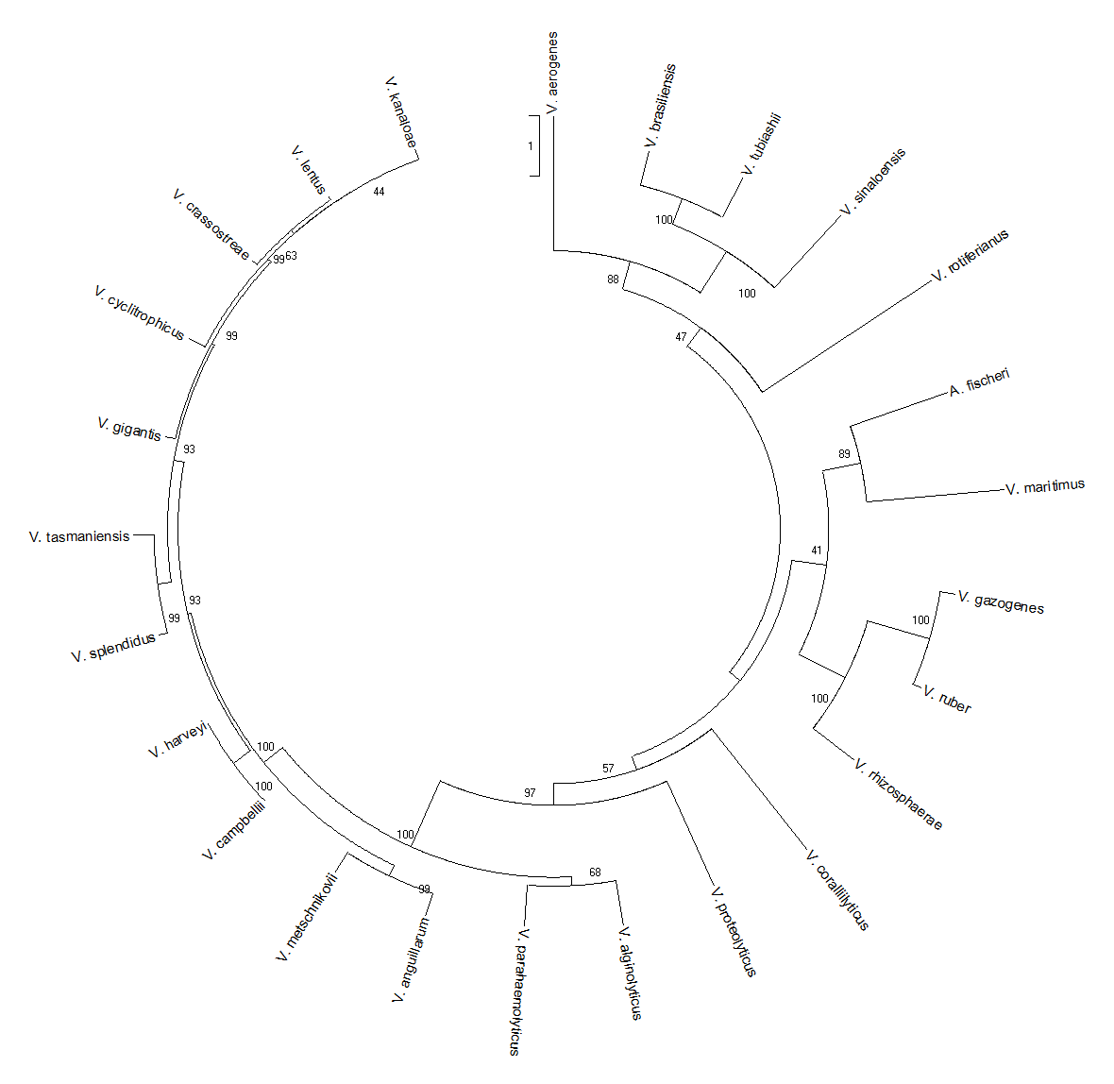

Figure S2: Neighbour joining tree of LuxS (~ 171 aa) for 56 *Vibrio* species using the JTT+G+I model (MEGA).

Bootstrap values are based on 1000 replicates.



Figure S3: Neighbour joining tree of CqsA (~ 385 aa) for 39 *Vibrio* species using the JTT+G+I model (MEGA).

Bootstrap values are based on 1000 replicates.

