Synthesis, Self-Assembly, and Photomechanical Actuator Performance of a Sequence-Defined Polyviologen Crosslinker

Abigail O. Delawder,‡ Anusree Natraj,‡ Nathan D. Colley, Tiana Saak, Angelique F. Greene, Jonathan C. Barnes*

Department of Chemistry, Washington University in St. Louis, St. Louis, MO 63130, USA

*E-mail: jcbarnes@wustl.edu
‡ These authors contributed equally

Table of Contents
Section A. Materials / General Methods / Instrumentation ------------------------------------------------------- S3
Section B. Synthetic Protocols -------------------------------------------------------------------------------------------- S4
- 2V•2PF₆ S4
- 2V•4PF₆ S4
- 4V•6PF₆ S5
- 4V•8PF₆ S6
- 6V•10PF₆ S6
- 6V–St•10PF₆•2Cl, 6V–St •12Cl S7
- 6V-St•12PF₆ S8
Section C. Spectroscopic Characterisation --------------------------------------------------------------------------- S9
- Nuclear Magnetic Resonance (¹H) S9
- UV-Vis-NIR S10
- Gel Permeation Chromatography S12
Section D. Electrochemical Characterisation ----------------------------------------------------------------------- S12
Section E. Thermal Characterisation ----------------------------------------------------------------------------------- S12
- Differential Scanning Calorimetry (DSC) S12
- Thermogravimetric Analysis (TGA) S13
Section F. Gel Preparation, Photochemical Reduction, Actuation, and Mechanical Properties ---- S13
- General Procedure for the Preparation of Gels S13
  - Organogels S13
  - Hydrogels S14
- Calculations of Crosslinking Density, Swelling ratio, and M_{c} S14
- As-Synthesised, Swollen Rheology S15
- Photochemical Reduction of Gels: Procedure, Kinetics, and Rheology S15
Section G. References ------------------------------------------------------------------------------------------------------ S17

Section A. Materials / General Methods / Instrumentation
All reagents were purchased from commercial suppliers and used without further purification unless stated otherwise. The chemical and photochemical reduction of polyviologens and gels was performed under an inert atmosphere of UHP nitrogen. All nuclear magnetic resonance (NMR) spectra were recorded on Varian Inova-500 with working frequencies of 500 (¹H) and 125 (¹³C) MHz. Chemical shifts are reported in ppm relative to the signals corresponding to the residual non-deuterated solvent: (CD₃)₂SO: δ_{H} = 2.50 ppm and δ_{C} = 39.52 ppm. Ultraviolet-Visible-Near Infrared (UV-Vis-NIR) absorbance spectra were recorded on an Agilent Cary 5000 spectrophotometer with a PbSmart NIR detector. Infrared spectroscopy (IR) was performed on a Bruker Alpha Platinum ATR FT-IR spectrometer. Electrochemical measurements were obtained with a Gamry multipurpose potentiostat with a Ag/AgCl reference electrode, glassy carbon working electrode, platinum wire auxiliary electrode, and 0.1 M KCl or TBAPF₆ as the supporting electrolyte. Size exclusion chromatography (SEC) analyses were performed on an Agilent 1260 Infinity setup with three PSS NOVEMA MAX Lux analytical 100 Å columns in tandem and 0.025 M Na₂SO₄ in H₂O mobile phase run at 23 °C. The differential refractive index (dRI) of each compound was monitored using a Wyatt Optilab T-rEX detector and the light scattering (LS) of each compound was monitored using a Wyatt Dawn Heleos-II detector. High-Res Mass Spectrometry (HRMS) was recorded on a Bruker maXis 4G UHR-TOF mass spectrometer. Frequency sweep (1.0% strain, 0.1 to 30 rad s^{–1}) and strain sweep (1 rad s^{–1}, 0−50% strain) experiments were performed on a TA AR-G2 Oscillatory Shear Rheometer with 20 mm geometry with 0.5 N of normal force applied to gels before acquisition. Thermogravimetric analysis (TGA) was performed on a TA Instruments TGA5000 and differential scanning calorimetry (DSC) was performed on a TA instruments DSC2500. Photochemical reduction of the viologen-based gels using [Ru(bpy)₃]Cl₂ and triethanolamine (TEOA) was accomplished using two Hampton Bay desk lamp with ABI LED Aquarium light bulbs (450 nm / 12 Watt / 740 lumens). To aid in the precipitation of viologen-based compounds from their crude reaction mixtures, a Thermo Scientific Sorvall ST 8 small benchtop centrifuge was employed.

Section B. Synthetic Protocols
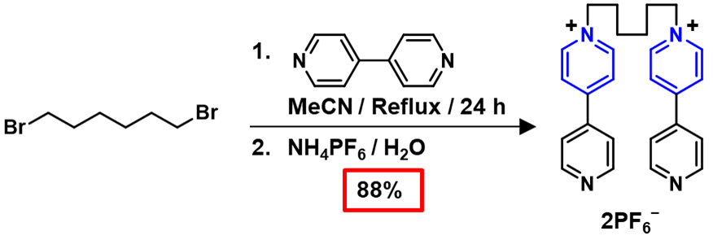
            - Synthesis of 2V•2PF₆
1,6-Dibromohexane (2.5 g, 1.58 mL, 10.25 mmol, 1 equiv) and 4,4ʹ-bipyridine (32.0 g, 205 mmol, 20 equiv) were dissolved in MeCN (250 mL) and heated to reflux for 24 h. The resulting yellow solid was filtered and washed with PhMe to remove remaining starting materials. The solid was dissolved in a minimal amount of H₂O (~100 mL) and NH₄PF₆ (5.01g, 30.75 mmol, 3 equiv) was added to precipitate the compound. The solid was filtered, washed with copious amounts of H₂O, and dried overnight to yield 2V•2PF₆ as an off-white solid (6.22 g, 88% yield). ¹H NMR (500 MHz, (CD₃)₂SO): δ_{H} 9.21 (d, J = 6.6 Hz, 4H); 8.88 (d, J = 5.6 Hz, 4H); 8.64 (d, J = 6.6 Hz, 4H); 8.03 (d, J = 5.8 Hz, 4H); 4.63 (t, J = 7.3 Hz, 4H); 1.98 (p, J = 7.2 Hz, 4H); 1.38 (p, J = 3.6 Hz, 4H). ¹³C NMR (125 MHz, (CD₃)₂SO): δ_{C} 152.35, 150.98, 145.25, 140.83, 125.37, 121.87, 60.30, 30.36, 24.88. HRMS-ESI for 2V•2PF₆; Calcd for C₂₆H₂₈F₆N₄P : m/z = 541.1950 [M – PF₆]⁺ ; Found: 541.1920 [M – PF₆]⁺.
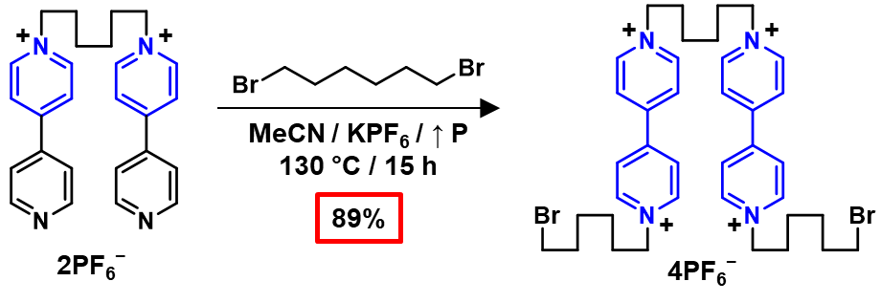
            - Synthesis of 2V•4PF₆
2V•2PF₆ (1.0 g, 1.46 mmol, 1 equiv), 1,6-dibromohexane (10.7 g, 6.72 mL, 43.71 mmol, 30 equiv) and KPF₆ (1.61 g, 8.74 mmol, 6 equiv) were dissolved in dry MeCN (29 mL, 35 mg/mL 2V•2PF₆) and heated to 130 °C in a 100 mL high pressure vessel while stirring for 15 h. The reaction vessel was cooled to room temperature and the solution was decanted into four 50 mL centrifuge tubes and diluted to 50 mL with PhMe. The tubes were centrifuged at 4500 rpm for 2 min. The solution was decanted away, the solid was re-dissolved in a minimal amount of MeCN and diluted to 50 mL with PhMe. The previous two steps were repeated three times. The solid was filtered, dried with Et₂O, sonicated in H₂O to remove the remaining unwanted salts, and dried again with Et₂O to yield 2V•4PF₆ as an off-white solid (1.70 g, 89% yield). ¹H NMR (500 MHz, (CD₃)₂SO): δ_{H} 9.36 (m, 8H); 8.76 (m, 8H); 4.69 (t, J = 7.5 Hz, 8H); 3.54 (t, J = 6.7 Hz, 4H); 2.08 – 1.94 (m, 8H); 1.82 (p, J = 6.7 Hz, 4H); 1.41 (m, 12H). ¹³C NMR (125 MHz, (CD₃)₂SO): δ_{C} 148.70, 148.60, 145.76, 145.71, 126.56, 60.89, 60.83, 34.96, 31.89, 30.51, 30.46, 26.88, 24.92, 24.54. HRMS-ESI for 2V•4PF₆; Calcd for C₃₈H₅₂Br₂F₁₂N₄P₂ : m/z = 507.0905 [M – 2PF₆]²⁺ ; Found: 507.0884 [M – 2PF₆]²⁺.
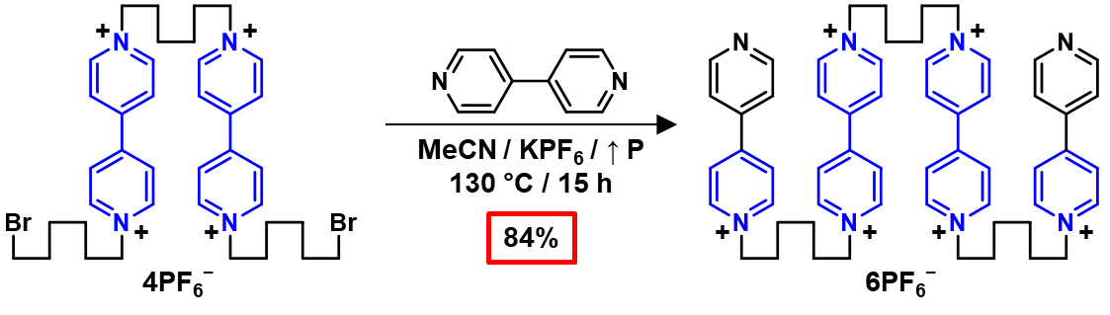
            - Synthesis of 4V•6PF₆
2V•4PF₆ (1.0 g, 0.767 mmol, 1 equiv), 4,4ʹ-bipyridine (3.59 g, 23.01 mmol, 30 equiv), and KPF₆ (847 mg, 4.602 mmol, 6 equiv) were dissolved in dry MeCN (29 mL, 35 mg/mL 2V•4PF₆) and heated to 130 °C in a 100 mL high pressure vessel while stirring for 15 h. The reaction vessel was cooled to room temperature and the solution was decanted into four 50 mL centrifuge tubes and diluted to 50 mL with PhMe. The tubes were centrifuged at 4500 rpm for 2 min. The solution was decanted away, the solid was re-dissolved in a minimal amount of MeCN and diluted to 50 mL with PhMe. The previous two steps were repeated three times. The solid was filtered, dried with Et₂O, sonicated in H₂O to remove the remaining unwanted salts, and dried again with Et₂O to yield 4V•6PF₆ as an off-white solid (1.132 g, 84% yield). ¹H NMR (500 MHz, (CD₃)₂SO): δ_{H} 9.36 (d, J = 6.3 Hz, 8H); 9.22 (d, J = 6.9 Hz, 4H); 8.91 (d, J = 6.2 Hz, 4H); 8.76 (d, J = 5.4 Hz, 8H); 8.65 (d, J = 6.9 Hz, 4H); 8.08 (d, J = 6.2 Hz, 4H); 4.73 – 4.60 (m, 12H); 1.99 (m, 12H); 1.46 – 1.34 (m, 12H).¹³C NMR (125 MHz, (CD₃)₂SO): δ_{C} 150.41, 145.73, 145.28, 126.52, 125.46, 122.15, 60.80, 60.32, 30.53, 30.49, 30.40, 25.01, 24.98, 24.90. HRMS-ESI for 4V•6PF₆; Calcd for C₅₈H₆₈F₂₄N₈P₄ : m/z = 728.2062 [M – 2PF₆]²⁺ ; Found: 728.2060 [M – 2PF₆]²⁺.

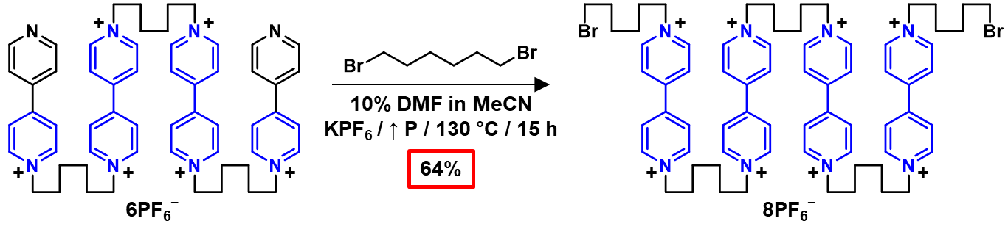
            - Synthesis of 4V•8PF₆

4V•6PF₆ (3.00 g, 1.72 mmol, 1 equiv), 1,6-dibromohexane (16.79 g, 10.60 mL, 68.8 mmol, 40 equiv), and KPF₆ (1.90 g, 10.32 mmol, 6 equiv) were dissolved in 10% DMF in MeCN (dry, 60 mL total, 50 mg/mL 4V•6PF₆) and heated to 130 °C in a 250 mL high pressure vessel while stirring for 15 h. The reaction vessel was cooled to room temperature, the reaction mixture was filtered, and the solute was transferred into eight 50 mL centrifuge tubes and diluted to 50 mL with Et₂O. The tubes were centrifuged at 4500 rpm for 2 min. The solution was decanted away, the solid was re-dissolved in a minimal amount of MeCN and diluted to 50 mL with Et₂O. The previous two steps were repeated three times. The solid was filtered, dried with Et₂O, sonicated in H₂O to remove the remaining unwanted salts, and dried again with Et₂O to yield 4V•8PF₆ as a light brown solid (2.61 g, 64% yield). ¹H NMR (500 MHz, (CD₃)₂SO): δ_{H} 9.37 (m, 16H); 8.76 (m, 16H); 4.68 (t, J = 7.3 Hz, 16H); 3.54 (t, J = 6.6 Hz, 4H); 2.00 (m, 16H); 1.82 (m, 4H); 1.50 – 1.29 (m, 20H).¹³C NMR (125 MHz, (CD₃)₂SO): δ_{C} 148.60, 145.72, 126.54, 60.86, 60.79, 34.95, 31.87, 30.51, 30.49, 26.87, 24.98, 24.96, 24.53. HRMS-ESI for 4V•8PF₆; Calcd for C₇₀H₉₂Br₂F₃₀N₈P₅ : m/z = 643.1328 [M – 3PF₆]³⁺ ; Found: 643.1306 [M – 3PF₆]³⁺.
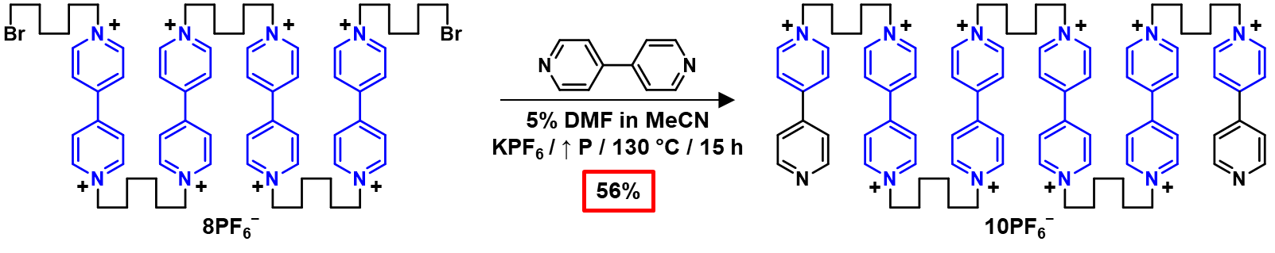
            - Synthesis of 6V•10PF₆
4V•8PF₆ (500 mg, 0.2114 mmol, 1 equiv), 4,4ʹ-bipyridine (991 mg, 6.34 mmol, 30 equiv), and KPF₆ (233 mg, 1.27 mmol, 6 equiv) were dissolved in 5% DMF in MeCN (dry, 10 mL total, 50 mg/mL 4V•8PF₆) and heated to 130 °C in a 40 mL high pressure vessel while stirring for 15 h. The reaction vessel was cooled to room temperature, the reaction mixture was filtered, and the filtrate was transferred into six 15 mL centrifuge tubes and diluted to 15 mL with Et₂O. The tubes were centrifuged at 4500 rpm for 2 min. The solution was decanted away, the solid was re-dissolved in a minimal amount of MeCN and diluted to 15 mL with Et₂O. The previous two steps were repeated three times. The solid was filtered, dried with Et₂O, sonicated in H₂O to remove the remaining unwanted salts, and dried again with Et₂O to yield 6V•10PF₆ as a light brown solid (330 mg, 56% yield). ¹H NMR (500 MHz, (CD₃)₂SO): δ_{H} 9.36 (m, 16H); 9.22 (d, J = 6.9 Hz, 4H); 8.90 (dd, J = 4.6, 1.6 Hz, 4H); 8.77 (m, 16H); 8.64 (d, J = 6.9 Hz, 4H); 8.07 (dd, J = 4.6, 1.6 Hz, 4H); 4.73 – 4.61 (m, 20H); 2.06 – 1.94 (m, 20H); 1.47 – 1.35 (m, 20H).¹³C NMR (125 MHz, (CD₃)₂SO): δ_{C} 152.24, 150.63, 148.63, 145.73, 145.27, 141.26, 126.53, 125.44, 122.06, 60.82, 60.33, 30.52, 30.47, 30.40, 24.99, 24.96, 24.89. HRMS-ESI for 6V•10PF₆; Calcd for C₉₀H₁₀₈F₄₂N₁₂P₇ : m/z = 790.5432 [M – 3PF₆]³⁺ ; Found: 790.8784 [M – 3PF₆]³⁺.
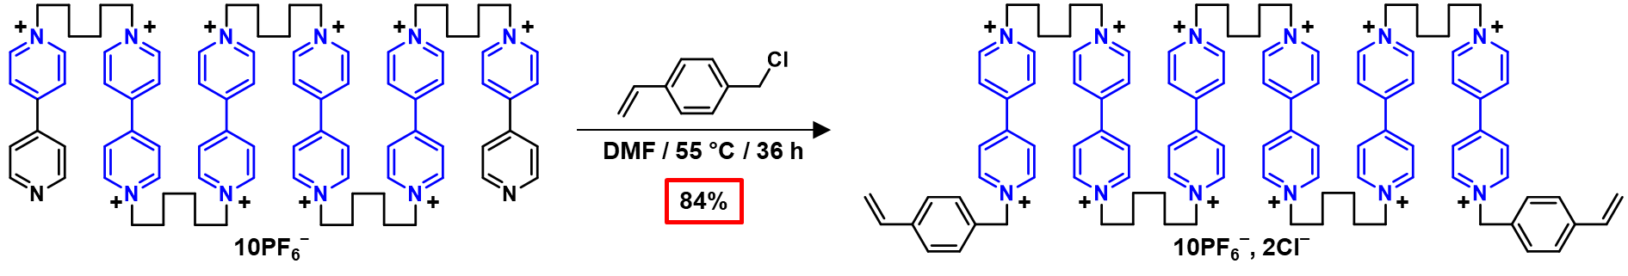
            - Synthesis of 6V–St •10PF₆•2Cl
6V•10PF₆ (1 g, 0.356 mmol, 1 equiv) and 4-vinylbenzyl chloride (2.72 g, 2.51 mL, 17.80 mmol, 50 equiv) were dissolved in DMF (dry, 20 mL, 50 mg/mL 6V•10PF₆) and heated to 55 °C for 36 h. The reaction vessel was cooled to room temperature and the solution was transferred into four 50 mL centrifuge tubes and diluted to 50 mL with Et₂O. The tubes were centrifuged at 4500 rpm for 2 min. The solution was decanted away, the solid was re-dissolved in a minimal amount of DMF and diluted to 50 mL with Et₂O. The previous two steps were repeated three times. The solid was filtered, dried with Et₂O to yield 6V–St•10PF₆•2Cl as a light brown solid (928 mg, 84% yield). ¹H NMR (500 MHz, (CD₃)₂SO): δ_{H} 9.54 (d, J = 6.0 Hz, 4H); 9.51 – 9.41 (m, 20H); 8.89 – 8.70 (m, 24H); 7.59 (dd, J = 20.4, 8.1 Hz, 8H); 6.75 (dd, J = 17.6, 11.0 Hz, 2H); 5.95 (s, 4H); 5.90 (d, J = 17.6 Hz, 2H); 5.33 (d, J = 10.9 Hz, 2H); 4.77 – 4.67 (m, 20H); 2.08 – 1.92 (m, 20 H); 1.49 – 1.35 (m, 20H).¹³C NMR (125 MHz, (CD₃)₂SO): δ_{C} 149.14, 148.67, 148.57, 145.79, 145.70, 138.30, 135.76, 133.47, 129.33, 127.08, 126.88, 126.67, 126.55, 115.83, 63.17, 60.68, 30.47, 24.86. HRMS-ESI for 6V–St•10PF₆2Cl; Calcd for C₁₀₈H₁₂₆F₄₈N₁₂P₈ : m/z = 687.9344 [M – 2Cl – 2PF₆]⁴⁺ ; Found: 687.9346 [M – 2Cl – 2PF₆]⁴⁺. 6V–St•10PF₆•2Cl was converted to 6V–St•12Cl for spectroscopic characterization by the addition of excess tetrabutylammonium chloride (TBACl) in MeCN and several washes with MeCN.
            - Synthesis of 6V-St•12PF₆
Note: This modified synthesis of the macrocrosslinker was added post-review. Using this protocol, complete conversion to the final product was obtained as the all PF₆– salt. However, the gels reported herein were prepared using 6V–St•10PF₆•2Cl.
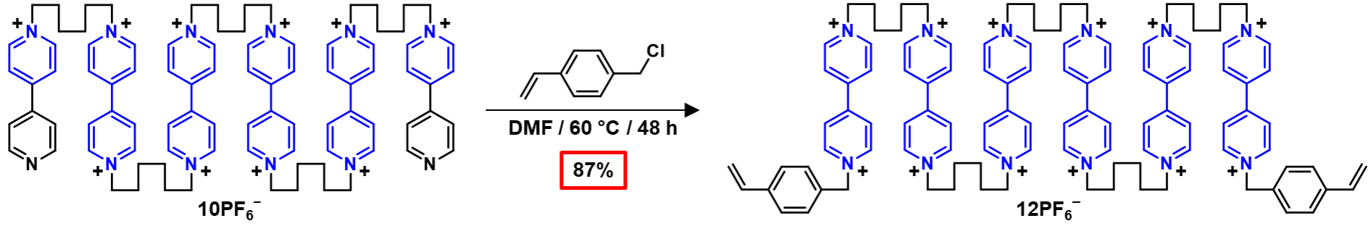
6V•10PF₆ (500 mg, 0.178 mmol, 1 equiv), 4-vinylbenzyl chloride (1.36 g, 1.25 mL, 8.90 mmol, 50 equiv), and KPF₆ (197 mg, 1.07 mmol, 6 equiv) were dissolved in DMF (dry, 10 mL, 50 mg/mL 6V•10PF₆) and heated to 60 °C for 48 h. The reaction vessel was cooled to room temperature and the solution was transferred into four 50 mL centrifuge tubes and diluted to 50 mL with Et₂O. The tubes were centrifuged at 4500 rpm for 2 min. The solution was decanted away, the solid was re-dissolved in a minimal amount of DMF and diluted to 50 mL with Et₂O. The previous two steps were repeated three times. The solid was filtered, dried with Et₂O, sonicated in H₂O to remove the remaining unwanted salts, and dried again with Et₂O to yield 6V–St•12PF₆ as a light brown solid (517 mg, 87% yield). ¹H NMR (500 MHz, (CD₃)₂SO): δ_{H} 9.49 (d, J = 6.1 Hz, 4H), 9.42 – 9.30 (m, J = 9.8 Hz, 20H), 8.83 – 8.69 (m, 24H), 7.59 (s, 8H), 6.76 (dd, J = 17.6, 11.0 Hz, 2H), 5.93 (s, 4H), 5.91 (d, J = 18.6 Hz, 2H), 5.34 (d, J = 10.9 Hz, 2H), 2.12 – 1.89 (m, 20H), 1.51 – 1.32 (m, 20H). ¹³C NMR (125 MHz, (CD₃)₂SO): δ_{C} 148.63, 148.61, 145.73, 145.69, 138.33, 135.75, 133.43, 129.31, 127.07, 126.89, 126.67, 126.53, 115.85, 63.28, 60.80, 30.54, 30.53, 30.52, 30.50, 30.48, 30.46, 25.00, 24.99, 24.96.

Section C. Spectroscopic Characterisation
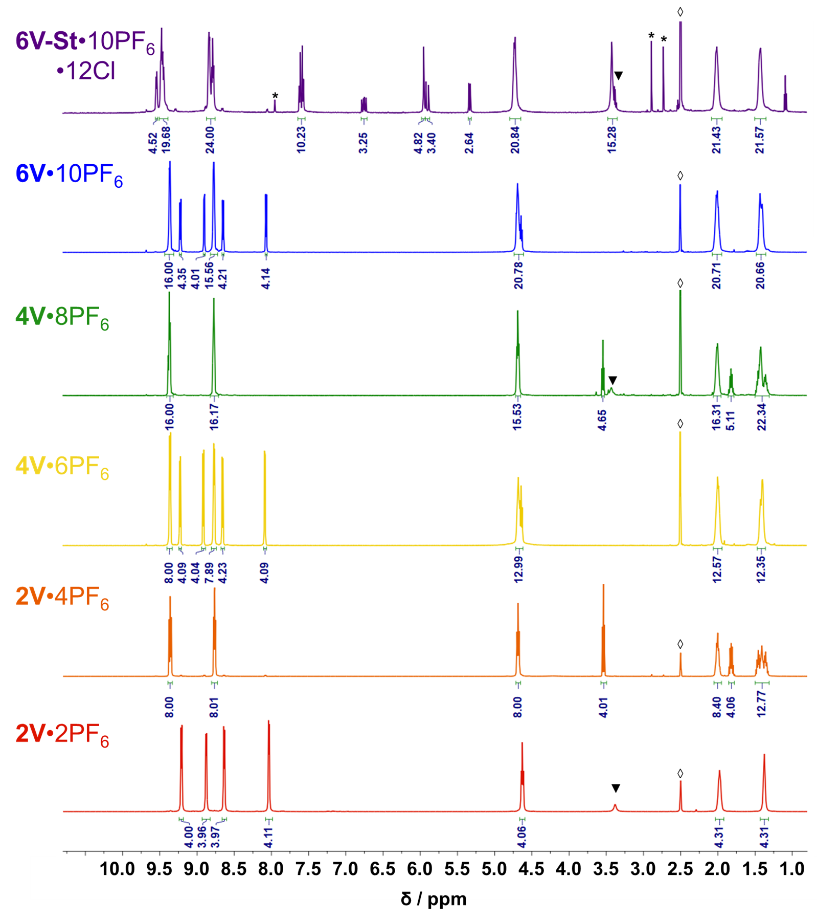
- Nuclear Magnetic Resonance (¹H)
Figure S1: ¹H NMR (500 MHz, (CD₃)₂SO) spectra for each iterative product in the synthesis of the crosslinker
(6V–St•10PF₆•12Cl) used in the synthesis of organogels and hydrogels. *DMF ◊DMSO ▼H₂O

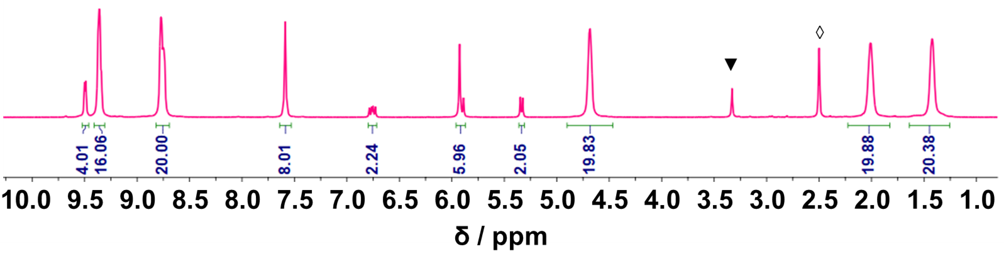
Figure S2: ¹H NMR (500 MHz, (CD₃)₂SO) spectra for the improved synthesis of the all PF₆– crosslinker,
6V–St•12PF₆. ◊DMSO ▼H₂O
- UV-Vis-NIR
To prepare the photoreduced polyviologen sample for UV-Vis-NIR analysis in D₂O, a solution containing 0.05 mM 6V–St•12Cl, 0.15 mM [Ru(bpy)₃]Cl₂, and 3.00 mM TEOA in D₂O was prepared in an N₂-filled glovebox and irradiated with ~450 nm blue light for 20 min while stirring. The sample was transferred to a 0.7 mL, 2 mm path length quartz cuvette and stoppered with a PTFE stopper. UV-Vis-NIR scans were immediately taken at 25 °C. The aqueous sample was prepared in D₂O instead of H₂O to eliminate the large H—O peak in the near-IR region of the spectra. To prepare the photoreduced polyviologen sample for UV-Vis-NIR in DMF, a solution containing 0.05 mM 6V–St•10PF₆•2Cl, 0.15 mM [Ru(bpy)₃]Cl₂, and 3.00 mM TEOA in DMF was prepared in an N₂-filled glovebox and irradiated with ~450 nm blue light for 20 min while stirring. The sample was transferred to a 0.7 mL, 2 mm path length quartz cuvette and stoppered with a PTFE stopper. UV-Vis-NIR scans were immediately taken at 25 °C. Additional samples were prepared according to the above procedure with a crosslinker concentration of 25.0 μM and 12.5 μM in D₂O (Figure S3a). Additionally, the polyviologen compounds were reduced via chemical reduction in D₂O and DMF with Na₂S₂O₄ and Zn⁰ dust, respectively (Figure S3b). To prepare the reduced polyviologen sample for UV-Vis-NIR in D₂O, a stock solution containing 8.1 mg 6V–St•12Cl in 3 mL of solvent (D₂O) was prepared. The stock solution was diluted to 0.05 mM and 200 equiv of Na₂S₂O₄ was added to reduce the viologen subunits in the crosslinker. The sample was transferred to a 0.7 mL, 2 mm path length quartz cuvette and stoppered with a PTFE stopper. UV-Vis-NIR scans were immediately taken at 25 °C. To prepare the reduced polyviologen sample for UV-Vis-NIR in DMF, a stock solution containing 6.2 mg 6V–St•10PF₆•2Cl in 2 mL of solvent (DMF) was prepared. The stock solution was diluted to 0.05 mM, an excess of Zn⁰ dust was added, and the solution was stirred for 20 min to reduce the viologen subunits of the crosslinker. The sample was transferred to a 0.7 mL, 2 mm path length quartz cuvette and stoppered with a PTFE stopper. UV-Vis-NIR scans were immediately taken at 25 °C.
Figure S3: UV-Vis-NIR spectra of a) the photochemical reduction of the crosslinker (6V–St•12Cl) in D₂O at 25.0 µM and 12.5 µM and b) the chemical reduction of the crosslinker in DMF and D₂O at 0.05 mM

- Gel Permeation Chromatography (GPC)
Samples for GPC were prepared by dissolving in a minimal amount of MeCN:MeOH (50:50) and precipitating the compound as a HSO₄– salt with a drop of concentrated H₂SO₄. The precipitate was collected and washed with MeCN. The compounds were dissolved in a 0.025M solution of Na₂SO₄ in H₂O at a concentration of 2 mg/mL. The samples were filtered with a 0.22 μm hydrophilic disk filter into a pre-cleaned HPLC vial (no particulate contamination) before injection onto the SEC columns at 23 °C. Data traces were collected using a differential refractive index (dRI) detector in line with the SEC columns.

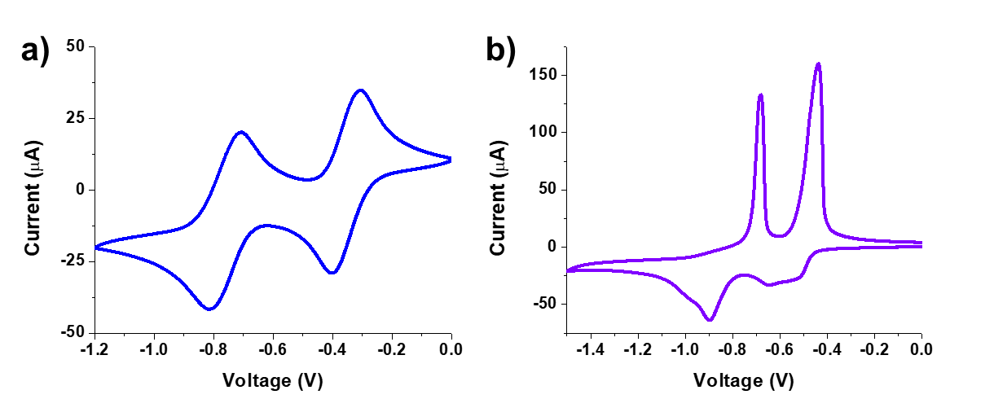
Section D. Electrochemical Characterisation
Figure S4: Cyclic voltametry of a) 6V–St•10PF₆•2Cl in DMF and b) 6V–St•12Cl in H₂O (both 1 mM) at 100 mV/s vs. Ag/AgCl.

Section E. Thermal Characterisation
- Differential Scanning Calorimetry (DSC)
Differential scanning calorimetry was attempted for 6V•10PF₆ and 6V–St•10PF₆•2Cl by equilibrating at 200 °C for 15 min, cooling from 200 °C to 0 °C at 10 °C per min, heating from 0 °C to 200 °C at 10 °C per min, cooling from 200 °C to 0 °C at 2 °C per min, and heating from 0 °C to 225 °C at 2 °C per min with no discernible peaks for a melting temperature (T_{m}) or glass transition temperature (T_{g}).
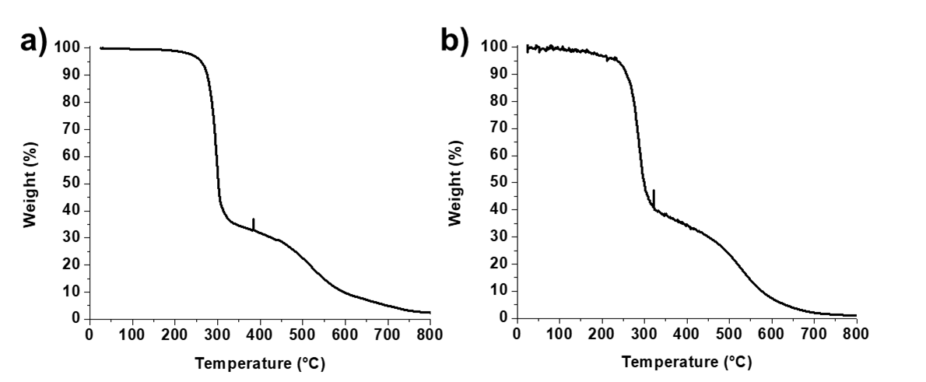
- Thermogravimetric Analysis (TGA)
Figure S5: Thermogravimetric analysis of a) 6V•10PF₆ and b) 6V–St•10PF₆•2Cl

Section F. Gel Preparation, Photochemical Reduction, Actuation, and Mechanical Properties
- General Procedure for the Preparation of Gels
  - Organogels
Crosslinker (6V–St•10PF₆•2Cl) | 0.15 mol %
HEA (mg) | 2006.00
Crosslinker (mg) | 81.20
Ammonium Persulfate (mg) | 2.80
Total mass (mg) | 2090.00
DMSO (mL) | 4.20
A modified procedure^{S1} was used for the synthesis of the organogels. The reagents for polymerisation (Table S1) were dissolved in 4.20 mL of DMSO and the solution was vortexed and sonicated to ensure complete dissolution and even mixing. The solution was then plated into a 2.54 cm × 2.54 cm clear, square mould (1.5 mL/mould) and heated in an oven at 75 °C for 1 h (Figure S6a). The cured gels were carefully removed from the gel mould using a spatula and placed in a solvent-resistant plastic box. The gels were then soaked in DMF for 48 h to allow for full swelling. FTIR was performed on a separate, as synthesised gel to confirm complete conversion of the crosslinker (Figure S6b).

Table S1: Reagents used for the synthesis of four gels containing 0.15 mol% 6V–St•10PF₆•2Cl

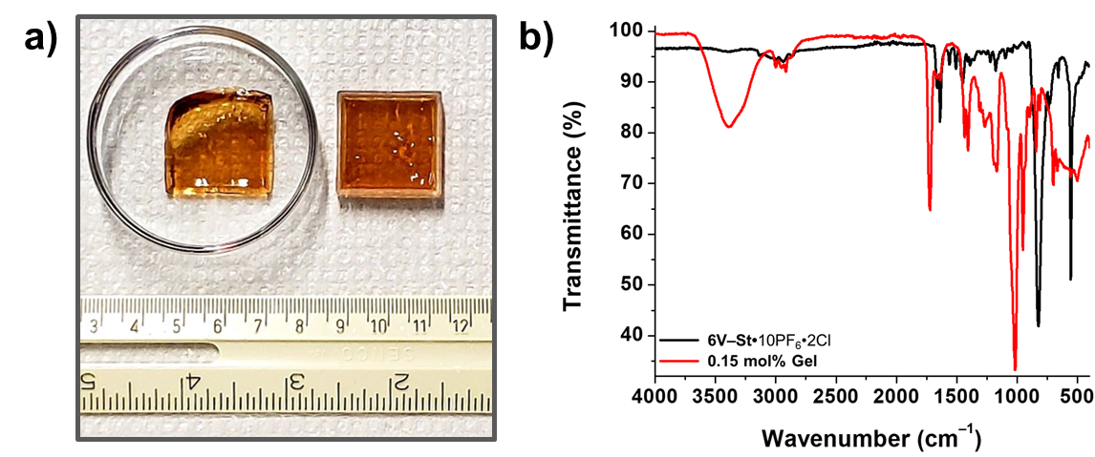
b) Hydrogels
Figure S6: a) As synthesised organogel before swelling. b) FT-IR of 6V–St•10PF₆•2Cl and the 0.15 mol% as-synthesised organogel. The disappearance of the sp² CH stretch at 3137 cm⁻¹ and the C=C stretch at 1638 cm⁻¹ indicates total conversion of 6V–St•10PF₆•2Cl into the gel network.

The hydrogels were first synthesised as organogels with the above procedure. After swelling for 48 h, the gels were transferred into a 0.1M solution of TBACl in an 80:20 DMF:H₂O mixture and were soaked for 3.5 h. The solution was decanted away from the gels and the gels were soaked in a solution of 0.1M TBACl in a 50:50 DMF:H₂O mixture for 3.5 h, in a solution of 0.1M TBACl in an 20:80 DMF:H₂O mixture for 3.5 h, then in a solution of 0.1M TBACl in 100% H₂O for 12 h, and finally in pure H₂O for 48 h to ensure complete counteranion exchange.
- Calculations of Crosslinking Density, Swelling ratio, and M_{c}
The volumetric swelling ratio^{S2}, Q, was calculated as follows: Q =$1+\frac{ρ_{HEA}}{ρ_{DMF}}\left(\frac{M_{s}}{M_{d}}-1\right)$, where ρ_{HEA} is the density of poly(2-hydroxyethyl acrylate) at 298 K (1.30 g/mL, average calculated data^{S3}), ρ_{DMF} is the density of DMF at 298 K (0.948 g/mL) , M_{s} is the mass of the swollen gel in DMF, and M_{d} is the mass of the dried gel. The crosslinking density^{S4} was calculated as follows: Crosslinking Density = $\frac{G\left(\sqrt[3]{Q}\right)}{RT}$, where G is the equilibrium shear modulus ($\sqrt{{\left(Gʹ\right)}^{2}+{\left(Gʺ\right)}^{2} }$ from oscillatory shear rheology at 1 rad s^{–1} and 1% strain), R is the gas constant (8.314459848 $\frac{m^{3}Pa}{mol K}$), and T = 298K, in units of $\frac{mol}{m^{3}}$. The average molecular weight between crosslinks^{S5} (M_{c}) was calculated as follows: M_{c} = $\frac{ρ_{gel}RT}{G}$ where ρ_{gel} is the density of the gel ((M_{d} / (M_{s}–M_{d})) * ρ_{DMF}) in $\frac{g}{{cm}^{3}}$, R is the gas constant (8.314459848 x 10⁶ $\frac{{cm}^{3}Pa}{mol K}$), and T = 298 K, in units of $\frac{g}{mol}$.
Crosslinker  (6V–St•10PF₆•2Cl) | Q  (Swelling Ratio) | G  (Pa) | Crosslinking Density (mol/m³) | M_{c}  (kDa)
0.15 mol% | 40.55 | 1169 | 1.62 | 69.64

- As-Synthesised, Swollen Gel Rheology
Gels synthesised as shown above were swollen in DMF for 48 h. A 20 mm disc was punched out of the swollen gels and the rheological data (Figure S9) was acquired.

- Photochemical Reduction of Gels: Procedure, Kinetics, and Rheology
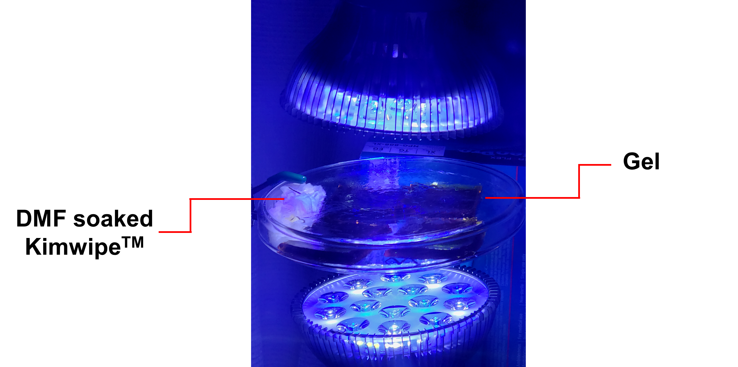
All kinetics experiments were performed in either quadruplicate or triplicate inside of an N₂-filled glovebox. The gels were prepared as described above (organogels and hydrogels) and were swollen for an additional 23 h in a degassed solution of 0.15 mM [Ru(bpy)₃]Cl₂ and 3.00 mM triethanolamine (TEOA) in either DMF or H₂O inside the glovebox. The average (n = 3 or 4) gel volume at t = 0 was 10.97 cm³ for the organogels and 4.30 cm³ for the hydrogels. The gels were then removed from solution and placed in a 14 cm diameter glass petri dish. An H₂O or DMF-soaked Kimwipe was also placed inside the petri dish, which was covered by a lid. The gels were irradiated with ~450 nm light from the top and bottom for 4 h, maintaining a 5.5 cm distance between the gel and the light source (Figure S7) with volume measurements taken at regular intervals (Figure S8). After irradiation, the gels were removed from the light source and a 20 mm diameter disc was punched out of the material. The gel discs were placed into an airtight container and transported for rheological experiments, which were performed to obtain the reduced/contracted rheological data on the gels. The resulting discs were oxidized and swollen in either DMF or H₂O. A new 20 mm diameter disc was punched out from the resulting reswollen gels and the oxidized rheological data were recorded (Figure S9). For the control, the same protocol was repeated on a swollen triplicate set of organogels, except the addition of [Ru(bpy)₃]Cl₂/TEOA in the DMF or H₂O solutions.
Figure S7: Experimental setup for photoirradiation kinetics experiments. Square gels in a large, glass petri dish were irradiated from top and bottom approximately 5.5 cm away from the gels with a 450 nm light source.

Figure S8: Kinetic plot of a) the relative volume change and b) the absolute volume change during the 4 h irradiation period for each indicated gel.

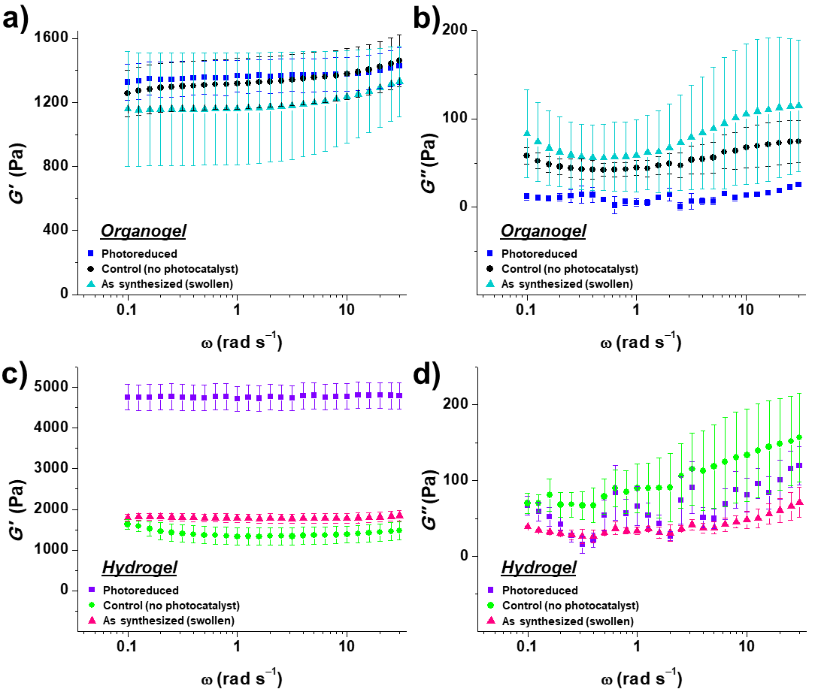
Section G. References
Figure S9: a) Storage modulus (Gʹ) of the organogels b) loss modulus (Gʺ) of the organogels c) storage modulus (Gʹ) of the hydrogels d) loss modulus (Gʺ) of the hydrogels

- Liu, X.; Zhang, Q.; Duan, L.; Gao, G. Bioinspired Nucleobase-Driven Nonswellable Adhesive and Tough Gel with Excellent Underwater Adhesion. ACS Appl. Mater. Interfaces 2019, 11, 6644–6651.
- Bryant, S. K; Chowdhury, T. T.; Lee, D. A.; Bader, D. L.; Anseth, K.S. Crossliking Density Influences Chrondrocyte Metabolism in Dynamically Loaded Photocrosslinked Poly(ethylene glycol) Hydrogels. Annals of Biomedical Engineering, 2004, 32, 407–417.
- Poly(2-hydroxyethyl acrylate). CROW Polymer Database. http://polymerdatabase.com/polymers/
poly2-hydroxyethyl%20acrylate.html
- DeForest, C. A; Anseth, K. S. Advances in Bioactive Hydrogels to Probe and Direct Cell Fate. Annu. Rev. Chem. Biomol. Eng. 2012, 3, 421–444.
- Andreopoulos, A. G. Properties of poly(2-hydroxyethyl acrylate) networks. Biomaterials 1989, 10, 101–104.

