Supplementary Materials

Additional Analysis 1

In addition to the analyses presented in the main text, this document provides a short summary of the alternative measurement model and structural model without removing any items from the scales.

The alternative measurement model included all of the items from the scales measuring the eight latent variables, which are southern identity, southern pride, southern nationalism, southern constructive patriotism, conservation values, openness to change values, self-enhancement values, and self-transcendence values. The model’s appropriateness was tested by conducting a Confirmatory Factor Analysis (CFA). The global fit indices indicated that our measurement model yielded a poor fit, χ² = 2227.72, df = 791, p < .001; χ²/df = 2.82; RMSEA = .08 (CI [.08, .09]); CFI = .82; TLI = .80; SRMR = .09 (see Figure 2). Continuing with this measurement model, the structural model that was specified in Figure 2 also yielded a poor fit, χ² = 2269.78, df = 800, p < .001; χ²/df = 2.84; RMSEA = .08 (CI [.08, .09]); CFI = .81; TLI = .80; SRMR = .10. Results of CFA indicated that item 5 of the southern nationalism scale and item moderate and item humble of the conservation values subscale have very poor factor loadings (< .40). And the model modification indices and the normalized residuals indicated that item 5, 6 and 7 of the southern pride scale, item 1 of the southern constructive patriotism scale, item self-discipline of the conservation values subscale, and item wisdom of the self-transcendence subscale largely caused the model misfit. Including those bad items in models, both the measurement model and the structural model yielded a worse fit comparing to the models that we used in the main text without those items. Therefore, we should remove those items from our models.
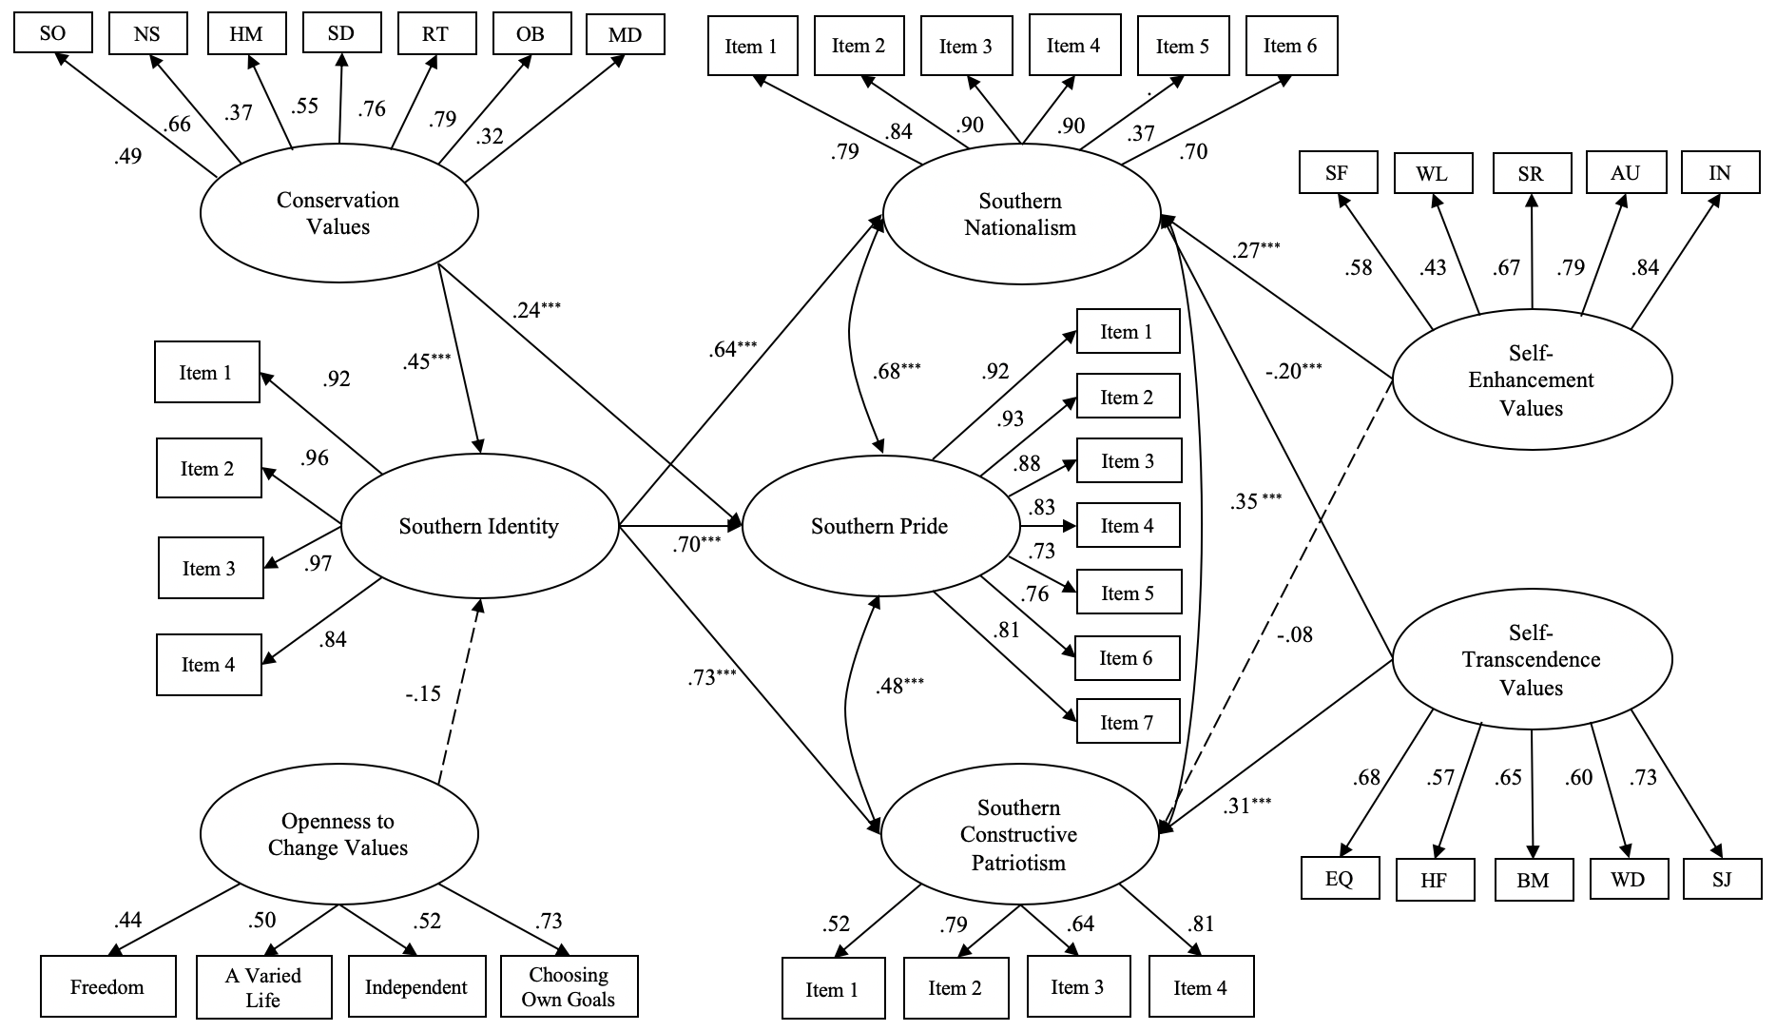
Figure 2. The structural model of personal values predicting Southern attachments (including dropped items).
Note. N = 268. SO = social order, NS = national security, HM = humble, SD = self-discipline, RT = respect for tradition, OB = obedient, MD = moderate, SF = successful, WL = wealth, SR = social recognition, AU = authority, IN = influential, EQ = equality, HF = helpful, BM = broadminded, WD = wisdom, SJ = social justice. Coefficients are standardized regression weights. The model fit indices: χ ² = 2269.78, df = 800, p < .001; χ ²/df = 2.84; RMSEA = .08 (CI [.08, .09]); CFI = .81; TLI = .80; SRMR = .10. * p < .05. ** p < .01. *** p < .001 (two-tailed).
Additional Analysis 2
In order to find out whether the first four variables, southern identity, southern nationalism, southern pride, and southern constructive patriotism, have a single underlying construct or not because they are so highly correlated with each other, this document compares a one-factor model with a four-factor model by conducting Confirmatory Factor Analyses (CFA).
The one-factor model included the four variables as one factor in the model. The global fit indices indicated that the one-factor model yielded a very poor fit, χ² = 1336.68, df = 104, p < .001; χ²/df = 12.85; RMSEA = .21 (CI [.20, .22]); CFI = .71; TLI = .67; SRMR = .09. The four-factor model that included the four variables as four separate factors in the model yielded a much better fit compared to the one-factor model, χ² = 308.73, df = 98, p < .001; χ²/df = 3.15; RMSEA = .09 (CI [.08, .10]); CFI = .95; TLI = .94; SRMR = .07. Moreover, the four-factor model was based on the findings from previous research (Huddy and Khatib, 2007) and also supported by the fit statistics.

