Supporting information for
Enhanced photovoltaic performances of C219-based dye sensitizers by introducing electron-withdrawing substituents: a density functional theory study
Caibin Zhao^{a∗}, Qiang Zhangª, Xiaohu Yu^{a*}, Ke Zhouª, Lingxia Jin^{a*} and Wenliang Wang^{b}
ªShaanxi Key Laboratory of Catalysis, School of Chemical and Environmental Science, Shaanxi University of Technology, Hanzhong, Shaanxi 723001, P. R. China
^{b}Key Laboratory for Macromolecular Science of Shaanxi Province, School of Chemistry and Chemical Engineering, Shaanxi Normal University, Xi’an, Shaanxi 710062, P. R. China
Contents
Table S1 Calculated excited energies for the C219 dye with different TD-DFT methods
Figure S1 Simulated and experimental UV-vis absorption spectra for the C219 dye with the TD-CAM-B3LYP/6-31G(d) method
Table S2 Calculated frontier molecular orbital levels for the C219 dye with different DFT methods
Table S3 Calculated frontier molecular orbital levels for the C219 dye with the optimized CAM-B3LYP/6-31G(d) method
Table S4 Optimized main dihedral angles between adjacent units in all studied dyes with the B3LYP/6-31G(d) method
Figure S2 Optimized geometries for 1/(TiO₂)₃₈, 3/(TiO₂)₃₈, 5/(TiO₂)₃₈, and 7/(TiO₂)₃₈ complexes
Figure S3 Optimized slant angles for all studied dye/(TiO₂)₃₈ complexes
Table S5 Optimized Ti-O bond lengths for all studied dye/(TiO₂)₃₈ complexes
Table S6 Calculated hole-electron distances (D_{he}) and hole-electron overlaps (O_{he}) for all studied dyes in the S₁ state
Figure S4 Calculated HOMO and LUMO profiles with Isovalue=0.04(left: HOMOs, right: LUMOs)
Figure S5 Schematic diagram of the distance from the HOMO/LUMO center to the TiO₂ surface (d₁ represents the distance from the HOMO center to the TiO₂ surface, and d₂ represents the distance from the LUMO center to the TiO₂ surface)
description process of in cus equation
Calculation details of the relevant parameters in Marcus model

Table S1
Functional/Basis | λ_{max}/nm | Δλ_{max}/nm^{b}
B3LYP/6-311G(d,p) | 646.7 | 153.7
B3PW91/6-311G(d,p) | 645.2 | 152.2
CAM-B3LYP/6-311G(d,p) | 497.7 | 4.7
CAM-B3LYP/6-31G(d) | 494.6 | 1.6
M062X/6-311G(d,p) | 499.7 | 6.7
MPW1PW91/6-311G(d,p) | 750.8 | 257.8
PBEPBE/6-311G(d,p) | 911.5 | 418.5
TPSSTPSS/6-311G(d,p) | 883.3 | 390.3
wB97XD/6-311G(d,p) | 480.8 | -12.2
Exp.t | 493.0ª | /
ª From the reference [12]. ^{b} Δλ_{max}=λ_{max}(Cal.)- λ_{max}(Exp.)

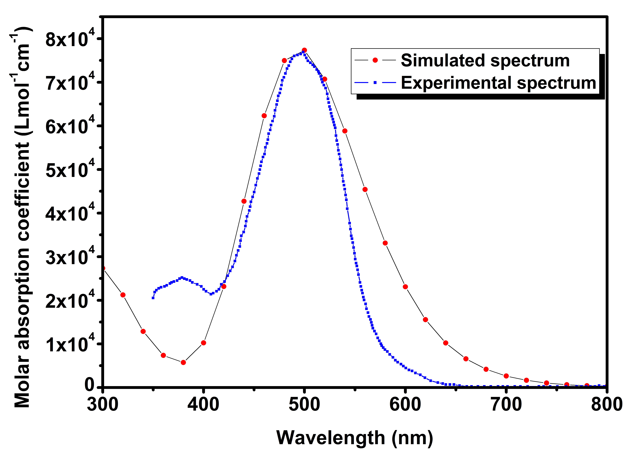
Figure S1

Table S2
Scheme | Calculated value |  |  | Deviation ^{b}
Scheme | E_{HOMO} | E_{LUMO} | E_{gap} | △E_{HOMO} | △E_{LUMO} | △E_{gap}
B3LYP/6-31G(d) | -4.875 | -2.765 | 2.110 | 0.085 | 0.705 | 0.62
B3PW91/6-31G(d) | -4.816 | -2.904 | 1.912 | 0.144 | 0.566 | 0.422
CAM-B3PW91/6-31G(d) | -5.830 | -1.840 | 3.990 | -0.870 | 1.630 | 2.500
LC-wPBE/6-31G(d) | -7.034 | -1.167 | 5.867 | -2.074 | 2.303 | 4.377
M062X/6-31G(d) | -5.833 | -2.204 | 3.629 | -0.873 | 1.266 | 2.139
PBEPBE/6-31G(d) | -4.118 | -3.162 | 0.956 | 0.842 | 0.308 | -0.534
MPW1PW91/6-31G(d) | -4.967 | -2.796 | 2.171 | -0.007 | 0.674 | 0.681
TPSSTPSS/6-31G(d) | -4.109 | -3.110 | 0.999 | 0.851 | 6.58 | -0.491
wb97XD/6-31G(d) | -6.413 | -1.357 | 5.056 | -1.453 | 2.113 | 3.566
Experimental FMO levelª | -4.960 | -3.470 | 1.490
ª From reference [12].
^{b}△E_{HOMO}= E_{HOMO}(Exp.)- E_{HOMO}(Cal.), △E_{LUMO}= E_{LUMO}(Exp.)- E_{LUMO}(Cal.), △E_{gap}= E_{gap}(Exp.)- E_{gap}(Cal.).

Table S3
E_{XP}=P₂E_{X}^{HF} + P₁(P₄E_{X}^{Slater} + P₃ΔE_{x}^{non-local}) + P₆E_{C}^{local} + P₅ΔE_{C}^{non-local}
Scheme | Calculated value |  |  | Deviation value ^{b}
Scheme | E_{HOMO} | E_{LUMO} | E_{gap} | △E_{HOMO} | △E_{LUMO} | △E_{gap}
1 | -5.830 | -1.840 | 3.990 | 0.870 | -1.630 | -2.500
2 | -5.106 | -3.073 | 2.033 | 0.146 | -0.397 | -0.543
3 | -4.064 | -2.615 | 1.449 | -0.896 | -0.855 | 0.041
4 | -4.582 | -2.846 | 1.736 | -0.378 | -0.624 | -0.246
5 | -4.167 | -2.661 | 1.506 | -0.793 | -0.809 | -0.016
6 | -4.115 | -2.638 | 1.477 | -0.845 | -0.832 | 0.013
7 | -5.553 | -4.063 | 1.490 | 0.593 | 0.593 | 0.000
8 | -4.868 | -3.384 | 1.484 | -0.092 | -0.086 | 0.006
9 | -5.005 | -3.520 | 1.485 | 0.045 | 0.050 | 0.005
10 | -4.936 | -3.452 | 1.484 | -0.024 | -0.018 | 0.006
Exp.ª | -4.96 | -3.47 | 1.49 | / | / | /
ª From reference [12].
^{b}△E_{HOMO}= E_{HOMO}(Exp.)- E_{HOMO}(Cal.), △E_{LUMO}= E_{LUMO}(Exp.)- E_{LUMO}(Cal.), △E_{gap}= E_{gap}(Exp.)- E_{gap}(Cal.).
1. P₁=1.00, P₂=0.19, P₃=0.65, P₄=0.81, P₅=0.65, P₆=0.35. 2. P₁=0.80, P₂=0.40, P₃=0.65, P₄=0.81, P₅=0.65, P₆=3.45.
3. P₁=0.80, P₂=0.20, P₃=0.65, P₄=0.81, P₅=0.65, P₆=3.45. 4. P₁=0.80, P₂=0.30, P3=0.65, P₄=0.81, P₅=0.65, P₆=3.45
5. P₁=0.80, P₂=0.22, P₃=0.65, P₄=0.81, P₅=0.65, P₆=3.45. 6. P₁=0.80, P₂=0.21, P₃=0.65, P₄=0.81, P₅=0.65, P₆=3.45.
7. P₁=0.80, P₂=0.21, P₃=0.65, P₄=0.81, P₅=0.00, P₆=4.50. 8. P₁=0.80, P₂=0.21, P₃=0.65, P₄=0.81, P₅=0.00, P₆=4.00.
9. P₁=0.80, P₂=0.21, P₃=0.65, P₄=0.81, P₅=0.00, P₆=4.10. 10. P₁=0.80, P₂=0.21, P₃=0.65, P₄=0.81, P₅=0.00, P₆=4.05.

Table S4
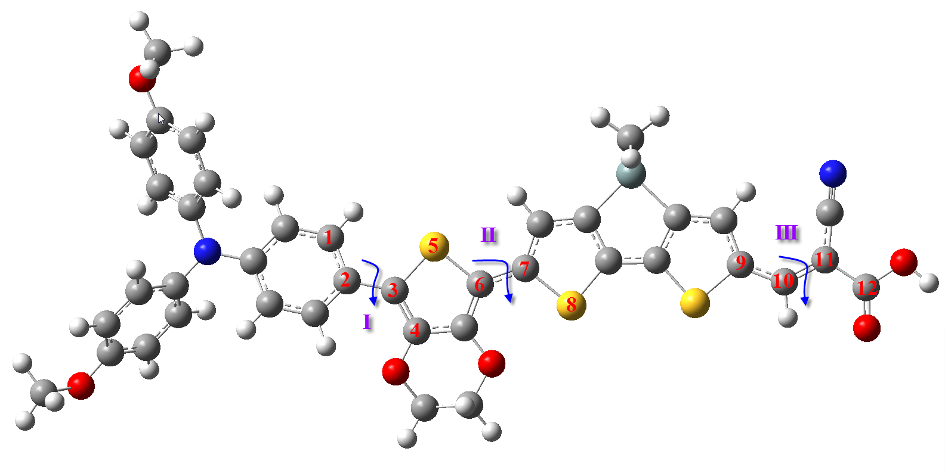
Dye | I | II | III
C219 | 16.5 | 1.3 | 0.1
1 | 18.7 | 0.7 | 24.1
2 | 17.6 | 1.6 | 10.1
3 | 16.7 | 1.5 | 11.1
4 | 15.6 | 1.4 | 0.1
5 | 18.1 | 0.2 | 0.1
6 | 17.5 | 1.5 | 0.4
7 | 18.5 | 1.5 | 1.0

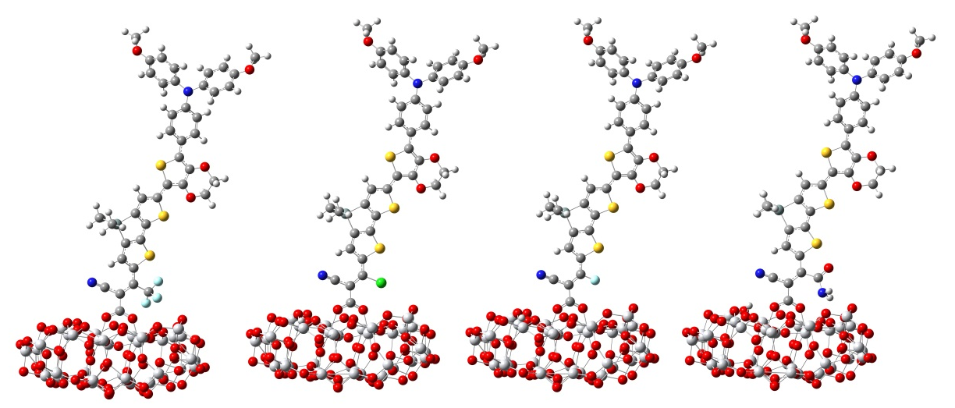
Figure S2

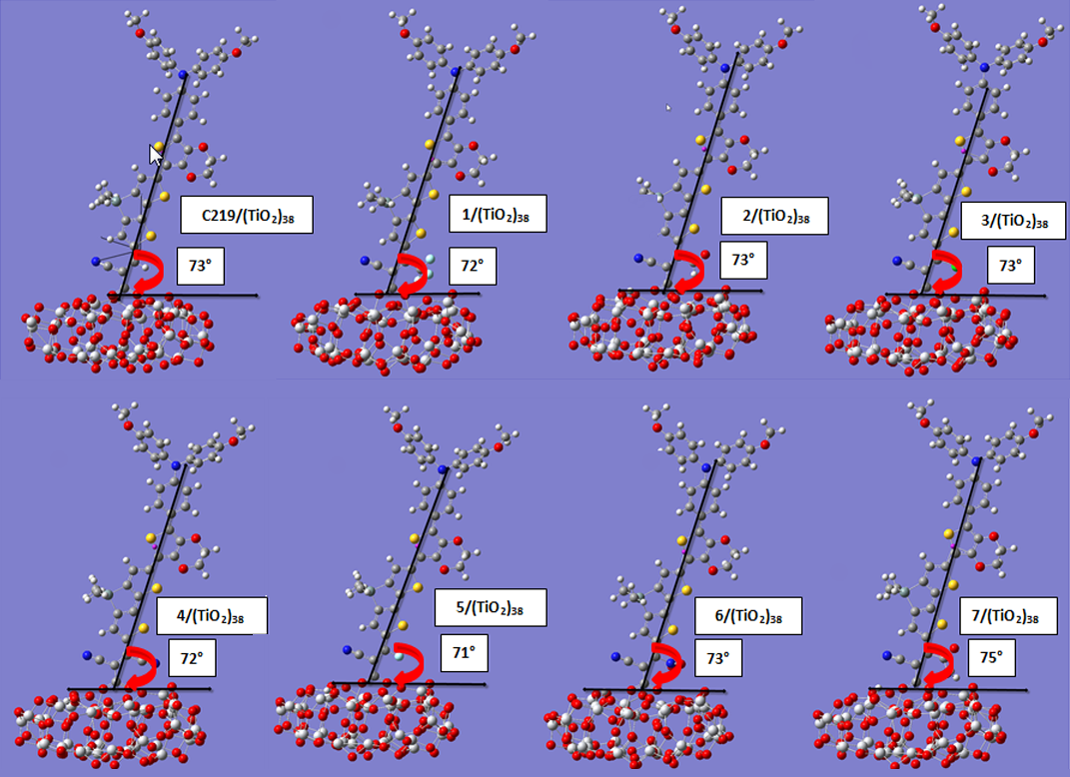
Figure S3

Table S5
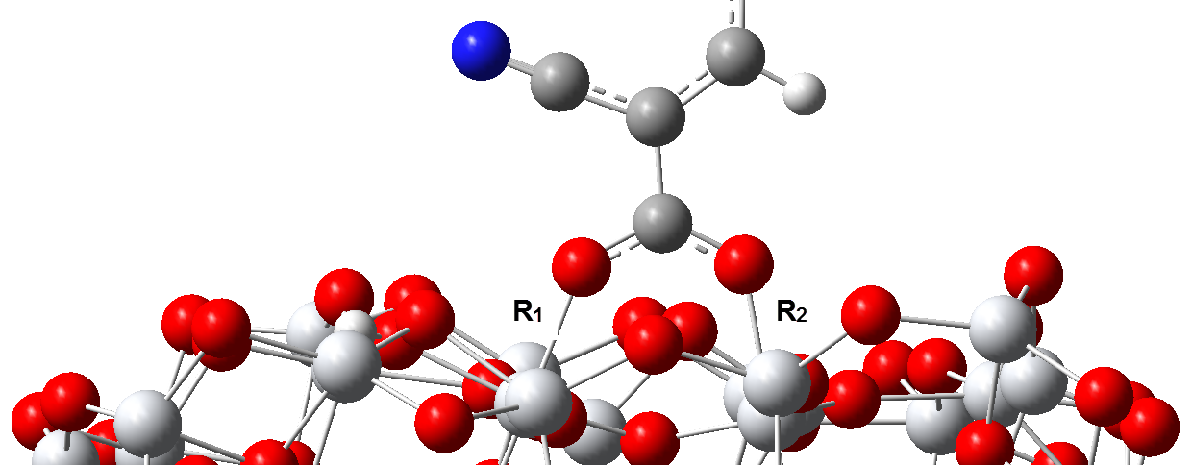
Dye | R₁/Å | R₂/Å
C219 | 2.037 | 2.156
1 | 2.075 | 2.077
2 | 2.102 | 2.173
3 | 2.063 | 2.074
4 | 2.053 | 2.103
5 | 2.032 | 2.112
6 | 2.076 | 2.126
7 | 2.087 | 2.199

Table S6 Calculated hole-electron distances (D_{he}) and hole-electron overlaps (O_{he}) for all studied dyes in the S₁ state
Dye | D_{he}/Å | O_{he}/Å
C219 | 3.184 | 0.418
1 | 3.578 | 0.383
2 | 3.913 | 0.369
3 | 3.787 | 0.379
4 | 4.374 | 0.353
5 | 3.416 | 0.403
6 | 3.783 | 0.376
7 | 3.390 | 0.400

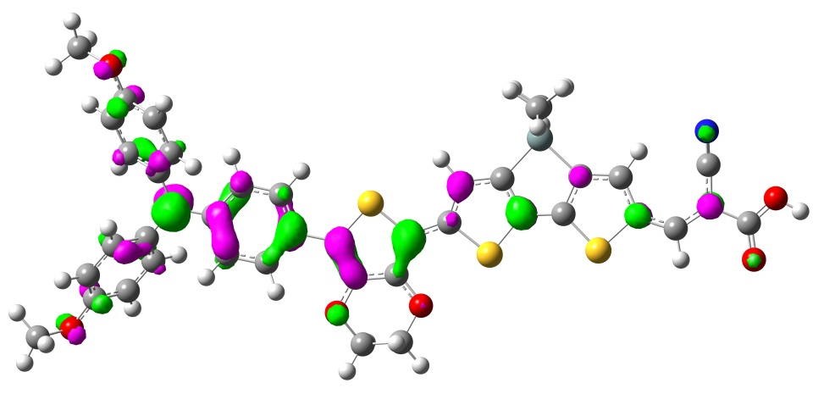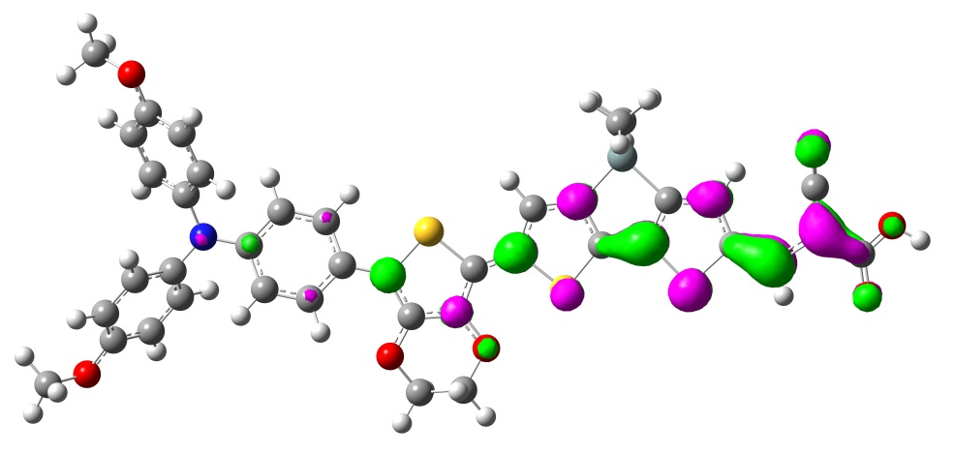
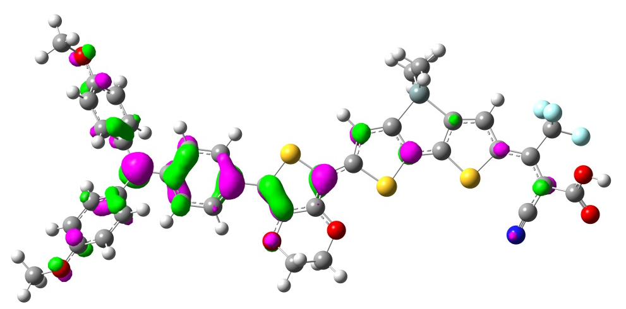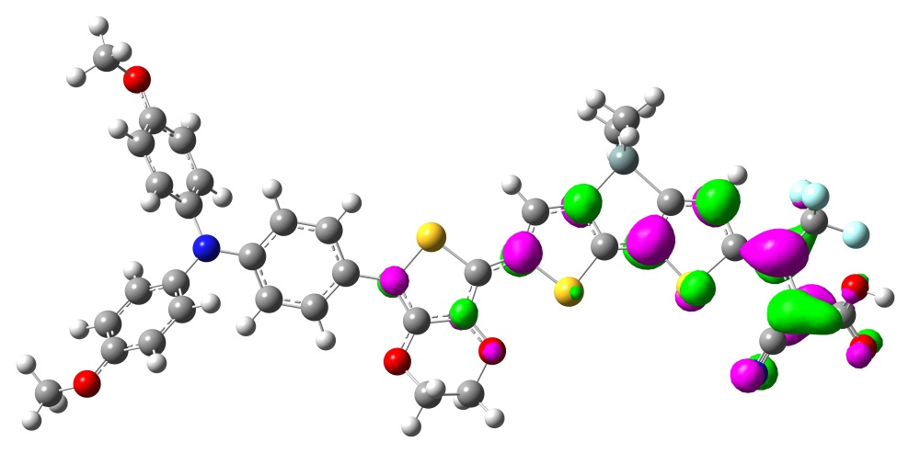
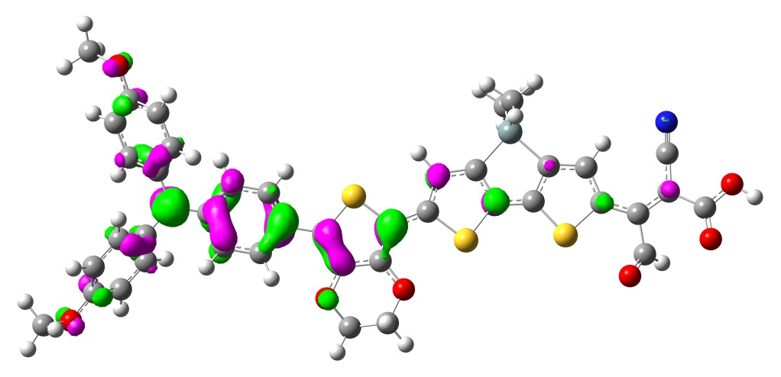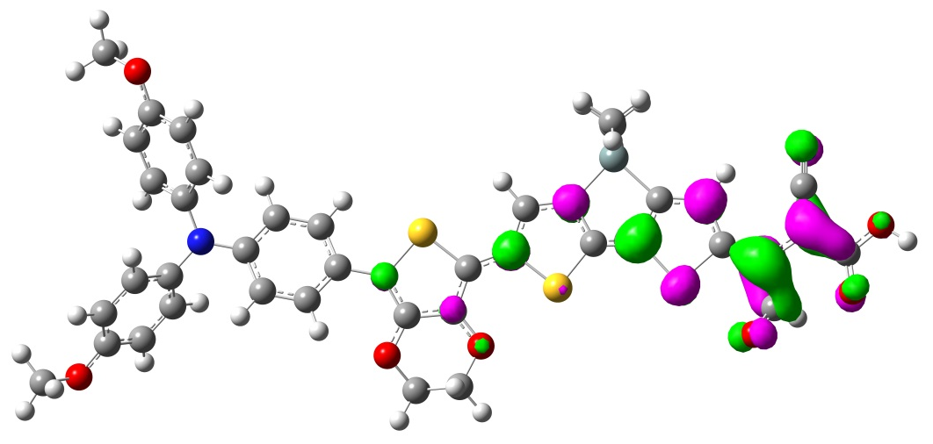
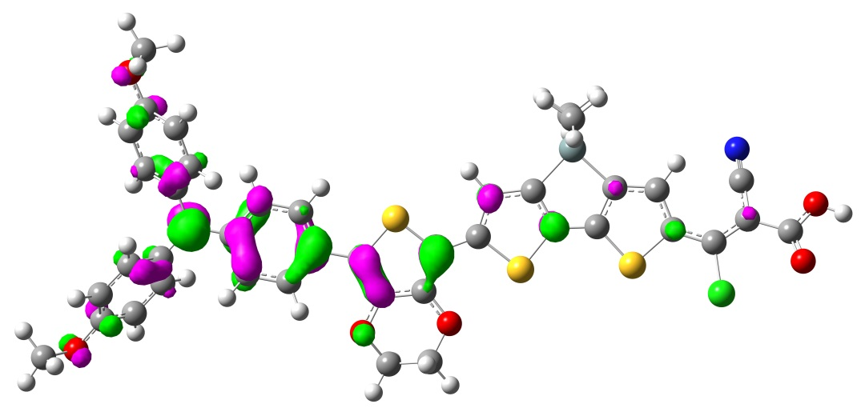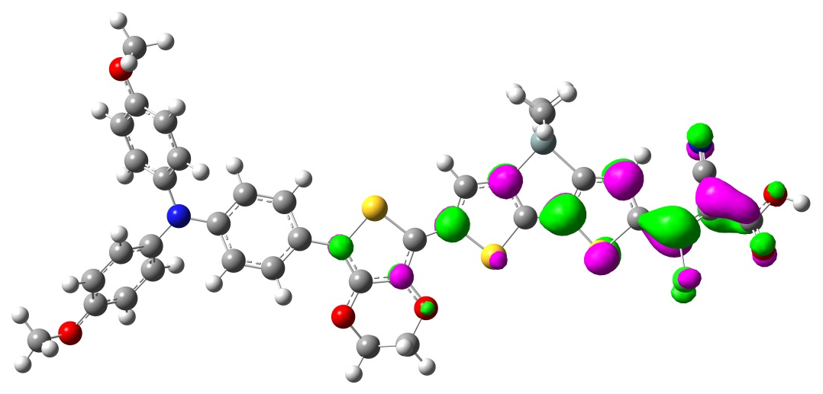
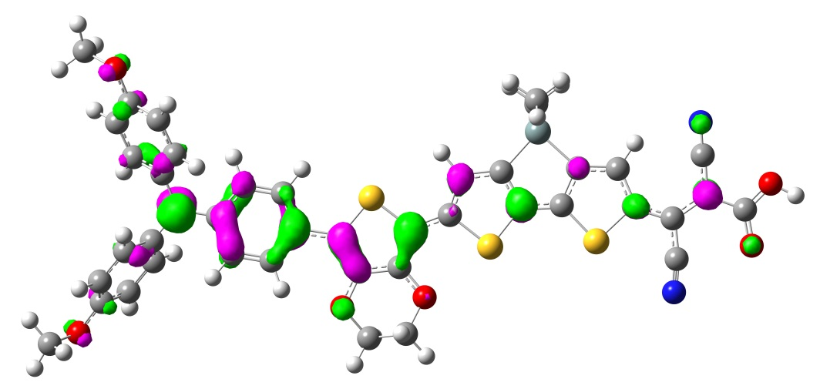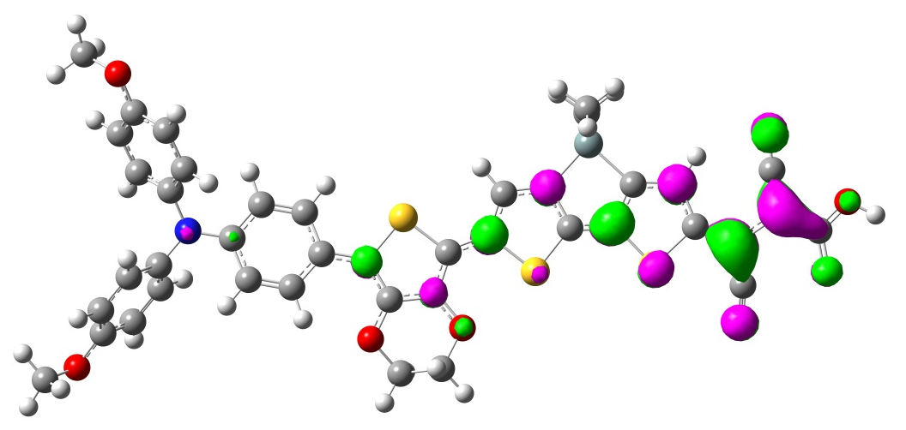

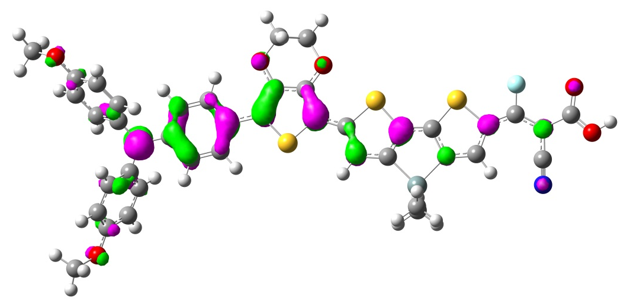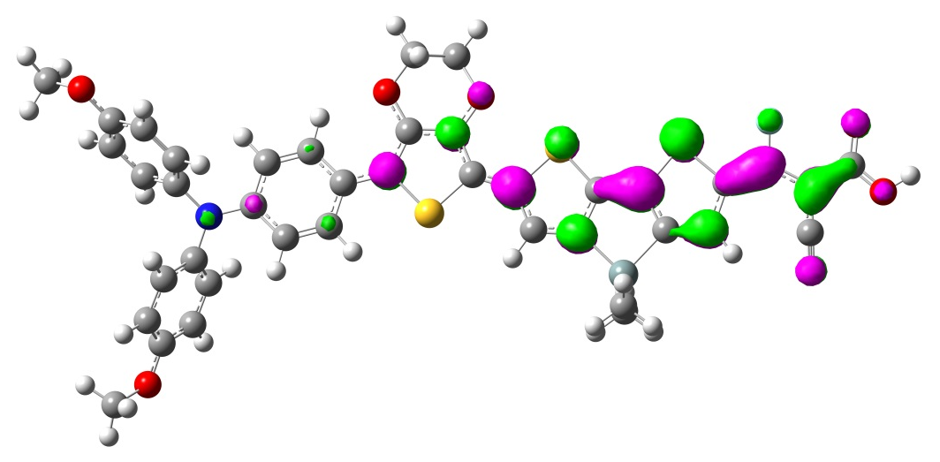
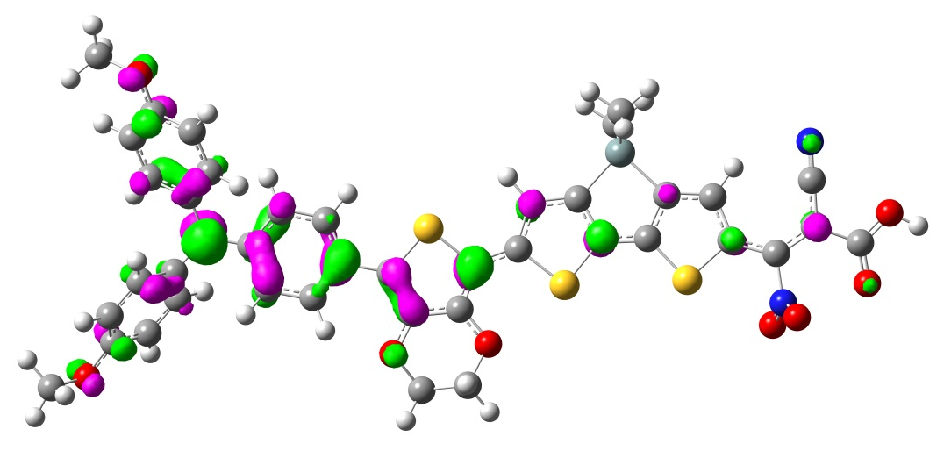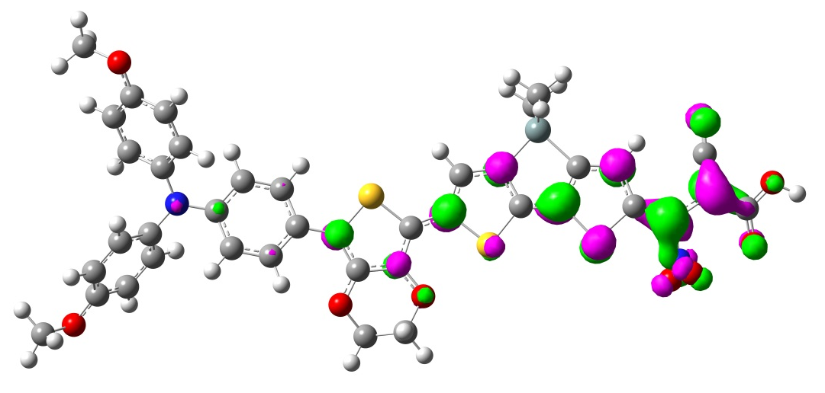
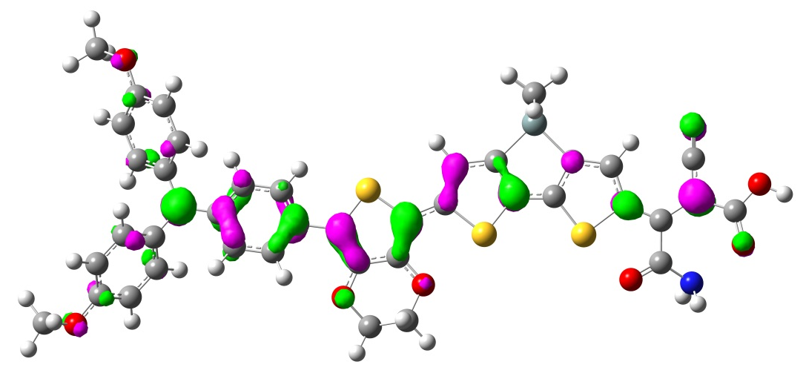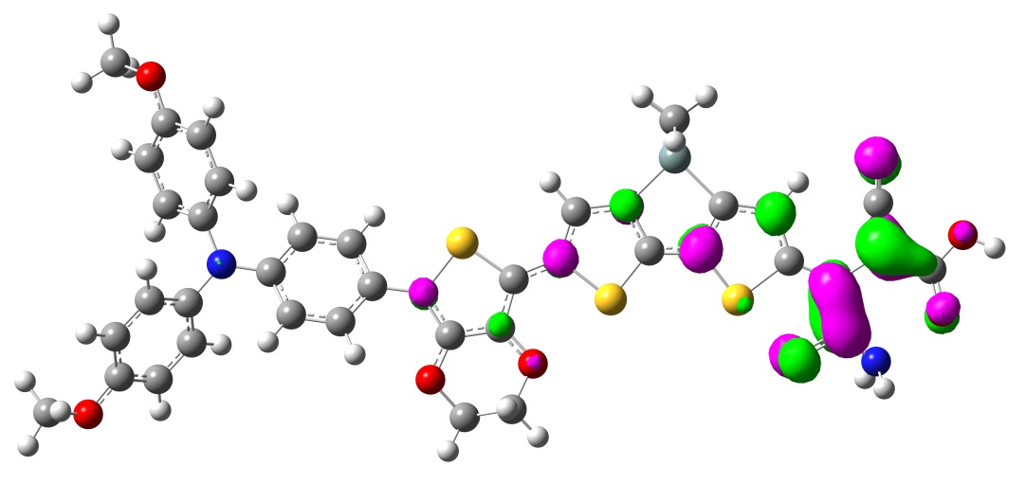
Figure S4

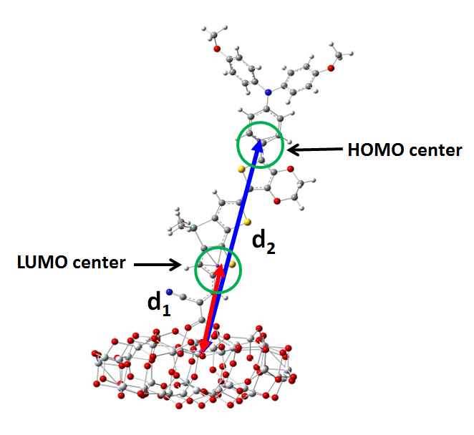
Figure S5

Calculation details of the relevant parameters in Marcus model
1. Driving forces of the electron injection(ΔG_{inj}) and electron recombination (ΔG_{rec})
According to the previous study, in DSSCs the ΔG in the electron injection (ΔG_{inj}) and electron recombination (ΔG_{rec}) processes can be estimated with [1],
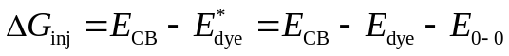 (S1)
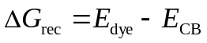 (S2)
where E_{CB} is the conduction band energy level of TiO₂, E*_{dye}/E_{dye} is the oxidation potential of excited/ground state, and E₀₋₀ is the vertical transition energy.
2. Reorganization energy (λ)
As shown in Eq(8), the λ is the sum of structural relaxation from dye molecule (λ_{dye}), semiconductor (λ_{sc}), and organic solvent (λ_{sol}) in the electron transfer process,
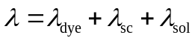 (S3)
Generally, the λ_{dye} can be calculated with the classical adiabatic potential energy surface (PES) method [2]. According to the four-point model, the λ_{dye} term in the electron injection (λ_{inj}) and electron recombination (λ_{rec}) processes can be obtained with [3]
(S4)
(S5)
where E*(g*)/E*(g⁺) is the excited state energy with the excited state/cationic geometry, E⁺(g*)/E⁺(g⁺) is the cationic energy with the excited state/cationic geometry, E⁰(g⁺)/E⁰(g⁰) is the neutral energy with the cationic/neutral geometry, E⁺(g⁰)/E⁺(g⁺) is the cationic energy with the cationic/neutral geometry. On basis of the study from Wei et al, the λ_{sc} was set to 0.026eV [4]. Relatively, the λ_{sol} term is still not easy to be calculated accurately. Here, the λ_{sol} was approximately estimated with the modified Marcus scheme [5]. According to this model, the λ_{sol} is calculated by,
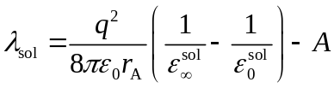 (S6)
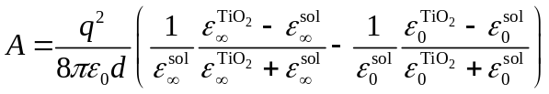 (S7)
where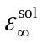/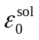is the optical/static dielectric constant of solvent, which is 1.81/37.50 for acetonitrile, 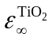/ 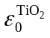is the optical/static (6.45/48.00) dielectric constant of TiO₂, r_{A} is the dye radius, and d is the distance between the TiO₂ surface and the dye LUMO/HOMO center for the electron injection/recombination process.
3. Electron coupling (V)
According to the previous study, since the electron transfer in large π-conjugated systems has strong distance dependence, the V term can be calculated with [6],
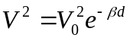 (S8)
where V₀ is the electron coupling without considering the distance dependence, β is the damped exponential, d is the separation distance from the dye LUMO/HOMO center to the TiO₂ surface for the electron injection /recombination process. As seen in Figure S4, because the studied dyes’ HOMO is mainly localized in TPA, EDOT, and π-bridge units, while their LUMO is centered on the π-bridge and acceptor, we defined the centroid of TPA, EDOT, and π-bridge segments as the HOMO center. Similarly, the LUMO center was set to the centroid of the π-bridge and acceptor (Figure S5). According to the recent reports, the β was set to 0.5/1.0 for the electron injection/recombination process [7-8].
In this work, the V₀ in Eq(S8) was calculated with the direct-coupling (DC) method [9-10], which can provide more accurate V₀ value than the other methods, since it involves the orbital overlap correction. In terms of this method, the V₀ can be estimated with [11],
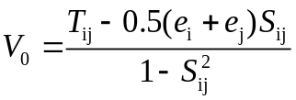 (S9)
where T_{ij} is the electron coupling without considering the orbital overlap correction, S_{ij} is the spatial overlap integral, and e_{i}/e_{j} is the site energy. The T_{ij}, S_{ij}, and e_{i}/e_{j} can be calculated via T_{ij}=<ψ_{i}|F^{KS}|ψ_{j}>, S_{ij}=<ψ_{i}|ψ_{j}>, and e_{i}/e_{j}=<ψ_{i}/ψ_{j}|F^{KS}| ψ_{i}/ψ_{j}>. Among them, ψ_{i} is the HOMO/LUMO of dye, ψ_{j} is the LUMO of TiO₂, and F^{KS} is the Kohn-Sham matrix of dye/(TiO₂)₃₈ complex.
References
[1] J. Preat, C. Michaux, D. Jacquemin, and E.A. Perpete, J. Phys. Chem. C 113, 16821 (2009). doi:10.1021/jp904946a.
[2] M. Malagoli and J.L. Bredas, Chem. Phys. Lett. 327, 13 (2000). doi:10.1016/S0009-2614(00)00757-0.7.
[3] H.-Y. Chen and I. Chao, Chem. Phys. Lett. 401, 539 (2005).doi:10.1016/j.cplett.2004.11.125.
[4] H. Wei, J.-W. Luo, S.-S. Li, and L.-W. Wang, J. Am. Chem. Soc.138, 8165 (2016). doi:10.1021/jacs.6b03524.
[5] E. Maggio, N. Martsinovich, and A. Troisi, J. Chem. Phys. 137, 22A508 (2012). doi:10.1063/1.4737101.
[6] J.N. Clifford, E. Palomares, M.K. Nazeeruddin, M. Grätzel, J. Nelson, X. Li, N.J. Long, and J.R. Durrant, J. Am. Chem. Soc. 126, 5225 (2004). doi:10.1021/ja039924n.
[7] T.J. Barr and G.J. Meyer, ACS Energy Lett. 2, 2335 (2017). doi:10.1021/acsenergylett.7b00569.
[8] J.N. Clifford, E. Palomares, M.K. Nazeeruddin, M. Grätzel, J. Nelson, X. Li, N.J. Long, and J.R. Durrant, J. Am. Chem. Soc. 126, 5225 (2004). doi:10.1021/ja039924n.
[9] S. Yin, Y. Yi, Q. Li, G. Yu, Y. Liu and Z. Shuai, J. Phys. Chem. A 110, 7138 (2006). doi:10.1021/jp057291o.
[10] A. Troisi and G. Orlandi, J. Phys. Chem. A 110, 4065 (2006). doi:10.1021/jp055432g.
[11] S. Yin, L. Li, Y. Yang, and J.R. Reimers, J. Phys. Chem. C 116, 14826 (2012). doi:10.1021/jp303724r.

 Corresponding author: Tel.: +86 916 2640660 E-mail address: zhaocb@snut.edu.cn (C. Zhao), yuxiaohu950203@163.com (X. Yu), jinlx@snut.edu.cn (L. Jin).
 

