Supplementary information

The ubiquitin-specific protease USP8 directly deubiquitinates SQSTM1/p62
to suppress its autophagic activity

Hong Peng^{1,2,*}, Fang Yang^{1,*}, Qianwen Hu¹, Jian Sun³, Heng Zhang¹, Cheng Peng¹, Yao Zhao⁴, Chuanxin Huang^{1,#}

¹Shanghai Institute of Immunology & Department of Immunology and Microbiology, Key Laboratory of Cell Differentiation and Apoptosis of Chinese Ministry of Education, Faculty of Basic Medicine, Shanghai Jiao Tong University School of Medicine, Shanghai 200025, China
²Laboratory of Medical Virology, School of Medicine, Sun Yat-sen University, Guangzhou 510080, China
³Department of Breast Surgery, Obstetrics and Gynecology Hospital , Fudan University , Shanghai 200011 , China
⁴Department of Neurosurgery, Huashan Hospital, Shanghai Medical College, Fudan University, Shanghai 200040, China

*These authors contributed equally to this work
#Correspondence should be addressed to:
Chuanxin Huang
Shanghai Jiao Tong University School of Medicine, Shanghai 200025, P.R.China
Tel: +86-21-54610161; Email: huangcx@shsmu.edu.cn

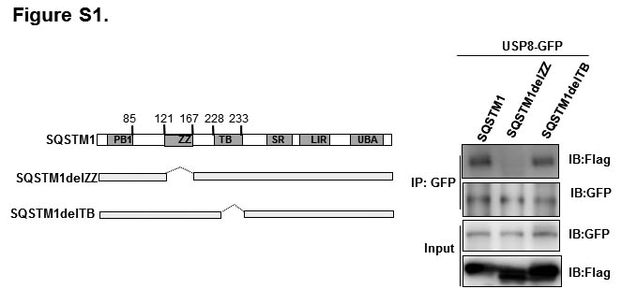

Figure S1. Schematic representation of Flag-tagged SQSTM1 truncated mutants (left panel). HEK293T cells were co-transfected with USP8-GFP and Flag-tagged SQSTM1 truncated mutants, immunoprecipitated with anti-GFP beads and immunoblotted with antibodies against Flag and GFP (right panel).

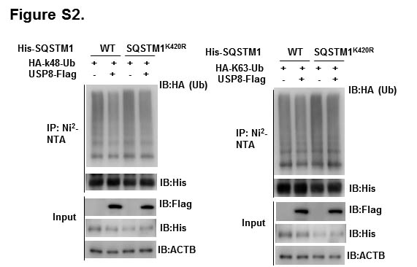

Figure S2. USP8 overexpression did not reduce K48- and K63-linked ubiquitination of the SQSTM1^{K420R} mutant. HEK293T cells transfected with HA-K48- or K63-Ub and His-tagged SQSTM1 or SQSTM1^{K420R} mutant with or without USP8-Flag for 48 h. The cells were subjected to pull down using the Ni2⁺-NTA beads, followed by immunoblotting.

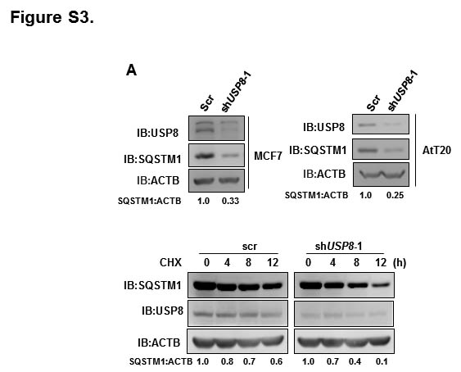

Figure S3. USP8 knockdown promoted autophagic degradation of SQSTM1. (A) Immunoblotting of SQSTM1 and USP8 protein in scramble (scr) or shUSP8-infected MCF7 and AtT20 cells. (B) Immunoblotting of SQSTM1 protein in scramble (scr) or shUsp8-infected MEFs in the presence of cycloheximide (CHX, 50 µg/ml) for indicated times.

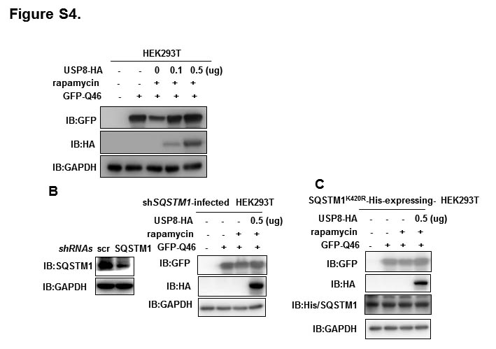

Figure S4. USP8 overexpression delayed GFP-Q46 degradation induced by rapamycin through deubiquitinating SQSTM1 at K420. Wild-type (A) SQSTM1-knockdown (B) or SQSTM1^{K420R} mutant-expressing HEK293T cells (C) were co-transfected with GFP-Q46 and USP8-HA. 48 h later, cells were treated with 500nM rapamycin for 12 h, followed by western blotting using indicated antibodies. SQSTM1-knockdown HEK293T cells were generated by infection of specific shRNA against SQSTM1 (shSQSTM1). The knockdown efficiency of SQSTM1 in HEK293T cells was confirmed by immunoblotting (B, left). The lentivirus encoding the SQSTM1^{K420R}-His mutant was used to infect SQSTM1-knockdown HEK293T cells to generate SQSTM1^{K420R} -His mutant-expressing HEK293T cells.

Table S1. The sequence of primers used in this study.
Primers for subcloning and point mutation
SQSTM1-FL- Forward: 5-CCGGAATTCatggcgtcgctcaccgtgaa-3
SQSTM1-FL- Reverse: 5-CCGCTCGAGcaacggcgggggatgctttg-3
SQSTM1-T1- Forward: 5-CCGGAATTC atggccatgtcctacgtgaa-3
SQSTM1-T1- Reverse: 5-CCGCTCGAGcaacggcgggggatgctttg-3
SQSTM1-T2- Forward1: 5-CCGGAATTCatggcgtcgctcaccgtgaa-3
SQSTM1-T2- Reverse1: 5-tgtcaattcctcgtcactggaaaaggcaacccccaacgttcttcaggaaattcac-3
SQSTM1-T2- Forward2: 5-cttttccagtgacgaggaattgacagtgaatttcctgaagaacgttggggagagt-3
SQSTM1-T2- Reverse2: 5-CCGCTCGAGcaacggcgggggatgctttg-3
SQSTM1-T3- Forward1: 5-CCGGAATTCatggcgtcgctcaccgtgaa-3
SQSTM1-T3- Reverse1: 5-cgccctcaacattcccacccggcttactcggatcctccgatggaccagaa-3
SQSTM1-T3- Forward2: 5-ttctggtccatcggaggatccgagtaagccgggtgggaatgttgagggcg-3
SQSTM1-T3- Reverse2: 5-CCGCTCGAGcaacggcgggggatgctttg-3
SQSTM1-T4- Forward1: 5-CCGGAATTC atggcgtcgc tcaccgtgaa-3
SQSTM1-T4- Reverse1: 5-gccgcgggtcagcctctggcgggaggctggggtcagagcagcagctgctt-3
SQSTM1-T4- Forward2: 5-agcagctgctgctctgaccccagc ctcccgccagaggctgacccgcggc-3
SQSTM1-T4- Reverse2: 5-CCGCTCGAGcaacggcgggggatgctttg-3
SQSTM1-T5- Forward: 5-CCGGAATTCatggcgtcgctcaccgtgaa-3
SQSTM1-T5- Reverse: 5-CCGCTCGAGgcgggagatgtgggtacaaggcagcttc-3
SQSTM1delZZ- Forward1: 5-CCGGAATTCatggcgtcgctcaccgtgaa-3
SQSTM1delZZ- Reverse1: 5-gcccgaaggggctggggaacatgttgcggggcgcctcctgag-3
SQSTM1delZZ- Forward2: 5-gccccgcaacatgttccccagccccttcgggcac-3
SQSTM1delZZ- Reverse2: 5-CCGCTCGAGcaacggcgggggatgctttg-3
SQSTM1^{K420R}-forward: 5-TCACCAGGCTCCTGCAGACCaggAACTATGAC-3
SQSTM1^{K420r}-reverase: 5-gccgctccgatgtcatagttcctggtctgcag-3

