Supplementary material for "Influence of Wax Inhibitor Molecular Weight: Part 1. Fractionation and Effect on Crystallization of Polydisperse Waxes."
Table 1. Gelation Point average, maximum, and minimum from rheometer experiments with 500 ppm PPD with or without impurities in different waxy oils. Each sample was measured four or more times.
 | Pure PPD |  |  | PPD + Impurities
 | Average | Maximum | Minimum | Average | Maximum | Minimum
PPD Ω, Model Oil A | 16.57 | 17.86 | 15.80 | 17.52 | 17.64 | 17.45
PPD Ω, Model Oil B | 12.28 | 13.49 | 10.66 | 11.47 | 13.12 | 10.71
PPD Ω, Model Oil C | 12.46 | 13.46 | 10.46 | 13.58 | 14.21 | 12.96
PPD τ, Model Oil A | 21.24 | 22.05 | 19.32 | 18.93 | 19.48 | 17.99
PPD τ, Model Oil B | 47.47 | 47.90 | 46.86 | 45.83 | 46.69 | 44.46
PPD τ, Model Oil C | 11.71 | 12.21 | 11.21 | 11.83 | 11.95 | 11.70
PPD τ, Model Crude | 9.97 | 13.07 | 5.92 | 10.01 | 10.33 | 9.69

Table 2. WAT average, maximum, and minimum from DSC experiments with 500 ppm PPD with or without impurities in different waxy oils. Each sample was measured four or more times.
 | Pure PPD |  |  | PPD + Impurities
 | Average | Maximum | Minimum | Average | Maximum | Minimum
PPD Ω, Model Oil A | 34.99 | 36.25 | 33.49 | 34.72 | 35.10 | 33.97
PPD Ω, Model Oil B | 49.28 | 49.32 | 49.24 | 49.05 | 49.26 | 48.94
PPD Ω, Model Oil C | 24.73 | 25.21 | 24.48 | 25.44 | 25.81 | 24.99
PPD Ω, Model Crude | 23.18 | 23.35 | 23.04 | 21.89 | 21.93 | 21.84
PPD τ, Model Oil A | 35.34 | 36.90 | 34.43 | 34.85 | 36.06 | 34.19
PPD τ, Model Oil B | 50.68 | 50.77 | 50.55 | 50.86 | 50.95 | 50.75
PPD τ, Model Oil C | 27.47 | 27.66 | 27.22 | 27.68 | 27.97 | 27.33
PPD τ, Model Crude | 28.14 | 28.45 | 27.91 | 29.55 | 30.34 | 27.66

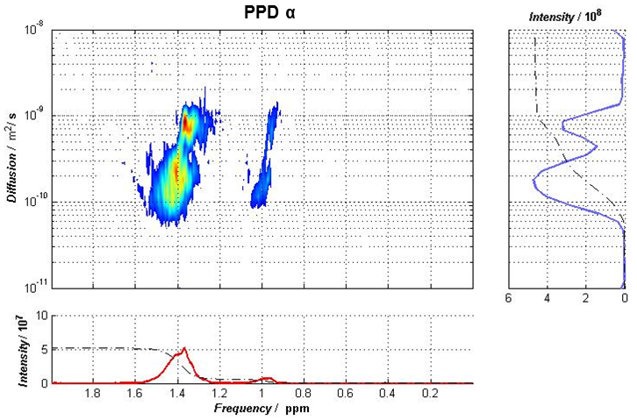
Figure 1. NMR DOSY spectrum of 1000 ppm PPD α in deuterated toluene.
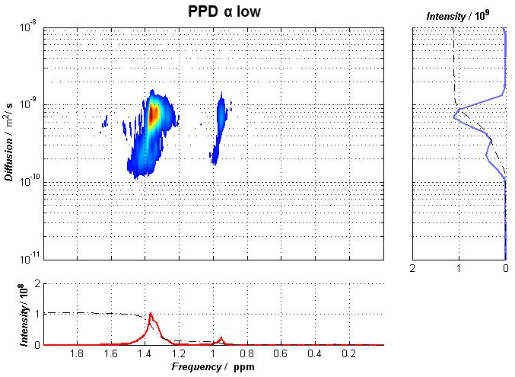
Figure 2. NMR DOSY spectrum of 1000 ppm PPD α low in deuterated toluene.
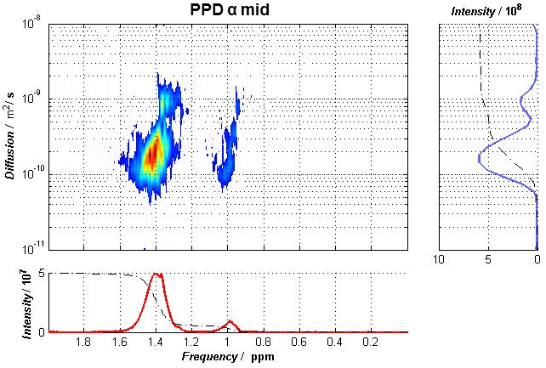
Figure 3. NMR DOSY spectrum of 1000 ppm PPD α mid in deuterated toluene.
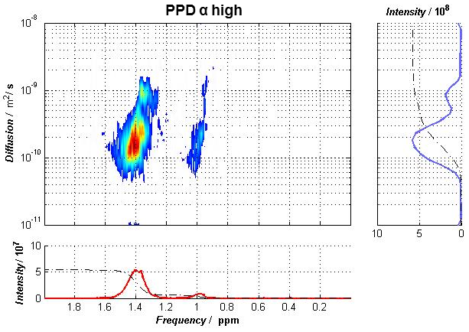
Figure 4. NMR DOSY spectrum of 1000 ppm PPD α high in deuterated toluene.
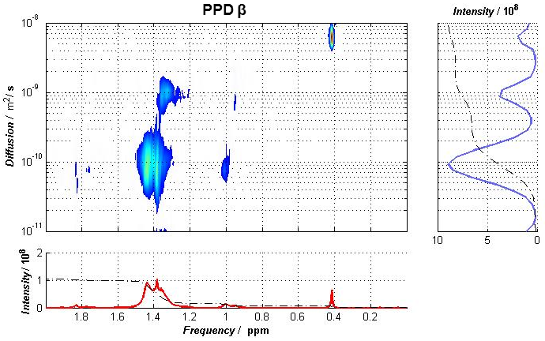
Figure 5. NMR DOSY spectrum of 1000 ppm PPD β in deuterated toluene.
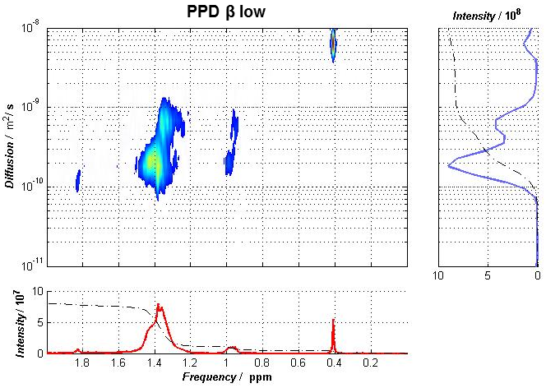
Figure 6. NMR DOSY spectrum of 1000 ppm PPD β low in deuterated toluene.
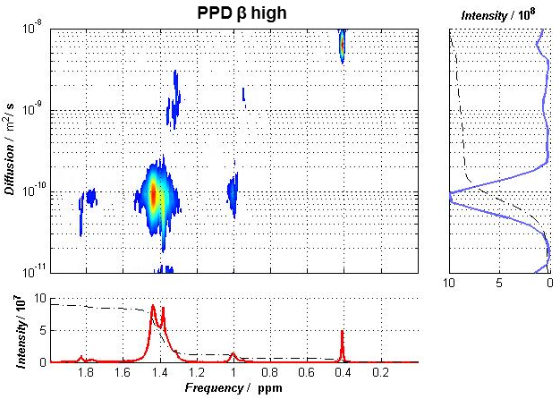
Figure 7. NMR DOSY spectrum of 1000 ppm PPD β high in deuterated toluene.
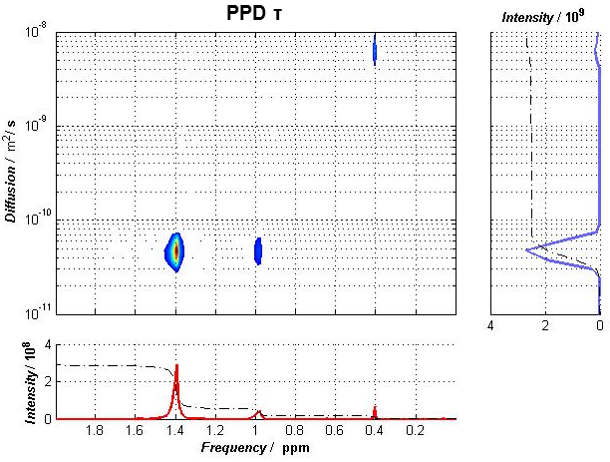
Figure 8. NMR DOSY spectrum of 1000 ppm PPD τ low in deuterated toluene.
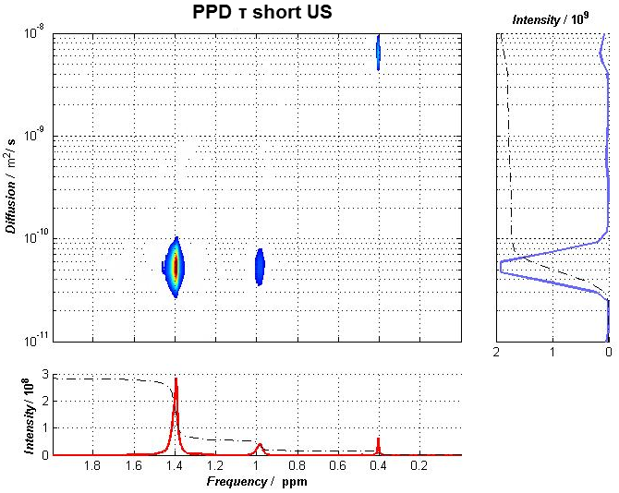
Figure 9. NMR DOSY spectrum of 1000 ppm PPD τ short US in deuterated toluene.
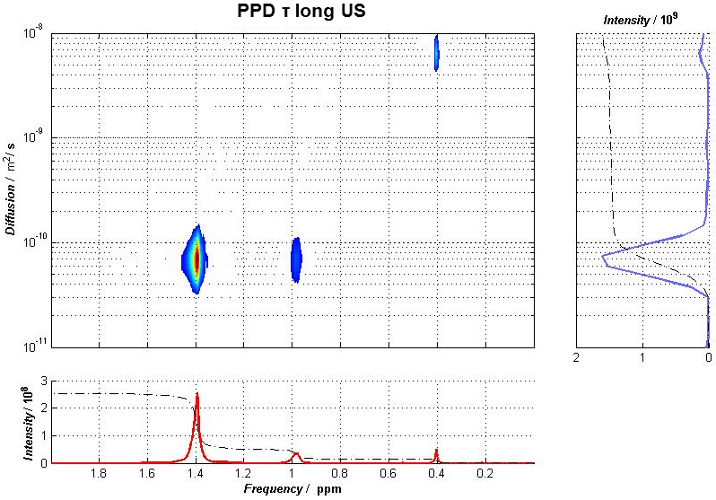
Figure 10. NMR DOSY spectrum of 1000 ppm PPD τ long US in deuterated toluene.

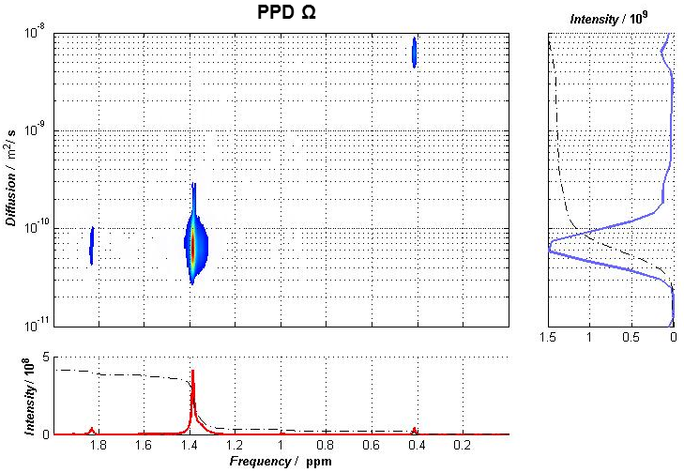
Figure 11. NMR DOSY spectrum of 1000 ppm PPD Ω in deuterated toluene.

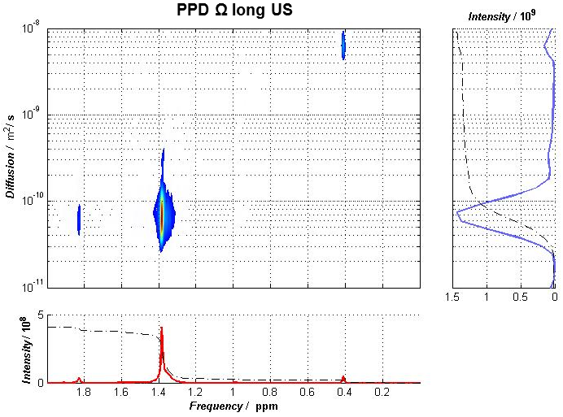
Figure 12. NMR DOSY spectrum of 1000 ppm PPD Ω long US in deuterated toluene.
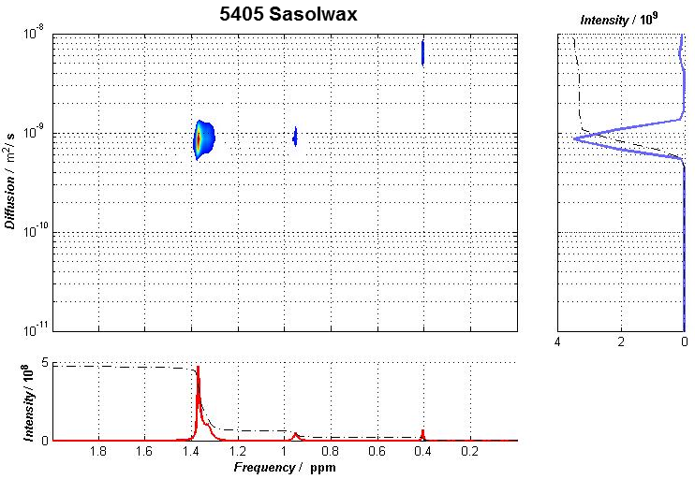
Figure 12. NMR DOSY spectrum of 1000 ppm 5405 Sasolwax in deuterated toluene.
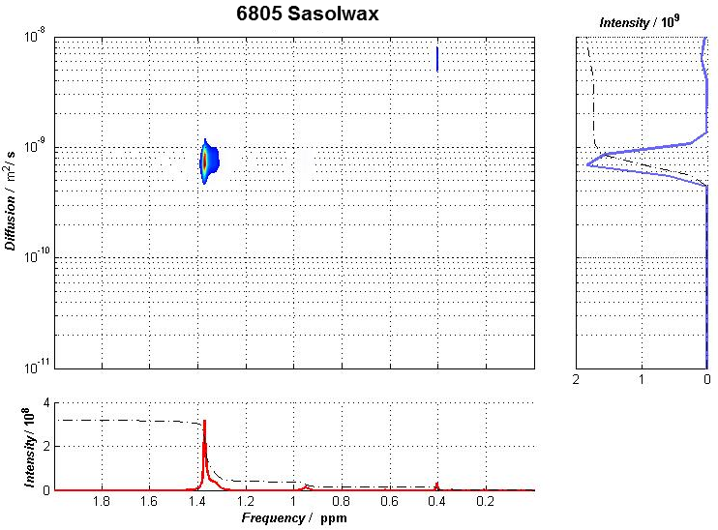
Figure 12. NMR DOSY spectrum of 1000 ppm 6805 Sasolwax in deuterated toluene.

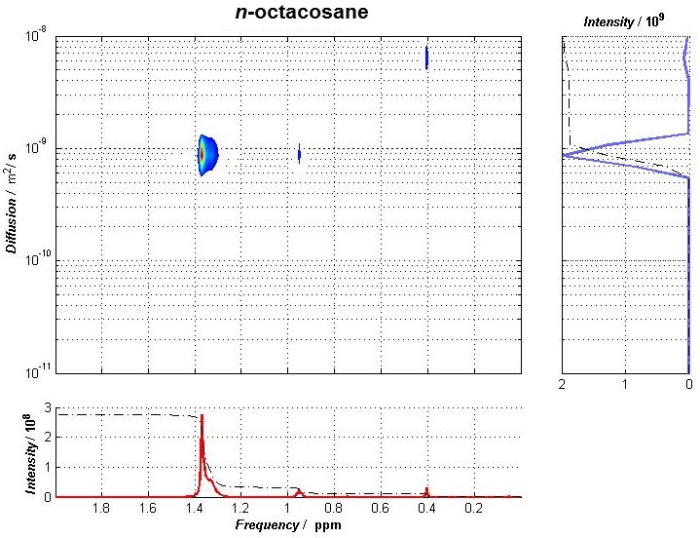
Figure 12. NMR DOSY spectrum of 1000 ppm n-octacosane in deuterated toluene.

