SUPLEMENTARY DATA
Influence of cold gas spray parameters on the corrosion resistance of Al-Al₂O₃ coatings sprayed on carbon steel

F. S. da Silva^{a,b*}, N. Cinca^{b}, S. Dosta^{b}, I. G. Cano^{b}, J. M. Guilemany^{b}, A. V. Benedettiª
ªUNESP - São Paulo State University, Institute of Chemistry, Prof. Francisco Degni, 55,
P.O. Box 355, 14800-060, Araraquara, SP, Brazil
^{b}Barcelona University, CPT, Martí I Franqués 1, 08028 Barcelona, Spain

*Corresponding author
E-mail address: fernandoquimicauems@gmail.com (F. S. da Silva)

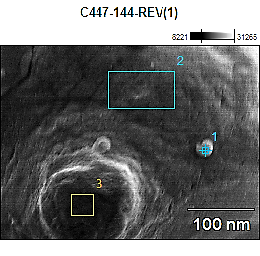

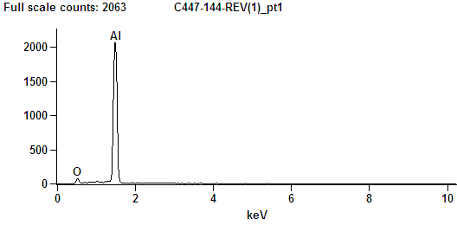

Weight %
 | O-K | Al-K
C447-144-REV(2)_pt2 | 2.06 | 97.94

(a)

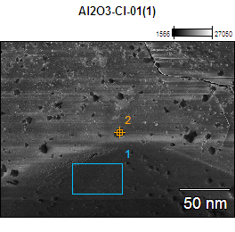

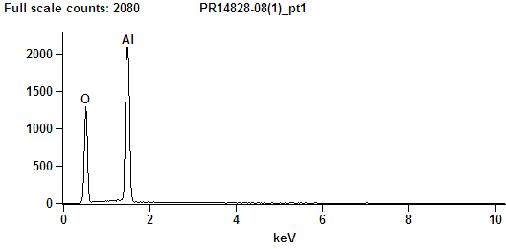

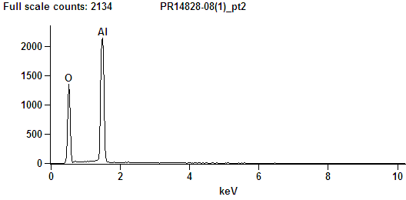
Weight %
 | O-K | Al-K
PR14828-08(1)_pt1 | 43.37 | 56.63
PR14828-08(1)_pt2 | 43.82 | 56.18

(b)
Fig. S1. EDS spectra of Al (a) and Al₂O₃ (b) powders, which revealed Al and oxygen.

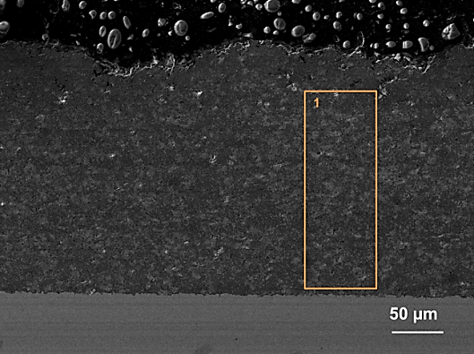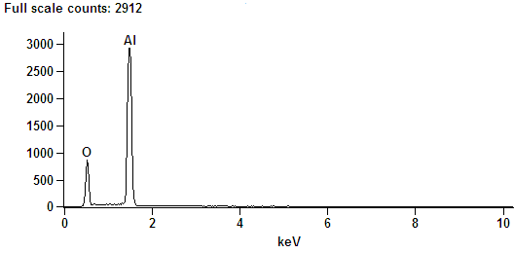
Weight %
 | O-K | Al-K
PR14828-10(1)_pt1 | 28.16 | 71.84
(a)
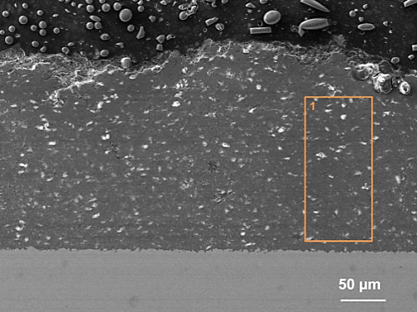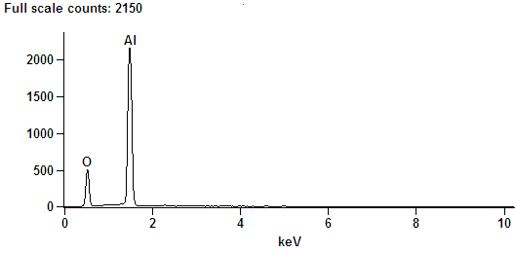
Weight %
 | O-K | Al-K
Al2O3--09(1)_pt1 | 28.57 | 71.43

(b)
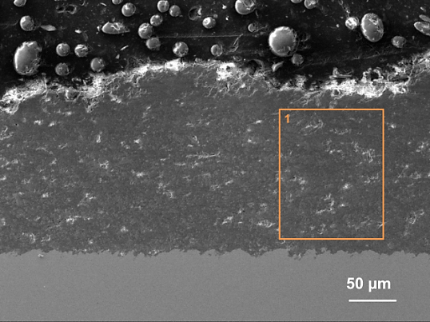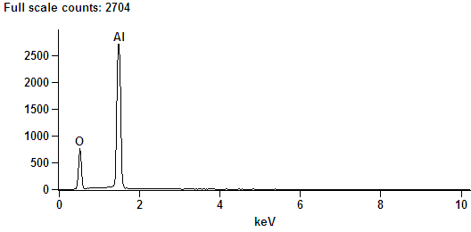
Weight %
 | O-K | Al-K
Al-Al2O3-14(1)_pt1 | 30.20 | 69.80
(c)
Figure S2. EDS spectra of cross section for Al-Al₂O₃ coatings after ~1200 h of immersion in 3.5 wt.% NaCl solution: (a) 5T4, (b) 15T4 and (c) 15T3. The analysis revealed aluminum and oxygen. Iron was not detected all over the cross section even near the coating/substrate interface.
(a)
(b)
Fig.S3. (a) Nyquist diagrams, (b) Bode log |Z| vs. log f and Bode Φ vs. log f diagrams for the substrate in 3.5 wt.% NaCl solution, at 25 ºC. The symbols correspond to the experimental data. The fittings are shown by the solid lines.

(a)
(b)
Fig.S4. (a) Nyquist diagrams, (b) Bode log |Z| vs. log f and Bode Φ vs. log f diagrams for the coatings after 200 h of immersion in 3.5 wt.% NaCl solution, at 25 ºC. The symbols correspond to the experimental data. The fittings are shown by the solid lines.

(a)
(b)
Fig.S5. (a) Nyquist diagrams, (b) Bode log |Z| vs. log f and Bode Φ vs. log f diagrams for the coatings after ≈1300 h of immersion in 3.5 wt.% NaCl solution, at 25 ºC. The symbols correspond to the experimental data. The fittings are shown by the solid lines.
Table S1. EEC parameters used to fit the EIS diagrams (Fig. 7S) obtained in 3.5 wt.% NaCl solution for the substrate and Al-Al₂O₃ coatings deposited on steel, and at different times of immersion. The values in parenthesis are the error percentage of each one of the EEC parameter.

Steel Substrate
Time/h | 48 h | 96 h | 120 h
R_{s}/Ω cm² | 20 (0.2) | 20 (0.2) | 20 (0.2)
¹CPE_{dl-}T/µFcm⁻² s^{ndl−1} | 19 (13) | 47 (11) | 68 (4)
n_{dl} | 0.83 (2) | 0.9 (2) | 0.94 (2)
R_{ct}/kΩ cm² | 0.9 (10) | 0.5 (4) | 0.3 (4)
CPE_{film}-T/mF cm⁻² s^{nfilm−1} | 431 (1) | 833 (1.1) | 123 (0.2)
n_{film} | 0.81 (1.2) | 0.77 (0.2) | 0.71 (0.1)
R_{film}/kΩ cm² | 1.4 (0.2) | 1.2 (0.2) | 1.1 (0.2)
χ²/10⁻⁵ | 0.4 | 0.5 | 0.1

5T4
Time/h | 24 | 200 | 450 | 550 | 700 | 1300
R_{s}/Ω cm² | 17 (0.4) | 19 (0.1) | 16 (0.3) | 16 (0.3) | 16 (0.5) | 19 (0.5)
CPE_{dl-}T/µF cm⁻² s^{ndl−1} | 82 (0.5) | 82 (0.4) | 85 (0.4) | 105 (0.7) | 120 (1) | 125 (1)
n_{dl} | 0.8 (0.1) | 0.76 (0.1) | 0.76 (0.1) | 0.72 (0.1) | 0.71 (0.1) | 0.71 (0.1)
R_{ct}/kΩ cm² | 1.7 (0.7) | 2.7 (0.7) | 4.0 (1) | 5.6 (1) | 4.3 (1.2) | 5.3 (1.2)
CPE_{po}-T/mF cm⁻² s^{npo−1} | 2.4 (3) | 3.1 (3) | 1.5 (8) | 4.2 (11) | 4.66 (10) | 7.7 (10)
n_{po} | 0.55 (2) | 0.7 (1.6) | 0.62 (4) | 0.84 (5) | 0.85 (5.7) | 0.97 (5.7)
R_{po}/kΩ cm² | 2.6 (4) | 2.2 (4) | 4.8 (7) | 3.5 (9) | 3.0 (9) | 2.6 (9)
χ²/10⁻⁴ | 1.5 | 1.0 | 5.0 | 7.0 | 1.1 | 1.3

15T4
Time/h | 96 | 170 | 378 | 520 | 810 | 1000 | 1300
R_{s}/Ω cm² | 20 (0.2) | 20 (0.2) | 21 (0.2) | 20 (0.2) | 20 (0.3) | 19 (0.5) | 17 (0.5)
CPE_{dl-}T/µF cm⁻² s^{ndl−1} | 82 (0.7) | 86 (0.6) | 89 (0.5) | 92 (0.5) | 103 (0.6) | 102 (0.6) | 95 (1)
n_{dl} | 0.76 (0.1) | 0.75 (0.1) | 0.74 (0.1) | 0.73 (0.1) | 0.71 (0.2) | 0.71 (0.2) | 0.71 (0.2)
R_{ct}/kΩ cm² | 2.4 (1) | 3.1 (1) | 4.3 (0.8) | 5.7 (0.8) | 7.1 (1.3) | 6.5 (1) | 8.5 (3)
CPE_{po}-T/mF cm⁻² s^{npo−1} | 1.8 (4) | 1.4 (4.5) | 1.6 (4.7) | 2.5 (8.5) | 2.6 (13) | 2.3 (12) | 1.2 (11)
n_{po} | 0.55 (3) | 0.57 (3.3) | 0.68 (2.5) | 0.8 (3.6) | 0.78 (5.7) | 0.77 (5) | 0.62 (12)
R_{po}/kΩ cm² | 4.3 (6) | 5.7 (6.7) | 5.6 (4.2) | 4.4 (5.8) | 5.3 (10) | 5.1 (8) | 10 (13)
χ²/10⁻⁴ | 0.2 | 0.2 | 0.2 | 0.2 | 4 | 4 | 1

15T3
Time/h | 24 | 120 | 200 | 400 | 720 | 1200
R_{s}/Ω cm² | 29 (0.1) | 36 (0.2) | 33 (0.4) | 28 (0.4) | 30 (0.5) | 30 (0.3)
CPE_{dl-}T/µF cm⁻² s^{ndl−1} | 19 (0.5) | 25 (0.5) | 27 (0.7) | 29 (0.8) | 19 (3) | 20 (2.4)
n_{dl} | 0.8 (0.1) | 0.8 (0.1) | 0.8 (0.1) | 0.8 (0.1) | 0.85 (0.5) | 0.84 (5)
R_{ct}/kΩ cm² | 9.2 (1) | 14 (0.6) | 15 (0.7) | 12.3 (15) | 2 (15) | 1.6 (5.2)
CPE_{po}-T/mF cm⁻² s^{npo−1} | 0.4 (3.4) | 0.7 (4.5) | 1.3 (8) | 1.2 (3) | 24 (3) | 35 (2)
n_{po} | 0.52 (2.8) | 0.8 (2) | 0.92 (2) | 0.82 (4) | 0.64 (1.3) | 0.72 (1.3)
R_{po}/kΩ cm² | 21 (6) | 20.5 (4.6) | 14.5 (5.4) | 13 (8) | 12.5 (4) | 8.1 (1.6)
χ²/10⁻⁴ | 1.8 | 3.3 | 7.8 | 9.6 | 5 | 3

