The supporting information for
Predicting the contents of polysaccharides and its monosugars in Dendrobium huoshanense by Partial Least Squares Regression Model Using attenuated total reflectance Fourier Transform Infra-red Spectroscopy
Jing-Wen Hao^{1,2}, Nai-Dong Chen^{1,3,4,}∗, Xu-Cheng Fu ¹, Jian Zhang ¹
¹ College of Biotechnology and Pharmaceutical Engineering，West Anhui University，Lu’an City 237012，China
² School of pharmacy, Anhui University of Traditional Chinese Medicine, Hefei 230012, China
³ West Anhui Biotechnology Research Center of Natural Medicine and Traditional Chinese Medicine, West Anhui University, Lu’an City 237012, China
⁴ College of Pharmacy, Anhui Medical University, Hefei 230032, China

S-Table 1
The list of Dendrobium huoshanense samples
Samples | Collection place | Collection time
S1-S17 | Jinzhai Count, Anhui Province, China | January,2015-December,2015
S18-S40 | Huoshan Count, Anhui Province, China | January,2015-December,2015
S41-S52 | Yingshan Count, Anhui Province, China | January,2015-December,2015
S53-S56 | Huoshan Count, Anhui Province, China | September,2015-December,2015
S57-S60 | Huoshan Count, Anhui Province, China | September,2016-December,2017
S61-S63 | Jinzhai Count, Anhui Province, China | October,2015-November,2015
S64-S66 | Jinzhai Count, Anhui Province, China | October,2016-November,2016
S67-S69 | Yingshan Count, Anhui Province, China | October,2015-December,2015
S70-S72 | Yingshan Count, Anhui Province, China | October,2016-December,2016
S73-S103 | Huoshan Count, Anhui Province, China | October,2018- November,2018
S104-S132 | Jinzhai Count, Anhui Province, China | October,2018- November,2018

S-Table 2
The calibration curve, limit of detection (LOD), limit of quantification(LOQ) and precision (repeatability and reproducibility) of the monosaccharide standards detected by Gas Chromatography-Mass Spectrometry.
Compound | Equation | Correalrion coefficient (r²) | Linea range (μg) | LOD  (μg) | LOD  (μg) | Reproducibility (%) | Repeatability (%)
Arabinose | A=0.607C | 0.985 | 0.5-1600 | 0.2 | 0.8 | 12 | 6
Rhamnose | A=0.652C | 0.975 | 0.5-1600 | 0.2 | 0.5 | 9 | 11
Xylose | A=0.547C | 0.989 | 0.5-600 | 0.1 | 0.5 | 7 | 6
Mannose | A=0.811C | 0.993 | 2.5-1500 | 0.1 | 0.6 | 7 | 3
Galactose | A=0.392C | 0.987 | 1.5-1500 | 0.3 | 0.7 | 7 | 5
Glucose | A=0.913C | 0.998 | 1.0-1600 | 0.1 | 1.8 | 7 | 5
Galacturonic acid | A=0.238C | 0.977 | 4.0-1300 | 0.1 | 5.0 | 9 | 7
Fucose | A=0.566C | 0.969 | 0.5-550 | 0.4 | 1.2 | 12 | 9
Inositol | A=0.954C | 0.993 | 1.0-1500 | 0.2 | 1.5 | 10 | 1

S-Table 3
The assignment of attenuated total reflectance Fourier transform infra-red spectroscopy signals relative to functional groups of polysaccharide
Absorption (cm^{–1}) | Functional group | Structural characteristic
3600-3200 | hydroxyl group (-OH) | stretching vibration of O-H
3000-2800 | alkyl group (-CH2-) | stretching vibration of C-H
1750-1600 | carboxyl group (-COOH), aldehyde group(-CHO) or esterfunction (-COOR) | stretching vibration of C=O
1500-1400 | alkyl group (-CH2- or –CH3) | bending vibration of C-H
1350-1290 | carboxyl group (-COOH) | symmetrical stretching vibration of C=O
1280-1200 | carboxyl group (-COOH) | bending vibration of O-H
1160-1070 | ether (-C-O-C-) | stretching vibration of C-O
1060-970 | hydroxyl group (-OH) | bending vibration of O-H
930-800 | D-glucopyranose ring  α-type glycosidic linkage  α-D-galactopyranose | antisymmetrical ring vibration  bending vibration of C-H

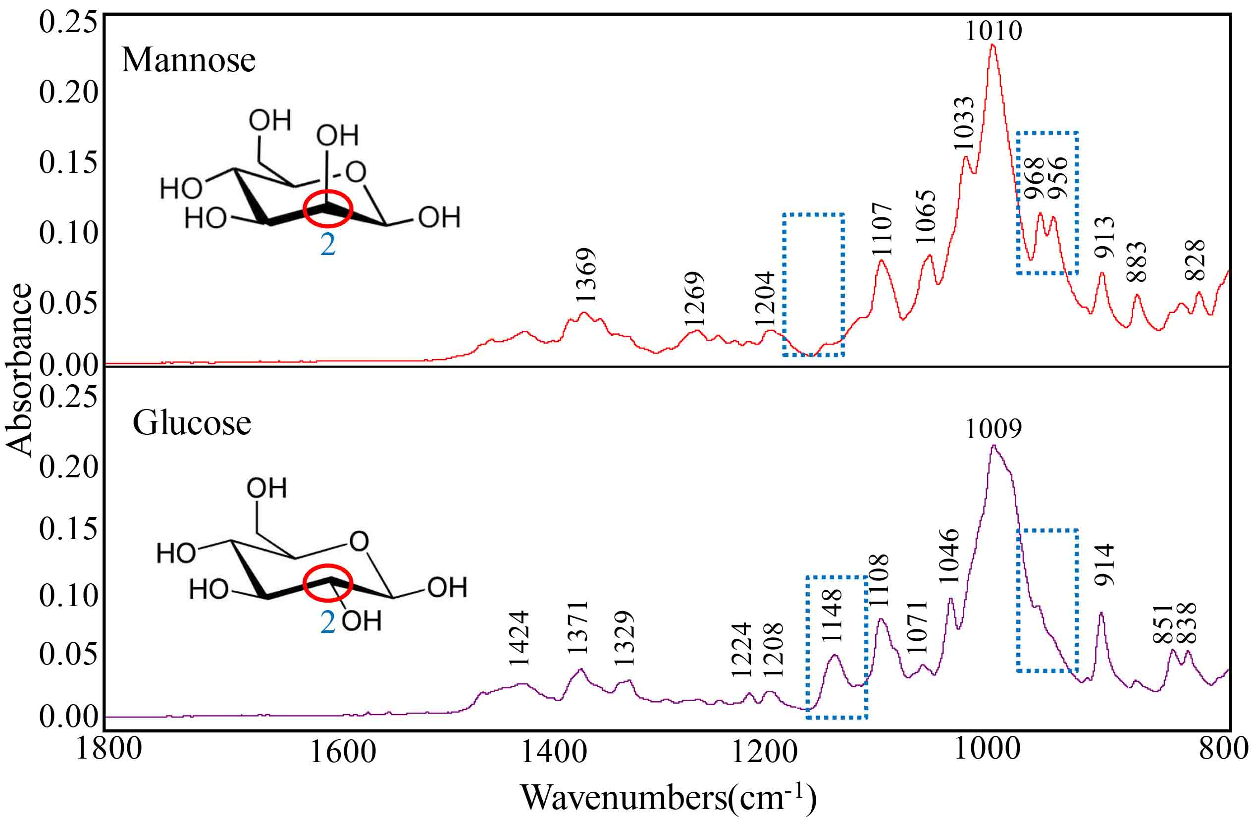
S-Fig 1. The representative attenuated total reflectance Fourier transform infra-red spectroscopy of the mannose and glucose samples.

∗ corresponding author: Professor Nai-Dong Chen, e-mail: 2004cnd@163.com

