SUPPLEMENTARY INFORMATION

Hydrodeoxygenation of stearic acid using Mo modified Ni and Co/alumina catalysts: Effect of calcination temperature

Pankaj Kumar, Sunil K. Maity*, Debaprasad Shee
Department of Chemical Engineering, Indian Institute of Technology Hyderabad, Kandi, Sangareddy-502285, Telangana, India.

*Corresponding author (Dr. Sunil K. Maity): Phone: +91-40-2301-6075; Fax: +91-40-2301 6003, E-mail: sunil_maity@iith.ac.in

Table S1. Reproducibility of catalysts for HDO of stearic acid.ª
Catalysts | Experiments | Conversion of stearic acid, %^{b} | Product of distribution, wt%
 |  |  | C₁₅ | C₁₆ | C₁₇ | C₁₈ | C₁₇-CHO | C₁₈-OH
4.1C773 | Run 1 | 99.8 | 1.6 | 1.8 | 40.4 | 15.0 | - | 41.2
 | Run 2 | 99.6 | 0 | 1.2 | 38.7 | 15.2 | - | 44.9
 | Run 3 | 99.9 | 0 | 1.3 | 39.5 | 15.7 | - | 43.5
 | SD | 0.15 | 0.92 | 0.32 | 0.85 | 0.36 | - | 1.87
1.7C2.4M973 | Run 1 | 76.3 | 0.5 | 0.8 | 3.1 | 10.2 | 2.8 | 82.6
 | Run 2 | 79.7 | 0 | 0.6 | 3.4 | 11.1 | 2.3 | 82.6
 | Run 3 | 78.5 | 0 | 0.9 | 2.3 | 9.2 | 2.7 | 82.5
 | SD | 1.72 | 0.29 | 0.15 | 0.56 | 0.95 | 0.26 | 0.05
4.1N973 | Run 1 | 45.0 | 0 | 3.1 | 43.2 | 0.4 | - | 53.3
 | Run 2 | 46.3 | 0 | 2.2 | 42.8 | 0.2 | - | 54.8
 | Run 3 | 45.6 | 0 | 2.9 | 43.8 | 0.3 | - | 53.0
 | SD | 0.65 | 0.00 | 0.47 | 0.50 | 0.10 |  | 0.96
1.7N2.4M973 | Run 1 | 77.4 | 0 | 0.2 | 4.2 | 7.8 | 2.2 | 85.6
 | Run 2 | 76.6 | 0 | 0.6 | 3.6 | 6.6 | 1.9 | 87.3
 | Run 3 | 78.2 | 0 | 0.3 | 3.8 | 6.9 | 2.1 | 86.9
 | SD | 0.80 | 0.00 | 0.21 | 0.31 | 0.62 | 0.15 | 0.76
ªConditions: concentration of stearic acid=0.18 kmol/m³, n-dodecane = 100 ml, catalysts loading = 0.5(w/v)%, temperature = 543K, and initial hydrogen pressure = 20 bars.^{b}Reaction time = 240 min SD=standard deviation.

Figure S1. TPR profile of Mo catalyst at different calcination temperature.
Figure S2. TPR profile of calcined NiMo catalyst at different calcination temperature.

Figure S3. Typical chromatogram of stearic acid in dodecane solvent before reaction. Coloumn: ZB-5HT (60 m×0.32 mm×0.10 μm). Carrier gas: nitrogen injector and detector = 613K and 653K, and column temperature: 393K for 5 min, ramped to 498K@45K/min kept for 2 min and again ramped to 508K@20K/min, stay for 2 min.

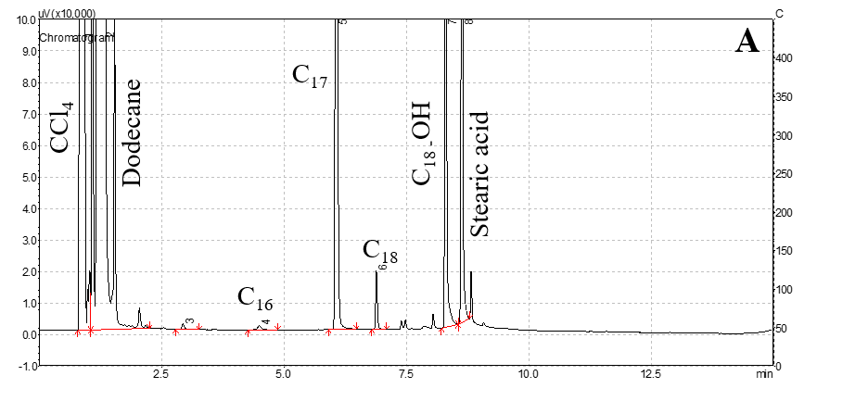
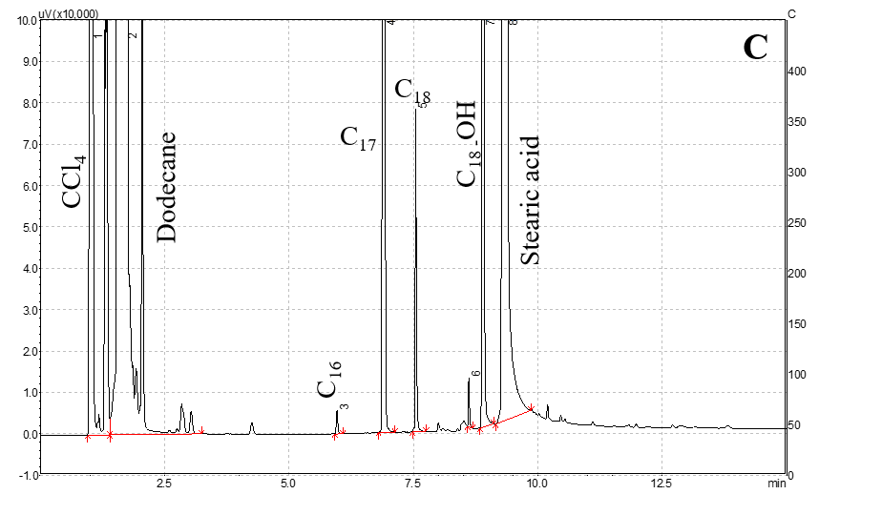
Figure S4. Typical chromatogram of product using catalyst (A) Ni/γ-Al₂O₃ (B) NiMo/γ-Al₂O₃ (C) Co/γ-Al₂O₃, and (D) CoMo/γ-Al₂O₃. Coloumn: ZB-5HT (60 m×0.32 mm×0.10 μm). Carrier gas: nitrogen, injector and detector = 613 K and 653K, and column temperature: 393 K for 5 min, ramped to 498 K @ 45 K/min kept for 2 min and again ramped to 508K@20 K/min, stay for 2 min. Reaction condition: concentration of stearic acid=0.18 kmol/m³, n-dodecane = 100ml, catalysts loading = 0.5 (w/v)%, temperature= 543K and initial hydrogen pressure = 20bars.

Figure S5. A typical product distribution over (A) Ni, (B) NiMo, (C) Co, and (D) CoMo catalyst at their optimum calcination temperature. Reaction conditions: concentration of stearic acid=0.18 kmol/m³, n-dodecane = 100 ml, catalysts loading = 0.5(w/v)%, temperature= 543K, and initial hydrogen pressure = 20 bars.

Figure S6. Pyridine adsorbed FTIR spectra of reduced 1.7N2.4M1023 and 1.7N2.4M973 and calcined 1.7N2.4M973.
Experimental procedure: FTIR analysis of adsorbed pyridine catalyst was performed in Bruker Tensor 37 equipped with air cooled IR source and low noise DLATGS detector. Pyridine adsorbed catalysts were first mixed with KBr powder (less than 1 wt%) and pelletized using hydraulic press. IR spectra of prepared samples were then acquired in transmission mode in the wave number range of 400–4000 cm⁻¹ at ambient temperature with a spectral resolution of 4 cm⁻¹ and 256 number of scan using KBr as background.
Figure S7. Comparison of catalytic performance of alumina supported Ni, NiMo, Co, and CoMo catalysts at their optimum calcination temperature. Conditions: concentration of stearic acid=0.18 kmol/m³, n-dodecane = 100 ml, catalysts loading = 0.5 (w/v)%, temperature= 543K, and initial hydrogen pressure = 20 bars.

