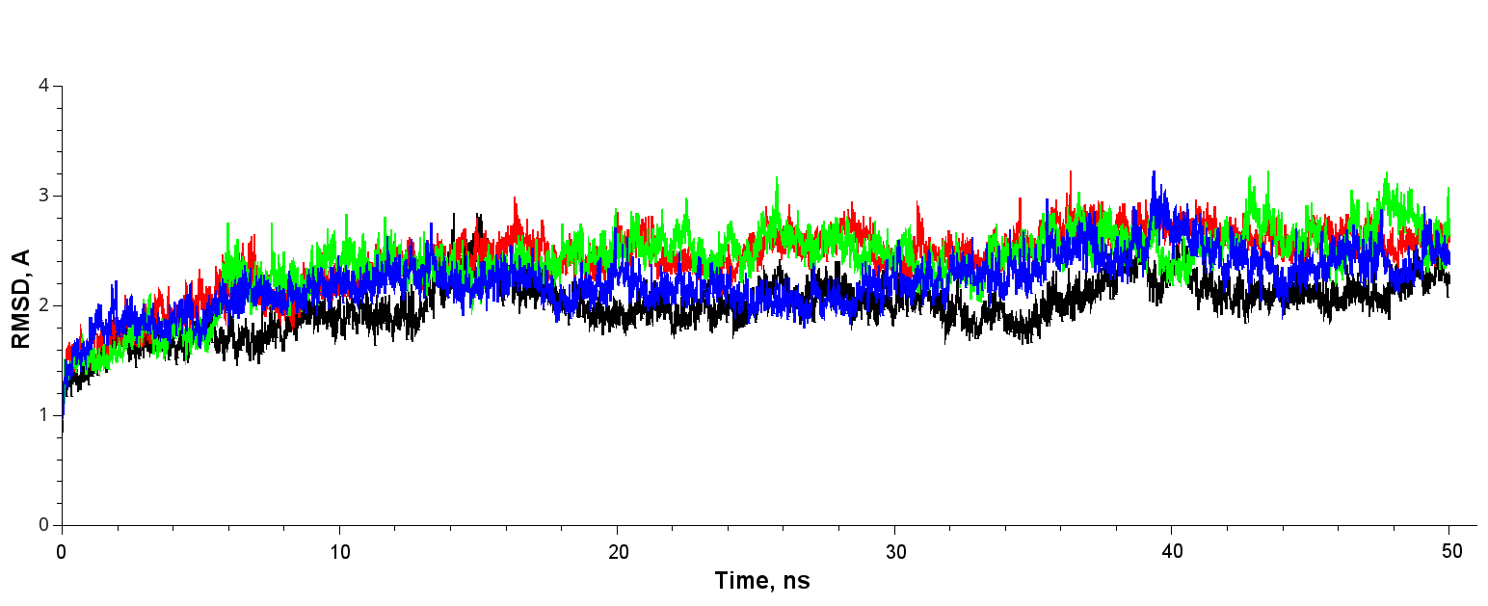
Figure 1S. RMSD values of TEM type β-lactamases during MD simulations at 400K. TEM-1 – black, TEM-1_{238,240} – green, TEM-1_{238,240,182} – red, TEM-1_{238,240,182,39} – blue.

Table 1S. The list of residues with altered values of RMSF (Å) in TEM variants in compare to TEM-1.

TEM-1_{238,240} vs TEM1 |  | TEM-1_{238,240,182} vs TEM1 |  |  | TEM-1_{238,240,182,39} vs TEM1
RMSF Up | RMSF Down | RMSF Up | RMSF Down | RMSF Up |  | RMSF Down
158 HIS | 32 LYS | 26 HIS | 32 LYS | 158 HIS |  | 32 LYS
161 ARG | 104 GLU | 72 PHE | 35 ASP | 161 ARG |  | 35 ASP
215 LYS | 105 TYR | 156 GLY | 63 GLU | 177 GLU |  | 63 GLU
219 PRO | 196 GLY | 157 ASP | 104 GLU | 178 ARG |  | 104 GLU
220 LEU | 197 GLU | 158 HIS | 105 TYR | 288 HIS |  | 172 ALA
254 GLY | 204 ARG | 161 ARG | 172 ALA |  |  | 173 ILE
288 HIS | 224 ALA | 163 ASP | 173 ILE |  |  | 174 PRO
 | 225 LEU | 164 ARG | 174 PRO |  |  | 175 ASN
 | 226 PRO | 170 ASN | 175 ASN |  |  | 182 THR
 |  | 178 ARG | 182 THR |  |  | 204 ARG
 |  | 215 LYS | 196 GLY |  |  | 217 ALA
 |  | 219 PRO | 197 GLU |  |  | 218 GLY
 |  | 220 LEU | 204 ARG |  |  | 220 LEU
 |  | 230 PHE | 217 ALA |  |  | 221 LEU
 |  | 238 SER | 218 GLY |  |  | 222 ARG
 |  | 241 ARG | 219 PRO |  |  | 223 SER
 |  | 254 GLY | 221 LEU |  |  | 224 ALA
 |  | 256 PRO | 222 ARG |  |  | 226 PRO
 |  |  | 223 SER |  |  | 227 ALA
 |  |  | 224 ALA |  |  | 231 ILE
 |  |  | 225 LEU |  |  | 232 ALA
 |  |  | 226 PRO |  |  | 266 GLY
 |  |  | 227 ALA |  |  | 277 GLN
 |  |  | 231 ILE
 |  |  | 232 ALA
 |  |  | 266 GLY
 |  |  | 277 GLN

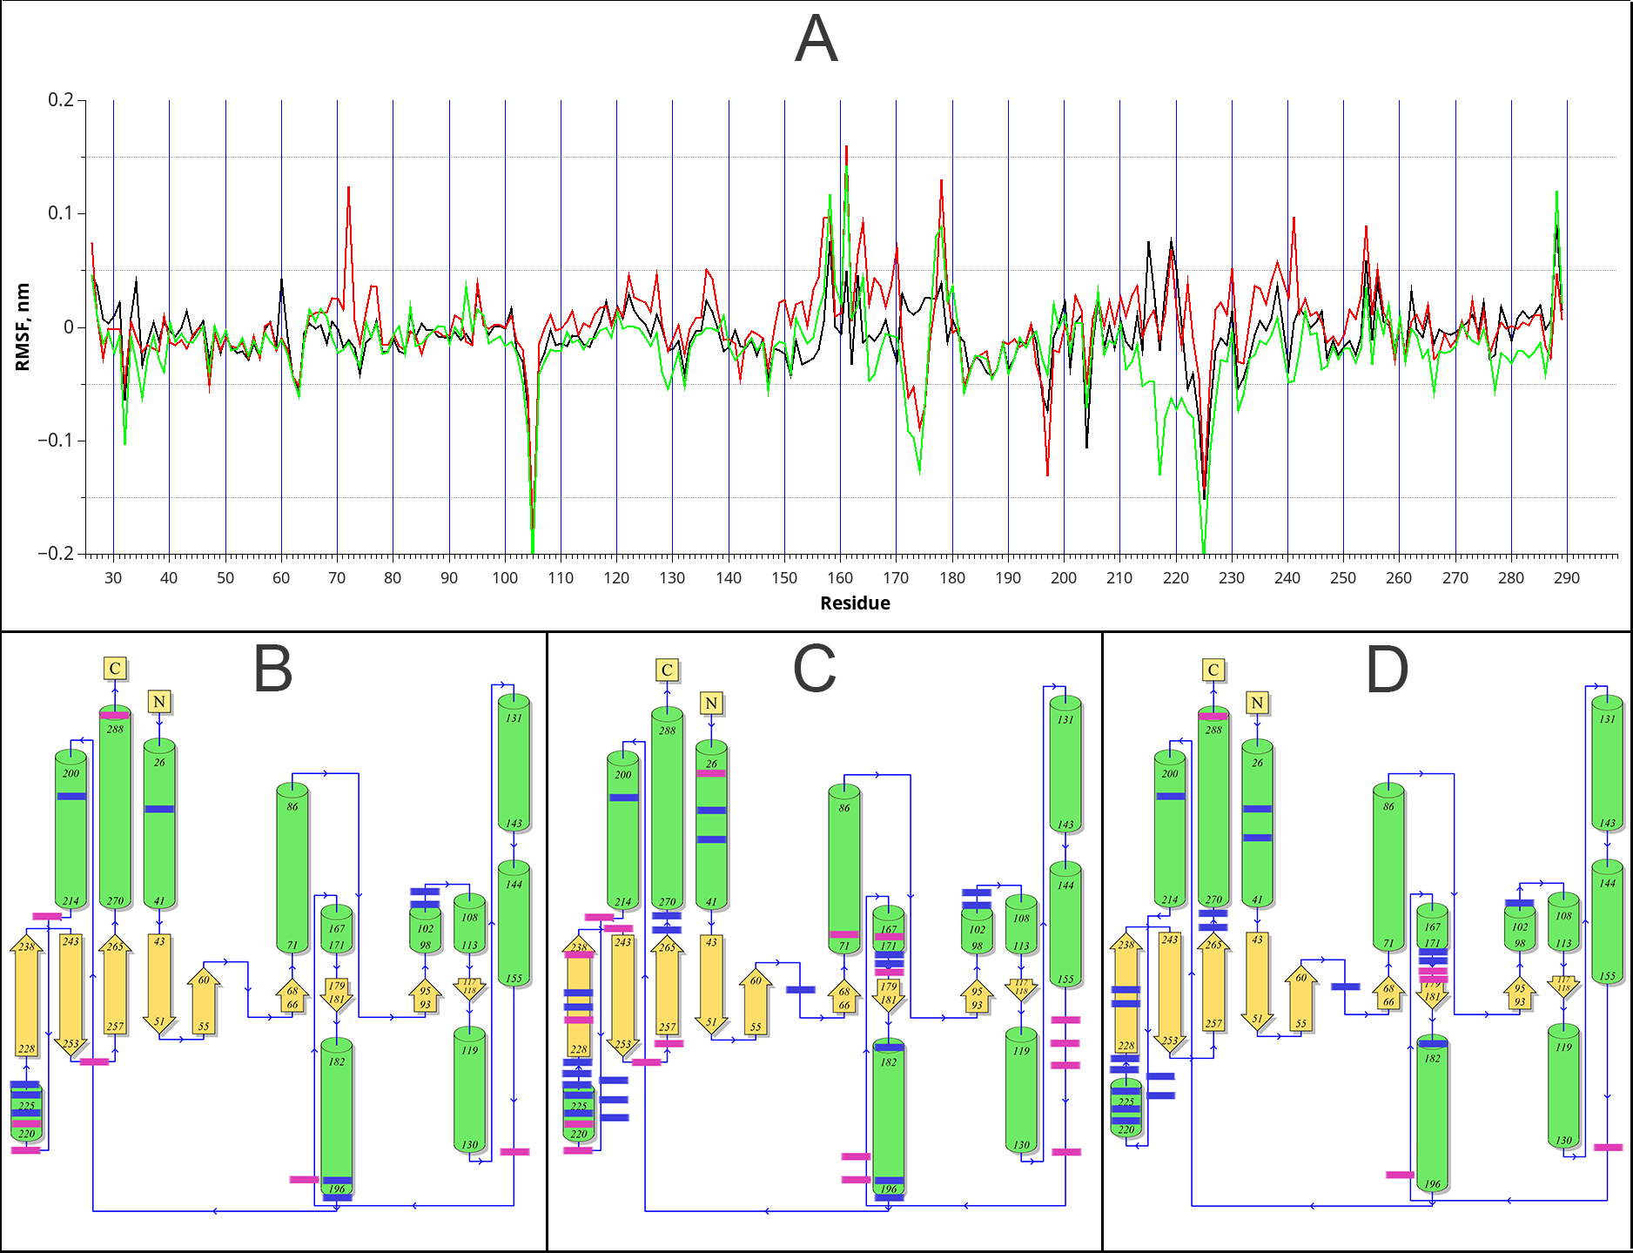

Figure 2S Differences in amino acid fluctuations (RMSF) during molecular dynamics.
A) Differences of values between TEM-1_{238,240} and TEM-1 (black), TEM-1_{238,240,182} and TEM-1 (red), TEM-1_{238,240,182,39} and TEM-1(green). See Table 1S.
Residues with significantly changed fluctuation values (difference of more than |0.5A|) are represented at PDBsum schemes: B) TEM-1_{238,240,} C) TEM-1_{238,240,182} and D) TEM-1_{238,240,182,39}
Residues with the increased RMSF values compared to the TEM-1 are represented in red, with the decreased values- blue.

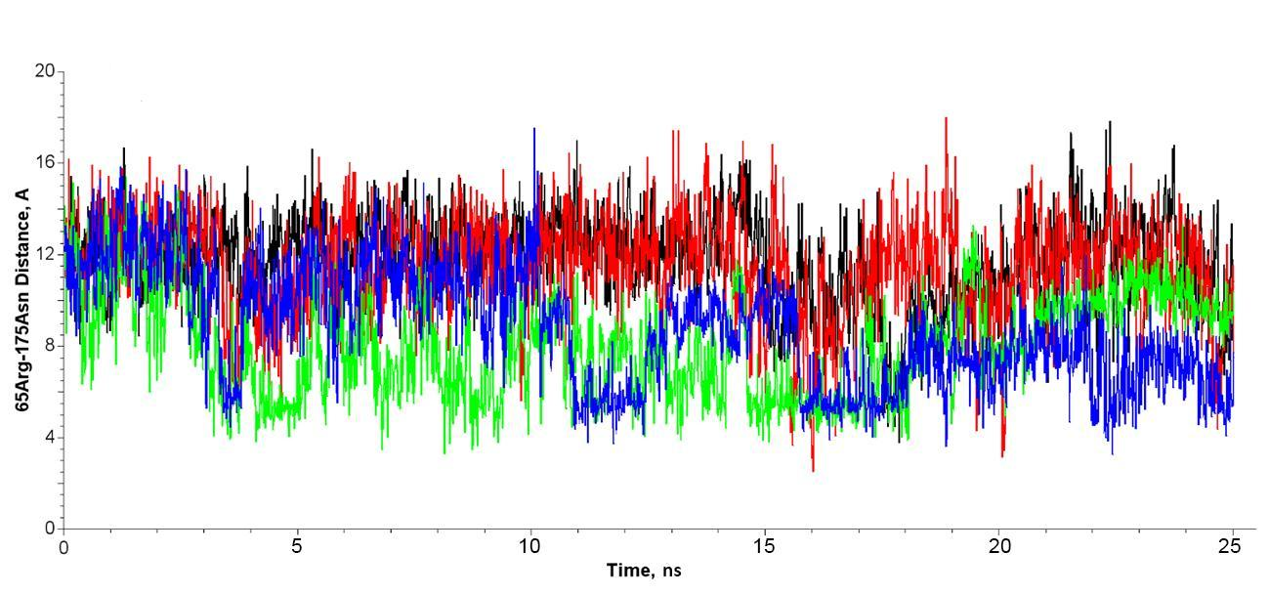

Figure 3S. Distance between residues R65 and N175 during MD simulation of TEM type β-lactamases. TEM-1 – black, TEM-1_{238,240} – red, TEM-1_{238,240,182} – green, TEM-1_{238,240,182,39} – blue.

