Supplementary material
The SEM images were captured by a JSM-6010LA, Jeol, and the TEM images were taken by JEM 1400 Plus, Jeol. The XRD analysis was done by PAN analytical X’pert Pro. The SEM image was taken after drying the catalyst which was moreover in agglomerated stage. Figure S1.(a) depicts a SEM micrographs of the manganese catalyst samples. The Surface of the catalyst looks to be rougher and small crystals are grown throughout the surface. The EDX of the catalyst [Figure S1.(b)] shows the elemental structure of it, where the percentage of oxygen and manganese predominates. For the better magnification, the TEM micrograph, shown in Figure S2, shows the nanoparticles of about 20 nm in size. However, the particles are not spherical, but similar to the structure described as El_Sawy et al. (El-Sawy et al., 2014), which is octahedral. The XRD pattern shown in Figure S3 shows the prominent peaks at 32.9 º and 55.1º and depicts that the catalyst pose a crystalline structure. The XRD pattern has been matched with JCPDS and the results show Mn(II) oxide chemical formula MnO. Figure S4, illustrates the effect of pH on adsorption of phenol on Mn(II) oxide.

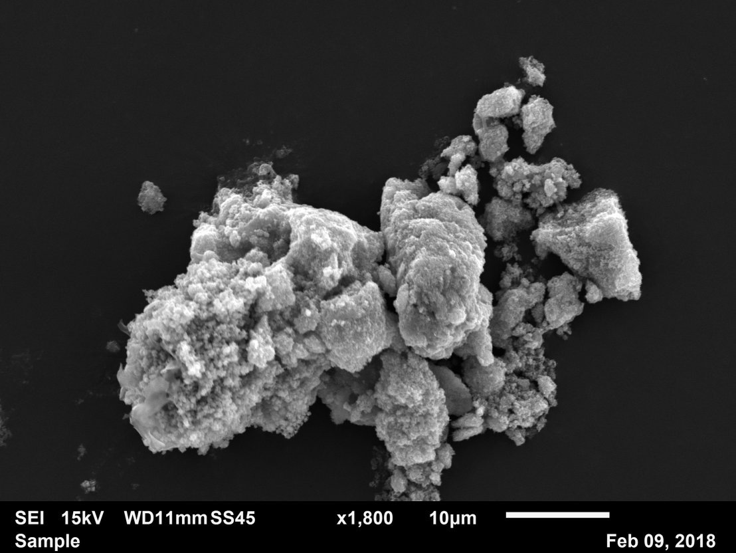
(a)
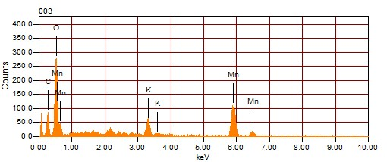
(b)
Figure S1. (a) SEM image of the manganese catalyst, (b) EDX results of the manganese catalyst.

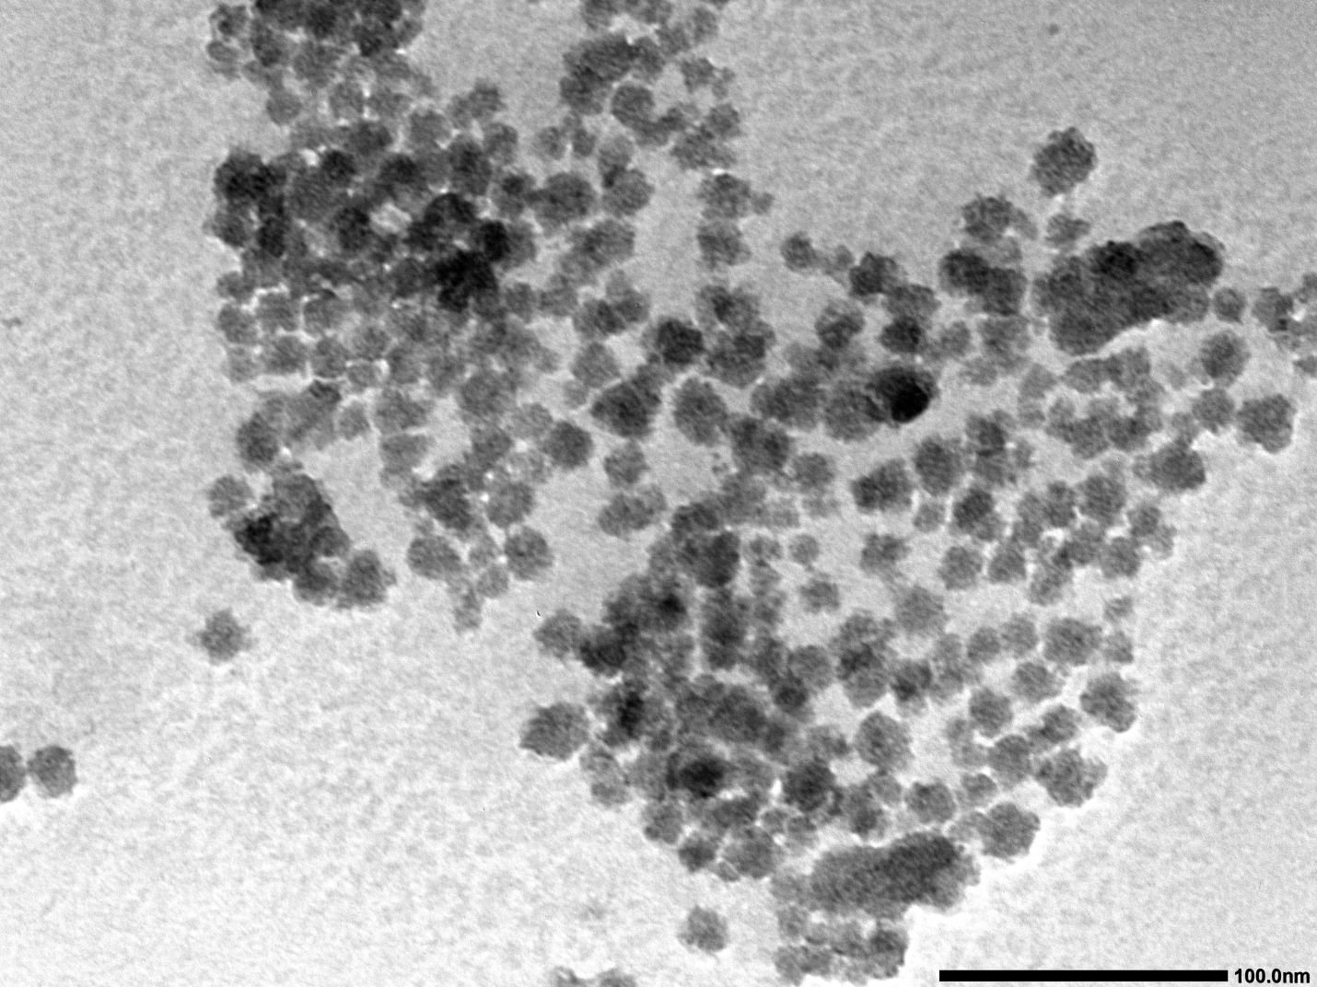
Figure S2. TEM micrograph of the manganese catalyst.

Figure S3. XRD analysis of the powder catalyst.

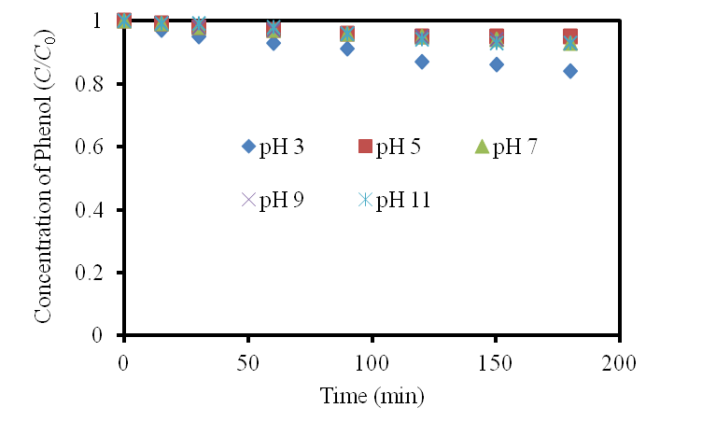
Figure S4. Effect of pH on adsorption of phenol on Mn(II) Oxide (1 L batch adsorption, 25 ºC, 1 g/L catalyst dose)

