SUPPORTING INFORMATION

for

Entrapment of a Linear Water Pentamer into a Uranyl-Salophen Dimer in the Solid State.

Massimo Cametti,*ª Arto Valkonen^{b} and Kari Rissanen*^{,b}

ª Department of Chemistry, Materials and Chemical Engineering, Politecnico di Milano, Via Luigi Mancinelli, 7, 20131, Milano, Italy.
^{b} University of Jyväskylä, Department of Chemistry, Jyväskylä, P.O. Box 35, FIN-40014, Finland.

Table of Content:

X-ray crystallography …………………………………………………...…….2S

Synthesis……………………………………………………………… ………3S

References………………………………………………………………….…..5S

X-ray crystallography: The data for (1)₂•(H₂O)₅•(MeCN)_{3.5} were collected at 123(2) K on a Bruker-Nonius KappaCCD diffractometer with an APEX-II detector and MoKα radiation (λ = 0.71073 Å). COLLECT¹ data collection software was utilized and data were processed with DENZO-SMN.² The structure was solved by direct methods using SIR-2004³ and refined on F² using SHELXL-2018/3.⁴ The reflections were corrected for Lorenz polarization effects multi-scan absorption correction (SADABS⁵) was utilized. The hydrogen atoms, except O-H, were calculated to their idealized positions with isotropic temperature factors (1.2 or 1.5 times the C temperature factor) and refined as riding atoms. Hydrogens attached to O were located from electron density maps and fixed to their ideal distance from their parent atoms (0.84 Å for O-H at 123 K), with isotropic temperature factors of 1.5 times the parent atom factor. Two geometrical restraints (s = 0.02) were used to make C-C and C-N distances more relevant in one disordered CH₃CN molecule. Also, anisotropic displacement parameters were restrained (s1 = 0.04, s2 = 0.08) to be more similar in two CH₃CN molecules. The figure(s) were drawn with Mercury.⁶ Crystallographic data (excluding structure factors) for the structure in this paper have been deposited with the Cambridge Crystallographic Data Centre as supplementary publication number CCDC-921455. This data can be obtained free of charge at http://www.ccdc.cam.ac.uk/conts/retrieving.html.

Crystal data of (1)₂•(H₂O)₅•(MeCN)_{3.5}: C₁₈₂H₁₆₁N₃₁O₃₄U₄, F.W. = 4278.54, crystal size 0.17 x 0.16 x 0.10 mm, triclinic, space group P-1 (no. 2), a = 11.33810(10), b = 18.5861(2), c = 20.4670(2) Å, α = 96.1240(10), β = 92.9870(10), γ = 101.3150 °, V = 4193.25(7) Å³, Z = 1 (Z´= 0.5), D_{calc} = 1.694 Mg/m³, μ = 3.937 mm⁻¹, F(000) = 2110, 49053 collected reflections (θ_{max} = 25.00°) of which 14629 independent [R_{int} = 0.0464] and 11922 with I > 2σ(I), T_{max} = 0.6710, T_{min} = 0.5488, full-matrix least-squares on F² with 30 restraints and 1179 parameters, GOF = 1.069, R1 = 0.0330 [I>2σ(I)], wR2 (all data) = 0.0473, largest peak/hole = 0.813/-0.558 e⁻Å⁻³.

Two of total 3.5 co-crystallized acetonitrile molecules interact with assemblies by one C-H•••N contact donated by 1,2-phenylenediamine moiety, by one π•••π contact between salicylidene ring and triple bond, as well as, by two C-H•••π contacts donated by salicylidene moiety and methyl group and accepted by triple bond and 1,2-phenylenediamine ring, respectively. The half molecule of MeCN is disordered geometrically around the inversion center with 180° turn, the other half belonging to the next asymmetric unit. Therefore, the overall crystal structure is described in crystal data to contain two [(1)₂•(H₂O)₅] units and seven co-crystallized MeCN solvent molecules.

Synthesis:

Synthesis of the UO₂ complex 1: To a refluxing solution of UO₂(OAc)₂•2H₂O (0.155 g, 0.367 mmol) in methanol (50 mL) were added a solution of 5 (0.150 g, 0.490 mmol) in CH₂Cl₂ (10 mL) and methanol (25 mL), and a solution of 1,2-benzenediamine (0.027g, 0.245 mmol) in methanol (40 mL) in 45 min. Reflux was maintained for 45 min whereupon the mixture was allowed to cool to room temperature overnight. Most of the solvents were evaporated and the precipitated red solid was filtered. Yield: 67 %. ¹H NMR (500 MHz, DMSO-d_{6,} 30 °C): δ = 9.60 (s, 2H), 8.86 (s, 2H), 8.63 (dq, 2H, J₁ = 0.9 Hz, J₂ = 4.8 Hz), 8.36 (dd, 2H, J₁ = 0.5 Hz, J₂ = 8.2 Hz), 8.31 (dt, 2H, J₁ = 0.8 Hz, J₂ = 7.0 Hz), 8.12 (dd, 2H, J₁ = 2.3 Hz, J₂ = 8.2 Hz), 7.88 (td, 2H, J₁ = 1.8 Hz, J₂ = 7.8 Hz), 7.728-7.746 (m, 2H), 7.529-7.548 (m, 2H), 7.45 (dd, 2H, J₁ = 1.5 Hz, J₂ = 8.1 Hz), 7.42-7.43 (m, 2H), 7.34 (dd, 2H, J₁ = 1.5 Hz, J₂ = 7.8 Hz), 6.63 (t, 2H, J = 7.8 Hz) and 5.47 ppm (s, 4H); ¹³C NMR (126 MHz, DMSO, 30 °C): δ = 166.9, 161.4, 155.3, 155.2, 149.7, 149.4, 147.0, 137.8, 137.6, 134.0, 129.4, 128.8, 125.0, 124.7, 121.0, 120.9, 120.7, 120.6, 116.7, and 68.4 ppm; MS(ES): m/z calcd for C₄₃H₃₃O₇N₆U 983.8 [M+CH₃O]⁻; found: 983.6; Anal. Calcd. for C₄₂H₃₀O₆N₆U+2 H₂O + CHCl₃ (M_{r} 1108.242): C, 46.38; H, 3.46; N, 7.19. Found: C, 46.60; H, 3.18; N, 7.58.

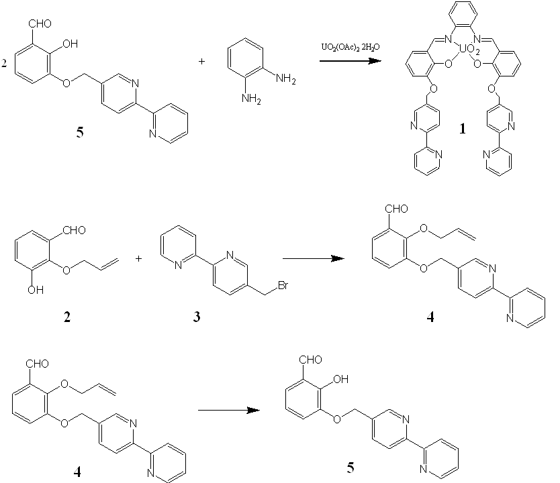

Synthesis of 2-hydroxyl-3-(2,2’-bipyridine-5-methoxy)-benzaldehyde 5: A mixture of 2-allyloxy-3-(2,2’-bipyridine-5-methoxy)-benzaldehyde 4 (0.59 g, 1.70 mmol), SeO₂ (0.19 g, 1.70 mmol), acetic acid (0.102 g, 1.70 mmol), and 1,4-dioxane (25 mL) was refluxed under nitrogen overnight. To the cooled mixture water (20 mL) and CHCl₃ (25 mL) was added. Layers were extracted and organic phase was washed with water (4x10 ml), dried with Na₂SO₄ and evaporated. The product was purified by column chromatography (silica gel, acetone). Yield: 31 %. ¹H NMR (500 MHz, CDCl₃-d_{6,} 30 °C): δ = 11.17 (s, 1H), 9.92 (s, 1H), 8.74 (s, 1H), 8.68 (dq, 1H, J₁ = 0.9 Hz, J₂ = 4.8 Hz), 8.42 (dd, 1H, J₁ = 0.6 Hz, J₂ = 8.1 Hz), 8.40 (dt, 1H, J₁ = 1.0 Hz, J₂ = 8.0 Hz), 7.94 (dd, 1H, J₁ = 2.3 Hz, J₂ = 8.2 Hz) 7.82 (td, 1H, J₁ = 1.8 Hz, J₂ = 7.5 Hz), 7.30-7.35 (m, 1H), 7.23 (dd, 1H, J₁ = 1.5 Hz, J₂ = 7.8 Hz), 7.17 (dd, 1H, J₁ = 1.0 Hz, J₂ = 8.0 Hz), 6.92 (t, 1H, J = 7.9 Hz), and 5.27 ppm (s, 2H); ¹³C NMR (126 MHz, CDCl_{3,} 30 °C): δ = 196.5, 156.2, 155.8, 152.6, 149.2, 148.5, 146.7, 136.9, 136.4, 132.1, 126.2, 123.8, 122.0, 121.3, 121.1, 121.0, 119.5, and 69.3 ppm; MS(ES): m/z calcd for C₁₈H₁₅O₃N₂ 307.3 [M+H]⁺; found: 307.1.

Synthesis of 5-Bromomethyl-2,2’-bipyridine 3: 5-Methyl 2,2’-bipyridine (1.67 g, 9.90 mmol), and N-bromosuccinimide (1.76 g, 9.90 mmol) were dissolved in CCl₄ (150 mL). The reaction mixture was stirred and warmed using lamps to 30 °C whereupon AIBN (0.41 g, 2.50 mmol) was added and the reaction mixture was left to stir with lamps overnight. CCl₄ was evaporated. The product was purified by column chromatography (silica gel, acetone/CHCl₃, 2:3). The yellow precipitate was washed with hexane to give the pure product. Yield: 65 %. ¹H NMR (500 MHz, CDCl₃-d_{6,} 30 °C): δ = 8.69 (s, 2H), 8.40 (d, 2H, J = 8.5 Hz), 7.85 (dd, 1H, J₁ = 2.4 Hz, J₂ = 8.2 Hz), 7.82 (td, 1H, J₁ = 1.8 Hz, J₂ = 7.8 Hz), 7.30-7.33 (m, 1H), and 4.53 ppm (s, 2H); ¹³C NMR (126 MHz, CDCl_{3,} 30 °C): δ = 156.1, 155.5, 149.3, 149.2, 137.5, 137.1, 133.6, 124.2, 121.2, 121.0, and 29.6 ppm.

Synthesis of 2-allyloxy-3-hydroxybenzaldehyde 2: To a suspension of NaH (0.5 g, 60 % in oil), pre-washed with light petroleum, in DMSO (23 mL) was added a solution of 2,3-dihydoxybenzaldehyde (1.5 g, 11.0 mmol) in DMSO (10 mL). After 40 min of stirring 3-bromo-1-propene was added whereupon the mixture was left to stir overnight. The mixture was poured into water (50 mL) and extracted with CHCl₃ (3x50 mL) whereupon combined CHCl₃ layers were washed with water (3x30 mL). CHCl₃ was evaporated. The product was purified by column chromatography (silica gel, CHCl₃) and recrystallized from light petroleum to give light yellow needles. Yield: 38 %. ¹H NMR (500 MHz, CDCl₃-d_{6,} 30 °C): δ = 10.26 (s, 1H), 7.37 (dd, 1H, J₁ = 1.7 Hz, J₂ = 7.5 Hz), 7.22 (dd, 1H, J₁ = 2.0 Hz, J₂ = 8.0 Hz), 7.15 (td, 1H, J₁ = 0.5 Hz, J₂ = 7.7 Hz), 6.07-6.15 (m, 1H), 5.83 (s, 1H), 5.34-5.45 (m, 1H), and 4.58 ppm (dt, 1H, J₁ = 1.0 Hz, J₂ = 6.0 Hz); ¹³C NMR (126 MHz, CDCl_{3,} 30 °C): δ = 189.6, 149.7, 147.8, 132.4, 129.4, 125.1, 121.7, 121.6, 120.1, and 25.1 ppm.

Synthesis of 2-allyloxy-3-(2,2’-bipyridine-5-methoxy)-benzaldehyde 4: 2-allyloxy-3-hydroxybenzaldehyde 2 (1.12 g, 6.30 mmol), and K₂CO₃ (13.13 g, 95.00 mmol) were stirred under nitrogen in acetonitrile (30 mL) for 45 min. 5-bromomethyl-2,2’-bipyridine, 3, was added in acetonitrile (20 mL) whereupon the mixture was stirred overnight. The solvent was evaporated and the residue was purified by column chromatography (silica gel, acetone/CH₂Cl_{2,} 1:6). Yield: 27 %. ¹H NMR (500 MHz, CDCl₃-d_{6,} 30 °C): δ = 10.44 (s, 1H), 8.77 (s, 1H), 8.71 (dq, 1H, J₁ = 1.0 Hz, J₂ = 5.0 Hz), 8.49 (d, 1H, J = 8.1 Hz), 8.43 (d, 1H, J = 8.0 Hz), 7.94 (dd, 1H, J₁ = 2.1 Hz, J₂ = 8.1 Hz), 7.86 (td, 1H, J₁ = 1.7 Hz, J₂ = 7.7 Hz) 7.48 (dd, 1H, J₁ = 1.5 Hz, J₂ = 7.8 Hz), 7.35 (ddd, 1H, J₁ = 1.0 Hz, J₂ = 4.5 Hz, J₃ = 7.5 Hz), 7.23 (dd, 1H, J₁ = 1.5 Hz, J₂ = 8.1 Hz), 7.27 (t, 1H, J = 7.9 Hz), 6.02-6.07 (m, 1H), 5.35 (t, 0.5 H, J = 1.4 Hz), 5.31 (t, 0.5 H J = 1.4 Hz), 5.25 (dd, 1H, J₁ = 1.0 Hz, J₂ = 10.6 Hz), 5.22 (s, 2 H), and 4.69 ppm (dt, 2H, J₁ = 1.0 Hz, J₂ = 6.0 Hz); ¹³C NMR (126 MHz, CDCl_{3,} 30 °C): δ = 190.1, 155.7, 155.3, 151.8, 151.7, 148.9, 148.3, 137.4, 136.4, 132.9, 132.1, 130.6, 124.2, 124.0, 121.4, 121.3, 120.4, 120.3, 119.1, 75.4, and 68.9 ppm; MS(ES): m/z calcd for C₂₁H₁₈O₃N₂Na 369.4 [M+Na]⁺; found: 369.1.

References:

^{1.} COLLECT, Bruker AXS Inc., 2004, Madison, WI.
^{2.} Z. Otwinowski, W. Minor, in: C. W. Carter Jr, R. M. Sweet (eds), Methods in Enzymol., Macromolecular Crystallography, part A, vol. 276, New York, Academic Press, 1997, p. 307–326.
^{3.} M.C. Burla, R. Caliandro, M. Camalli, B. Carrozzini, G. L. Cascarano, L. De Caro, C. Giacovazzo, G. Polidori and Riccardo Spagna. J. Appl. Crystallogr., 2005, 38, 381–388.
^{4.} G. M. Sheldrick, Acta Crystallogr., Sect. A: Found. Adv., 2015, 71, 3–8.
^{5.} G. M. Sheldrick, SADABS, University of Göttingen, Germany, 1996.
^{6.} C. F. Macrae, I. J. Bruno, J. A. Chisholm, P. R. Edgington, P. McCabe, E. Pidcock, L. Rodriguez-Monge, R. Taylor, J. van de Streek and P. A. Wood, J. Appl. Crystallogr. 2008, 41, 466–470.

