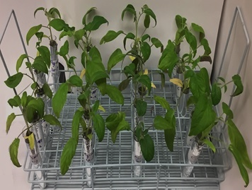
SI.1- Plant growth in Hoagland media in a controlled environment at 25±2ºC and a 16hr/day photoperiod.
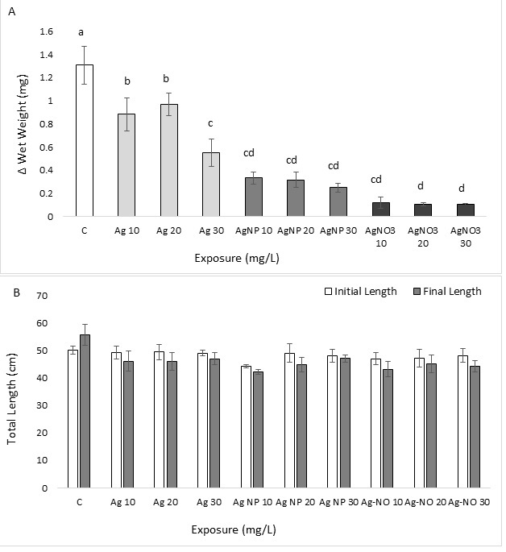
SI.2- Changes in the total wet weight (A) and total length (B) of plants after 7 days exposure to silver (Ag), silver nanoparticle (AgNP), and silver nitrate (AgNO₃). Different letters show significant difference in final-initial wet weight.

