Appendix 1

Figure A1. The proportion of survey simulations in which every case of resistance was missed. Panel headers show the percent of population samples, panel rows show the size of the sample population (number of farms). For simulations with farm numbers higher than 3000 some cases of resistance were detected in all simulations.
Figure A2. The proportion of survey simulations in which an estimate of resistance is obtained within 10% of the actual level of resistance. Panel headers show the percent of population samples, panel rows show the size of the sample population (number of farms). An absence of observations within 10% of the value results in no points being plotted.
A1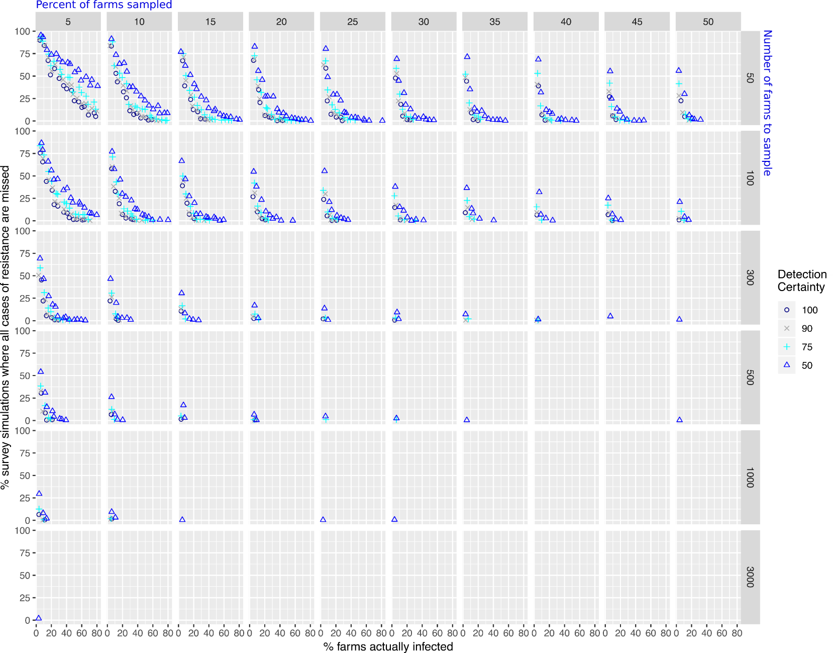
A2