Appendix 1: Inclusion and Exclusion Criteria:
SCREENING INCLUSION CRITERIA
Participants must fulfil all of the following inclusion criteria to be eligible for participation in the study:
- Age 18-75 years at the time of the screening visit
- Able to provide informed consent and comply with study procedures
- Sporadic ALS diagnosed as probable, laboratory-supported probable or definite according to the World Federation of Neurology El Escorial revised criteria as determined by a neurologist with neuromuscular subspecialty training
- Diagnosis <24 months from date of enrolment
- Vital capacity at least 60% of predicted value for gender, height and age at the screening visit
- If taking riluzole, must be on a stable dose for at least 30 days prior to the screening visit, or stopped taking riluzole at least 30 days prior to the screening visit
- Participant has established care with a neurologist at one up to four specialized ALS clinics involved in the study and will maintain this clinical care throughout the study
- Participants can participate in clinical registries, but will be excluded to this protocol if they are participating in a clinical trial involving additional or investigative treatment exposure.

SCREENING EXCLUSION CRITERIA
Participants who meet the following criteria were excluded from the study:
A participant was excluded if he or she has any of the following:
- Dependence on mechanical ventilation at the time of screening
- Gastrostomy at the time of screening
- Absence of Upper Motor Neuron Signs
- Participation in any other investigational drug trial or using investigational drug (within 12 weeks prior to screening)
- Known hypersensitivity to dolutegravir, abacavir or lamivudine, or to any of the excipients
- Presence of the HLA-B*5701 allele at screening
- Presence of a monogenic cause of ALS (e.g. known mutation in SOD1, expansion in c9orf72 etc.)
- History of positive test or positive result at screening for HIV
- Participants positive for Hepatitis B at screening (+HBsAg), or anticipated need for Hepatitis C virus (HCV) therapy during the study;
- Women must not be able to become pregnant (post-menopausal for >1 year, surgically sterile, adequate contraception) or breastfeed for the duration of the study. Women of childbearing potential must have a negative pregnancy test at screening and be non-lactating
- Other interventional clinical trial
- Participant is taking medication contraindicated with Triumeq. Dofetilide (or pilsicainide [available in Japan]) is prohibited as DTG may inhibit its renal tubular secretion resulting in increased dofetilide concentrations and potential for toxicity.
- Presence of any of the following clinical conditions at the time of screening: o Drug or alcohol abuse o Unstable medical disease (such as unstable angina or chronic obstructive pulmonary disease), or active infectious disease (such as Hepatitis B or C or tuberculosis), or current malignancy o Unstable psychiatric illness defined as psychosis or untreated major depression within 90 days of the screening visit. This exclusion criteria is based on a prior psychiatric diagnosis that is unstable as determined by the participant’s treating Psychiatrist o Dementia as previously diagnosed by a medical practitioner
- Safety Laboratory Criteria at the screening visit: o Alanine aminotransferase (ALT) ≥5 times the upper limit of normal (ULN), OR ALT ≥3xULN and bilirubin ≥1.5xULN (with >35% direct bilirubin) o Total bilirubin, lactate, triglycerides, amylase, or lipase greater than 2.0 times the upper limit of normal. Participant has creatinine clearance of < 1*109/L o Platelet concentration of < 100*109/L o Haemoglobin < 100g/L

Appendix 2: Schedule of Visits

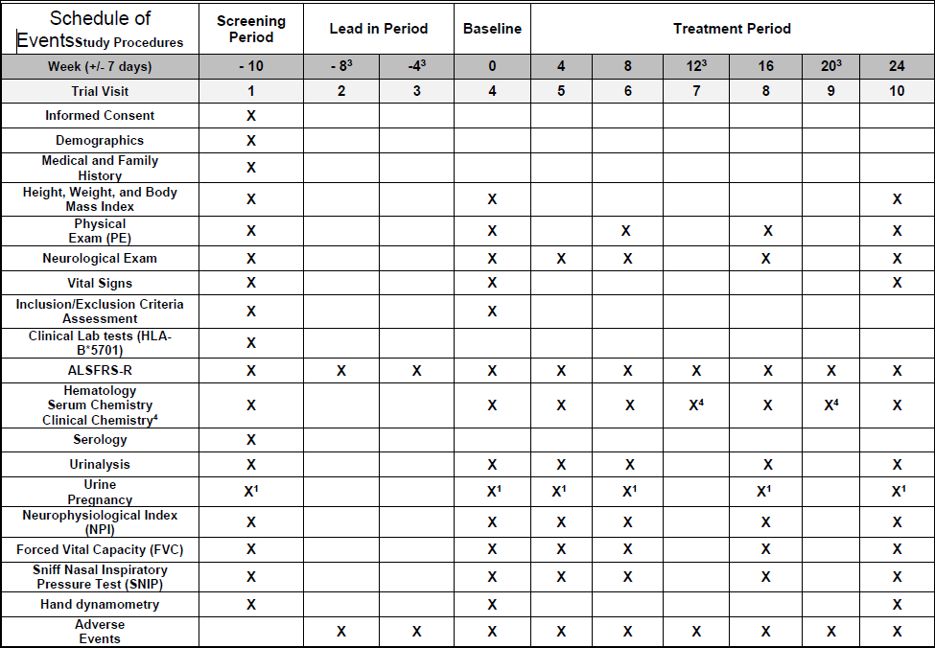

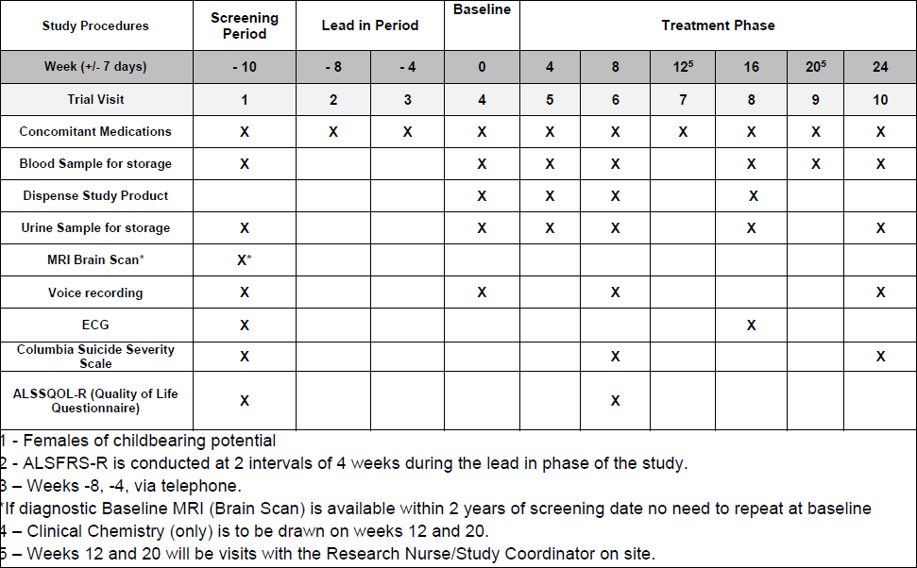

Appendix 3: HERV-K Analysis

Serum was centrifuged at 300 g for 10 minutes to clear cell debris, and total nucleic acids were extracted from the supernatant (500 ul) with Ultrasens kit (Qiagen, Hilden, Germany), following manufacturer’s instructions. Samples having less than 500 ul were excluded from the analysis. Nucleic acids were eluted in 30 ul of AVE buffer (RNase-free water with 0.04% Sodium azide). Digital PCR was performed in duplicate in a QX200 AutoDG Droplet Digital PCR System (Bio-Rad, Hercules, CA, USA) with two sets of primers and probes: one (FAM labeled) to detect HERV-K env and another (HEX labeled) to detect the genomic copies of the single copy gene RPP30. RPP30 copy number was used as a measure of cellular DNA in the serum sample. The master mix was composed of 8.75 ul of water, 12.5 ul of ddPCR Supermix (no dUTP) (Bio-Rad, Hercules, CA, USA), 1.25 ul of a mix of HERV-K env primers (900 nm) and probe (250 nm), 1.25 ul of ddPCR RPP30 copy number assay (20X; assay ID: dHsaCP1000485) (both from Bio-Rad (Hercules, CA, USA)) and 2.5 ul of the extracted nucleic acids. The empty wells of the PCR plate were filled with a mix of 12.5 ul of ddPCR Control Buffer (Bio-Rad, Hercules, CA, USA) and 12.5 ul of water, to get a similar viscosity in all wells. After preparing the droplets, the PCR was performed in a T100 Thermal cycler (Bio-Rad. Hercules, CA, USA) with these cycling conditions: 95ºC for 10 minutes, 40 cycles of 95ºC for 30 seconds and 60ºC for 1 minute, and 95ºC for 10 minutes. Finally, the number of copies was determined in the digital PCR reader. The following primer and probe sequences were used to detect HERV-K env: forward primer: 5’ ATTTGGTGCCAGGAACTGAG 3’; reverse primer: 5’ GCTGTCTCTTCGGAGCTGTT 3’and probe 5’ 6-FAM-AGGAGTTGCTGATGGCCTCG-Iowa Black FQ 3’. A blast search of the HERV-K env primers used in this study on the Human GRCh38.p12 identified the HERV-K loci detected with 100% homology:

Chromosome | Start | End | Amplicon length
1 | 75382253 | 75382431 | 179 bp
1 | 155627693 | 155627871 | 179 bp
1 | 160698811 | 160698989 | 179 bp
2 | 129962985 | 129963163 | 179 bp
3 | 113025296 | 113025474 | 174 bp
3 | 125898560 | 125898733 | 179 bp
4 | 165001719 | 165001893 | 175 bp
5 | 156658733 | 156658911 | 179 bp
6 | 77717964 | 77718142 | 179 bp
7 | 4591957 | 4592153 | 179 bp
7 | 4583453 | 4583631 | 179 bp
8 | 7498902 | 7499080 | 179 bp
8 | 139460933 | 139461111 | 179 bp
8 KI270813v1 alt | 182005 | 182183 | 179 bp
11 | 118722041 | 118722219 | 179 bp
12 | 58328486 | 58328664 | 179 bp
19 | 27638644 | 27638822 | 179 bp
19 | 35572497 | 35572675 | 179 bp
19 GL383576 v1 alt | 76109 | 76287 | 179 bp
19 GL383575 v2 alt | 11481 | 11659 | 179 bp
22 | 18946647 | 18946825 | 179 bp

