Fig. S1. The plots of ln K_{b} versus 1000/T for BSA-DVH system

Fig. S2. The Circular dichroism spectrum of BSA and DVH-BSA system at two different concentrations of DVH

Fig. S3. FTIR spectra of BSA (blue line) and BSA -NPs (red line)

Fig. S4. The standard calibration curve of DVH concentrations vs. absorbance in PBS and ethanolic stock at room temperature (λ =391 nm)

Fig. S5. DVH release of BSANPs at pH 7.2

Fig. S6. DVH release of BSANPs at pH 5.5

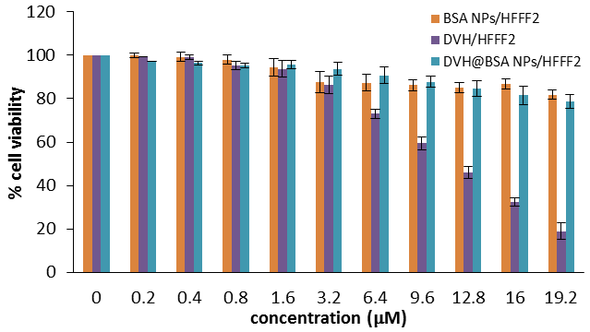
Fig. S7. MTT assay of BSA NPs, DVH, DVH@BSANPs on HFFF2 normal cells

