Appendix A. Product codes in WIOD
P1 Products of agriculture hunting and related services
P2 Products of forestry logging and related services
P3 Fish and other fishing products services incidental of fishing
P4 Coal and lignite peat
P5 Crude petroleum and natural gas services incidental to oil a
P6 Uranium and thorium ores
P7 Metal ores
P8 Other mining and quarrying products
P9 Food products and beverages
P10 Tobacco products
P11 Textiles
P12 Wearing apparel furs
P13 Leather and leather products
P14 Wood and products of wood and cork except furniture articles
P15 Pulp paper and paper products
P16 Printed matter and recorded media
P17 Coke refined petroleum products and nuclear fuels
P18 Chemicals chemical products and man-made fibres
P19 Rubber and plastic products
P20 Other non-metallic mineral products
P21 Basic metals
P22 Fabricated metal products except machinery and equipment
P23 Machinery and equipment nec
P24 Office machinery and computers
P25 Electrical machinery and apparatus nec
P26 Radio, television and communication equipment and apparatus
P27 Medical precision and optical instruments watches and clocks
P28 Motor vehicles trailers and semi-trailers
P29 Other transport equipment
P30 Furniture other manufactured goods nec
P31 Secondary raw materials
P32 Electrical energy gas steam and hot water
P33 Collected and purified water distribution services of water
P34 Construction work
P35 Trade maintenance and repair services of motor vehicles and
P36 Wholesale trade and commission trade services except of moto
P37 Retail trade services except of motor vehicles and motorcycles
P38 Hotel and restaurant services
P39 Land transport and transport via pipeline services
P40 Water transport services
P41 Air transport services
P42 Supporting and auxiliary transport services travel agency se
P43 Post and telecommunication services
P44 Financial intermediation services except insurance and pensions
P45 Insurance and pension funding services except compulsory social
P46 Services auxiliary to financial intermediation
P47 Real estate services
P48 Renting services of machinery and equipment without operator
P49 Computer and related services
P50 Research and development services
P51 Other business services
P52 Public administration and defence services compulsory social
P53 Education services
P54 Health and social work services
P55 Sewage and refuse disposal services sanitation and similar s
P56 Membership organisation services nec
P57 Recreational cultural and sporting services
P58 Other services
P59 Private households with employed persons

Appendix B. Plausibility of re-export redistribution

In order to get some sense of the reliability of our re-export matrices , we compared our results with existing information for the Netherlands. Statistics Netherlands provides information on the destination of Dutch re-exports. The information is based on customs data and company surveys. Hence, we have examined the correlation of the country pattern of re-exports (by product) from the Netherlands in the two data sets. The data from Statistics Netherlands are classified according the Standard International Trade Classification (SITC). The allocation of the WIOD product categories into SITC digit-1 groups has been somewhat crude due to the aggregation level of the data. We have merged SITC 0 and 1, and SITC 2 and 4, because product categories from WIOD could not clearly be assigned to one SITC category. Furthermore, the comparison is limited to goods trade only.

Figure B1 plots the shares (percentages) of destination countries in exports for the two datasets. The correlation between the two sets is quite high in chemicals and manufacturing (SITC 5, 6 and 8). In other words, re-exports from the Netherlands seem to be distributed across destinations consistently in both data sets. This evidence, however limited, does provide some credibility to our results.

Figure B1. Comparing distribution of Dutch re-exports across destinations with official statistics, in 2010

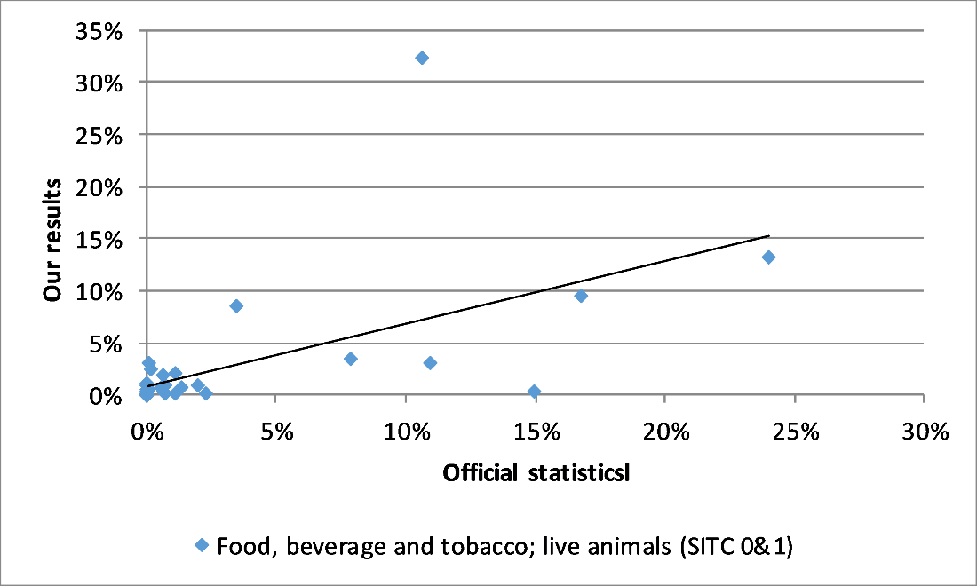

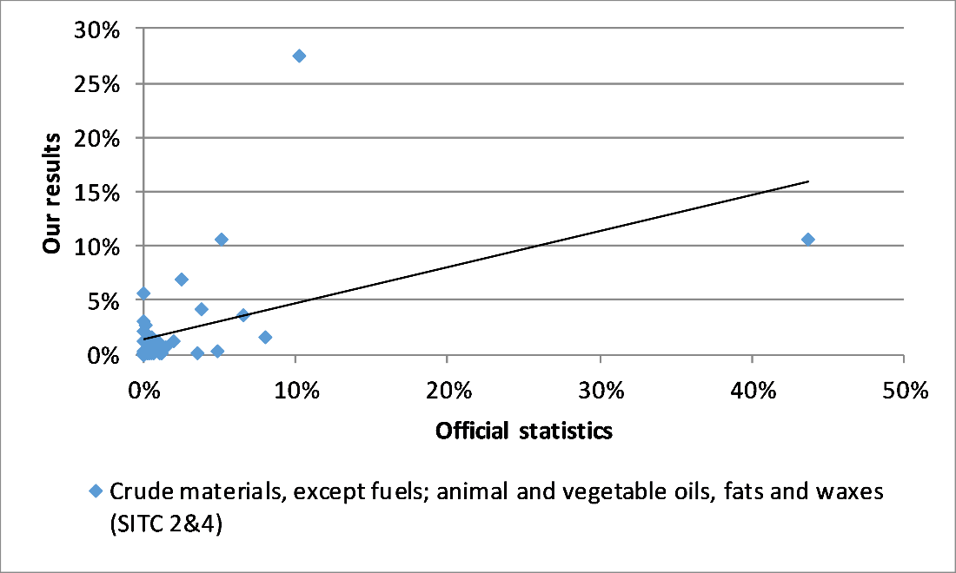

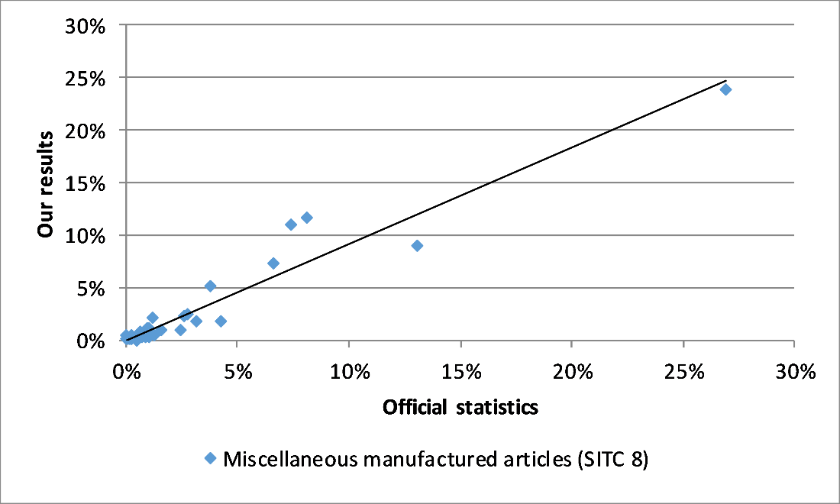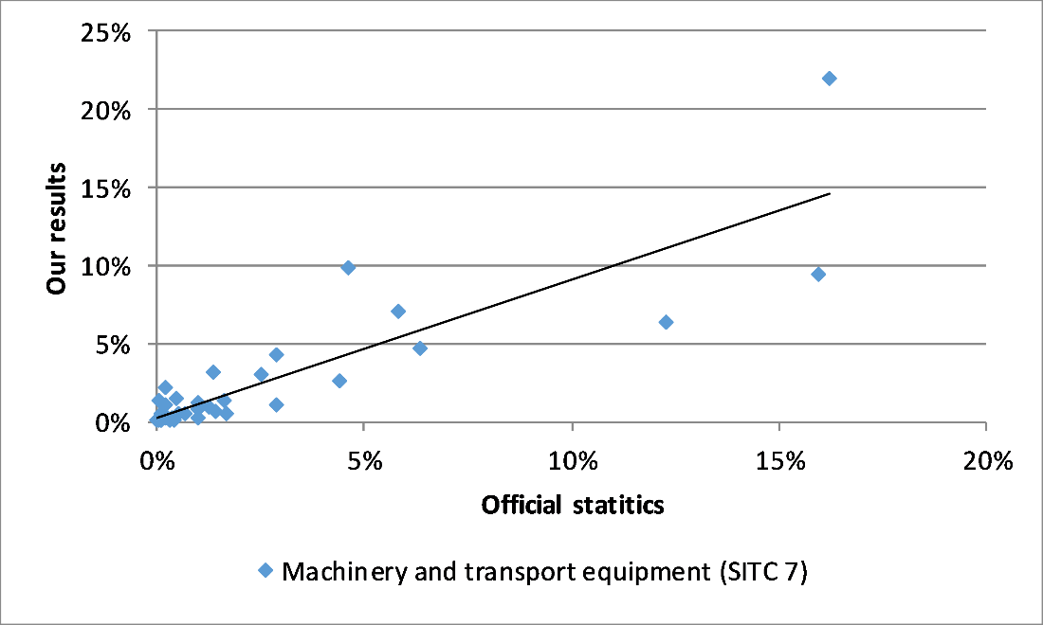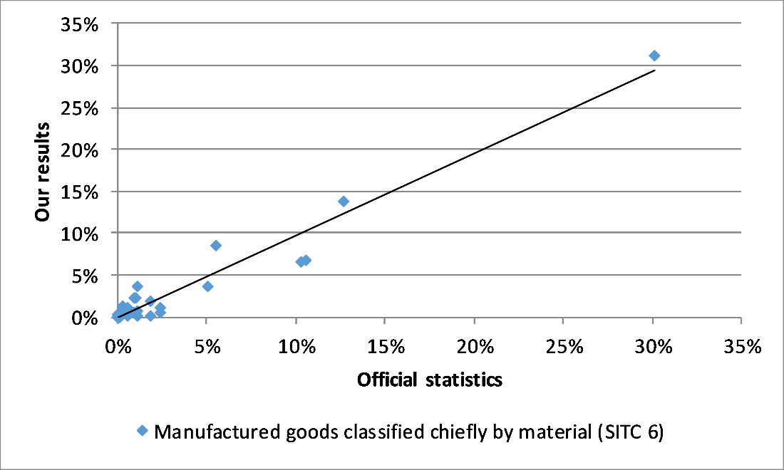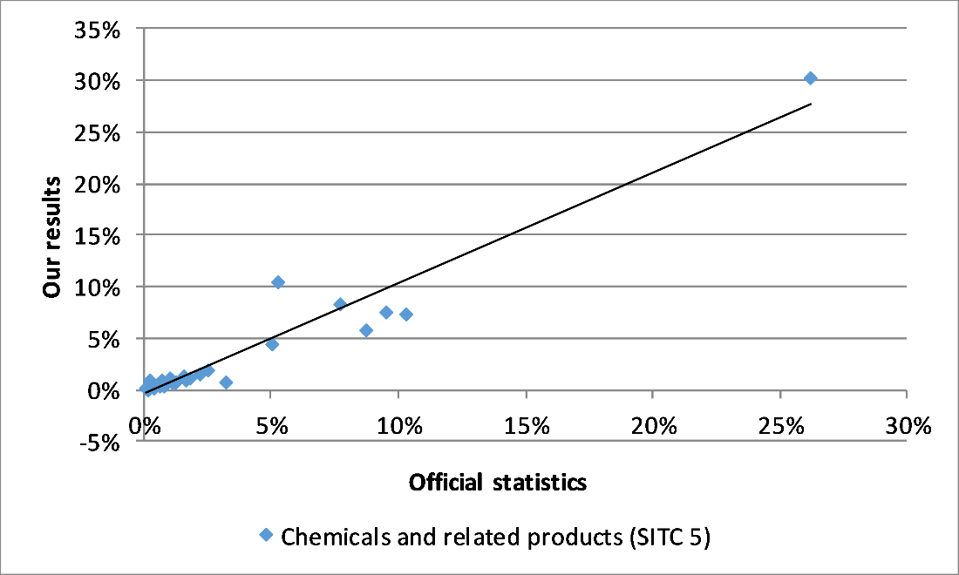
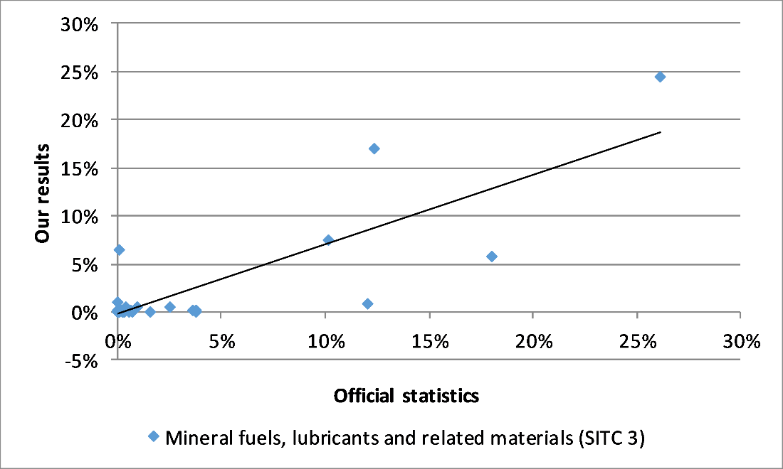

The data are available at http://statline.cbs.nl/Statweb/publication/?DM=SLNL&PA=83028NED&D1=1-3&D2=a&D3=9-77&D4=116&VW=T
WIOD registers product categories according to the European Statistical Classification of Products by Activity (CPA) 2002.

