Supporting Information
for
Brain-targeted intranasal delivery of dopamine with borneol and lactoferrin co-modified nanoparticles for treating Parkinson’s disease
Shengnan Tang^{1,*}, Aiping Wang^{1,*}, Xiuju Yan¹, Liuxiang Chu¹, Xiucheng Yang¹, Yina Song¹, Kaoxiang Sun¹ , Xin Yu¹, Rongxia Liu¹, Zimei Wu¹, Peng Xue ²

¹School of Pharmacy, Collaborative Innovation Center of Advanced Drug Delivery System and Biotech Drugs in Universities of Shandong, Key Laboratory of Molecular Pharmacology and Drug Evaluation (Yantai University), Ministry of Education, Yantai University, Yantai, Shandong Province, People’s Republic of China
²State Key Laboratory of Long-Acting and Targeting Drug Delivery System, Shandong Luye Pharmaceutical Co., Ltd, Yantai, Shandong Province, People’s Republic of China
*These authors contributed equally to this work.
Corresponding author:
Aiping Wang
School of Pharmacy, Yantai University, No 30 Qingquan road, Yantai, 264005, Shandong Province, People’s Republic of China
Tel: 86 535 39462458, Email: wangaiping@luye.com
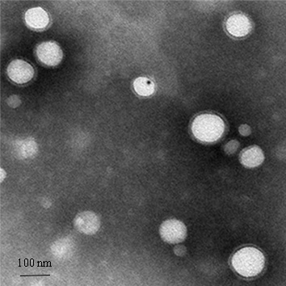
Figure S1. Transmission Electron Microscopy (TEM) images of Lf-BNPs (Scare bar 100 nm).
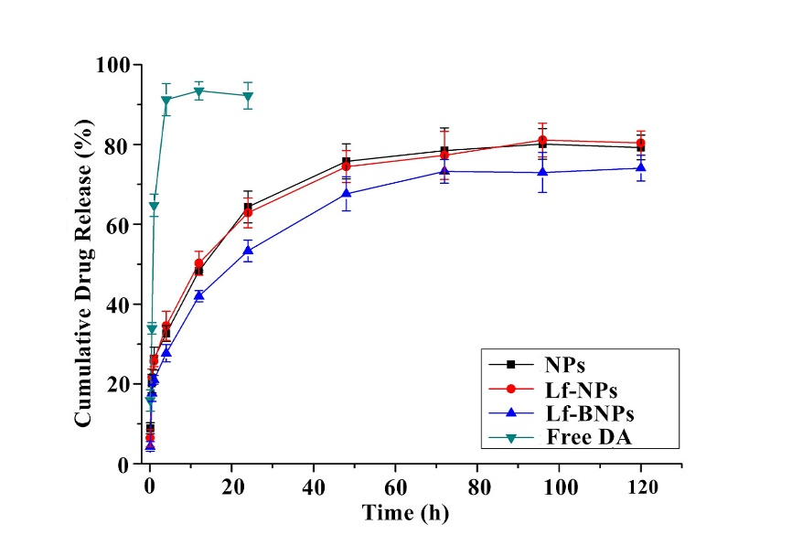
Figure S2. Release profile of dopamine in PBS from free dopamine, dopamine-loaded NPs, Lf-NPs, and Lf-BNPs (n=3, mean ± SD).

