Supplementary Information

Development of synthetic high-density lipoprotein-based ApoA-I mimetic peptide loaded docetaxel as a drug delivery nanocarrier for breast cancer chemotherapy

Miaomiao Gong^{1,2}, Qi Zhang³, Qi Zhao^{1,2}, Jiani Zheng^{1,2}, Yue Li^{1,2}, Siling Wang^{1,}*, Yue Yuan^{1,2}*,
1School of Pharmacy, Shenyang Pharmaceutical University, 103 Wenhua Road, Shenyang, 110016, P. R. China
2Shenyang Key Laboratory of Functional Drug Carrier Materials, Shenyang Pharmaceutical University, 103 Wenhua Road, Shenyang, 110016, P. R. China
3Department of General Surgery, General Hospital of Benxi Iron and Steel CO. LTD, No. 29 Renmin Road, Benxi, 117000, P. R.China,

*Corresponding author: Prof. Yue Yuan and Prof. Siling Wang
Mail address: School of Pharmacy, Shenyang Key Laboratory of Functional Drug Carrier Materials, Shenyang Pharmaceutical University, No.103, Wenhua Road, Shenyang 110016, China
Tel: +86-24-43520585; Fax: +86-24-43520585
Mobile phone: 13940047880 (Yue Yuan)
E-mail: hiyueyuan@163.com (Yue Yuan), silingwang@syphu.edu.cn (Siling Wang)

Figure S1. The structure of DMPC, DPPC, HSPC, and POPC.

Figure S2. The appearance of different types of sHDL nanoparticles.

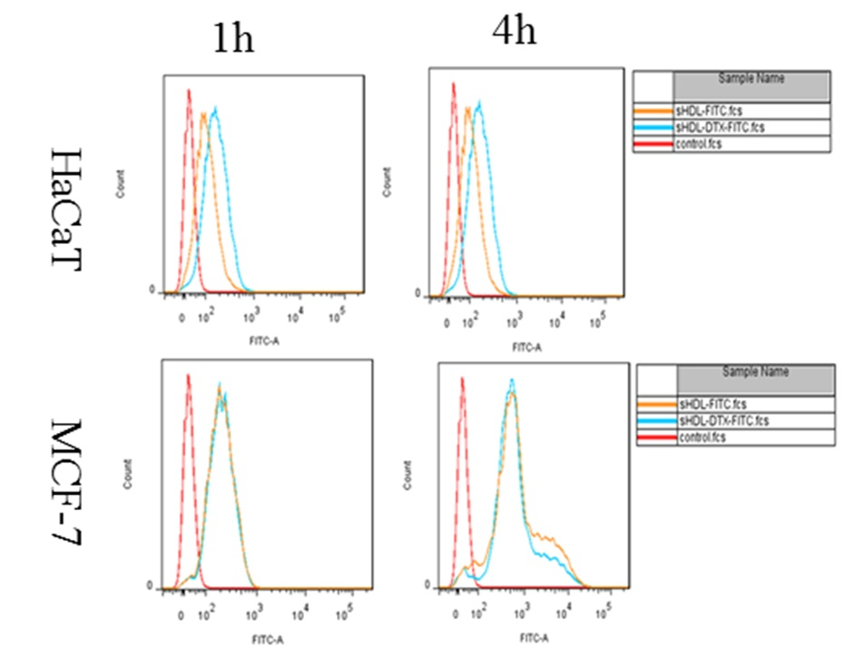
Figure S3. FCM results of cellular uptake in HaCaT cells and MCF-7 cells after incubation with sHDL-FITC nanoparticle and DTX-sHDL-FITC nanoparticle for 1 h and 4 h, respectively.

Figure S4. The image of resected tumor treated with Saline, DTX-sol, sHDL, and DTX-sHDL nanoparticles.

Table S1 The properties of blank sHDL made with different types of phospholipids

Parameter | DMPC | DPPC | HSPC | POPC
Size | 12.58±0.34 | 20.84±0.13 | 30.09±0.27 | 118.84±61.07
Turbidity | 0.022±0.002 | 0.061±0.001 | 0.292±0.002 | 0.598±0.0006
Enthalpy | -233.08 | -278.14 | -301.43 | -307.78
Binding Energy | -357.798 | -320.962 | -259.296 | -281.279

Table S2 In vitro release kinetics parameters.
Model | Equation | Equation pH 7.4 | R²
Zero order | R=kt+C | R=0.0138t+0.2795 | 0.8785
First order | In(1-R)=kt+C | In(1-R)= -0.057t-0.0639 | 0.9729
Higuchi | R= kt^{1/2} +C | R=0.1323t^{1/2} +0.0342 | 0.9811
Riger-Peppas | InR=kInt +C | InR=0.488Int -1.9129 | 0.9894

