Supplemental Information,
Design and optimization of a Medium Flow Differential Mobility Analyzer (MF-DMA) for classification of high-density particles
T. Rosenberger¹, D. Kiesler¹, E. Hontañón¹, D. Fuentes², E. Ramiro², and F.E. Kruis¹
¹Intitute of Technology for Nanostructures (NST) and Center for Nanointegration Duisburg-Essen (CENIDE), University Duisburg-Essen, Duisburg, D-47057, Germany
²Ramem S.A., Madrid, 28027, Spain

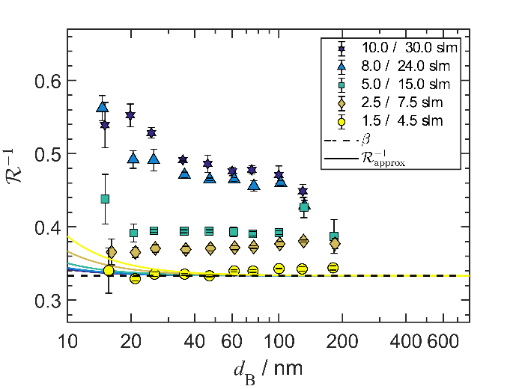 | 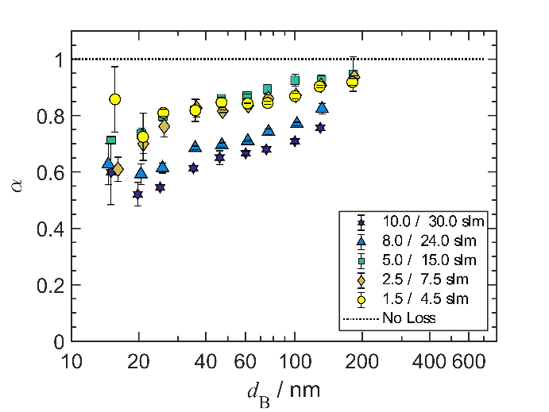
Figure S1 Width $R^{-1}$ (left) and the height $α$ (right) of the transfer function of the Short MF-DMA for a flow ratio $β=0.33$ and an aerosol inlet gap of 1 mm.
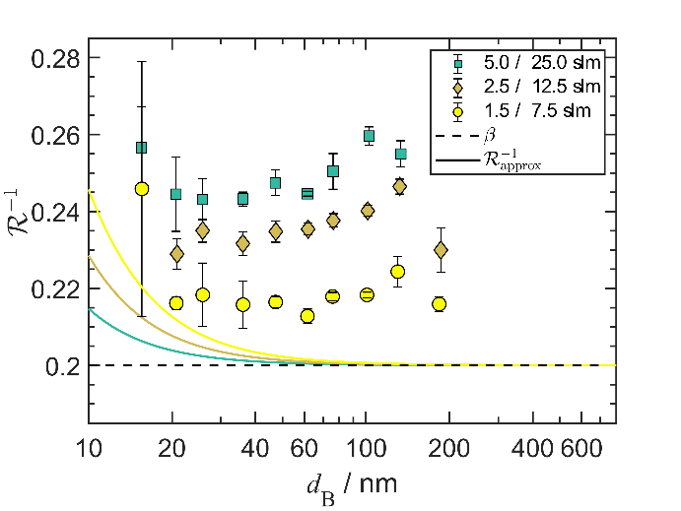 | 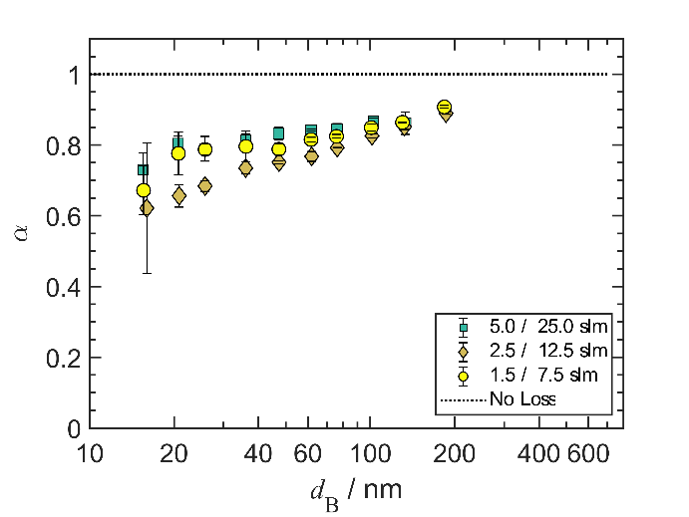
Figure S2 Width $R^{-1}$ (left) and the height $α$ (right) of the transfer function of the Short MF-DMA for a flow ratio $β=0.2$ and an aerosol inlet gap of 1 mm.
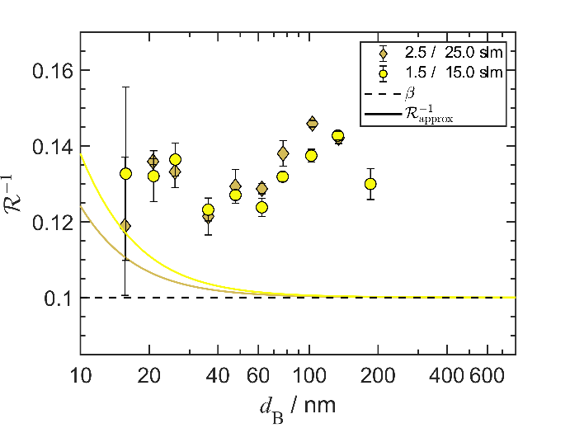 | 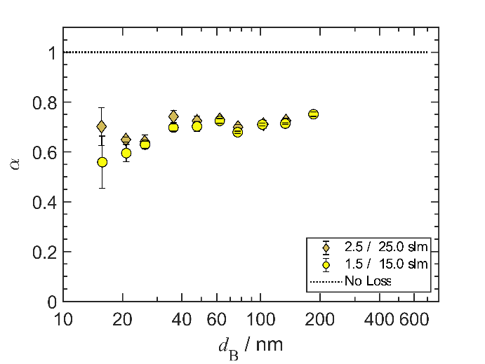
Figure S3 Width $R^{-1}$ (left) and the height $α$ (right) of the transfer function of the Short MF-DMA for a flow ratio $β=0.1$ and an aerosol inlet gap of 1 mm.
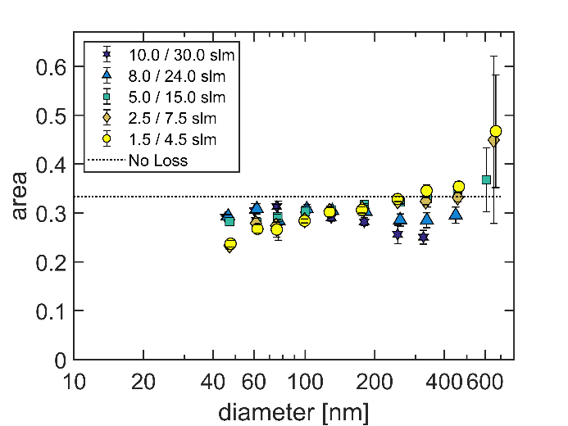 | 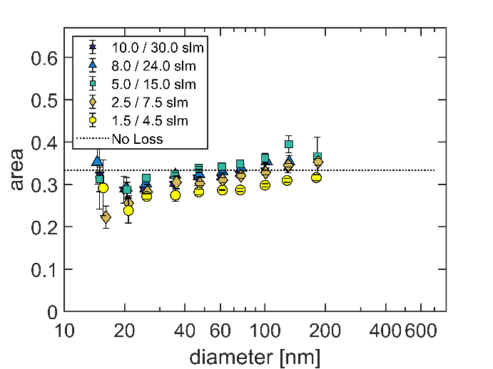
Figure S4 Area plot of the transfer function of the Long MF-DMA (left) and the Short MF-DMA (right) for a flow ratio $β=0.33$ and an aerosol inlet gap of 1 mm.
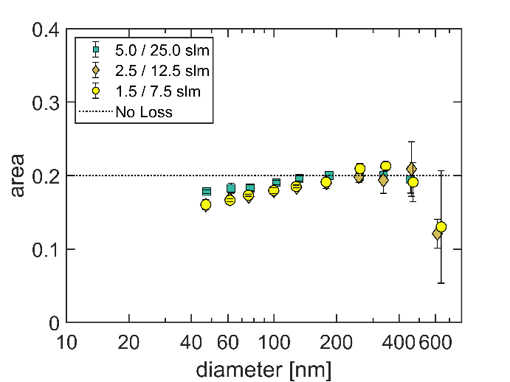 | 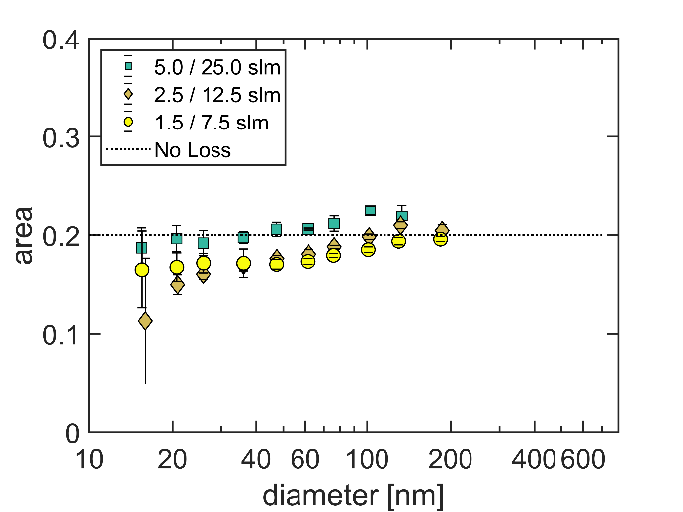
Figure S5 Area plot of the transfer function of the Long MF-DMA (left) and the Short MF-DMA (right) for a flow ratio $β=0.2$ and an aerosol inlet gap of 1 mm.
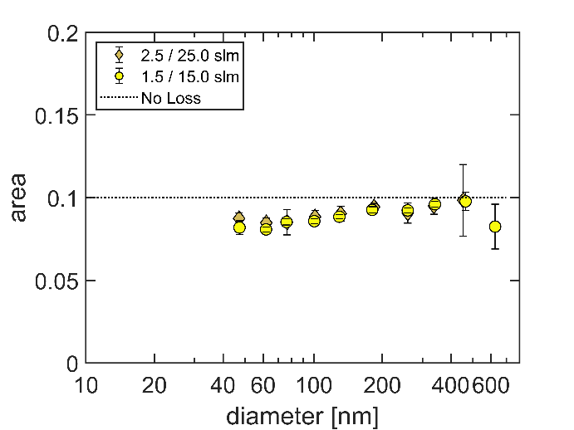 | 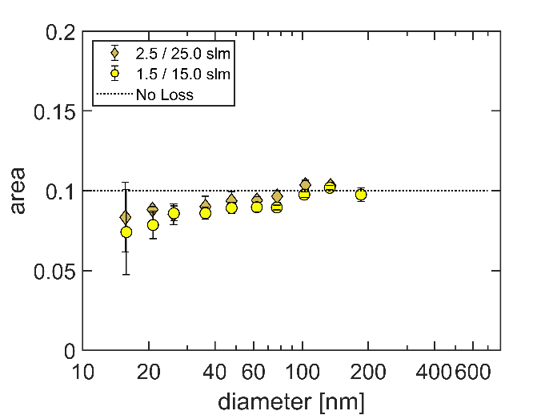
Figure S6 Area plot of the transfer function of the Long MF-DMA (left) and the Short MF-DMA (right) for a flow ratio $β=0.1$ and an aerosol inlet gap of 1 mm.

