Supplementary Material

Pigeon circoviruses from feral pigeon in Australia demonstrates extensive recombination and genetic admixture with other circoviruses

Subir Sarker^{1,2}, Shubhagata Das², Seyed A. Ghorashi², Jade K. Forwood³, and Shane R. Raidal^{2,4*}

¹Department of Physiology, Anatomy and Microbiology, School of Life Sciences, La Trobe University, Melbourne, VIC 3086, Australia. ²School of Animal and Veterinary Sciences, Charles Sturt University, Wagga Wagga, NSW 2678, Australia. ³School of Biomedical Sciences, Charles Sturt University, Wagga Wagga, NSW 2678, Australia. ⁴Veterinary Diagnostic Laboratory, Charles Sturt University, Wagga Wagga, NSW 2678, Australia.

*Author for correspondence: shraidal@csu.edu.au

Supplementary Figures

Supplementary Fig. S1: Bayesian phylogenetic inference of evolutionary relationships amongst 12 PiCV full genome sequences isolated in this study from feral Pigeon (C. livia) in Australia with others 107 selected PiCV genome sequences available in GenBank. Maximum clade credibility tree automatically rooted using a uncorrelated relaxed lognormal clock model in Beast v1.8.3, and FigTreev1.4.2 was used to generate the consensus tree. Labels at branch tips refer to GenBank accession number. Original clade posterior probability values are highlighted by colours. Background shading clade and pink taxa highlights the PiCV genome sequences isolated from feral pigeons geographically located in Australia.

Supplementary Fig. S2: Bayesian phylogenetic inference of evolutionary relationships amongst 13 partial Rep gene of PiCV sequences isolated in this study with others 107 selected partial Rep gene sequences. A maximum clade credibility tree automatically rooted in Beast v1.8.3 (GTR+I+G4 substitution model, a uncorrelated relaxed lognormal clock model, and coalescent Bayesian skyline prior). FigTreev1.4.2 was used to generate the consensus tree. Labels at branch tips refer to GenBank accession number. Original clade posterior probability values are shown at tree nodes. Background shading clade and pink taxa highlights the PiCV sequences isolated from feral pigeons geographically located in Australia.

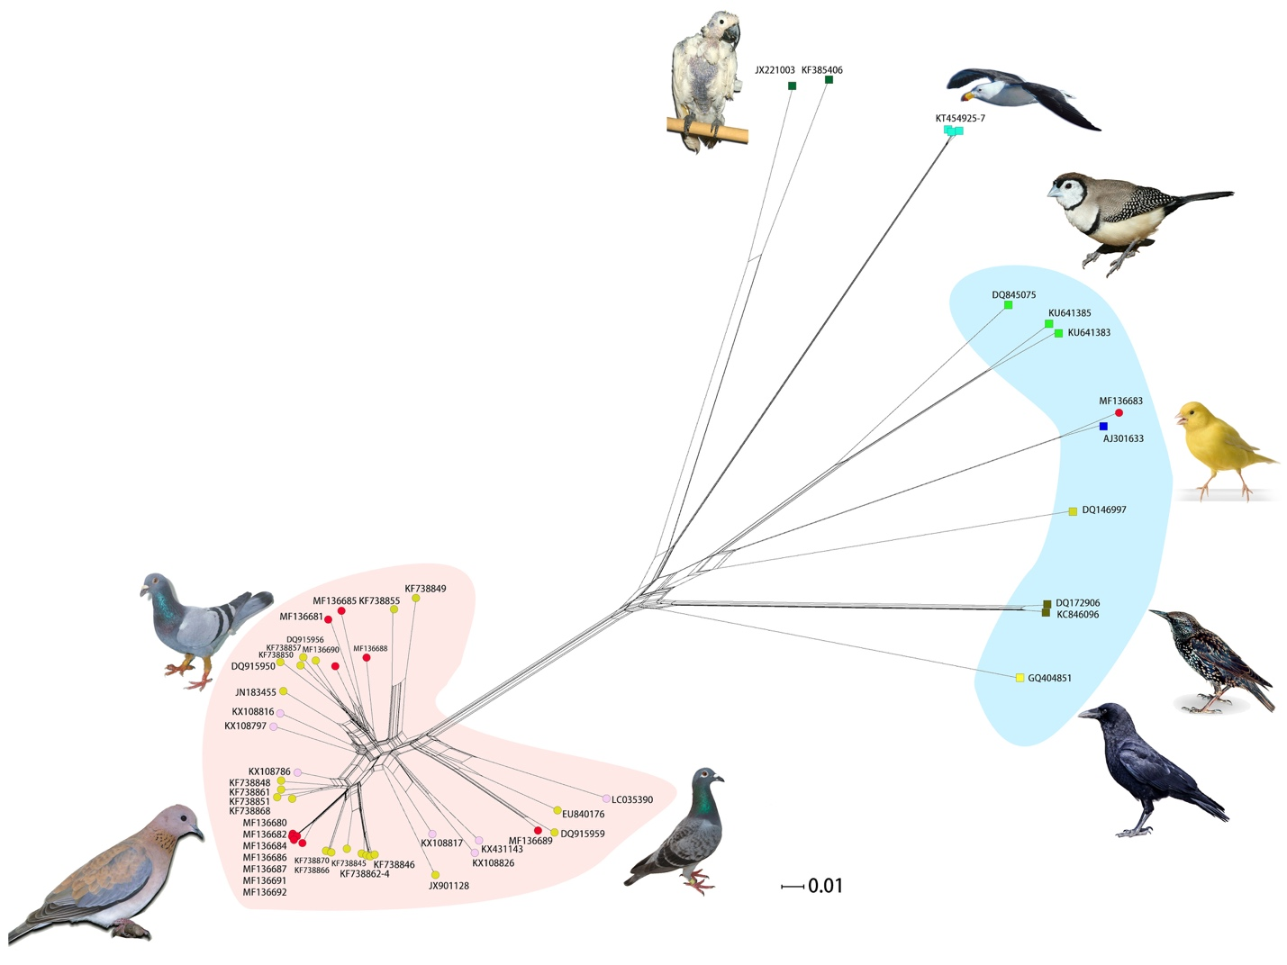

Supplementary Fig. S3: Neighbor-Net network analyses among selected 57 partial Rep DNA sequences to identify potential evolutionary history of an Australian PiCV. Black highlighted box indicated that there was a likely spillover of a novel PiCV from a wild canary circovirus.

Supplementary Table
Table S1. Pairwise distance matrix generated using the Tamura‐Nei parameter model in Geneious (version 10.2.3)
 |  | 1 | 2 | 3 | 4 | 5 | 6 | 7 | 8 | 9 | 10 | 11 | 12 | 13
1 | MF136689
2 | MF136681 | 90.5
3 | MF136692 | 87.7 | 87.5
4 | MF136691 | 87.2 | 86.4 | 97.7
5 | MF136687 | 87.1 | 86.3 | 97.8 | 99.6
6 | MF136682 | 87.1 | 86.5 | 97.9 | 99.7 | 99.9
7 | MF136680 | 87.2 | 86.4 | 97.9 | 99.7 | 99.9 | 100
8 | MF136686 | 87.3 | 86.5 | 97.8 | 99.6 | 99.8 | 99.9 | 99.9
9 | MF136684 | 87.2 | 86.4 | 97.8 | 99.6 | 99.8 | 99.9 | 99.9 | 99.8
10 | MF136688 | 86.6 | 90.9 | 92.5 | 94.4 | 94.5 | 94.6 | 94.6 | 94.5 | 94.5
11 | MF136690 | 85.8 | 92.5 | 90.8 | 89.9 | 89.7 | 89.8 | 89.8 | 89.7 | 89.7 | 94.3
12 | MF136685 | 85.0 | 90.5 | 87.3 | 87.5 | 87.4 | 87.4 | 87.5 | 87.6 | 87.4 | 91.9 | 91.1
13 | DQ915959 | 97.8 | 89.3 | 86.0 | 85.8 | 85.9 | 85.9 | 85.9 | 86.0 | 85.8 | 85.4 | 84.4 | 84.4

