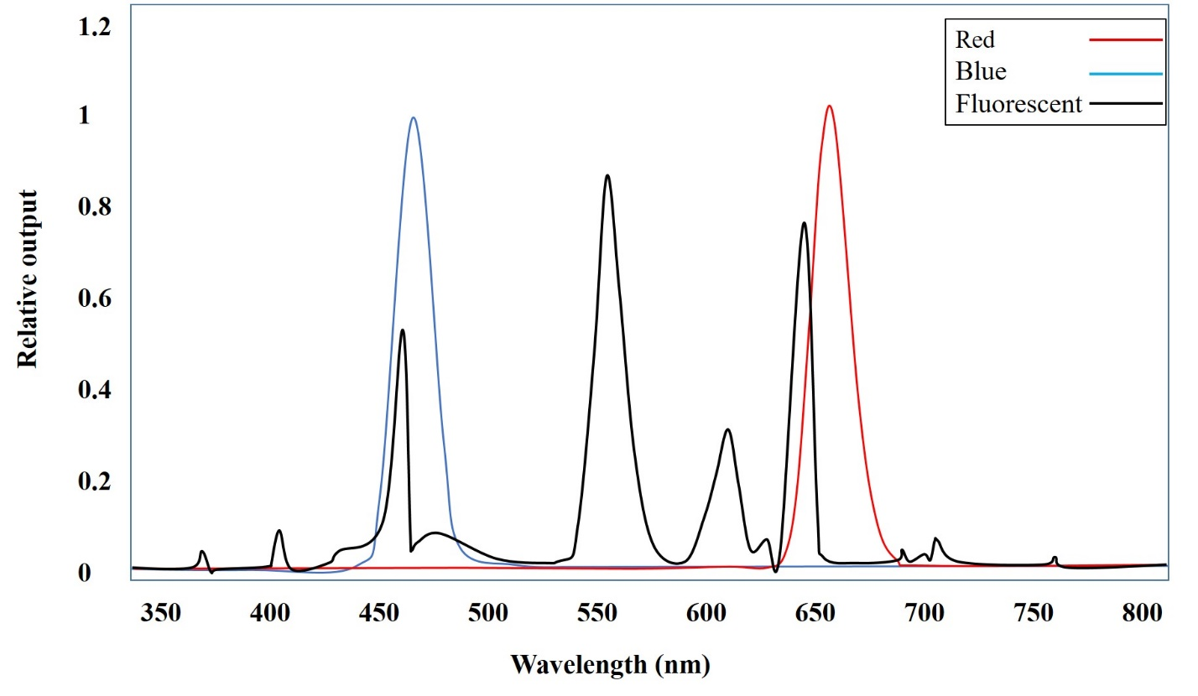

Supplementary data 1: The spectrum of red, blue and fluorescent lights