Supporting Information

Extraordinarily large kinetic isotope effect on
alkene hydrogenation over
Rh-based intermetallic compounds

Shinya Furukawa, ,*^{,a,b} Pingping Yi,^{b} Yuji Kunisada,^{c}
and Ken-ichi Shimizu^{a,b}

ª Institute for Catalysis, Hokkaido University, N-21, W-10, Sapporo 001-0021, Japan
^{b} Elements Strategy Initiative for Catalysts and Batteries,
Kyoto University, Katsura, Kyoto 615-8520, Japan
^{c} Center for Advanced Research of Energy and Materials, Faculty of Engineering,
Hokkaido University, Sapporo 060-8628, Japan

E-mail: furukawa@cat.hokudai.ac.jp,
Tel: +81-11-706-9162, Fax: +81-11-706-9163

Table S1. Adsorption (E_{ad}) and dissociation (E_{dis}) energies of H₂ on Rh-based surfaces.
 | E_{ad} (eV) |  | E_{dis} (eV)
 | H₂ | D₂ | H₂ | D₂
Rh | −0.049 | −0.049 | 0.013 | 0.011
RhIn | −0.028 | −0.029 | 0.076 | 0.074
RhPb₂ | −0.046 | −0.049 | 0 | 0

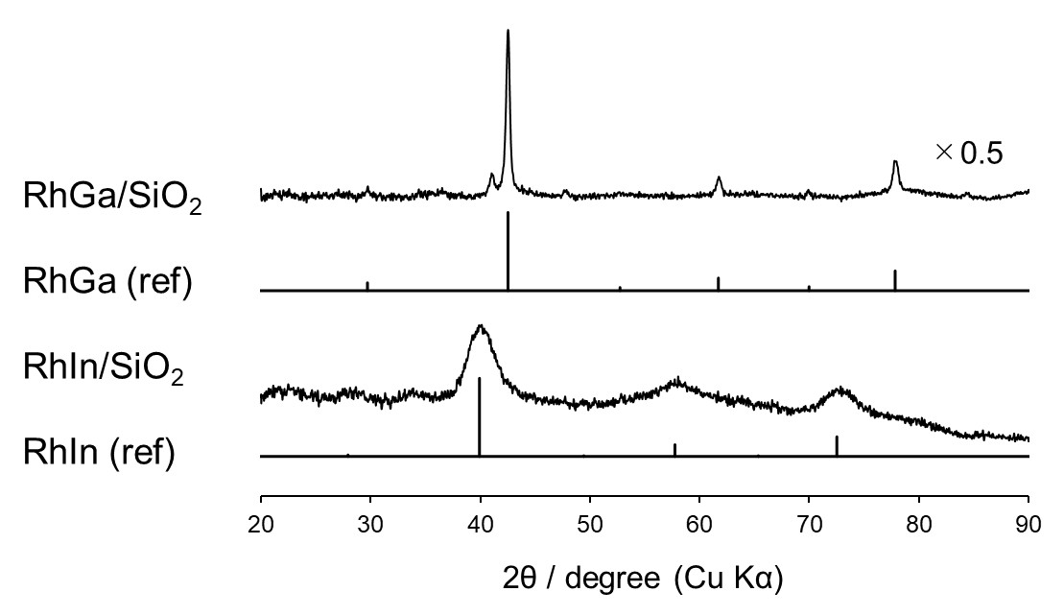
Figure S1. XRD patterns of RhGa/SiO₂ and RhIn/SiO₂. References are shown as black vertical lines. The desired intermetallic phases were observed with high phase purities.

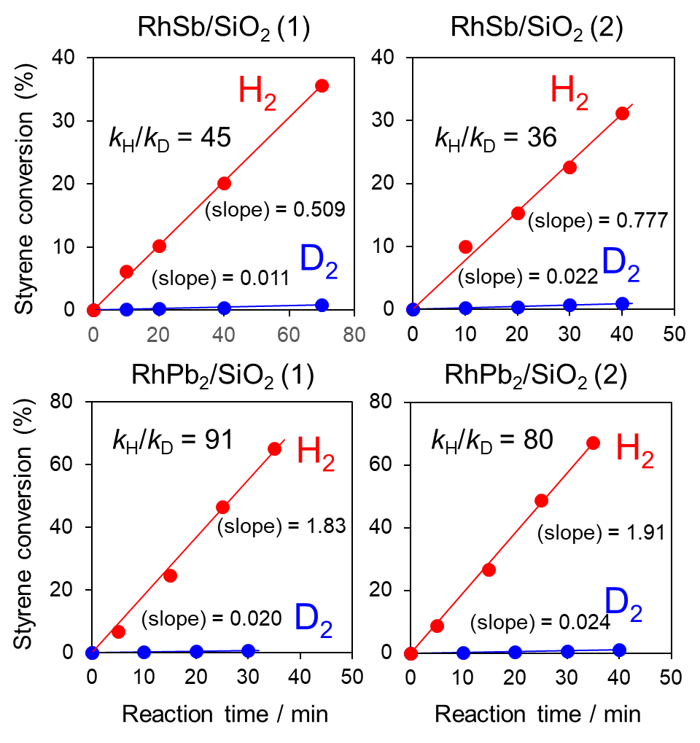

Figure S2. Time-course of styrene conversion in styrene hydrogenation over RhSb/SiO₂ and RhPb₂/SiO₂ catalysts when H₂ (red) or D₂ (blue) was used as a hydrogen source.
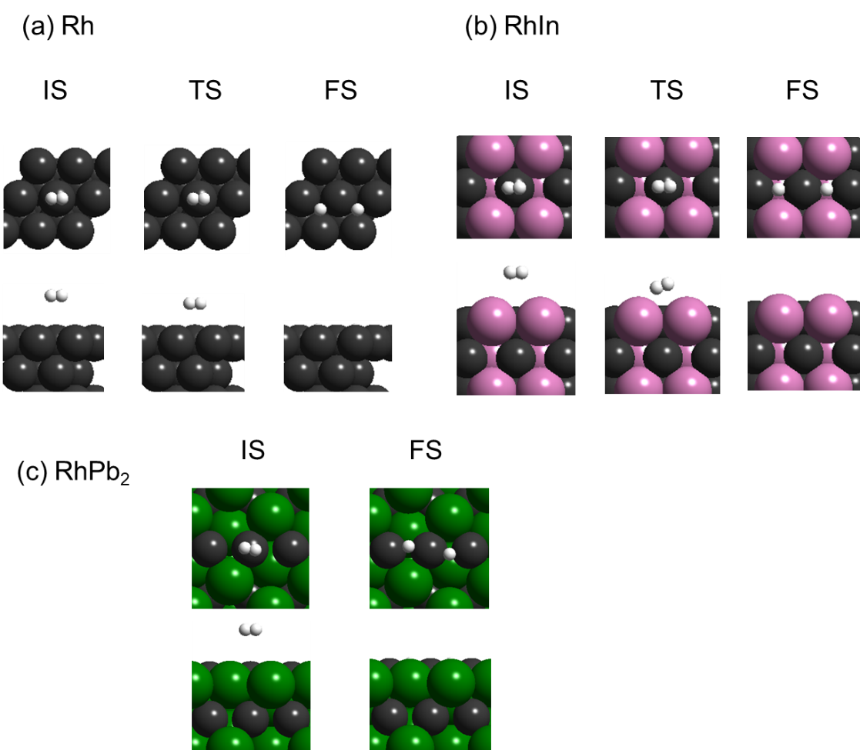
Figure S3. Structures of initial (IS: H₂ molecule), transition (TS), and final (FS: two H atoms) states during H₂ activation process over (a) Rh(111), (b) RhIn(110), and (c) RhPb₂(100) surfaces.

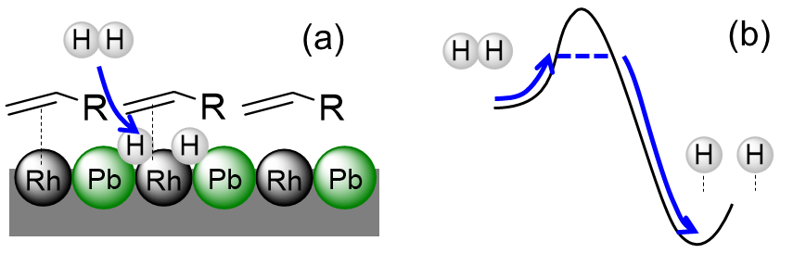
Figure S4. (a) Schematic illustration and (b) energy diagram of hydrogen dissociative adsorption on RhPb₂ covered with alkene. The dotted line in (a) indicates adsorption of the C=C moiety on the Rh site.

