A Novel Nanoparticle Drug Delivery System based on PEGylated Hemoglobin for Cancer Therapy
Yongmei Zhao¹, Gang Chen², Zhengjie Meng³, Guangming Gong⁴, Wei Zhao⁵, Kaikai Wang^{1*}, Tianqing Liu⁶

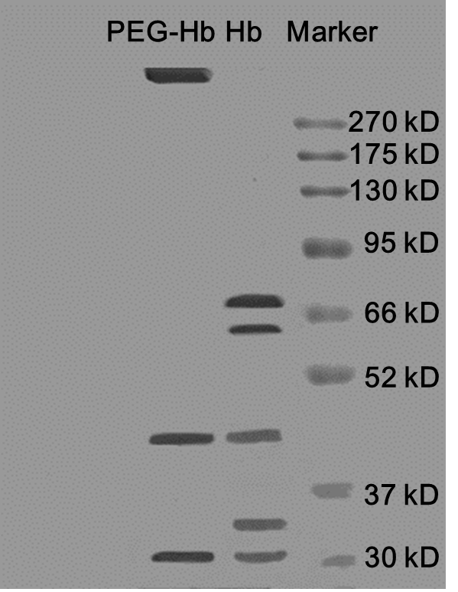
Figure S1. SDS-PAGE analysis of Hb and PEG-Hb.

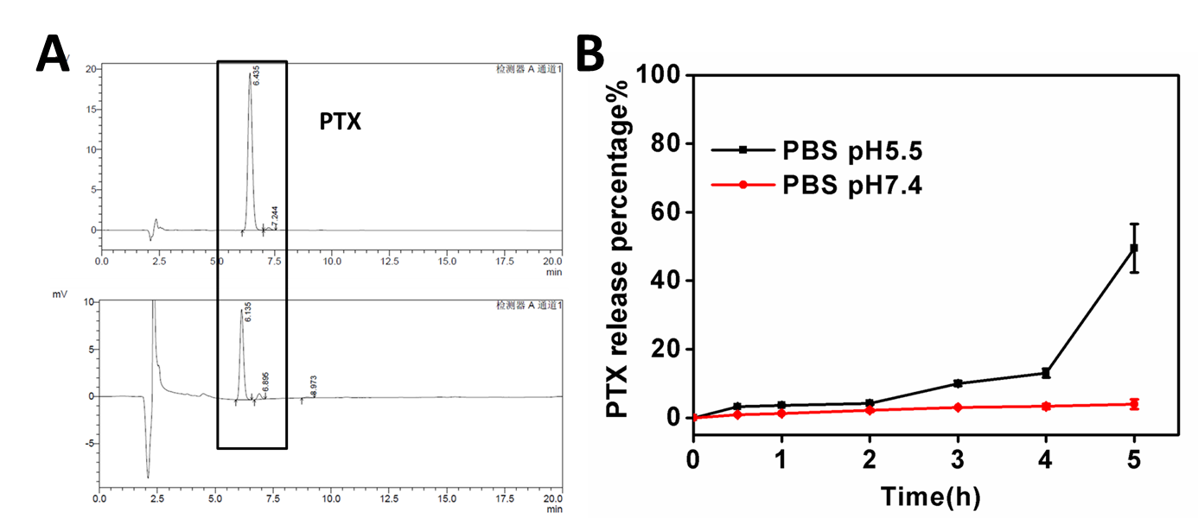
Figure S2. PTX release percentage (%) in PEG-Hb-PTX NPs. (A) HPLC chromatogram of PTX. (B) In vitro release profiles of PTX from the nanoparticles at pH 5.5 and 7.4.
Figure S3. Stability of of PEG-Hb-PTX NPs at different time points in fetal blood serum.

Figure S4. Plasma PTX concentration–time profile after the intravenous injection of a 10 mg/kg dose of Taxol and PEG-Hb-PTX NPs. Data are expressed as mean ± SD, n = 3 per time point.

Table S1 Pharmacokinetic parameters of PTX in ICR mice by iv injection (10 mg/kg).
Pharmacokinetic Parameters | Taxol | PEG-Hb-PTX NPs
AUC (μg/mL*h) | 8.7368±0.57 | 20.4286±1.12
t_{1/2} (h) | 0.3917±0.22 | 1.0587±0.29
MRT (h) | 0.5651±0.32 | 1.38±0.56
AUC: Area under the curve; t_{1/2}: Half-life; MRT: Mean residence time.

