Supplementary Material

Appendix: Validation of the L4-5 Spinal Segment Finite Element Model

Chaochao Zhou ^{1, 2, 3}, Thomas Cha ^{1, 3}, Guoan Li ^{1,} *

¹ Orthopaedic Bioengineering Research Center, Newton-Wellesley Hospital, Harvard Medical School, Newton, MA; ² Department of Mechanical Engineering, State University of New York at Binghamton, Binghamton, NY; ³ Department of Orthopaedic Surgery, Massachusetts General Hospital, Harvard Medical School, Boston, MA

* To whom correspondence should be addressed:
Guoan Li, PhD
Orthopaedic Bioengineering Research Center
Newton-Wellesley Hospital
Harvard Medical School
159 Wells Avenue
Newton, MA, 02459
Phone: +1 (617) 530-0563
Email: gli1@partners.org

To model the disc material heterogeneity, the annulus fibrosis (AF) was divided into 3 polar sections and 3 radial sections, where reinforcing elements were assigned circumferentially and radially varying fiber tensile properties (Fig. A1). The stress-stretch curves of fiber lamellae at the anterior-external (Pol Sec 1 and Rad Sec 1), anterior-internal (Pol Sec 1 and Rad Sec 3), posterior-external (Pol Sec 3 and Rad Sec 1), and posterior-internal (Pol Sec 3 and Rad Sec 3) sites were fitted from the in-vitro single lamellar tensile test data (Holzapfel et al. 2005). Stress-stretch curves at other sites were interpolated to simulate the gradual transition in the collagen content distribution. The thicknesses of reinforcing elements were varied across the AF (Pol Sec 1: 0.73 mm, Pol Sec 2: 0.56 mm, Pol Sec 3: 0.39 mm) (Holzapfel et al. 2005). Circumferentially and radially varying fiber orientations in a crossing pattern were assigned to the reinforcing elements (Zhu et al. 2008).

There are seven intersegmental ligaments in the lumbar spine, including anterior longitudinal ligament (ALL), posterior longitudinal ligament (PLL), capsular ligament (CL), ligamentum flavum (LF), interspinous ligament (ISL), supraspinous ligament (SSL), and intertransverse ligament (ITL). Each ligament was modeled using nonlinear spring elements with no resistance to compression and an exponential force-deflection relation in tension (Rohlmann et al. 2006).

To calibrate material properties of discs and ligaments, the kinematic responses of the L4-L5 lumbar segment FE model were simulated using a step-wise addition procedure of spinal structures (Schmidt et al. 2006; Noailly et al. 2007; Schmidt et al. 2007). According to the in-vitro loading protocols (Wilke et al. 1998; Heuer et al. 2007), a pure moment of 10 Nm was applied to the L4 superior endplate surface of each intact/defected L4-5 segment FE model, while the L5 inferior endplate surface was fully constrained. The material properties of the added functional structure in each intact/defected segment model (i.e., the AF fiber orientations and ligament force-deflection relations) were calibrated using the optimization toolbox in MATLAB 2014a (Natick, MA), such that the simulated segmental ranges of motion (ROMs) of each model matched in-vitro measurements in the four loading scenarios (Heuer et al. 2007).

As listed in Table A1, the calibrated angles of annular fibers within the AF were 30° at the anterior-external site, 58° at the anterior-internal site, 44° at the posterior-external site, and 66° at the posterior-internal site; fiber angles at other sites were linearly interpolated. The fiber orientation which varied both radially and circumferentially were also observed by Zhu et al. (2008). The calibrated force-deflection curves of spinal ligaments were presented in Fig. A2. In general, the stiffnesses of ligaments at the anterior were larger than those at the posterior, consistent with the ligament tensile properties calibrated by Schmidt et al. (2007). As shown in Fig. A3, the simulated kinematic responses of the intact/defected L4-5 segments in pure-moment loading scenarios were excellent agreement with those in-vitro experimental measurements (Heuer et al. 2007). When a pure moment of 10 Nm was applied to the intact L4-5 segment, the simulated segmental ROMs 7.2° in flexion, 5.2° in extension, 6.8° in lateral bending, and 3.9° in axial torsion, respectively. The calibrated material properties were also assigned to spinal tissues at other segments in the lumbar spine model.

References

Heuer F, Schmidt H, Klezl Z, Claes L, Wilke H-J. 2007. Stepwise reduction of functional spinal structures increase range of motion and change lordosis angle. J Biomech [Internet]. 40:271–280. Available from: http://www.jbiomech.com/article/S0021-9290(06)00030-3/abstract
Holzapfel GA, Schulze-Bauer CAJ, Feigl G, Regitnig P. 2005. Single lamellar mechanics of the human lumbar anulus fibrosus. Biomech Model Mechanobiol. 3:125–140.
Noailly J, Wilke HJ, Planell JA, Lacroix D. 2007. How does the geometry affect the internal biomechanics of a lumbar spine bi-segment finite element model? Consequences on the validation process. J Biomech. 40:2414–2425.
Rohlmann A, Zander T, Schmidt H, Wilke HJ, Bergmann G. 2006. Analysis of the influence of disc degeneration on the mechanical behaviour of a lumbar motion segment using the finite element method. J Biomech. 39:2484–2490.
Schmidt H, Heuer F, Drumm J, Klezl Z, Claes L, Wilke HJ. 2007. Application of a calibration method provides more realistic results for a finite element model of a lumbar spinal segment. Clin Biomech. 22:377–384.
Schmidt H, Heuer F, Simon U, Kettler A, Rohlmann A, Claes L, Wilke HJ. 2006. Application of a new calibration method for a three-dimensional finite element model of a human lumbar annulus fibrosus. Clin Biomech. 21:337–344.
Wilke HJ, Wenger K, Claes L. 1998. Testing criteria for spinal implants: Recommendations for the standardization of in vitro stability testing of spinal implants. Eur Spine J. 7:148–154.
Zhu D, Gu G, Wu W, Gong H, Zhu W, Jiang T, Cao Z. 2008. Micro-structure and mechanical properties of annulus fibrous of the L4-5 and L5-S1 intervertebral discs. Clin Biomech. 23:74–82.

Figures:

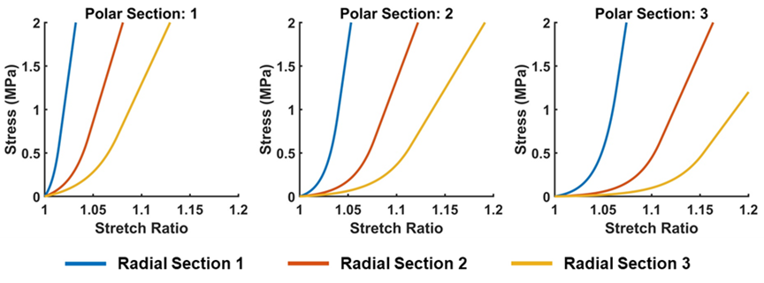

Fig. A1. Circumferentially and radially varying fiber lamellar stress-stretch relations fitted and interpolated from previous experimental measurements by Holzapfel et al (2005).

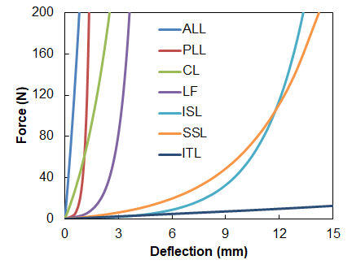

Fig. A2. The calibrated force-deflection curves of spinal ligaments. (ALL = anterior longitudinal ligament; PLL = posterior longitudinal ligament; CL = capsular ligament; LF = ligamentum flavum; ISL = interspinous ligament; SSL = supraspinous ligament)

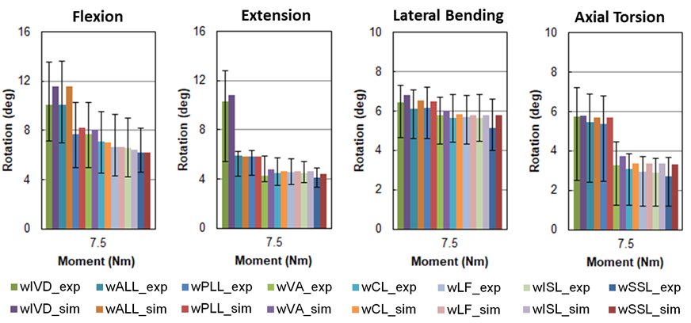

Fig. A3. Comparison of simulated kinematical responses of the L4-5 segment with previously reported in-vitro measurements by Heuer et al (2007) in various pure-moment loading scenarios, when spinal tissues were stepwise added in the L4-5 FE model. For brevity, only segmental rotations at 7.5 Nm were presented. (IVD = intervertebral disc; ALL = anterior longitudinal ligament; PLL = posterior longitudinal ligament; VA = vertebral arch; CL = capsular ligament; LF = ligamentum flavum; ISL = interspinous ligament; SSL = supraspinous ligament)

Tables:

Table A1. Calibrated fiber angles (°) in different polar sections and radial sections which were assigned to the reinforcing elements of the disc FE model in this study.

 | Pol Sec 1 | Pol Sec 2 | Pol Sec 3
Rad Sec 1 | 30.0 | 37.0 | 44.2
Rad Sec 2 | 44.1 | 49.6 | 55.1
Rad Sec 3 | 58.5 | 62.2 | 65.9

