Supplementary Materials
Supplementary Figures
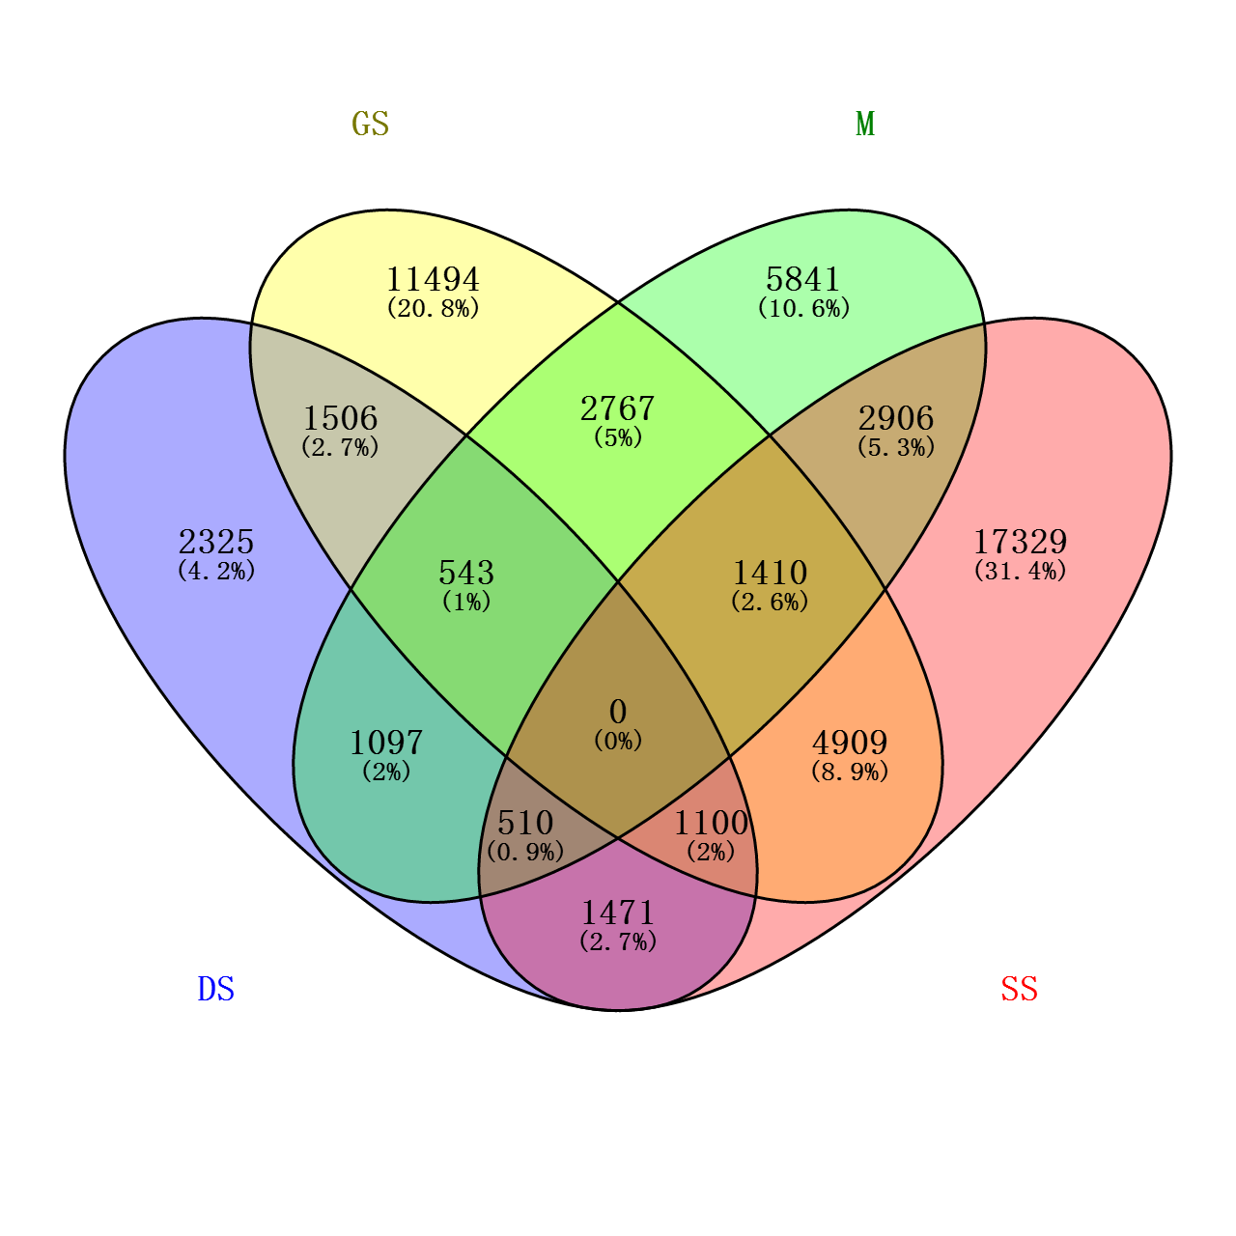
Supplementary Fig. S1 A four-way Venn diagram to show fixed SNPs (MAF = 0) in the four breeds. The numbers of SNPs shared in common are indicated at the intersections of the circles in the Venn diagram. In addition, 11494, 2325, 5841 and 17329 SNPs were recognized as "private SNPs" for German Shepherd (GS), Dutch Shepherd (DS), Malinois (M), and Springer Spaniel (SS).
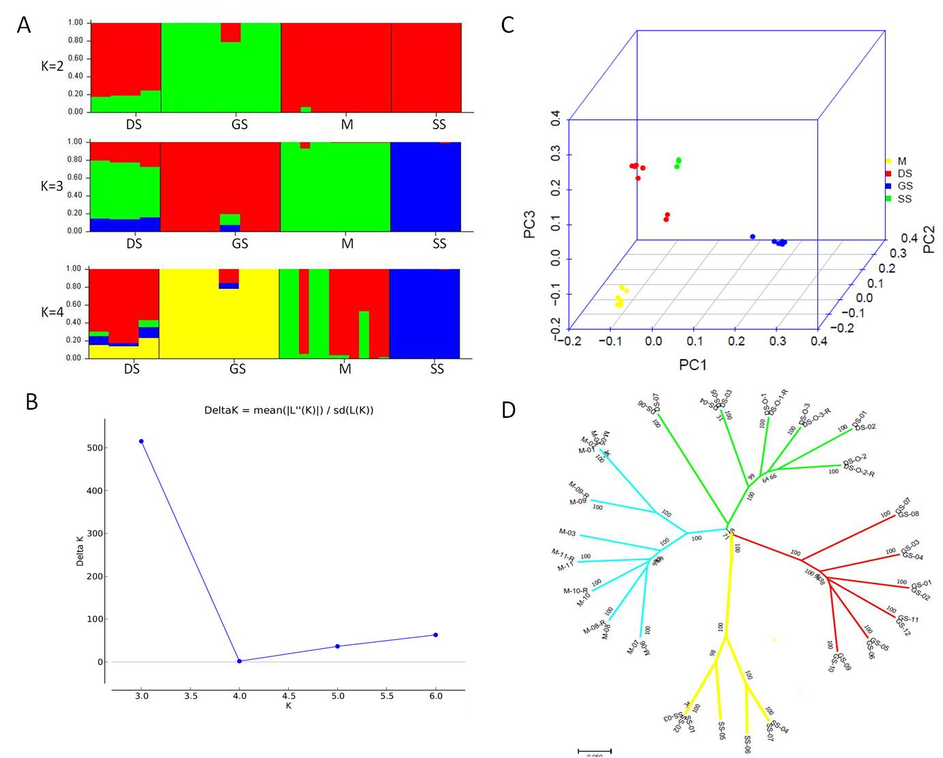
Supplementary Fig. S2 Population analysis estimated for 7,660 SNPs among unrelated individuals of the four breeds. GS=German Shepherd; DS=Dutch Shepherd; SS=Springer Spaniel; M=Malinois. (A) Proportion of membership of 37 individuals from four canine populations for K=2-4, as calculated by STRUCTURE software. (B) Multiple runs for each K were concatenated using CLUMPP, and Distruct was subsequently used to generate images. Delta K plot showing a peak at K=3. (C) Three-dimensional principle component analysis of the four breeds. Each point represents one animal, and individuals are colored according to the breed. (D) Phylogenetic tree analysis of the four breeds.

Supplementary Tables
Supplementary Table S1 The detail information of samples and correspondingly extracted DNAs and sequencing positions on the CanineHD BeadChip
List | Breeds | Analysis_  ID | Sex | DNA Concentration (ng/μL) | DNA: A260/280 | DNA: A260/230 | SentrixBarcode | SentrixPosition | Note
1 | German Shepherd (GS) | GS-01 | M | 64.7 | 1.80 | 1.09 | 200514100015 | R01C02
2 |  | GS-02 | M | 119.8 | 1.86 | 1.50 | 200514100015 | R02C02
3 |  | GS-03 | M | 79.0 | 1.82 | 2.04 | 200514100004 | R02C02
4 |  | GS-04 | M | 85.1 | 1.85 | 2.07 | 200514100012 | R02C02
5 |  | GS-05 | M | 284.3 | 1.90 | 1.78 | 200514100015 | R03C02
6 |  | GS-06 | M | 137.0 | 1.84 | 1.77 | 200514100015 | R01C01
7 |  | GS-07 | M | 161.5 | 1.90 | 1.83 | 200514100015 | R04C02
8 |  | GS-08 | M | 161.5 | 1.89 | 1.78 | 200514100015 | R05C02
9 |  | GS-09 | F | 317.6 | 1.92 | 1.78 | 200514100015 | R06C02
10 |  | GS-10 | F | 164.8 | 1.86 | 2.06 | 200514100015 | R03C01
11 |  | GS-11 | F | 318.3 | 1.93 | 1.91 | 200514100049 | R01C01
12 |  | GS-12 | F | 148.3 | 1.82 | 2.06 | 200514100015 | R04C01
13 | Dutch Shepherd (DS) | DS-01 | F | 213.3 | 1.90 | 1.96 | 200514100049 | R02C01
14 |  | DS-02 | F | 155.8 | 1.91 | 1.99 | 200514100015 | R05C01
15 |  | DS-03 | M | 334.4 | 1.95 | 1.85 | 200514100049 | R03C01
16 |  | DS-04 | M | 136.0 | 1.85 | 2.06 | 200514100004 | R04C02
17 |  | DS-05 | M | 248.3 | 1.85 | 2.15 | 200514100012 | R04C02
18 |  | DS-06 | F | 127.5 | 1.87 | 1.83 | 200514100004 | R03C02
19 |  | DS-07 | F | 515.1 | 1.84 | 1.91 | 200514100012 | R03C02
20 |  | DS-O-1 | M | 200.3 | 1.87 | 2.17 | 200514100004 | R05C01 | Offspring of sample DS-01 and DS-03
21 |  | DS-O-2 | M | 209.3 | 1.87 | 2.15 | 200514100004 | R06C01 | Offspring of sample DS-01 and DS-03
22 |  | DS-O-3 | M | 129.0 | 1.85 | 1.70 | 200514100004 | R01C02 | Offspring of sample DS-01 and DS-03
23 |  | DS-O-1-R | M | 324.2 | 1.86 | 2.09 | 200514100012 | R05C01 | Second time of blood collecting from sample DS-O-1
24 |  | DS-O-2-R | M | 301.9 | 1.87 | 2.01 | 200514100012 | R06C01 | Second time of blood collecting from sample DS-O-2
25 |  | DS-O-3-R | M | 215.5 | 1.85 | 2.11 | 200514100012 | R01C02 | Second time of blood collecting from sample DS-O-3
26 | Springer Spaniel (SS) | SS-01 | M | 290.5 | 1.90 | 1.81 | 200514100049 | R03C02
27 |  | SS-02 | M | 138.3 | 1.85 | 2.09 | 200514100004 | R06C02
28 |  | SS-03 | M | 315.3 | 1.84 | 2.10 | 200514100012 | R06C02
29 |  | SS-04 | F | 481.2 | 1.90 | 1.64 | 200514100049 | R04C02
30 |  | SS-05 | F | 125.0 | 1.82 | 2.03 | 200514100015 | R06C01
31 |  | SS-06 | F | 481.9 | 1.89 | 1.67 | 200514100049 | R05C02
32 |  | SS-07 | F | 205.8 | 1.83 | 1.91 | 200514100015 | R02C01
33 | Malinois (M) | M-01 | M | 459.2 | 1.91 | 1.65 | 200514100049 | R04C01
34 |  | M-02 | M | 383.6 | 1.91 | 1.79 | 200514100049 | R05C01
35 |  | M-03 | F | 401.2 | 1.88 | 1.80 | 200514100049 | R06C01
36 |  | M-04 | F | 118.0 | 1.85 | 2.07 | 200514100004 | R05C02
37 |  | M-05 | F | 376.1 | 1.83 | 2.01 | 200514100012 | R05C02
38 |  | M-06 | F | 330.5 | 1.90 | 1.81 | 200514100049 | R01C02
39 |  | M-07 | F | 313.4 | 1.90 | 1.63 | 200514100049 | R02C02
40 |  | M-08 | F | 132.8 | 1.81 | 1.54 | 200514100004 | R01C01
41 |  | M-09 | M | 383.3 | 1.86 | 2.07 | 200514100004 | R02C01
42 |  | M-10 | M | 93.5 | 1.87 | 1.89 | 200514100004 | R03C01
43 |  | M-11 | F | 177.5 | 1.85 | 2.04 | 200514100004 | R04C01
44 |  | M-08-R | F | 109.5 | 1.84 | 2.19 | 200514100012 | R01C01 | Second time of blood collecting from sample M-08
45 |  | M-09-R | M | 274.7 | 1.85 | 2.20 | 200514100012 | R02C01 | Second time of blood collecting from sample M-09
46 |  | M-10-R | M | 165.9 | 1.85 | 2.05 | 200514100012 | R03C01 | Second time of blood collecting from sample M-10
47 |  | M-11-R | F | 144.2 | 1.84 | 2.02 | 200514100012 | R04C01 | Second time of blood collecting from sample M-11
48 |  | Neg | / | / | / | / | / | / | Negative control
Sex column: F=Female; M=Male

Supplementary Table S2 Genetic differentiation between breeds, expressed as the fixation index (Fst)
Canine breeds | Fst
 | German shepherd | Dutch Shepherd | Malinois | Springer spaniel
German shepherd | /
Dutch Shepherd | 0.14 | /
Malinois | 0.19 | 0.04 | /
Springer spaniel | 0.18 | 0.13 | 0.22 | /

Word count= 3247

