Cmr3 regulates the suppression on cyclic oligoadenylate synthesis by tag complementarity in a Type III-B CRISPR-Cas system
Tong Guo¹, Fan Zheng², Zhifeng Zeng², Yang Yang², Qi Li², Qunxin She³, Wenyuan Han²*
¹ Danish Archaea Center, Department of Biology, University of Copenhagen, Ole Maaløes Vej 5, Copenhagen Biocenter, DK-2200 Copenhagen N, Denmark
² State Key Laboratory of Agricultural Microbiology and College of Life Science and Technology, Huazhong Agricultural University, 430070 Wuhan, China
³ State Key Laboratory of Microbial Technology, Shandong University, Binhai Road 72, Jimo, 266237 Qingdao, China

* Correspondence should be addressed to hanwenyuan@mail.hzau.edu.cn, Tel.: +86-13583776032.

Supplementary Table 1. Primers used in this work
Name | Sequence (5’~3’)
Cmr3-up-NdeI | GCGATATCCATATGTATTTGCTAATAAAACCTTTAG
Cmr3-dw-SalI | GTACGTCGACAATTTCGACTACAGAACCCCAAC
Cmr3-M1-R-UP | GACTAAGGAAGGCTATGCTGCTATGGAGAAAATGCTCGATTTG
Cmr3-M1-L-DW | CTCCATAGCAGCATAGCCTTCCTTAGTCATCTTAG
Cmr3-M2-R-UP | GGATATAACTCCGGAGGAGCTATAAATAGTGG
Cmr3-M2-L-DW | TATAGCTCCTCCGGAGTTATATCCTCCCCAC
Cmr3-M3-R-UP | CCATATTATTGTTTGGAGCTATAAATAGTGGCTATTTTG
Cmr3-M3-L-DW | CTATTTATAGCTCCAAACAATAATATGGAGTTATATCC
Cmr3-M4-R-UP | CCATATTATTGGGATTTGCTATAAATAGTGGCTATTTTG
Cmr3-M4-L-DW | CTATTTATAGCAAATCCCAATAATATGGAGTTATATC
Cmr3-M5-R-UP | GTGGGGAGGAATATTATTGGGAGGAGCTATAAATAG
Cmr3-M5-L-DW | CCCAATAATATTCCTCCCCACTTGAATACTAC
Cmr3-M6-R-UP | GTGGGGAGGAGGAGGAGCTATAAATAGTGGC
Cmr3-M6-L-DW | ATAGCTCCTCCTCCTCCCCACTTGAATACTAC
Cmr3-M7-R-UP | GTAGTAGCAGCTGCAGGAGGATATAACTCCATATTATTG
Cmr3-M7-L-DW | GGAGTTATATCCTCCTGCAGCTGCTACTACCGAACCTAAAGGTT
MRS-up | ATGCCCCGGGATGTTAAACAAGTTAGG
MRS-dw | GGCACTCGAGAAAAAAAAGATTTTGCTTAATGGTG

Supplementary Table 2. Plasmids used in this work
Plasmids | Genotype and features | Reference
pAC-MS1 | Derived from pSeSD1, carrying an artificial CRISPR locus with 10 copies of 43 nt SS1 spacer. | (1)
pcmr3α | Derived from pSeSD1, expressing His-tagged Cmr3α | This work
pAC-cmr3α | Derived from pAC-MS1, expressing both SS1 crRNA and a His-tagged Cmr3α | This work
pAC-cmr3α-M1 | Expressing both SS1 crRNA and a His-tagged Cmr3α mutant carrying alanine substitutions of I123 and Y124. | This work
pAC-cmr3α-M2 | Expressing both SS1 crRNA and a His-tagged Cmr3α mutant carrying deletion of I21, L22 and L23. | This work
pAC-cmr3α-M3 | Expressing both SS1 crRNA and a His-tagged Cmr3α mutant carrying substitution of G24 with phenylalanine. | This work
pAC-cmr3α-M4 | Expressing both SS1 crRNA and a His-tagged Cmr3α mutant carrying substitution of G25 with phenylalanine. | This work
pAC-cmr3α-M5 | Expressing both SS1 crRNA and a His-tagged Cmr3α mutant carrying deletion of Y18, N19 and S20. | This work
pAC-cmr3α-M6 | Expressing both SS1 crRNA and a His-tagged Cmr3α mutant carrying deletion of Y18, N19, S20, I21, L22 and L23. | This work
pAC-cmr3α-M7 | Expressing both SS1 crRNA and a His-tagged Cmr3α mutant carrying substitution of F13, K14and W15 with alanine. | This work

Supplementary Table 3. DNA oligos to generate DNA template for the in vitro transcription assay
Name | Sequences(5’ ̴ 3’)
SS1-46-Fwd | TAATACGACTCACTATAGGGTGTTAAGTCTGGTTTCCCTCCAGGGTATCTAAGCTT
T1-Rev | TGTTTTTTCAAAGCTTAGATACCCTGGAGG
T2-Rev | TTATTTTTCAAAGCTTAGATACCCTGGAGG
T3-Rev | TTTATTTTCAAAGCTTAGATACCCTGGAGG
T4-Rev | TTTTATTTCAAAGCTTAGATACCCTGGAGG
T5-Rev | TTTTTGTTCAAAGCTTAGATACCCTGGAGG
T6-Rev | TGATTTTTCAAAGCTTAGATACCCTGGAGG
T7-Rev | TTAATTTTCAAAGCTTAGATACCCTGGAGG
T8-Rev | TTTAATTTCAAAGCTTAGATACCCTGGAGG
T9-Rev | TTTTAGTTCAAAGCTTAGATACCCTGGAGG
T10-Rev | TGTATTTTCAAAGCTTAGATACCCTGGAGG
T11-Rev | TGTTATTTCAAAGCTTAGATACCCTGGAGG
T12-Rev | TTATATTTCAAAGCTTAGATACCCTGGAGG
T13-Rev | TGAATTTTCAAAGCTTAGATACCCTGGAGG
T14-Rev | TTAAATTTCAAAGCTTAGATACCCTGGAGG
T15-Rev | TTTAAGTTCAAAGCTTAGATACCCTGGAGG
T16-Rev | TGATATTTCAAAGCTTAGATACCCTGGAGG
T17-Rev | TGATTGTTCAAAGCTTAGATACCCTGGAGG
T18-Rev | TTAATGTTCAAAGCTTAGATACCCTGGAGG
T19-Rev | TGTAATTTCAAAGCTTAGATACCCTGGAGG
T20-Rev | TGAAATTTCAAAGCTTAGATACCCTGGAGG
T21-Rev | TTAAAGTTCAAAGCTTAGATACCCTGGAGG
T22-Rev | TGAATGTTCAAAGCTTAGATACCCTGGAGG
T23-Rev | TGAAAGTTCAAAGCTTAGATACCCTGGAGG
CT-Rev | TTTTTTTTCAAAGCTTAGATACCCTGGAGG
ATT-Rev | TTATTGAAAGTTCAAAGCTTAGATACCCTGGAGG

Supplementary Table 4. RNA and DNA substrates used in this study.
Name | Sequence (5’~3’) and comments | Size (mer)
RNA
SS1-46 | UGUUAAGUCUGGUUUCCCUCCAGGGUAUCUAAGCUUUGAAAAAAAA | 46
DNA
S10 | ACTATAGGGAGaATAGAATGCCCCCATTATACAATATCTACGTTTTAGATGAcccccccc | 60

Supplementary Table 5. T-test of the difference of the relative cOA synthesis activity between wild type and each mutated Cmr-α-RNP. The p values derived from each mutated complex and each activator RNA are listed and those < 0.05 are shown in bold. The p values are further highlighted in red if Cmr3α mutation resulted in decreased activities or green at elevated activities.
 | M1 | M2 |  | M3 |  | M5
T1 | 0.224692 | 0.315743 |  | 0.361633 |  | 0.570926
T2 | 0.181143 | 0.03761 |  | 0.72335 |  | 0.648135
T3 | 0.085569 | 0.027309 |  | 0.062331 |  | 0.671732
T4 | 0.769568 | 0.249633 |  | 0.369268 |  | 0.023871
T5 | 0.210257 | 0.195068 |  | 0.442248 |  | 0.145594
T6 | 0.292525 | 0.039325 |  | 0.165012 |  | 0.88646
T7 | 0.196536 | 0.027036 |  | 0.154184 |  | 0.980367
T8 | 0.067998 | 0.340957 |  | 0.113082 |  | 0.008942
T9 | 0.659345 | 0.016944 |  | 0.519521 |  | 0.036846
T10 | 0.376532 | 0.039387 |  | 0.281622 |  | 0.218794
T11 | 0.127611 | 0.068646 |  | 0.559029 |  | 0.378406
T12 | 0.710317 | 0.050394 |  | 0.54289 |  | 0.488581
T13 | 0.147748 | 0.227208 |  | 0.418707 |  | 0.049983
T14 | 0.039676 | 0.006215 |  | 0.319659 |  | 0.157741
T15 | 0.139704 | 0.164088 |  | 0.341246 |  | 0.016065
T16 | 0.216748 | 0.004152 |  | 0.825972 |  | 0.042466
T17 | 0.180856 | 0.916396 |  | 0.452718 |  | 0.443897
T18 | 0.451832 | 0.334371 |  | 0.261926 |  | 0.310802
T19 | 0.534571 | 0.032591 |  | 0.591317 |  | 0.147792
T20 | 0.013141 | 0.00237 |  | 0.217918 |  | 0.95273
T21 | 0.046943 | 0.007265 |  | 0.894416 |  | 0.004957
T22 | 0.824426 | 0.145876 |  | 0.077042 |  | 0.01682
T23 | 0.064275 | 0.003381 |  | 0.46702 |  | 0.571251
ATT | 0.009152 | 0.000217 |  | 0.46312 |  | 0.592051

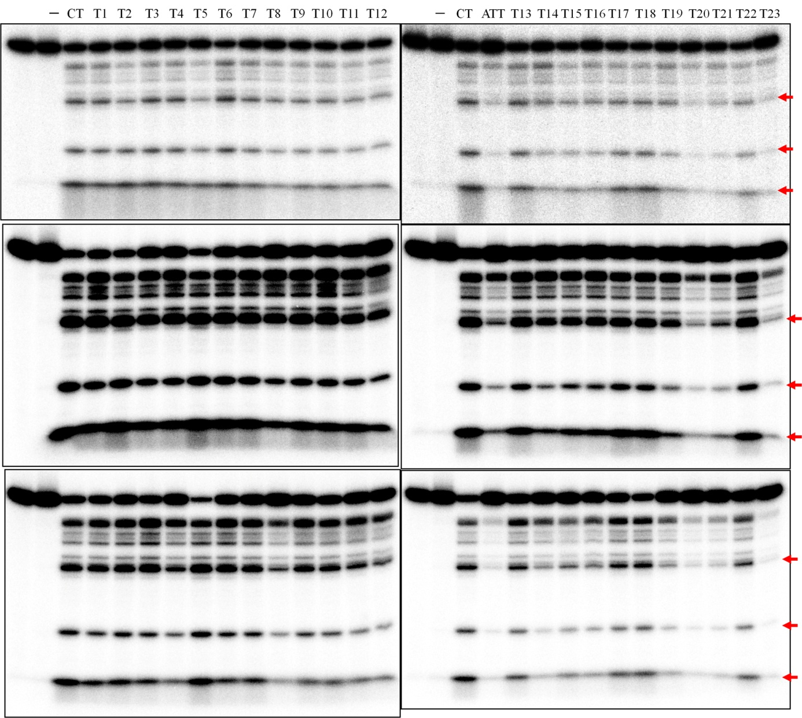
Supplementary figure S1. DNA cleavage gels for Figure 1. The three bands indicated by arrows were chosen for quantification.

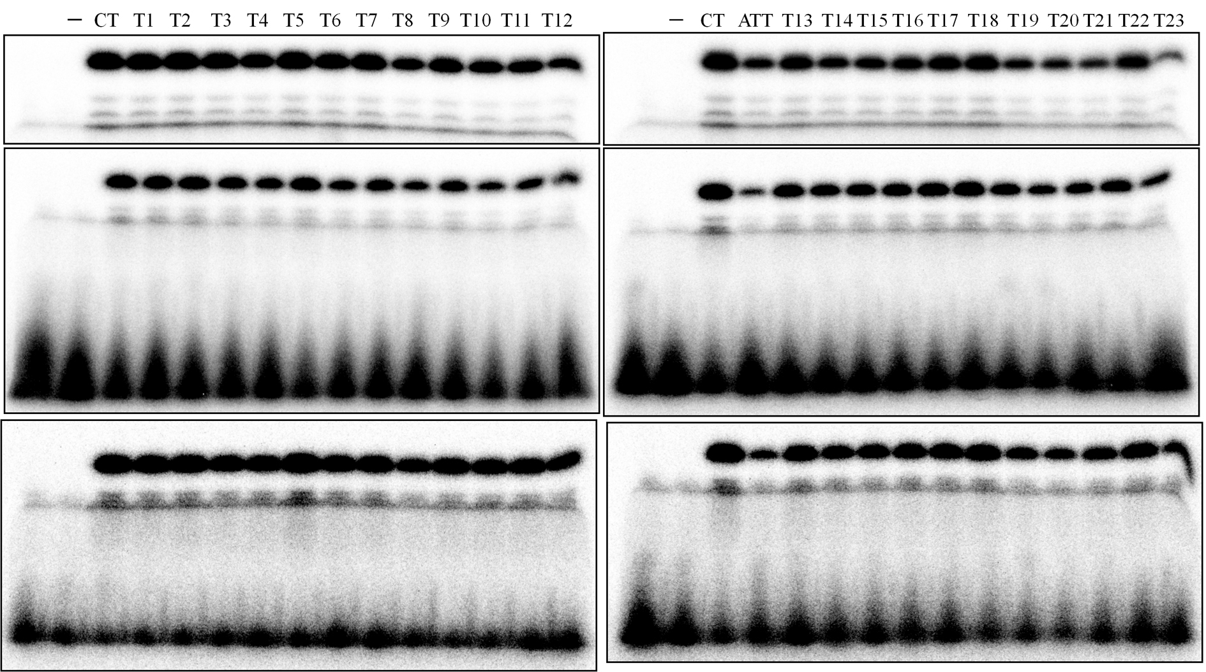
Supplementary figure S2. cOA synthesis gels for Figure 1.
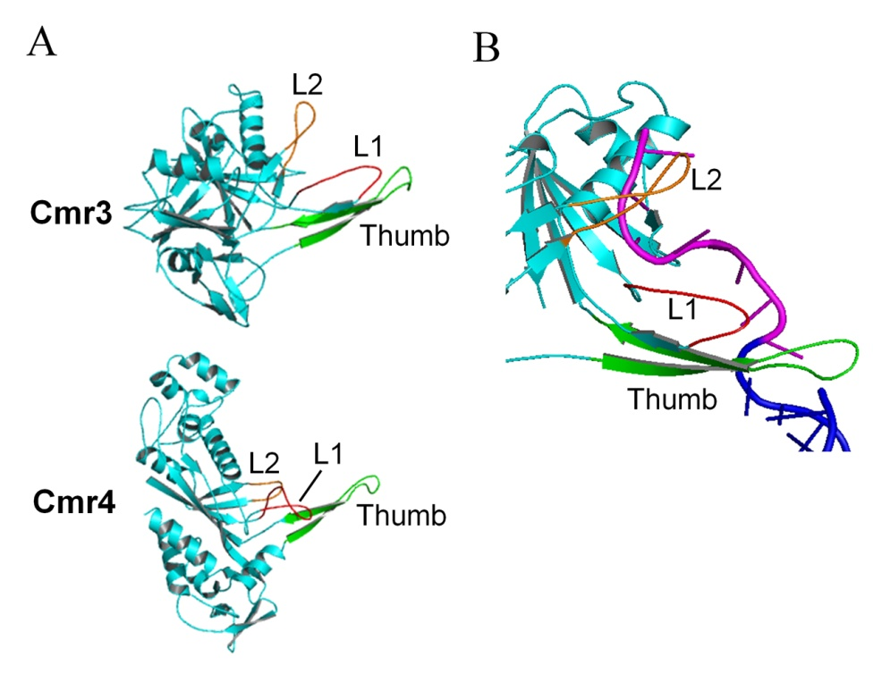
Supplementary figure S3. (A) Comparison of the structures of Cmr3 (upper panel) and Cmr4 (lower panel). Loop 1 (L1), loop 2 (L2) and thumb are shown in red, orange and green, respectively. (B) Interaction between Cmr3 and crRNA. The crRNA tag is shown in pink, while the spacer region of crRNA and target RNA are shown in blue. The structures are modified from P. furiosus Cmr3 and Archaeoglobus fulgidus Cmr4 (PDB: 3X1L, chain B and C respectively) using PyMOL (http://www.pymol.org)

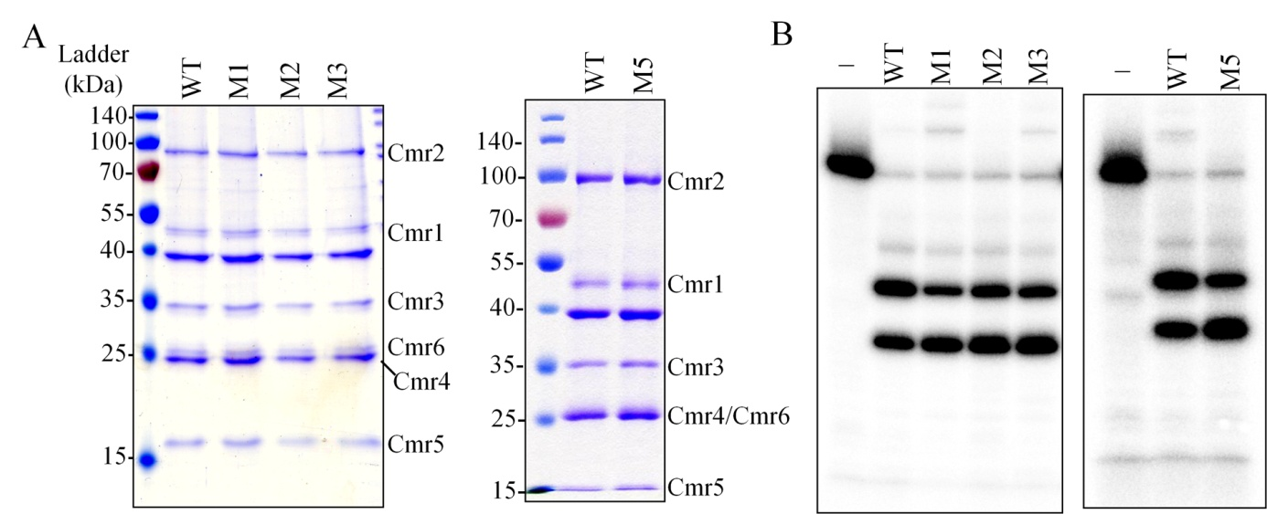
Supplementary figure S4. SDS-PAGE analysis (A) and RNA cleavage activity (B) of wild type and Cmr3α mutant complexes.

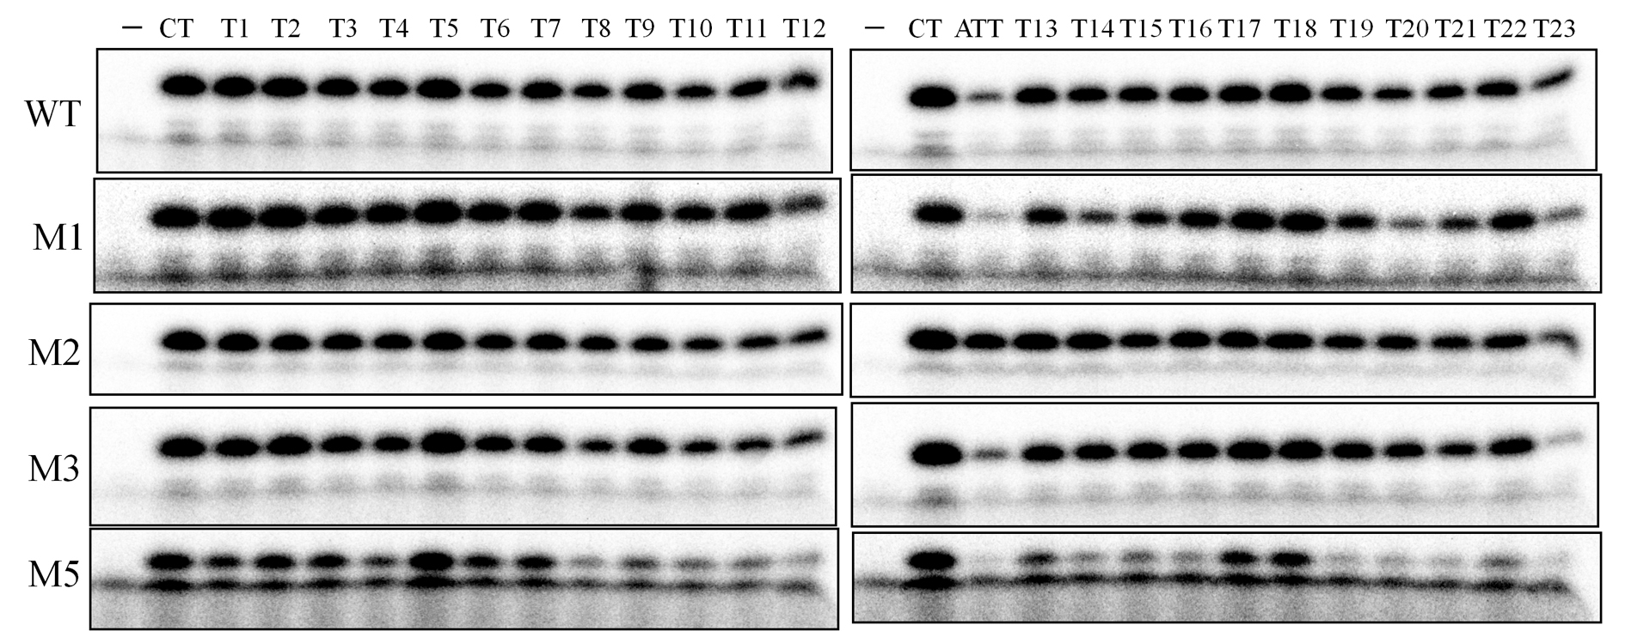
Supplementary figure S5. Representing gels for Figure 3 and Supplementary figure S6.

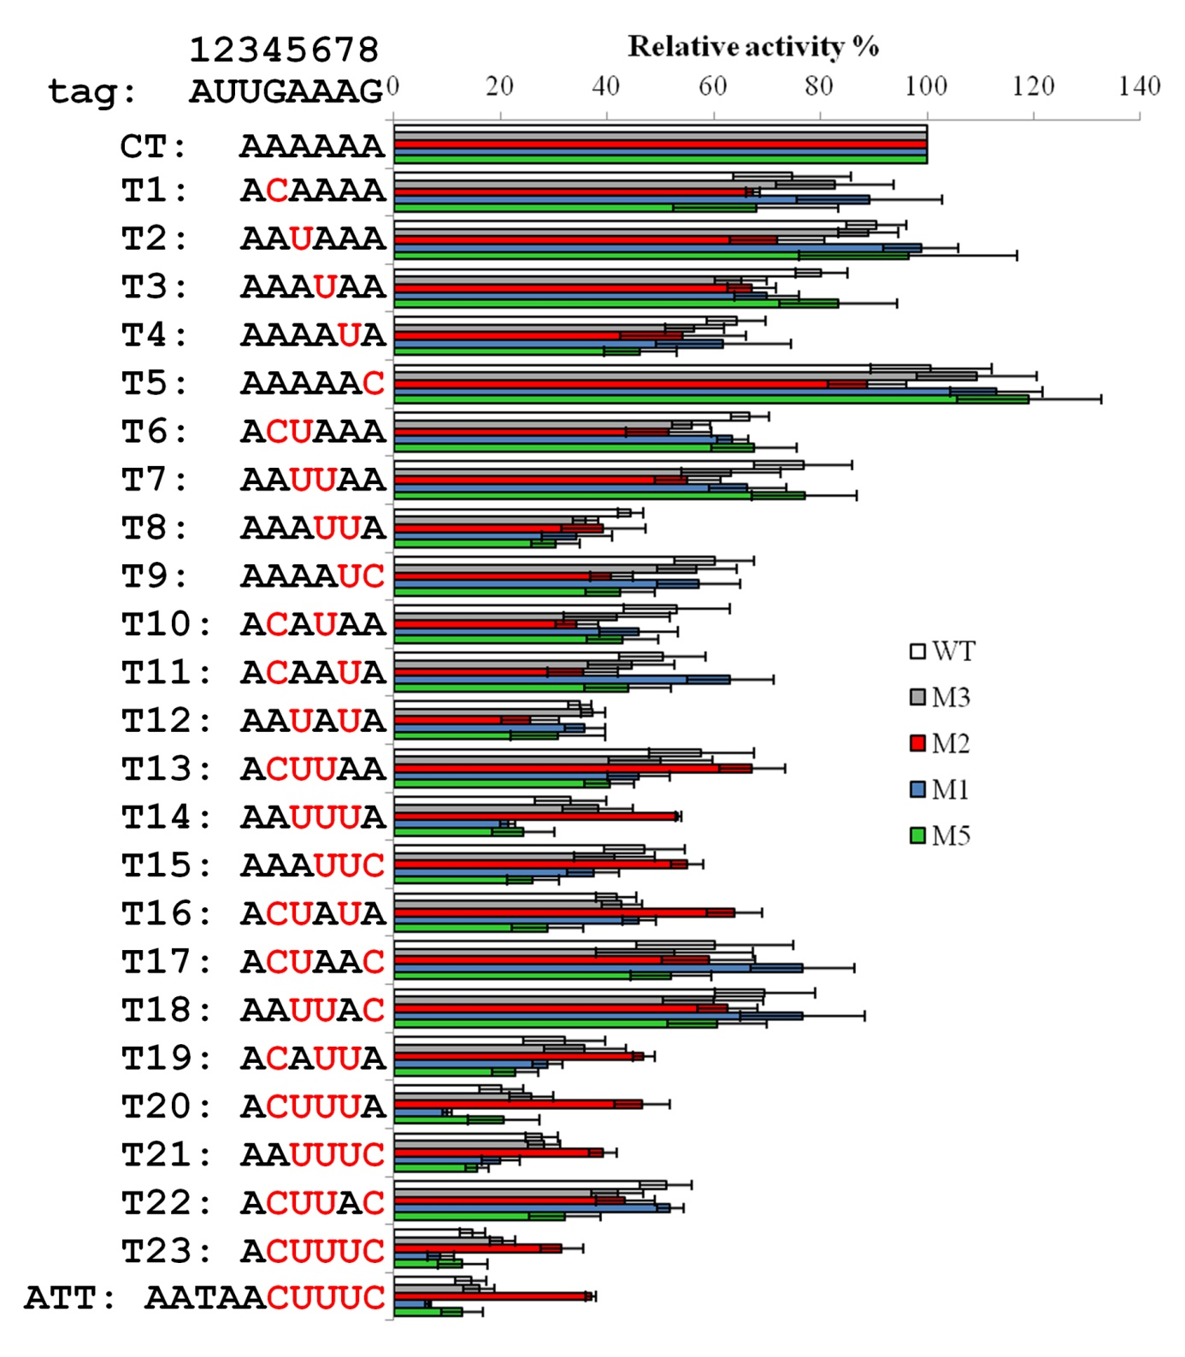Supplementary figure S6. The relative cOA synthesis activity of wild type and Cmr3α mutants in the presence of different activator RNA oligos. White: WT; gray: M3 (G24F); red: M2 (deletion of I21, L22 and L23); blue: M1 (I123A-Y124A); green: M5 (deletion of Y18, N19 and S20). Error bar represents SD of three independent experiments.

