***Supporting Information***

**Alkylthio- and alkyl-substituted asymmetric diphenyldiacetylene-based liquid crystals: phase transitions, mesophase and single-crystal structures, and birefringence**

Yuki Arakawa,a* Satoyoshi Inui,a Kazunobu Igawa b and Hideto Tsuji a

a Department of Environmental and Life Sciences, Graduate School of Engineering, Toyohashi University of Technology, Tempaku-cho, Toyohashi, Aichi 441-8580, Japan.

E-mail: ya017@edu.tut.ac.jp

b Institute for Materials Chemistry and Engineering, Kyushu University, Fukuoka 816-8580, Japan

***1H and 13C NMR and FT-IR characterisation data for 6S*–*DPDA*–*m***

**6S–DPDA–0:** 1H NMR (400 MHz, CDCl3) δ 7.55–7.50 (m, Ar–*H*, 2H), 7.42 (d, *J* = 8.8 Hz, Ar–*H*, 2H), 7.38–7.31 (m, Ar–*H*, 3H), 7.22 (d, *J* = 8.8 Hz, Ar–*H*, 2H), 2.94 (t, *J* = 7.6 Hz, S–C*H*2, 2H), 1.67 (tt, *J* = 7.2 and 7.6 Hz, S–CH2–C*H*2, 2H), 1.44 (tt, *J* = 7.2 and 7.4 Hz, S–(CH2)2–C*H*2, 2H), 1.36–1.24 (m, S–(CH2)3–(C*H*2)2, 4H), 0.89 (t, *J* = 6.8 Hz, C*H*3, 3H) ppm. 13C NMR (100 MHz, CDCl3) δ 139.7, 139.6, 132.7×2, 132.4×2, 129.2×2, 127.4×2, 118.7, 118.4, 82.1, 81.2, 74.3, 73.4, 32.7, 31.4, 28.9, 28.6, 22.5, 14.0 ppm. Yield: 22% (78 mg). FTIR (KBr): 2214, 2147 cm-1.

**6S–DPDA–1**: 1H NMR (400 MHz, CDCl3) δ 7.41 (d, *J* = 8.4 Hz, Ar–*H*, 2H), 7.41 (d, *J* = 8.4 Hz, Ar–*H*, 2H), 7.22 (d, *J* = 8.4 Hz, Ar–*H*, 2H), 7.14 (d, *J* = 8.4 Hz, Ar–*H*, 2H), 2.94 (t, *J* = 7.6 Hz, S–C*H*2, 2H), 2.37 (s, Ar–C*H*3, 3H), 1.67 (tt, *J* = 7.6 and 7.6 Hz, S–CH2–C*H*2, 2H), 1.43 (tt, *J* = 7.2 and 7.6 Hz, S–(CH2)2–C*H*2, 2H), 1.36–1.27 (m, S–(CH2)3–(C*H*2)2, 4H), 0.89 (t, *J* = 6.8 Hz, S–(CH2)5–C*H*3, 3H) ppm. 13C NMR (100 MHz, CDCl3) δ 139.7, 139.6, 132.7×2, 132.4×2, 129.2×2, 127.4×2, 118.7, 118.4, 82.1, 81.2, 74.3, 73.4, 32.7, 31.3, 28.9, 28.6, 22.5, 21.6, 14.0 ppm. Yield: 36% (136 mg). FTIR (KBr): 2140 cm-1.

**6S–DPDA–2**: 1H NMR (400 MHz, CDCl3) δ 7.44 (d, *J* = 8.0 Hz, Ar–*H*, 2H), 7.41 (d, *J* = 8.0 Hz, Ar–*H*, 2H), 7.21 (d, *J* = 8.0 Hz, Ar–*H*, 2H), 7.17 (d, *J* = 8.0 Hz, Ar–*H*, 2H), 2.94 (t, *J* = 7.4 Hz, S–C*H*2, 2H), 2.66 (q, *J* = 7.6 Hz, Ar–C*H*2, 2H), 1.67 (tt, *J* = 7.4 and 7.4 Hz, S–CH2–C*H*2, 2H), 1.43 (tt, *J* = 7.0 and 7.4 Hz, S–(CH2)2–C*H*2, 2H), 1.36–1.27 (m, S–(CH2)3–(C*H*2)2, 4H), 1.23 (t, *J* = 7.6 Hz, Ar–CH2–C*H*3, 3H), 0.89 (t, *J* = 6.6 Hz, S–(CH2)5–C*H*3, 3H) ppm. 13C NMR (100 MHz, CDCl3) δ 145.8, 139.7, 132.7×2, 132.5×2, 128.1×2, 127.4×2, 119.0, 118.4, 82.1, 81.1, 74.3, 73.4, 32.7, 31.3, 28.9×2, 28.6, 22.5, 15.2, 14.0 ppm. Yield: 33% (129 mg). FTIR (KBr): 2210, 2131 cm-1.

**6S–DPDA–3**: 1H NMR (400 MHz, CDCl3) δ 7.43 (d, *J* = 8.8 Hz, Ar–*H*, 2H), 7.41 (d, *J* = 8.4 Hz, Ar–*H*, 2H), 7.22 (d, *J* = 8.4 Hz, Ar–*H*, 2H), 7.15 (d, *J* = 8.8 Hz, Ar–*H*, 2H), 2.94 (t, *J* = 7.6 Hz, S–C*H*2, 2H), 2.59 (t, *J* = 7.6 Hz, Ar–C*H*2, 2H), 1.67 (tt, *J* = 7.6 and 7.6 Hz, S–CH2–C*H*2, 2H), 1.64 (tq, *J* = 7.2 and 7.6 Hz, Ar–CH2–C*H*2, 2H), 1.44 (tt, *J* = 7.4 and 7.6 Hz, S–(CH2)2–C*H*2, 2H), 1.37–1.22 (m, S–(CH2)3–(C*H*2)2, 4H), 0.94 (t, *J* = 7.2 Hz, Ar–(CH2)2–C*H*3, 3H), 0.89 (t, *J* = 6.8 Hz, S–(CH2)5–C*H*3, 3H) ppm. 13C NMR (100 MHz, CDCl3) δ 144.3, 139.7, 132.7×2, 132.4×2, 128.7×2, 127.4×2, 119.0, 118.4, 82.1, 81.2, 74.3, 73.4, 38.1, 32.7, 31.4, 28.9, 28.6, 24.3, 22.5, 14.0, 13.8 ppm. Yield: 34% (141 mg). FTIR (KBr): 2137 cm-1.

**6S–DPDA–4**: 1H NMR (400 MHz, CDCl3) δ 7.43 (d, *J* = 8.0 Hz, Ar–*H*, 2H), 7.41 (d, *J* = 8.4 Hz, Ar–*H*, 2H), 7.22 (d, *J* = 8.4 Hz, Ar–*H*, 2H), 7.15 (d, *J* = 8.0 Hz, Ar–*H*, 2H), 2.94 (t, *J* = 7.2 Hz, S–C*H*2, 2H), 2.62 (t, *J* = 7.6 Hz, Ar–C*H*2, 2H), 1.67 (tt, *J* = 7.2 and 7.2 Hz, S–CH2–C*H*2, 2H), 1.59 (tt, *J* = 7.6 and 7.6 Hz, Ar–CH2–C*H*2, 2H), 1.44 (tt, *J* = 7.2 and 7.2 Hz, S–(CH2)2–C*H*2, 2H), 1.33 (tq, *J* = 6.8 and 7.6 Hz, Ar–(CH2)2–C*H*2, 2H), 1.36–1.27 (m, S–(CH2)3–(C*H*2)2, 4H), 0.92 (t, *J* = 6.8 Hz, Ar–(CH2)3–C*H*3, 3H), 0.89 (t, *J* = 6.6 Hz, S–(CH2)5–C*H*3, 3H) ppm. 13C NMR (100 MHz, CDCl3) δ 144.6, 139.7, 132.7×2, 132.4×2, 128.6×2, 127.4×2, 118.9, 118.4, 82.1, 81.1, 74.3, 73.4, 35.7, 33.3, 32.7, 31.4, 28.9, 28.6, 22.5, 22.3, 14.0, 13.9 ppm. Yield: 37% (159 mg). FTIR (KBr): 2140 cm-1.

**6S–DPDA–5**: 1H NMR (400 MHz, CDCl3) δ 7.43 (d, *J* = 8.4 Hz, Ar–*H*, 2H), 7.41 (d, *J* = 8.0 Hz, Ar–*H*, 2H), 7.22 (d, *J* = 8.0 Hz, Ar–*H*, 2H), 7.14 (d, *J* = 8.4 Hz, Ar–*H*, 2H), 2.94 (t, *J* = 7.6 Hz, S–C*H*2, 2H), 2.61 (t, *J* = 7.6 Hz, Ar–C*H*2, 2H), 1.67 (tt, *J* = 7.6 and 7.6 Hz, S–CH2–C*H*2, 2H), 1.59 (tt, *J* = 7.6 and 7.6 Hz, Ar–CH2–C*H*2, 2H), 1.43 (tt, *J* = 7.2 and 7.6 Hz, S–(CH2)2–C*H*2, 2H), 1.38–1.25 (m, S–(CH2)3–(C*H*2)2 and Ar–(CH2)2–(C*H*2)2, 8H), 0.89 (t, *J* = 6.8 Hz, S–(CH2)5–C*H*3, 3H), 0.89 (t, *J* = 6.8 Hz, Ar–(CH2)4–C*H*3, 3H) ppm. 13C NMR (100 MHz, CDCl3) δ 144.6, 139.7, 132.7×2, 132.4×2, 128.6×2, 127.4×2, 118.9, 118.4, 82.1, 81.1, 74.3, 73.4, 36.0, 32.7, 31.4, 31.3, 30.8, 28.9, 28.6, 22.5×2, 14.0×2 ppm. Yield: 34% (120 mg). FTIR (KBr): 2136 cm-1.

**6S–DPDA–6**:1H NMR (400 MHz, CDCl3) δ 7.43 (d, *J* = 8.4 Hz, Ar–*H*, 2H), 7.41 (d, *J* = 8.4 Hz, Ar–*H*, 2H), 7.22 (d, *J* = 8.4 Hz, Ar–*H*, 2H), 7.14 (d, *J* = 8.4 Hz, Ar–*H*, 2H), 2.94 (t, *J* = 7.2 Hz, S–C*H*2, 2H), 2.61 (t, *J* = 7.6 Hz, Ar–C*H*2, 2H), 1.67 (tt, *J* = 7.2 and 7.6 Hz, S–CH2–C*H*2, 2H), 1.60 (tt, *J* = 7.2 and 7.6 Hz, Ar–CH2–C*H*2, 2H), 1.44 (tt, *J* = 7.4 and 7.6 Hz, S–(CH2)2–C*H*2, 2H), 1.36–1.25 (m, S–(CH2)3–(C*H*2)2 and Ar–(CH2)2–(C*H*2)3, 10H), 0.89 (t, *J* = 6.8 Hz, S–(CH2)5–C*H*3, 3H), 0.88 (t, *J* = 6.8 Hz, Ar–(CH2)5–C*H*3, 3H) ppm. 13C NMR (100 MHz, CDCl3) δ 144.6, 139.7, 132.7×2, 132.4×2, 128.6×2, 127.4×2, 118.9, 118.4, 82.1, 81.1, 74.3, 73.4, 36.0, 32.7, 31.7, 31.3, 31.1, 28.9×2, 28.6, 22.6, 22.5, 14.1, 14.0 ppm. Yield: 27% (100 mg). FTIR (KBr): 2212, 2141 cm-1.

**6S–DPDA–8**: 1H NMR (400 MHz, CDCl3) δ 7.43 (d, *J* = 8.4 Hz, Ar–*H*, 2H), 7.41 (d, *J* = 8.4 Hz, Ar–*H*, 2H), 7.22 (d, *J* = 8.4 Hz, Ar–*H*, 2H), 7.14 (d, *J* = 8.4 Hz, Ar–*H*, 2H), 2.94 (t, *J* = 7.4 Hz, S–C*H*2, 2H), 2.60 (t, *J* = 7.2 Hz, Ar–C*H*2, 2H), 1.67 (tt, *J* = 7.0 and 7.4 Hz, S–CH2–C*H*2, 2H), 1.60 (tt, *J* = 7.0 and 7.2 Hz, Ar–CH2–C*H*2, 2H), 1.43 (tt, *J* = 7.0 and 7.2 Hz, S–(CH2)2–C*H*2, 2H), 1.37–1.21 (m, S–(CH2)3–(C*H*2)2 and Ar–(CH2)2–(C*H*2)5, 14H), 0.89 (t, *J* = 6.8 Hz, S–(CH2)5–C*H*3, 3H), 0.88 (t, *J* = 6.8 Hz, Ar–(CH2)7–C*H*3, 3H) ppm. 13C NMR (100 MHz, CDCl3) δ 144.6, 139.7, 132.7×2, 132.4×2, 128.6×2, 127.4×2, 118.9, 118.4, 82.1, 81.1, 74.3, 73.4, 36.0, 32.7, 31.9, 31.3, 31.2, 29.4, 29.3, 29.2, 28.9, 28.6, 22.7, 22.5, 14.1, 14.0 ppm. Yield: 39% (152 mg). FTIR (KBr): 2212, 2142 cm-1.

**6S–DPDA–12**: 1H NMR (400 MHz, CDCl3) δ 7.43 (d, *J* = 8.4 Hz, Ar–*H*, 2H), 7.41 (d, *J* = 8.4 Hz, Ar–*H*, 2H), 7.22 (d, *J* = 8.4 Hz, Ar–*H*, 2H), 7.14 (d, *J* = 8.4 Hz, Ar–*H*, 2H), 2.94 (t, *J* = 7.4 Hz, S–C*H*2, 2H), 2.60 (t, *J* = 7.6 Hz, Ar–C*H*2, 2H), 1.67 (tt, *J* = 7.4 and 7.4 Hz, S–CH2–C*H*2, 2H), 1.60 (tt, *J* = 7.0 and 7.6 Hz, Ar–CH2–C*H*2, 2H), 1.44 (tt, *J* = 7.4 and 7.4 Hz, S–(CH2)2–C*H*2, 2H), 1.37–1.20 (m, S–(CH2)3–(C*H*2)2 and Ar–(CH2)2–(C*H*2)9, 22H), 0.89 (t, *J* = 7.0 Hz, S–(CH2)5–C*H*3, 3H), 0.88 (t, *J* = 7.0 Hz, Ar–(CH2)11–C*H*3, 3H) ppm. 13C NMR (100 MHz, CDCl3) δ 144.6, 139.7, 132.7×2, 132.4×2, 128.6×2, 127.4×2, 118.9, 118.4, 82.1, 81.1, 74.3, 73.4, 36.0, 32.7, 31.9, 31.4, 31.2, 29.7×3, 29.6, 29.5, 29.4, 29.3, 28.9, 28.6, 22.7, 22.5, 14.1, 14.0 ppm. Yield: 27% (121 mg). FTIR (KBr): 2211, 2141 cm-1.

**POM images**

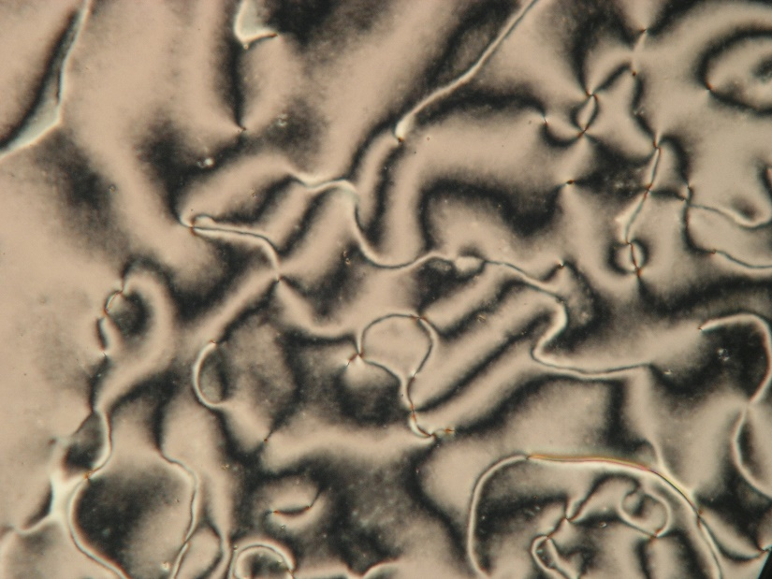

Figure S1. POM image of N phase at 60 ºC for 6S–DPDA–2.

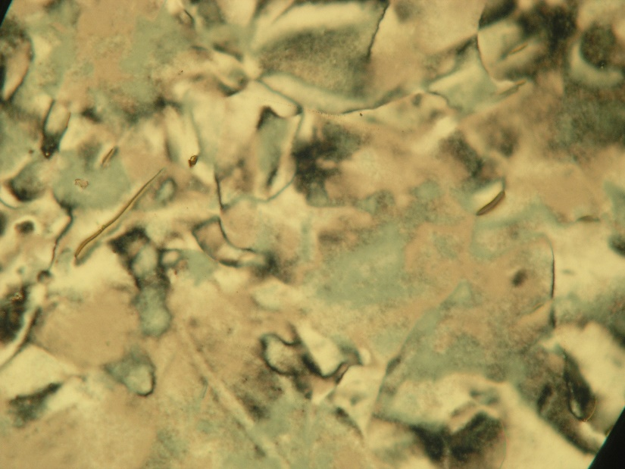

Figure S2. POM image of N phase at 80 ºC for 6S–DPDA–3.

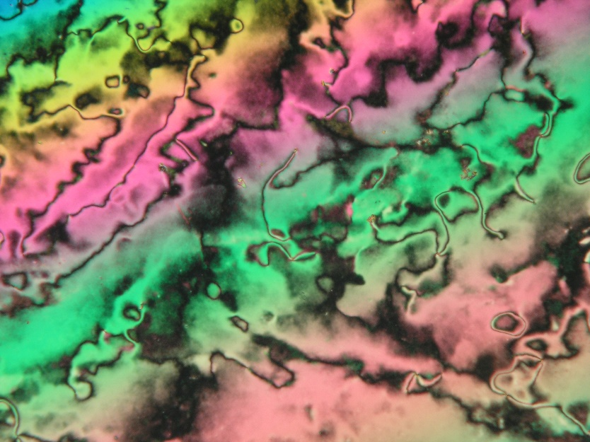

Figure S3. POM image of N phase at 60 ºC for 6S–DPDA–4.

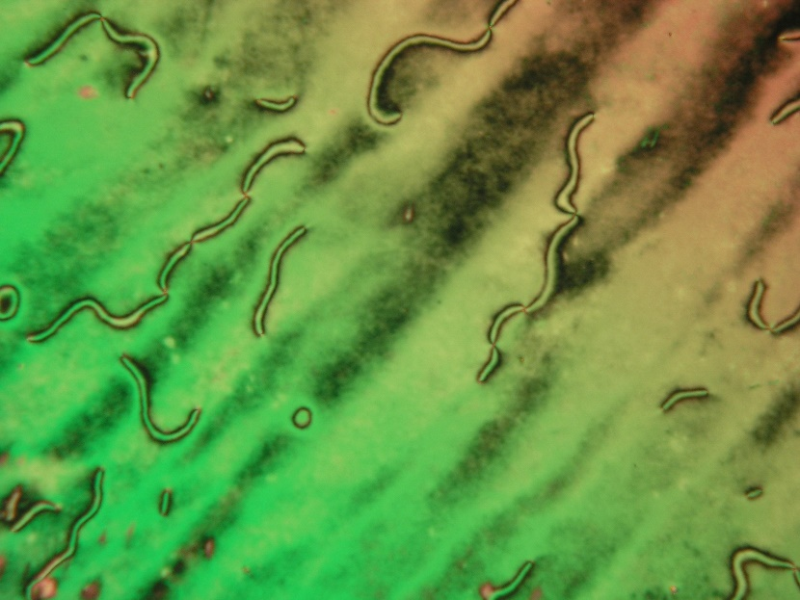

Figure S4. POM image of N phase at 80 ºC for 6S–DPDA–5.

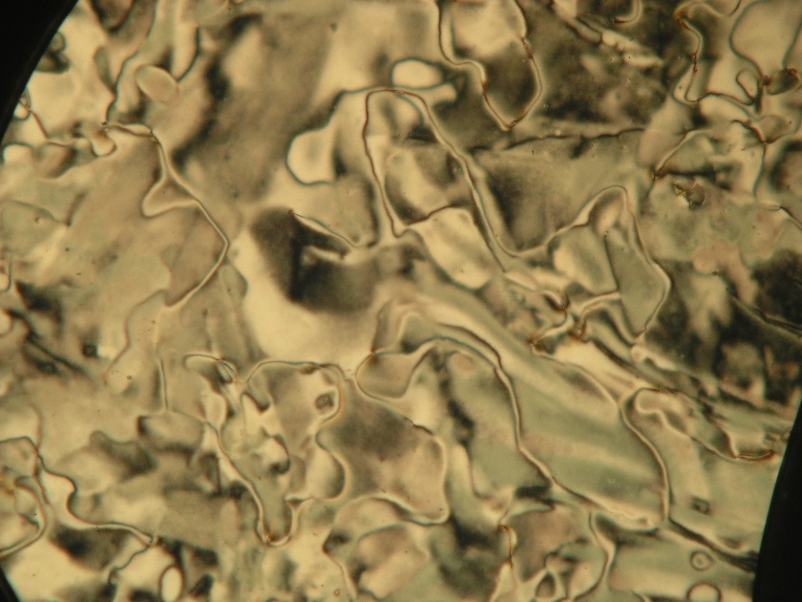

Figure S5. POM image of N phase at 70 ºC for 6S–DPDA–6.

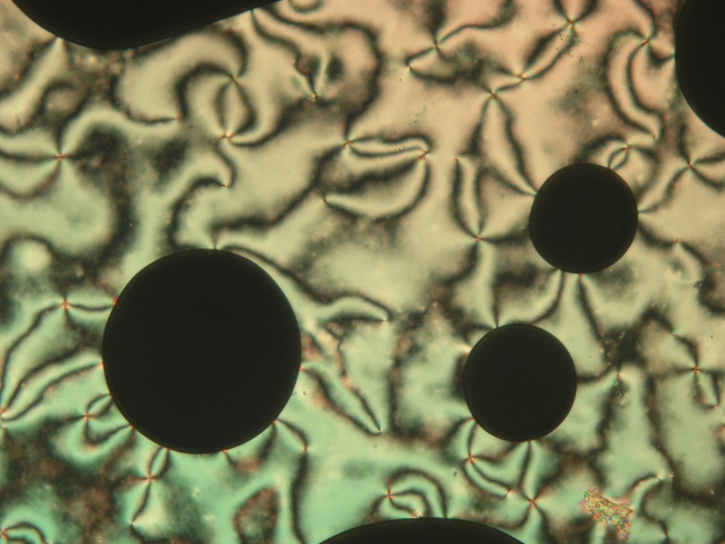

Figure S6. POM image of N phase at 80 ºC for 6S–DPDA–7.

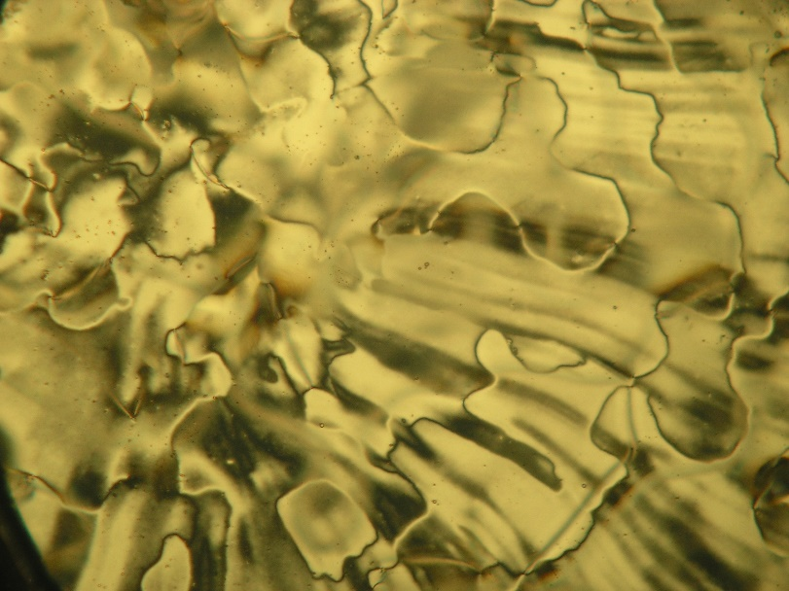

Figure S7. POM image of N phase at 60 ºC for 6S–DPDA–8.

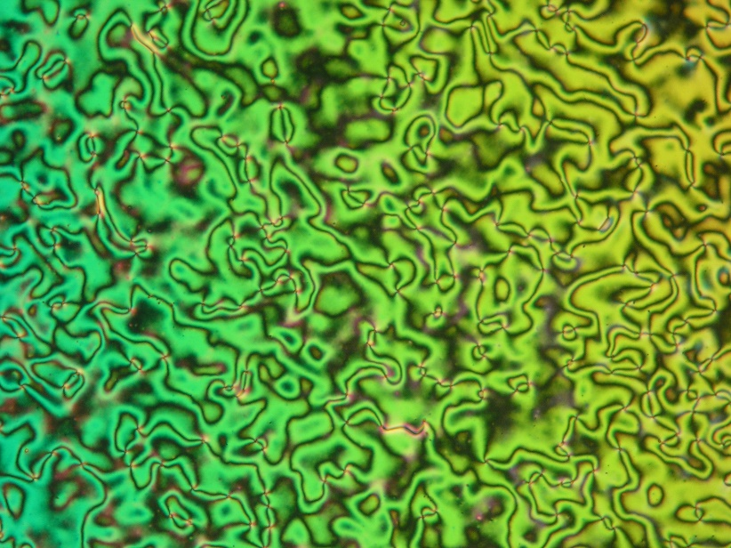

Figure S8. POM image of N phase at 70 ºC for 6S–DPDA–12.

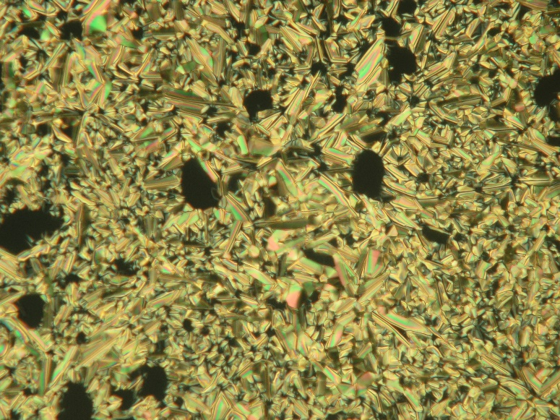

Figure S9. POM image of highly ordered X phase at 40 ºC for 6S–DPDA–12.

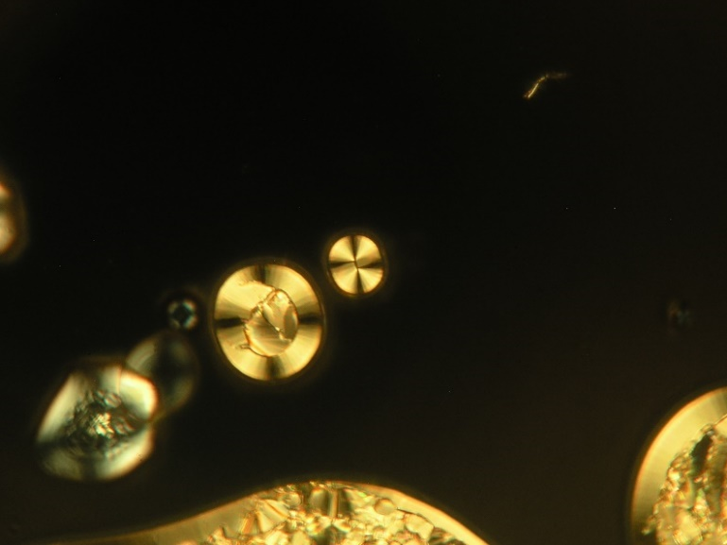

Figure S10. POM image of highly ordered X phase at 30 ºC

for other parts of 6S–DPDA–12.

***DSC measurements***

In those cases with a detectable difference between the 1st and 2nd heating, the DSC curves upon 1st cooling are also shown by dashed lines.

Figure S11. DSC curve for 6S–DPDA–0.

Figure S12. DSC curve for 6S–DPDA–1.

Figure S13. DSC curve for 6S–DPDA–2.

Figure S14. DSC curve for 6S–DPDA–3.

Figure S15. DSC curve for 6S–DPDA–4.

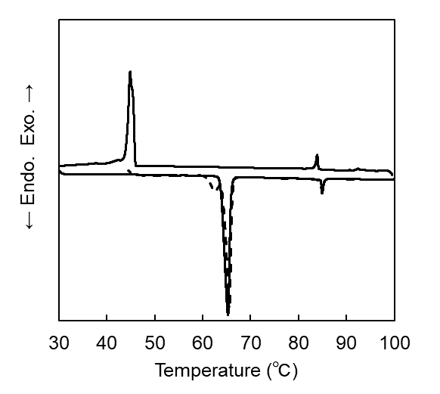

Cr

Cr

NC

N

Cr

Cr

Figure S16. DSC curve for 6S–DPDA–5.

Figure S17. DSC curve for 6S–DPDA–6.

Figure S18. DSC curve for 6S–DPDA–7.

Figure S19. DSC curve for 6S–DPDA–8.

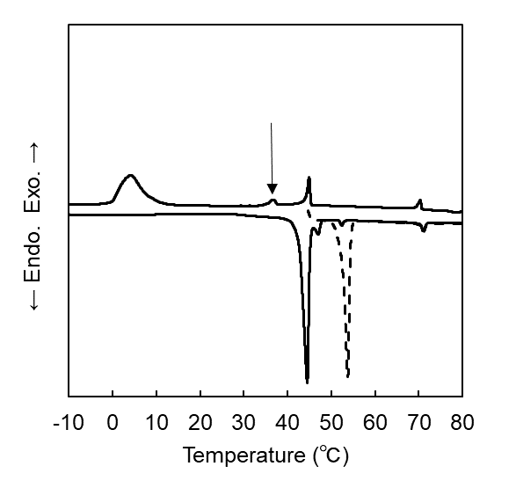

Cr

X

N

Iso

Iso

N

X

Due to liquid nitrogen

Cr

Figure S20. DSC curve for 6S–DPDA–12.

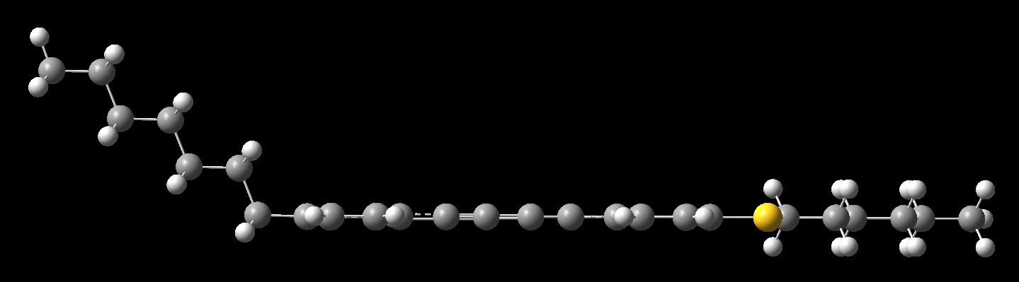

Figure S21. The optimised structure for 6S–DPDA–7 based on DFT calculation using Gaussian 16 with the spacer in the all-trans conformation at the B3LYP/6-31G(d) level of theory.