Supporting Information
Highly polarized luminescence from ordered guest-host systems
SchemeS1. Synthetic route of T₁, T₂, T₃and T₄.
1.1 Synthesis of 4,7-bis (4- methoxyphenyl) benzo-2,1,3-thiadizole (1)
Dibrombenzothidiazole (11.76g, 40mmol), 4-methoxyphenylboronic acid (15.19g, 100mmol) and Pd(PPh₃)₄ (3.48g, 3mmol) were added to a 500mL two-neck flask equipped with septum. The flask was evacuated and back filled with nitrogen. 1,4-dioxane (210mL) and K₂CO₃ (2M, 60mL, 120mmol) was added via a syringe at room temperature. The reaction mixture was heated at 110 °C for 24h. The precipitation was collected by filtration and the crude product was performed silica gel column to give a yellow green powder (9.53g) with a yield of 68.4%.
¹H-NMR ( CDCl₃, 600 MHz, δ= ppm ): 7.92 ( d, 4 H, J = 9.0 Hz ), 7.71 ( s, 2 H ), 7.08 ( d, 4 H, J = 9.0 Hz ), 3.89 ( s, 6 H ).
¹³C-NMR ( CDCl₃, 150 MHz, δ= ppm ): 162.39, 156.85, 134.98, 133.04, 132.65, 130.09, 116.75, 58.08.
1.2 Synthesis of 4,7-bis(4-hydroxyphenyl) benzo-2,1,3-thiadizole (2)
4,7-bis(4-methoxyphenyl)benzo-2,1,3-thiadizole (1) (4.65g, 13mmol) and tetrabutylammoni-um bromide (4.62g, 13mmol) were added to a 250mL flask. Then, HBr (33% in HOAc, 100mL) was added. The mixture was heated for 24h at 100 °C, then cooled to room temperature, and 300mL water was added. The precipitation was collected by filtration and washed with methanol to give a yellow powder (3.05g) with a yield of 72.2%.
¹H-NMR ( DMSO, 600 MHz, δ= ppm ): 9.74 ( s, 2 H ) , 7.86 ( d, 4 H, J = 6.0Hz ) , 7.80 ( s, 2 H ) , 6.92 ( d, 4 H, J = 6.0Hz).
¹³C-NMR ( DMSO, 150 MHz, δ= ppm ): 160.79, 156.59, 133.40, 130.25, 118.48, 109.99.
1.3 Synthesis of 6-bromohexyloxy acrylate (3)
Triethylamine (2.62g, 26mmol) was added to a cold solution (0 °C) of 6-bromohexyloxy (3.60g, 20mmol) in 50mL of CH₂Cl₂.Then, acryloyl chloride (1.98 g, 22 mmol) was added dropwise to the solution at 0 °C. The solution was allowed to stir for 24h at 25 °C and 30 mL water was added. The solution was extracted with CH₂Cl₂ for three times and the organic solution was collected, dried with NaSO₄ and evaporated with a rotary evaporator to give the brown liquid monomer (3.62g) with a yield of 77.0%.
¹H-NMR ( CDCl₃, 600 MHz, δ= ppm ): 6.37 ( d, 1 H, J = 12.0 Hz ) , 6.09 ( q, 1 H , J = 10.0 Hz ) , 5.79 ( d, 1 H, J = 12.0 Hz ) , 4.13 ( t, 2 H, J = 6.0 Hz ) , 3.38 ( t, 2 H, J = 6.0 Hz ) , 1.84 ( m, 2 H, J = 6.0 Hz ) , 1.66 ( m, 2 H, J = 6.0 Hz ) , 1.45 ( m, 2 H, J = 6.0 Hz ) , 1.38 ( m, 2 H, J = 6.0 Hz ).
¹³C-NMR ( CDCl₃, 150 MHz, δ= ppm ): 168.96, 133.30, 131.15, 67.07, 36.43, 35.25, 31.09, 30.44, 27.82.
1.4 Synthesis of 9-bromononyloxy acrylate (4)
Triethylamine (2.62 g, 26 mmol) was added to a cold solution (0 °C) of 9-bromononyloxy (4.46 g, 20 mmol) in 50 mL of CH₂Cl₂. Then, acryloyl chloride (1.98 g, 22 mmol) was added dropwise to the solution at 0 °C. The solution was allowed to stir for 24 h at 25 °C and 30 mL water was added. The solution was extracted with CH₂Cl₂ for three times and the organic solution was collected, dried with NaSO₄ and evaporated with a rotary evaporator to give the brown liquid monomer (4.34 g) with a yield of 78.3%.
¹H-NMR ( CDCl₃, 600 MHz, δ= ppm ): 6.36 ( d, 1 H, J = 12.0 Hz ) , 6.08 ( q, 1 H , J = 10.0 Hz ) , 5.78 ( d, 1 H, J = 12.0 Hz ) , 4.12 ( t, 2 H, J = 6.0 Hz ) , 3.37 ( t, 2 H, J = 6.0 Hz ) , 1.83 ( m, 2 H, J = 6.0 Hz ) , 1.64 ( m, 2 H, J = 6.0 Hz ) , 1.42 ( m, 2 H, J = 6.0 Hz ) , 1.35 ( m, 8 H, J = 6.0 Hz ).
¹³C-NMR ( CDCl₃, 150 MHz, δ= ppm ): 168.87, 133.26, 131.22, 67.13, 36.67, 35.23, 32.25, 32.09, 31.57, 31.25, 30.54, 28.17.
1.5 Synthesis of 11-bromoundecyloxy acrylate (5)
Triethylamine (2.62 g, 26 mmol) was added to a cold solution (0 °C) of 11-bromoundecyloxy (5.07 g, 20 mmol) in 50 mL of CH₂Cl₂. Then, acryloyl chloride (1.98 g, 22 mmol) was added dropwise to the solution at 0 °C. The solution was allowed to stir for 24 h at 25 °C and 30 mL water was added. The solution was extracted with CH₂Cl₂ for three times and the organic solution was collected, dried with NaSO₄ and evaporated with a rotary evaporator to give the brown liquid monomer (4.54 g) with a yield of 74.5%.
¹H-NMR ( CDCl₃, 600 MHz, δ= ppm ): 6.36 ( d, 1 H, J = 12.0 Hz ) , 6.09 ( q, 1 H , J = 10.0 Hz ) , 5.78 ( d, 1 H, J = 12.0 Hz ) , 4.11 ( t, 2 H, J = 6.0 Hz ) , 3.37 ( t, 2 H, J = 6.0 Hz ) , 1.82 ( m, 2 H, J = 6.0 Hz ) , 1.63 ( m, 2 H, J = 6.0 Hz ) , 1.39 ( m, 2 H, J = 6.0 Hz ) , 1.31 ( m, 12 H, J = 6.0 Hz ).
¹³C-NMR ( CDCl₃, 150 MHz, δ= ppm ): 168.99, 133.14, 131.25, 67.35, 36.75, 35.46, 32.10, 32.08, 32.05, 31.87, 31.40, 31.23, 30.81, 28.55.
1.6 Synthesis of 4,7-Bis(4-hexyloxy acrylate)phenyl)benzo-2,1,3-thiadizole (T₁)
4,7-bis(4-hydroxyphenyl) benzo-2,1,3-thiadizole (2) (1.28 g, 4 mmol), K₂CO₃ (1.38 g, 10 mmol), 6-bromohexyloxy acrylate (3) (2.08 g, 8.8 mmol) and 25mLDMF were added to a 100mL two-neck flask. The reaction mixture was heated at 90 °C for 24 h, then cooled to room temperature, and 200 mL water was added. The solution was extracted with CH₂Cl₂ for three times and the organic solution was collected, dried with NaSO₄ and evaporated with a rotary evaporator. The crude product was performed silica gel column to give a yellow green powder (1.71 g) with a yield of 68.2%.
¹H-NMR ( CDCl₃, 600 MHz, δ= ppm ): 7.91 ( d, 4 H, J = 12.0 Hz ) , 7.72 ( s, 2 H ) , 7.07 ( d, 4 H, J = 6.0 Hz ) , 6.42 ( d, 2 H, J = 12.0 Hz ) , 6.14 ( q, 2 H, J = 10.0 Hz ) , 5.83 ( d, 2 H, J = 12.0 Hz ) , 4.19 ( t, 4 H, J = 6.0 Hz ) , 4.05 ( t, 4 H, J = 6.0 Hz ) , 1.85 ( m, 4 H, J = 6.0 Hz ) , 1.73 ( m, 4 H, J = 6.0 Hz) , 1.53 ( m, 8 H, J = 12.0 Hz ).
¹³C-NMR ( CDCl₃, 150 MHz, δ= ppm ): 169.03, 161.90, 156.85, 134.98, 133.29, 133.01, 132.49, 131.22, 130.05, 117.27, 70.52, 67.22, 31.82, 31.24, 28.44.
FT-IR ( KBr, cm⁻¹ ): 2931 (vs), 1723 (vs), 1604 (s), 1512 (s), 1470 (vs), 1408 (vs), 1249 (vs), 1179 (vs), 1070 (vs), 1003 (vs), 891 (vs), 815 (vs).
HRMS (MALDI-TOF) m/z: Found: [M+H]⁺ 628.2582; molecular formula C₃₆H₄₀N₂O₆S requires [M+H]⁺ 628.2607.
1.7 Synthesis of 4,7-Bis(4-nonyloxy acrylate)phenyl)benzo-2,1,3-thiadizole (T₂)
4,7-bis(4-hydroxyphenyl) benzo-2,1,3-thiadizole (2) (1.28 g, 4 mmol), K₂CO₃ (1.38 g, 10 mmol),9-bromononyloxy acrylate (4) (2.43 g, 8.8 mmol) and 25mLDMF were added to a 100mL two-neck flask. The reaction mixture was heated at 90 °C for 24 h, then cooled to room temperature, and 200 mL water was added. The solution was extracted with CH₂Cl₂ for three times and the organic solution was collected, dried with NaSO₄ and evaporated with a rotary evaporator. The crude product was performed silica gel column to give a yellow green powder (1.93 g) with a yield of 67.7%.
¹H-NMR ( CDCl₃, 600 MHz, δ= ppm ): 7.91 ( d, 4 H, J = 6.0 Hz ) , 7.72 ( s, 2 H ) , 7.07 ( d, 4 H, J = 6.0 Hz ) , 6.40 ( d, 2 H, J = 12.0 Hz ) , 6.12 ( q, 2 H, J = 10.0 Hz ) , 5.82 ( d, 2 H, J = 12.0 Hz ) , 4.16 ( t, 4 H, J = 6.0 Hz ) , 4.05 ( t, 4 H, J = 6.0 Hz ) , 1.83 ( m, 4 H, J = 6.0 Hz ) , 1.68 ( m, 4 H, J = 6.0 Hz) , 1.49 ( m, 4 H, J = 6.0 Hz ) , 1.38 ( m, 16 H, J = 12.0 Hz ).
¹³C-NMR ( CDCl₃, 150 MHz, δ= ppm ): 168.98, 161.99, 156.87, 134.99, 133.05, 132.97, 132.44, 131.29, 130.00, 117.30, 70.73, 67.33, 32.07, 31.93, 31.90 31.83, 31.25, 28.68, 28.56.
FT-IR ( KBr, cm⁻¹ ): 2927 (vs), 1721 (s), 1603 (vs), 1512 (s), 1471 (s), 1406 (s), 1248 (vs), 1183 (vs), 1062 (vs), 887 (m), 816 (vs).
HRMS (MALDI-TOF) m/z: Found: [M+H]⁺ 712.3527; molecular formula C₄₂H₅₂N₂O₆S requires [M+H]⁺ 712.3546.

1.8 Synthesis of 4,7-Bis(4-undecyloxy acrylate)phenyl)benzo-2,1,3-thiadizole (T₃)
4,7-bis(4-hydroxyphenyl) benzo-2,1,3-thiadizole (2) (1.28 g, 4 mmol), K₂CO₃ (1.38 g, 10 mmol),11-bromoundecyloxy acrylate(5) (2.67 g, 8.8 mmol) and 25mLDMF were added to a 100mL two-neck flask. The reaction mixture was heated at 90 °C for 24 h, then cooled to room temperature, and 200 mL water was added. The solution was extracted with CH₂Cl₂ for three times and the organic solution was collected, dried with NaSO₄ and evaporated with a rotary evaporator. The crude product was performed silica gel column to give a yellow green powder (1.91 g) with a yield of 62.2%.
¹H-NMR ( CDCl₃, 600 MHz, δ= ppm ): 7.91 ( d, 4 H, J = 6.0 Hz ) , 7.71 ( s, 2 H ) , 7.07 ( d, 4 H, J = 6.0 Hz ) , 6.40 ( d, 2 H, J = 12.0 Hz ) , 6.12 ( q, 2 H, J = 10.0 Hz ) , 5.82 ( d, 2 H, J = 12.0 Hz ) , 4.15 ( t, 4 H, J = 6.0 Hz ) , 4.04 ( t, 4 H, J = 6.0 Hz ) , 1.83 ( m, 4 H, J = 7.5 Hz ) , 1.67 ( m, 4 H, J = 6.0 Hz) , 1.48 ( m, 4 H, J = 6.0 Hz ) , 1.31 ( m, 24 H, J = 12.0 Hz ).
¹³C-NMR ( CDCl₃, 150 MHz, δ= ppm ): 169.05, 161.98, 156.86, 134.98, 133.18, 132.98, 132.41, 131.27, 130.04, 117.28, 70.75, 67.41, 32.22, 32.17, 32.05, 31.92, 31.26, 28.73, 28.59.
FT-IR ( KBr, cm⁻¹ ): 2920 (vs), 1723 (s), 1604 (vs), 1512 (s), 1470 (s), 1408 (s), 1249 (vs), 1198 (vs), 1042 (vs), 974 (s), 887 (m), 818 (vs).
HRMS (MALDI-TOF) m/z: Found: [M+H]⁺ 768.4172; molecular formula C₄₆H₆₀N₂O₆S requires [M+H]⁺ 768.4153.
1.9 Synthesis of 4,7-Bis(4-nonylalkoxy)phenyl)benzo-2,1,3-thiadizole (T₄)
4,7-bis(4-hydroxyphenyl) benzo-2,1,3-thiadizole (2) (1.28 g, 4 mmol), K₂CO₃ (1.38 g, 10 mmol),1-Bromononane(1.82 g, 8.8 mmol) and 25mLDMF were added to a 100mL two-neck flask. The reaction mixture was heated at 90 °C for 24 h, then cooled to room temperature, and 200 mL water was added. The solution was extracted with CH₂Cl₂ for three times and the organic solution was collected, dried with NaSO₄ and evaporated with a rotary evaporator. The crude product was performed silica gel column to give a yellow green powder (1.65 g) with a yield of 72.3%.
¹H-NMR ( CDCl₃, 600 MHz, δ= ppm ): 7.91 ( d, 4 H, J = 6.0 Hz ) , 7.91 ( d, 4 H, J = 12.0 Hz ) , 7.72 ( s, 2 H ) , 7.07 ( d, 4 H, J = 12.0 Hz ) , 4.04 ( t, 4 H, J = 6.0 Hz ) , 1.83 ( m, 4 H, J = 6.0 Hz ) , 1.49 ( m, 4 H, J = 6.0 Hz) , 1.33 ( m, 20 H, J = 6.0 Hz ) , 0.89 ( t, 6 H, J = 6.0 Hz ).
¹³C-NMR ( CDCl₃, 150 MHz, δ= ppm ): 162.02, 156.88, 135.01, 132.97, 132.43, 130.00, 117.32, 70.80, 34.54, 32.21, 32.06, 31.93, 31.25, 28.72, 25.33, 16.76.
FT-IR ( KBr, cm⁻¹ ): 2922 (vs), 1719 (s), 1603 (vs), 1517 (s), 1471 (s), 1402 (s), 1237 (vs), 1183 (vs), 1062 (vs), 887 (m), 816 (vs).
HRMS (MALDI-TOF) m/z: Found: [M+H]⁺572.3418; molecular formula C₃₆H₄₈N₂O₂S requires [M+H]⁺572.3436.
SchemeS2. Synthetic route of LC monomer P.
2.1 Synthesis of (4- hydroxyhexoxy) ethylbenzoate (6)
Ethyl 4-hydroxybenzoate (9.96 g, 60 mmol), K₂CO₃ (9.98 g, 60 mmol) and 80 mL DMF were added to a 250 mL two-neck flask. The reaction mixture was heated at 90 °C for 24 h, then cooled to room temperature, and 500 mL water was added. The solution was extracted with ethyl acetate for three times and the organic solution was collected, dried with NaSO₄ and evaporated with a rotary evaporator to give the pale yellow liquid monomer (13.24 g) with a yield of 82.9%.
¹H-NMR ( CDCl₃, 600 MHz, δ= ppm ): 7.91 ( d, 2 H, J = 6.0 Hz ) , 6.82 ( d, 2 H, J = 6.0Hz ) , 4.27 ( q, 2 H, J = 9.0 Hz ) , 3.93 ( t, 2 H, J = 6.0 Hz ) , 3.58 ( t, 2 H, J = 6.0 Hz ) , 2.43 ( s, 1 H ) , 1.74 ( m, 2 H, J = 4.5 Hz ) , 1.53 ( m, 2 H, J = 6.0 Hz ) , 1.40 ( m, 4 H, J = 7.5 Hz ) , 1.30 ( t, 3 H, J = 8.0 Hz ).
¹³C-NMR ( CDCl₃, 150 MHz, δ= ppm ): 169.09, 165.45, 134.14, 125.34, 116.64, 70.66, 65.45, 63.25, 35.24, 31.73, 28.47, 28.17, 17.02.
2.2 Synthesis of (4- hydroxyhexoxy)benzoicacid (7)
(4- hydroxyhexoxy) ethylbenzoate (6) (10.64 g, 40 mmol) and 100mL THF were added to a 250 mL two-neck flask. Then, KOH (6.72 g, 120mmol) in aqueous solutions 50mL was added. The reaction mixture was heated at 90 °C for 24 h, then cooled to room temperature. The precipitation was collected by filtration and dissolved in 400mL H₂O. The product was separated outafter regulate pH = 1 and collected by filtration to give the white powder (8.76 g) with a yield of 92.0%.
¹H-NMR ( DMSO, 600 MHz, δ= ppm ): 12.57 ( s, 1 H ) , 7.87 ( t, 2 H, J = 6.0Hz ) , 6.99 ( t, 2 H, J = 9.0 Hz ) , 4.34 ( s, 1 H ), 4.03 ( t, 2 H, J = 6.0 Hz ) , 3.39 ( t, 2 H, J = 6.0 Hz ) , 1.72 ( m, 2 H, J = 7.5 Hz ) , 1.42 ( m, 4 H, J = 7.0 Hz ) , 1.35 ( m, 2 H, J = 6.0 Hz ).
¹³C-NMR ( DMSO, 150 MHz, δ= ppm ): 170.09, 165.40, 134.43, 125.87, 117.31, 70.85, 63.73, 35.57, 31.70, 28.47, 28.36.
2.3 Synthesis of 4-(6-acryloyloxyhexyloxy) benzoic acid (8)
Triethylamine (2.62 g, 26 mmol) was added to a cold solution (0 °C) of (4- hydroxyhexoxy)benzoic acid (7) (4.76 g, 20 mmol) in 300 mL of THF. Then, acryloyl chloride (1.98 g, 22 mmol) was added dropwise to the solution at 0 °C. The solution was allowed to stir for 24 h at 25 °C and 30 mL water was added. The solution was extracted with CH₂Cl₂ for three times and the organic solution was collected, dried with NaSO₄ and evaporated with a rotary evaporator. The crude product was performed silica gel column to give a white solid (4.18 g) with a yield of 71.6%.
¹H-NMR ( DMSO, 600 MHz, δ= ppm ): 12.57 ( s, 1 H ) , 7.85 ( d, 2 H, J = 12.0 Hz ) , 6.98 ( d, 2 H, J = 12.0 Hz ) , 6.30 ( d, 1 H, J = 12.0 Hz ) , 6.15 ( q, 1 H, J = 6.0 Hz ) , 5.91 ( d, 1 H, J = 12.0 Hz ) , 4.09 ( t, 2 H, J = 6.0 Hz ) , 4.02 ( t, 2 H, J = 6.0 Hz ) , 1.72 ( m, 2 H, J = 6.0 Hz ) , 1.62 ( m, 2 H, J = 6.0 Hz ) , 1.43 ( m, 2 H, J = 6.0 Hz ) , 1.37 ( m, 2 H, J = 6.0 Hz ).
¹³C-NMR ( DMSO, 150 MHz, δ= ppm ): 170.10, 168.64, 165.37, 134.50, 134.43, 131.51, 125.87, 117.31, 70.77, 67.14, 31.51, 31.14, 28.23, 28.22.
2.4 Synthesis of 1,2-bis(4-hydroxyphenyl)ethane (9)
To a solution of 4,4'-ethylenedianiline (10.61 g, 50 mmol) in 75 mL concentrated hydrochloric acid and 400 mL water, cooled to 0 °C, a solution of sodium nitrite (7.59 g, 110 mmol) in 50mL water was added dropwise with stirring. After the addition was complete, the solution mas stirred for 20 minutes and then the excess nitrous acid was destroyed with urea. The resulting mixture was heated to boiling. cooled and filtered with suction. The residue was washed with water and taken up in a solution of sodium hydroxide (12.05 g, 300 mmol) in 500mL water, decolorized with activated carbon. The solution was extracted with ethyl acetate for three times and the organic solution was collected, dried with NaSO₄ and evaporated with a rotary evaporator to give a brown-yellow solid (8.57 g) with a yield of 80.1%.
¹H-NMR ( DMSO, 600 MHz, δ= ppm ): 9.1 ( s, 2 H ) , 6.97 ( d, 4 H, J = 12.0Hz ) , 6.94 ( d, 4 H, J = 12.0 Hz ) , 2,68 ( s, 4 H ).
¹³C-NMR ( DMSO, 150 MHz, δ= ppm ): 158.38, 134.88, 132.25, 118.03, 39.83.
2.5 Synthesis of 6-(4-(2-(4-hydroxyphenyl)ethyl)phenoxy)hexanol(10)
1,2-bis(4-hydroxyphenyl)ethane(9) (6.42 g, 30 mmol), K₂CO₃ (4.14 g, 30 mmol) and 80 mL DMF were added to a 250 mL two-neck flask. The reaction mixture was heated at 90 °C for 24 h, then cooled to room temperature, and 500 mL water was added. The solution was extracted with ethyl acetate for three times and the organic solution was collected, dried with NaSO₄ and evaporated with a rotary evaporator to give the pale yellow liquid monomer (7.43 g) with a yield of 67.3%.
¹H-NMR ( DMSO, 600 MHz, δ= ppm ): 9.08 ( s, 1 H ) , 7.06 ( q, 2 H, J = 4.2 Hz ) , 6.96 ( q, 2 H, J = 4.2 Hz ) , 6.78 ( d, 2 H, J = 12.0 Hz ) , 6.62 ( d, 2 H, J = 6.0 Hz ) , 4.22 ( t, 1 H, J = 6.0 Hz ) , 3.88 ( t, 2 H, J = 6.0 Hz ) , 3.62 ( d, 2 H, J = 6.0 Hz ) , 3.36 ( q, 2 H, J = 6.0 Hz ) , 2.69 ( m, 4 H, J = 10.3 Hz ) , 1.66 ( m, 2 H, J = 6.0 Hz ) , 1.39 ( m, 4 H, J = 7.7 Hz ) , 1.31 ( m, 2 H, J = 6.0 Hz ).
¹³C-NMR ( DMSO, 150 MHz, δ= ppm ): 159.90, 158.38, 136.55, 134.88, 132.25, 118.03, 117.22, 70.37, 63.75, 39.83, 39.70, 35.60, 31.92, 28.57, 28.41.
2.6 Synthesis of 6-(4-(2-(4-hydroxyphenyl) ethyl) phenoxy) hexyl acrylate (11)
Triethylamine (2.62 g, 26 mmol) was added to a cold solution (0 °C) of 6-(4-(2-(4-hydroxyphenyl)ethyl)phenoxy)hexanol (10) (6.28 g, 20 mmol) in 80 mL of THF. Then, acryloyl chloride (1.98 g, 22 mmol) was added dropwise to the solution at 0 °C. The solution was allowed to stir for 24 h at 25 °C and 30 mL water was added. The solution was extracted with CH₂Cl₂ for three times and the organic solution was collected, dried with NaSO₄ and evaporated with a rotary evaporator. The crude product was performed silica gel column to give a white solid (5.47 g) with a yield of 74.4%.
¹H-NMR ( DMSO, 600 MHz, δ= ppm ): 9.09 ( s, 1 H ) , 7.06 ( d, 2 H, J = 12.0 Hz ) , 6.96 ( d, 2 H, J = 12.0 Hz ) , 6.78 ( d, 2 H, J = 12.0 Hz ) , 6.62 ( d, 2 H, J = 12.0 Hz ) , 6.30 ( d, 1 H, J = 12.0 Hz ) , 6.15 ( q, 1 H, J = 6.0 Hz ) , 5.91 ( d, 1 H, J = 12.0 Hz ) , 4.10 ( t, 2 H, J = 6.0 Hz ) , 3.88 ( t, 2 H, J = 6.0 Hz ) , 2.69 ( m, 4 H, J = 6.0 Hz ) , 1.67 ( m, 2 H, J = 6.0 Hz ) , 1.61 ( m, 2 H, J = 6.0 Hz ) , 1.39 ( m, 4 H, J = 6.0 Hz ).
¹³C-NMR ( DMSO, 150 MHz, δ= ppm ): 168.64, 159.87, 158.40, 136.56, 134.75, 134.47, 132.35, 132.27, 131.51, 118.04, 117.21, 70.29, 67.15, 39.71, 31.73, 31.16, 28.32, 28.28.
2.7 Synthesis of 4-(4-(6-(Acryloyloxy)hexyloxy)phenethyl) phenyl-4-(6-(Acryloyloxy)hexyloxy) benzoate (P)
To a solution of 6-(4-(2-(4-hydroxyphenyl) ethyl) phenoxy) hexyl acrylate (11)(3.68 g, 10 mmol) in 50 mL of dichloromethane, 4-(6-acryloyloxyhexyloxy) benzoic acid (8) (2.93 g, 10 mmol) and N,N-dimethylaminopyridine (0.12 g, 1mmol) and few crystals of 2,6,-ditert-butyl-4-methylphenol (radical inhibitor) were added under argon atmosphere. The solution was cooled into an ice-water bath and, after 15 minutes, dicylohexylcarbodiimide (2.06 g, 10 mmol) were added. The mixture was stirred at 0ºC during 15 minutes and then stirred overnight at room temperature. Afterwards, it was filtered through a pad of silica gel and the solvent evaporated to yield the crude product. Compound was recrystallised from ethanol to give a white powder (4.19 g) with a yield of 65.2%.
¹H-NMR ( CDCl₃, 600 MHz, δ= ppm ): 8.13 ( d, 2 H, J = 6.0 Hz ) , 7.20 ( d, 2 H, J = 12.0 Hz ) , 7.09 ( t, 4 H, J = 6.0 Hz ) , 6.96 ( d, 2 H, J = 12.0 Hz ) , 6.81 ( d, 2 H, J = 6.0 Hz ) , 6.41 ( d, 2 H, J = 6.0 Hz ) , 6.12 ( m, 2 H, J = 6.0 Hz ) , 5.82 ( m, 2 H, J = 6.0 Hz ) , 4.17 ( m, 4 H, J = 6.0 Hz ) , 4.05( t, 2 H, J = 6.0 Hz ) , 3.94 ( t, 2 H, J = 6.0 Hz ) , 2.89 ( m, 4 H, J = 6.0 Hz ) , 1.84 ( m, 2 H, J = 6.0 Hz ) , 1.79 ( m, 2 H, J = 6.0 Hz ) , 1.72 ( m, 4 H, J = 6.0 Hz ) , 1.50 ( m, 8 H, J = 6.0 Hz ).
¹³C-NMR ( CDCl₃, 150 MHz, δ= ppm ): 168.97, 167.72, 166.01, 159.99, 151.81, 141.91, 136.22, 134.88, 133.20, 133.14, 132.03, 131.98, 131.24, 131.21, 124.42, 124.15, 117.03, 116.89, 70.72, 70.43, 67.20, 67.12, 40.24, 39.66, 31.87, 31.64, 31.22, 31.20, 28.44, 28.42, 28.38, 28.35.
FT-IR ( KBr, cm⁻¹ ): 2937 (vs), 2858 (s), 1716 (vs), 1602(vs), 1514 (vs), 1409 (s), 1260(vs), 1190(vs), 1075 (vs), 978 (vs), 812 (s).
HRMS (MALDI-TOF) m/z: Found: [M+H]⁺ 643.3172; molecular formula C₄₆H₆₀O₆N₂S requires [M+H]⁺ 643.3193.
Fig. S1 The optimized molecular structure of the (a) T₁, (b) T₂, (c) T₃, (d) T₄. µ indicate the molecular transition dipole moment, l indicate the molecular long axis.

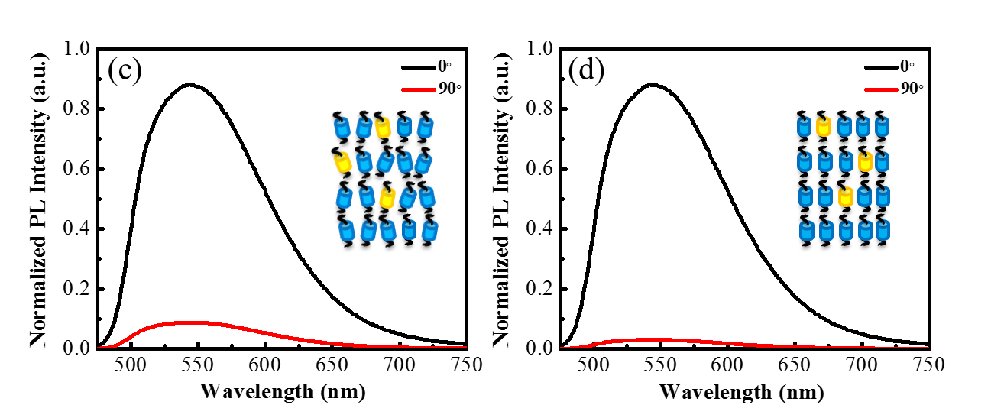
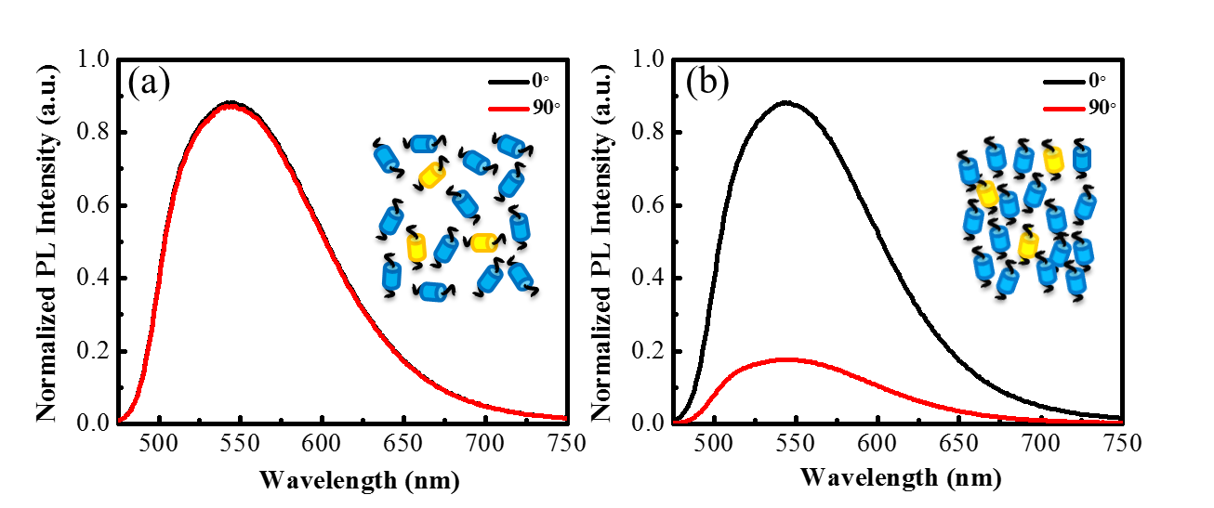
Fig.S2 Polarized PL spectra of M₂ (a) in the isotropic liquid DR = 1 and S = 0; (b) in the Nematic phase at 104 ºC, DR = 5, ρ = 0.66, S = 0.57; (c) in the SmA phase at 100 ºC, DR = 10, ρ = 0.83, S = 0.77; (d) in the SmB phase at 30 ºC, DR = 37, ρ = 0.95, S = 0.92. The black line represents absorbance in the parallel direction, red line represents absorbance in the perpendicular direction. Blue cylinders represent the LC molecules, Yellow cylinders represent dichroic dye molecules.

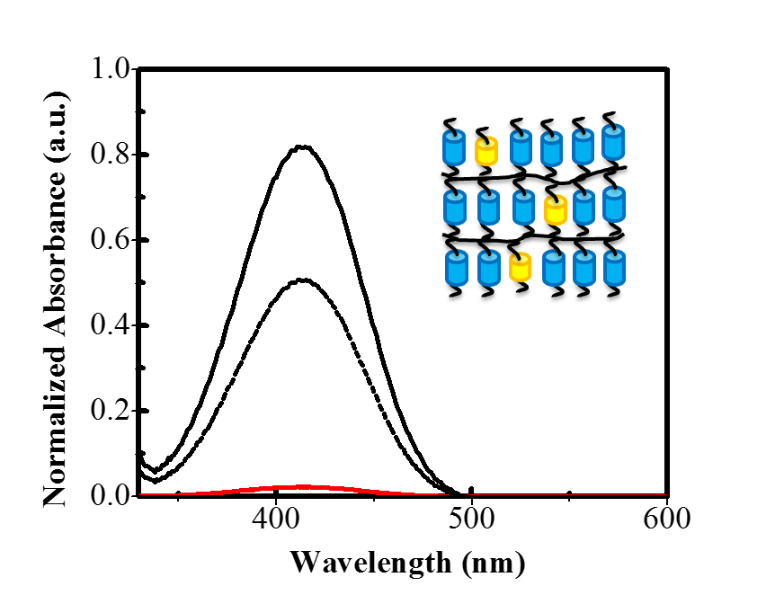
Fig. S3 Polarized UV/vis spectra of M₁ in the SmB phase before polymerization (solid line) at 45 ºC, DR=43, ρ=0.95, S=0.93. and after polymerization (dotted line) at RT, DR =25, ρ=0.92, S=0.89. The black line represents absorbance in the parallel direction, red line represents absorbance in the perpendicular direction. Blue cylinders represent the LC molecules, Yellow cylinders represent dichroic dye molecules.

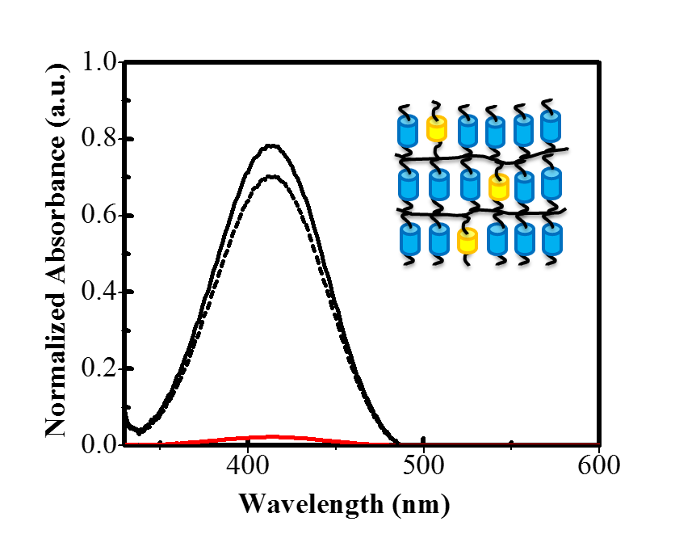
Fig. S4 Polarized UV/vis spectra of M₃ in the SmB phase before polymerization (solid line) at 45 ºC, DR = 31, ρ = 0.94, S = 0.91. and after polymerization (dotted line) at RT, DR = 27, ρ = 0.93, S = 0.90. The black line represents absorbance in the parallel direction, red line represents absorbance in the perpendicular direction. Blue cylinders represent the LC molecules, Yellow cylinders represent dichroic dye molecules.

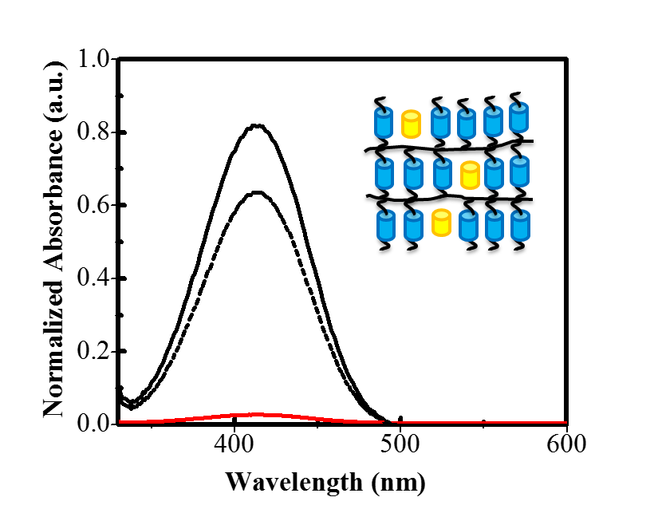
Fig. S5 Polarized UV/vis spectra of M₄ in the SmB phase before polymerization (solid line) at 45 ºC, DR = 44, ρ = 0.96, S = 0.93. and after polymerization (dotted line) at RT, DR = 33, ρ = 0.94, S = 0.91. The black line represents absorbance in the parallel direction, red line represents absorbance in the perpendicular direction. Blue cylinders represent the LC molecules, Yellow cylinders represent dichroic dye molecules.

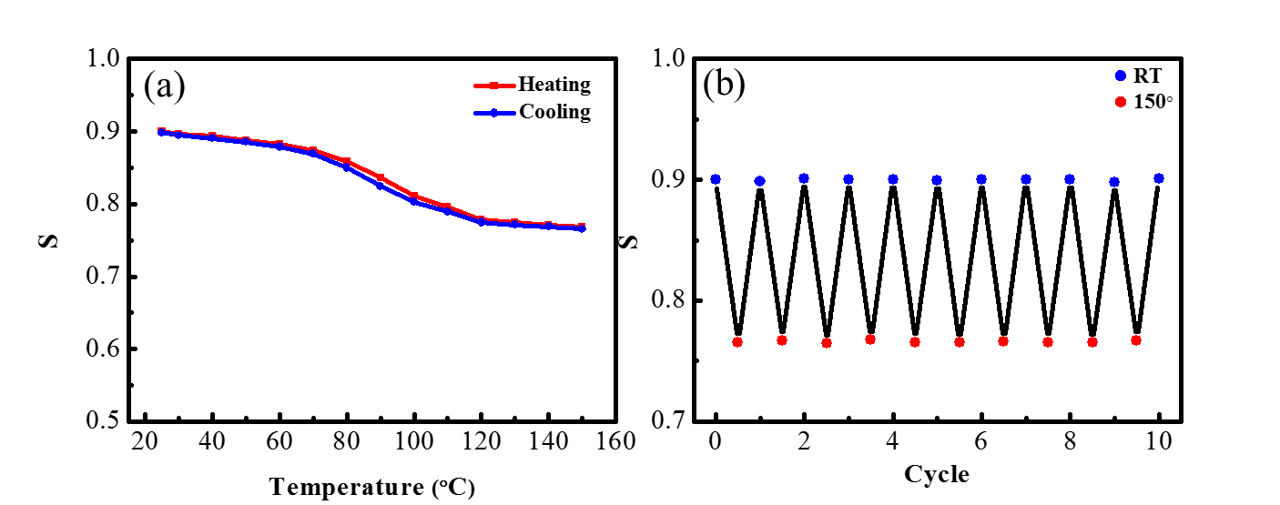
Fig. S6 Thermal stability for the film prepared from M₂. S data measured for the film (a) on the heating and cooling process, (b) for repeated switching on the heating and cooling process.

