SUPPORTING INFORMATION
Ternary Adsorbent Photocatalyst Hybrid (APH) Nanomaterials for Improved Abstraction of Tetracycline from Water
Sammar Minallahª, Erum Pervaizª*, Usman Yousaf ª, M. Bilal Khan Niaziª, Liu Honghong^{b} and Minghui Yang^{b}*
ª Department of Chemical Engineering, School of Chemical & Materials Engineering (SCME), National University of Sciences & Technology (NUST), Sector H-12 Islamabad, 44000, Pakistan.
^{b} Solid State functional Materials Research Lab, Ningbo Institute of Materials Technology and Engineering (NIMTE), Chinese Academy of Sciences (CAS), 315201, Ningbo China.
M. Yang email*: myang@nimte.ac.cn
Erum Pervaiz email*: erum.pervaiz@scme.nust.edu.pk
Address:
Department of Chemical Engineering, School of Chemical & Materials Engineering (SCME), National University of Sciences & Technology (NUST), Sector H-12 Islamabad, 44000, Pakistan.
Solid State functional Materials Research Lab, Ningbo Institute of Materials Technology and Engineering (NIMTE), Chinese Academy of Sciences (CAS), 315201, Zhungguan west road, Ningbo, PR. China

Fig. S1 SEM images of (a) CMZ-1 nanohybrid (b) SEM image of CMZ-4 nanohybrid
Fig. S2 HAADF images of CMZ-3 showing elemental mapping for C, Co, N, O, Mo

Fig. S3 N₂ adsorption-desorption isotherms for CMZ-3 and CMZ-4 nanohybrids (inset) pore size distribution
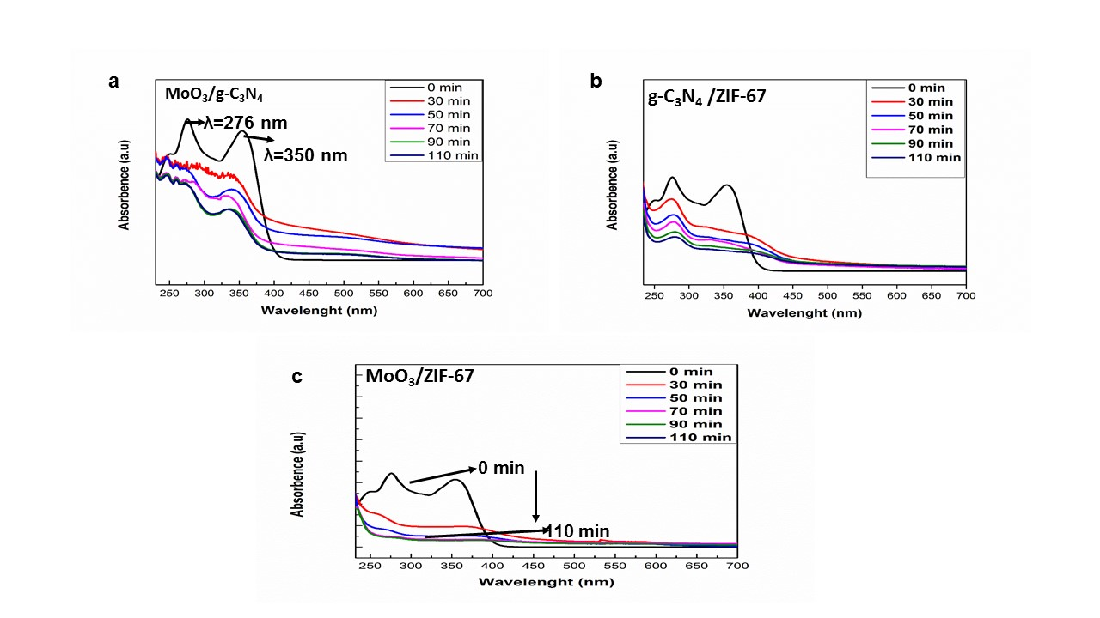
Fig. S4 Photocatalytic experiments performed with (a) CM (b) CZ and (c) MZ nanohybrids
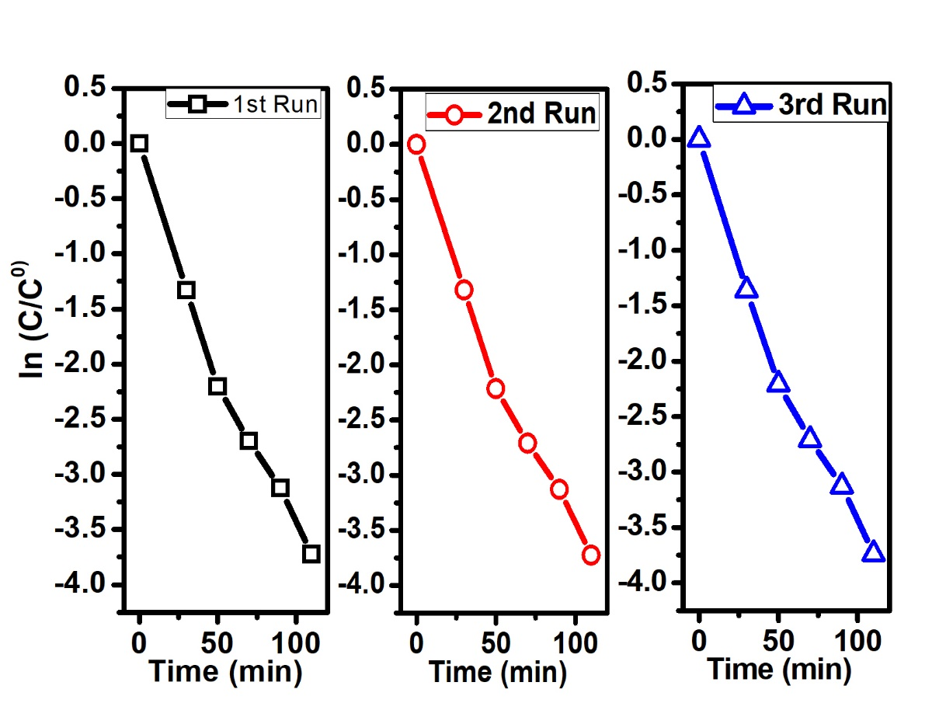
Fig. S5 Recyclability/Reusability analysis of TC degradation in the presence of CMZ-3 nanohybrid

