Parathyroid hormone-related protein Activates HSCs during Liver Fibrosis Development by Hedgehog signaling
Shuying He¹, Jing Tang¹, Na Diao¹，Yan Liao¹, Jie Shi ¹, Xiaoping Xu¹, Fang Xie¹, Lan Bai¹

Supplementary Fig. S1. N-terminal PTHrP were detected in different species hepatocytes. (A) The viability and purity of rat hepatocytes and mouse HSCs. (B) Western blots were used to determine the expression levels of PTHrP in hepatocytes. (C) AML12 and LO2 cells were transuded with a LV-NC or LV-PTHrP, and then Quantitative RT-PCR was used to determine the mRNA levels of PTHrP. The relative mRNA levels are expressed as fold induction over the level in the vehicle-treated group after normalization to GAPDH. Data was mean ± SD folds over the control. *p < 0.05; **p < 0.01.

Supplementary Fig. S2. PTHrP(1-36) could not induce PKA activation. (A) Immunoblotting showed that the PTHrP(1-36) do not enhanced the expression of PKA C-α and PKA RI-α/β. (B) Immunoblotting for phosphorylated CREB (Ser133) showed that PTHrP(1-36) do not promote phosphorylated CREB. The relative protein levels are normalized respectively by GAPDH and CREB. Data was mean ± SD folds over the control. *P < 0.05; **P< 0.01.

Supplementary Fig.S1
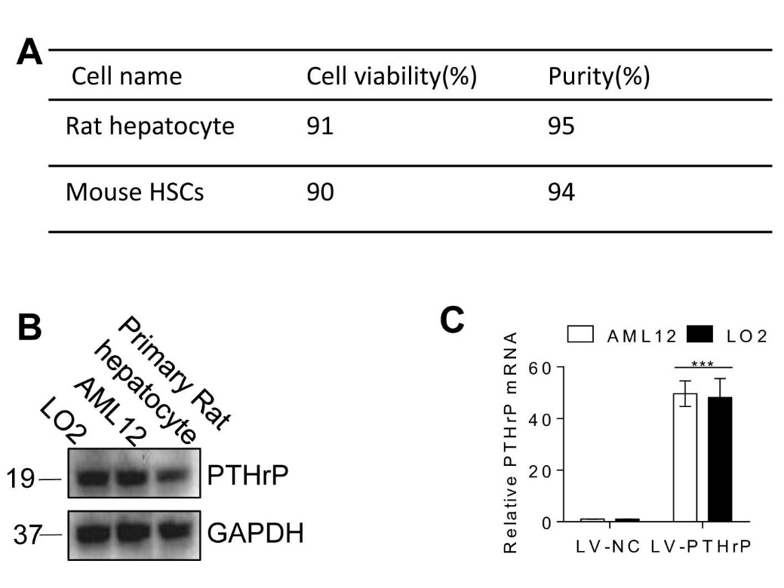

Supplementary Fig.S2

