Experimental and theoretical approaches on the reaction mechanism and kinetics of dimethyl 2-(6-oxopyridazin-1(6H)-yl)fumarate: micelle and salt effects
Yaser Shahbakhsh, Sayyed Mostafa Habibi-Khorasani*, Mehdi Shahraki
Department of Chemistry, Faculty of Science, University of Sistan and Baluchestan, P O Box 98135-674, Zahedan, Iran
E-mail: smhabibi@chem.usb.ac.ir
Supplemental Materials
Rate law derivation in the absence of SDS according to the proposed mechanism (Figure S 8):

Step₄ is RDS and steps 1 and 3 are in equilibrium state

Rate = k₄[I₃]
$\frac{d[I_{3}]}{dt}=0$ steady state approximation
$$\frac{d[I_{3}]}{dt}=k_{3}\left[I_{2}\right]\left[N\right]- k_{-3}\left[I_{3}\right]-k_{4}\left[I_{3}\right]=0→\left[I_{3}\right]=\frac{k_{3}\left[I_{2}\right][N]}{k_{4}+k_{-3}}$$
$$\frac{d\left[I_{2}\right]}{dt}= k_{-3}\left[I_{3}\right]+k_{2}\left[I_{1}\right]\left[2\right]{-k}_{3}\left[I_{2}\right]\left[N\right]=0$$
$k_{-3}\left[I_{3}\right]$ can be neglected, So $\left[I_{2}\right]=\frac{k_{2}\left[I_{1}\right][2]}{K_{3}[N]}$
$$\frac{d[I_{1}]}{dt}=k_{1}\left[1\right]\left[3\right]- k_{-1}\left[I_{1}\right]-k_{2}\left[I_{1}\right][2]=0→\left[I_{1}\right]=\frac{k_{1}\left[1\right][3]}{k_{-1}+k_{2}[2]}$$
So, the following expression can be written

$${(Rate)}_{mech}=\frac{k_{1}k_{2}k_{4}\left[1\right]\left[2\right][3]}{(k_{-3}+k_{4})(k_{-1}+k_{2}\left[2\right])}$$
Because the first step is fast then k₋₁>>k₂ [2] and according to assumption of k₄ as RDS, step k-3 >> k₄ so the (rate)_{mech} law can be introduced as the following expression:

${(Rate)}_{mech}=\frac{k_{1}k_{2}k_{4}\left[1\right]\left[2\right][3]}{k_{-3}k_{-1}}$
And we have:
$$k_{obs}=\frac{k_{1}k_{2}k_{4}\left[3\right]}{k_{-3}k_{-1}}$$
So:
$${(Rate)}_{mech}=k_{obs}\left[1\right][2]$$

Rate law derivation in the presence of SDS (Figure S 14):

Step₅ is RDS and steps 1 and 4 are in equilibrium state

Rate = k₅[I₄]
$\frac{d[I_{4}]}{dt}=0$ steady state approximation
$$\frac{d[I_{4}]}{dt}=k_{4}\left[I_{3}\right]\left[N\right]- k_{-4}\left[I_{4}\right][SDS]-k_{5}\left[I_{4}\right]=0→\left[I_{4}\right]=\frac{k_{4}\left[I_{3}\right][N]}{k_{5}+k_{-4}[SDS]}$$
$$\frac{d\left[I_{3}\right]}{dt}= k_{3}\left[I_{2}\right][SDS]+k_{-4}\left[I_{4}\right]\left[SDS\right]{-k}_{4}\left[I_{3}\right]\left[N\right]=0$$
$k_{-4}\left[I_{4}\right][SDS]$ can be neglected, So $\left[I_{3}\right]=\frac{k_{3}\left[I_{2}\right][SDS]}{k_{4}[N]}$
$$\frac{d[I_{2}]}{dt}=k_{2}\left[I_{1}\right][N]- k_{3}\left[I_{2}\right][SDS]=0→\left[I_{2}\right]=\frac{k_{2}\left[I_{1}\right][N]}{k_{3}[SDS]}$$
$$\frac{d[I_{1}]}{dt}=k_{1}\left[1\right]\left[3\right]- k_{-1}\left[I_{1}\right]-k_{2}\left[I_{1}\right][2]=0→\left[I_{1}\right]=\frac{k_{1}\left[1\right][3]}{k_{-1}+k_{2}[2]}$$

So, the following expression can be written

$${(Rate)}_{mech}=\frac{k_{1}k_{2}k_{5}\left[1\right]\left[2\right][3]}{(k_{-4}[SDS]+k_{5})(k_{-1}+k_{2}\left[2\right])}$$

Because the first step is fast then k₋₁>>k₂[2] and according to assumption of RDS for step_{5,} k₋₄ >> k₅ so:
${\left(Rate\right)}_{mech}=\frac{k_{1}k_{2}k_{5}\left[1\right]\left[2\right]\left[3\right]}{k_{-4}\left[SDS\right]k_{-1}}$
and
$k_{obs}=\frac{k_{1}k_{2}k_{5}[3]}{k_{-4}[SDS]k_{-1}}$

So we have:

(Rate)_{mech} = k_{obs}[1][2]

Pseudo order condition for partial orders determination

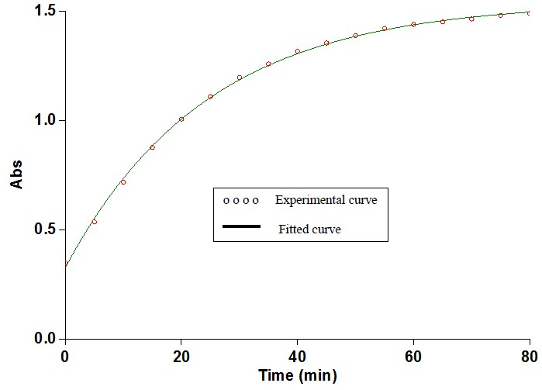
Figure S 1. First order fit on the reaction among (1), (2) and (3) when (2) is in excess and (3) is catalyst.

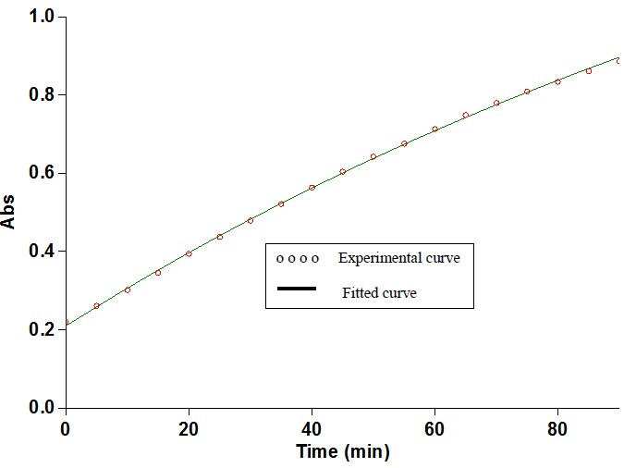
Figure S 2. First order fit on the reaction among (1), (2) and (3) when (1) is in excess and (3) is catalyst
Change in absorbance during the time in ethanol solvent

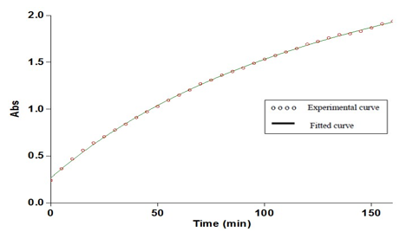
Figure S 3. Second order fitting curve (solid line) for product absorbance versus time at 360 nm wavelength in ethanol at 28°C in the reaction between 10⁻² M of (1), 10⁻² M of (2) in the presence of 5×10⁻³ M of (3).

The effect of temperature and activation parameters determination

Figure S 4. Dependence of ln k on reciprocal temperature for the reaction among (1), (2) and (3) in order to evaluate Ea/R from the slope according to the Arrhenius equation

Figure S 5. Dependence of ln k/T on reciprocal temperature for the reaction among (1), (2) and (3) in order to evaluate activation parameters (ΔH‡ and ΔS‡, respectively) from the slope and intercept according to the Eyring equation (8)

Figure S 6. Dependence of Tlnk/T on reciprocal temperature for the reaction among (1), (2) and (3) in order to evaluate activation parameters (ΔS‡ and ΔH‡, respectively) from the slope and intercept, according to the linearized form of the Eyring equation (9).

Salt effect on the reaction rate
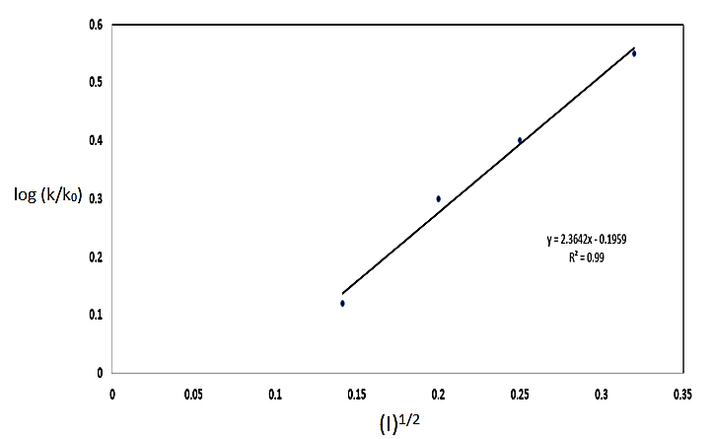
Figure S 7. Rate constant dependence on ionic strength (I) of NaBr for the reaction among reactants (1), (2) and (3) in methanol solvent at 28°C

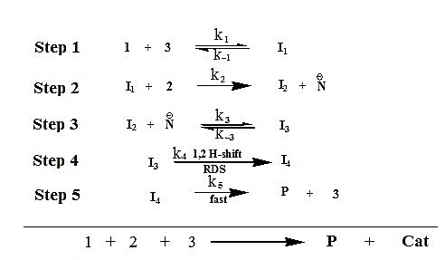
Figure S 8. Simplified form of the speculative mechanism for the reaction among (1), (2) and (3) in the absence of SDS.

The effect of SDS on the reaction

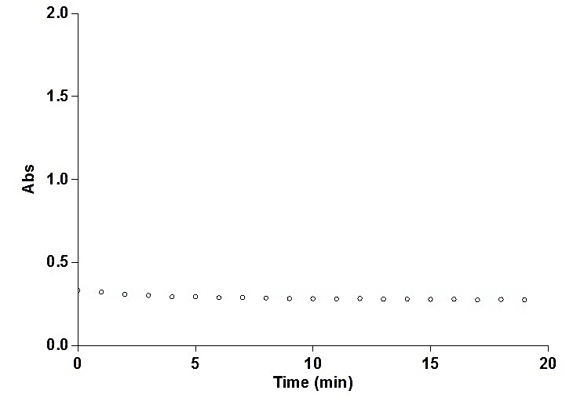
Figure S 9. No reaction between DMAD (1) and SDS (micelle)
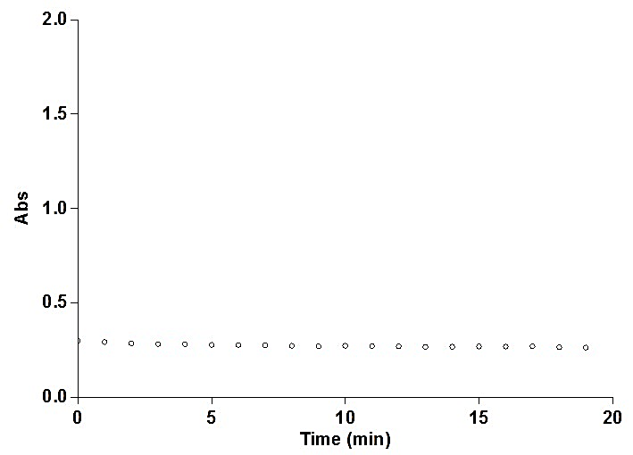
Figure S 10. No reaction between 3-(2H) pyridazinone (2) and SDS (micelle)

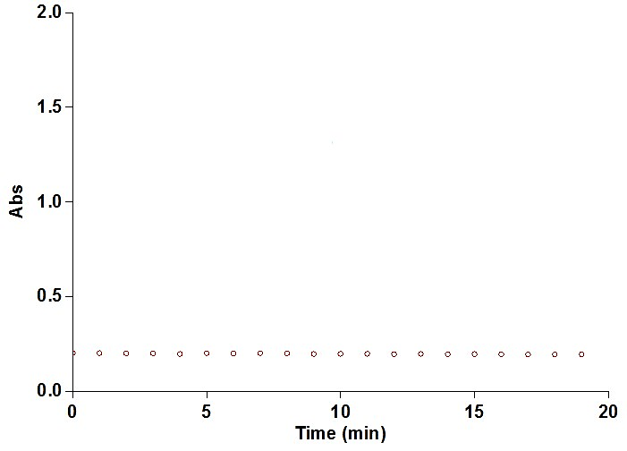
Figure S 11. No reaction between AsPh₃ (3) and SDS (micelle)
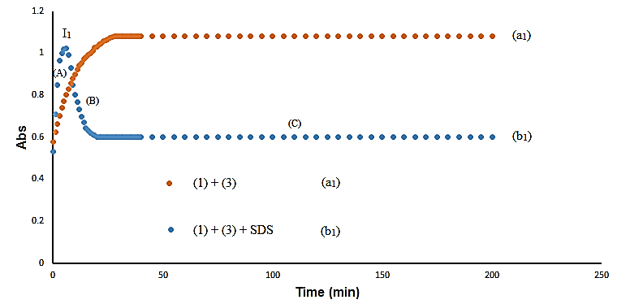
Figure S 12. The reaction between DMAD (1) and AsPh₃ (3) in the presence of SDS, spectrum (b₁) and in the absence of SDS, spectrum (a₁).

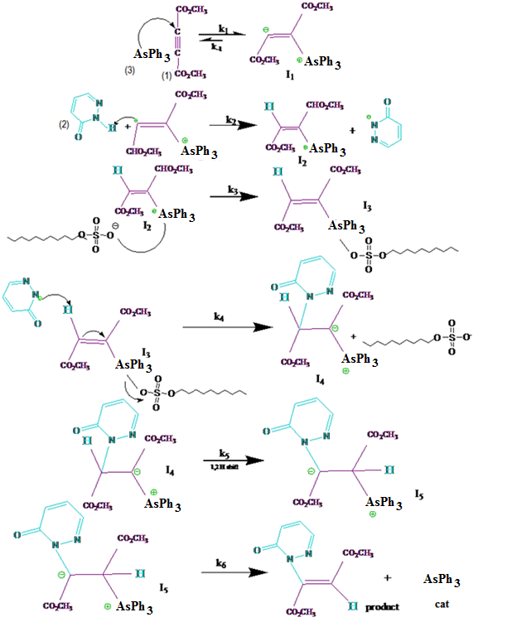
Figure S 13. Speculative mechanism for the reaction among (1), (2) and (3) in the presence of SDS.
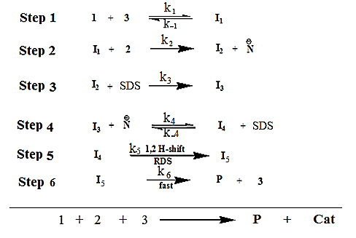
Figure S 14. Simplified form of the speculative mechanism of the reaction among (1), (2) and (3) in the presence of SDS.

Computational study

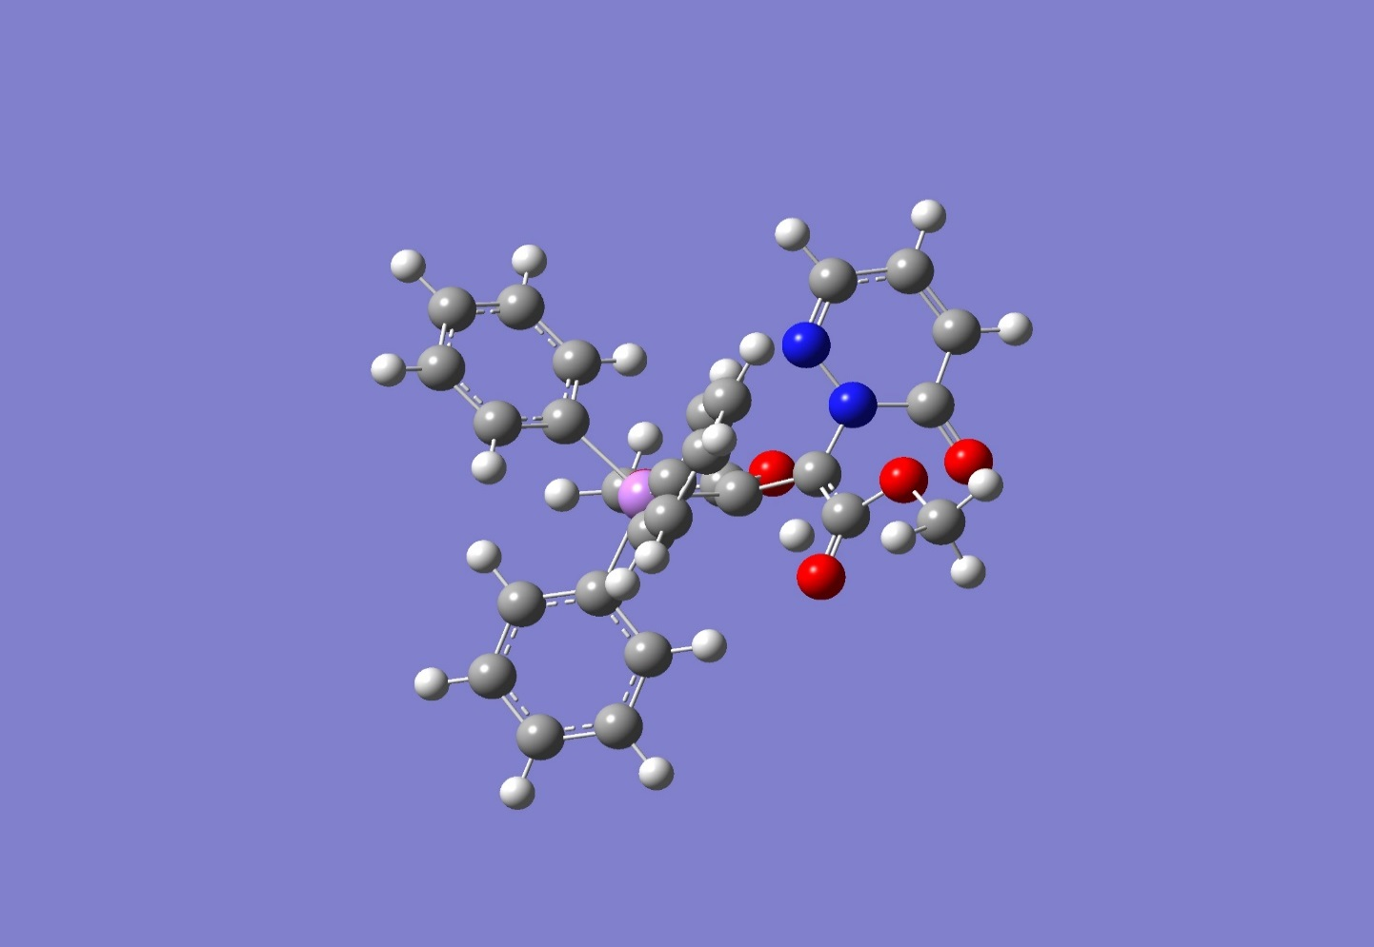
Figure S 15. T.S structure (T.S₄) in step₄ optimized by DFT method at the B3LYP/6-31+G(2d,p) level of theory in gas phase

Table S 1. Volume quantities (μL) of reactants (1), (2) and (3) that have been used to satisfy Job’s plot.
reactants |  |  | Volume (μL)
(1) | 1000 | 800 | 600 | 400 | 200 | 0
(2) | 0 | 100 | 200 | 300 | 400 | 500
(3) | 0 | 100 | 200 | 300 | 400 | 500

Table S 2. Comparison between the experimental rate law (Rate)_{exp} and the derived rate law (Rate)_{mech} law when each step (step₁ , step₂ , step_{3,} step_{4,} step₅) has been considered as RDS.

RDS step | Equilibrium step(s) | (Rate)_{mech} | k_{obs} | ( Rate)exp
1 | 1 | k_{obs}[1] | k₁[3] | k_{obs}[1][2]
2 | 1 | k_{obs}[1][2] | $$\frac{k_{1}k_{2}[3]}{k_{-1}}$$ | k_{obs}[1][2]
3 | 1&2 | $$\frac{k_{1}k_{2}k_{3}\left[1\right]\left[2\right][3]}{(k_{-2})(k_{-1}+k_{2}\left[2\right])}$$ |  | k_{obs}[1][2]
4 | 1&3 | k_{obs}[1][2] | $$\frac{k_{1}k_{2}k_{4}[3]}{(k_{-3})(k_{-1})}$$ | k_{obs}[1][2]
5 | 1&4 | k_{obs}[1][2] | $$\frac{k_{1}k_{2}k_{5}[3]}{(k_{-4})(k_{-1})}$$ | k_{obs}[1][2]

Table S 3. The first stretching frequencies (cm⁻¹) for the steps 2 and 4 of the reaction mechanism calculated by DFT method at B3LYP/6-31+G(2d,p) level of theory in gas phase
Step2 | first stretching frequency (cm⁻¹) | Step 4 | first stretching frequency (cm⁻¹)
I₁ | 9.25 | I₃ | 17.55
T.S₂ | -906.61 | T.S₄ | -1548.63
I₂ | 17.67 | P | 6.66

