Supplementary online materials
Contents
Supplementary material 1: Search strategy used for the SLR 2
Supplementary material 2: Systematic literature review eligibility criteria 4
Supplementary material 3: Baseline demographics for each study included in the heterogeneity assessment 9
Supplementary material 4: Definitions of outcomes from the considered trials in the NMA 31
Supplementary material 5: Network diagrams for analysis 34
References 38

Supplementary material 1: Search strategy used for the SLR
EMBASE, Medline, Medline (R) In-Process search strategy (EMBASE interface). Search dates: 17 December 2016, 12 December 2017 and 13 June 2019 (parentheses show number of hits on searches conducted each of these dates respectively).
(1) 'vein thrombosis'/exp OR 'venous thromboembolism'/exp OR 'leg thrombosis'/exp OR (((venous OR vein) NEXT/1 (thrombosis OR thrombus OR thromboembolism)) OR (dvt OR vte) OR ((pulmonary or lung) NEXT/6 (embolism or emboli))):ti,ab AND ('primary prevention'/de OR 'prophylaxis'/de OR 'thrombosis prevention'/de OR 'embolism prevention'/de OR thromboprophyla*:ti,ab OR prophylaxis:ab,ti OR prevention:ti,ab) (26,704, 28,602, 31,798)
(2) 'heparin'/exp OR 'low molecular weight heparin'/exp OR 'betrixaban'/exp OR heparinoid/exp OR (calciparine OR monoparin OR calcium multiparin OR bemiparin OR zibor OR dalteparin OR fragmin OR enoxaparin OR clexane OR lovenox OR tinzaparin OR innohep OR antixarin OR ‘CY 222’ OR embolex OR monoembolex OR tinzaparin OR suleparoide OR ardeparin OR certoparin OR nadroparin OR parnaparin OR reviparin OR tedelparin OR betrixaban OR fondaparinux OR arixtra OR danaparoid OR adomiparin OR deligoparin OR idrabiotaparinux OR idraparinux OR livaraparin OR ‘calcium minolteparin’ OR necuparanib OR ‘rd 11885’ OR semuloparin OR sevuparin):ab,ti (162,562, 170,067, 181,668)
(3) #1 AND #2 (13,353, 14,093, 15,334)
(4) #3 AND ('crossover procedure':de OR 'double-blind procedure':de OR 'randomized controlled trial':de OR 'single-blind procedure':de OR random*:de,ab,ti OR factorial*:de,ab,ti OR crossover*:de,ab,ti OR (cross NEXT/1 over*):de,ab,ti OR placebo*:de,ab,ti OR (doubl* NEAR/1 blind*):de,ab,ti OR (singl* NEAR/1 blind*):de,ab,ti OR assign*:de,ab,ti OR allocat*:de,ab,ti OR volunteer*:de,ab,ti) NOT ('meta analysis'/de OR 'systematic review'/de) (3,146, 3,290, 3,509)
(5 - original) #4 AND (2008:py OR 2009:py OR 2010:py OR 2011:py OR 2012:py OR 2013:py OR 2014:py OR 2015:py OR 2016:py) (1,875, N/A, N/A)
(5 – first update) #4 AND (2008:py OR 2009:py OR 2010:py OR 2011:py OR 2012:py OR 2013:py OR 2014:py OR 2015:py OR 2016:py OR 2017:py) (N/A, 2,020, N/A)
(5 – second update) #4 AND (2008:py OR 2009:py OR 2010:py OR 2011:py OR 2012:py OR 2013:py OR 2014:py OR 2015:py OR 2016:py OR 2017:py OR 2018:py or 2019:py) (N/A, N/A, 2,240)
(6) #5 NOT (letter:it OR editorial:it OR note:it OR review:IT) (1,161, 1,264, 1,416)
(7) #6 not (hip or knee):ti (970, 1,062, 1,198)
(8 – first update) #7 AND [17-12-2016]/sd (N/A, 97, N/A)
(8 – second update) #7 AND [12-12-2017]/sd (N/A, N/A, 162)
The Cochrane Central Register of Controlled Trials, HTA Database, NHS Economic Evaluation Database search strategy (Cochrane Library interface). Search dates: 17 December 2016, 12 December 2017 and 13 June 2019 (parentheses show number of hits on searches conducted each of these dates respectively).
(1) (MeSH descriptor: [Pulmonary Embolism] explode all trees OR MeSH descriptor: [Venous Thrombosis] explode all trees OR MeSH descriptor: [Venous Thromboembolism] explode all trees OR ((*venous OR *vein) NEXT (thrombosis OR thrombus OR thromboembolism) OR dvt OR vte OR (pulmonary OR lung) NEAR (embolism or emboli)):ti,ab) AND (MeSH descriptor: [Primary Prevention] explode all trees OR prophylaxis:ti,ab OR prevention:ti,ab OR thromboprophyla*:ti,ab) (2,827, 3,084, 5,282)
(2) MeSH descriptor: [Heparin] explode all trees OR (calciparine OR monoparin OR calcium multiparin OR bemiparin OR zibor OR dalteparin OR fragmin OR enoxaparin OR clexane OR lovenox OR tinzaparin OR innohep OR antixarin OR “CY 222” OR embolex OR monoembolex OR fragmin OR tinzaparin OR suleparoide OR ardeparin OR certoparin OR nadroparin OR parnaparin OR reviparin OR tedelparin OR betrixaban OR fondaparinux OR arixtra OR danaparoid OR adomiparin OR deligoparin OR idrabiotaparinux OR idraparinux OR livaraparin OR “calcium minolteparin” OR necuparanib OR “rd 11885” OR semuloparin OR sevuparin):ab,ti (5,616, 5,857, 6,599)
(3 – original) #1 AND #2, publication year from 2008-2016, in trials (321, N/A, N/A)
(3 – first update) #1 AND #2, publication year from 2016-2017, in trials (N/A, 88, N/A)
(3 – second update) #1 and #2, publication year from 2017-2019, in trials (N/A, N/A, 139)
(4) #3 not (hip or knee):ti (228, 69, 118)

Supplementary material 2: Systematic literature review eligibility criteria
Table S1. Eligibility criteria used
Selection criteria | Inclusion | Exclusion
Population | Acute, medically ill hospitalized adults (aged 18 or older) at risk of VTE§.  Acute medically ill is defined as at least one of the following:  Acute myocardial infarction  Acute heart failure  Acute respiratory failure or exacerbation of chronic respiratory disease  Acute infection  Acute rheumatic disorders including acute lumbar pain, sciatica, vertebral compression, rheumatoid arthritis, systemic lupus erythematosus, etc.  Acute ischaemic stroke  Paraplegia  Inflammatory bowel disease including ulcerative colitis and Crohn’s disease  Inflammatory disorder with immobility | Entirely comprised of non-acute or non-hospitalized, medically ill patients (e.g. patients with atrial fibrillation or with previous acute coronary syndrome requiring therapeutic anticoagulation)  Entirely comprised of patients aged under 18 years  Entirely comprised of surgical patients, trauma patients, cancer patients, pregnant patients  Entirely comprised of individuals with conditions requiring therapeutic anti-coagulation for VTE
Interventions/ comparators | Betrixaban  Fondaparinux sodium  Low molecular weight heparin  dalteparin  enoxaparin  tinzaparin  nadroparin  certoparin  bemiparin  UFH  No treatment/ placebo | Non-pharmacological prophylaxis
Outcomes | Mortality  Incidence of DVT  Incidence of PE  Adverse effects of treatment including bleeding events  HRQOL  Treatment adherence | No reported outcomes of interest, i.e., only reporting pharmacodynamics, pharmacokinetics, genetic, cellular, or molecular outcomes  Outcomes reported only in studies with a mixed population
Study type | RCT | Non- randomized studies  Observational studies (including patient registries)  Retrospective analyses  Modeling studies  Economic analyses  Narrative literature reviews, expert opinions, letters to the editor, editorials, or consensus reports  Case reports or case series of fewer than 10 patients  In vitro, animal, or foetal studies
Publication type | Article, conference abstract, conference paper, article in press | Short survey, letter, editorial, review*
Language | Article or abstract available in English | Non-english language articles (no abstract available in English)
DVT – Deep vein thrombosis; HRQOL – Health-related quality of life; PE – Pulmonary embolism; RCT – Randomized controlled trial; UFH – Unfractionated heparin; VTE – Venous thromboembolism
§Patients at risk and eligible for treatment defined in accordance with current guidelines and the APEX study.[1–3] *Reviews will be identified for cross-checking purposes

Supplementary material 3: Baseline demographics for each study included in the heterogeneity assessment
Table S2 shows the baseline demographic information for the studies included in the heterogeneity assessment, which was part of the feasibility assessment.
Table S2. Baseline demographic data for studies considered for inclusion in the network meta-analysis
^{Trial} | ^{Treatment arm} | ^{Eligible population} | ^{Age (mean (SD))} | ^{Gender (% male)} | ^{Ethnicity} | ^{Weight (mean (SD))} | ^{Primary enrolment diagnoses} | Additional risk factors for VTE | ^{Concomitant therapy}
^{APEX} | ^{Betrixaban} | ^{Aged ≥ 40}  ^{Acutely ill and hospitalised}  Immobilised, or anticipated to be so, for at least 24 hours | ^{76.6 (8.46)} | ^{45.40%} | White 93.2%; Asian 0.2%; Black 2.0%; Other 4.6% | ^{BMI 29.21 (6.60)}  ^{79.84kg} | ^{Heart failure 44.6%;}  ^{Infection 29.6%;}  ^{Respiratory failure 11.9%;}  ^{Ischemic stroke 10.9%;}  ^{Rheumatic disorder 2.9%} | Level of d-dimer ≥2 × ULN 62.3%;  ^{Age ≥75 yr 68.5%;}  ^{History of cancer 12.4%;}  ^{History of DVT or PE 8.3%;}  History of New York Heart Association class III or IV heart  ^{failure 22.7%;}  Concurrent acute infectious disease 16.0%;  ^{Severe varicosities 18.7%} | Concomitant P-glycoprotein inhibitor 18.0%  ^{The following were prohibited:}  Concomitant dual anti platelet therapy  Anticoagulants in addition to study drug  Aspirin ≥165mg qd unless patient has indication for TIA/stroke  Concomitant use of mechanical thromboprophylaxis other than compression stockings
 | ^{Enoxaparin} |  | ^{76.2 (8.31)} | ^{45.80%} | White 93.7%; Asian 0.2%; Black 1.9%; Other 4.2% | ^{BMI 29.54 (6.67)}  ^{80.74kg} | ^{Heart failure 44.5%;}  ^{Infection 28.2%;}  ^{Respiratory failure 12.6%;}  ^{Ischemic stroke 11.5%;}  ^{Rheumatic disorder 3.1%} | Level of d-dimer ≥2 × ULN 62.1%;  ^{Age ≥75 yr 67.0%;}  ^{History of cancer 11.8%;}  ^{History of DVT or PE 7.9%;}  History of New York Heart Association class III or IV heart  ^{failure 23.0%;}  Concurrent acute infectious disease 16.5%;  ^{Severe varicosities 18.4%} | Concomitant P-glycoprotein inhibitor 17.3%  ^{The following were prohibited:}  Concomitant dual anti platelet therapy  Anticoagulants in addition to study drug  Aspirin ≥165mg qd unless patient has indication for TIA/stroke  Concomitant use of mechanical thromboprophylaxis other than compression stockings
^{ARTEMIS} | ^{Fondaparinux} | ^{Aged ≥60}  Expected to remain in bed for at least four days  Patients with congestive heart failure class III/IV, acute respiratory illness with chronic lung disease, acute infections, inflammatory disorders such as arthritis, connective tissue diseases, or inflammatory bowel disease | ^{75.0 (8.3; range 60 to 93)} | ^{40.6%} | ^{Not reported} | ^{BMI 25.9 (5.5)}  ^{70.1kg (15.2; range 32 to 111)} | Acute infectious or inflammatory disease 24.9%;  Acute respiratory disease 17.2%;  Congestive heart failure (class III/IV) 24.7%;  ^{More than 1 reason 33.1%} | ^{Age ≥75 years 52.0%}  ^{History of VTE 4.2%}  Previous or current cancer 14.5% | Use of aspirin or non-steroidal anti-inflammatory drugs discouraged.  Compression stockings and physiotherapy allowed.
 | ^{Placebo} |  | ^{74.4 (8.3; range 53 to 96)} | ^{44.3%} | ^{Not reported} | ^{BMI 25.8 (5.7)}  ^{70.1kg (16.8; range 35 to 150)} | Acute infectious or inflammatory disease 25.5%;  Acute respiratory disease 22.1%;  Congestive heart failure (class III/IV) 25.2%;  ^{More than 1 reason 27.1%} | ^{Age ≥75 years 51.4%}  ^{History of VTE 5.0%}  Previous or current cancer 16.4%
^{Belch 1981} | ^{Heparin} | ^{Aged 40-80}  Admitted with diagnosis of heart failure or chest infection | ^{66.6} | ^{70%} | ^{Not reported} | ^{22% obese} | ^{Heart failure 42%;}  ^{Chest infection 36%;}  ^{Both 22%} | ^{22% obese;}  ^{Varicose veins 8%; 64% smokers} | Digoxin 14%; Diuretic 38%; Antibiotic 14%; Bronchodilator 30%
 | ^{No prophylaxis} |  | ^{65.0} | ^{68%} | ^{Not reported} | ^{22% obese} | ^{Heart failure 34%;}  ^{Chest infection 38%;}  ^{Both 28%} | ^{22% obese;}  Varicose veins 10%; 58% smokers | Digoxin 18%; Diuretic 42%; Antibiotic 20%; Bronchodilator 20%
^{Bergmann 1996} | ^{Enoxaparin} | ^{Aged ≥65}  Acute medical illness which has led to inability to walk 10m unassisted | ^{83.8 (0.51 SEM)} | ^{29%} | ^{Not reported} | ^{57.8kg (0.70 SEM)} | ^{Heart failure 18.5%;}  ^{Chest infection 22.7%;}  ^{Ischaemic stroke 8.3%;}  ^{Cancer 5.1%;}  ^{Malnutrition 6.9%;}  ^{Dehydration 18.1%;}  ^{Systemic infection 3.7%;}  ^{Other 57.9%} | ^{Cardiac failure 35.0%;}  ^{Respiratory failure 10.0%;}  ^{History of VTE 15.0%;}  ^{Cancer 20.0%;}  ^{Obesity 16.7%;}  ^{Varicose veins 35.0%;}  ^{Completely bedridden 65.0%;}  ^{Infectious disease 20.0%;}  ^{Paralysis of lower limbs 5.0%} | ^{Not reported}
 | ^{UFH} |  | ^{82.6 (0.46 SEM)} | ^{27%} | ^{Not reported} | ^{57.0kg (0.78 SEM)} | ^{Heart failure 20.8%;}  ^{Chest infection 26.0%;}  ^{Ischaemic stroke 19.6%;}  ^{Cancer 8.5%;}  ^{Malnutrition 8.1%;}  ^{Dehydration 18.4%;}  ^{Systemic infection 3.1%;}  ^{Other 54.3%} | ^{Cardiac failure 29.3%;}  ^{Respiratory failure 14.6%;}  ^{History of VTE 8.0%;}  ^{Cancer 14.6%;}  ^{Obesity 14.2%;}  ^{Varicose veins 23.8%;}  ^{Completely bedridden 52.1%;}  ^{Infectious disease 33.5%;}  ^{Paralysis of lower limbs 9.7%} | ^{Not reported}
^{CERTAIN} | ^{Certoparin} | ^{Aged >40}  Hospitalisation due to acute non-surgical disease  Completely bedridden or only able to walk short distances with the support of a nurse | ^{70.2 (12.2)} | ^{47.5%} | ^{Not reported} | ^{77.9kg (19.2)} | ^{Not reported}  ^{(Medical history:}  ^{Diabetes 31.9%;}  ^{COPD 25.8%}  ^{Coronary artery disease 16.0%)} | ^{≥65 years 73.0%;}  Cancer (previous or current) 9.2%;  ^{History of VTE 4.9%;}  ^{Obesity (BMI ≥30 kg/m2) 29.4%;}  ^{Varicose veins 12.9%;}  ^{Heart failure 35.0%;}  ^{≥2 risk factors 48.5%} | ^{Not reported}
 | ^{UFH} |  | ^{71.0 (12.4)} | ^{47.7%} | ^{Not reported} | ^{78.0kg (20.0)} | ^{Not reported}  ^{(Medical history:}  ^{Diabetes 31.6%;}  ^{COPD 28.7%}  ^{Coronary artery disease 19.0%)} | ^{≥65 years 73.0%;}  Cancer (previous or current) 8.0%;  ^{History of VTE 3.9%;}  ^{Obesity (BMI ≥30 kg/m2) 25.9%;}  ^{Varicose veins 6.9%;}  ^{Heart failure 32.2%;}  ^{≥2 risk factors 50.0%} | ^{Not reported}
^{CERTIFY} | ^{Certoparin} | ^{Aged ≥70}  Acute medical illness with a significant decrease in mobility (bedridden or only able to walk short distances) for at least 4 days | ^{79.0 (6.2)} | ^{41.2%} | ^{Caucasian 99.0%} | ^{72.3kg (16.2)} | Infections and infestations 26.8%;  ^{Cardiac disorders 22.0%;}  Respiratory, thoracic and mediastinal disorders 17.2%;  ^{Nervous system disorders 7.1%;}  Gastrointestinal disorders 7.3%;  ^{Vascular disorders 5.7%} | Mean immobilization ± SD (days) 10.0 ± 4.5  ^{Median (days) 9.0} | ^{Not reported}
 | ^{UFH} |  | ^{78.7 (6.3)} | ^{40.6%} | ^{Caucasian 98.9%} | ^{71.9kg (15.3)} | Infections and infestations 28.4%;  ^{Cardiac disorders 22.4%;}  Respiratory, thoracic and mediastinal disorders 17.3%;  ^{Nervous system disorders 6.1%;}  Gastrointestinal disorders 5.9%;  ^{Vascular disorders 5.9%} | Mean immobilization ± SD (days) 9.8 ± 4.1  ^{Median (days) 9.0} | ^{Not reported}
^{CY216} | ^{Nadroparin} | ^{Aged ≥40}  Have been hospitalised for less than 24h due to an acute medical illness  Unable to walk more than 10m alone | ^{76.1} | ^{42.0%} | ^{Not reported} | ^{59.5kg} | Acute cardiovascular disease 13.3%:  ^{Atrial fibrillation 11.5%;}  ^{Acute pulmonary disease 23.0%;}  ^{Cancer 13.6%:}  ^{Sepsis (not pulmonary) 21.2%:} | ^{Chronic heart failure 26.7%;}  ^{Previous VTE 1.9%;}  Chronic pulmonary disease 18.4%;  ^{Smoking 15.7%;}  ^{Alcohol abuse 10.0%;}  ^{Previous stroke 8.5%;}  Recent surgery or trauma (1–3 months) 3.7% | ^{Not reported}
 | ^{Placebo} |  | ^{76.5} | ^{39.0%} | ^{Not reported} | ^{59.6kg} | Acute cardiovascular disease 13.9%;  ^{Atrial fibrillation 12.6%;}  ^{Acute pulmonary disease 21.1%;}  ^{Cancer 4.1%;}  ^{Sepsis (not pulmonary) 24.8%} | ^{Chronic heart failure 24.8%;}  ^{Previous VTE 1.9%;}  Chronic pulmonary disease 17.6%;  ^{Smoking 14.1%;}  ^{Alcohol abuse 8.4%;}  ^{Previous stroke 7.1%;}  Recent surgery or trauma (1–3 months) 2.9% | ^{Not reported}
^{Forette 1995} | ^{Nadroparin} | ^{Aged ≥70 years}  Hospitalised for a recent and presumed transient decrease in the locomotor autonomy, justifying a medicinal prevention of venous thromboembolism. | ^{82.8 (0.5)} | ^{75.3%} | ^{Not reported} | ^{58.2kg (0.9)} | ^{Not reported} | ^{Venous insufficiency 37.0%}  ^{Cardiac insufficiency 25.3%}  ^{Obesity 13.7%}  ^{Respiratory insufficiency 9.6%}  ^{Previous DVT 8.2%}  ^{Cancer 6.2%} | Patients receiving acetylsalicylic acid or any pre-treatment containing al ticlopidine, a non-steroidal anti-inflammatory, treatment with haparinoid or antivitamin k were excluded.
 | ^{UFH} |  | ^{83.8 (0.6)} | ^{74.5%} | ^{Not reported} | ^{59.7kg (1.0)} | ^{Not reported} | ^{Venous insufficiency 40.3%}  ^{Cardiac insufficiency 28.9%}  ^{Obesity 18.8%}  ^{Respiratory insufficiency 7.4%}  ^{Previous DVT 12.8%}  ^{Cancer 4.0%}
^{Harenberg 1996} | ^{UFH} | ^{Aged 50-80}  Expected duration of bedrest >10 days  ^{More than one risk factor} | ^{70.4 (7.9)} | ^{47.7%} | ^{Not reported} | ^{69.9kg (14.5)} | ^{Cardiac insufficiency 18.3%;}  ^{Cerebrovascular disease 17.2%;}  ^{Coronary artery disease 16.8%;}  ^{Cancer 8.1%;}  ^{Diabetes 7.3%;}  ^{Gastro or neph. Disease 5.6%;}  ^{COPD 5.9%;}  ^{Pneumonia/infection 2.1%;}  ^{Other 18.6%} | ^{Adiposity 32.0%;}  ^{Previous DVT/PE 5.9%;}  ^{Varicosis 17.3%;}  ^{Ulcus crusis 4.5%;}  ^{Thrombocytosis 4.2%;}  Peripheral arterial disease 20.5%;  ^{Previous MI 14.5%;}  ^{Previous stroke 15.5%;}  ^{Cardiac insufficiency 44.0%;}  ^{Hyperviscosity 15.1%} | ^{Not reported}
 | ^{LMWH} |  | ^{70.5 (8.3)} | ^{42.5%} | ^{Not reported} | ^{69.7kg (14.5)} | ^{Cardiac insufficiency 18.5%;}  ^{Cerebrovascular disease 18.4%;}  ^{Coronary artery disease 17.1%;}  ^{Cancer 7.0%;}  ^{Diabetes 5.8%;}  ^{Gastro or neph. Disease 4.3%;}  ^{COPD 5.1%;}  ^{Pneumonia/infection 3.2%;}  ^{Other 20.5%} | ^{Adiposity 31.4%;}  ^{Previous DVT/PE 8.4%;}  ^{Varicosis 22.1%;}  ^{Ulcus crusis 4.1%;}  ^{Thrombocytosis 4.7%;}  Peripheral arterial disease 20.6%;  ^{Previous MI 15.2%;}  ^{Previous stroke 14.7%;}  ^{Cardiac insufficiency 43.0%;}  ^{Hyperviscosity 13.8%} | ^{Not reported}
^{Ishi 2013} | ^{UFH} | ^{No age requirement}  Medically ill with high or higher risk for DVT/PE and requiring either at least 3 days of ICU stay or 3 days non-ambulatory in another ward | ^{50.9 (20.1)} | ^{64.4%} | ^{Not reported} | ^{Not reported} | ^{CVA (not defined) 17.8%;}  Cardiological dysfunction 2.2%;  ^{Respiratory dysfunction 11.1%;}  ^{Sepsis 11.1%;}  ^{Toxicological causes 35.6%;}  ^{Multi system disorder 8.9%;}  ^{Others 13.3%} | All patients were at high risk of DVT/PE as determined by a pre-specified risk assessment | Any other supportive measures such as treatment of underlying condition, need for ventilator support, need for fresh frozen plasma,, blood, platelet, I.V. antibiotics and ulcer prophylaxis, inotropic supports were given as necessary
 | ^{Enoxaparin} |  | ^{57.9 (18.7)} | ^{56.1%} | ^{Not reported} | ^{Not reported} | ^{CVA 21.9%;}  Cardiological dysfunction 7.3%;  ^{Respiratory dysfunction 7.3%;}  ^{Sepsis 12.2%:}  ^{Toxicological causes 17.1%;}  ^{Multi system disorder 17.1%;}  ^{Others 17.1%} | All patients were at high risk of DVT/PE as determined by a pre-specified risk assessment
^{LIFENOX} | ^{Enoxaparin} | ^{Aged ≥40}  Hospitalised within 48h before randomisation for an acute medical illness (acute decompensation of heart failure, active cancer, severe systemic infection) with at least one risk factor  Expected to have a hospital duration of 6 days | ^{65.6 (12.0)} | ^{62.4%} | ^{Not reported} | ^{BMI 23.4 (5.4)} | Heart failure 1280/4166 (30.7%);  - NYHA Class I or II 206/4166 (4.9%);  - NYHA Class III or IV 1055/4166 (25.3%);  - NYHA class not determined 19/4166 (0.5%);  Severe systemic infection 2383/4166 (57.2%);  ^{Active cancer 195/4166 (4.7%);}  Heart failure and severe systemic infection 253/4166 (6.1%);  Heart failure and active cancer 7/4166 (0.2%);  Severe systemic infection and active cancer 45/4166 (1.1%);  Heart failure, severe systemic infection, and active cancer 3/4166 (0.1%);  None of the above 24/4171 (0.6%) | ^{Age ≥75 yr 1079/4171 (25.9%);}  Personal history of venous thromboembolism 27/4168 (0.6%);  Family history of venous thromboembolism 4/4166 (0.1%);  ^{Active cancer 250/4170 (6.0%);}  Body-mass index ≥30† 431/4111 (10.5%);  Coagulation disorder 2/4168 (<0.1%);  Hospitalization within previous 3 months for acute medical illness 377/4168 (9.0%) | Knee-high compression stockings were provided to both groups.
 | ^{Placebo} |  | ^{65.3 (12.2)} | ^{63.1%} | ^{Not reported} | ^{BMI 23.3 (5.4)} | Heart failure 1297/4134 (31.4%);  - NYHA Class I or II 210/4134 (5.1%);  - NYHA Class III or IV 1069/4134 (25.9%);  - NYHA class not determined 18/4134 (0.4%);  Severe systemic infection 2336/4134 (56.5%);  Active cancer 170/4134 (4.1) 195/4166 (4.7%);  Heart failure and severe systemic infection 262/4134 (6.3%);  Heart failure and active cancer 5/4134 (0.1%);  Severe systemic infection and active cancer 62/4134 (1.5%);  Heart failure, severe systemic infection, and active cancer 2/4134 (<0.1%);  None of the above 25/4136 (0.6%) | ^{Age ≥75 yr 1030/4136 (24.9%);}  Personal history of venous thromboembolism 21/4135 (0.5%);  Family history of venous thromboembolism 5/4134 (0.1%);  ^{Active cancer 239/4136 (5.8%);}  Body-mass index ≥30† 429/4084 (10.5%);  Coagulation disorder 3/4134 (0.1%);  Hospitalization within previous 3 months for acute medical illness 390/4135 (9.4%)
^{MEDENOX} | ^{Enoxaparin 40mg} | ^{Aged ≥40 years}  Projected to stay in hospital for ≥6 days and not immobilized for >3 days  Congestive heart failure, acute respiratory failure or acute medically ill plus one or more risk factor | ^{73.1 (10.8)} | ^{46.6%} | ^{Not reported} | ^{BMI 24.9 (5.9)} | NYHA class III congestive heart failure 103 (28.1%);  NYHA class IV congestive heart failure 26 (7.1%);  Acute respiratory failure 202 195 (53.1%);  Acute infectious disease 197 (53.7%);  Acute rheumatic disorder28 (7.6%);  Inflammatory bowel disease 3 (0.8%) | ^{Age >75 yr 1185 (50.4%);}  Cancer (previous or current) 45 (12.3%);  History of venous thromboembolism 30 (8.2%);  ^{Obesity: 72 (19.6%);}  ^{Varicose veins 98 (26.7%);}  ^{Hormone therapy 5 (1.4%);}  Chronic heart failure 123 (33.5%);  Chronic respiratory failure 195 (53.1%);  ^{≧2 Risk factors 245 (66.8%)} | Throughout the treatment period, intramuscular injections and treatment with nephrotoxic substances, particularly nephrotoxic antibiotics, were not permitted. Other treatments, elastic bandages or support stockings, and physiotherapy were used according to the usual practise at each centre. Centres were advised to avoid giving patients nonsteroidal anti-inflammatory drugs if possible.
 | ^{Placebo} |  | ^{74.1 (10.6)} | ^{51.8%} | ^{Not reported} | ^{BMI 25.0 (6.5)} | NYHA class III congestive heart failure 95 (25.7%);  NYHA class IV congestive heart failure 32 (8.6%);  Acute respiratory failure 202 (54.6%);  Acute infectious disease 193 (52.2%);  Acute rheumatic disorder 32 (8.6%);  Inflammatory bowel disease 1 (0.3%) | ^{Age >75 yr 197 (53.2%);}  Cancer (previous or current) 56 (15.1%);  History of venous thromboembolism 39 (10.5%);  ^{Obesity: 71 (19.2%);}  ^{Varicose veins 93 (25.1%);}  ^{Hormone therapy 9 (2.4%);}  Chronic heart failure 124 (33.5%);  Chronic respiratory failure 197 (53.2%);  ^{≧2 Risk factors 247 (66.8%)}
^{PREVENT} | ^{Dalteparin} | Aged ≥40 requiring hospitalisation for at least 4 days and 3 days of prior immobilisation  Admitted for acute medical illness. If congestive heart failure or acute respiratory failure at least one additional risk factor was required. | ^{68.5 (11.1)} | ^{47.8%} | ^{Not reported} | ^{BMI 27.4 (5.9)} | Acute congestive heart failure (NYHA class III or IV) 965 (52.2%);  Acute respiratory failure 561 (30.4%);  Other acute conditions 749 (40.5%);  Infectious disease 673 (36.4%);  Rheumatologic disorder 200 (10.8%);  Inflammatory bowel disease 10 (0.5%) | ^{Age 75 years 611 (33.1%)}  ^{Cancer 85 (4.6%)}  Previous deep vein thrombosis or pulmonary embolism 62 (3.4%)  ^{Obesity 558 (30.2%)}  ^{Varicose veins 487 (26.4%)}  ^{Hormone therapy 33 (1.8%)}  Chronic heart failure 925 (50.1%)  Myeloproliferative syndrome 5 (0.3%)  Chronic respiratory failure 176 (9.5%) | ^{Not reported}
 | ^{Placebo} |  | ^{68.5 (11.7)} | ^{48.4%} | ^{Not reported} | ^{BMI 27.5 (6.0)} | Acute congestive heart failure (NYHA class III or IV) 940 (51.3%);  Acute respiratory failure 560 (30.6%);  Other acute conditions 781 (42.6%);  Infectious disease 687 (37.5%);  Rheumatologic disorder 198 (10.8%);  Inflammatory bowel disease 8 (0.4%) | ^{Age 75 years 615 (33.6%)}  ^{Cancer 105 (5.7%)}  Previous deep vein thrombosis or pulmonary embolism 80 (4.4%)  ^{Obesity 560 (30.6%)}  ^{Varicose veins 530 (28.9%)}  ^{Hormone therapy 30 (1.6%)}  Chronic heart failure 946 (51.6%)  Myeloproliferative syndrome 9 (0.5%)  Chronic respiratory failure 183 (10.0%)
^{PRIME} | ^{Enoxaparin} | ^{Aged ≥18 years}  Expected to be immobilised for half the study period of 7 days  ^{One additional risk factor} | ⁷⁴ ⁽¹³⁾ | ^{38.4%} | ^{Not reported} | ^{66kg (15)} | ^{Cardiovascular diseases 67.5%}  ^{Endocrinologic diseases 27.9%}  ^{Respiratory diseases 24.3%}  Gastro and urogenital diseases 22.6%  ^{Central nervous diseases 15.8%}  ^{Cancer 14.7%}  ^{Bone diseases 10.8%}  ^{Skin diseases 3.5%}  ^{Other 8.2%} | ^{Immobilsation 100.0 %}  ^{Age >60y 87.2%}  ^{Heart failure 34.2%}  ^{Overweight 28.7%}  ^{Severe infection 20.1%}  ^{Malignant disease 20.1%}  Paresis, hemiplegia, paraplegia 7.5%  ^{Previous VTE 6.1%} | Patients on anticoagulants, aggregation inhibitors and NSAIDs were excluded from the study. Mechanical prophylaxis unknown.
 | ^{UFH} |  | ⁷⁴ ⁽¹³⁾ | ^{63.1%} | ^{Not reported} | ^{66kg (15)} | ^{Cardiovascular diseases 70.5%}  ^{Endocrinologic diseases 30.1%}  ^{Respiratory diseases 23.4%}  Gastro and urogenital diseases 21.8%  ^{Central nervous diseases 17.8%}  ^{Cancer 12.9%}  ^{Bone diseases 12.2%}  ^{Skin diseases 3.1%}  ^{Other 8.9%} | ^{Immobilsation 100.0 %}  ^{Age >60y 88.8%}  ^{Heart failure 35.9%}  ^{Overweight 32.8%}  ^{Severe infection 19.1%}  ^{Malignant disease 14.7%}  Paresis, hemiplegia, paraplegia 7.5%  ^{Previous VTE 7.7%}
^{PROMPT} | ^{Enoxaparin} | ^{Aged ≥60}  Admitted to study hospital on day of randomisation or day before  Expected to be at the medical centre for at least 3 days | ^{71.3} | ^{99.3%} | ^{White 82.3%} | ^{85.1kg} | ^{Not reported}  (Medical history: Thromboembolism, 5.7%; Cancer, 5.0%; cerebrovascular disease 8.6%; COPD 47.1%; Diabetes 27.9%; congestive heart failure 22.1%; MI 25.7%; peripheral vasuclar disease 22.0%) | ^{Not reported} | ^{Not reported}
 | ^{Placebo} |  | ^{72.1} | ^{97.8%} | ^{White 75.2%} | ^{85.5kg} | ^{Not reported}  (Medical history: Thromboembolism, 3.6%; Cancer, 4.3%; cerebrovascular disease 11.4%; COPD 40.0%; Diabetes 28.6%; congestive heart failure 27.1%; MI 22.9%; peripheral vasuclar disease 10.0%) | ^{Not reported}
^{THE-PRINCE} | ^{Enoxaparin} | ^{Aged ≥18 years}  Hospitalised for severe respiratory disease or heart failure  Confined to bed for more than 2/3 of each day | ^{70 (range ±14)} | ^{48.2%} | ^{Not reported} | ^{70kg (15)} | Respiratory disease 168, (50.6%)  ^{Heart failure 164 (49.2%)} | ^{Immobilization 332 (100)}  Congestive heart failure 186 (56.0%)  ^{Age ≥70 y 185 (55.7%)}  ^{COPD 134 (40.4%)}  ^{Venous disease 137 (41.3%)}  ^{Overweight104 (31.3%)}  ^{Diabetes mellitus 101 (30.4%)}  ^{Severe infection 61 (18.4%)}  Previous myocardial infarction 41 (12.3%)  Pre-existing malignancy 25 (7.5%)  ^{Dehydration 15 (4.5%)}  ^{History of DVT 20 (6.0)} | Compression stockings were applied to 20% of patients  Patients taking anticoagulants/platelet inhibitors or nonsteroidal anti-inflammatory drugs were excluded.
 | ^{UFH} |  | ^{70 (range ±14)} | ^{55.0%} | ^{Not reported} | ^{71kg (16)} | Respiratory disease 164 (49.4%)  ^{Heart failure 169 (50.8%)} | ^{Immobilization 333 (100%)}  Congestive heart failure 186 (55.9%)  ^{Age ≥70 y 187 (56.2%)}  ^{COPD 142 (42.6%)}  ^{Venous disease 129 (38.7%)}  ^{Overweight 98 (29.4%)}  ^{Diabetes mellitus 104 (31.2%)}  ^{Severe infection 56 (16.8%)}  Previous myocardial infarction 41 (12.3%)  Pre-existing malignancy 16 (4.8%)  ^{Dehydration 23 (6.9%)}  ^{History of DVT 19 (5.7%)}
^{Comparability assessment} |  | All studies except PRIME, THE-PRINCE and Ishi 2013 required patients to be at least 40 years old; PRIME and THE-PRINCE required patients to be older than 18. Ishi 2013 gave no age requirement.  The eligible population across all studies is acute medically ill, however, there is heterogeneity between the studies regarding the definition of acute medically ill. This may cause issues with comparability. | In all studies but Ishi 2013, patients are on average aged ≥65 years old. The average age in treatment arms are 50.9 and 57.9 years in Ishi 2013. This is significantly lower than the other studies. The lower age groups may not be comparable.  10/16 studies have an average age of between 70-80 years in each arm. | The proportion of males enrolled ranges from 27% to 99.3%. This is a very ride range. Mostly, the range is 35-65% (in 12/16 studies).  Such discrepancy between the proportions of males may impact outcomes. | Ethnicity is not recorded in 13/16 of the studies.  Where it has been recorded, patients are predominantly white (>75% in one study and >95% in the other two).  Ethnicity appears comparable between the studies. | In the 14 studies where weight has been recorded, it is a mixture of BMI and kg with two studies reporting both.  BMI is recorded in five studies; it ranges from an average of 23.3 to 29.54. This indicates above average weight as healthy is in the range 18.5-25; a BMI above 25 is overweight.  Kg is recorded in 9 studies; it ranges from 57.0-85.5kg. This is a very broad range but bears no indication of whether patients are under or overweight as average height is not known. Typically, 57kg would indicate low weight and 85kg high weight. | In the 13/16 studies reporting diagnosis on enrolment, all include cardiac conditions. All 13 studies report additional diagnoses on enrolment, with 10 reporting respiratory conditions, 11 reporting infection (including sepsis) and 5 reporting gastrointestinal conditions. A number of other conditions are reported as diagnoses on enrolment, including renal, metabolic and other conditions.  Diagnosis on hospital admission is not recorded in three studies. Two of these studies give medical histories of patients. The medical history includes cardiac conditions and diabetes in both.  Two studies include only two diagnoses on admission; this is more precise than the other studies. | One study does not report additional risk factors required in addition to medical conditions for enrolment.  In the 15 that do, 12 list previous VTE as a risk factor, with 9 and 10 listing weight or cardiac conditions, respectively, and 8 and 10 listing age or cancer (current or past) as a risk factor. Varicose veins are a risk factor in 7 of the studies.  Immobility is an important risk factor that is often needed for enrolment or as an additional risk factor in four studies. | Concomitant therapy is not recorded in 7/16 studies.  6 studies recommended to avoid use of or excluded patients for anti-inflammatories or anticoagulants.  5 studies did not exclude compression stockings.  Treatments for underlying conditions were not excluded in most studies, unless they were anticoagulants of nonsteroidal anti-inflammatories.  These studies appear comparable for their use of concomitant therapies as on the whole, the data is not recorded.

Supplementary material 4: Definitions of outcomes from the considered trials in the NMA
Table S3 defines each of relevant outcomes reported in the studies included in analysis.
Table S3. Outcomes included in the analysisª
Outcome | Study | Definition
VTE | APEX | Composite of asymptomatic proximal DVT, symptomatic proximal or distal DVT, symptomatic nonfatal PE or death from VTE
 | ARTEMIS | Any symptomatic VTE
 | CERTIFY | Composite endpoint – proximal DVT, symptomatic non-fatal PE and VTE-related death
 | PREVENT | VTE and sudden death
VTE-related death | APEX | Death from VTE
 | ARTEMIS | Fatal PE
 | CERTIFY | VTE related death
 | LIFENOX | Primary adjudicated reason for death - PE
 | PREVENT | Fatal PE
Major bleed | APEX | Major bleeding
 | CERTIFY | Major bleeding
 | Forette 1995 | Major haemorrhage
 | PREVENT | Major haemorrhage
PE | APEX | Symptomatic non-fatal PE
 | ARTEMIS | Non-fatal PE
 | Belch 1981 | PE
 | CERTIFY | Symptomatic non-fatal PE
 | Forette 1995 | PE
 | PREVENT | Symptomatic PE
Asymptomatic DVT | APEX | Asymptomatic proximal DVT
 | CERTIFY | Symptomatic DVT
 | PREVENT | Proximal, asymptomatic DVT
Symptomatic DVT | APEX | Symptomatic proximal or distal DVT
 | ARTEMIS | Symptomatic DVT
 | CERTIFY | Proximal DVT
 | PREVENT | Proximal and distal symptomatic DVT
Any DVT | APEX | Asymptomatic proximal DVT
 |  | Symptomatic proximal or distal DVT
 | ARTEMIS | Symptomatic DVT
 | CERTIFY | Proximal DVT
 |  | Proximal or distal DVT
 |  | Symptomatic DVT
 | Forette 1995 | DVT
 | PREVENT | Distal symptomatic DVT
 |  | Proximal symptomatic DVT
 |  | Proximal asymptomatic DVT
 |  | Proximal and symptomatic distal
ªDVT=deep vein thrombosis, PE=pulmonary embolism, VTE=venous thromboembolism

Supplementary material 5: Network diagrams for analysis
Figure S1. Venous thromboembolism incidence network of evidenceª
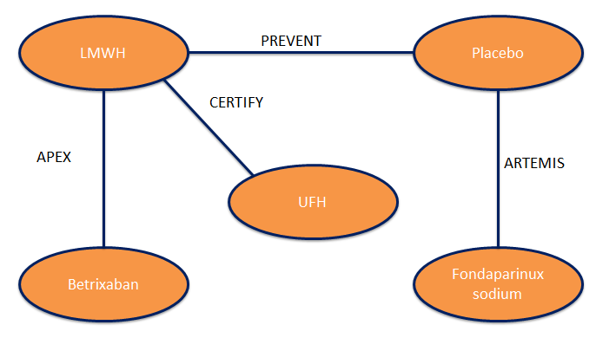
ªLMWH=low molecular weight heparin, UFH=unfractioned heparin
Figure S2. Venous thromboembolism related death network of evidenceª
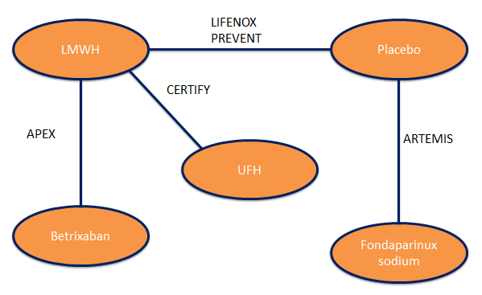
ªLMWH=low molecular weight heparin, UFH=unfractioned heparin
Figure S3. Major bleeds incidence network of evidenceª
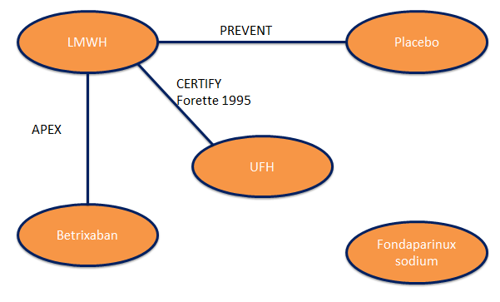
ªLMWH=low molecular weight heparin, UFH=unfractioned heparin
Figure S4. Symptomatic deep vein thrombosis incidence network of evidenceª
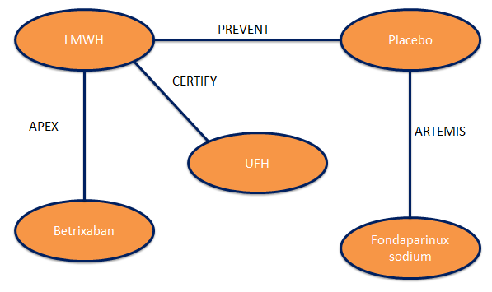
ªLMWH=low molecular weight heparin, UFH=unfractioned heparin
Figure S5. Asymptomatic deep vein thrombosis incidence network of evidenceª
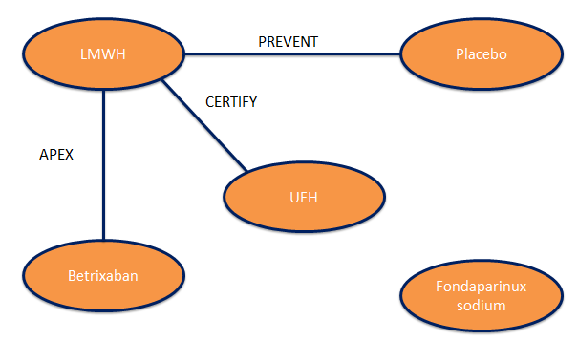
ªLMWH=low molecular weight heparin, UFH=unfractioned heparin

Figure S6. Pulmonary embolism incidence network of evidenceª
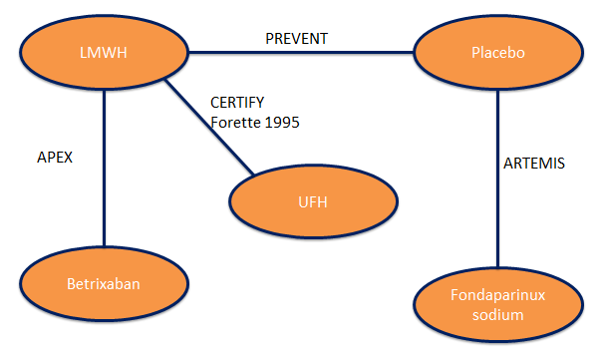
ªLMWH=low molecular weight heparin, UFH=unfractioned heparin
Figure S7. Pulmonary embolism incidence network of evidence (including Belch 1981)ª
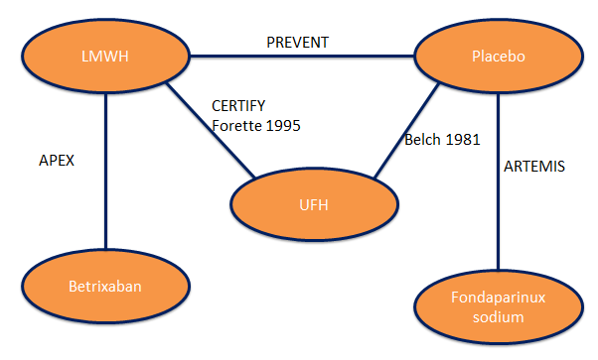
ªLMWH=low molecular weight heparin, UFH=unfractioned heparin

Figure S8. All deep vein thrombosis incidence network of evidenceª
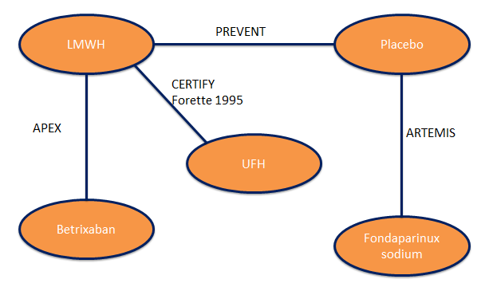
ªLMWH=low molecular weight heparin, UFH=unfractioned heparin

References
[1] Cohen AT, Harrington RA, Goldhaber SZ, Hull RD, Wiens BL, Gold A, et al. Extended thromboprophylaxis with betrixaban in acutely ill medical patients. N Engl J Med 2016;375:534–44. doi:10.1056/NEJMoa1601747.
[2] Cohen AT, Alikhan R, Arcelus JI, Bergmann J-F, Haas S, Merli GJ, et al. Assessment of venous thromboembolism risk and the benefits of thromboprophylaxis in medical patients. Thromb Haemost 2005;94:750–9.
[3] Department of Health. Department of Health. Risk assessment for venous thromboembolism (VTE) (2010). https://www.nice.org.uk/guidance/ng89/resources (accessed 2016 October 31). 2010.

